
Applied Computing
Wales Institute of Science and Art (WISA)

Digital Forensics (ACCA7031)

Investigative Process - Introduction


This Photo by Unknown Author is licensed under CC BY-NC

Lab Activities are based on
TryHackMe, EC Council – CHFI, and other Industry Digital Forensic Curriculum

Objectives
In continuation to our lectures, this hands-on Activity helps in providing you an overview of digital forensic investigation process.
ETHICAL STATEMENT
As discussed during our lectures, it is very important to adhere to Personal Ethics, Professional Ethics, Computer Ethics and Business Ethics.
We, the participants and stakeholders in the digital forensics laboratory, recognize the significance of ethical conduct when using digital forensics tools and processes for academic purposes. Our commitment to ethical standards is grounded in the principles of integrity, privacy, and responsible handling of digital data.
The tools and techniques you are exposed to’ in this lab is to work only on a virtual machine environment and the purpose is entirely to demonstrate various digital forensic activities. Experimentation with these tools, techniques, and resources is at the discretion of the instructor and institution. If you as a student consider using these tools for educational purposes on an outside environment, you should contact your lecturer prior to any experimentation.
Note: Unauthorized access to data, computer, and network systems is a crime in many jurisdictions and often is accompanied by severe consequences, regardless of the perpetrator’s motivations. It is the learner’s responsibility, as the user of this material, to be cognizant of and compliant with computer use laws.
Task 1: Ensuring Integrity of the data

Task 1: Ensuring Integrity
- Discuss with your Lecturer and Classmates on what are the necessary steps to take in ensuring the integrity of the data.
  - Document your reflection in Moodle – Discussion Forum.
- Do you know that using Windows Registry, you can prevent data from being written to any other external storage/ device?
Login to your Virtual Lab Windows Client: Make sure your Windows Client in your Virtual Lab could access USB Port.
- Review the options available in Windows Registry to accomplish the task to protect the data from being written to a USB storage/ device.
- Open Reg Edit
- Computer\HKEY_LOCAL_MACHINE\SYSTEM\CurrentControlSet
- Review the available Control Sets.
- Create a New Key under Control and name it appropriately. I named it as StorageDevicePolicy.
- Click New: What are those options? Research and discuss with your Team
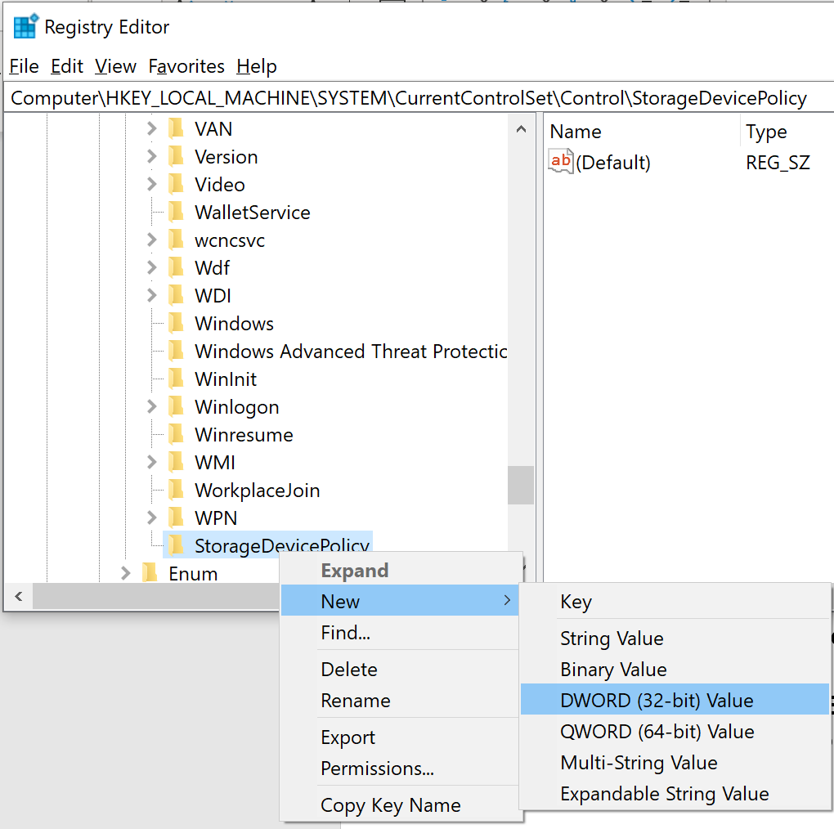
- Create a DWORD and name it appropriately. Change the value to 1.
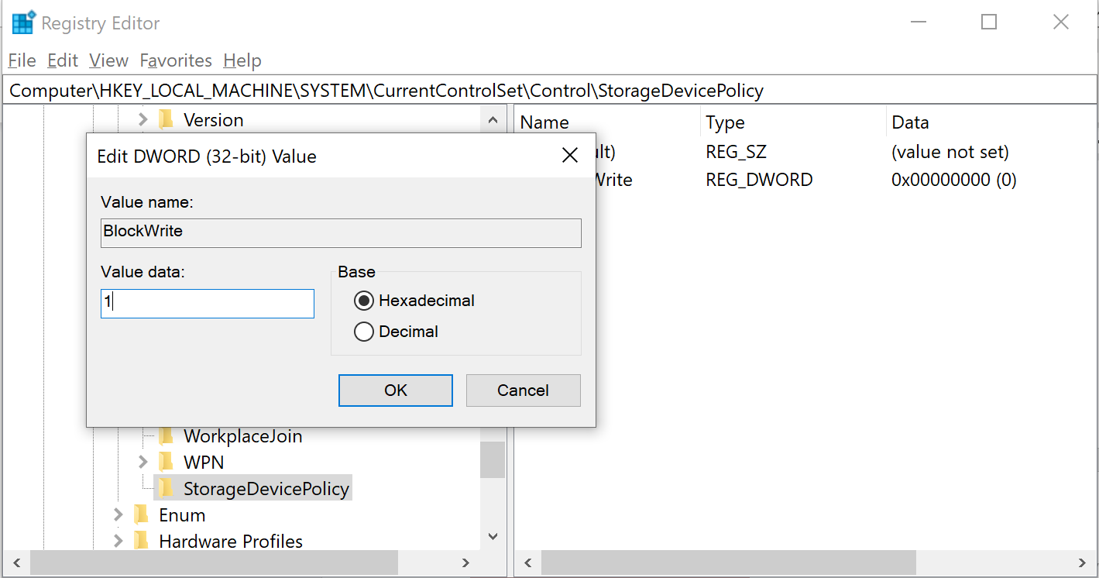
- Check the outcome by connecting a Flash Drive/ HDD and copying data to it.

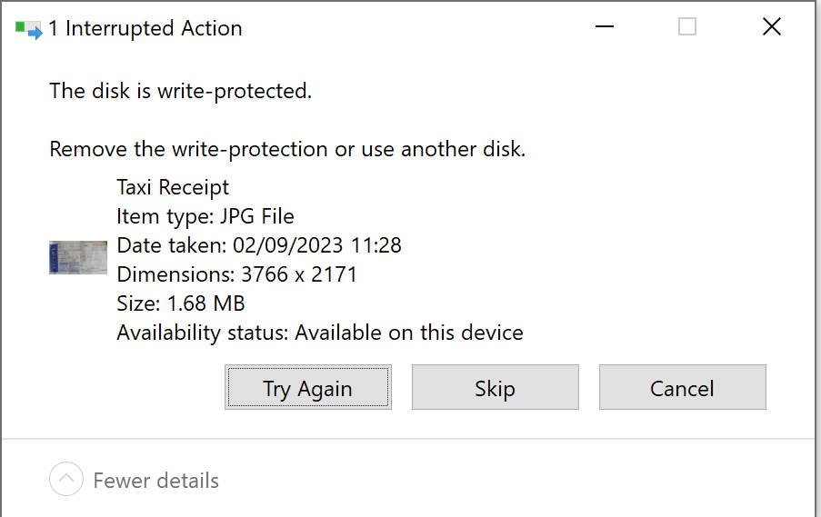

Overall Reflection
- Understanding on the concepts discussed in the lecture and its relation to the activity done.
- Understanding about various tools used and various frameworks available for DF Investigations.
- Rate yourself: Understanding of Preparation – DF Investigation
-------------------------------------------End of Activity--------------------------------------------

