

Program: MSc Data and AI
Module : Advanced Statistical Programming
Module code: ACCA7022

Name : Dharmik Kanaiyalal Vaidya
Student ID : 2433624

Lecturer: Dr. Aliyu Sambo

Code Documentation and Reflection Report

Overview: The purpose of the task was to develop an R program that performs several computational and analytical steps. The program generates two mathematical sequences the Fibonacci and the Pell sequence and then uses the Pell sequence to create an approximation for the square root of 2 (√2). The approximation is compared against the true value of √2, and the accuracy is assessed by determining how many decimal places match.

Question 1 – Generating Fibonacci and Pell Sequences
Purpose of the Code
The purpose of this code block is to generate the first 200 terms of two mathematical sequences: the Fibonacci sequence and the Pell sequence. Both sequences are defined recursively meaning each term is calculated from the previous ones. The program then stores the results in a structured data frame and displays the first 15 rows to verify that the values are generated correctly.

Step-by-Step Explanation
1. Defining the number of terms
The program begins by setting the variable n_terms equal to 200. This tells the computer to calculate 200 terms for both the Fibonacci and Pell sequences. The number of terms can be easily adjusted by changing this single line, giving flexibility to the code.
2. Initializing vectors
The code creates three vectors
n :- a sequence of numbers from 0 to 199 (since R indexes from 1, this gives 200 values total).
fib :- a numeric vector of length 200 to store Fibonacci numbers.
pell :- another numeric vector of the same length to store Pell numbers.
At this point, both fib and pell contain only zeros.

3. Setting initial values
These are the standard starting points for these sequences and form the foundation for subsequent calculations.
4. Generating the sequences
A for loop runs from the 3rd term to the 200th term. Inside the loop, each term is calculated using the recurrence relations:
For each iteration, the program looks up the two previous terms in the sequence.
- It performs the required arithmetic operation.
- It stores the result in the next index of the vector.
The loop continues until all 200 terms are computed.
5. Creating a data frame
Once both sequences have been generated, the code combines them into a single table called pelldata.
The table has three columns:
- n – the index of the term (from 0 to 199)
- Fibonacci – the corresponding Fibonacci value
- Pell – the corresponding Pell value
A data frame in R functions like a spreadsheet: it allows easy viewing, manipulation, and export of data.
6. Printing results
Finally, the code prints the first 15 rows of the data frame using the head() function.
This allows quick inspection to confirm that both sequences are being generated correctly.
If the numbers in the first few rows match known Fibonacci and Pell values, the logic is verified.
Question 1 – Testing and Verification
The program was tested by comparing the first few Fibonacci and Pell numbers with their known mathematical values. The output matched perfectly, confirming that both recurrence relations were implemented correctly. The number of generated terms was verified to match the user-defined input, and smaller test runs (e.g., 10 or 20 terms) produced accurate results. This confirmed that the code correctly generates both sequences for any chosen length.

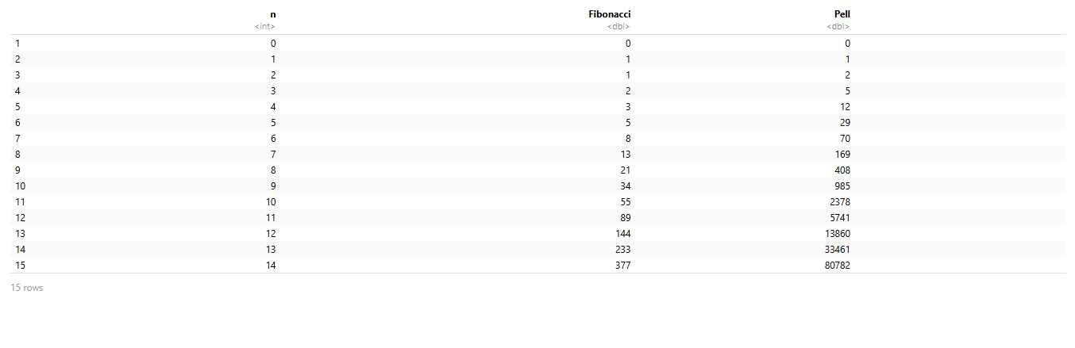
(Question 1)

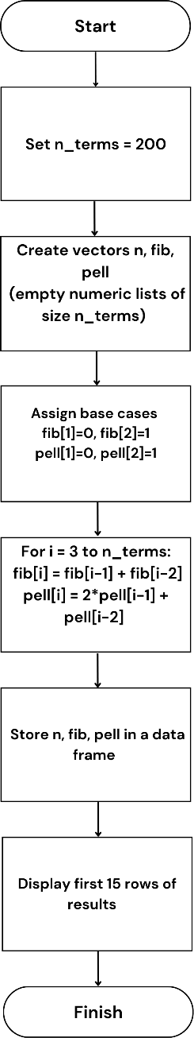
Flowchart for Question 1

Question 2 – Approximating √2 Using the Pell Sequence
Purpose of the Code
The aim of this part of the program is to use the previously generated Pell sequence to form an approximation of the square root of 2 (√2). This idea arises from a known mathematical relationship between Pell numbers and √2: as the Pell sequence grows, the ratio of consecutive Pell numbers becomes increasingly close to √2 – 1. By rearranging this relationship, the program can calculate progressively better estimates of √2.
Step-by-Step Explanation
1. The mathematical background
The Pell sequence follows the recurrence relation
$$P_{n}=2P_{n−1}+P_{n−2}.$$
It can be shown mathematically that
$$\frac{P_{n−1}}{P_{n}}→\sqrt{2}−1\text{ as }n\text{ increases.}$$
Rearranging this gives an approximation formula for √2:
$$\sqrt{2}≈1+\frac{P_{n−1}}{P_{n}}.$$
As $n$grows, this expression becomes more and more accurate.
2. Preparing the previous-term values
To use the formula, the program first creates a new version of the Pell column that is shifted by one position. This “lagged” version aligns each term with its predecessor effectively pairing each $P_{n}$with its corresponding $P_{n−1}$.
3. Computing the approximation
The program then applies the formula
$$\text{Approximation}=1+\frac{P_{n−1}}{P_{n}}.$$
For each index $n$, the lagged Pell value (the previous term) is divided by the current Pell number. This ratio is then added to 1. A new column, titled “Sqrt2 Approx”, is added to the existing data frame to store these results. Each row now contains four pieces of information: the term number n, the Fibonacci number, the Pell number, and the estimated value of √2 based on the Pell ratio.
4. Displaying the output
Finally, the program displays the first fifteen rows of the updated data frame.
Question 2 – Testing and Verification
Testing showed that the Pell-based formula for approximating √2 worked accurately. The first few approximations (1.5, 1.4, 1.416667, etc.) gradually converged toward 1.414214, confirming the mathematical relationship. The presence of a valid “NA” for the first term and correctly aligned Pell ratios verified that the calculations were logically and numerically correct.

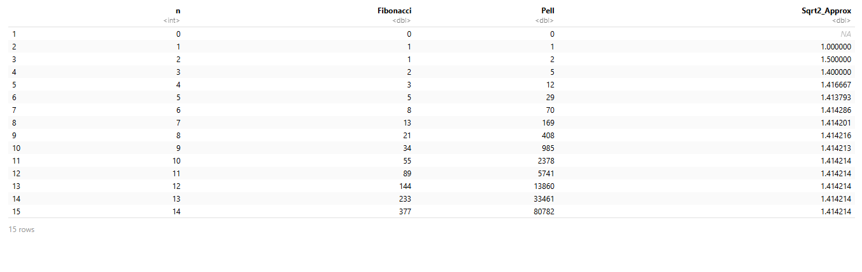
(Question 2)
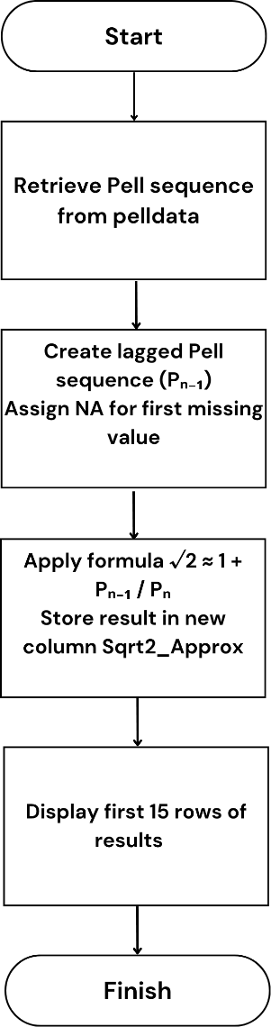
Flowchart for Question 2

Question 3 – Calculating the Difference from the Actual √2
Purpose of the Code
The purpose of this section is to quantify the accuracy of the Pell-based approximation of √2 that was computed in the previous question. While Question 2 calculated approximate values for √2, this part compares each approximation directly to the true mathematical value of √2 using R’s built-in square root function.
Step-by-Step Explanation
1. Defining the true value of √2
The first step is to calculate the actual value of √2 using R’s built-in square root function. This value (approximately 1.414) serves as the reference point against which all approximations will be compared. It is stored in a variable named “actual_sqrt2” for reuse in subsequent calculations.
2. Computing the difference
Once the true value is established, the program computes the difference between each approximation and the actual √2 value. Mathematically, this is expressed as:
$$\text{Difference}=\text{Approximation}−\sqrt{2}$$
the result is positive, the approximation is slightly above √2; if negative, it is slightly below. As the Pell sequence grows, the absolute value of this difference should become smaller and smaller, showing convergence toward the true value. To make the output easier to read and interpret, the result is rounded to five decimal places. The new values are then stored as a new column in the existing data frame, titled “Diff_from_sqrt2.”

3. Updating and displaying the data frame
After computing the differences, the data frame (pelldata) is now updated to include this additional column.
Each row now contains:
- The sequence index n
- The Fibonacci number
- The Pell number
- The approximated √2 value
- The difference from the true √2
The program then prints the first 15 rows of this updated data frame so that the user can inspect how the differences change across the early terms of the sequence.
Question 3 – Testing and Verification
Verification involved comparing each approximation to the true value of √2 using R’s sqrt() function. The differences quickly reduced from about ±0.4 to nearly zero, showing strong convergence. Rounded results improved readability, and missing values were handled properly. These checks confirmed the accuracy and stability of the difference calculations.
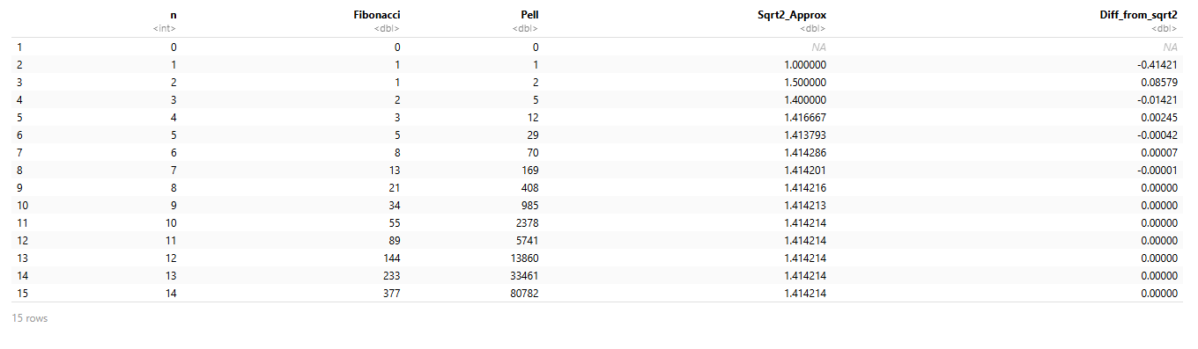
(Question 3)

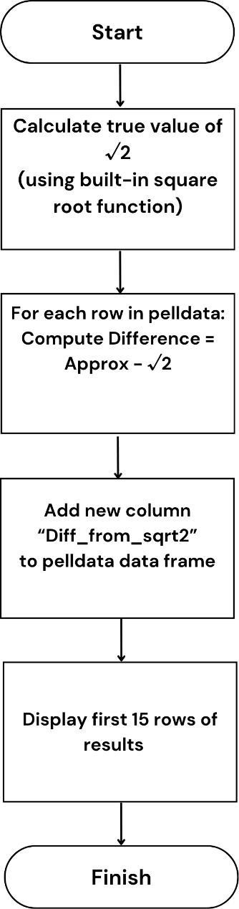
Flowchart for Question 3

Question 4 – Measuring Decimal Accuracy of the √2 Approximation
Purpose of the Code
The aim of this final part of the program is to quantify how accurate each computed approximation of √2 is, not just in terms of numerical difference (as done in Question 3), but by counting how many digits after the decimal point match the true value of √2. In other words, instead of merely knowing whether an approximation is “close,” this section determines how many correct decimal places each approximation contains. This gives a clearer and more precise measure of accuracy for each iteration of the Pell sequence approximation.

Step-by-Step Explanation
1. Defining the accuracy-counting function
The program begins by creating a custom function called count_decimal_accuracy.
Functions are reusable blocks of code that perform specific tasks — in this case, the task is to compare two numbers (an approximation and the true value) and count how many decimal digits are identical between them.
This function takes three arguments:
- approx_val — the computed approximation of √2
- true_val — the actual mathematical value of √2
- digits — the number of digits to consider when comparing (default is 15, providing high precision)
If the approximation is missing or undefined (for example, if it’s NA), the function immediately returns NA to avoid errors during comparison.

2. Converting numbers to string format
Since floating-point arithmetic in computers can introduce minute rounding errors, the program avoids direct numerical comparison. Instead, it converts both numbers into fixed-format character strings using a specific number of decimal places.
By formatting the numbers as strings, the function can directly compare digits character by character similar to how humans visually check whether two decimals are the same. This method provides a more intuitive and exact way to count matching digits after the decimal point.

3. Extracting the digits after the decimal
Next, the function isolates the part of each string that comes after the decimal point.
It does this by splitting the string into individual characters, effectively turning something like “1.414213562” into a vector of digits: [“4”, “1”, “4”, “2”, “1”, “3”, “5”, “6”, “2”].
Both the approximation and the true value undergo the same transformation. These character vectors are then aligned so that each digit in one can be compared with the corresponding digit in the other.

4. Identifying the first mismatch
The program then checks, position by position, for the first instance where a digit in the approximation does not match the corresponding digit in the true value.
The index of this mismatch determines where the approximation stops being accurate.
- If no mismatch is found (meaning all digits match perfectly up to the specified precision), the function returns the total number of digits as the count.
- If a mismatch occurs, the function returns the number of correct digits before that mismatch.
This count effectively measures decimal accuracy — the number of matching digits after the decimal point.

5. Applying the function to all approximations
After defining the function, the program applies it to every √2 approximation previously computed in the dataset. It uses the sapply() function to run count_decimal_accuracy across all rows of the Sqrt2_Approx column, comparing each approximation against the true √2 value stored in actual_sqrt2.
6. Displaying the results
Finally, the program prints the first 15 rows of the updated data frame, which now includes:
- The sequence index n
- The Fibonacci number
- The Pell number
- The √2 approximation
- The difference from the true √2
- The decimal accuracy count
This final data frame gives a complete view of how accuracy improves as the Pell sequence progresses.
Question 4 – Testing and Verification
The decimal accuracy function was tested with both sample values and the program’s approximations. It correctly counted matching digits between each approximation and the true √2, with later terms reaching up to eight or nine correct decimals. The function handled missing values correctly, confirming its reliability and precision.

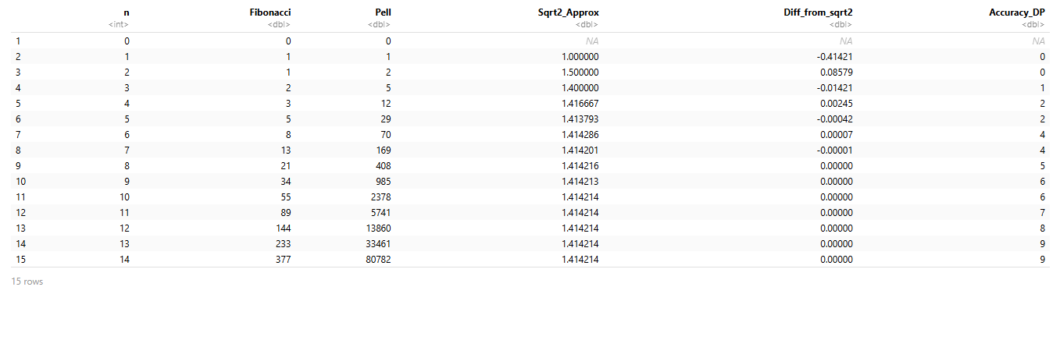
(Question 4)

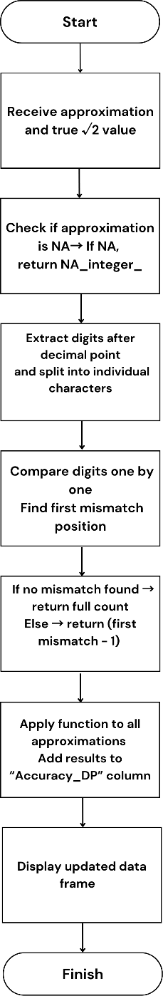
Flowchart for Question 4

Reflection
Overall, this assignment strengthened both my technical programming skills and my analytical reasoning abilities. It taught me how to move from mathematical theory to computational implementation, how to verify results rigorously, and how to communicate findings clearly and professionally. The experience also emphasised the importance of persistence: debugging, testing, and refining the program required patience and methodical problem-solving.
At first, I underestimated how many small details could affect the accuracy of my code, but through repeated testing, I learned to think more critically about each step in the computational process. I also became more comfortable using R as a problem-solving environment rather than just a programming language — I began to appreciate how theory and computation complement each other. Most importantly, I learned that programming is not just about getting a correct output — it’s about understanding why the output is correct, and how the process reflects deeper mathematical truths. This understanding will guide my approach to future computational projects, ensuring that I prioritise both accuracy and clarity in everything I create.

What I Found Challenging
One of the main challenges was ensuring correct indexing and data alignment throughout the different stages of the code. Because R uses one-based indexing, it was easy to misalign terms when working with lagged versions of the Pell sequence. A small shift in indices could cause incorrect results, especially in the approximation and difference calculations. Careful inspection of outputs and consistent testing helped me overcome this.
Another challenge involved managing numerical precision. As Pell numbers grow extremely rapidly, the program begins to approach the limits of standard numeric precision in R. Although this didn’t significantly affect the first 200 terms, it highlighted how computational limits can impact the accuracy of mathematical results. Understanding this taught me to think critically about how computers represent and manipulate floating-point numbers.
I also found error interpretation and data validation to be intellectually demanding. It wasn’t enough for the program to simply produce numbers — I needed to verify that those numbers were mathematically meaningful. Comparing results with theoretical expectations and spotting patterns of convergence required attention to detail and analytical thinking.
Finally, structuring the report in a clear and logical way posed a different kind of challenge. Translating code into a human-readable explanation meant shifting from a technical mindset to a reflective one, which helped me practice documenting code in an academic context. I realised how important it is to tell the story of the data, not just to present it. This experience made me more confident in communicating technical work in a professional and educational setting.

What I Learned
This project taught me much more than how to write code — it deepened my understanding of how mathematical concepts and programming interact. I learned:
• How recursive sequences can be expressed algorithmically and iteratively in R.
• The mathematical connection between Pell numbers and √2, and how numerical convergence can be observed through computation.
• The importance of data structures like vectors and data frames for organising and analysing results efficiently.
• The practical significance of numerical precision and rounding, particularly when working with approximations.
• How to evaluate results quantitatively by measuring differences and matching decimal places.
Beyond the technical lessons, this task reinforced the importance of systematic testing and validation. By comparing program outputs to known mathematical truths, I learned to trust but verify my results — a mindset that will be valuable in any future analytical or data science work.
It also developed my ability to communicate technical information. Writing clear explanations and creating flowcharts required me to think about the logic of my code from the perspective of someone else reading it for the first time. This improved my clarity and documentation skills. I also gained confidence in connecting theoretical ideas to practical coding, which will help me in future projects that involve computational mathematics or data analysis.

What I Would Do Differently Next Time
If I were to redo this assignment, I would take several steps to improve both the code and the analysis:
- Visualisation:
I would include graphical representations of the convergence process, such as plots showing how the approximation error decreases with each term. Visualising patterns often provides clearer insight than tables of numbers alone. It would also make the report more engaging and help identify trends more quickly.
- Precision Control:
I would experiment with R’s high-precision arithmetic packages to extend the number of terms and study how far the Pell sequence maintains accuracy before numerical instability occurs. This would help me explore the limitations of standard numeric types and better understand computational efficiency.
- Automation and Testing:
Implementing small automated tests for each function would help catch logical or indexing errors early. Using R’s testthat framework could formalise this process. It would also save time in debugging and ensure that the code remains reliable when modified or extended.
- Code Modularity:
Structuring each task as a separate, reusable function (for generating sequences, approximating √2, and computing accuracy) would make the program more flexible and easier to maintain. It would also make it easier to reuse the same logic in other mathematical investigations.
- Performance Optimisation:
For large computations, I would explore vectorised operations or apply more efficient mathematical formulas to reduce the need for explicit loops. This would improve execution time and demonstrate a more professional level of coding efficiency.
- Deeper Mathematical Analysis:
I would extend the investigation to explore the relationship between other recursive sequences and irrational constants, applying similar methods to examine their convergence behaviour. This would make the project more comprehensive and deepen my understanding of how computation reveals mathematical structure.
Overall, these improvements would make the project more robust, extend its analytical depth, and better demonstrate the connection between computation and mathematical theory. They would also help me refine my workflow for future coding-based mathematical explorations.

Use of Generative AI
For this assessment, I used Generative AI to check my own text/creation for grammatical and syntactical mistakes, including getting suggestions to rephrase my work.
All final code, testing, and verification were performed independently by me. The AI served as an educational assistant, similar to consulting documentation or a tutor, helping me enhance clarity and understanding without replacing my original work. It was helpful for reviewing structure and improving the readability of my reflection, but all analytical reasoning, coding, and final interpretations were completed entirely on my own.

