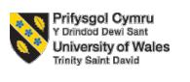

LCMB7023
Human Capital Management

Assessment 1

Lecturer: Gladius Kulothungan (London)

Student Name- Hasibur Rahman
Student ID- 2436834

Submission deadline: Friday 14th November 2025 by 2pm

Table of Contents
Introduction 3
1. How are technological advancements reshaping labour markets, and what implications does this have for HRM and IHRM strategies? 4
1.1. The Reshaping of Labour Markets: Polarisation and Platformisation 4
1.2. Strategic Implications for HRM and IHRM 5
2. What are the key demographic and geopolitical factors influencing employment markets today and how do they create challenges for HR professionals 6
2.1. Key Demographic Influences 6
2.2. HR Professionals Geopolitical Challenges. 7
3. How can organisations address persistent skills gaps and talent shortages in critical sectors (e.g., tech, hospitality, healthcare) through strategic HRM? 8
3.1. The Build Strategy: Nurturing Talent within the company. 8
3.2. The Buy and Borrow Strategies: Strategic Acquisition and Flexibility. 9
3.3. The Foundation of Retention 10
4. Reflective Report on Present Capabilities to the Globalised Workplace. 11
4.1. Evaluation of the existing capabilities. 11
4.2. Future Improvement Development Plan. 13
Conclusion 14
References 15

Introduction
This report describes an acute and research-based discussion of the dynamic interaction between changing labour markets and strategies of organisations people. It will begin to break down the way technological progressions including artificial intelligence and online platform are radically changing the nature of work and require new strategic addresses by HR. The report will subsequently recommend and analyse combined strategic HRM interventions that will alleviate the continued and harmful skills deficiencies plaguing such crucial areas as technology and healthcare.

1. How are technological advancements reshaping labour markets, and what implications does this have for HRM and IHRM strategies?

1.1. The Reshaping of Labour Markets: Polarisation and Platform Economy
Labour Market Polarisation
More and more activities, both manual and cognitive, routine, modifiable, can be handled by automation and AI (Autor, 2015). This has a sharp shrink in the mid-skilled jobs including the ones in administrative support and conventional manufacturing and a high demand on two opposing sets. High-skilled jobs with complex problem-solving, creativity, and technological capabilities (e.g., AI specialists, data scientists, cybersecurity experts) and, paradoxically enough, increased demand of low-skilled jobs that require deep human interaction, emotional intelligence, physical dexterity, which are hard to automate (e.g., elder care, skilled trades, hospitality services) are on the rise (World Economic Forum, 2023).
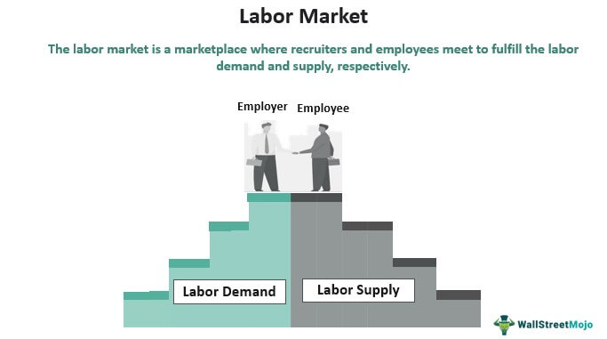
Figure: Labour Markets (Amazon, 2021).

The Rise of the Platform Economy:
There has been an exponential growth of non-standard work practises, including gig, freelance, and contract work, which has been enabled by the emergence of digital platforms of labour, including Uber, Deliveroo and Up-work. This development can severely test the core principles of the traditional models of HRM that were largely based on the employment relationships of permanent and full-time.
It also compels a paradigm shift in established practises concerning performance management, employee involvement, compensation, and benefits, and legal regulations in an environment characterised by increasingly blurred and conflicting employment relations (Spreitzer et al., 2017). The HR departments now have to create policies and systems to handle a mix group of employees and contingent workers, which in most cases are in a global scale.
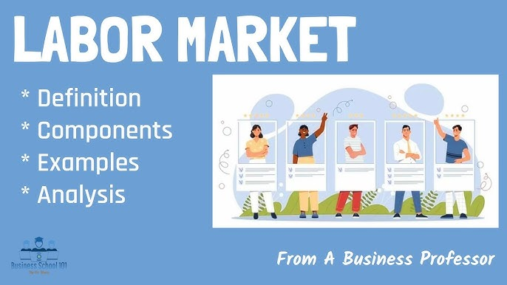Figure: Labour Markets (World Economic Forum, 2023).

1.2. Strategic Implications for HRM and IHRM
Radical Revolutionising of Talent Acquisition and Development: There is a radical Revolutionising of the processes involved in attracting and developing talent. AI-assisted talent acquisition is becoming more abusive of actively sourcing and recruiting talent, using AI to perform user screening and even primary recruitment interviews (Tambe et al., 2019).
At the same time, the Learning and Development (L&D) should be transformed to a new foundation called regular training vision (event-driven), to a culture of constant and life-long learning embedded into its structure. Organisations have now taken the initiative and one such case is Amazon that has invested heavily in its Upskilling 2025 programme committing more than 1.2 billion dollars to support the training of 300,000 employees in high-demand skills such as machine learning and cloud computing (Amazon, 2021).
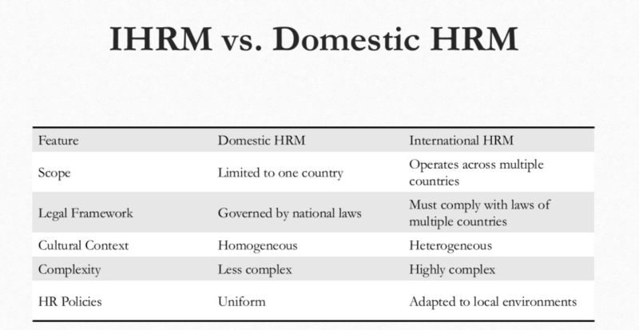
Figure: HRM (Amazon, 2021).
Managing Global, Virtual Workforce:
In the case of IHRM, the effects of technology are even more intricate and strategic. An example of such a company is Spotify, which runs on a model with decentralised groups of squads and tribes in various countries, which forwards on a collection of digital collaboration tools to promote innovation and cohesion (Spotify, 2023). Yet, there are deep ethical issues embedded in this global talent hunt on the form of a so-called global brain drain, where one selects the finest talents in both developing and developed countries has been systematically drained, causing the growing inequality of the world, and stifling innovation in the developing economies (Carr et al., 2016).

2. What are the key demographic and geopolitical factors influencing employment markets today and how do they create challenges for HR professionals?

2.1. Key Demographic Influences
The Ageing Populations and Changing Values of Labourers: In several developed economies, such as in Japan, Germany and Italy, the working average is shrinking gradually and consistently due to reducing birth rates and rising life expectancy. This demographic fact places a straining burden on state pension schemes, causes beneficial institutional knowledge to be lost as the old workers leave work and causes chronic talent shortages that in turn cannot be addressed simply through domestic hiring (UN Department of Economic and Social Affairs, 2023).
Youth Bulges in the Emerging Markets: In sharp contrast, other parts of the world like Sub-Saharan Africa as well as parts of Southeast Asia are growing with a very high percentage of population below the age of 25, which is called a youth Bulge. Whereas this is a possible long-term demographic dividend and a mega talent pool in the future, it is also a formidable challenge to provide future talent pools with enough formal jobs and equip them with relevant skills and training to assimilate this huge number of people into productive economy (World Economic Forum, 2023).
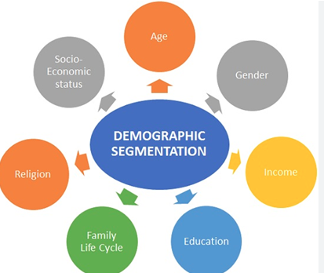
Figure: Demographic Influences (Meyer, 2015).

2.2. HR Professionals Geopolitical Challenges.
Economic Nationalism and Trade Protectionism: The recent developments of economic nationalism and trade protectionism that is currently evidenced with the US-China trade war and the United Kingdom moving out of the European Union (Brexit) directly interrupt the flow of supply chains worldwide and makes it challenging to move talent across the globe without any issues.
Brexit, as an example, has terminated the unrestricted movement of individuals across the UK and the EU causing major administrative impediments, visa limitations as well as a considerably decreased supply of accessible labour by UK-based companies in the hospitality, farming, and health-care sectors. This compels the HR to re-evaluate its approach to talent sourcing, which usually involves investing more in home automation and training initiatives (Migration Advisory Committee, 2022).
Political Instability and Ethical Compliance: These are political turmoil, regional crises, and health-related pandemics or war outbreaks like the pandemic or the war in Ukraine, which pose acute and urgent issues in the sphere of IHRM. Moreover, the world is becoming increasingly more sceptical of corporate ethics, especially with regard to human rights and sustainable sourcing in global value chains. Laws such as the Modern Slavery Act (2015) in the UK and the increasing trend in the EU toward the compulsory nature of human rights due diligence directly pressure the HR and procurement functions to perform thorough due diligence of their completely global activities.
Strategic HRM as a solution to Skills Gaps and Talent Shortages.
Ongoing and increasing skills gaps and shortages in talent is a real menace to organisational productivity, innovation, and economic growth and especially functional areas such as technology, healthcare, and hospitality. As one of the primary disconnects between the skills that employers require and those that the labour market offers, these discrepancies are impossible to address on the traditional recruitment practises (World Economic Forum, 2023).

3. How can organisations address persistent skills gaps and talent shortages in critical sectors (e.g., tech, hospitality, healthcare) through strategic HRM?

3.1. Tech sector- The Build Strategy: Nurturing Talent within the company.
Upskilling and Reskilling Programmes: In lieu of the reliance on external talent supply which is already limited and costly, progressive organisations are putting considerable resources into their inner talent supply. An example is that IBM has built its Skills Build platform, a set of free online education on such essential skills as cybersecurity, cloud computing, and data science to its employees as well as to the general community. This is an effective way of developing its own talent pipeline in the future, as well as meeting a corporative social responsibility requirement (IBM, 2023).
Educational and Apprenticeship Partnerships: Other effective build strategies are the apprenticeship programmes and deep strategic collaboration with universities, colleges, and vocational schools. In the medical industry, e.g., hospitals frequently have a special relationship with the nursing and medical schools to work out the curriculums of the educational institutions that match the real clinical requirements, as well as provide long-term clinical placements that become a huge interview in applicant forms.
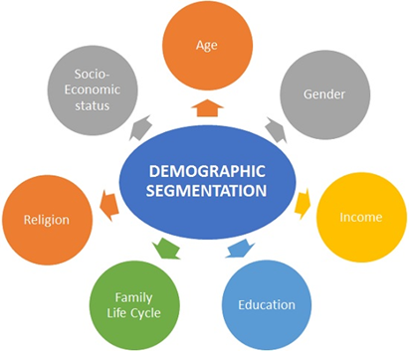
Figure: Demographic (Bock, 2016).

3.2. Hospitality sector- The Buy and Borrow Strategies: Strategic Acquisition and Flexibility.
More Intelligent Talent Acquisition ("Buy): In an attempt to improve the competence of external recruitment, organisations are shifting to skills-based recruitment, concentrating on visible capabilities and talent instead of concentrating on traditional credentials when recruitment is being done such as university degrees. This includes capitalising on new measurement technologies, actively exploring new pools of talent (including career-changers, military veterans, or neurodiversity people, and, most importantly, improving Employer Value Proposition (EVP) as a whole (World Economic Forum, 2023).
When competing in the highly competitive technology industry, organisations such as Google have been placing a strong emphasis on their innovative culture, project independence, and special benefits and offices to secure the most talented employees, and they have realised that this particular group of workers does not respond to remuneration alone (Bock, 2016).
Tap into the Agile Workforce ("Borrow"): The third strategic pillar is to tap into the agile workforce by borrowing talent in the form of agile workforce models. This involves a rewarding, strategic utilisation of gig workers, freelancers, independent consultants, and outsourcing partners to acquire definite and high-need skills on a momentary basis or even on a project-specific undertaking. This gives organisations a much-needed flexibility, cost containment capacity and adaptability to any project based needs or market changes in a very short period without complicating it with a permanent employee.

3.3. Healthcare sector- The Foundation of Retention
One of the pillars that supports and increases the effectiveness of the model of build, buy and borrow is an unstopped concentration on increasing employee retention. It is a universal fact that it is less disruptive and more economical to keep an experienced staff member than to hire, inductor, and develop a new staff member.
Enculturation of Engagement and Loyalty:
Strategic HRM curbs the retention aspect by incorporating integrated programmes aimed at holistic employee care, availability of career path and internal mobility opportunities, and core and unconditional reward and recognition systems. In the hospitality sector that is notoriously characterised by a high turnover rate, the management of organisations such as Marriott International have enacted extensive employee recognition programmes, clear promotion into high corporate positions, and an intensive focus on corporate values. It shows a real sense of investment in the development and welfare of the employees, and this inevitably leads to increased loyalty and decreased expensive turnover (Marriott International, 2022).

4. Reflective Report on Present Capabilities to the Globalised Workplace.

4.1. Evaluation of the existing capabilities.
Technology
I am strongest in an area I am well grounded in my basic productivity software base (e.g., Microsoft 365, Google Workspace) and I have shown that I can readily learn and use new collaborative packages. Nevertheless, one of the major weaknesses is that I do not have more in-depth technical expertise in the selected specialised topics, such as data analytics and visualisation (e.g., with Power BI or Tableau) and a lower, theoretical awareness of the business strategic implications of technologies, such as AI. Although I can competently work with the operational tools, I am not competent yet to create information into an actionable business insight, which becomes particularly in-demand in all business functions, such as HR, marketing, and finance (World Economic Forum, 2023).

Figure: Globalised Workplace (Meyer, 2015).

Communication and Teamwork
I am able and skilled in formalised, written and structured presentation settings and I have demonstrated capability of structuring clear, concise and professional messages. I also realised that I was too often using low-context communication standards when the messages are expected to be clear. I had to learn to be significantly more proficient at receiving subtle feedback, reading between the lines and adjusting my communication style to the preferences of various cultures that is a crucial ability in developing authentic trust and functional operational work in a cross-cultural group (Meyer, 2015).
Regarding teamwork, I am a punctual, responsible, and cooperative team player who attaches strong importance to success in the team. Recently in a module, I collaborated well in a very diverse group to formulate a complicated business plan where I took the initiative to develop a common online workspace that kept us on track and in order. I am an organisation person and I make the team a positive and inclusive place to work.
Main Discovery: Leadership and Self-Directed Learning: My major area of growth is that of promotion of innovation and agility. I am more prone to structured, linear management and may become reluctant to switch the direction or be creative once an unforeseen obstacle or an unfamiliar fact is introduced, which can be taken as a weakness within a competitive, global environment that values flexibility.
My personal curiosity and the capacity to recognise gaps in knowledge are one of my strengths. I tend to base my learning activities on urgent needs or desire and not on strategic plans on the long-time career goals. To genuinely constantly update and innovate, as required of the modern economy, I should organise a more coherent, disciplined, and progressive personal growth plan.

4.2. Future Improvement Development Plan.
In order to generative, exploit the strengths that I have identified and actively exploit my areas of weakness in a structured and time-sensitive manner; I have designed an action plan that is tangible and timely within the next 6-12 months.
Technology Enhancement: I will take and pass an online-certified data analytics and visualisation course using Power BI in the next 6 months. In order to make it a practical activity I will also work on my own project, task at the same period and analyse a publicly available dataset on global trends of the labour market, conclusively developing a dashboard of operational insights, and will thus shift my theoretical knowledge to practical ability.
Intercultural Communication Development
I will willingly explore and interact with a more diverse peer group in the international student body and societies of the university. To internalise models of realising the various communication styles, I will read and critically reflect on The Culture Map by Erin Meyer (Meyer, 2015). I will consciously perform active listening in a team environment, and rephrasing feedback and instructions to make sure everyone is on the same page and there is no misunderstanding among people, in particular, in the cross cultural situations.
Teamwork and Leadership Development
I will take the initiative and volunteer to manage a small, cross-cultural virtual project either in the course environment or as an extracurricular activity. I will leverage this as a safe environment under my control to train in facilitating challenging conversations, establishing explicit virtual team norms, and agile methodologies of team designing to create a more adaptive, iterative, and innovative team culture, which in turn directly works upon my agility and virtual conflict management capabilities.
Organised Self-Directed Learning
I will develop a 12-month Personal Development Plan (PDP) that outlines three primary areas of skills that reflect my career goals of the selected type (e.g., data literacy, agile project management, cross-cultural negotiation). Regarding them, I would establish certain, quantifiable goals and spend some time on their improvement every week, by modifying a set of MOOCs, industry webinars, professional networking, and working with academic projects.

Conclusion
To sum up, the impact of the national and international labour market on HRM and IHRM strategies is so significant, multidimensional, and persistent. Not only are technological tools including AI and automation automating routine work, as it is being examined in this comprehensive report, they are also actively developing new digital work paradigms and polarised employment landscape to the degree that strategic HR is required to respond in large-scale reskilling, ethical use of technology, and effective management of a blended workforce.

References
Amazon. (2021). Amazon’s Upskilling 2025 pledge. Amazon About Us.
Autor, D. H. (2015). Why are there still so many jobs? The history and future of workplace automation. Journal of Economic Perspectives, 29(3), 3-30.
Bock, L. (2016). Work Rules!: Insights from Inside Google That Will Transform How You Live and Lead. John Murray Press.
Carr, S. C., Parker, J., Arrowsmith, J., & Watters, P. A. (2016). The precarious ethics of global brain drain. International Journal of Psychology, 51(1), 1-5. FB
Gratton, L. (2021). How to do hybrid right. Harvard Business Review, 99(3), 66-74
IBM. (2023). IBM SkillsBuild. IBM Corporate Social Responsibility.
Marriott International. (2022). Marriott International Named to Fortune’s 100 Best Companies to Work For® List for 25th Time. Marriott News Center.
Meyer, E. (2015). The Culture Map: Breaking Through the Invisible Boundaries of Global Business. PublicAffairs.
Migration Advisory Committee. (2022). *Annual Report, 2021-2022*. UK Government.
Spreitzer, G. M., Cameron, L., & Garrett, L. (2017). Alternative work arrangements: Two images of the new world of work. Annual Review of Organizational Psychology and Organizational Behavior, 4, 473-499.
Spotify. (2023). How we work: Engineering culture at Spotify. Spotify Labs.
Tambe, P., Cappelli, P., & Yakubovich, V. (2019). Artificial intelligence in human resources management: Challenges and a path forward. California Management Review, 61(4), 15-42.
UK Government. (2015). Modern Slavery Act 2015. legislation.gov.uk.
UN Department of Economic and Social Affairs. (2023). World Population Prospects 2022. United Nations.
World Economic Forum. (2023). Future of Jobs Report 2023. World Economic Forum.

