

Data Security, Governance and Compliance
(ACCA7028)

Name: Zhao Weiyu
Student code: 2203629
Tutor: Assoc. Prof. Carlene Campbell
Department: Software Engineering

Abstract
With the increasing popularity of network technology, information security has been widely used in many fields. From national communications and data security, to corporate computer network security and the prevention of personal information leakage, all belong to the scope of information security. Today's society is a highly developed information dissemination society, and for an enterprise, effective information security control plays a decisive role in the normal operation of the enterprise. This report will examine how an information security system can be implemented to apply and meet Coffeeblend's growing business expansion and information security requirements, with reference to the ISO27000 Information Security Management System.
The main contents of this report include: firstly, an explanation of the concept of information security, followed by an introduction to the ISO270001 standard and the PDCA process model in the ISO27000 series, and finally, an explanation of the security management of information construction in an enterprise based on the ISO27001 standard and the PDCA model.

- Introduction
The development of information technology has removed the time and space barriers to shopping and has made it very easy to sell online. Nowadays, with the support of information technology, companies can sell their products very easily to customers all over the world.[1] On the one hand, the development of information technology has created a large number of business opportunities, but on the other, information technology has also brought new security risks. The web platform stores a large amount of information about users (including employees and customers), production and business data as well as patents, papers and other information. Information leakage can cause huge losses to the company and its customers, so how to establish an information security system has become a matter of consideration for the company's development.[2]
In order to help the company to better develop information security management, this report selects ISO27000, which is currently a representative international general standard for information security management, and uses the methodology proposed by ISO27001 under this series of standards as a guide to establish an information security management system model for Coffeeblend.
At present, there are many more mature models on information security risk management, such as PDCA, PDRR, PADIMEE and other models; at the same time, there are also many methods for risk assessment, such as fault tree analysis method, hierarchical analysis and risk matrix, etc. Among them, the PDCA model is the model commonly used in the actual assessment process of the international information security management standard ISO/IEC27001: 2005.
This report first introduces the concept of information security and the ISO27000 series of standards, which focuses on the PDCA model, i.e. Plan-Do-Check-Act, before detailing the steps of how to build Coffeeblend's Information Security Management Systems(ISMS) with reference to the PDCA model.

2．Concept
2.1 Information Security
Information Security is the protection and maintenance of Confidentiality, Integrity and Availability of information.
Confidentiality ensures that information is only accessible to those authorised to use it. Information is classified into different levels according to the number of people who are allowed to access it, information that can be accessed by all people is public information, information that requires restricted access is generally sensitive information or secret
Integrity, is to protect the accuracy and integrity of information and its processing methods. On the one hand, it means that the information is not tampered with, lost or damaged in the process of use, transportation and storage; on the other hand, it means the correctness of the information processing methods, improper operations, such as the mistaken deletion of files, may cause the loss of information integrity.
Availability means that the information and associated information assets are immediately available to the authorised person when they are needed. For example, the failure of a communication line can cause information to be unavailable for a period of time, affecting normal business operations.

2.2 ISO27000 series standards
The current mainstream information security risk management standards focus on different information security priorities: ISO/ICE 15408 (CC) and ISO27001, which focus on information assets; SO/ICE 13335, which focuses on risk; and SSE-CMM, which focuses on security-oriented engineering.
Obviously, for CoffeeBlend's situation, the company is more focused on information assets such as employees, customers and intellectual property, so this report focuses on the IOS27000 series of standards.
The ISO/IEC 27000 series of standards take the business security risks faced by an organisation (or organisation) as a starting point and provide guidelines for setting up, implementing, running, seeing, reviewing, maintaining and improving an ISMS appropriate to its size, security needs, objectives etc. through a continuous PDCA process model.
The ISO27000 series of standards consists of the following components.
- ISO27000 Information technology -- Security techniques -- Information security management systems -- Overview and vocabulary
- ISO 27001 Information technology -- Security techniques -- Information security management systems –Requirements [8]
- ISO 27002 Information technology -- Security techniques -- Code of practice for information security management[9]
- ISO 27003 ISMS Information technology -- Security techniques -- Information security management systems implementation guidance
- ISO 27004 Information technology -- Security techniques -- Information security management —Measurements
- ISO 27005 Information technology -- Security techniques --Information security risk management
- ISO 27006 Information technology -- Security techniques -- Requirements for bodies providing audit and certification of information security management systems
- ISO 27007 Information technology-Security techniques-ISMS auditor guidelines
ISO27001 is the focus of the ISO27000 series of standards and can be used as the basis for an organisation's work on information security. ISO27001 follows the PDCA model introduced by W. Edwards Deming in 1950.[4]
The PDCA model designs the workflow as a cycle of improvement, Plan-Do-Check-Act, [5]which tells people that each process needs to be implemented and improved by first planning the relevant guidelines and reference standards before it can be implemented. During the implementation process, the results of its implementation and the problems encountered in the process need to be evaluated and checked, the results compared with the guidelines, the obtained non-conformities with the plan analysed, and if there are possibilities for improvement, then the improvements are made and the plan revised at the same time. The PDCA model applied to the ISMS in ISO27001 is shown in the diagram below.
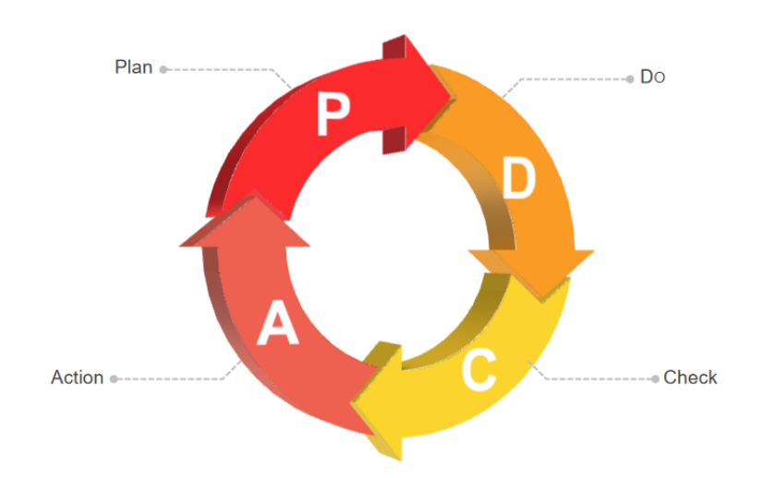
Figure1 PDCA

3．ISO27001-based ISMS
The general steps involved in setting up an ISMS are: planning and preparation before the implementation of an ISMS, establishing an information security management framework, and the preparation of ISMS documentation.
3.1 Pre-implementation preparation
The IT structure is changed to meet the needs of information security, and an independent information security team is set up to coordinate the IT support departments within the company and to raise the level of information security requirements of the company.
The first thing the information security team should obtain prior to the implementation of the ISMS is the approval and commitment of the Coffeeblend Board of Directors or managers, which is an important guarantee for the effective implementation of the ISMS. The Coffeeblend managers commit to: establishing an information security policy; defining roles and responsibilities for information security; determining the level of acceptable risk; and conducting an ISMS review. The information security policy must be developed in the early stages of ISMS implementation to demonstrate management commitment and guide the implementation of the ISMS; for example, based on the agreements reached between the security team and the management, several guidelines such as "Information Security Structure Obligations and Responsibilities", "Information Security" and "Information Protection" are established as a benchmark for information security in the company.
Once the objectives of the company have been established for the effective establishment of the information system, the security team needs to define the roles and responsibilities of the various parties involved in the ISMS establishment process[12]. Organisational and staff building tasks include: establishing an information security committee; appointing an information security management manager; and ensuring that the division of labour, responsibilities and competencies of the relevant personnel are shared and communicated effectively.
It is important to note that the establishment of an ISMS is a complex system project, which takes a long time to set up and includes a lot of work such as training, risk assessment and documentation. In order to ensure that the system is set up smoothly, Coffeeblend should plan and organise its work in a practical manner, i.e. draw up a realistic work plan, define the tasks and objectives for different time periods and the division of responsibilities, control the work schedule and organise and develop the overall plan[13]. Once the overall plan has been approved, detailed plans can be developed for specific items of work. In developing the plan, the company should consider resource requirements, such as staffing needs, funding for training, office facilities, the cost of hiring consultants, etc. Management should ensure that the necessary human and financial resources are available to establish the system.
The management of information security is not only about information data and equipment, but also about the management of people.[3] Improving the security awareness and competence of the company's employees is a very important part of information security management. The security team should design a training plan for information security and train all employees. Training should be conducted in a hierarchical and progressive manner. Hierarchical training means targeted training for different levels of personnel, which includes training for management, audit and verification personnel and operational executives, and the content of the training should be focused on each. Control the training schedule, focus the work and organise and develop the overall plan.

3.2 ISMS
Firstly the security team has to take a holistic view of the company as a whole and build up the security system and propose security solutions for all levels of the information system from the information system itself by creating an inventory of assets, conducting risk analysis, requirements analysis and selecting security controls, among other steps.[6]
3.2.1 Asset identification
Confidentiality, integrity and availability of information assets are three recognised elements that reflect the security characteristics of an asset. The different security characteristics of information assets also determine the value of their information, as well as the vulnerabilities, threats, protection and security controls that need to be implemented[10]. It is therefore necessary to identify the information assets in the Coffeeblend network environment in order to facilitate subsequent security management activities.
The security team may choose to do this through site surveys, information briefings and personnel interviews. The survey will mainly cover the main business functions and requirements; the network architecture and network environment, including internal and external connections; system boundaries; main hardware, software; data and information; sensitivity of the system and data; and the people who support and use the system.
For Coffeeblend the assets were categorised as follows:
Table1 asset[7]

3.2.2 Threat identification
A threat is any event or action that potentially compromises the confidentiality, integrity and availability of a system or asset to the extent that it affects the normal use and operation of the system or asset. Threat analysis essentially means identifying threats to critical assets in the context of defining the organisation's critical assets, describing the security needs of the critical assets, and defining the likelihood of a threat occurring and the potential to compromise the system or asset. During the threat assessment process, the security team identifies threats for each critical asset that the party being assessed needs to protect, primarily through security policy document review, business process analysis, network topology analysis, questionnaires, and personnel interviews, and based on the environmental conditions in which the asset is located and the previous threat damage to the asset. An asset may face multiple threats, and the same threat may affect different assets.
3.2.3 Vulnerability identification
Vulnerability is a general term for one or more asset weaknesses. Vulnerability identification, also known as vulnerability identification, is an important element of risk assessment. Vulnerabilities are inherent to the asset and can be exploited by threats, causing damage to the asset or business objectives. Vulnerabilities include the vulnerability of various assets such as the physical environment, organisation, processes, people, management, configuration, hardware, software and information. Vulnerabilities are assessed primarily in terms of both technical and managerial aspects and involve security at all levels, including the physical, network, system, application and management layers.
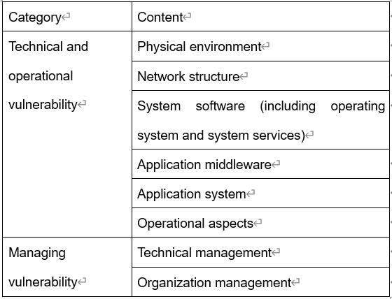
Table2 Vulnerability assessment
3.2.4 Risk treatment
Risk treatment is based on the results of the risk assessment and is carried out in response to the risk assessment report output from the risk analysis phase. Risk is accepted in moderation and residual security risks are kept within acceptable limits based on the organisation's acceptable disposal costs.
Risk management of information security is a key component of an organisation's information security system. It can further affect the operations of the business. When an organisation identifies information security risks to the business, it then needs to manage the information security risks to the business. Risk management measures mainly include risk reduction, avoidance, transfer and acceptance, and the organisers of an enterprise should choose the appropriate approach according to the actual situation of their organisation.
Define control objectives and select control measures. A risk reduction approach is taken for certain important risks, so that the appropriate processes need to be introduced to select the appropriate control measures to meet the safety requirements by selecting and implementing the control objectives and control measures of ISO 27002.
There is no standard or common approach to the selection of control objectives and controls, and the selection process is often not straightforward and may involve a series of decision-making steps, consultation processes, discussions with different business units and a large number of key personnel, extensive analysis of business objectives, and the production of results that well meet the organisation's requirements for business objectives, asset protection and investment budgets.

3.3 Implementing and running an ISMS
After some of the above steps are completed it is specifically into the bad section of the operation of the information security system of the enterprise. In the process of running the information security system the security team should strictly follow the relevant rules and guiding documents to keep a check on the operation of the company's information security system[14]. Timely discovery of unreasonable problems arising in the operation, mutual communication, the development of appropriate measures to correct. At this point, ISMS will enter the operation stage.
The initial stage of system operation is in the system's break-in period, generally known as the trial run period, during which the system operation aims to test the adequacy, applicability and effectiveness of the system in practice. In the early stage of system operation, the organisation should strengthen the operation, through the implementation of its manuals, procedures and a variety of operational guidance documents and a series of documents, give full play to the functions of the system itself, timely discovery of the problems in the system planning itself, identify the root cause of the problem, take corrective measures to correct a variety of non-conformities, and in accordance with the change control procedures required for the system to be changed, in order to further improve the ISMS The purpose of the system is to further improve the ISMS.

4. Monitoring and reviewing the ISMS
4.1 ISMS audits
Coffeblend shall establish and maintain an audit programme and procedures to conduct regular ISMS audits to ensure that it has a documented process to check that information security activities and implementation records meet the scope of the ISO 27001 labeling and statements. The purpose of an ISMS audit is to identify Security gaps and weaknesses,
The security team provides managers with the status of achievement of security control objectives, enables managers to understand security issues, identifies significant control weaknesses, formalises risks and provides opportunities to improve the ISMS. The information security team monitors the information security implementation process for compliance with the organisation's guidelines, objectives and planning requirements and provides the audit results to managers to support their information security decisions.

4.2 Management Review of ISO27001 Information Security Management System
With the development of the economy, the environment will also produce a series of changes, which requires the company to regularly take some measures to review the organization's information security management system, so that the information security system is more suitable for the needs of the organization, and promote the better development of the business.
After the security team has discovered through various inspection measures that the operation of the organisation's ISMS does not meet the prescribed requirements, it needs to take improvement measures and review whether the corrections taken are reasonable. The operation of the ISMS involves all parts of the organisational system and deviations from the standard are inevitable in the course of operation. Therefore, the organisation should establish a feedback and information security coordination mechanism in accordance with the principles of strict, streamlined and unified information feedback and processing of abnormal information, and improve the problems that arise to improve and ensure the continuous normal operation of the system.
Review inputs include the following:
- Check that information security activities and implementation records meet the scope of the ISO27001 label and statement;
- Review of corrective actions taken;
- Review of preventive control measures taken;
- Determine the level of acceptable risk and conduct an ISMS review;
- Ensure that the division of labour, responsibilities and authorities of the personnel involved are effectively communicated;
Once the input phase of the management review has been completed, an output review report on the organisation's situation is produced by the company's managers and approved by senior management[15].
The findings of the review relate to the following areas:
- A report of the corresponding corrective actions;
- Inspection of information security activities;
- ISMS documentation (mainly security management manuals and procedure documents);
- the status of achievement of security control objectives to provide managers with an understanding of security issues;
- Recommendations for improvement;
- Whether ISMS risks need to be adjusted and updated

5 Maintaining and improving the ISMS
Once the various inspection measures have identified matters in the operation of the organisation's ISMS that do not meet the specified requirements, improvement measures need to be taken.
Corrective measures:
- Identify the time of non-conformity in the implementation and/or operation of the ISMS;
- Determine the cause of the non-conformity;
- Identify and implement the required corrective action;
- Document the results of the measures taken;
- Review of corrective actions taken
Preventive controls:
- Document the results of the measures taken;
- Review the preventive controls taken;
- Identify changed risks and ensure that attention is focused on significant changed risks;
- Prioritisation of corrective actions should be based on the results of the risk assessment;
During the operation of a company's information security system, various man-made and natural problems are bound to arise. These problems will certainly hinder the continuous operation of the organisation's business and create certain disturbances for the organisation's operation. As a business organiser, it is important to take into account the actual situation of the business to correct and prevent any inconsistencies with the ISMS requirements in order to continuously improve the effectiveness of the ISMS.

6 conculsion
ISO27001 puts the focus on the protection of asset information. This paper details how Coffeeblend can establish a security system by creating an asset inventory, conducting a risk analysis, a requirements analysis and selecting security controls, with reference to the PDCA process model. Through these steps, Coffeeblend can establish its own ISMS to protect the security of its information assets.

7 reference
[1] Soomro, Z. A., Shah, M. H., & Ahmed, J. (2016). Information security management needs more holistic approach: A literature review. International Journal of Information Management, 36(2), 215-225.
[2] Prislan, K., & Bernik, I. (2010). Risk management with ISO 27000 standards in information security. Inf. Secur, 58-63.
[3]Soomro, Z. A., Shah, M. H., & Ahmed, J. (2016). Information security management needs more holistic approach: A literature review. International Journal of Information Management, 36(2), 215-225.
[4] Disterer, G. (2013). ISO/IEC 27000, 27001 and 27002 for information security management. Journal of Information Security, 4(2).
[5] 黄水清.(2013). 数字图书馆信息安全管理的过程方法.图书情报工作， 57（11）， 5.
[6] Pavlov, G., & Karakaneva, J. (2011). Information security management system in organization. Trakia Journal of Sciences, 9(4), 20-25.
[7] 2007, G. T. (2007). 信息安全技术信息安全风险评估规范 [S] (Doctoral dissertation).
[8] Fenz, S. (2010, March). Ontology-based generation of IT-security metrics. In Proceedings of the 2010 ACM Symposium on Applied Computing (pp. 1833-1839).
[9] ISO/IEC 27002 (2013), “Information technology – security techniques – code of practice for information security controls”
[10] Meriah, I., & Rabai, L. B. A. (2019). Comparative study of ontologies based iso 27000 series security standards. Procedia Computer Science, 160, 85-92.
[11] Siponen, M., & Willison, R. (2009). Information security management standards: Problems and solutions. Information & management, 46(5), 267-270.
[12] Siponen, M., & Willison, R. (2009). Information security management standards: Problems and solutions. Information & management, 46(5), 267-270.
[13] Broderick, J. S. (2006). ISMS, security standards and security regulations. information security technical report, 11(1), 26-31.
[14] 李鸿恩. (2006). 文博图书馆的专业性及其数字化建设思路. 图书馆论坛, 26(4), 12-15.
[15] 俞小清. (2000). 试论以 BS7799 的要求建立组织的信息安全管理体系. 电子质量, (5), 39-43.

