NICUSOR MIHAI ENACHE (1912495) INFORMATION ENGINEERING ASSIGNMENT 2 RESIT/Rework

Universal Sports Database

Task 2 Report

Tables
The database has a total of 16 tables, 4 tables for the casual staff branch, 6 for the fitness instructors branch and 6 for the swimming pool attendants branch. For the tables to relate accordingly, I have used the same data types for each table ensuring that each table has a primary and foreign key so that no errors are present. The relationships between the tables allow referencial integrity as well as well as cascade updates related fields and cascade delete related records. The reason I have used the cascade update settings was because I was unable to use the forms that I have created to update the tables as the error: ”You cannot add or change records because the table contains related records” was displayed. By using the cascade update options my problem was solved.
Forms
The database has 16 different forms and subforms designed to meet the user’s requirements. I decided to use subforms instead of normal forms because it is faster and easier to manage. Subforms also allow the user to introduce data to two tables at the same time increasing efficiency and saving more time. I have added three buttons to my forms: “previous page”, “save record”, and “next page”. This way the user will be able to easily save the form and browse through the form’s pages if he must change anything, extending the functionality of the database. I have also used the light blue colour to highlight the content of the forms, making them more appealing and user friendly. Because the cascade update options are turned on, the user will be able to update two certain records through a single form. For example, the casual staff emergency contacts table is connected to the casual staff personal data table meaning that to update the staff code that is present in the emergency contacts table, the user only must add the staff code to the casual staff personal data form. In the event of the database not saving the record for one of the sub-tables, the user can use the subforms to save the record.
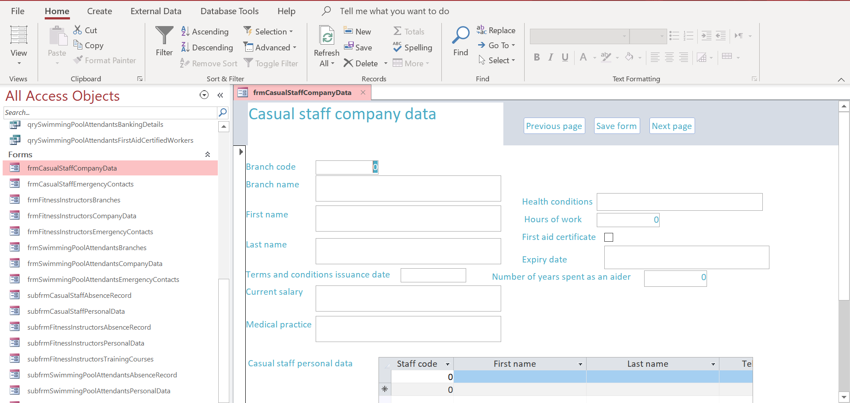

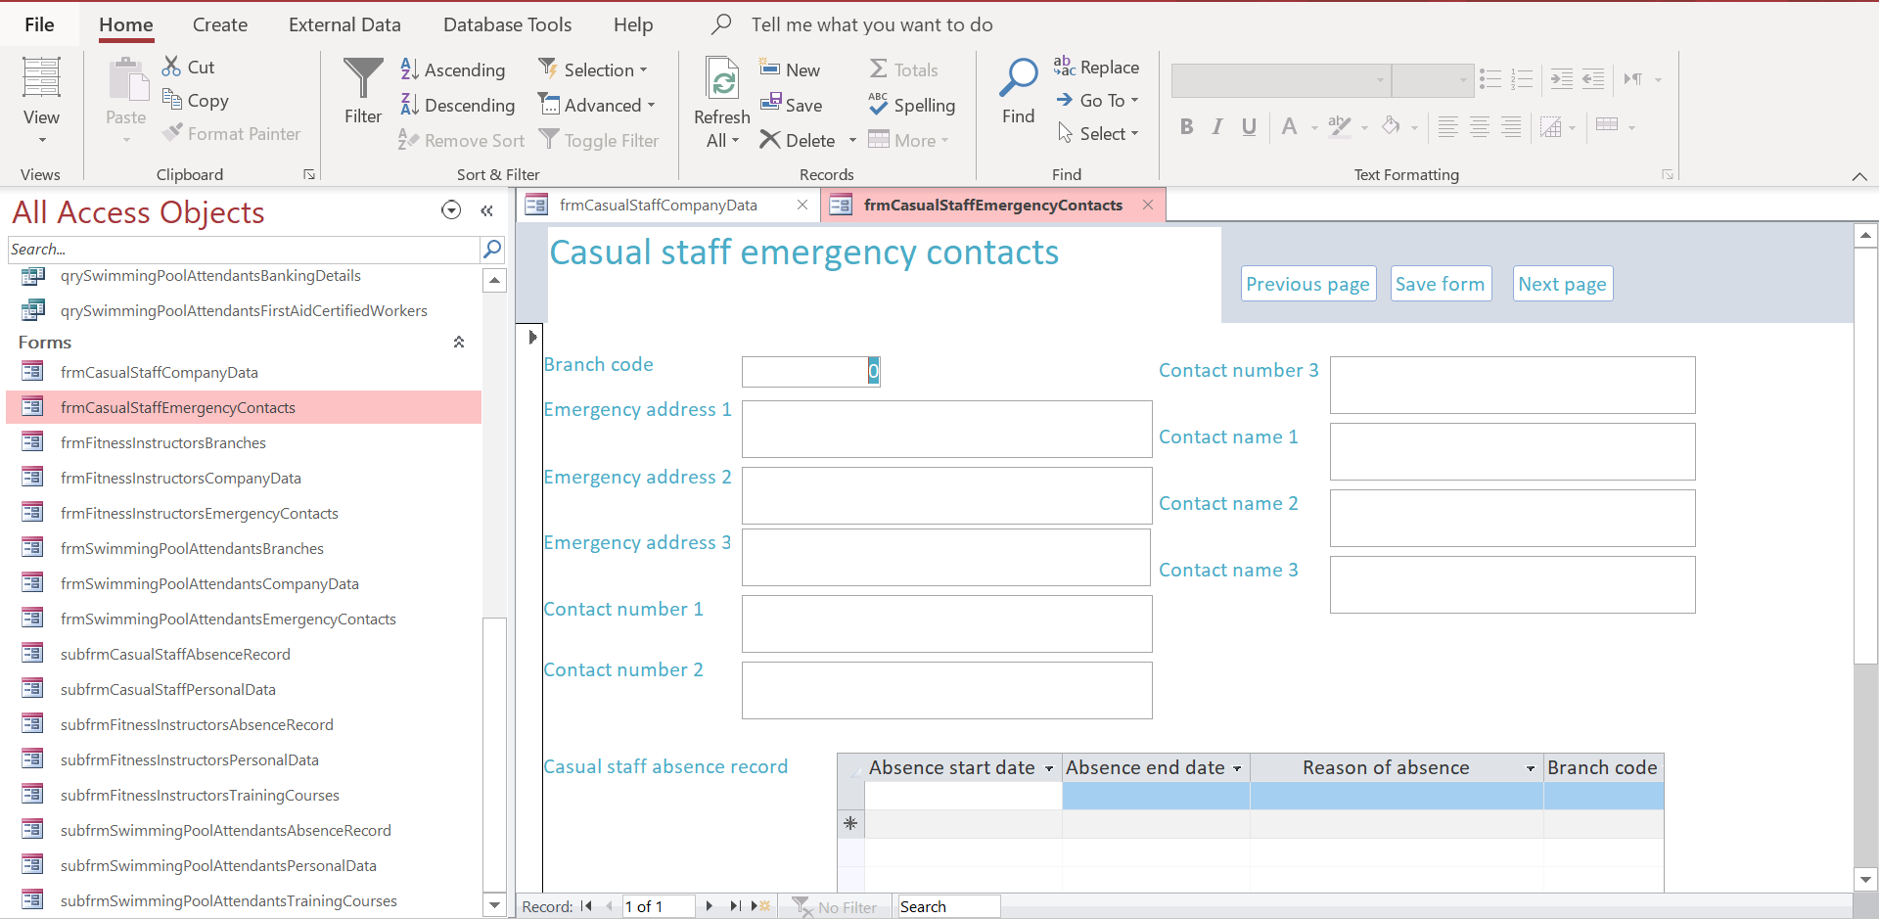
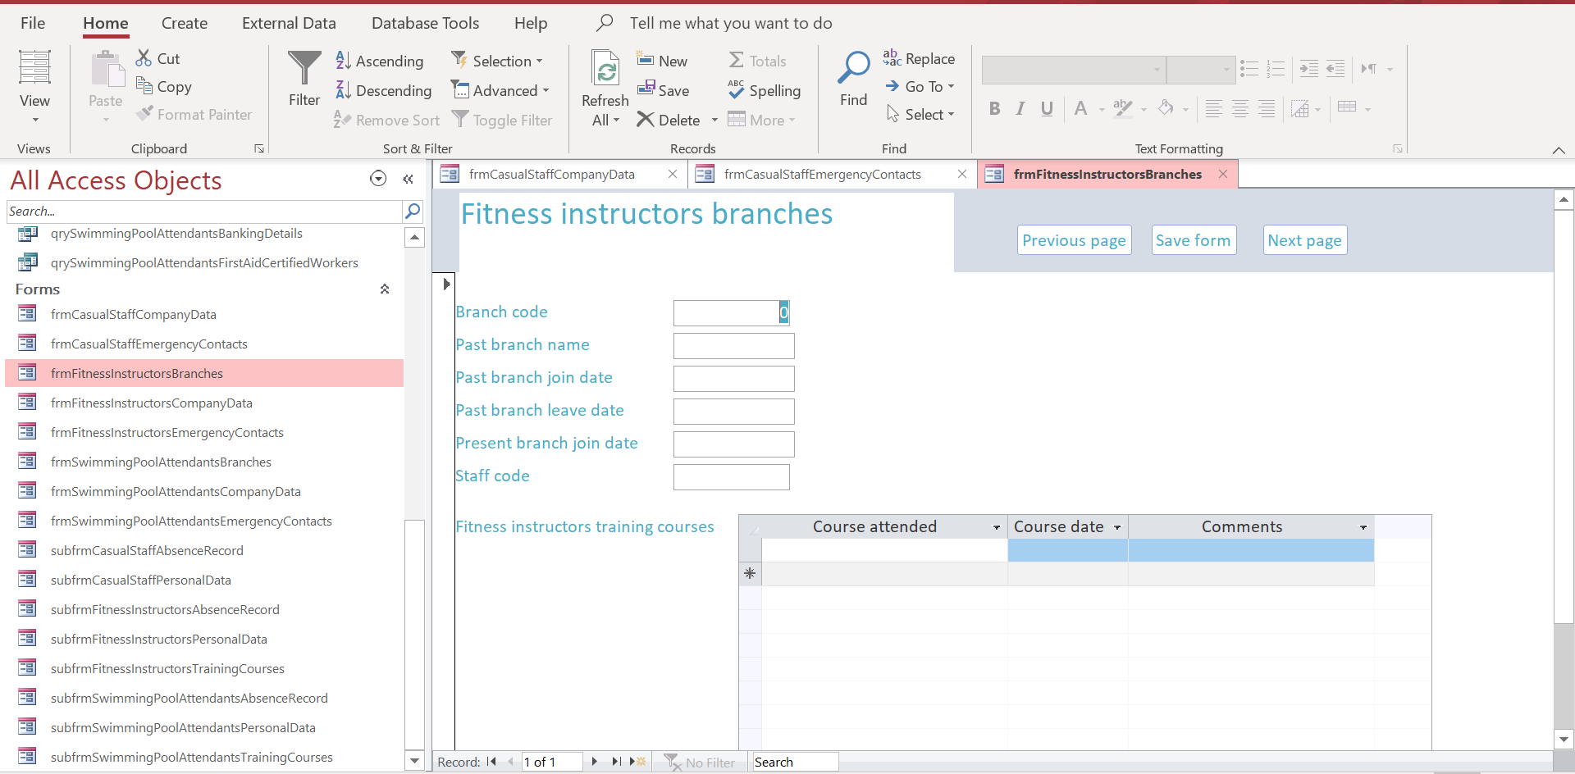
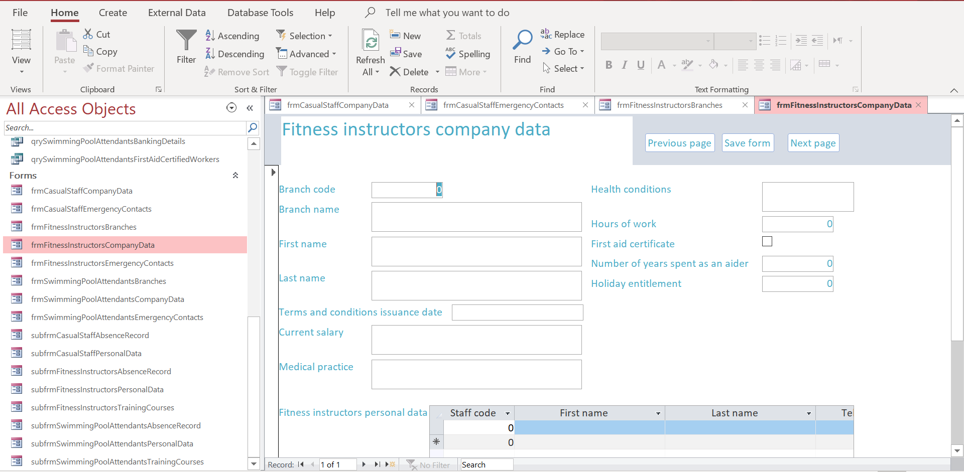
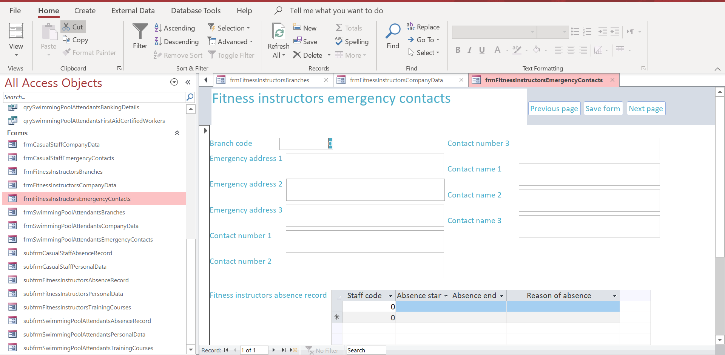
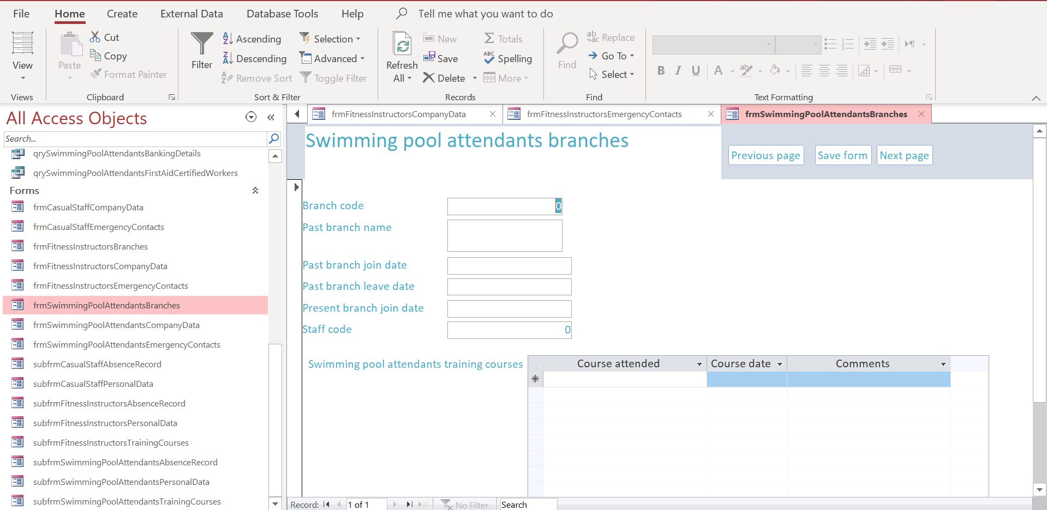
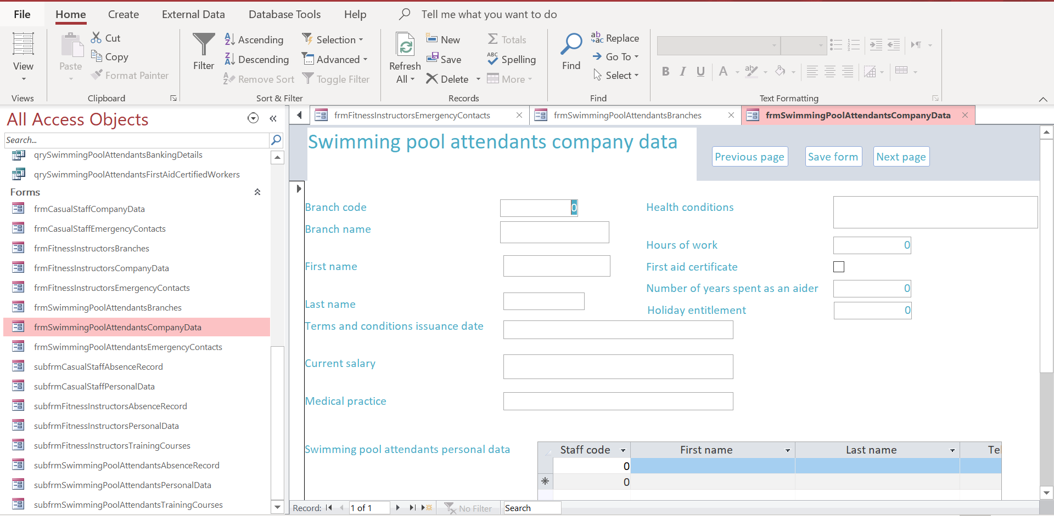
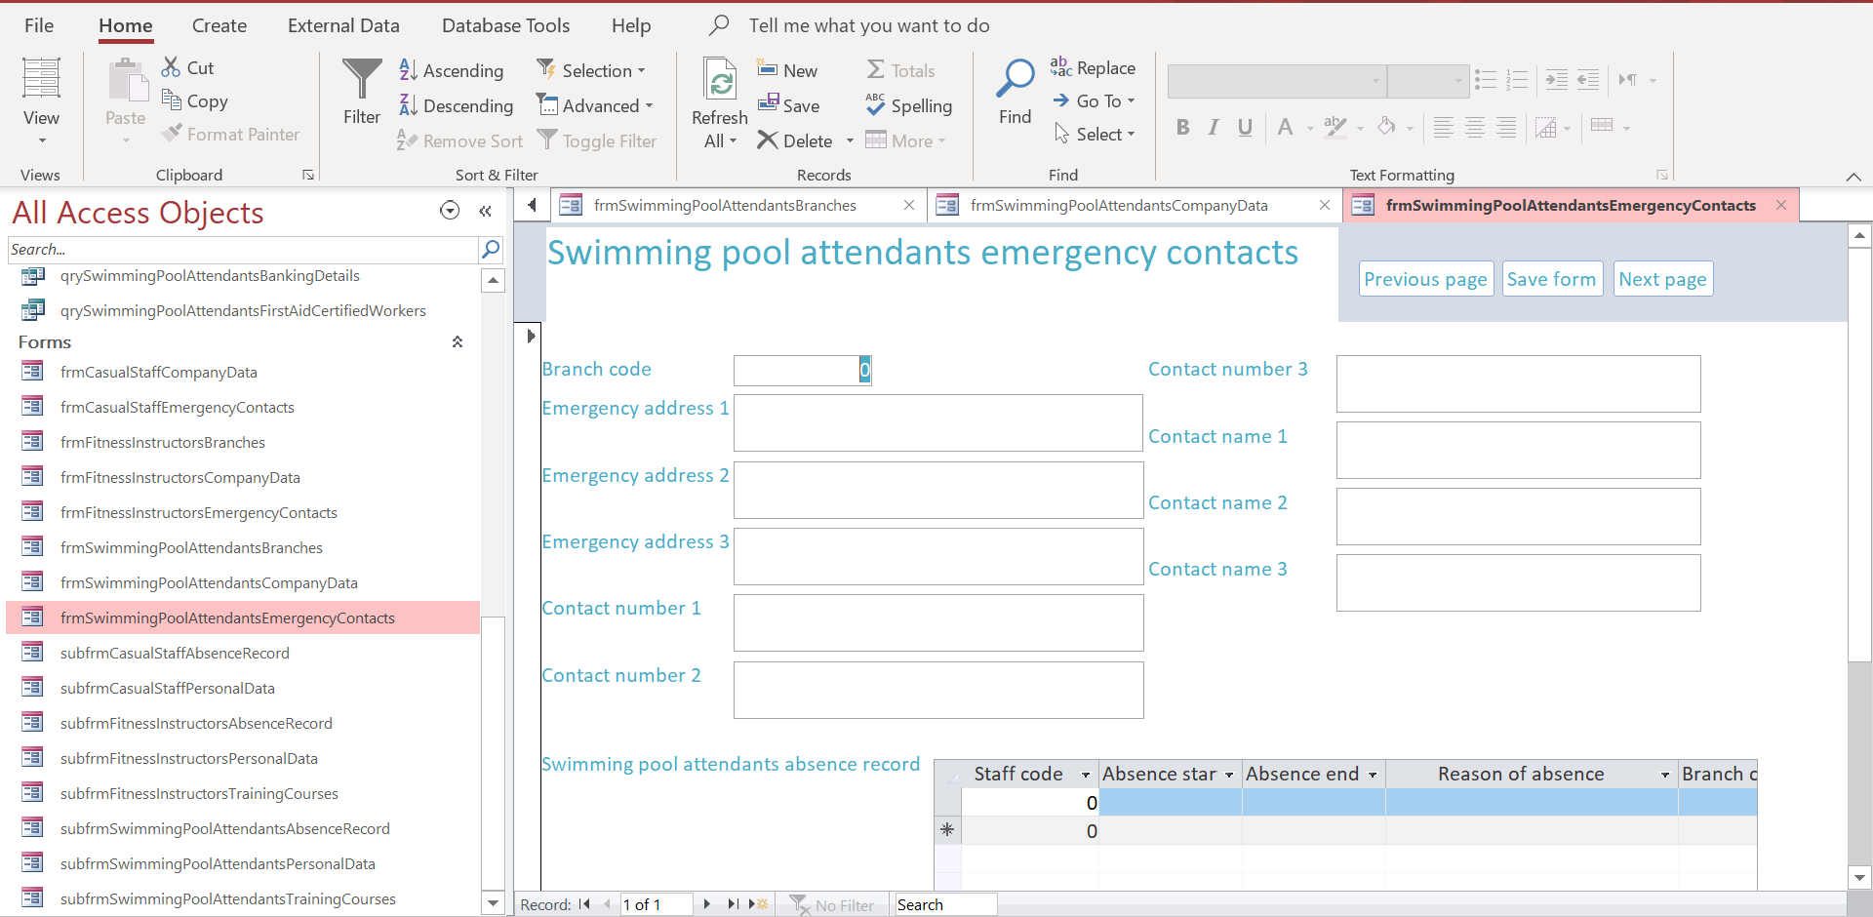
Subforms:
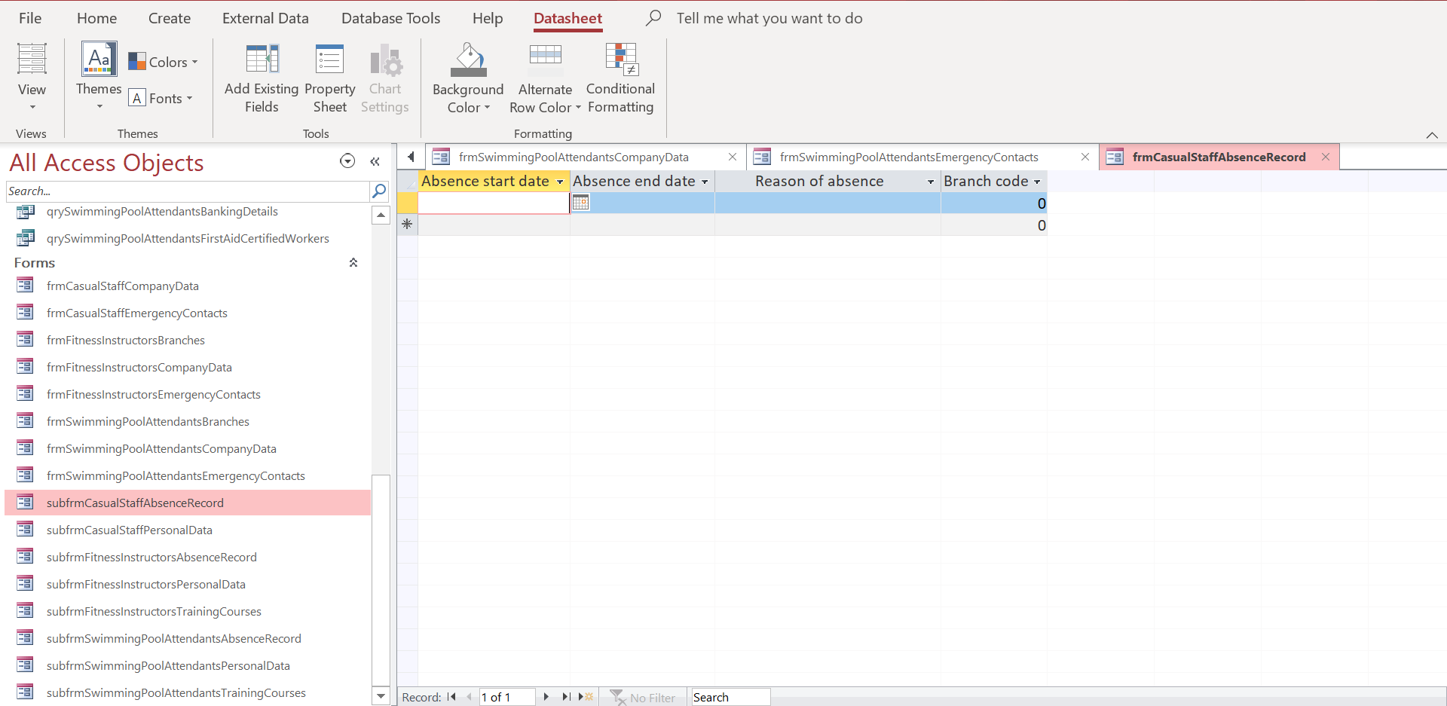
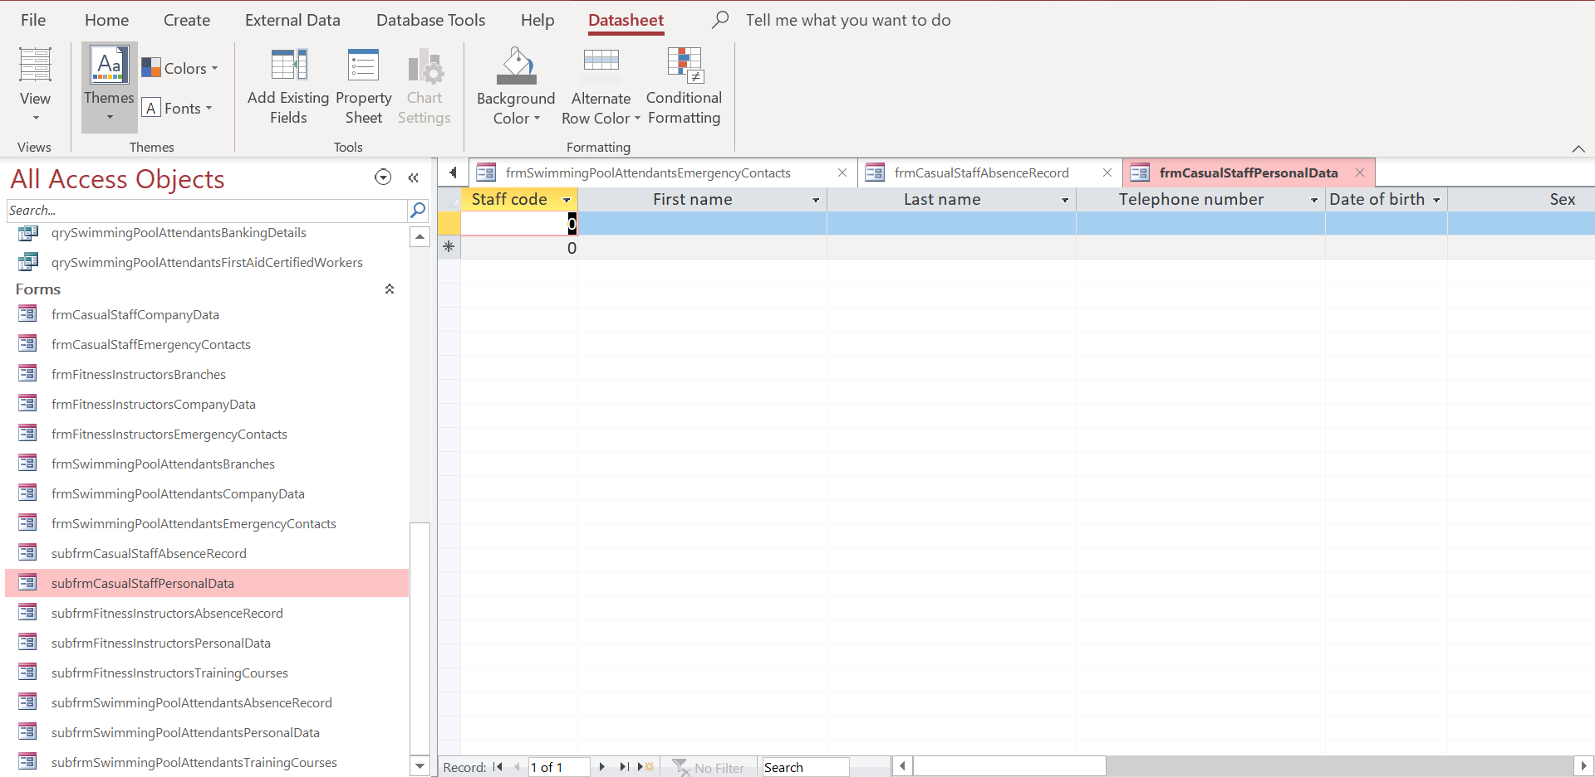
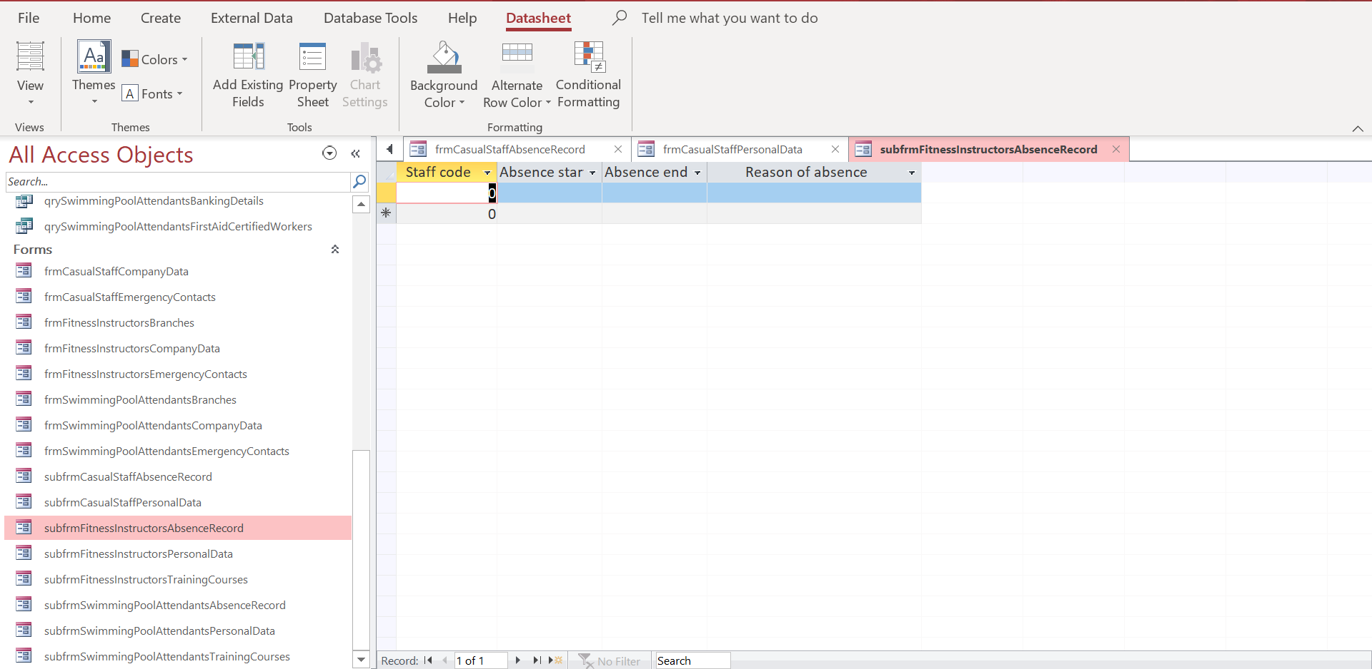
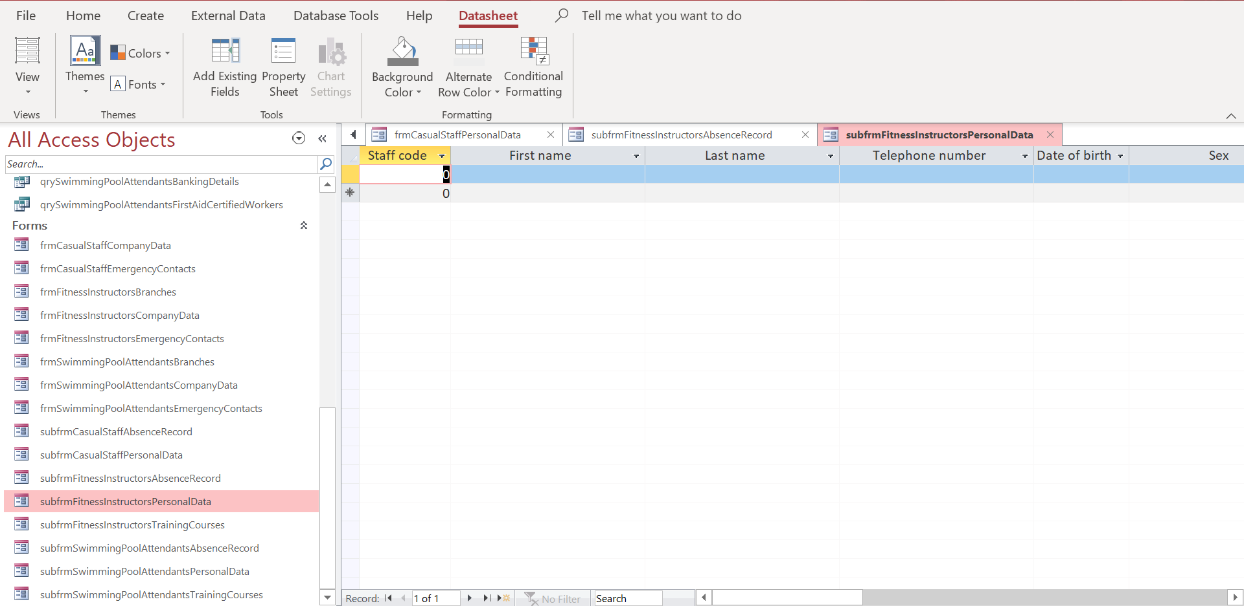
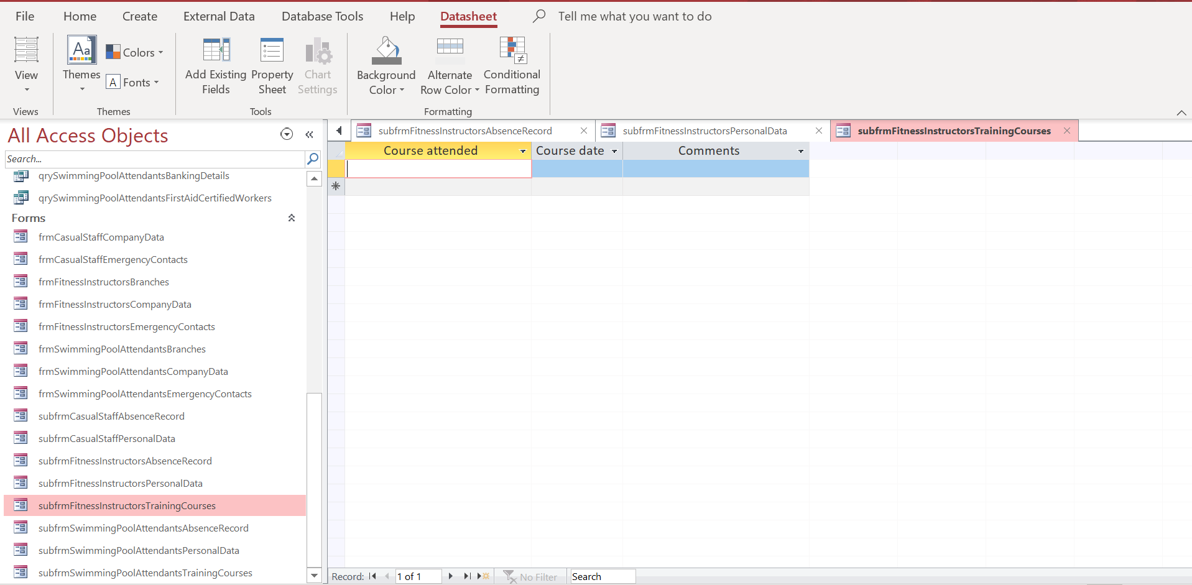
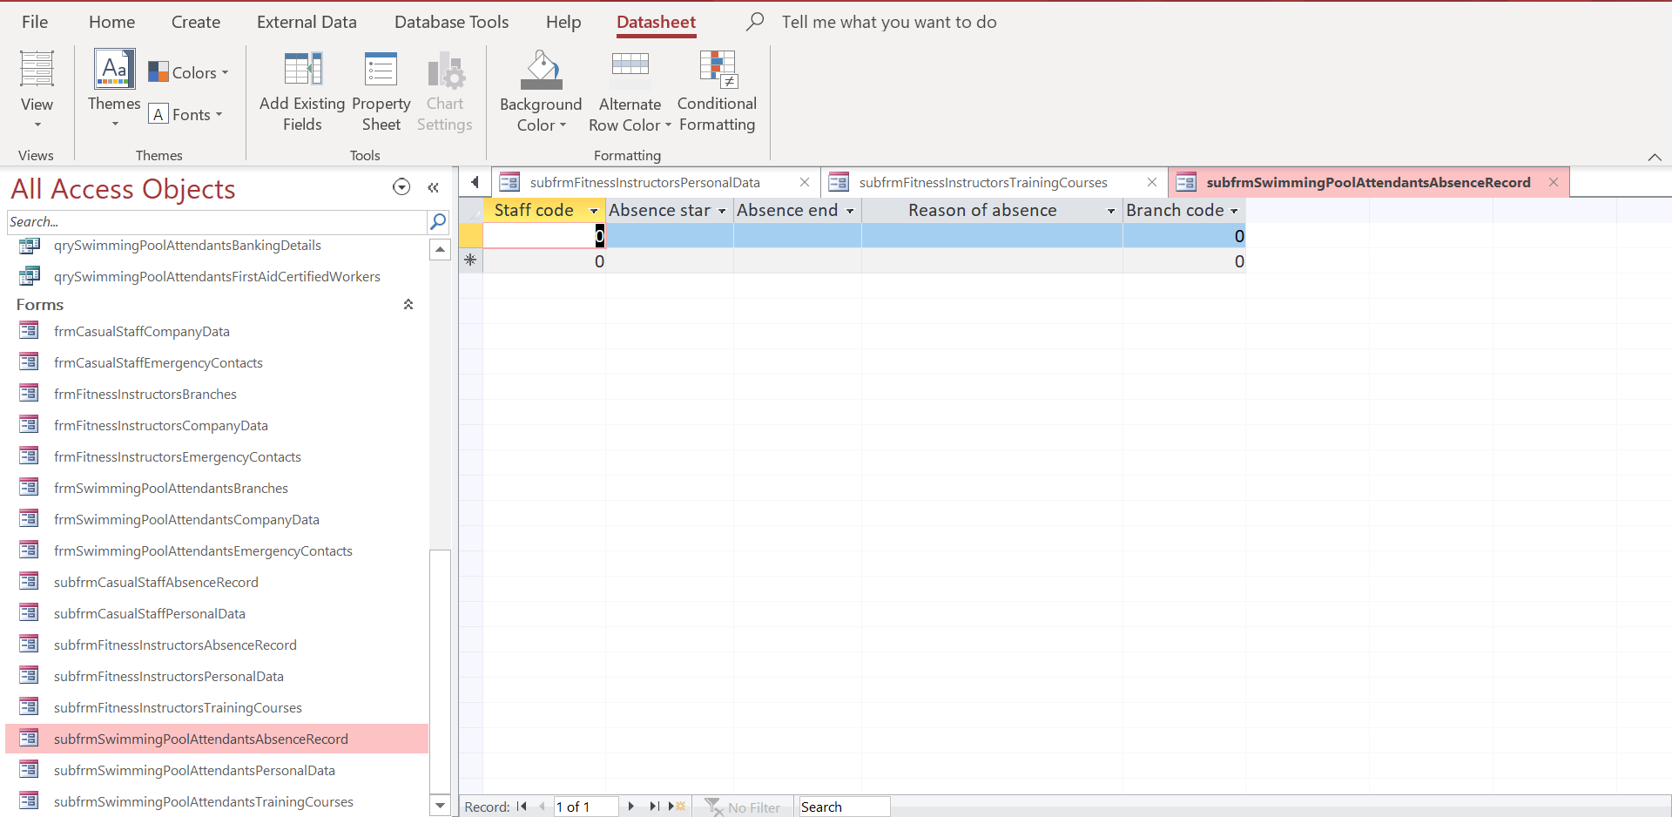
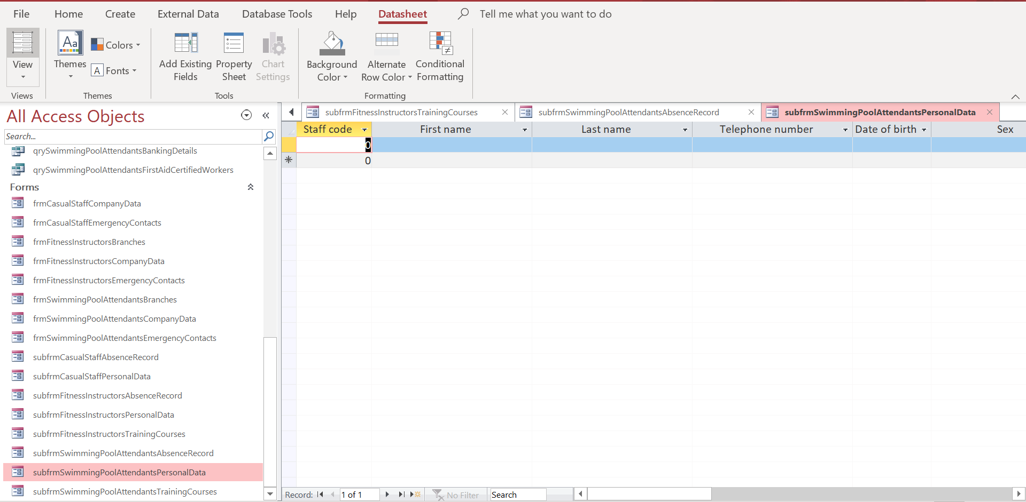
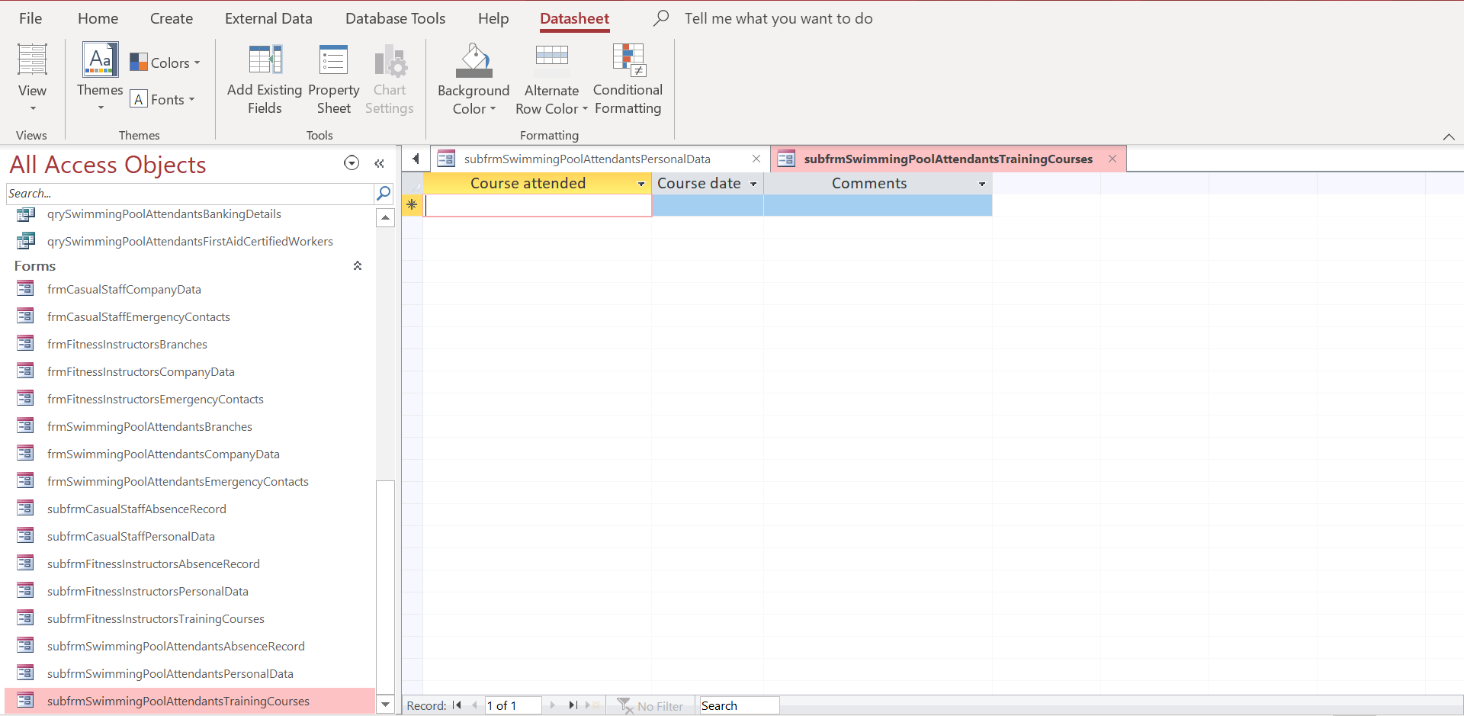

Queries.
Because the number of queries required was not specified, I have created queries for the data that I thought was important and the user may need as fast as possible. Furthermore, I have created two queries for each branch: Banking details queries and employees with first aid certificates. Banking details are important because Universal Sports will have to pay its employees and because the business has more than 60 employees, it would be hard to search for this data without a query. Furthermore, I decided to create the first aid certified employees query because I thought Universal sports may have to allocate a number of workers that have first aid qualifications to each branch meaning that they will have to check which employees have first aid certificates fast and easy.

In conclusion the database I have created and implemented meets the requirements of Universal sports because it provides the user with tables that relate together correspondingly, allows the user to easily introduce data to the mentioned tables through the use of forms and provides the user with ways of accessing data depending on certain criteria through the use of queries.

