Information Engineering
Assignment 1

Contents
Task 1 2
Entity Relationship Diagram 2
Tables / Fields 2
Lucidchart 3
Task 2 4
Relationship Diagram 4
Reports 5
Forms 6
User Guide 10
Improvements 12

Task 1

Entity Relationship Diagram
Below is a screenshot of the entity relationship diagram I have created for this project. ✓
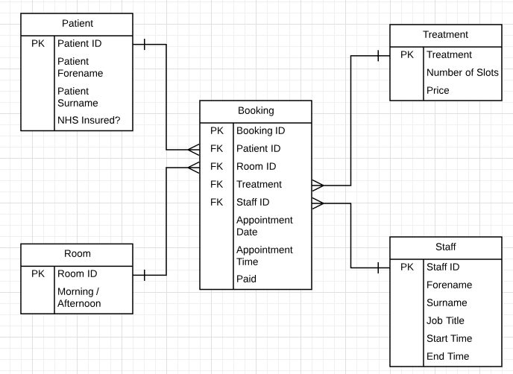
I have set the “Booking” table to be the main table. This is because all the information from the other tables needs to come together to one place. The primary key for this table is the Booking ID because this will need to be displayed on both the forms and on the invoice/reports. Foreign keys coming from other tables include Patient ID, Room ID, Treatment and Staff ID. These are tables which need to be implemented to store other information and then relate certain bits of information to the Booking table when called upon. All these relationships are one-to-many relationships.✓

Tables / Fields
I feel that this was the easiest and most simple way of combining information from different tables into one big table which can then be displayed in a form view or in report. I have 5 tables in total which are titled Patient, Treatment, Room, Staff and Booking. Inside the Patient table it has the patients ID, forename, surname and whether they are insured by the NHS. If they are then a box is ticked and they won’t need to pay for the treatment as it will be covered by the NHS. The next table I have is the Treatment table. Inside the treatment table there is a list of different treatments which are available along with how many slots they will take, this indicates how long the treatment will take. The price is included in this table for those who aren’t covered by the NHS. Inside the Room table it just has the ID of the room and then whether that room is for the morning or the afternoon. Inside the Staff table is their ID, forename, surname, job title and when they start and finish shifts. This is because all members of staff won’t be working all morning and afternoon. This way I have set it so that half of the staff are booked in to work the morning and the other half to work the afternoon. The Booking table is where everything is connected to form one big table with all the necessary information alongside the appointment date and time. There are 4 foreign keys in this table which are the primary keys of each table. The design of this ERD meets user requirements as they can add or delete information from any table, view ongoing patient appointments and charges, querying the system and printing out reports and view the scheduling and booking of treatments.

Lucidchart
The final ERD was created in Lucidchart which is an online tool which allows people to create ERD’s, DFD’s and flowcharts easily. I feel that it is an extremely easy to use piece of software and helped me to create an aesthetically pleasing ERD which is fit for purpose in a real-life situation.✓

Task 2

Relationship Diagram
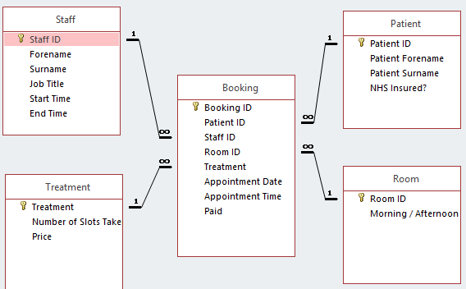
These are the relationships I have created in Microsoft Access. I have explained in detail why I created these tables and the relationships in the task above.

Reports
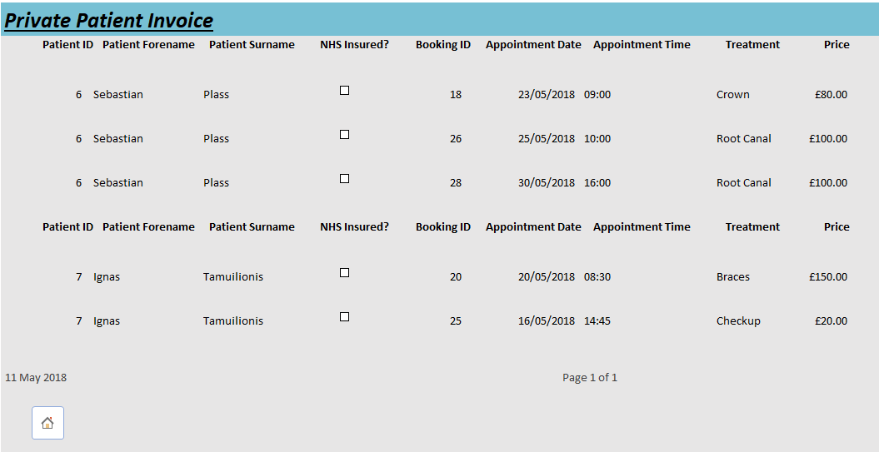
This is the first report I have, it is an invoice for all private patients and what the price was for each of their treatments. This is a useful piece of information because it shows every non-NHS member’s treatment and how much the price for each was. This report is also used in another way which is to print a singular record. To do this I have created a macro which will take a singular record from a form and then make it so that you can print it out✓. A screenshot of this report has been placed below. Could do with formatting to look more like a traditional invoice
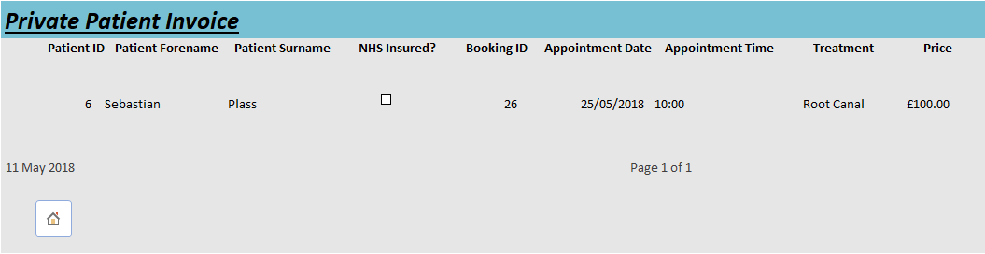
This is what happens if you would like to print a singular record as an invoice to give to the patient.
The next report I have created checks whether the patient has paid for their treatments. If not, then they will be placed in this report with the prices of each treatment they had. It calculates a total amount which has not yet been paid. This way they can send out invoices to each patient with the relevant information for them to pay. This is also a useful report because it can be used to see how much money is owed to the company.
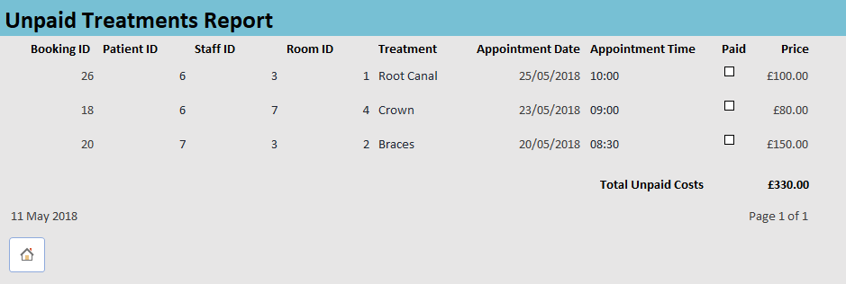

Forms
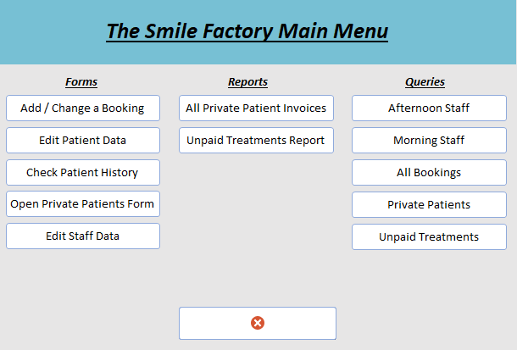
This is the main menu form which will be opened automatically on launch.✓ This is done with a macro which would auto execute as soon as the database has been opened. From here you can access all forms, reports and queries and then exit the program. Each form will have a home page which will redirect back to this form. Clear menu
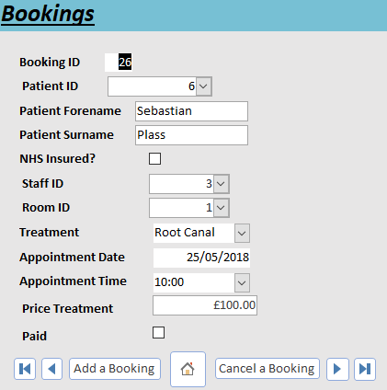
This is the Bookings form. Information here is added via the drop-down menus. The patient forename and surname are automatically filled in from another form along with the price. In this form it is possible to add and delete bookings which will then be removed from the Booking table. Inside each drop-down menu it displays a combo box which will contain more than one column so that the staff member operating knows exactly which patient or staff member they are assigning the booking. An example of this has been placed below this could be formatted a bit better
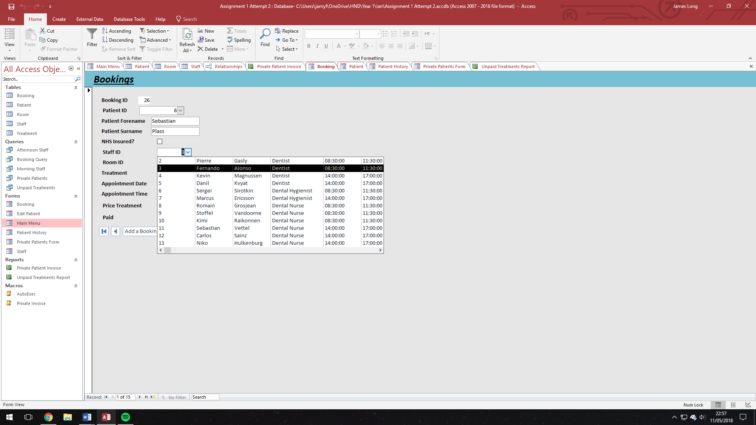
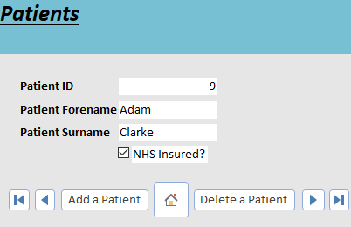
This is the patients form. In this form it will show the patient’s ID number, forename and surname along with whether they are NHS insured. From this form you can add a new patient or delete an existing patient. More detail needed for patient
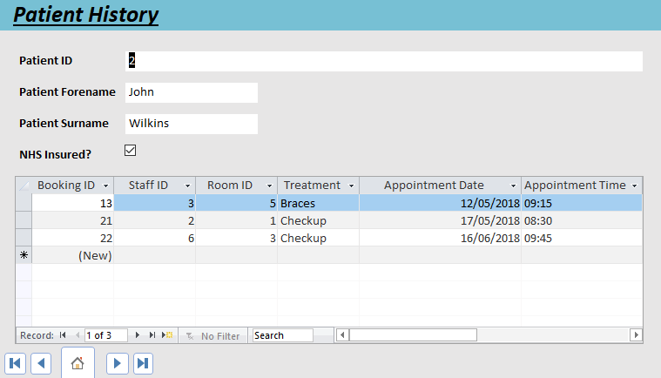
This is the Patient History form. Inside this form it will show what appointments this person has already had or has booked for the future. This is done with a sub-form to show what the booking ID was along with who they were with, for what treatment and when it was. To improve this further I would need to add the price to the sub-form✓
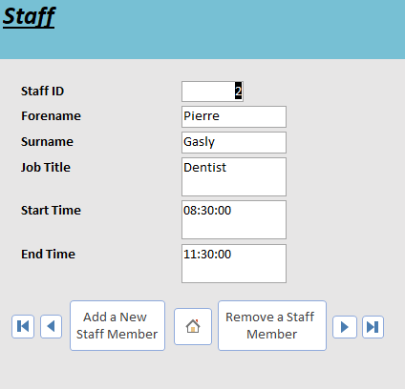
This is the staff form. It shows when they start and finish along with their ID, forename, surname and job title. From this form you can add a new member of staff or remove and existing staff member. More detail required for staff✓

User Guide
When you load up the database the first thing that will load is the main menu which is pictured above. This is the main area which will be used for traversing between forms, reports and queries. To get started click one of the buttons under the “Forms” section. Once you have done this a new form will load up with different buttons and more information. An example form is below
On this form you have 7 buttons which all do different things.
The first button will show the first record in the table. This is useful if you need to go back to the start of the table quickly.
The next button will go back one record.
The button after this will allow you to add a new staff member. The process of adding a new staff member includes you going to the end of the records and then enterring the relevant information in the empty boxes and then pressing this button. 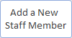
The next button will return you to the main menu.
The next button will allow you to remove a member of staff. This will remove the current member of staff which you are on. 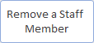
The next button allows you to go to the next member of staff.
The final button will move you to the final member of staff in the table. This is useful for going to the end, so you can add a new member of staff or just traversing quickly
Once you have gone back to the homepage open one of the reports and you should be greeted with the print preview of a report like the one pictured below.
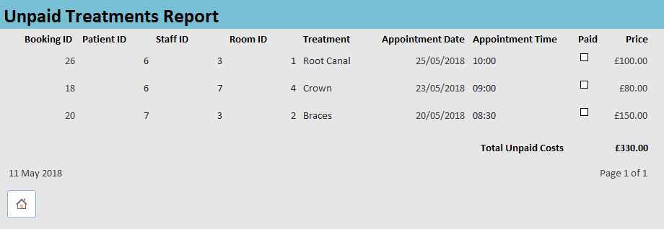
In this report it shows all the unpaid treatments and then you can either print off the report or return to the main menu.
If you would like to print off just one invoice for a certain treatment you can do this by clicking the button labelled “Open Private Patients Form”. Once inside this form if you press the “Print Record” button it will then open a report which acts as an invoice for that one record. As you can see in the picture below it has only selected the one record I chose.
To go back to the main menu simply click the Home button.
When looking at queries it will open in the table view. To close these queries down simply right-click the tab which should be open at the top and then select close. If you haven’t saved any changes the program will then prompt you if you would like to save the changes or not.
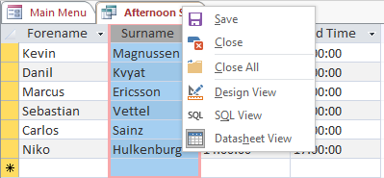
Once you have finished editing the database simply return to the main menu and then click the button which is at the bottom of the screen with the red circle with the white “X”. It will then prompt whether you would like to save any changes which you have made before closing the application.


Improvements
There are several improvements which I would like to make to the database if I had more time to tidy things up. One example of this is to find a way to prevent any double bookings in the “Booking” table. This would be to prevent the same member of staff appointed to 2 separate appointments on the same time. Alongside this I would like to implement a way of having it so that when a person has a long appointment it would blank out multiple times for that one member of staff.✓
Another improvement I would like to make if I had more time would be to spend more time tidying up the reports and the forms along with creating each query into a form view other than a normal table/query view. If I did this I believe it would make it easier to traverse the database along with making it more user friendly for the end user.✓
Another improvement I would like to make would be to include more information in the patient table with things such as their addresses, phone numbers and more information so that it looks a bit more professional on the invoices / reports.✓
One final improvement I would like to have made to the database would be to include a proper colour scheme which would match the company along with a logo for the main menu. If I did this I believe it would make it more professional and more aesthetically pleasing. Along with this I would’ve liked to implement a “tabbed view” so that the end user wouldn’t need to keep going to the main menu to change form or report and instead be able to view them from a tab above the current form.✓

