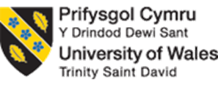
Programme: Master of Business Administration
Module: Strategic Management
Module code: LCMB7003
Lecturer : Dr Robert Ejike Udeogu
Strategic Management at Microsoft: An Evaluation of Competitive Advantage in the Global Technology Industry

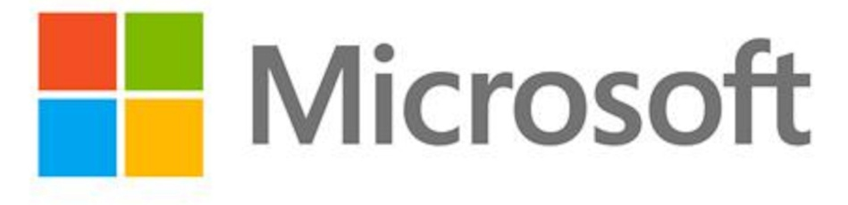

Student Name: Pratikkumar Jagdishbhai Kevadiya
Student ID: 2435897
Total Words: 5018

Table of Contents
Section 1: Individual Report 6
1. Organisational Context and Overview 6
1.1 Organisation Background and Summary 6
1.2 Industry of Operation 7
2. External and Internal Environment Analysis 9
2.1 External Environment Analysis 9
2.2 Internal Strengths & Competitive Advantage 12
3. CSR and Sustainability Objectives 15
4. Comprehensive and Holistic View of Microsoft Corporation 17
4.1 Financial Perspective: 18
4.2 Customer Perspective: 19
4.3 Internal Business Processes: 20
4.4 Learning & Growth: 20
4.5 Integrated Strategic Commentary 20
5. Strategic Choices and Implementation 21
5.1 Business-Level Strategic Choices 21
5.2 Corporate-Level Strategic Choices 21
5.3 Change Management and Strategic Implementation 22
6. Strategic Evaluation and Recommendations 23
6.1 Strategic Evaluation – SWOT Analysis of Microsoft 23
6.2 Recommendations to Improve Strategy 24
Section 2: Reflective Account 26
2.1 Introduction 26
2.2 Kolb's Cycle of Reflective Practice 26
2.2.1 Concrete Experience 26
2.2.3 Reflective Observation 27
2.2.4 Abstract Conceptualisation 28
2.2.5 Active Experimentation 28
2.3 Conclusion 29
Reference List 30

List of Figures
Figure 1: Business Model of Microsoft 6
Figure 2: Revenue of Microsoft 7
Figure 3: Market Cap of Tech Companies 8
Figure 4: Revenue Growth for Azure Cloud 10
Figure 5: Global AI demand 11
Figure 6: Cloud Business for Microsoft 13
Figure 7: AI Investment for Microsoft 14
Figure 8: Scaling Impact of Overall Journey 15
Figure 9: 2025 Impact of Microsoft 16
Figure 10: Microsoft Insights on Global Diversity & Inclusion 17
Figure 11: Revenue Forecast of Microsoft 19
Figure 12: Azure Market Share 19
Figure 13: Framework of Kolb's Cycle of Reflective Practice 26

List of Tables
Table 1: Application of PESTLE Framework 9
Table 2: Application of VRIO Framework 12
Table 3: Balance Scorecard Perspective of Microsoft 18
Table 4: Strategic Implementation Plan 23
Table 5: Application of SWOT Framework 23
Table 6: Recommendations for Strategy improvement 24

Section 1: Individual Report

1. Organisational Context and Overview

1.1 Organisation Background and Summary
Microsoft is a multination technology company that was established by Bill Gates and Paul Allen in 1975 (Microsoft, 2025). Microsoft has been transforming the digital platform companies and currently occupies the heart of the global AI and cloud computing revolution, which started as a personal computing software company in the previous past five decades (Medium, 2023). The mission of the company is to enable every individual and every organisation on the globe to do more of what they can, which is the foundation of its long-term strategic plan and innovation agenda (Microsoft, 2025).
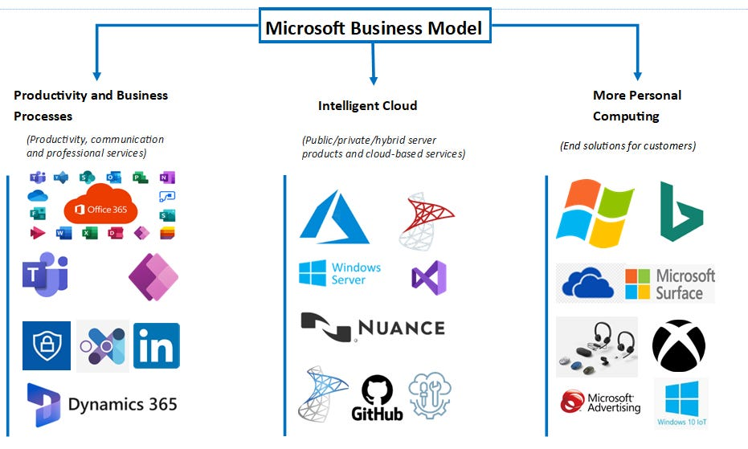

Figure 1: Business Model of Microsoft
(Source: Stockmarket.com, 2022)
Microsoft focuses on a platform-based business model, which makes revenue on cloud-based services, software licensing, digital advertising, and hardware (Medium, 2023). It has operations in three distinct categories, which include Productivity and Business Processes such as Microsoft 365, LinkedIn, Dynamics, Intelligent Cloud, thereby considering Azure, GitHub, and enterprise services, as well as More Personal Computing with a focus on Windows, Surface, Xbox as well as Bing (Stockmarket.com, 2022). According to Microsoft (2025) and Statista (2026), it recorded top-ever financial performance in 2025 with revenue of $281.7 billion and operating income of $128.5 billion, and Azure contributed a major aspect annually to its revenue, which is why cloud and AI are a strategic centre of its growth model.
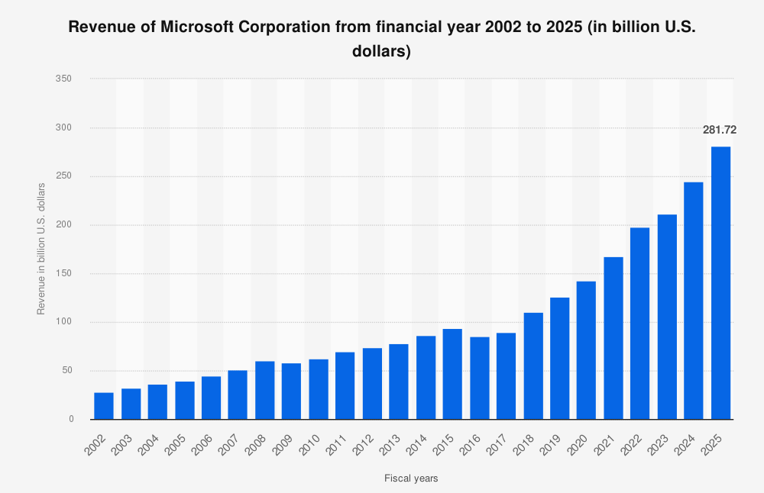

Figure 2: Revenue of Microsoft
(Source: Statista, 2026)

1.2 Industry of Operation
Microsoft is operating in a very dynamic and competitive industry that is characterised by a rapid change in technology, the digital transformation, and the introduction of artificial intelligence as a general-purpose technology. Microsoft is competing with the world leaders in cloud computing like Amazon (AWS) and Google (Alphabet), devices and ecosystems such as Apple, as well as digital platforms like Meta, and enterprise software like Oracle and Salesforce (Axios, 2024). At the same time, Microsoft has a strong market share, especially in the enterprise productivity software market, and is ranked among the three most common hyperscale cloud providers in the world despite the competitive market (Bhadra, 2022).
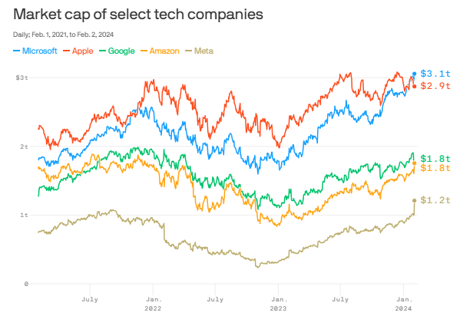

Figure 3: Market Cap of Tech Companies
(Source: Axios, 2024)
The strength of Microsoft on the market, at a strategic level, is supported by its vast international infrastructure, which is more than 400 data centres in 70 locations, and a long-term collaboration with OpenAI, which allows it to deploy advanced AI models into the entire product ecosystem (Microsoft, 2025). This placement enables Microsoft to maintain the ability to maintain the competitive advantage based on scale, innovation, and integration of ecosystems and makes it a prominent architect of the developing AI-driven digital economy.

2. External and Internal Environment Analysis

2.1 External Environment Analysis

2.1.1 Applying PESTEL
The application of the framework of PESTEL has been done in this section to evaluate the micro-environmental factors affecting Microsoft.
Factor | Key External Influences on Microsoft
Political | Data privacy laws such as GDPR, international trade agreements, and antitrust scrutiny influence strategic decisions and compliance requirements (Cate, 2025). Political stability in major markets offers growth opportunities, while shifting government policies present risks. Governments increasingly regulate AI and tech platforms, especially in the EU and the US (Brookings, 2023).
Economic | Macroeconomic conditions affect demand for technology solutions. Stable GDP and rising middle-class incomes in emerging markets support sales, while exchange-rate fluctuations, inflation, and slower global growth can dampen enterprise spending (S&P Global, 2024). Microsoft’s cloud segment (Azure) continues to grow rapidly, contributing significantly to overall revenue; global tech spend remains robust (Microsoft, 2025).
Social | Sociocultural trends influence product adoption, and workforce expectations increase demand for Microsoft Teams, cloud services, and productivity tools. Increasing digital literacy, remote work preferences, and demand for high-quality customer service expand opportunities (Aji and Akbardin, 2024). However, cultural diversity requires tailored strategies across regions.
Technological | Rapid innovation in AI, cloud computing, automation, and cybersecurity shapes Microsoft’s competitive landscape. Technology adoption drives opportunities for new services such as Azure and AI platforms but also intensifies rivalry as competitors pursue similar advancements (Axios, 2024). Microsoft is investing heavily in AI considering the OpenAI partnership to maintain its innovation edge (Microsoft, 2025).
Environmental | Growing environmental concerns influence Microsoft’s sustainability commitments considering carbon reduction goals. Growing demand for green products and sustainable operations is pressuring tech firms to adopt renewable energy, recycled materials, and eco-efficient infrastructure (Firoozi, Oyejobi and Firoozi, 2025). Microsoft has set aggressive environmental goals thus being carbon negative by 2030 (Microsoft, 2025).
Legal | Legal and regulatory frameworks governing data privacy laws like GDPR and IP laws, cybersecurity, intellectual property, and antitrust can impose compliance obligations and expose Microsoft to fines and litigation (Cate, 2025). Strengthening international legal standards increases operational complexity and cost.

Table 1: Application of PESTLE Framework
It can be noted that there are external macro factors that have a strong impact on the strategic decisions of Microsoft. There are political as well as legal pressure investments which demand compliance; while on the other hand, economic conditions define capital investment and pricing. At the same time, social technological adoption increases cloud and productivity segments as well as fast paced technology change enhances innovation and competitive differentiation; and environmental pressures demand operations which are sustainable.

2.1.2 Critical Success Factors and Strategic Challenges in Microsoft’s External Environment
Within the fast-changing external environment, the critical success factors or CSF of Microsoft are based on maintaining leadership in innovation, spreading the use of clouds, and responding to the global demand of AI. It has been reported that Intelligent Cloud revenue is considerably projected to grow by significant revenue growth considering that Azure cloud revenue grew about 26 to 39% annually in FY2025, thus indicating high enterprise demand of cloud infrastructure as well as digital services (Reuters, 2025).
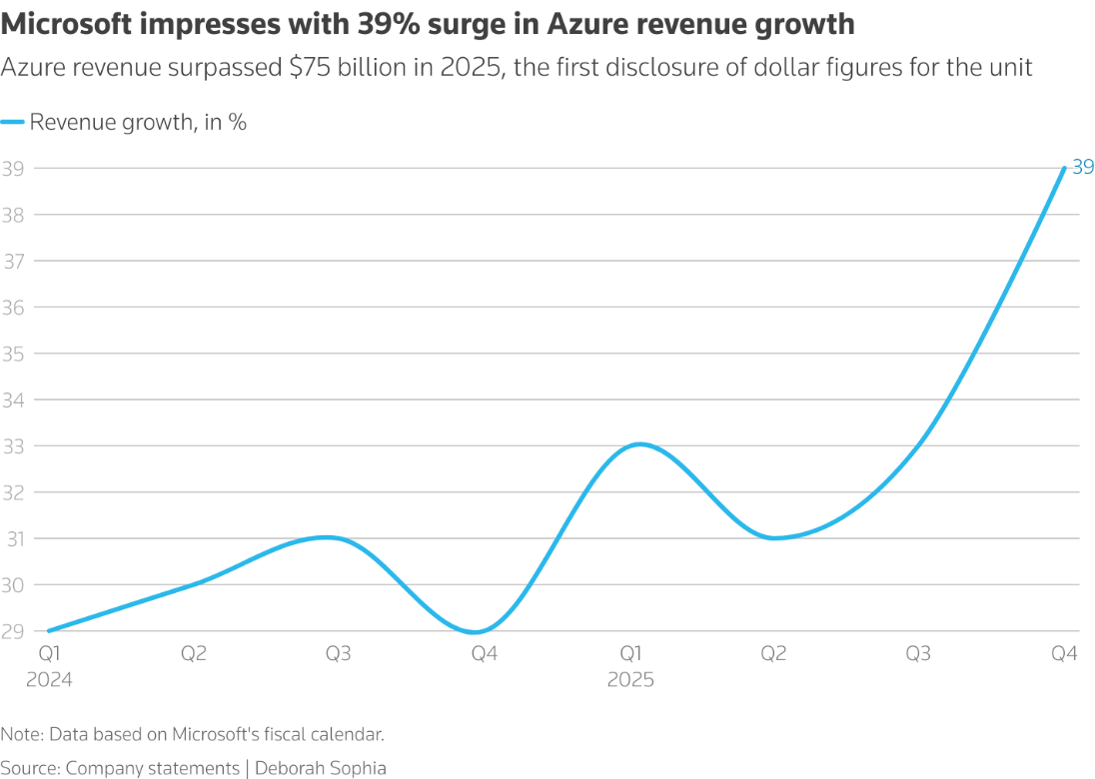

Figure 4: Revenue Growth for Azure Cloud
(Source: Reuters, 2025)
Along with this, the rapid AI integration around the global aspects and landscape, with about a significant number of individuals accessing and using generative AI tools by the end of 2025, will bring Microsoft the possibility to incorporate AI into its ecosystem and platform lock-in (Microsoft Source, 2025). Additionally, there are also strategic collaborations such as recent associations with Anthropic along with Nvidia, that has allowed and helped to expand the AI infrastructure base of Microsoft and diversify its competitive partnerships (Microsoft Corporate Responsibility, 2026).
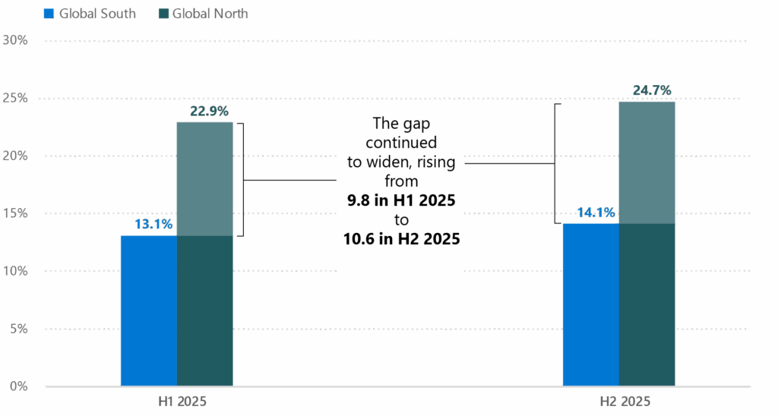

Figure 5: Global AI demand
(Source: Microsoft Corporate Responsibility, 2026)
However, Microsoft does not overcome the strong strategic challenges fully. The significant rivalry that is present within cloud and AI markets, in which AWS has approximately 30% globally as compared to 20% with Microsoft, makes prices, rate of innovation, and positioning a factor (Crn.com, 2025). At the same time, large capital investments in AI infrastructure such as considering $37.5 billion in data-centre spending have haunted investors as they are uncertain about the returns on their investments, therefore this could mean they have a problem balancing spending in innovation and profitability (Reuters, 2026).
Additionally, the risk of compliance and possible operational limits is the changing regulatory scrutiny and antitrust probes, particularly in the EU and UK regarding cloud competition issues (Brookings, 2023). The strategic implementation is also complicated by geopolitical forces and the uneven distribution of the AI technology in the areas (Medium, 2023; Reuters, 2025). Therefore, in a comprehensive and holistic manner, success will be determined by how Microsoft can be an innovator with a responsible attitude, competitiveness in cloud and AI market, and governmental regulation and investment risks control in the external environment.

2.2 Internal Strengths & Competitive Advantage

2.2.1 Applying VRIO for Analysis of Competitive Advantage
The analysis of the key resources and capabilities of Microsoft is performed with the help of the VRIO framework.
Key Resource / Capability | Valuable (V) | Rare (R) | Inimitable (I) | Organised (O) | Core Competency / Implication
Global cloud infrastructure (Azure) | Yes | Yes | Yes | Yes | Sustainable competitive advantage through scale and reliability
AI ecosystem (OpenAI partnership, Copilot) | Yes | Yes | Yes | Yes | Differentiated innovation capability in enterprise AI
Brand reputation & enterprise trust | Yes | Yes | No | Yes | Temporary advantage based on strong customer loyalty
Intellectual property & patents | Yes | Yes | Yes | Yes | Long-term technological leadership
Integrated product ecosystem (Windows, 365, Teams) | Yes | No | No | Yes | Competitive parity with strong network effects

Table 2: Application of VRIO Framework
Altogether, it can be stated that the competitive advantages of Microsoft are strongest in the case of its cloud infrastructure and the power of AI as they are valuable, rare, and difficult to thereby imitate, and are fully justified by the organisational processes. These assets or the considered and identified competencies form the basis of the Microsoft core competencies of digital platform orchestration, enterprise solutions, and large-scale innovation, which can allow the company to maintain the long-term competitive advantage in the landscape of technology.

2.2.2 How Microsoft’s Internal Strengths Contribute to Its Competitive Advantage
The internal strengths present in Microsoft are the basis of its competitive advantage in the technological industry within the world. In this case, one of the strengths for the brand stand to be its cloud infrastructure as well as AI integration leadership. Therefore, for instance, the Azure platform of Microsoft has been and thereby focus and provide scalability as well as reliability of cloud solutions as well as advanced AI workloads that are increasingly important in enterprise transformation (Axios, 2024). At the same time, in 2025, Microsoft Cloud revenue particularly strengthened, with Intelligent Cloud accounting a large part of the total revenues of the business which has thereby been more than $75 billion of the company revenue using Azure indicating robust customer demand and competitive factors as compared to other competitors (Microsoft, 2025; Statista, 2026).
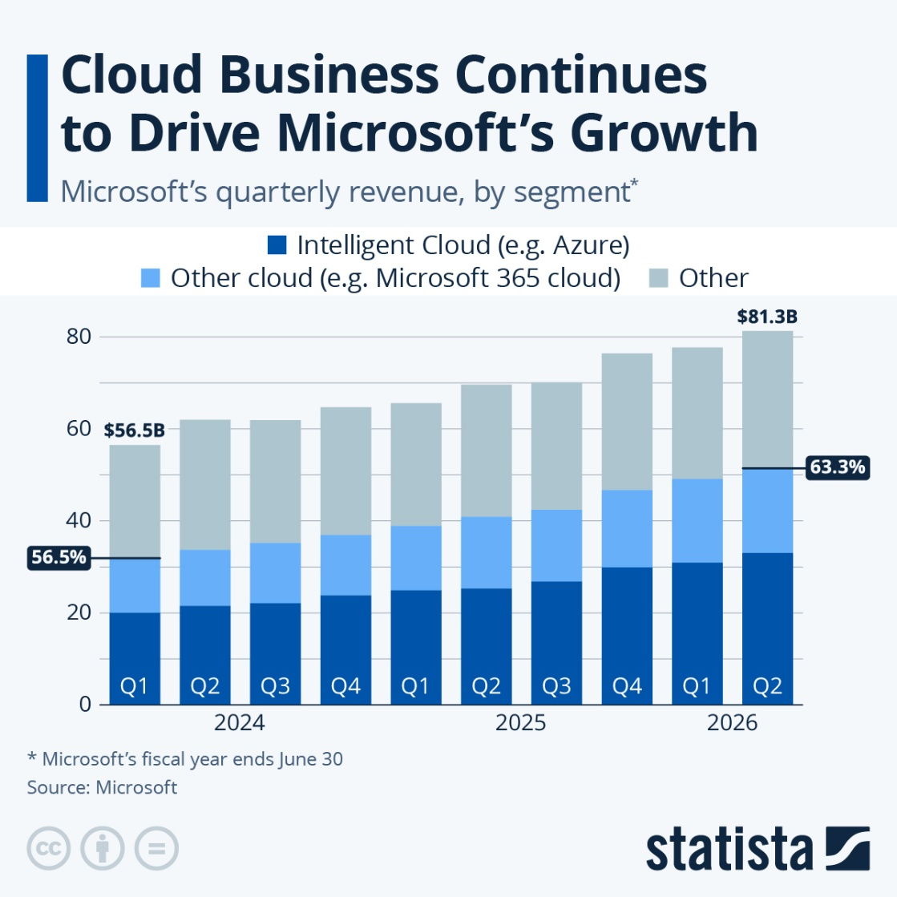

Figure 6: Cloud Business for Microsoft
(Source: Statista, 2026)
On the other hand, the ecosystem that the company has established, thereby interconnecting Windows, Microsoft 365, Teams, Dynamics 365 along with LinkedIn, and Azure, particularly helps and creates switching costs which allows to increase customer retention (Stockmarket.com, 2022). Such an interoperative portfolio creates a smooth user experience and contributes to cross-product usage, which strengthens a network effect that is difficult to imitate by competitors. Along with this, the brand reputation and enterprise trust are also another factor that makes Microsoft firm in the market (Qiang, 2025). Thus, decades of experience in the enterprise software industry have allowed and fostered excellent customer relations, which means that Microsoft solutions stand as the default options in the choice of productivity, security, as well as the consideration for business continuity (Ahmadi, 2023).
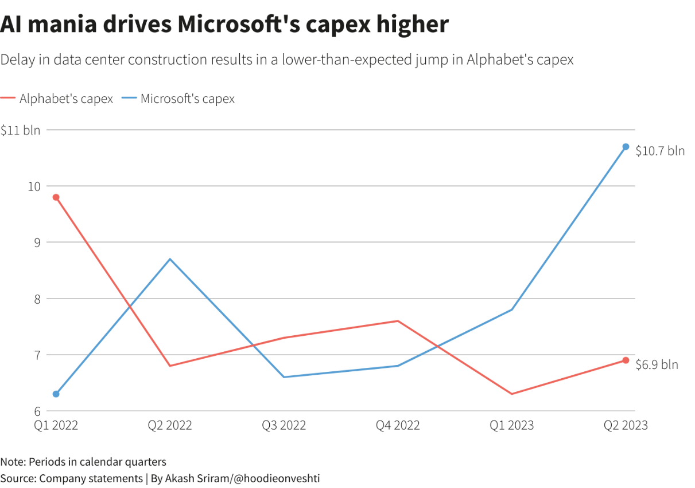

Figure 7: AI Investment for Microsoft
(Source: Reuters, 2023)
Another advantage is that, due to the financial strength and investment capability, Microsoft can afford to invest in long term R&D and strategic capital investment in new technology. In this context, the heavy investment, estimated to reach over $80 to 100 billion considerably on AI infrastructure, which thereby enables the company to become innovative in a rapid manner and keep up with the key technology fields (Reuters, 2026; Reuters, 2023). To conclude, it can also be noted that the organisational culture of the company, which is oriented on growth mind and talent development, fosters innovation and flexibility, increasing its responsiveness to changes in the market. Thus, a combination of these strengths leads to the formation of a layered competitive advantage: technological leadership, an ecosystem that is sticky, trusted brand equity, operational abilities to innovate, all of which will thereby uphold dominance by Microsoft in cloud, AI, and enterprise software (Ahmadi, 2023).

3. CSR and Sustainability Objectives
The CSR strategy of Microsoft is closely connected to the main mission of the company to empower all people and organisations in the world, which relates to the social and environmental priorities. The company enjoys a holistic sustainability agenda, which has become very consistent with its overall business goals of innovation, long term development and worldwide impact. The core of its CSR plan is ambitious environmental commitments, such as to be carbon negative, water positive, and zero waste by the year 2030 (Microsoft, 2024).
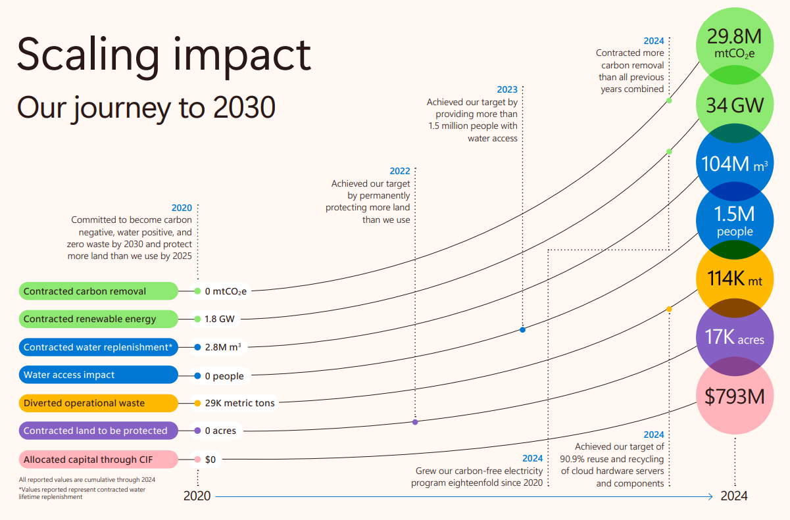

Figure 8: Scaling Impact of Overall Journey
(Source: Microsoft, 2025)
Microsoft has shown quantifiable improvements towards these targets statistically. As an example, it has already procured over 19 GW of renewable energy sources in 21 countries to assist in its energy transition to clean energy and requires supplying 100% renewable energy by 2025 (Williment, 2025). It has also increased water replenishment projects, which add millions of tonnes of replenishment water than what it uses and the diversion of thousands of tonnes of waste off the landfills each year (Microsoft, 2024).
The summary of its impact points to an intended investment of US 4 billion through Microsoft Elevate in education and nonprofit support, which will reach 37000 nonprofits in the world (Microsoft, 2023). The company also records more than 18 billion dollars spent on over 700 different and underrepresented suppliers.
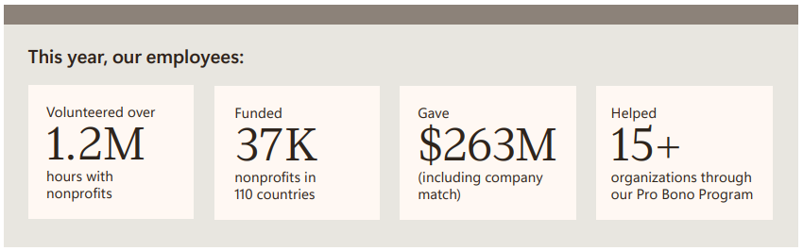

Figure 9: 2025 Impact of Microsoft
(Source: Microsoft, 2023)
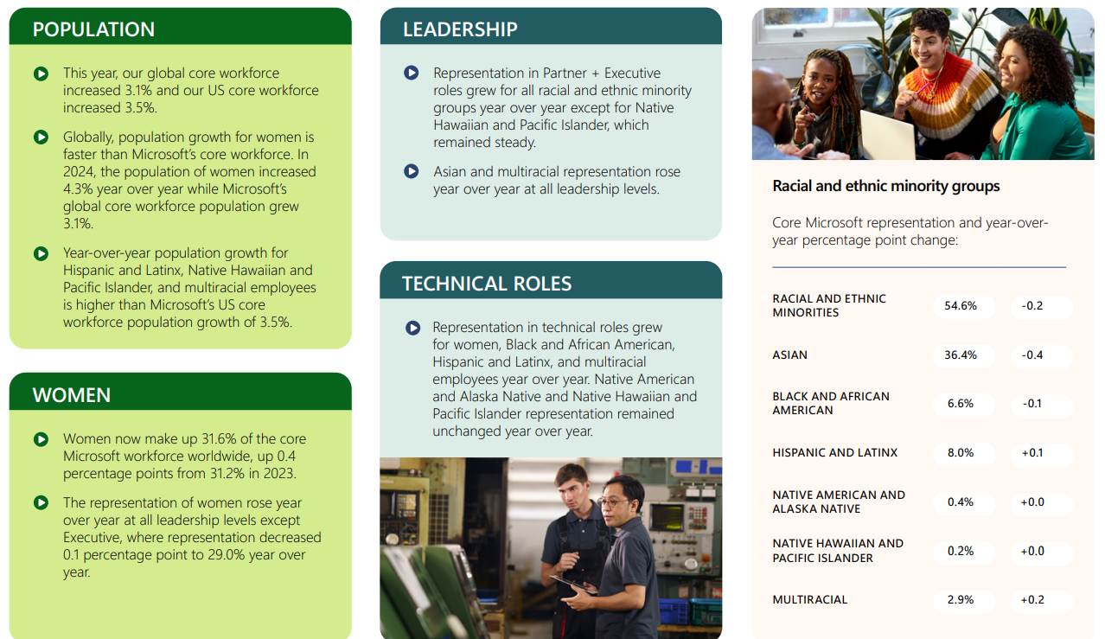

Figure 10: Microsoft Insights on Global Diversity & Inclusion
(Source: Microsoft, 2023)
The CSR activities are compatible with the business goals as they help to increase corporate visibility, minimise the risk of operations, and increase the confidence of stakeholders (Zakaria, 2025). Besides, the CSR approach helps Microsoft to play a competitive role in the technology sector of the world through clean technology and inclusive digital transformation innovations.

4. Comprehensive and Holistic View of Microsoft Corporation
The following is a balanced-scorecard perspective (Financial, Customer, Internal Process, Learning and Growth) projected to the mission of Microsoft which is to empower all people and organizations on the planet, with objectives and measurable KPIs, realistic targets and strategic initiatives that are based on the recent corporate data.
Perspective | Objectives | Key KPIs | Targets | Key Initiatives
Financial | Sustain profitable growth through AI & cloud | Revenue growth, operating margin, R&D spend | Double-digit revenue growth; high margins | AI/cloud investment, cost discipline
Customer | Increase enterprise adoption & loyalty | Azure market share, NPS, renewals | Grow Azure share; high retention | AI-enabled services, partner ecosystem
Internal Processes | Operational efficiency & reliability | Renewable energy %, service uptime | 100% renewable electricity | Datacentre optimisation, automation
Learning & Growth | Innovation & talent development | R&D workforce, skills training | Expand AI skills pipeline | Upskilling, D&I, innovation culture

Table 3: Balance Scorecard Perspective of Microsoft

4.1 Financial Perspective:
Objectives: To increase cloud and AI revenue, healthy margins, and cash to invest strategically (AI, datacentres, M&A).
KPIs & targets: revenue (goal: keep growing by double-digits every year; revenue of $281.7B in FY2025), operating margin, free cash flow, R&D (as a percentage of revenue) (R&D expenditure of $32.5B in 2025). Efforts: strategic AI infrastructure capital investment, selective acquisitions/strategic alliances (with AI companies), controlled cost programmes (reorganisation/reductions in headcount). These financial indicators indicate that Microsoft is investing in its strategic change to AI/cloud and profitability (Marketviews, 2021).
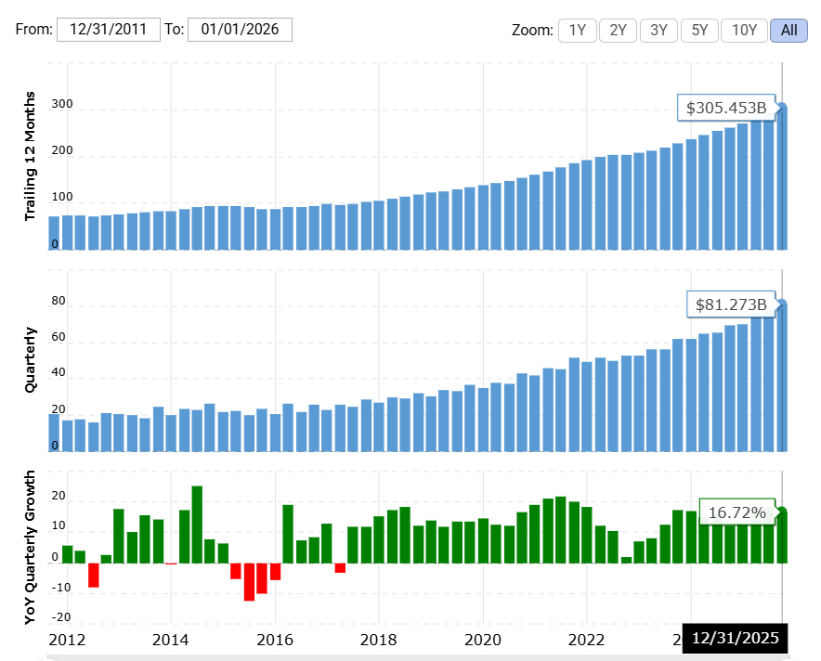

Figure 11: Revenue Forecast of Microsoft
(Source: Marketviews, 2021)

4.2 Customer Perspective:
Objectives: To raise subscriptions to enterprises, market share and retention of customers to Microsoft 365, Azure and Dynamics.
KPIs & targets: Azure market share (goal: narrow the gap with the leader; Azure 20-24% market share in commercial cloud), commercial cloud revenue growth, Net Promoter Score (NPS), commercial engagements with enterprises using AI. Efforts: enhance industry-specific cloud products, package AI-based services, increase the global partner ecosystem and vertical solutions to enhance time-to-value and stickiness. Ensuring customer performance in the regulated sphere (healthcare, finance, government) will secure the long-term contracts and renewals (Statista, 2025).
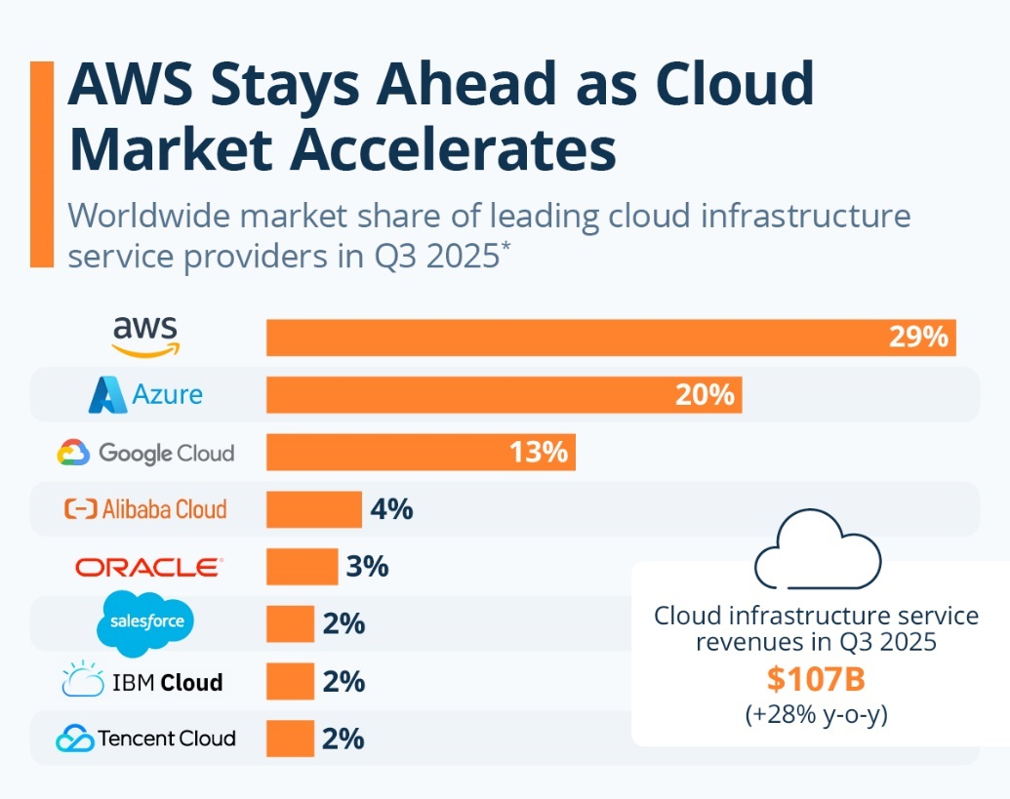

Figure 12: Azure Market Share
(Source: Statista, 2025)

4.3 Internal Business Processes:
Objectives: To streamline datacentre processes, purchase more renewable energy, enhance security and compliance, and shorten product delivery schedules.
KPIs & targets: datacentre PUE/efficiency, 100% renewable energy to run operations (target: 100% direct renewable electricity by 2025/large-scale PPAs-19 GW new in 2024/34 GW contracted in total), incident MTTR, service availability (SLA achievement), time-to-market to AI services. Efforts include bulk renewable PPAs, automation of infrastructure, zero-trust security investments, and supply-chain resilience programs (Microsoft, 2024). These process KPIs eliminate the operational risk, minimise the long-term cost and facilitate brand trust.

4.4 Learning & Growth:
Objectives: To increase the capacity to use AI/R&D, reskill employees, develop inclusivity and leadership.
KPIs & targets: number of employees in R&D (81,000 in product R&D segments; total employees 228,000), proportion of workforce trained in AI/digital skills, targets on female/minority representation in core workforce (women 31.6% of core workforce), employee engagement indices and internal promotion rates. Programs: enterprise reskilling (LinkedIn + Microsoft programs), recruiting specific cloud/AI jobs, investing in diversity and inclusion, and strategic-based incentive systems (Microsoft, 2024). Such investments maintain innovation, decrease skill gaps, and contribute to the implementation of sophisticated AI/cloud solutions.

4.5 Integrated Strategic Commentary
The Balanced Scorecard demonstrates the evident correspondence between the mission and specific priorities: customer value (AI/cloud) is provided by effective processes (datacentres, renewable energy), and it is sustained by people (R&D headcount, reskilling, D&I). Periodic reviews of targets ought to include quick AI-era changes (including infrastructure expenditure, customer penetration) and confirm short-term investor anxieties that AI capital intensity is high with long-term strategic outcomes (Marketviews, 2021).

5. Strategic Choices and Implementation

5.1 Business-Level Strategic Choices
At business level, Microsoft is pursuing both differentiation and cost leadership strategy to maintain competitive advantage in the technology industry of the world. Its differentiation approach focuses on innovation and the high value products including Azure cloud services, Microsoft 365, and AI-focused productivity solutions that can serve enterprise customers with the aim of providing superior functionality and integration across platforms. All these are anchored by sustained R&D spending such as Microsoft recorded $32.5 billion in R&D expenses in 2025 was proving to tend to focus on product innovation and quality rather than just price. This generates a good brand loyalty and promotes high prices (Microsoft.com, 2025).
Cost leadership is used in addition to differentiation and focuses on the maximization of operational efficiencies and competitive pricing of cloud and software services. The case of OneDrive and other cloud infrastructure products can serve as an example, with their prices set at cost efficient levels that are accepted by wide variety of customers with Microsoft scale affording the infrastructure costs.

5.2 Corporate-Level Strategic Choices
Diversification and internationalisation are the main strategic options at corporate level. Microsoft has branched out of its software business into cloud computing, gaming (Xbox), professional-networking (LinkedIn) and AI platforms. Such actions decrease the risks of revenue of any given business unit and introduces cross-business synergies. Besides, Microsoft is aggressively venturing into international markets and joint ventures; international demand is 85 percent of enterprise organizations intend to invest more in Microsoft cloud and artificial intelligence solutions by 2025 (Charter Global, 2025).
Another business decision is strategic alliance and ecosystem creation such as B2B collaborations with international businesses, system integrators, and software suppliers result in greater acceptance and strengthen the dominance of the Microsoft platform across the world. These partnerships increase market presence and lower barriers to entry in a wide variety of regulatory structures.
Under such possibilities, differentiation focus with selective cost leadership is the most appropriate and is backed by the ability and position of Microsoft. The focus on AI and cloud was highlighted by the fact that the revenues of Azure exceed 75 billion with an annual growth rate of 34 per cent, which supports product leadership (Microsoft Source, 2025).

5.3 Change Management and Strategic Implementation
The implementation of the strategy has entailed a substantial organizational shift at Microsoft to cloud services and AI-first. Microsoft is a company that underwent internal change as an evolutional change to an AI-based engineering organization, leading to effective change leadership and flexibility (Boyd, Miniken and Hirning, 2025).
However, large-scale change has not been devoid of challenges such as restructuring of the workforce and regular layoffs highlight the existence of a period of friction as the company is streamlining its operations to be nimble (Business Insider, 2025). This structured implementation plan focuses on enabling the company to explain strategic committed into outcomes of operation at the same time managing change in an effective manner and sustaining advantages based on its competitiveness in dynamic landscape of global markets.
Implementation Area | Key Actions | Responsible Units | Timeframe | Success Measures
Strategic Alignment | Align AI-first and cloud strategy with business units | Corporate Strategy, Senior Leadership | Short-medium term | Strategy execution milestones achieved
Resource Allocation | Increase capital investment in AI, cloud infrastructure, and R&D | Finance, Azure, Product Divisions | Medium term | ROI on AI/cloud investments, margin stability
Organisational Change | Restructured teams to support agile, cross-functional delivery | HR, Engineering, IT | Short term | Faster product release cycles
Capability Development | Workforce reskilling in AI, cybersecurity, and cloud | HR, Learning & Development | Ongoing | % workforce AI-certified, engagement scores
Performance Monitoring | Track KPIs via balanced scorecard reviews | Executive Management | Ongoing | Revenue growth, customer retention

Table 4: Strategic Implementation Plan

6. Strategic Evaluation and Recommendations

6.1 Strategic Evaluation

6.1.1 SWOT Analysis of Microsoft
The framework of SWOT has been applied here which provides a structured evaluation of the current strategic position for Microsoft.
Strengths | Weaknesses
- Market leadership in cloud computing (Azure) and enterprise software (Reuters, 2025).  - Deep AI capabilities through Copilot and OpenAI partnership (Microsoft, 2025).  - Highly diversified product portfolio across business and consumer markets. | - High dependence on cloud and AI growth for future revenue (Reuters, 2026).  - Increasing operating costs due to capital-intensive datacentre and AI infrastructure investments (Microsoft Corporate Responsibility, 2026).  - Limited success in consumer hardware compared to rivals such as Apple.
Opportunities | Threats
- Rapid global adoption of generative AI across industries (Ali, ul Mustafa and Aysan, 2025).  - Growth in digital transformation and remote work solutions.  - Expansion in emerging markets and sovereign cloud services (S&P Global, 2024). | - Intense competition from AWS, Google Cloud, and Apple (Axios, 2024).  - Regulatory pressure and antitrust scrutiny, particularly in the EU and US (Brookings, 2023).  - Geopolitical instability affecting global operations.

Table 5: Application of SWOT Framework
It can be stated that the strategy of Microsoft is well orientated towards the direction of differentiation based on innovation, especially in AI-founded platforms and cloud services. Its weaknesses are greatly outweighed by strength, which puts it in a good position to take advantage of AI-based opportunities. Nevertheless, increased regulatory oversight, level of competition and increasing infrastructure expenses are structural threats that could put a limit on long-term profitability.

6.1.2 Application of Ansoff Matrix
In this section Ansoff’s Matrix has been applied which assesses the growth strategy of Microsoft for its business expansion.
Strategy | Application to Microsoft | Strategic Interpretation
Market Penetration | Expanding Microsoft 365, Teams, and Copilot within existing enterprise customers (Stockmarket.com, 2022). | Increases revenue per user and strengthens customer lock-in.
Product Development | Launch of AI tools such as Copilot, Azure AI Foundry, and GitHub Copilot (Medium, 2023). | Leverages innovation to deepen value proposition.
Market Development | Expansion of Azure and cloud services into emerging markets and sovereign clouds (Reuters, 2025). | Accesses new geographic and public-sector customers.
Diversification | Entry into quantum computing, gaming acquisitions (Activision Blizzard), and AI platforms (S&P Global, 2024). | High-risk, high-return growth through new technologies and industries.
It can be noted that Microsoft implements a dual strategy which combines product development with diversification efforts to achieve its goal of becoming the leader in AI-based digital services in the global regard while maintaining its current market leadership status.

6.2 Recommendations to Improve Strategy
Strategic Recommendation | Purpose | Expected Outcome
Diversify AI partnerships & in-house models | Reduce dependence on OpenAI and spread AI risk | Enhanced autonomy and tailored AI capabilities
Enhance monetisation of AI products | Increase ROI from Copilot and cloud AI services | Stronger revenue growth and investor confidence
Strengthen cybersecurity & ethical AI governance | Build stakeholder trust and compliance | Higher customer confidence, fewer regulatory risks
Optimize cost structures in cloud & data centres | Balance investment with sustainable margins | Improved profitability and capital efficiency

Table 6: Recommendations for Strategy improvement
Microsoft ought to diversify its approach to AI to support and improve the competitive advantage. Although it has accelerated its adoption of generative AI due to its collaboration with OpenAI, overdependence on one external partner, poses a strategic risk and raises some level of concern among investors. Better autonomy, breadth of innovations, and a lack of dependency risk can be enhanced through developing in-house AI models and additional alliances a step that does not contradict the RBV theory, which focuses on creating unique, hard-to-copy capabilities instead of using external resources (Marjomäki, 2025). Furthermore, Microsoft should focus to increase monetisation of its AI products. According to ByteBot (2025), even with such massive integration, Copilot has a small adoption compared to the number of users, which means that it has a minimal impact on revenue. Pricing and bundling packages and usage-based fee designs should be the most effective methods to move AI innovation to profitability, which is expected to meet stakeholder expectations and reinforce financial performance (Bhadra, 2022).
Also, it is becoming more important to reinforce cybersecurity, ethical AI governance, and trust mechanisms (Ali, ul Mustafa and Aysan, 2025). With the increasing intensity of competitors and regulators, the entrenching of ethical protective mechanisms is consistent with the Stakeholder Theory and posits that companies must strike a balance between profit and social demands to maintain legitimacy and long-term privilege (Zakaria, 2025). Lastly, the cost structure optimisation, especially datacentre and cloud infrastructure, will assist in maintaining the margins without reducing capital expenditure. Investment-efficiency balance also guarantees sustainable growth and competitive positioning in the long term in the technological industry.

Section 2: Reflective Account

2.1 Introduction
This reflective report assesses the method employed to research, analyse and put together part one of the strategic management report on Microsoft. Experiential learning cycle model offered by Kolb has offered reflective frame, which allows the methodical contemplation of experience, critical observation, theoretical understanding and implementation to future strategic analysis of the academic and professional fields (Alharbi, 2021).
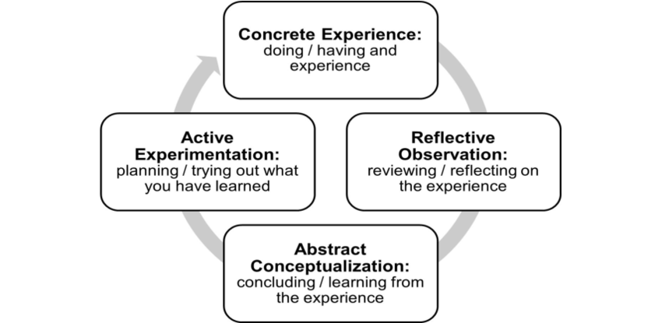

Figure 13: Framework of Kolb's Cycle of Reflective Practice
(Source: Alharbi, 2021)

2.2 Kolb's Cycle of Reflective Practice

2.2.1 Concrete Experience
The real-life experience entailed conducting a comprehensive strategic analysis of Microsoft in the technology sector throughout the world. This step involved the collection of the information on company reports, industry review, scholarly journals, and the reputable media sources to examine Microsoft competitive advantage. The experience was complicated because of the scope of operations of Microsoft that include cloud computing, artificial intelligence, productivity software, gaming, and sustainability efforts. It took a spirited workout to organise a substantial amount of quantitative data, such as revenues, cloud market share, and AI investment rates, as well as qualitative data regarding leadership, innovation and regulatory pressure. The use of strategic management models such as PESTEL, VRIO, SWOT, and the Balanced Scorecard gave a chance to combine theory with actual corporate practice. It was also a synthesising experience that entailed a combination of divergent views into a coherent story that was prepared according to Level 7 academic standards. The dilemma was how to find a balance between the descriptive data of the industry and the critical analysis and to ensure that the analysis extended beyond being explanative to interpretation and judgement. The experience has underscored the need to ensure academic rigour, sectional planning, and consistency when connecting the strategic decisions, sustainability agenda and implementation results of Microsoft to a coherent strategic argument based on evidence and theory.

2.2.3 Reflective Observation
The reflective experience on the process of research and writing indicated that there are several strengths and limitations. One of the strengths was the fact that a systemic approach was taken in the organization of the report, and it reflected the module learning outcomes and logical development of the environmental analysis to strategic recommendations. Analytical depth and scholarly soundness were enhanced by the application of credible sources including Microsoft annual reports, Reuters and peer-reviewed journals. But consideration also revealed difficulties. First, there was a tendency to overuse the factual reporting especially in the parts that deal with financial performance and AI investment, which threatened to undermine a critical assessment. Time also turned out to be a limitation because it involved revisiting huge data sets to create succinct arguments. Also, it was quite challenging to combine the analysis of sustainability and CSR with the competitive strategy, as it presupposed coordinating the ethical aspects with the financial performance. This introspective phase underpinned the relevance of assumption testing, opposition of opposing opinions, and bias on confirmation in the interpretation of industry data. The presence of these constraints led to a more critical approach and the increased interest in theory and the enhanced coherence between the strategic environment of Microsoft, company capabilities and long-term competitive positioning.

2.2.4 Abstract Conceptualisation
The experience was related to the existing strategic management theory through abstract conceptualisation. Learning model by Kolb focuses on the fact that knowledge can be generated through conversion of experience into conceptual knowledge as seen in the application of theoretical models to the strategic environment of Microsoft (Kolb, 1984). The Resource-Based View theory helped explain how the cloud infrastructure and AI ecosystem at Microsoft represent the valuable, rare and challenging-to-copy resources, which reinforce the continuity of competitive advantage. On the same note, Porters generic strategies were used in determining the hybrid differentiation and cost leadership strategy of Microsoft. The stakeholder theory was used to analyse the CSR and sustainability activities of Microsoft and reveal how ethical responsibility is associated with long-term value creation instead of being counterproductive to profitability. The Balanced Scorecard model also allowed conceptual connection of both financial and non-financial drivers including innovation capability, employee development and operational efficiency. This step helped to turn this piece-meal information into a coherent strategic conception and shows how theory can serve as a blind through which multi-faceted organisational situations can be coherently interpreted, criticised and explicated at an academic level.

2.2.5 Active Experimentation
Active experimentation is concerned with the way the learning based on this assessment is going to be applied to the future practice. Learned lessons will guide better organization of complicated research work, especially with previous framework mapping and better distinction between description and critique. Strategic analyses will focus more on the involvement of opposing scholarly perspectives in the future to enhance the argument. Another lesson learned in the experience is the importance of going through a number of drafts, which allowed to refine critical voice and integrate theories. In practice, the systematic application of such a tool as PESTEL and VRIO to a larger range of tools will be used selectively, with an emphasis on applicability and not a complete set of tools. Professionally, strategic data can be interpreted in a holistic manner, which will increase the skills of making a decision in the dynamic organisational environment. The systematic application of the reflective learning will help to achieve the ongoing improvement in academic research and strategy thinking so that the further analyses should be characterized by the increased level of originality, clarity of the concept, and correspondence to the requirements of the postgraduate assessment.

2.3 Conclusion
This reflective paper shows that the systematic reflection based on the cycle of the Kolb cycle facilitated learning during the process of the strategic analysis. The experience reinforced critical thinking, theoretical application and analytical discipline. Reflecting helped to convert practice research issues into the generalizable strategic understanding, which aids in strategic management scenarios in sustaining academic growth and professional competence.

Reference List
Ahmadi, A., (2023). Microsoft customer relationship management for small and medium-sized enterprises: challenges and opportunities. Asian Journal of Computer Science and Technology, 12(1), pp.1-6. https://www.ajcst.co/index.php/ajcst/article/download/3505/7601
Aji, A.S.S. and Akbardin, M., (2024). Economic insights into workforce dynamics: Analyzing labor supply, demand, and compensation. Advances in Human Resource Management Research, 2(2), pp.113-126. https://advancesinresearch.id/index.php/AHRMR/article/download/305/123
Alharbi, B., (2021). Development of an ERP System Design Course to Improve Students' Learning Outcomes. International Journal of Emerging Technologies in Learning (Online), 16(12), 276. https://doi.org/10.3991/ijet.v16i12.22281
Ali, H., ul Mustafa, A. and Aysan, A.F., (2025). Global adoption of generative AI: what matters Most?. Journal of Economy and Technology, 3, pp.166-176. https://www.sciencedirect.com/science/article/pii/S2949948824000520
Axios (2024). Charted: How Microsoft’s AI lead is showing up. [online] Available at: https://www.axios.com/2024/02/02/microsoft-tech-earnings-ai-apple-google-meta-amazon. (Accessed: 01 February 2026).
Bhadra, R., (2022). LinkedIn: A case study into how tech giants like Microsoft abuse their dominant market position to create unlawful monopolies in emerging industries. Hastings Sci. & Tech. LJ, 13, p.3. https://repository.uclawsf.edu/cgi/viewcontent.cgi?article=1108&context=hastings_science_technology_law_journal
Boyd, K., Miniken, L. and Hirning, D. (2025). Digitally transforming Microsoft: Our IT journey - Inside Track Blog. Inside Track Blog. Available at: https://www.microsoft.com/insidetrack/blog/digitally-transforming-microsoft-our-it-journey/ (Accessed: 2 February, 2026).
Brookings (2023). The EU and U.S. Diverge on AI regulation: a Transatlantic Comparison and Steps to Alignment. [online] Available at: https://www.brookings.edu/articles/the-eu-and-us-diverge-on-ai-regulation-a-transatlantic-comparison-and-steps-to-alignment/. (Accessed: 01 February 2026).
Business Insider (2025). Microsoft replaces top HR exec as it rethinks performance reviews. Business Insider. Available at: https://www.businessinsider.com/microsoft-replaces-top-hr-exec-performance-reviews-2025-3 (Accessed: 2 February, 2026).
ByteBot (2025). Microsoft Copilot Adoption Crisis: Sales Targets Cut in Half. [online] Byteiota | from Bits to Bytes. Available at: https://byteiota.com/microsoft-copilot-adoption-crisis-sales-targets-cut-in-half/ (Accessed: 01 February 2026).
Cate, M., (2025). Regulatory Frameworks and Compliance Strategies for Protecting Consumer Data. https://www.researchgate.net/profile/Mia-Cate/publication/392069810_Regulatory_Frameworks_and_Compliance_Strategies_for_Protecting_Consumer_Data/links/68321493be1b507dce90221b/Regulatory-Frameworks-and-Compliance-Strategies-for-Protecting-Consumer-Data.pdf
Charter Global (2025). Charter Global Overview. Charter Global. Available at: https://www.charterglobal.com/five-microsoft-trends/ (Accessed: 2 February 2026).
Crn.com (2025). Cloud Market Share Q2 2025: Microsoft Dips, AWS Still Kingpin. [online] Available at: https://www.crn.com/news/cloud/2025/cloud-market-share-q2-2025-microsoft-dips-aws-still-kingpin. (Accessed: 01 February 2026).
Firoozi, A.A., Oyejobi, D.O. and Firoozi, A.A., (2025). Innovations in energy-efficient construction: Pioneering sustainable building practices. Cleaner Engineering and Technology, p.100957. https://www.sciencedirect.com/science/article/pii/S2666790825000801
Marjomäki, N., (2025). From scarcity to abundance: leveraging AI to optimize resources in startups. https://lutpub.lut.fi/bitstream/handle/10024/170117/mastersthesis_marjomaki_noel.pdf?sequence=1
Marketviews (2021). Trending ETF | MarketViews. Marketviews.com. Available at: https://www.marketviews.com/trending-etf/?utm_source=Backfill&utm_medium=native&utm_term=Macrotrends (Accessed: 1 February, 2026).
Medium (2023). Microsoft Business Model Analysis. [online] Available at: https://medium.com/@neryrodriguez/microsoft-business-model-analysis-80102fb02260. (Accessed: 31 January 2026).
Microsoft (2023). The 2023 Microsoft Impact Summary | Microsoft CSR. Microsoft. Available at: https://www.microsoft.com/en-us/corporate-responsibility/impact-summary (Accessed: 1 February, 2026).
Microsoft (2024). Environmental Sustainability – Microsoft CSR. Microsoft. Available at: https://www.microsoft.com/en-us/corporate-responsibility/sustainability (Accessed: 1 February, 2026).
Microsoft (2024). Microsoft 2024 Annual Report. Microsoft.com. Available at: https://www.microsoft.com/investor/reports/ar24/ (Accessed: 2 February, 2026).
Microsoft (2025). 2025 Environmental Sustainability Report - Accelerating progress to 2030. Available at: https://cdn-dynmedia-1.microsoft.com/is/content/microsoftcorp/microsoft/msc/documents/presentations/CSR/2025-Microsoft-Environmental-Sustainability-Report.pdf (Accessed: 1 February, 2026).
Microsoft (2025). Microsoft 2025 Annual Report. [online] Microsoft.com. Available at: https://www.microsoft.com/investor/reports/ar25/index.html. (Accessed: 01 February 2026).
Microsoft Corporate Responsibility (2026). Global AI Adoption in 2025 – AI Economy Institute | Microsoft. [online] Available at: https://www.microsoft.com/en-us/corporate-responsibility/topics/ai-economy-institute/reports/global-ai-adoption-2025/. (Accessed: 01 February 2026).
Microsoft Source (2025). Microsoft Cloud and AI Strength Fuels Fourth Quarter Results. [online] Source. Available at: https://news.microsoft.com/source/2025/07/30/microsoft-cloud-and-ai-strength-fuels-fourth-quarter-results/. (Accessed: 01 February 2026).
Microsoft Source (2025). Microsoft Cloud and AI strength fuels fourth quarter results - Source. Source. Available at: https://news.microsoft.com/source/2025/07/30/microsoft-cloud-and-ai-strength-fuels-fourth-quarter-results/ (Accessed: 2 February 2026).
Microsoft.com (2025). Microsoft 2025 Annual Report. Microsoft.com. Available at: https://www.microsoft.com/investor/reports/ar25/index.html (Accessed: 2 February 2026).
Qiang, Q., (2025). Corporate soft power strategy in shaping global influence: a case study of Microsoft (Doctoral dissertation, Pepperdine University). https://search.proquest.com/openview/ef33d739ac7138b5e1118439e34aebfc/1.pdf?pq-origsite=gscholar&cbl=18750&diss=y
Reuters (2023). AI Lesson for Microsoft and Google: Spend Money to Make Money. [online] 26 Jul. Available at: https://www.reuters.com/technology/ai-lesson-microsoft-google-spend-money-make-money-2023-07-25/. (Accessed: 01 February 2026).
Reuters (2025). Microsoft to Spend Record $30 Billion This Quarter as AI Investments Pay off. [online] 30 Jul. Available at: https://www.reuters.com/business/microsoft-spend-record-30-billion-this-quarter-ai-investments-pay-off-2025-07-30/. (Accessed: 31 January 2026).
Reuters (2026). Microsoft’s Massive AI Spending Draws Investor Concerns as Cloud Business Booms. [online] 30 Oct. Available at: https://www.reuters.com/business/microsofts-cloud-surge-lifts-revenue-above-expectations-2025-10-29/. (Accessed: 31 January 2026).
S&P Global (2024). Emerging Markets Growth Remains Solid amid Intensifying Inflationary Pressures. [online] IHS Markit. Available at: https://www.spglobal.com/marketintelligence/en/mi/research-analysis/emerging-markets-growth-remains-solid-amid-intensifying-inflationary-pressures-mar24.html. (Accessed: 31 January 2026).
Statista (2025). AWS Stays Ahead as Cloud Market Accelerates. Statista Daily Data. Available at: https://www.statista.com/chart/18819/worldwide-market-share-of-leading-cloud-infrastructure-service-providers/?srsltid=AfmBOoq6-UgV0_wuXvmhdIxe_0BOLskYruomeHLsCO6n-YfzZitUWTyu (Accessed: 1 February 2026).
Statista (2026). Infographic: Microsoft Makes Half of Its Money in the Cloud. [online] Statista Infographics. Available at: https://www.statista.com/chart/29863/microsofts-cloud-revenue-vs-total-revenue/. (Accessed: 01 February 2026).
Statista (2026). Microsoft: Revenue 2002-2025 | Statista. [online] Statista. Available at: https://www.statista.com/statistics/267805/microsofts-global-revenue-since-2002/. (Accessed: 01 February 2026).
Stockmarket.com (2022). Research: Microsoft Part 1. [online] 0to1stockmarket.com. Available at: https://www.0to1stockmarket.com/p/research-microsoft-part-1. (Accessed: 31 January 2026).
Williment, C. (2025). Microsoft’s CSR Blueprint: Technology with a Purpose. Sustainabilitymag.com. Available at: https://sustainabilitymag.com/articles/microsofts-csr-blueprint-technology-with-a-purpose (Accessed: 1 February, 2026).
Zakaria, Z., (2025). Evaluation of Ethical Dilemmas and Business Sustainability in Maintaining a Company's Reputation in Global Markets. Paradoks: Jurnal Ilmu Ekonomi, 8(3), pp.837-851. https://jurnal.feb-umi.id/index.php/PARADOKS/article/download/1490/1072

