ENTREPRENEURSHIP

  - ASSESSMENT 2

Module Code: LCBB5001

Table of Contents

BUSINESS DESCRIPTION 3
MISSION STATEMENT OF THE BUSINESS 5
PRODUCT OR SERVICE DESCRIPTION 5
OWNERSHIP STRUCTURE 6
INDUSTRY ANALYSIS 8
THREAT OF NEW ENTRY 8
THREAT OF SUBSTITUTES 9
BARGAINING POWER OF CUSTOMERS 9
BARGAINING POWER OF SUPPLIERS 9
OPERATIONS AND MANAGEMENT TEAM 11
OPERATIONS 11
MANAGEMENT TEAM 12
MARKETING 14
FINANCIALS 16
MARKET RESEARCH 18
REFERENCES 20

BUSINESS DESCRIPTION
The business is the starting of an online learning platform through a website and an application. The online learning platform will be based on the subscription and the user, or the customer is required to pay as per the course content and the time duration for which the user is accessing the course. The business or online learning platform will be accessible through both i.e., the website and the application. The website will be helpful for the customer in accessing essential information that about the business and the different plans they can access as per their need (Liu et al., 2020). The courses will be diversified in manner such that their will an academic courses section that provides the students with relevant content related to school courses and subjects. Another section will be of Academic skills that consists of courses that are helpful in enriching specific academic skills of the user or student. Another section that will be the innovative part of the business is that a separate section will be available for the users and students that consists of popular co-curricular activities such as sports, music, art and crafts, literature, poetry, robotics, cooking, personal development etc. One of the major issues that parents and students experience while studying through online learning is that they are only able to enrich their knowledge related to course subjects and skills and are unable to enrich in their fields of their passion and interest that are the co-curricular activities that are taken care of when the students went to schools (Camargo et al., 2020). Thus, this feature is implemented and inculcated in the business in order to fulfil the mentioned gap. This innovative section will be available to the users as an add-on service that they can add with their main or primary course through a subscription fee based on the time period for which the user requires to avail the services.

Fig: Logo for the new online learning platform
Source: Developed by writer
All the sections of the business i.e., there will be three sections that are academic course, academic skills and curricular activities. All of these three sections are having both written and video content that will be recorded lectures. Also, there will be certain live lectures that will be forecasted in case any new additional information is required to be distributed. Mentors are available for all the subjects, skills and curricular activities. The user can avail the services of mentors in which certain monthly sessions are free and additional to those are paid (Liu et al., 2020). Also, the students that are enrolled in the same course can chat with each other regarding the course chat over which qualified teachers are also available to resolve the queries. This will be the proposed business that will be resolving the issues and overcoming the limitations of offline learning.

MISSION STATEMENT OF THE BUSINESS
The mission statement of the business will be “providing learning community with technical skills and online learning solutions that enable them to pursue their educational, professional and personal goals”.
The mission statement attempts to reflect that the business platform that is the online learning platform and is not only for children or students rather any individual that required to enrich his knowledge and is eager to learn or is part of the global learning community can enrol in the desired course. Also, the platform not only enables the development of professional skills or knowledge but also help in development of educational and personal skills and knowledge (Liu et al., 2020). Thus, the objective of the business platform is to make learning easier and more accessible.

PRODUCT OR SERVICE DESCRIPTION
The product will be educational content in written and visual format. The services are available through both official website and a dedication application that can be available on both android and iOS powered app stores. There are under-graduation courses, school-based courses and post graduate courses. Also, there will be content related to the development of different academic skills (Xu and Zhou, 2020). Another service that will be provided is co-curricular section that consists of multiple curricular activities an individual can add on with his primary course.
The product is designed in a manner that it will be instrumental in preventing the loss in terms of educational and professional development and learning that students and other people that are part of the learning community is facing due to the disruptions that are caused due to the restrictive measures that are required being implemented due to Covid-19 pandemic (Camargo et al., 2020). The product aims to prevent the decline in learning efficiency of the students through providing them an integrated learning service that only take care of their academic needs and expectations but caters also to the professional and personal development.

OWNERSHIP STRUCTURE
The ownership structure of the business will be LLP i.e., limited liability partnership. The rationale behind the choice of this structure is that it helps in the development of limited liability over the owners and is considered to be instrumental in business start-ups that requires investment from private investors (Majmudar, 2021). All the partners will be having a say in decision making it productive for the business. It will help in lowering the personal liability, unlimited partners can be included, the taxation obligations are comfortable and flexible and helps in providing more credibility to the customers (Rashid, 2020).
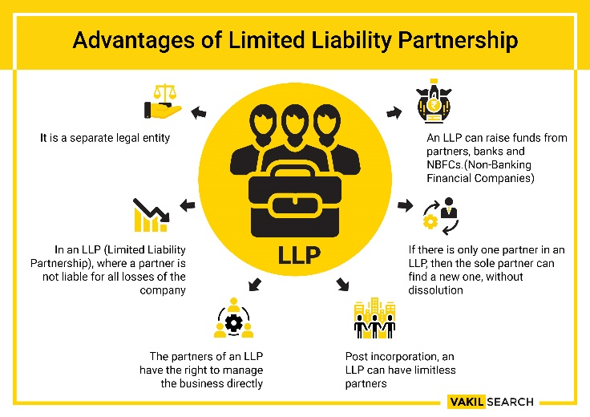
Fig: Limited Liability Partnership
Source: https://vakilsearch.com/advice/why-you-should-choose-an-llp-limited-liability-partnership/

INDUSTRY ANALYSIS
Industry analysis can be done through the use of porters five force analysis of the online learning industry that eventually helps in acknowledging the extent of competition in the industry helping the new business to appropriately strategize its business concept (Culot et al., 2020).
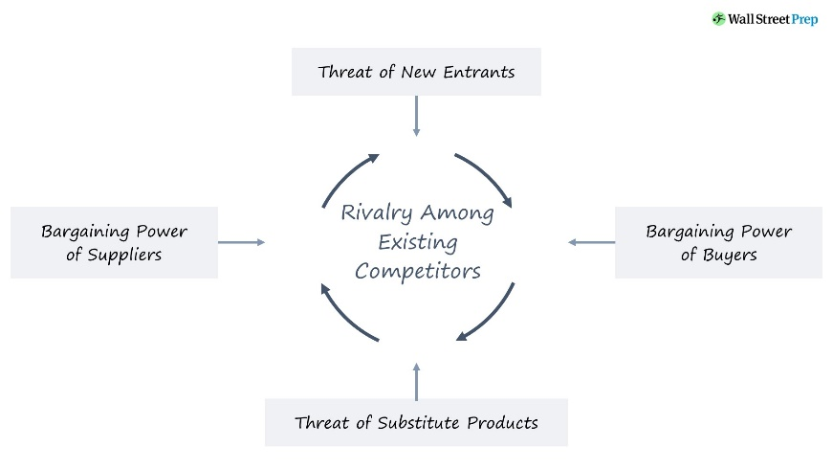
Fig: Porters Five Forces
Source: https://www.wallstreetprep.com/knowledge/porters-five-forces-model/

THREAT OF NEW ENTRY
Concerning the online learning industry, the barriers to entry are significantly low. Two of the most prominent barriers to entry are cost and time. The cost required to start an online learning business is low in comparison to start an offline learning business. The time required to start an online learning platform is less in comparison to the same in regards with an offline learning business. Due to the significant low barriers to entry in the online learning industry, the threat of new entrants is strong force (Bruijl and Gerard, 2018).

THREAT OF SUBSTITUTES
As the barriers to entry in the online learning business are low, it makes it easy for small businesses or entrepreneurs to replicate the competitive factor of an established online learning platform making the competition even tougher. This eventually results in making the threat of substitutes a moderate to strong force as the new or proposed business is having a variety of courses that other business may or may not replicate in the same manner (Culot et al., 2020).

BARGAINING POWER OF CUSTOMERS
Customers are paying for the services they are availing and have the freedom to review the services of the business. Many a times these feedbacks and reviews are falsified and faked that eventually manipulates the viewers. Despite this fact, the availability of substitutes makes the switching cost low, but the user once opt for one platform will have to pay for the services in advance and any issues developed afterwards can be resolved through customer services. This the power of buyers will be moderate to Strong (Bruijl and Gerard, 2018).

BARGAINING POWER OF SUPPLIERS
Due to the availability of the large number of substitutes, the suppliers that can be software developers, electronic devices, tutors and educators etc. are having low switching eventually enabling them with moderate to high bargaining power as the effectiveness of both the online learning platform and the educator eventually supports the success of each other. Thus, while exercising a mutually beneficial relation, buyers are having moderate bargaining power.

Competitive Rivalry: who are your main competitors and how can you differentiate yourself from them

Name of competitor | Differentiation
Udemy   | The business extensively focusses on course that are instrumental in enabling the development of professional skills in order to get a job. The business is having a significant suppliers and user base across the globe but does not provide curricular activities. Also, the new business is capable of providing educational and personal development related courses also.
Coursera   | The Coursera is having limited courses that are available for a period of four to twelve weeks and is not having school-based courses. The new business idea will be having course contents in under-graduate, postgraduate and school-based courses. Along with this the business is enabling skill development programs and curricular activities courses that are not available with Coursera.
Skillshare   | Though skillshare is instrumental in enabling its users with diversified courses such as marketing, fashion, and design etc. but is not instrumental in providing academic course content that are based on university-based guidelines which is what provided by the new business (Kay et al., 2019).

OPERATIONS AND MANAGEMENT TEAM

OPERATIONS
Business process refers to all then processes that are part of the business. An online learning business consists of a webspace or application or portal that is instrumental in enabling the users or the customers with content that can be educational or academic. The business process for the new business consists of following process that eventually leads to the development of online learning platform and its maintenance (Zurich and Documentation, 2018). The business processes that are involved are as follows:

The new business will allow the users to interact with the business either through the website or the application that will be available on both Android and iOS. The user through interacting with the interface came across multiple options along with their description as what they contain. Prominently the customer or user is required to choose in between the type of course content that the user want i.e., academic course content, academic skills and curricular activity courses (Zurich and Documentation, 2018). Among these three services, the user will be required to choose either the academic course content or academic skills course as a basic or primary course to which the customer can add-on any of the curricular activity course. Choosing the course content, the user have to pay the subscription fee for a certain period until which that chosen course will be applicable and accessible by the user.
Concerning the suppliers of the business, the business will be getting its suppliers in the form the tutors and educators, electronics equipment providers, software developers, academicians, researchers, field experts etc. These suppliers will be enabling the business with essential inputs that proves to be instrumental in enhancing the efficiency of business operations. These suppliers will be providing their knowledge through lectures and sessions and through providing necessary information that helps in delivering better results (Hadining et al., 2019).
The video lectures will be recorded in a studio that is designed and developed by the business in order to provide uniformity in presentation of the content. These studios where the recording of the lecture will take place will be technologically advanced allowing the tutor to use technologies such as AI, VR etc. to better transfer the knowledge (Hadining et al., 2019).

How would you generate revenue for your business?
The revenue generation will be through subscriptions and the add-on courses and other services such as mentorship services etc. are chosen or opted by the users or customers. The pay per course pricing strategy of the business will be instrumental in attracting the customer as they are able to get customised services as per their choice (Palvia et al., 2018).

MANAGEMENT TEAM

Name | Skills | What do they bring to the firm
Subject matters expert | Having specialized knowledge in regards with a specific subject. | Helps in development of lectures
e-learning consultant | Having appropriate knowledge of the tools and approaches that are beneficial for the chosen organization. | Training of the employees or educators will be appropriate, and the delivery of content will be of high quality.
Graphic designers | Skills and knowledge in regards with designing the webpage and graphics for the application. | Helps in the development of interactive content and interface that makes learning more engaging for the learners.
Curriculum developers | Knowledge and expertise in arranging relevant content altogether in order to design and provide the courses appropriately. | Helps in designing the courses as per the standards and requirements of different universities (Cordiner, 2021).

MARKETING
The four Ps analysis will be instrumental in reflecting and developing the marketing plan for the new business and enables the acknowledgment of the areas that are essential for the appropriate marketing of the product or service that proves to be instrumental for the business.
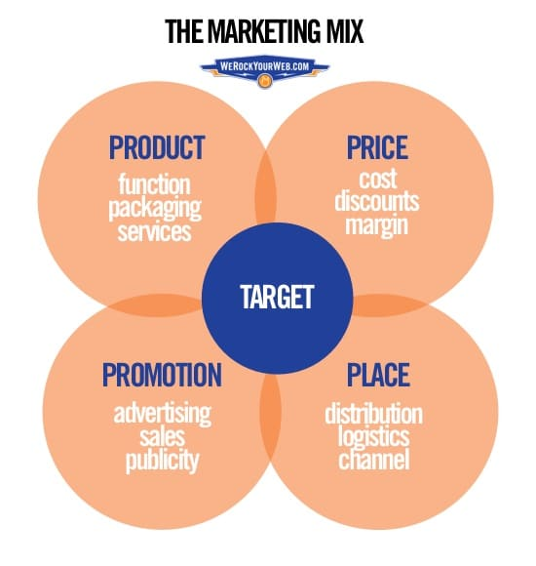
Fig: Four Ps of marketing
Source: https://www.campaignmonitor.com/resources/knowledge-base/what-are-the-4-ps-of-marketing/
Product:
The product will be in the form of services that consists of course contents in the form of written and visual format i.e., video lectures. The business will be providing three types of courses that are academic courses as per university guidelines across different nations, academic skill development courses and curricular courses that will be the innovative segment of the business (Lahtinen et al., 2020).

Price:
The pricing strategy that will be adopted by the business will be pay per course pricing model. As per this pricing strategy, the users are required to pay for the services or courses that they are availing only and are not required to pay for any additional service. The choice of this pricing strategy is as this enables the required simplicity to the customers as well as the business and provides the business with immediate revenue generation along with enabling appropriate scope for measuring and forecasting the success and issues with the business organization (Lahtinen et al., 2020).

Promotional Mix:
The promotional strategy for the business will consists of promotional emails with personalized information. Also, the marketing activities will be performed through social media platforms and search engine optimization marketing strategy. This will eventually enable the business to target its customer base (Lahtinen et al., 2020).

Place (Distribution strategy):
The distribution of the services will be through the official website of the business. Also, the courses are availed through the dedicated application that will be available and operatable over Android and iOS powered devices (Lahtinen et al., 2020).

FINANCIALS

Sources of funds: where would you be getting funds from?

The funds will be collected from different rounds of angel financing and VC firms. Since the business is in its developmental stage, use of VC will be a great source of introducing capital into the organisation as this will help in bring experience of VC firms with the expertise of making business operations. along with bank loan has been taken of £20,000 to initiate basic business process and allocation of computers and land to setup organisation basic landscape. These sources are elaborated as follows:

- Long term Bank loan: it is the simplest form of financing in which a principal taken as debt from the bank. it has to be repaid to the bank along with interest in the form of Equated monthly instalment. The amount of bank loan will be £20,000.

- Venture capital: in this type of financing, investors and companies invest in start-ups and small companies that are supposed to have long term growth in the future. this also brings experience of VC’s that can be a great asset for small companies. The VC rounds will be targeted with raising £45,000.

Use of funds

 | Month 1 | Month 2 | Month 3 | Month 4 | Month 5 | Month 6
Revenue (from your operations and marketing section) | 60000 | 64800 | 68040 | 71442 | 75014 | 78765
Fixed Costs | 30000 | 31050 | 32137 | 33262 | 34426 | 35631
- support tools development
- investment in computers and online education materials development
- payment to teachers
- payment to experts in maintaining website
Variable Costs | 21150 | 22419 | 23764 | 25190 | 26701 | 28303
- tutorship and maintenance of records
- web server running cost
- site maintenance
- technical support and student support services
Profit | 8850 | 11331 | 12139 | 12990 | 13887 | 14831

MARKET RESEARCH
Online learning industry is one of the merging markets across the globe and contains significant potential for growth and success. concerning the low barriers to entry, the industry is experiencing significant competition still is having potential for growth and success. following are market insights for online learning industry.
- Global e-learning market was sized approx. 200 billion US dollars in year 2019. 18 billion US dollars were generated in same year by LMS (Learning management system). Market.
- It is expected that digital education market will grow 33.28% CAGR from year 2020-2026 as global e-learning technology market size is expected to reach USD 56490 Million by year 2026 which was USD 11850 Million in year 2019 (Mital et al., 2021).
- It was projected that from year 2011 to 2021 the number of e-learners increased from 300,000 to 220 million.
- Among global leaders in e-learning platforms, US is undisputedly leading the digital education across the word as various online courses are made available to students (Rashid, 2020).
PEST ANALYSIS
POLITIICAL FACTORS  - Changes in political parties  - Changes in educational policies  - Corruption rate  - Laws and regulations | ECONOMIC FACTORS  - Inflation rate  - Change in income level  - Change in interest rate  - Monetary and fiscal policies
SOCIAL FACTORS  - Changes in customer perspectives  - Changes in lifestyle | TECHNOLOGICAL FACTORS  - Technological advancement  - IT-infrastructure in schools and colleges  - AI-enabled classrooms

REFERENCES
Bruijl, D. and Gerard, H.T., 2018. The relevance of Porter's five forces in today's innovative and changing business environment. Available at SSRN 3192207.
Camargo, C.P., Tempski, P.Z., Busnardo, F.F., Martins, M.D.A. and Gemperli, R., 2020. Online learning and COVID-19: a meta-synthesis analysis. Clinics, 75.
Cordiner. S., 2021. 14 essential roles that every organization needs on their e-learning development team. (Online). Available at; https://ceoworld.biz/2021/03/24/14-essential-roles-that-every-organisation-needs-on-their-e-learning-development-team/ [Accessed on 7th July 2022].
Culot, G., Nassimbeni, G., Orzes, G. and Sartor, M., 2020. Behind the definition of Industry 4.0: Analysis and open questions. International Journal of Production Economics, 226, p.107617.
Hadining, A.F., Sukanta, S. and Hidayat, W., 2019. An Investigation of Student Perspective for E-Learning Readiness Measurement. In Proceedings of the International Conference on Industrial Engineering and Operations Management (pp. 5-7).
Kay, J., Ferns, S., Russell, L., Smith, J. and Winchester-Seeto, T., 2019. The Emerging Future: Innovative Models of Work-Integrated Learning. International Journal of Work-Integrated Learning, 20(4), pp.401-413.
Lahtinen, V., Dietrich, T. and Rundle-Thiele, S., 2020. Long live the marketing mix. Testing the effectiveness of the commercial marketing mix in a social marketing context. Journal of Social Marketing.
Liu, Z.Y., Lomovtseva, N. and Korobeynikova, E., 2020. Online learning platforms: Reconstructing modern higher education. International Journal of Emerging Technologies in Learning (iJET), 15(13), pp.4-21.
Majmudar, S., 2021. The Era of Limited Liability Partnership. Issue 3 Int'l JL Mgmt. & Human., 4, p.4584.
Mital, D., Dupláková, D., Duplák, J., Mital’ová, Z. and Radchenko, S., 2021. Implementation of Industry 4.0 Using E-learning and M-learning Approaches in Technically-Oriented Education. Assoc. Inf. Commun. Technol. Educ. Sci, 10, pp.368-375.
Palvia, S., Aeron, P., Gupta, P., Mahapatra, D., Parida, R., Rosner, R. and Sindhi, S., 2018. Online education: Worldwide status, challenges, trends, and implications. Journal of Global Information Technology Management, 21(4), pp.233-241.
Rashid, M.M., 2020. Ownership structure and firm performance: the mediating role of board characteristics. Corporate Governance: The International Journal of Business in Society, 20(4), pp.719-737.
Xu, W. and Zhou, Y., 2020. Course video recommendation with multimodal information in online learning platforms: A deep learning framework. British Journal of Educational Technology, 51(5), pp.1734-1747.
Zurich, B.L.L. and Documentation, X., 2018. Service operations and management. Master of Science in Engineering, p.380.

