Critical Reflection – Worksheet
This activity guides you through a structured, critical reflection on your individual research project using Gibbs’ Reflective Cycle (1988). It supports both personal reflection (identity, emotions, confidence, values) and academic reflection (research design, evidence, skills, theory, quality).

Refresher: Gibbs’ Reflective Cycle (1988)
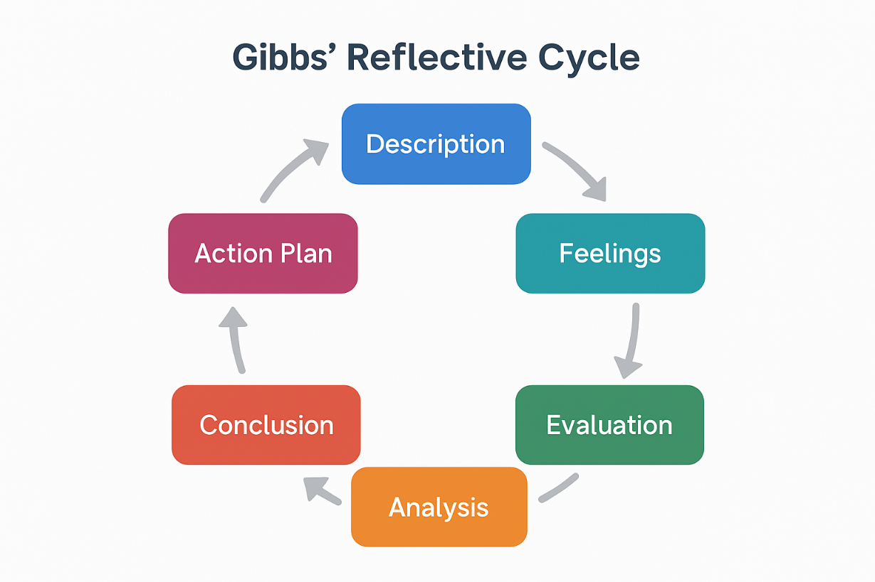
- Description – What happened?
- Feelings – What were you thinking/feeling?
- Evaluation – What worked / didn’t work?
- Analysis – Why did it happen? (connect to theory/evidence)
- Conclusion – What else could you have done?
- Action Plan – What will you do next?

Part 1 – Individual Reflection Writing (45 min)
Please write in response to the questions below. Aim to write in full sentences, not bullet points.

Gibbs Reflection Worksheet: Your Research Project
1) Description
Describe the current stage of your research project.
- What is your research question/topic?
- What decisions have you made so far (method, scope, sources)?
- What challenge or turning point stands out most?
[enter text]

2) Feelings
Reflect honestly on your internal experience.
- What emotions have you experienced during the project (confidence, anxiety, frustration, excitement)?
- What moments made you feel most capable? Least capable?
- What personal values or identity factors shaped your approach (e.g. perfectionism, fear of failure, prior experiences)?
Side note: This is not “therapy” – it’s about understanding how emotions and identity shape academic work.
[enter text]

3) Evaluation
Judge what has worked and what has not.
- What has gone well so far (skills, planning, reading, writing, time management, e.g. sticking with milestones from Gantt chart?
- What has not gone well (delays, time constraints, unclear focus, weak sources, limited access to data, limited survey respondents)?
- How might this have affected my results (e.g. low survey respondents)?
- What feedback have I received (e.g. Assignment 1, 1:1s), and how did I respond to it?
- What have I learned about the topic of sustainable transportation in the context of my chosen destination/event etc. in general?
[enter text]

4) Analysis
Explain why outcomes occurred, using academic reasoning.
If you plan to reference academic literature, this is the most appropriate stage to incorporate it.
- Why did the challenges occur? (e.g. research design, feasibility, assumptions)
- Where might bias have influenced my choices (topic framing, sources, interpretation, questionnaire design)?
- How does my project connect to course concepts or relevant theory?
- What does the literature suggest about the effectiveness of my chosen research methods?
- What does the literature suggest about how researchers handle similar challenges?
[enter text]

5) Conclusion
Consider alternatives.
- What could I have done differently at key moments?
- What have I learned about myself as a researcher?
- What is the most important insight I want to carry forward?
[enter text]

6) Action Plan
Commit to specific improvements.
Examples:
- If I were to repeat a similar project in the future, I would…
- For my Independent Project (Level 6), I will avoid…
[enter text]

Part 2 – Peer Dialogue (20 min)
Work in pairs (or triads if needed). One student is the Researcher, the other is the Critical Friend.

Ground rules:
- Be respectful, but probing.
- Focus on improving thinking, not judging the person.
- Use “curious questioning”, not advice-giving first.
- Confidentiality: what’s shared stays in the pair.

Each student selects one major research moment to discuss:
- a turning point (e.g. topic change, data issue, feedback received)
- a challenge (e.g. procrastination, time constraints, low survey responses)
- a decision (e.g. narrowing scope, method selection)

Researcher speaks (2-3 min):
The Researcher briefly shares:
- what happened (project context)
- what they learned about themselves as a researcher
- one planned future action

Critical Friend questions (3 min):
The Critical Friend chooses 3 probing questions from the question bank below.
- What outcome were you aiming for?
- How well does your method actually match your research question?
- What is the biggest limitation in your design, and why?
- How might your personal beliefs/identity shape interpretation?
- When did you feel most confident? Least confident?
- What coping strategy did you use when stuck (avoidance, perfectionism, overworking)?
- What does this reveal about your researcher identity?
- What will you do differently at the start of the next project?
- What new habit would make the biggest difference?
- What would success look like in your next project (realistically)?

Switch roles.

