University of Wales Trinity Saint David

Ordnance, Munitions and Explosives



Advanced Chemistry of OME - ACDA6020

Laboratory Report – Rate of Reaction – Iodine Clock

Natalie Coplin - 2113351

Date – 11/2025

Lecturer: Ewa Kazimierska

Contents
List of Figures 3
List of Tables 3
List of Equations 3
1. Aim 4
1.1. Hypothesis 4
1.2. Predicted Outcome 4
1.3. Key Variables 4
1.4. Theory 5
1.5. Rate Law and Order of Reaction 5
1.6. Importance of kinetics in ordnance, munitions and explosives (OME) 6
2. Results 8
2.1. Observations 8
2.2. Calculations 8
2.2.1. Hydrogen Peroxide 8
2.2.2. Potassium Iodide 9
2.2.3. Rate Constant - k 11
2.2.4. Order of Reaction 12
2.2.5. Rate Law 13
3. Discussion 14
3.1. Experimental Error 14
3.2. Experiment discussion 14
4. Conclusion 16
5. References 17
6. Appendix 1 – Experimental Error 19
7. Appendix 2 – Methodology 21
7.1. Chemicals and equipment 21
7.2. Procedure 21
8. Appendix 3 – Anomalous Result 24

List of Figures
Figure 1 Series 1 Result - H₂0₂ 11
Figure 2 Series 2 Result – KI 11
Figure 3 Diagrammatic representation of experimental set-up - adapted from [13] 21
Figure 4 Series 2 results - 2.1 omitted 24
Figure 5 Series 2 results - 2.2 omitted 25

List of Tables
Table 1 Moles of H₂O₂ added and initial concentration of H₂O₂ in series 1 experiments 9
Table 2 Moles of KI added and initial concentration in series 2 experiments 10
Table 3 Complete experimental results 10
Table 4 Average of k (rate constant) 12
Table 5 Experimental Error 14
Table 6 Required volumes for each series 1 experiment 22
Table 7 Required volumes for each series 2 experiment 22
Table 8 Blank results table 22

List of Equations
Equation 1 Hydrogen peroxide oxides iodide ions 5
Equation 2 Ascorbic acid reduces iodine back to iodide ions 5
Equation 3 Rate of reaction 5
Equation 4 Rate equation expressed in terms of reactant concentration 6
Equation 5 Rate law equation 6
Equation 6 Molar concentration 8
Equation 7 Molarity Equation 8
Equation 8 Dilution equation 9
Equation 9 Rate law equation 12
Equation 10 Overall order of reaction 13

Aim
Using an experiment known as the Iodine clock, the purpose of this experiment is to determine the rate law for the formation of iodine in the reaction between hydrogen peroxide (H₂O₂) and iodine ions in aqueous solution. Ascorbic acid (C₆H₈O₆) will be used as the reducing agent, and starch as the colour change indicator which turns blue when it reacts with iodine.

Hypothesis
The rate of iodine formation in the reaction between hydrogen peroxide and iodide ions is dependent upon the concentration of both reactants. It is hypothesised that increasing the concentration of either of these reactants will increase the rate of the reaction, therefore decreasing the time taken for the ascorbic acid to be fully consumed and a blue colour change to be seen from the reaction of starch with accumulated iodine.

Predicted Outcome
As the concentration of 3% hydrogen peroxide increases in the reaction solution, it is expected that the rate of iodine formation will also increase. The time taken for the blue colour to appear will decrease due to the higher availability of the oxidising agent driving the reaction forward.
As the concentration of 0.2M KI increases in the reaction solution, the rate of iodine formation is expected to also increase, leading to faster consumption of ascorbic acid. Once fully consumed, iodine accumulates and reacts with starch to produce a visible colour change. Therefore, increasing iodide concentration should reduce the time taken to reach the end point of the reaction.

Key Variables
For this experiment the variables are:
Independent – series 1 – H₂O₂ concentration, series 2 - KI concentration
Dependent – time for solution to change colour.
Control – ascorbic acid and starch concentration, reaction solution volume.

Theory
In this kinetics experiment hydrogen peroxide oxidises iodide ions to form iodine, while ascorbic acid constantly reduces iodide back to iodine - delaying the accumulation of iodine and the colour change. The end point can be observed when the blue colour forms, allowing the rate of the reaction to be monitored as a function of time.
The reaction above involves two stages. The first is the reaction between hydrogen peroxide and iodide ions. Hydrogen peroxide oxides iodide ions to iodine, shown in Equation 1.
$$H_{2}O_{2} +2I^{-} +2H^{+} → I_{2} +2H_{2}O$$
Equation 1 Hydrogen peroxide oxides iodide ions
The second half of the reaction is the reduction of iodine back to iodide ions by the ascorbic acid, shown in Equation 2.
$$C_{6}H_{8}O_{6} + I_{2} → C_{6}H_{6}O_{6} +2I^{-} +2H^{+}$$
Equation 2 Ascorbic acid reduces iodine back to iodide ions

Rate Law and Order of Reaction
The order of a reaction describes how the rate of reaction is affected by the concentration of each reactant [1] [2]. It can only be determined experimentally by measuring how the reaction rate changes when the concentration of each reactants is varied. It is expressed using the rate law which illustrates the effect of varying concentration on the rate of the reaction [3].
Common orders of reaction include:
Zero – rate is independent of the reactant concentration; changes in concentration do not affect the rate.
First – rate is directionally proportional to the reactant concentration; doubling the concentration doubles the rate of reaction.
Second - rate is proportional to the square of the reactant concentration; doubling the concentration increases the rate by a factor of four. [4]
The rate law for the iodine clock can be determined by monitoring the rate at which iodine reacts with starch to produce a blue colour change. The colour formation marks the point at which ascorbic acid is fully consumed, and therefore the end point of the reaction. The time taken for the colour change is inversely proportional to the rate of iodine formation – based on the same amount of iodine being produced in each experiment. The reciprocal of time (1/t) is an approximate measure of the rate of reaction:
$$Rate ∝ \frac{1}{t}$$
Equation 3 Rate of reaction
Where time (t) is measured in seconds (s).
The general rate law for the reaction is:
$$rate=k[H_{2}O_{2}]^{m}[I^{-}]^{n}$$
Equation 4 Rate equation expressed in terms of reactant concentration
Given the rate is inversely proportional to time as shown in Equation 3, it can be expressed as:
$$1/t = k[H_{2}O_{2}]^{m}[I^{-}]^{n}$$
Where:
k = rate constant
[H₂O₂] = concentration of hydrogen peroxide
m = order of reaction with respect to hydrogen peroxide
[I⁻] = concentration of iodide ions
n = order of reaction with respect to iodide ions
Plotting log (1/time) against the log of the initial concentration of the reagents - [H₂O₂]₀ and [I⁻]₀, the order of each reaction can be determined.
This allows k to be calculated for each experiment using:
$$k= \frac{(1/{time})}{([H_{2}O_{2}]^{m}[I^{-}]^{n})}$$
Equation 5 Rate law equation
The average of k can then be determined.

Importance of kinetics in ordnance, munitions and explosives (OME)
Kinetic studies are invaluable in the field of OME for hazard and risk assessments and through-life surveillance. The rate of a reaction directly influences the performance, reliability and safety of explosives through the entire Manufacture to Target or Disposal Sequence (MTDS) [5]. Kinetic studies into areas such as activation energy, rate of reaction and thermal decomposition all play a key role in understanding how energetic materials will behave across their lifecycle.
For example, techniques such as differential thermal analysis (DTA), differential scanning calorimetry (DSC) and thermogravimetric analysis (TGA) are used to assess the thermal stability of explosives and energetic polymers during development of new compounds [6], [7] .
By combining experimental data with kinetic models, critical factors, including decomposition pathways, stabiliser aging, manufacture operating conditions and burn rates can be accurately determined informing the decision-making process for all aspects of the explosive life cycle [8],

Results

Observations
Upon mixing the colourless reagents, a blue colour developed in each reaction within minutes. The time taken for the colour change appearance decreased in each test series as the concentration of either reactant increased, indicating the rate of reaction in each series was increasing.

Calculations

Hydrogen Peroxide
To calculate the initial concentration of hydrogen peroxide in the reaction mixture, the number of moles of hydrogen peroxide in the stock solution must first be determined. A 3% w/v solution of hydrogen peroxide contains 3 g per 100 ml, equivalent to 30g in 1000ml. Using the periodic table, the molar mass of H₂0₂ can be found:
Hydrogen: 1.008 g/mol
Oxygen: 15.999 g/mol
For H₂0₂ = (2 x 1.008) + (2 x 15.999) = 34.014 g/mol.
Moles in 1 L:
$$Moles= \frac{Mass (g)}{Molar mass (g/mol)}$$
Equation 6 Molar concentration
$$Moles of H_{2}O_{2}= \frac{30}{34.014}$$
$$Moles of H_{2}O_{2}=0.882 mol$$
There are 0.882 mol of H₂0₂ in the stock solution, as this is calculated for 1 L the molarity is 0.882 mol/L. The molarity is required to calculate the number of moles of H₂0₂
Next find the number of moles added to reaction solution. Convert the volume of H₂0₂ added to each reaction from millilitres to litres:
For experiment 1.1 this is 1 ml = 0.001 L
$$Moles added (mol)=Molarity (mol/L)×Volume added(L)$$
Equation 7 Molarity Equation
$$Moles=0.882 ×0.001$$
$$Moles= 0.000882 mol$$
Finally, rearranging Equation 7, calculate the initial concentration of H₂0₂ in the reaction solution.
$$Initial \left[H_{2}O_{2}\right]=\frac{Moles added (mol)}{Volume of reaction solution (L)}$$
$$Initial \left[H_{2}O_{2}\right]=\frac{0.000882}{0.025}$$
$$Initial \left[H_{2}O_{2}\right]=0.03528 mol/L$$
Table 1 shows the results from performing the above steps for each experiment in series 1.
Table 1 Moles of H₂O₂ added and initial concentration of H₂O₂ in series 1 experiments
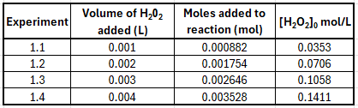

Potassium Iodide
The molarity of the stock solution of potassium iodide is already known, therefore, only the initial concentration in the reaction solution needs to be calculated. This is done using:
$$C1×V1 = C2×V2$$
Equation 8 Dilution equation
Where:
C1 = concentration of stock solution (0.2 M)
V1 = volume of stock solution added (0.001 L)
C2 = concentration of final solution (to be calculated)
V2 = volume of final solution (0.025 L)
For experiment 2.1:
$$C2= \frac{C1×V1}{V2}$$
$$C2= \frac{0.2×0.001}{0.025}$$
$$C2= 0.008 M$$
Table 2 shows the results from performing the above steps for each experiment in series 2.
Table 2 Moles of KI added and initial concentration in series 2 experiments
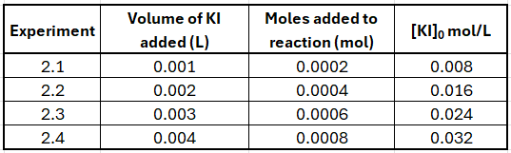
Table 3 shows the complete results from the experiments with the log of the reactant concentration and log of 1/t, which was plotted in Figure 1 and Figure 2.
Table 3 Complete experimental results
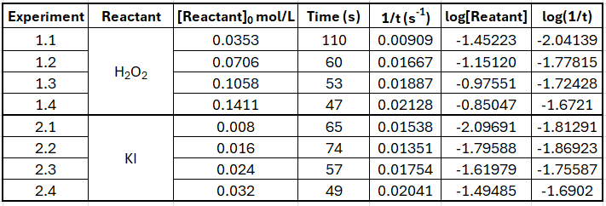

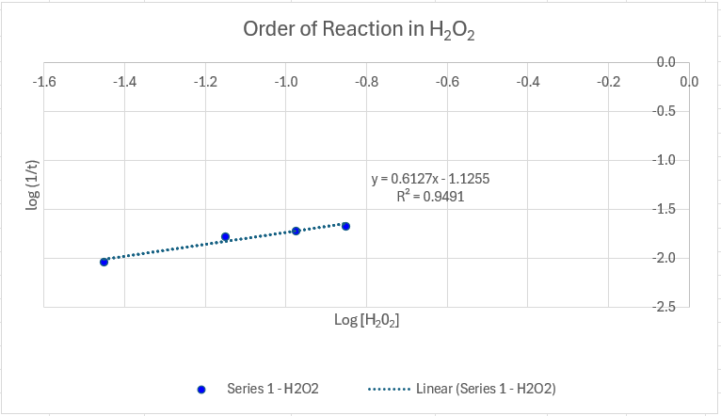
Figure 1 Series 1 esult - H₂0₂
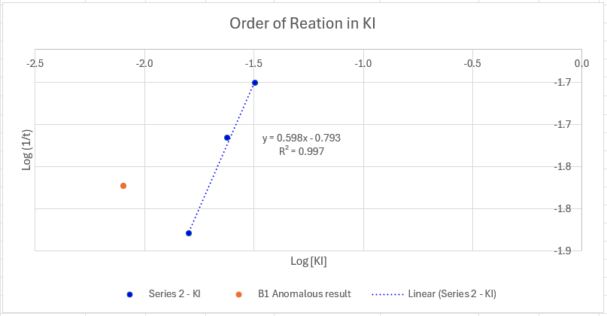
Figure 2 Series 2 Result – KI

Rate Constant - k
The rate constant k can be calculated using Equation 5, shown below for clarity.
$$k= \frac{(1/{time})}{([H_{2}O_{2}]^{m}[I^{-}]^{n})}$$
For experiment 1.1, this is as follows:
$$k= \frac{(0.00909)}{([0.0353]^{0.6127}[0.024]^{0.598})}$$
$$k=0.6561746$$
This is repeated for each experiment. The complete results are shown in Table 4 along with the average k.
Table 4 Average of k (rate constant)
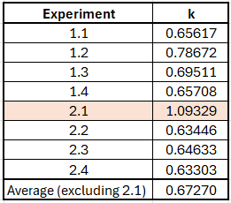
Averaged k for the two series of experiments is 0.67270, this is specific for this reaction. Experiment 2.1 is highlighted as it was identified as an anomalous results. This is discussed further in Appendix 3 – Anomalous Result.

Order of Reaction
The slopes of the log-log plots in Figure 1 and Figure 2 give the order of reaction with respect to H₂O₂ (m) and KI (n) respectively. These values correspond to the exponents of the concentration terms in the rate law. The overall order of reaction is the sum of these exponents.
$$rate=k{\left[A\right]}^{m}+{\left[B\right]}^{n}$$
Equation 9 Rate law equation
Where:
m = 0.6127 (H₂0₂)
n = 0.598 (KI)
Therefore:
$$Overall order reaction=m+n$$
Series 1 order of reaction = 0.6127
Series 2 order of reaction = 0.598
$$Overall order=0.6127 +0.598=1.21$$
Equation 10 Overall order of reaction
This indicates the order of reaction is neither first nor second with respect to either reactant. It exhibits non-linear (fractional) kinetics.
The overall order of reaction allows the units to be determined. The units for k depend on the order of the reaction [9].
$$Rate units=M∙L^{-1}∙ s^{-1}$$

And as the order is fractional, the following is used:
$$Units of k=M^{x-1}∙L^{1-x}∙ s^{-1}$$
Where:
x = 1.21
$$Units of k=M^{-0.21}∙L^{0.21}∙ s^{-1}$$

Rate Law
The rate law for this experiment has been determined.
Given:
Order with respect to H₂O₂ – m = 0.6123
Order with respect to KI – n = 0.598
Rate constant – k = 0.673
Therefore:
$$Rate=0.673*{\left[H_{2}O_{2}\right]}^{0.6123}*{[KI]}^{0.598}$$

Discussion

Experimental Error
The iodine clock experiment is inherently prone to experimental error. It involves measuring multiple reactants, visual observation of the colour change, and the need for accurate timing. Errors may also be introduced through environmental factors such as temperature changes. Table 5 lists sources of error in this experiment and makes suggestions for improvements. An in-depth discussion of these points can be found in Appendix 1.
Table 5 Experimental Error
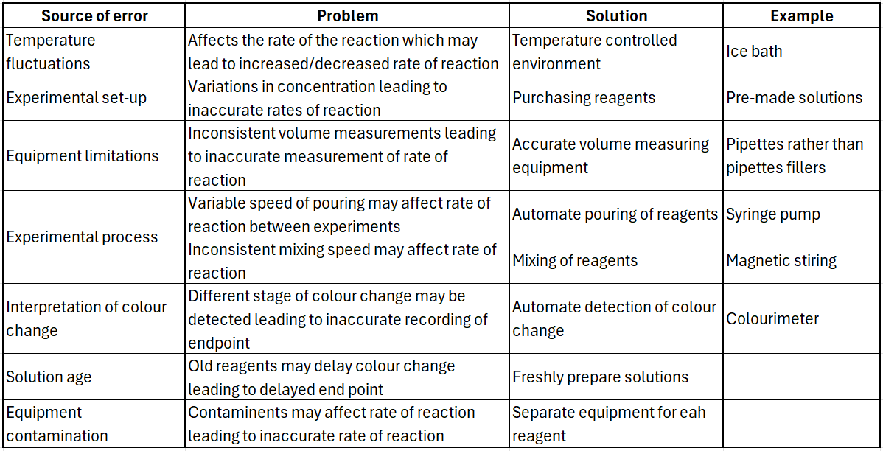

Experiment discussion
The iodine clock experiment successfully demonstrated the rate of iodine formation is dependent on the concentration of hydrogen peroxide and iodide ions. Reaction end point was visually monitored, and volume measurement method was not accurate. As discussed in 3.1 this can lead to experimental error and may have contributed to the anomalous result in series 2.
Log-log plots were used to determine the reaction orders, which were found to be neither first nor second order. The fractional orders of reaction were not expected and therefore further work is required. Repeat experiments using the same equipment would be an acceptable method, however, as discussed in Appendix 1, using more accurate equipment for the timing and volume measurements would provide greater confidence in the results.
Finally, performing the reaction at varying temperatures while keeping reactant concentration constant, would enable determination of activation energy (E_{a}) and the collision factor (A). Activation energy defined as the minimum energy required for a chemical reaction to occur [10], while collision factor represents the frequency of molecular collisions in a reaction and the probability of these having the correct orientation for a reaction to occur. Both are components in the Arrhenius equation which models the temperature dependence of the rate of reaction [11].

Conclusion
The results of this experiment support the initial hypothesis that the rate of the iodine formation is dependent on the concentration of hydrogen peroxide and iodide ions. As predicted, increase the concentration of either reactant resulted in an increase in the rate of reaction. This is seen with the decrease in time taken for the blue colour to appear.
Analysis of the results established the rate law to be:
$$Rate=0.673*{\left[H_{2}O_{2}\right]}^{0.6123}*{[KI]}^{0.598}$$
This confirms the prediction that higher concentrations of H₂O₂ or KI will lead to faster consumption of ascorbic acid, resulting in the accumulation of iodine which then reacts with starch more rapidly to produce the characteristic blue colour of the iodine clock reaction.

References

[1] | E.-F. Zhen, B.-Y. Liu, D.-C. Zhao, J.-Z. Zhu and Y.-X. Chen, “Determination of the reaction orders for electrode reactions,” Current Opinion in Electrochemistry, vol. 48, 2024.
[2] | K. A. Connors, Chemical Kinetics: The Study of Reaction Rates in Solution, Wiley, 1990.
[3] | J. Burés, “What is the Order of a Reaction?,” Topics in Catalysts, vol. 60, p. 631–633, 2017.
[4] | A. B. D. Nandiyanto, R. Ragadhita and M. Fiandini, “How to Calculate and Determine Chemical Kinetics: Step-by-Step Interpretation of Experimental Data to Get Reaction Rate and Order,” Indonesian Journal of Science & Technology, vol. 9, no. 3, pp. 759-774, 2024.
[5] | J. Akhavan, “Equilibria and Kinetics of Explosive Reactions,” in The Chemistry of Explosives, Royal Society of Chemistry, 2022, pp. 118-132.
[6] | B. Jin, J. Shen, X. Goa, R. Peng, S. Chu and H. Dong, “Synthesis, Characterization, Thermal Stability and Sensitivity Properties of New Energetic Polymers—PVTNP-g-GAPs Crosslinked Polymers,” Polymers, vol. 8, no. 10, 2016.
[7] | A. G. Harter, T. M. Klapötke, J. T. Lechner and J. Stierstorfer, “Kinetic Predictions Concerning the Long-Term Stability of TKX-50 and Other Common Explosives Using the NETZSCH Kinetics Neo Software,” Propellants, Explosives, Pyrotechnics, vol. 47, no. 7, 2022.
[8] | M. S. Miller and W. R. Anderson, “A Chemically Specific Burning Rate Preditor Model for Energeti Materials,” Army Research Laboratory, Maryland, 2001.
[9] | Khan Academy, “Units of the rate constant,” Khan Academy, [Online]. Available: https://www.khanacademy.org/science/ap-chemistry-beta/x2eef969c74e0d802:kinetics/x2eef969c74e0d802:introduction-to-rate-law/v/finding-units-of-rate-constant-k#:~:text=The%20units%20of%20the%20rate%20constant%2C%20k%2C,for%20a%20second%2Dorder%20reaction%2. [Accessed 13 11 2025].
[10] | I. W. M. Smith, “The temperature-dependence of elementary reaction rates: beyond Arrhenius,” Chemical Society Reviews, vol. 37, no. 4, pp. 812-826, 2008.
[11] | A. Mathur and S. Sur, Laboratory Techniques, New Dehli: Black Prints, 2002, pp. 18-25.
[12] | J. C. O. Young, “A Colorimetric Approach to Vitamin C Analysis,” The Chemical Educator, vol. 23, p. 96–98, 2018.
[13] | K. C. DeMella, N. Subraveti, K. Perry and S. P. Karna, “Capsules as Miniature Factories: On‐Demand Synthesis in Prepackaged Capsules Enabled by Switching on a Catalytic Reaction,” Advanced Functional Materials, vol. 18, p. 32, 2022.
[14] | J. Gao, “R-Squared (R2) – How much variation is explained?,” Research Methods in Medicine & Health Sciences, vol. 5, no. 4, pp. 104-109, 2023.
[15] | S. Nakagawa and H. Schielzeth, “A general and simple method for obtaining R2 from generalized linear mixed-effects models,” Methods in Ecology and Evolution, vol. 4, no. 2, pp. 133-142, 2013.
[16] | T. Zhang, M. H. Chen, X. B. Jia, H. N. Jia and Y. K. Chen, “The Application of Thermal Analysis to Research on Energetic Materials,” Advaned Materials Research, Vols. 250-252, pp. 1180-1183, 2013.
[17] | G. M. Nazin and B. L. Korsunskiy, “Determination of the Thermal Stability of Explosives,” Russian Journal of Physical Chemistry B, vol. 15, p. 271–277, 2021.
[18] | F. Krejčíř, J. Adam and R. Buldra, “Modeling of smokeless powders shelf life using results of multi-temperature study on stabilizer consumption,” in International Conference on Military Technologies (ICMT), Brno, Czech Republic, 2021.
[19] | J. S. Moore, K. D. Morrison, A. K. Burnham, A. Racoveanu, J. G. Reynolds, B. Koroglu, K. R. Coffee and G. L. Klunder, “TATB thermal decomposition: an improved kinetic model for explosive safety analysis,” in Next Generation Energetics: 2nd International Explosives Conference, Royal Society of Chemistry, 2025, pp. 142-152.
[20] | R. Mazumdar, “A Case for Chemical Kinetics in Explosives Ordnance Engineering,” in Australian Explosive Ordnance Safety Symposium, Canberra, 2024.
[21] | K.-T. Lu, K.-M. Luo, T. Yeh and P.-C. Lin, “The kinetic parameters and safe operating conditions of nitroglycerine manufacture in the CSTR of Biazzi process,” Process Safety and Environmental Protection, vol. 86, no. 1, pp. 37-47, 2008.

Appendix 1 – Experimental Error
A detailed discussion of sources of error for the Iodine clock experiment is shown below as a follow on from Table 5.
- Temperature changes – the rate of reaction is highly dependent on the ambient temperature and that of the solutions [10]. Higher temperatures will increase the rate of reaction, while lower temperatures will slow it down. Conducting the experiment in a temperature-controlled environment will help reduce this effect. This could be done simply, by using an ice bath.
- Experimental set-up – preparation of solutions of specific concentration and accurate measuring of small volumes are both prone to human error. These could be reduced by purchasing reagents at the required concentrations and by using more accurate equipment such as pipettes.
- Equipment limitations – the pipette fillers provided for this experiment are incredibly inaccurate and prone to human error [11]. Consistent and good technique is essential however, small variations in volume measurements will still be common. It is recommended that pipette fillers are not used for experiments requiring accurate volume measurements. Alternatively, pipettes can easily measure the smaller volumes required in this experiment – brands such as Gilson, VWR and Eppendorf all produce suitable manual and electronic options – noting that any equipment used should be regularly calibrated. Water could be accurately measured by weighing.
- Experimental process – combining the reagents manually introduced a potential variability in the speed at which the student poured. A syringe pump could help improve control but for a simple experiment, this may be excessive. Stirring the mixed reagents was also performed manually. In this case by the same person, for a measured amount of time in an attempt to reduce error. This could be further improved using a magnetic plate and stirrer, which should remain at the same speed for each experiment.
- Interpretation of the colour change – observation of the colour change is performed manually and is highly subjective. Using a colourimeter would eliminate this error [12]. This monitors the absorbance of the solution over time, producing an absorbance peak on a spectrum the moment the solution turns blue. Data analysis is slightly more complicated; however, the final data will be more consistent and accurate.
- Solution age - it is not clear if the solutions were freshly prepared or made in advance of the laboratory session. Older samples may weaken the colour change, resulting in slower observation of the colour.
- Equipment contamination - equipment was reused with only simple washing between experiments and rinsing with deionised water. If this was not performed thoroughly residual contaminants may be introduced to the subsequent experiment which could affect the rate of reaction. Ideally, separate equipment should be used for each reagent, to reduce the risk of contamination.
For all of the above, a balance must be struck between the level of accuracy required and the availability and cost of more sophisticated equipment.

Appendix 2 – Methodology

Chemicals and equipment
- 0.20 M KI solution
- 0.01 M ascorbic acid solution
- 1% starch indicator
- Distilled water
- 3% H₂O₂ solution
- 4 x 50 ml conical flasks
- 2 x glass pipettes
- Small beakers
- Test tube
- Stopwatch
- Glass stirring rod
- Personal protective equipment – laboratory coat, safety glasses, gloves

Procedure
Figure 3 is a basic schematic of the experimental set up showing H₂O₂ in one beaker and the remaining reagents in another beaker, with the colour change appearing after a time.
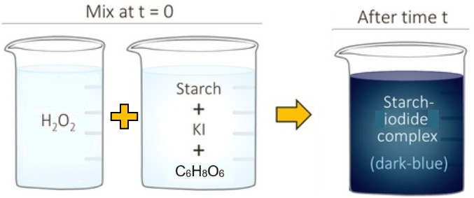
Figure 3 Diagrammatic representation of experimental set-up - adapted from [13]
Note for both series – the timer should be started as soon as both solutions are mixed and the solutions stirred for a set amount of time (i.e. 25 seconds).
Experimental set up:
The process below is repeated for each series – note the different volumes of each reactant between series, shown Table 6 and Table 7. Table 8 is provided for the recording of results.
- Take four conical flasks, label them according to the experiment numbers (1.1 – 1.4), label the beaker and test tube with ‘H₂O₂’.
- Prepare solution A - using a glass pipette measure the required volume of KI and ascorbic acid into the flask. Using the sales, measure the required volume of water.
- Add 1 ml of the starch solution to the same flask.
- Prepare solution B - using the second pipette, measure the required volume of H₂O₂ into the test tube.
- Ensure the stop clock is set to zero.
- Pour solution B from the test tube into solution A in the flask and start the stop clock. Using the glass stirring rod stir the mixture for the decided time.
- Observe the mixture until the blue colour appears. Promptly stop the stop clock.
- Dispose of the solution down the sink, wash all equipment before rinsing with deionised water.
Table 6 Required volumes for each series 1 experiment
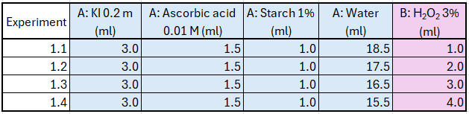
Table 7 Required volumes for each series 2 experiment
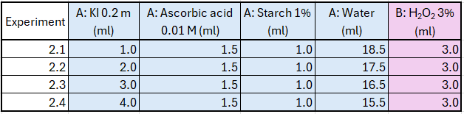
Table 8 Blank results table
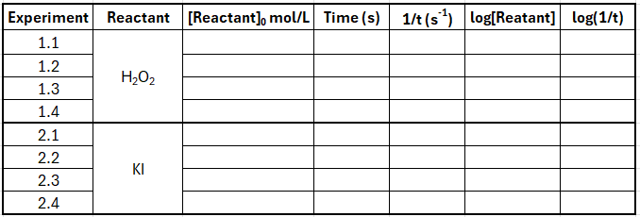

Appendix 3 – Anomalous Result
It was clear from looking at series 2 results that there was a deviation from the expected straight line, indicating an anomalous results. The rate-concentration relationship should produce a straight line when log[reactants] is plotted against log(1/t). By calculating the coefficient of determination (R²) after omitting each result, the anomalous result was determined to be 2.1 as this produced an R² value closer to 1 than by omitting 2.2 [14] [15]. This is shown in Figure 4 and Figure 5 where:
2.1 omitted R² = 0.997
2.2 omitted R² = 0.8717
Consequently, 2.1 was omitted from further calculations.
Figure 4 Series 2 results - 2.1 omitted
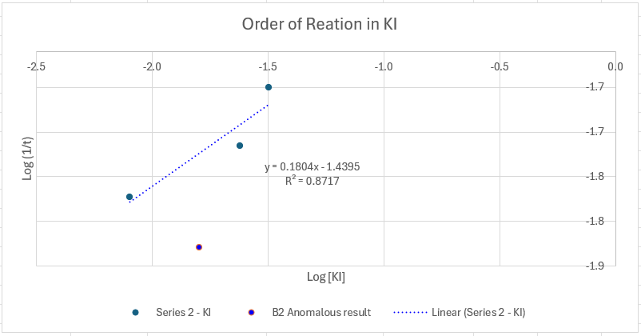
Figure 5 Series 2 results - 2.2 omitted

