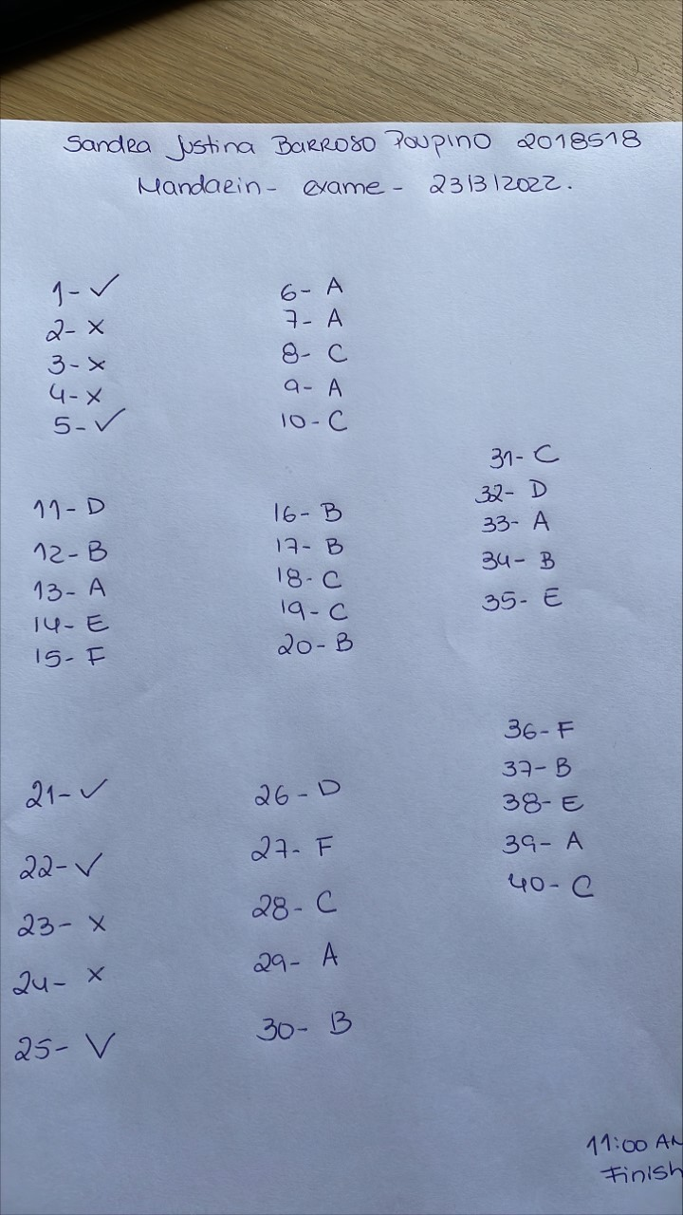
Sandra Poupino 2018518
Foreign Language & Cultural Awareness
Final Exam
Jinping Li
Hope I have done Enough , Thank you !

