BIM-ACBA 5010
Sam Tucker
2018390
BIM-ACBA 5010
Client Letter
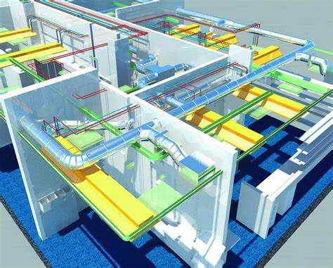


TM Solutions Ltd

Tucker Management Solutions Ltd
105 Lime Street, SA4 4 EF
01792 234343
TMSolutions@Gmail.com

Carmarthen County Council
County Hall, Caste Hill, SA31 1JP
22nd December 2022

Dear Recipient:

I am writing to you today regarding the proposed development of Ysgol Glangwili. I would like to thank you for your invitation to tender. Under the Government’s Strategy in May 2011, it states all public sector Projects to be completed at BIM maturity level 2 as a minimum by 2016.
BIM levels promotes collaborative working. The progressive milestones are defined as differing levels, which are based on differing levels of collaboration actioned by these millstones. These levels are grades 0-3. The level of maturity I propose for this project is that BIM levels promotes collaborative working. The progressive milestones are defined as differing levels, which are based on differing levels of collaboration actioned by these millstones. These levels are grades 0-3. The level of maturity I propose for this project is that of level 2. This level of collaboration gives each stakeholder its own 3D CAD model and requires streamlined information exchange related to a project and seamless coordination between all the systems and the stakeholders (BIM, BIM Maturity Levels Explained- Level 0, Level 1, Level 2, Level 3, 2023). See figure 1 in Appended document for BIM maturity level diagram. BIM maturity requires the exchange of information between all the parties involved while operating or developing a built assets at specific milestones or exchange points. The “British Standards Institution suggests that BSEN 1192-2014 defines expectations for exchange of information throughout the lifecycle of a facility “ (buildings, 2020).The collaboration will only be successful when each participants contribution to the Ysgol Glangwili project is clearly defined. The level of definition during BIM level 2 includes the quality of information that is linked or embedded to differing categories of elements in the chosen federation model. The level of definition at

at each stage needs to be agreed and the purpose intending to establish the extent each project member that is contractually obliged to develop elements within the model, and linking the aspects of design, construction and facilities management to that model, along with gauging to what extent elements from each model along with their associated data needs to be relied on by other members of the team. This can be completed by the use of a Model Production and Delivery table, which is a management tool for assigning responsibility to all the project members for adding the increased definitive information and geometric detail to varying elements within the 3D model, along with 3D coordination. The level of definition will be an estimate that comprises two gauges of design development, these being LOD and LOI, whereas the level of detail is mainly related to only the geometric representation of the elements within the model and the level of information referring to text and numbers that are correlated to those elements. This should help the development of Ysgol Glangwili in establishing the completeness of the model elements and what data is required needed for the formal issue to each project team member at each data point drop or milestone.
Software used to create each model can be different. There is no standard documentation stating all project members need to use the same software, and tools used to produce or update models should be the best suited to their respective specialties. However, all must be capable of being exported to a common format that allows them to get combined (Shepard, BIM Management handbook, 2020) For this project I propose A-Site as the working platform to be used and will be highlighted within the BEP, this is because BSEN 19650-3:2020 states a common data environment should be established by the appointing party in accordance with BSEN 19650-1:2018 clause 12 (BSI, BSEN ISO 19650-1:2020, 2020).
As the lead Consultant, I will comply with BSEN ISO 19650-3:2020 by nominating individuals within my organisation to “undertake the information management function on behalf of its delivery team” (BSI, BSEN ISO 19650-1:2020, 2020)Thus, ensuring the capacity and capability of individuals or third party that have been appointed to undertake the information management function. Within the information management the levels of details will be agreed. Appended to this letter is a report highlighting the level of information need and its collaboration with the RIBA seven stages and the alignment of information exchanges at completion of each stage. See appended document.
My lead as appointed party will also review the delivery of a BIM execution plan for describing the approach that will be taken to the project along with confirming the resources required to fulfil the level of requirements that you the client will set out in your Exchange information requirements document are met, thus meeting the objectives you have set out in your OIR. I shall communicate the BIM execution plan to all relevant parties and actors and constantly review. The BEP will be a response to the clients EIR and include the timing, quantity and scope of information exchanges. The use of a BEP will confirm details of any clash detection processes and any associated workflows, any collaboration processes that need to be met under the requirements in BS1192 for Common Data Environment, which will include the

frequency of exchanged data, details of model review workshops, the form of sharing to be used and extent of the model used for increased or reduced level of detail.
Under CDM, health and safety obligations will also need to be met and the need for detailed BIM enabled processes will be used to manage employees, the overview of key health and safety deliverables will be used at each stage, how they are stored and any critical path or disaster planning that may be needed. As the lead consultant competency of the team can be obtained by using the PAS 1192-6 that gives guidance on how “health and safety information is produced, flows, and can be used throughout the project and asset lifecycle. While all H&S risk information can be included within an information model” (BSI, PAS 1192-6 , 2018)The standard also requires the contextualization and filtering of any hazards or risks to prioritize the heightened risks and aspects that are safety-critical. Under PAS1192-5, the need for security of personal data is also needed and this will be provided to you within the BEP. BSEN ISO 19650-5 also highlights information management using building information modelling for the security minded approach to information management. (BSI, BSEN ISO 19650-1:2020, 2020)
A compliance plan will be completed confirming within the BEP, the intentions to comply with the EIR and all appropriate standards and the intended approval and authorization process for the delivery of Ysgol Glangwili.

Yours sincerely
MR SAM TUCKER
Director

Appended Report

Level of information need

Sam tucker- 2018390

Table of Contents
1.0 Executive Summary 6
2.0 Procedure 6
3.0 Findings 6
3.1 BIM overview 6
3.2 Level of information need 7
3.2.1 Level of detail 9
3.2.1.1 Geometrical information 10
3.2.1.2 Alphanumerical information 11
3.2.2 Level of information 11
3.2.2.1 Documentation 12
3.4 RIBA stages 13
4.0 Conclusion 14
5.0 References 15
6.0 Appendices 16
Appendix A- Cost and Program LOD example 16
Appendix B- Short sample of maintainable Items within a model in EIR 17
Appendix c- Case study Production and Delivery table 18

Executive Summary

This report is an appended document to the Client letter which highlights the authors BIM maturity understanding, associated standards and how information gets managed, coordinated and shared and the use of a BIM execution plan (BEP). The report will define the level of information need throughout the RIBA stages assets Lifecyle model and the appropriate standards using industry examples. For the purpose of the reader, referencing from the client letter will be shown at the end of this report, along with any figures referenced within the letter.

2.0 Procedure

This report has content derived from the background research from books, Journals, online resources, revision of corresponding course lecture notes, The CIS and published British Standards.

3.0 Findings

3.1 BIM overview

Building information modelling is a process that “encourages collaborative working between all the disciplines involved in design, construction, maintenance and use of buildings. All parties share the same information simultaneously, in the same format” (CITB, 2023). The value of BIM is in giving a graphical in which all specialised data for any area or element in a proposed building is immediately accessible to all of the users involved (Shepard, BIM Managment Handbook, N.D).The levels of BIM maturity are shown in Figure 1.

Figure 1
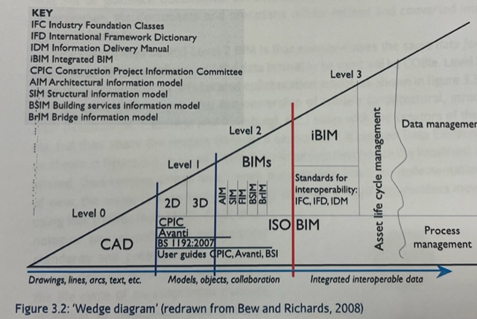
(Kumar, 2015)

3.2 Level of information need
Classification of the level of information needed and its subdivision stated in the BSEN 17412-1:2020, describes the level of information need as a framework defining to what extent and granularity of information to be exchanged. In Compliance with this standard, the level of information need should be described by different concepts. These being Geometrical information, alphanumerical and documentation, as shown in figure 2.

Figure 2
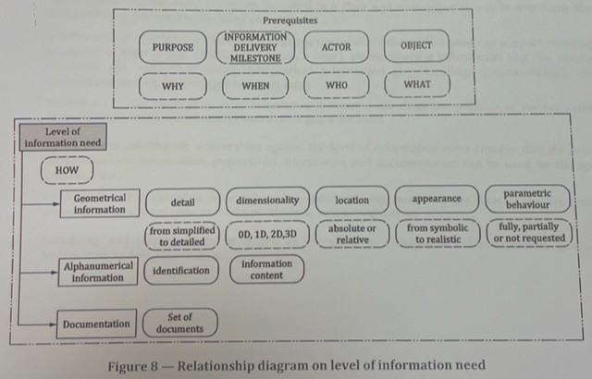
(BSI, BSEN 17412-1:2020, 2020)
The level of information needs to be specified and the need for knowing how that information will be delivered. A framework can be used for specifying level of information need. This includes the purpose for the information use, information delivery milestones, the actors in which the information will be delivered along with who requests the information and the objects organised in more or one breakdown structure. The purposes need to be considered. These need to be specified to clarify what, why and how the information being gathered is needed and for the purposes only. However, the information need will not specify these purposes directly (BSI, Building information modelling-Level of information need part 1, 2020). BIM data can be verified by the use of the BIM toolkit. The BIM toolkit is a portal where the data can be verified against defined standards for modelling and embedded information. The toolkit aids defining the level of definition needed to be included inside the model at each data drop, and also helps to verify the correct level of information is present. To be able to establish projects are validated and controlled as they develop, information within the building information model will be extracted and submitted to the employer as agreed at the key milestones. These milestones are usually defined as data drops in industry. Data drops are a “release of defined information in accordance with the development of the project as set out withing the employer’s information requirements (Shepard, BIM Management handbook, 2020, p. 145).These data drops align to the different stages of the project and the level of information shared at the milestones reflects the agreed level of development that should be completed by the end of each stage. The data drops include data structures such as the COBie files. Although COBie does not increase level of information need and only structures the information in a more accessible format, it aids recording all the important data for the project at the point of origin. These include product data sheets, warranties, maintenance schedules and equipment lists. COBie data not only provides an organised summary for all the end users, once verified it becomes an asset database for the handover to the facilities management (Shepard, BIM Management handbook, 2020). The Government soft landing systems can be adopted by the client to ensure the transition from construction completion to handover and occupation runs smoothly, thus the overall operational performance of the asset is optimised (Wiki, 2021). Level of information need can be split into two characteristics. Level of detail and level of information, as described below.

3.2.1 Level of detail

Level of detail also called LOD, is used to define the amount of information for a building that needs to be inputted into the BIM model. It can be classed as a framework that specifies the development of the BIM model, that includes geometrical and alphanumerical information that helps coordination and communication between project members. Figure 3 shows an example of associate purpose of scope and level of detail.

Figure 3
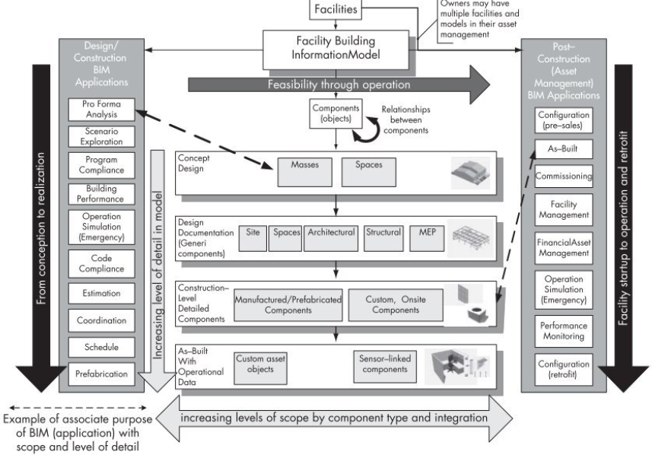
(al, 2011)

3.2.1.1 Geometrical information

Geometrical information is the description of details and extent of information expressed using dimensions, shape, location and appearance and detail. As the continued level of information need grows throughout the project, depending on the required purpose and delivery milestone, more refined geometric representation can be shown as seen in figure 4 that shows the progression detail of a door (BSI, BSEN 17412-1:2020, 2020).

Figure 4
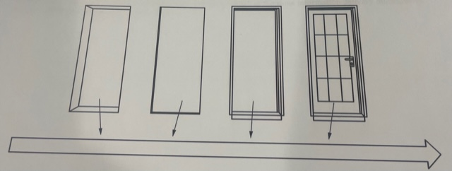
(BSI, Building information modelling-Level of information need part 1, 2020, p. 11)

3.2.1.2 Alphanumerical information

Alphanumerical information, which can be described as information expressed using symbols, digits, mathematical symbols or punctuation marks. (LOD1) Objects start conceptually, (LOD2) then develop into generic representations, (LOD3) further developing and further matching the geometry of the specified element (LOD4). The last Level of detail (LO5) is finally developed to support all the details for the construction and all installation documents (BIM, United BIM, 2023)

3.2.2 Level of information

Level of Information Is classed as a non-graphical equivalent of the process described in 3.2.1. Elements start with an outline description (LOI2), further developing to include performance measures (LOI3), then developed further including information on the specified element or product (LOI4), then finally developed to include information on any associated products (LOI5), and finally developed to include installation and maintenance information for the built asset (LOI6). Cost and Programming can also be added into the model in the EIR and stages develop as per the LOD (BIM, United BIM, 2023)This can be seen in Appendix A.

3.2.2.1 Documentation
Documentation describes all the documentation related to the project that could include support processes, decisions, and all approvals and verification of information deliverables. Examples of this in industry are that of survey reports, soil sample reports, geotechnical reports, specifications, user manuals and maintenance manuals or photographs (BSI, BSEN 17412-1:2020, 2020). Appendix B shows a table of maintainable items from a case study on Pembrey school. The Level of need for this element will increase throughout the project and need for more complex information will be needed. However not all project members would need this level of information. For example, an architect would not need to know the full details of electrical component documentation at stages 1-3, however the information would be critical for the contractor and Facility management during stages 5-7, these being construction, handover and in use. although, all model elements needed throughout the lifecycle needs to be included in the EIR.

All three of these concepts address a specific purpose at a specific agreed date or delivery milestones. The level of information need offers approaches or methods for describing how information will be exchanged or delivered according to the clients exchange information requirements (EIR). The EIR will specify the wanted information exchange and this can be defined as the process of information delivery which is applicable to the whole life cycle of the built asset. All of the above which can be linked to the RIBA plan of works (Institute, 2020) Figure 4 shows where the above lie in coordination with the main concepts related to information exchange included in the BSEN 19650-1 standard and exchange information requirements. Appendix C shows a product and delivery table from a case study of a new school development in Pembrey. The model shows the overall content on the left and information within the table showing the level of detail over six stages along with the model originator. This table clearly shows an increase in LOD needed as the project progresses along with the designated project team member the information should be sent to. This is a document used within the EIR from Carmarthenshire city council.
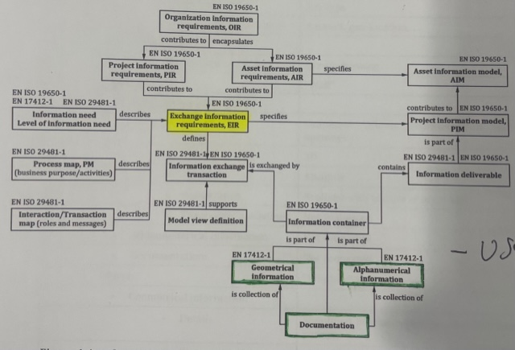
Figure 4

(BSI, Building information modelling-Level of information need part 1, 2020)

3.4 RIBA stages

With the success of a project being at the forefront of the clients’ proprieties, it is vital a detailed plan of work and BIM implementation is used to highlight the needs for information at desired stages. The RIBA plan of work 2013, Figure 5, is well suited to BIM, as is the AIA scheme, but must align. They may not necessarily align with each RIBA stage however; it is vital all information is delivered at the correct milestones and in the agreed format set out in the EIR. The information needed can be variable depending on client’s needs. To eliminate incorrect data being shared at incorrect stages and to the incorrect Project team members, it is vital the EIR states the exact actor and LOD at each point.

Figure 5
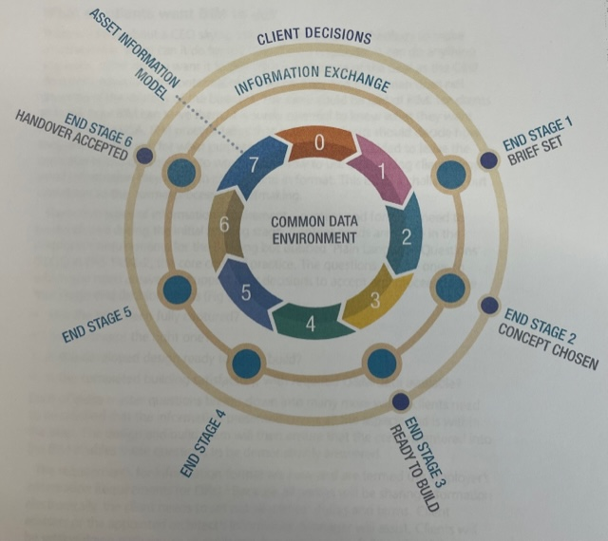 (Saxon, N.D)

4.0 Conclusion

To conclude this report, from the findings and researched examples used in industry, the author can identify the level of information needed by the client can vary at each data drop depending on the project. However, it is vital all levels of information need in the clients EIR, must be clear, have agreed milestones and one common data environment. A lack of user control, the lack of Addressing the BEP, lack of model element detail or even over detailed input can result in failings in the delivery of the asset.

5.0 References
al, C. E. (2011). Bim Handbook. Hoboken: John Wiley & Sons.
BIM, U. (2023, January 4th). BIM Maturity Levels Explained- Level 0, Level 1, Level 2, Level 3. Retrieved from United BIM: https://www.united-bim.com/bim-maturity-levels-explained-level-0-1-2-3/
BIM, U. (2023, January 10). United BIM. Retrieved from BIM Levdel of development: https://www.united-bim.com/bim-level-of-development-lod-100-200-300-350-400-500/
BIM, U. (2023, January 11). United BIM. Retrieved from a practical approach to level of detail: https://www.united-bim.com/practical-approach-to-level-of-detail/#:~:text=The%20Level%20of%20Detail%20%28LOD%29%20is%20to%20define,but%20also%20the%20data%20associated%20with%20the%20objects.
BSI. (2018). PAS 1192-6 . British standards institue.
BSI. (2020). BSEN 17412-1:2020. BSI.
BSI. (2020). BSEN ISO 19650-1:2020. BSI.
BSI. (2020). Building information modelling-Level of information need part 1. BSI.
buildings, D. (2020, January 8). cohesive BIM. Retrieved from Level of information: https://www.designingbuildings.co.uk/wiki/Level_of_information_need
CITB. (2023, January 10). Building Information Modelling (BIM) is a way of working together, a process for creating and managing all of the information on a construction project. Retrieved from What is BIM: https://www.citb.co.uk/about-citb/partnerships-and-initiatives/building-information-management-bim-for-site-workers/what-is-bim/
Council, C. C. (2018). Pembrey . Carmarthen: Cararthen City Council.
Institute, B. S. (2020). Building Informtion Modelling- Level of Information Need. BSI Standards Limited 2020.
Kumar, B. (2015). A practical guide to adopting BIM in construction projects. Dunbeath: Whittles Publishing.
Saxon, R. (N.D). BIM For construction clients. RIBA .
Shepard, D. (2020). BIM Management handbook. NBS.
Shepard, D. (N.D). BIM Managment Handbook. RIBA Publishing.
Wiki, B. (2021, September 15). Cohesive BIM. Retrieved from BIM Level 2: https://www.designingbuildings.co.uk/wiki/BIM_level_2

6.0 Appendices

Appendix A- Cost and Program LOD example

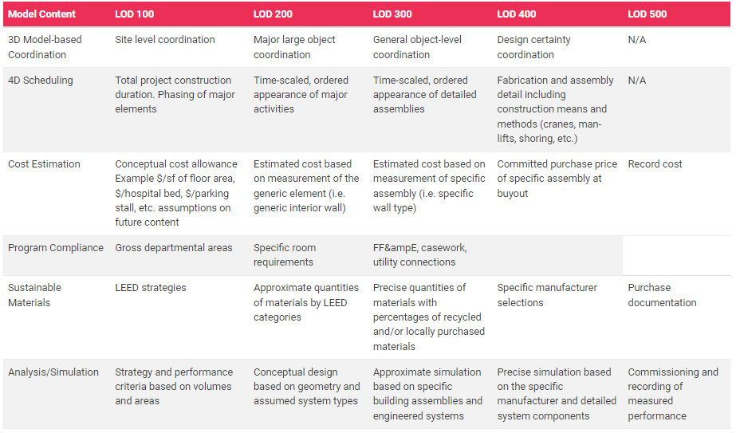

(BIM, United BIM, 2023)

Appendix B- Short sample of maintainable Items within a model in EIR

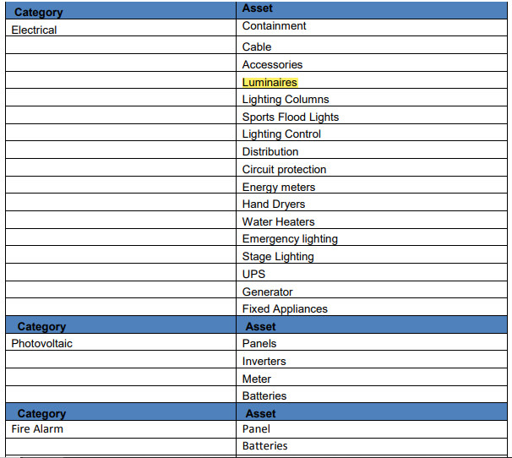
(Council, 2018)

Appendix c- Case study Production and Delivery table

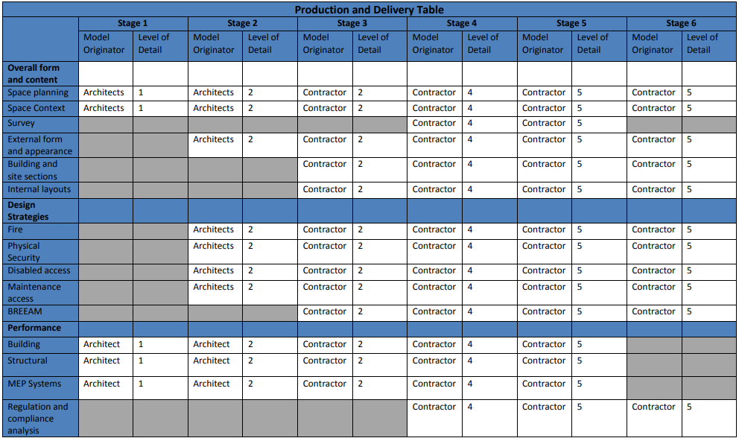
(Council, 2018)

