Coursework Title
Module Name: Computer Architecture and Operating Systems

Module Code:(ACCA4022_BIRM)
Student Name:MUHAMMAD SHAHID
Student ID:2507804
Lecturer Name: SHAH ROOM

Submission date:

Contents
Introduction 4
Key functions of general Operating Systems 4
Task Management: 4
Application/Program Management: 4
File/Directory Management: 5
Device Management: 5
Security Management: 6
Use of Windows OS CLI commands 7
Example 1: 7
Example 2: 7
Example 3: 8
Example 4: 8
Example 5: 8
Example 6: 9
Example 7: 9
Example 8: 10
Example 9: 10
Example 10: 11
Use of Linux OS CLI commands 11
Example 1: 11
Example 2: 12
Example 3: 12
Example 4: 13
Example 5: 13
Example 6: 14
Example 7: 14
Example 8: 15
Example 9: 15
Example 10: 16
Use of Windows OS scripts 16
Example 1: 16
Example 2: 17
Use of Linux OS scripts 18
Example 1: 18
Example 2: 19
Conclusion 20
References 20
Appendices 21

Introduction
This course is part of the MSW capstone experience. Students apply their knowledge and skills in this advanced, concentration specific, field practicum. Students integrate and apply the material learned in the classroom and in the foundation internship/BSW Internship. Students can demonstrate all nine practice competencies and behaviors in the Advanced field internship. The Field Seminar offers students the opportunity to address questions and challenges experienced in the social work agency field placement, and integrate practice, policy and research. Students will develop their capacity as leaders in the field and contribute to the welfare of the agency through integration of advanced practice methods. 5 credits Prerequisite: Completion of the Foundation Curriculum/Admission to the Advanced Standing Curriculum. Secured a field placement practicum through the field placement process.

Key functions of general Operating Systems
Write an introduction about windows operating system when it came, importance, functions.
Introduction to the Windows Operating System
The Windows Operating System, developed by Microsoft Corporation, was first introduced in November 1985 as a graphical user interface (GUI) extension for MS-DOS. Over the decades, it has evolved into one of the most widely used operating systems in the world, powering personal computers, laptops, tablets, and even some embedded systems. Its user-friendly interface, broad compatibility, and continuous innovation have made it a cornerstone of modern computing.
‌

Task Management:
Task management is performed ctrl+alt+delete is page coming and all detail.for example

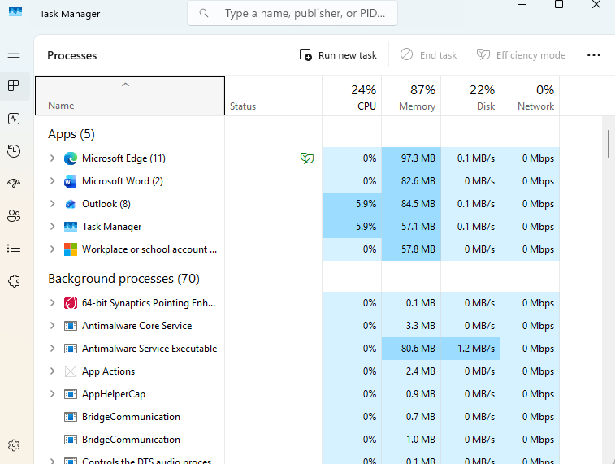

Application/Program Management:
Application and Program Management in Windows
Managing applications in Windows is a core part of keeping a system organized, secure, and running smoothly. Windows provides several built-in tools and settings that help users install, update, troubleshoot, and remove software. Each component plays a different role, and understanding them makes it easier to maintain a healthy system.
Installing Applications
Windows supports multiple installation methods:
- Microsoft Store Offers curated, verified apps with automatic updates and simplified installation.
- Executable installers (.exe, .msi) Common for desktop software. These installers often include setup wizards, license agreements, and customization options.
- Portable applications Apps that run without installation. They don’t modify system files or the registry, making them easy to move or delete.
Managing Installed Programs
Windows centralizes application management through several interfaces:
Settings App → Apps & Features
- View all installed applications.
- Uninstall programs.
- Move or modify supported apps.
- Manage optional features and app execution aliases.
Control Panel → Programs and Features
- Legacy interface still used for many traditional desktop applications.
- Allows uninstalling, repairing, or changing installed programs.
- Useful for software that installs system-level components.
Updating Applications
Keeping software updated improves security and performance.
- Microsoft Store apps update automatically unless disabled.
- Windows Update can deliver updates for Microsoft products and some drivers.
- Third-party apps often include built-in updaters or require manual downloads.
Startup Application Management
Too many startup apps can slow down boot time.
- Task Manager → Startup tab Enables or disables programs that run at startup and shows their performance impact.
- Settings → Apps → Startup Provides a simplified list of startup-enabled apps.
Background App Permissions
Windows allows users to control which apps run in the background:
- Reduces battery usage on laptops.
- Improves performance and privacy.
Uninstalling and Cleaning Up
Removing unused programs frees disk space and reduces clutter.
- Apps & Features for modern apps.
- Programs and Features for traditional software.
- Disk Cleanup or Storage Sense to remove leftover files.
- Third-party uninstallers (used cautiously) can remove residual registry entries.
Advanced Tools for Program Management
- Task Manager Monitors running processes, resource usage, and allows force-closing unresponsive apps.
- System Configuration (msconfig) Manages boot options and advanced startup settings.
- Registry Editor Stores configuration data for installed programs (advanced users only).
- Group Policy Editor (Windows Pro/Enterprise) Controls software installation rules and restrictions across a system or network.
Why Application Management Matters
Effective program management:
- Improves system performance.
- Enhances security by removing outdated or risky software.
- Reduces storage waste.
- Helps maintain system stability

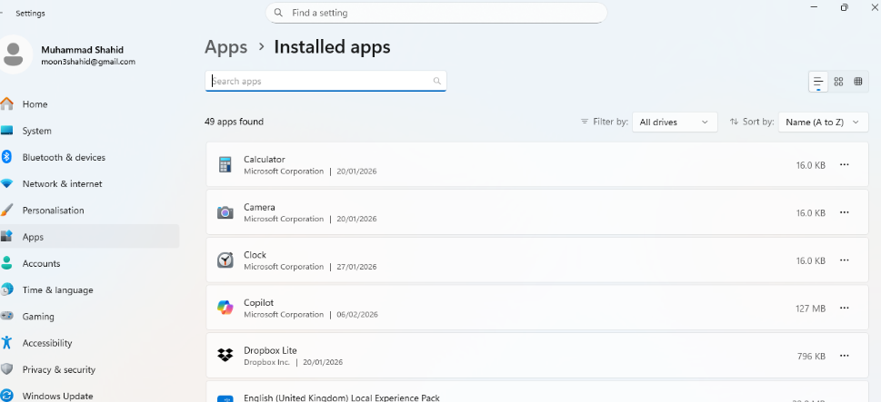

File/Directory Management:
File and directory management in Windows involves organizing files and directories to enhance e Windows stores data in a hierarchical structure. At the top are drives (like C:), inside them are folders (directories), and inside those folders are files. Managing them effectively means knowing how to create, move, rename, organize, search, and protect your data .
Drives
- Represent storage locations such as internal disks, USB drives, or network locations.
- Common examples: C: (system drive), D: (data drive), removable drives.
Folders (Directories)
- Containers that help organize files.
- Can be nested to create a structured system.
- Examples: Documents, Pictures, Downloads, or custom folders you create.
Files
- Individual items such as documents, images, videos, applications, or system components.
- Identified by extensions like .docx, .jpg, .exe, .txt.
Essential File/Directory Operations
Creating
- Right-click → New → choose Folder or a file type.
- Keyboard shortcut for a new folder: Ctrl + Shift + N.
Renaming
- Right-click → Rename.
- Or select the item and press F2.
Copying and Moving
- Copy duplicates; Move relocates.
- Drag-and-drop works, but keyboard shortcuts are faster:
  - Ctrl + C to copy
  - Ctrl + X to cut (move)
  - Ctrl + V to paste
Deleting
- Delete key sends items to the Recycle Bin.
- Shift + Delete removes permanently.
Searching
- Use the search bar in File Explorer.
- You can search by name, file type, date, or even content.
Sorting and Filtering
- File Explorer lets you sort by name, size, type, date modified.
- Filters help narrow down large folders quickly.
Tools Windows Provides
File Explorer
The main interface for browsing and managing files. It includes:
- Navigation pane
- Address bar
- Ribbon/command bar
- Preview pane
- Search box
Quick Access
- Shows frequently used folders and recent files.
- You can pin your favourite folders for faster access.
Libraries
- Virtual collections (Documents, Pictures, Music, Videos) that gather content from multiple locations.
Command Line Options
For more advanced users:
- Command Prompt (commands like dir, copy, move)
- PowerShell (cmdlets like Get-ChildItem, Copy-Item, New-Item)
- Windows Terminal brings these together in one place.

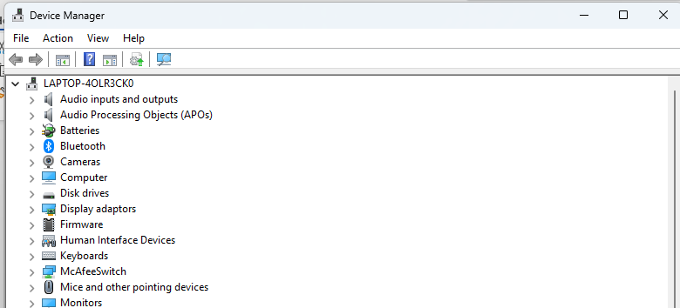

Device Management:
Device management in Windows refers to the tools, features, and processes used to control, monitor, configure, and maintain hardware devices connected to a computer. These devices include components such as keyboards, printers, graphics cards, storage drives, network adapters, and other peripherals. Effective device management ensures that hardware works correctly, remains secure, and performs efficiently.
What is device management?
In general, device management allows administrators or users to track, secure, update, and configure devices connected to a system. It helps ensure that devices run the correct software, receive security updates, and comply with policies or system requirements.
Device Manager in Windows
The primary built-in tool for managing hardware in Windows is Device Manager. It is a system utility that displays all hardware devices installed on the computer in a structured list.
Using Device Manager, users can:
- View all connected hardware devices
- Install, update, or remove device drivers
- Enable or disable specific devices
- Check device status and troubleshoot problems
- View technical details and properties of devices
If a device has an issue, Device Manager usually displays a warning symbol next to it and provides an error message to help identify the problem.

Security Management:

Security management in Microsoft Windows refers to the set of tools, policies, and features that protect the operating system, data, and users from unauthorized access, malware, and other threats. Windows includes built-in security mechanisms that help administrators and users maintain a secure computing environment.
1. User Account Control (UAC)
User Account Control is a core Windows security feature that prevents unauthorized changes to the system. When an application tries to make system-level changes, UAC prompts the user for permission or administrator credentials. This reduces the risk of malware silently installing or modifying critical settings.
2. Windows Defender and Antivirus Protection
Windows includes Microsoft Defender Antivirus, which provides real-time protection against viruses, spyware, ransomware, and other malicious software. It automatically scans files, monitors system behavior, and updates virus definitions through Windows Update to stay protected against new threats.
3. Windows Firewall
Windows Firewall helps block unauthorized access to the computer from networks or the internet. It monitors incoming and outgoing network traffic and allows users or administrators to define rules that permit or block specific programs or ports.
4. BitLocker Drive Encryption
BitLocker is a full-disk encryption feature available in certain editions of Windows. It protects data by encrypting the entire drive, ensuring that even if the device is lost or stolen, the data remains inaccessible without the proper authentication key.
5. Windows Update
Windows Update is essential for security management because it delivers patches and updates that fix vulnerabilities and improve system stability. Keeping Windows up to date helps protect against known exploits and cyberattacks.
6. Group Policy and Security Policies
Group Policy is a management tool used mainly in enterprise environments. It allows administrators to control security settings across multiple computers, such as password policies, user permissions, software restrictions, and network configurations.
7. Access Control and Permissions
Windows uses file and folder permissions to control who can read, write, or execute data. These permissions are based on user accounts and groups, ensuring that only authorized individuals can access sensitive information.
8. Windows Hello and Authentication Methods
Windows supports multiple authentication methods, including passwords, PINs, fingerprints, and facial recognition through Windows Hello. These options provide stronger and more convenient user authentication.

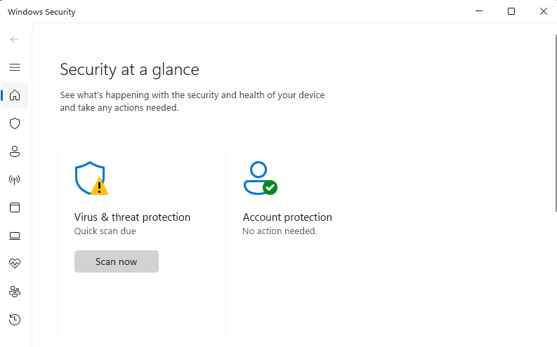

Use of Windows OS CLI commands

Example 1:
The dir command is a built-in utility in Windows Command Prompt used to display the contents of a directory. It lists files, subdirectories, and their attributes, making it a powerful tool for navigating and managing files in the command-line interface.
Syntax
The general syntax for the dir command is

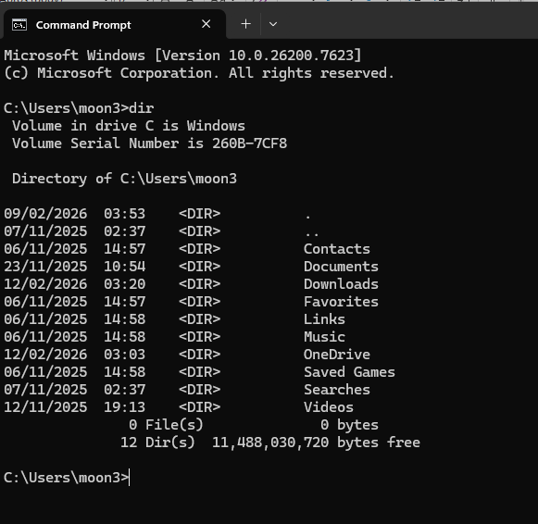

Example 2:
The seconds commands is arp. The arp command is used to display or change entries in the ARP cache.
ARP commands are used to view or manage the Address Resolution Protocol (ARP) table on a device.
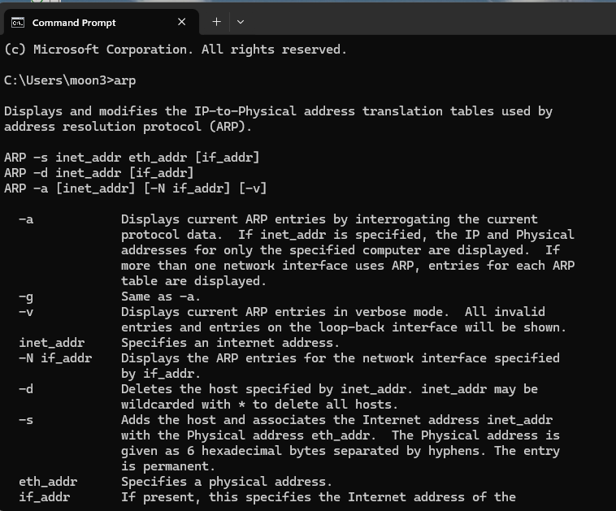

Example 3:
the call command is used to run a script or batch program from within another script or batch program. The call command has no effect outside of a script or batch file. In other words, running the call command at the Command Prompt or MS-DOS prompt will do nothing.

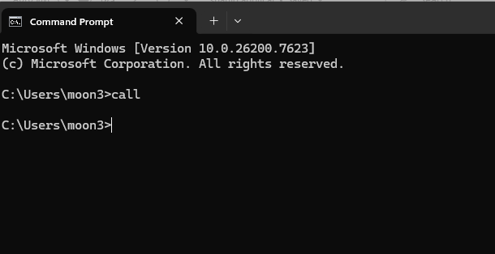

Example 4:
- Shutdown The shutdown command allows you to shut down, restart, or log off your computer. For example to shut down your PC, you can use shutdown /s

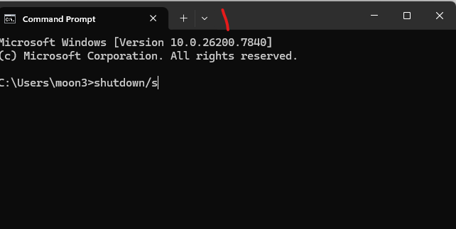

Example 5:
- Ping The ping command tests the connectivity between your computer and another device on the network. For example, to ping a website:

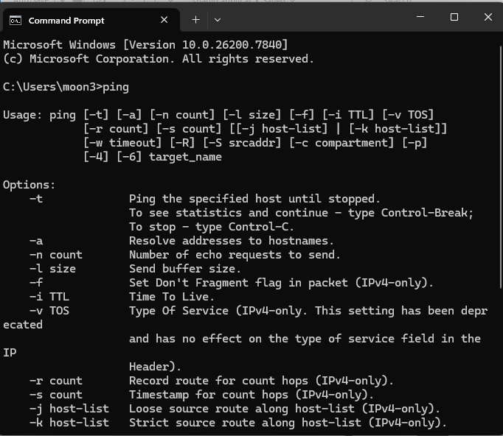

Example 6:
- Systeminfo The systeminfo command provides detailed information about your computer's hardware and software configuration. To view system information, use:

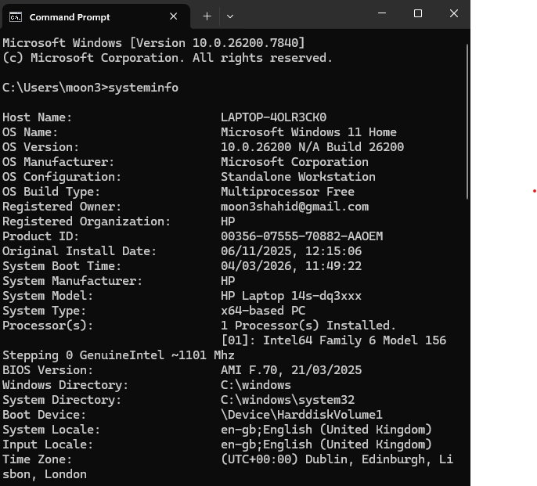

Example 7:
- Tracert The tracert command traces the route that packets take to reach a destination. This is useful for diagnosing network issues. For example, to trace the route to a website:

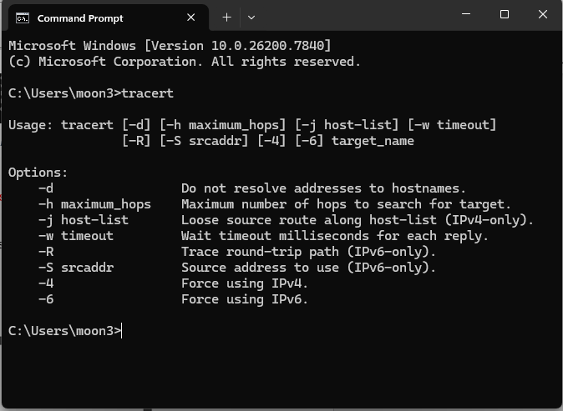

Example 8:
- Tasklist The tasklist command displays a list of all running processes on your computer. This is useful for monitoring system performance and identifying resource-hogging applications.

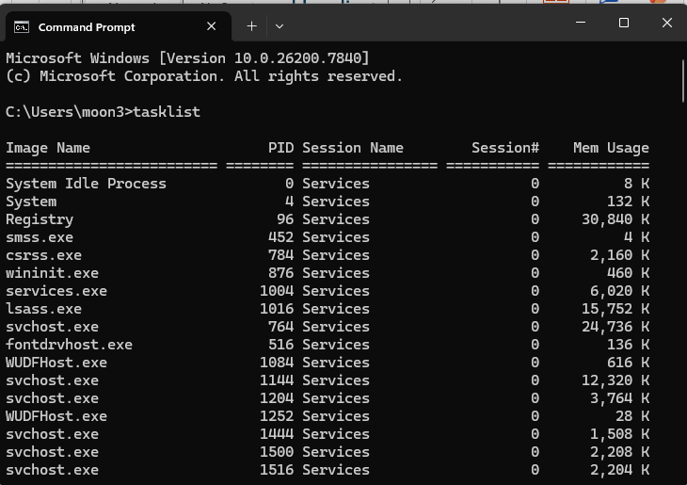

Example 9:
- Taskkill The taskkill command allows you to terminate processes by specifying their process ID (PID) or image name. For example, to kill a process by its PID:
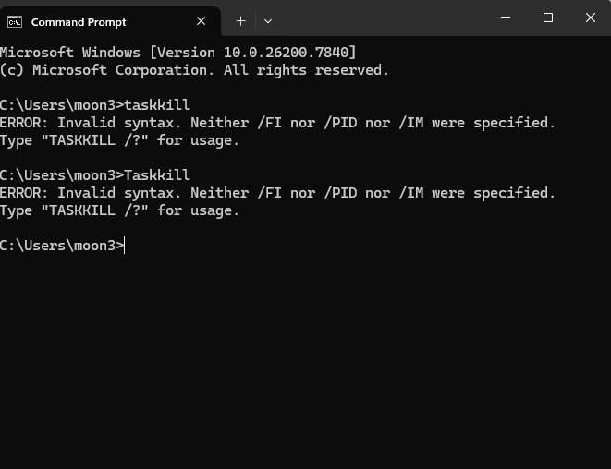

Example 10:

Sfc /scannow

While the previous command helps check errors on drives, when it comes to scanning the integrity of system files and repairing them, you should use the command: sfc. Not only that it checks all essential files in the operating system, but it also replaces incorrect versions of them with the right ones. In Command Prompt, to scan your system drive, run

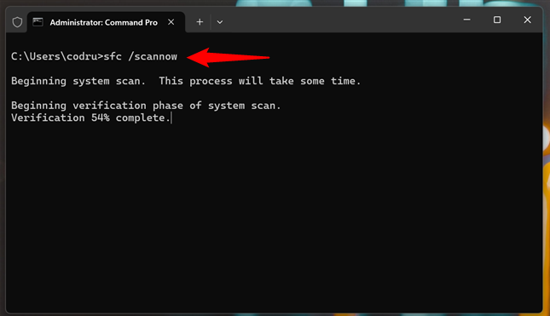

Use of Linux OS CLI commands

Example 1: rm commands
The rm command will ignore directories that it's asked to remove; to delete a directory, use a recursive option, either the -r or -R options. Just be careful since these options are "recursive", this will delete all files and all subdirectories:
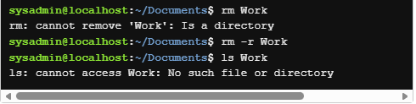

Example 2: ls command
The result of executing the previous command would create a copy of the contents of the /etc/passwd file in the Documents directory, since that is our current directory. This can be confirmed using the ls command:
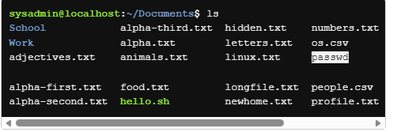

Example 3: mv command

The mv command is able to move multiple files, as long as the final argument provided to the command is the destination. For example, to move three files into the School directory

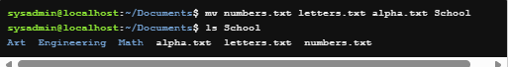

Example 4:
Moving a file within the same directory is an effective way to rename it. For example, in the following example the animals.txt file is given a new name of zoo.txt
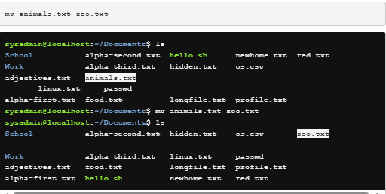

Example 5: Grep command
The grep command is a powerful text-search utility in Linux/Unix used to find lines matching a given pattern in files or input streams. It supports regular expressions, making it ideal for searching logs, configuration files, and command outputs.
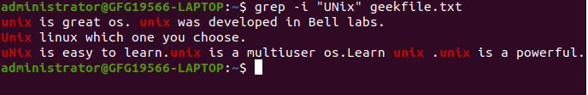

Example 6: mkdir command

The mkdir command in Linux/Unix is used to create one or more directories. It supports several arguments to control behavior, permissions, and output
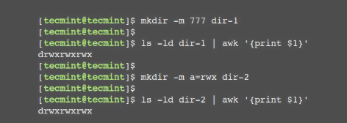

Example 7: dd command
The dd command is a utility for copying files or entire partitions at the bit level. This command has several useful features, including:
- It can be used to clone or delete (wipe) entire disks or partitions.
- It can be used to copy raw data to removable devices, such as USB drives and CDROMs.
- It can backup and restore the MBR (Master Boot Record).
- It can be used to create a file of a specific size that is filled with binary zeros, which can then be used as a swap file (virtual memory).
Let's examine the following example. The dd command creates a file named /tmp/swapex with 50 blocks of zeros that are one megabyte in size:

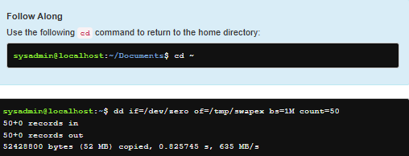

Example 8: chown command

The chown command is used to change the ownership of files and directories. Changing the user owner requires administrative access. A regular user cannot use this command to change the user owner of a file, even to give the ownership of one of their own files to another user. However, the chown command also permits changing group ownership, which can be accomplished by either root or the owner of the file. Currently all the files in the Documents directory are owned by the sysadmin user. This can be verified by using the ls -l command. Recall that the third column indicates the user owner.

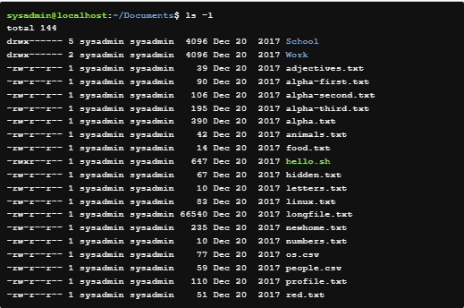

Example 9: sudo command
Only the user owner has the execute permission, and now the root user is the user owner. This file now requires administrative access to execute. Use the sudo command to execute the script as the root user.

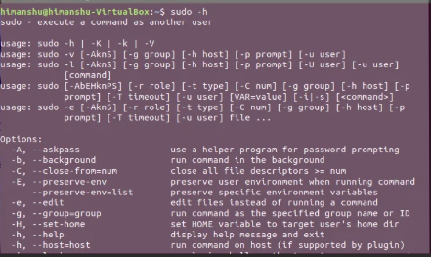

Example 10: ifconfig
The ifconfig command stands for "interface configuration" and is used to display network configuration information

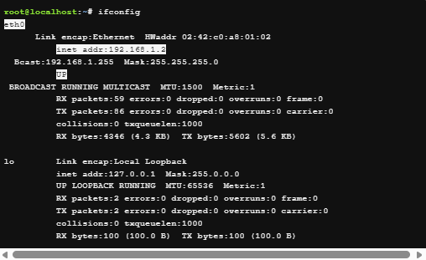

Use of Windows OS scripts
. System Administration
- Automating repetitive tasks like creating users, setting permissions, or mapping network drives.
- Managing Windows services (start, stop, restart).
- Scheduling tasks with Task Scheduler.
Example (PowerShell):
Powershell
Copy code
# Restart a specific service
Restart-Service -Name "Spooler"
2. Software Installation & Updates
- Deploying applications across multiple machines.
- Installing Windows updates automatically.
- Removing unwanted software.
Example (Batch):
Batch
Copy code
@echo off
echo Installing Notepad++
start /wait notepadpp_installer.exe /S
3. File & Folder Management
- Bulk renaming, moving, or deleting files.
- Backing up important data.
- Cleaning temporary files to free up space.
Example (PowerShell)

Example 1:
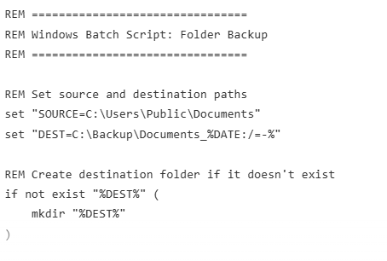
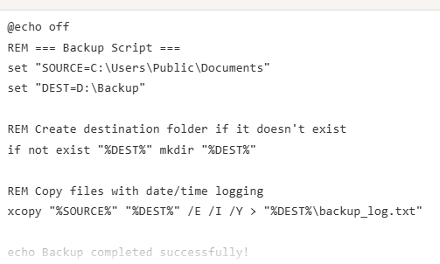

Example 2:
A script is a set of instructions written in a programming or scripting language that tells a computer what to do.
- Purpose: Automates tasks, processes data, or controls application behavior.
- Examples of scripting languages: JavaScript, Python, Bash, PHP.
- Execution: Usually interpreted (run directly by an interpreter) rather than compiled into machine code.
Example (JavaScript script):
Javascript
Copy code
// This is a simple script
let name = "Alice";
console.log("Hello, " + name + "!");
Here, the script instructs the browser (or Node.js) to store "Alice" in a variable and print a greeting.
2. What is Output?
Output is the result produced when a script runs.
It can be:
- Text in a console (e.g., console.log() in JavaScript)
- Changes on a web page (e.g., updating HTML content)
- Pop-up messages (e.g., alert() in JavaScript)
- Files or data sent to another system
Example Outputs for the above script:
- Console Output

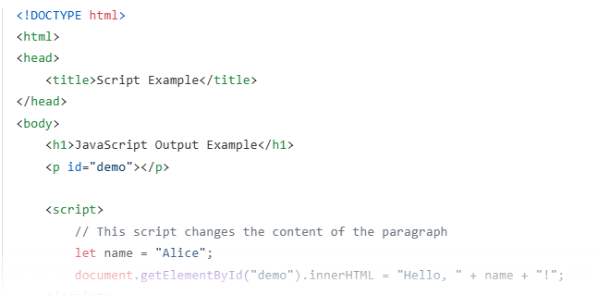

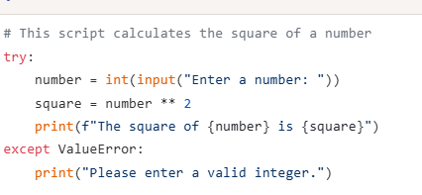

Use of Linux OS scripts
Bash (Bourne Again SHell) is a command-line interpreter and scripting language widely used in Unix-like operating systems such as Linux and macOS. Bash scripting involves writing a sequence of commands in a file (script) to automate tasks, reducing the need for repetitive manual input.
A Bash script typically contains:
- Shebang line (#!/bin/bash) to specify the interpreter.
- Commands and control structures (loops, conditionals, functions).
- Variables for storing and manipulating data.
Applications of Bash Scripting
- Automation of System Tasks
  - Automating backups, log rotation, and software updates.
  - Scheduling jobs with cron or systemd timers.
- Data Processing
  - Parsing and transforming text files using tools like grep, awk, and sed.
  - Batch renaming or moving files.
- Deployment and DevOps
  - Automating build and deployment pipelines.
  - Managing server configurations.
- Monitoring and Reporting
  - Checking system health (CPU, memory, disk usage).
  - Sending alerts or generating reports.
- Custom Command Utilities
  - Creating reusable scripts for repetitive developer or admin tasks.
Advantages
- Portability: Works across most Unix-like systems.
- Integration: Can call other programs and scripts easily.
- Efficiency: Saves time by automating repetitive tasks.

Example 1:

A script is a set of instructions written in a programming or scripting language that tells a computer what to do.
- Purpose: Automates tasks, processes data, or controls application behavior.
- Examples of scripting languages: JavaScript, Python, Bash, PHP.
- Execution: Usually interpreted (run directly by an interpreter) rather than compiled into machine code.
Example (JavaScript script):
Javascript
Copy code
// This is a simple script
let name = "Alice";
console.log("Hello, " + name + "!");
Here, the script instructs the browser (or Node.js) to store "Alice" in a variable and print a greeting.
2. What is Output?
Output is the result produced when a script runs.
It can be:
- Text in a console (e.g., console.log() in JavaScript)
- Changes on a web page (e.g., updating HTML content)
- Pop-up messages (e.g., alert() in JavaScript)
- Files or data sent to another system
Example Outputs for the above script

Example 2:
Explain the script and output.
A script is a set of instructions written in a scripting language (like JavaScript, Python, or Bash) that tells a computer what to do.
Scripts are usually interpreted (run directly by an interpreter) rather than compiled into machine code. They are often used to automate tasks, manipulate data, or control the behavior of applications and websites.
In JavaScript, a script can:
- Perform calculations
- Manipulate HTML/CSS
- Respond to user actions
- Display output in various ways (console, alerts, webpage content)

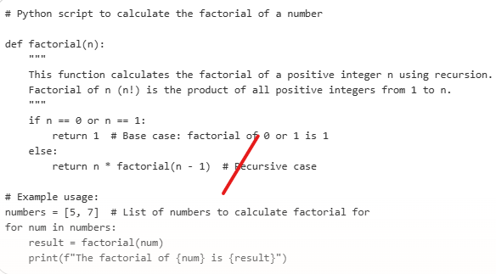

Conclusion
Summarize the report and your understanding of these tasks. (50 words)

Microsoft. (2024). Windows security overview. Retrieved from:
https://learn.microsoft.com/windows/security/

Appendices
Online Course name:



