UNIVERSITY OF WALES: TRINITY SAINT DAVID - SWANSEA

INVESTIGATION AND DESIGN OF TEMPERATURE DATA LOGGER USING PIC MICROCONTROLLER

By
Samih Altigany

A project submitted in partial fulfilment for the
Degree of BEng. (Hons) Electrical and Electronic Eng.

In the
School of Applied Computing
Faculty of Architecture, Computing and Engineering

Supervisor: Dr Stephen Mosey

April 2021

Declaration of Authorship

I, Samih Altigany declare that I am the sole author of this Project; that all references cited have been consulted; that I have conducted all work of which this is a record, and that the finished work lies within the prescribed word limits.

This work has not previously been accepted as part of any other degree submission.

Signed: …………………………………………..

Date: ………………………………………………..

Form of Consent

I Samih Altigany, hereby consent that my Project, submitted in candidature for the BEng. (Hons) Electrical and Electronic degree, if successful, may be made available for inter-library loan or photocopying (subject to the law of copyright), and that the title and abstract may be made available to outside organisations.

Signed: ………………………………………………………….

Date: …………………………………………………………….

UNIVERSITY OF WALES: TRINITY SAINT DAVID - SWANSEA

Abstract
Temperature monitoring is essential procedure in many industries such as in pharmaceutical laboratories where defining the chemical composition over time is crucial, in food industry where monitoring the temperature is important to prevent bacteria and to meet the food and safety regulatory agencies, in warehouses where some products are sensitive to temperature and need to be kept in a temperature controlled environment, in logistics where the supply chain process require the temperature to maintained and kept track on it by the company, also in equipment monitoring where keeping track on the temperature where the equipment’s operate, reduces the wear and tear and in return it reduces equipment’s breakdowns and makes the condition based maintenance CBM more efficient.
This report is a documentation of the temperature measuring techniques and the acquisition devices, and in addition detailing and elaborating about the process of designing temperature data logger using PIC microcontroller The objective of this project is framed in the context of studying the temperature data loggers available in the market and designing a battery powered data logger using PIC microcontroller, by collecting the temperature readings through a temperature sensor using LM35 the readings will be presented on an LCD screen, and all the data will be saved on a non-volatile memory EEPROM, and the device could also be connected to a computer through USB and RS232.
The full content of this report includes:

- Conducting a market research looking for the different types of temperature data logger available in the market and identifying the similarities and differences in terms of the operation and the components in order to get a deep insight about the components which should be included in the design.
- Producing a design brief
Depending on the background research which I have carried out, I have reached to a conclusion encompasses my initial design brief summarizing the components I will use, which could be altered along the way depending on the hardship I may encounter.
- Produce design specifications
Laying out system specifications is a must in order to choose the right components for the circuit, the temperature resolution required in order to select a suitable sensor, and the time duration the data logging to determine the size of the memory and battery required.
- Component research
There are always several ways to do any particular task therefore, All the methods which temperature could be measured with will be looked at and put in consideration, and the sensors used in these methods and several types of sensors for each method and select the optimal.
In the same manner, looking for different ways to interface the LCD, USB and SD card and different types and then the optimal type and method is selected.
- Simulation for the circuit
Using Proteus software, an operational schematic has been produced to make sure the circuit function and operate as intended for.
- Breadboard prototype
This is the stage of converting the schematics into a physical circuit, and testing its functionality.
- A suitable software
Using CCS compiler, a suitable code has been written
- Designing a PCB for the circuit

The different software packages used to design and build the project are as follows:
- Proteus.
- CCS Compiler.
- MpLabx.
- Microsoft Word.
- Microsoft Excel.

Faculty of Architecture, Computing and Engineering
School of Applied Computing

BEng. (Hons) Electrical and Electronic Eng.

By Samih Altigany

Acknowledgements

I would like to express my sincere gratitude and thanks to my advisor, Dr Stephen Mosey, for his patience, motivation, enthusiasm and immense knowledge and Dr Gary Jones for his consideration, support and guidance throughout this thesis without which this study would not have been possible. And finally, I would like to express my gratitude to my family and my friends for helping me and supporting me.

Table of Contents
1 Chapter one: Introduction 13
2 Chapter two: planning 14
2.1 Planning stage: 14
2.2 Investigation stage: 14
2.3 Implementation stage: 14
2.4 Evaluation stage: 14
2.5 Project milestones 14
2.6 Project breakdown 15
2.6.1 Planning stage 15
2.6.2 Investigation stage 16
2.6.3 Implementation stage 16
2.6.4 Evaluation stage 17
3 Chapter three: The research methodology 18
3.1 The layers of the research onion 18
3.2 The research philosophy 19
3.2.1 Ontology: 19
3.2.2 Epistemology: 19
3.2.3 Axiology 20
3.3 The research approaches 20
3.3.1 The deductive approach 20
3.3.2 The inductive approach 20
3.4 The research strategies 20
3.4.1 Experimental 20
3.4.2 Survey 20
3.4.3 Case study 21
3.5 Action research 21
3.6 Research choice 21
3.6.1 Mono method: 21
3.6.2 Mixed method: 21
3.6.3 Multi- method 21
3.6.4 The time horizon 21
3.6.5 Cross sectional 21
3.6.6 Longitudinal 22
3.7 Analysis and data collection 22
4 Chapter Four: market research 23
4.1 RS PRO 1384 temperature logger 23
4.1.1 Applications 23
4.2 MCR-4TC temperature logger 23
4.2.1 Applications 24
4.3 TRIX-8 24
4.3.1 Applications 24
5 24
6 ITAG4 24
6.1.1 Applications 25
7 Chapter Five: Investigation of the components 27
7.1 The temperature sensor options 27
7.2 The selected temperature sensor 30
7.3 The selected display 31
7.4 The LED selection 32
7.5 The push button options 32
8 Chapter six: Memory sizing 33
8.1 The memory structures 33
8.2 The memory sizing 34
9 Chapter seven: The microcontroller selection 34
9.1 Microcontroller specifications 34
9.1.1 ROM size approximation 34
9.1.2 RAM size approximation 34
9.1.3 CPU speed approximation 34
9.2 The required number of pins on the microcontroller 35
9.3 Minimum specifications of the microcontroller 35
9.4 Microcontroller selection 35
9.5 The external memory 36
9.6 RS232 to USB convertor 37
10 Chapter eight: the battery and the voltage regulator sizing and selection 37
10.1 Voltage regulator 37
10.2 Voltage regulator selection 38
10.3 The battery options 38
11 Chapter nine: the design 40
11.1 The operational flowchart 40
11.2 The operational schematics for the simulation 41
11.2.1 The terminal 41
11.2.2 The LCD 42
11.2.3 The EEPROM connection 43
11.2.4 The LEDs connection 44
11.2.5 The push buttons 45
11.2.6 The temperature sensor 46
11.2.7 The voltage regulator 48
11.3 The software flowchart 49
11.4 The code for the simulation 49
11.5 The operational schematics for the prototype 52
11.6 The code for the prototype 53
11.7 The prototype 55
11.7.1 The connections of the voltage regulator 55
11.7.2 The connections of the microcontroller 56
11.7.3 The connections of the EEPROM 56
11.7.4 The LCD connections 57
12 Chapter ten: The analysis 57
12.1 Testing the program on the simulation 57
12.2 Testing the prototype 57
13 Chapter eleven: evaluation 57
14 Chapter twelve: the conclusion 57
15 Chapter thirteen: recommendations 58
16 Chapter fourteen: reflection 59
17 References 60

List of tables
Table 1: the project milestones 15
Table 2: the project breakdown 16
Table 3: the investigation stage of the project 16
Table 4: the implementation stage of the project 17
Table 5: the evaluation stage of the project 17
Table 6: examples for the temperature loggers available in the market 26
Table 7: highlights the key differences between temperature sensor types 29
Table 8: highlights the different types of the semiconductor temperature sensors and the selected sensor 30
Table 9: highlights the key differences between display types 32
Table 10: highlights different types of LEDs and the selected one 32
Table 11: highlights the different types of push buttons available 33
Table 12: demonstrates the process of memory sizing 34
Table 13: demonstrates the number of pins required 35
Table 14: demonstrates the minimum microcontroller required 35
Table 15: highlights the different specifications of microcontrollers and the selected one 36
Table 16: highlights the selected external EEPROM 36
Table 17: the chosen RS232 to USB convertor 37
Table 18: demonstrates the voltage and current consumption of the circuit 37
Table 19: highlights the different types of 5V voltage regulators and the selected one 38
Table 20: illustration of the battery sizing 38
Table 21: highlights the different types of batteries and the selected type 39

Tables of figures
Figure 1: the research onion 19
Figure 2: RS PRO 1384 temperature logger 23
Figure 3: MCR-4TC temperature logger 23
Figure 4: TRIX-8 24
Figure 5: ITAG4 24
Figure 6: demonstrates the memory structure 34
Figure 7: block diagram shows the operation of and the layout of the device 40
Figure 8: the operational schematics for the simulation 41
Figure 9: the terminal connection 41
Figure 10: the LCD connections 42
Figure 11: the EEPROM connections 43
Figure 12:EEPROM connections from the datasheet 44
Figure 13: the Led connection 44
Figure 14: the pushbutton connection 45
Figure 15: LM35 connections for positive and negative temperature 46
Figure 16: LM35 connections for positive and negative temperature from the datasheet 47
Figure 17: the voltage regulator connectionns 48
Figure 18: the connections of the voltage regulator from the datasheet 48
Figure 19: the software flow chart 49
Figure 20: the operational schematics for the prototype 52
Figure 21: LM35 connections for only positive temperature 53
Figure 22: the prototype 55
Figure 23: the legs connections for the voltage regulator 55
Figure 24: the connections of the voltage regulator from the datasheet 56
Figure 25:PIC 18F25K50 pins layout from the datasheet 56
Figure 26: FM24C16 pins layout from the datasheet 57

Chapter one: Introduction
Temperature monitoring is essential procedure in many industries such as in pharmaceutical laboratories where defining the chemical composition over time is crucial, in food industry where monitoring the temperature is important to prevent bacteria and to meet the food and safety regulatory agencies, in warehouses where some products are sensitive to temperature and need to be kept in a temperature controlled environment, in logistics where the supply chain process require the temperature to maintained and kept track on it by the company, also in equipment monitoring where keeping track on the temperature where the equipment’s operate, reduces the wear and tear and in return it reduces equipment’s breakdowns and makes the condition based maintenance CBM more efficient. [1]

Chapter two: planning
In order to achieve any goal, a plan has to be set detailing and highlighting all the necessary and important steps to reach that goal, and in this case the goal is converting the idea of the project into concept and then into a product.
Designing a product should go through several stages which are: planning stage, investigation stage, implementation stage and evaluation stage which are detailed below.

Planning stage:
In this stage a thorough thought of the project starting with the project proposal where the objective of the project is identified and a general idea of the project and how it is going to be execute is clarified, and the a brief for the project is produced highlighting the technical specifications of the device and the components and parts needed stating with the sensors, LCD, the microcontroller, and all the other parts. and then a Gantt chart is produced to translate the project proposal ideas into scheduled steps and mile stones with deadlines to insure a consistent progress for the project.

Investigation stage:
In this stage a feasibility study is conducted to determine the possibility of finishing the project on time before the dead line and the obstacles along the way and how to overcome them in order to finish the project which is the risk assessment, also a market research is conducted looking for the similar products in the market and the different types of sensors for temperature and the different types of microcontrollers, EEPROM and voltage regulator.

Implementation stage:
In this stage, all the planning and investigation processes will be executed by producing a circuit schematics design using the components chosen on the investigation stage using proteus software, and then testing the functionality of that schematics by producing a suitable software code using CCS compiler, and then building a breadboard prototype module to demonstrate the functionality of the device in the real world.
In addition, after testing the prototype and making sure that it works as it intended to, a printed circuit board PCB will be designed.

Evaluation stage:
In this stage, the progress and outcomes of the project will be evaluated and discussed in relation to the Gantt chart scheduled deadlines, in addition, the skills grasped through the execution of this project, will be pointed out and highlighted.

Project milestones
This is an approximate estimation for the timescale of the stages of the project to ensure stable progress for the project, and achievable time constraints.
Task: | Start date | Finish date
Project planning stage | 16th of October 2020 | 4th of November 2020
Investigation stage | 5th of November 2020 | 19th of November 2020
Implementation stage | 20th of November 2020 | 25th of March 2021
Evaluation stage | 26th of March 2021 | 5th of April 2021
Interim viva | 20th of January 2021 | 20th of January 2021
Final Viva | 30th of April 2021 | 30th of April 2021
Table 1: the project milestones

Project breakdown
The Gantt chart is broken down into several stages in order to make it easier to explain and discuss.

Planning stage
Project Plan Tasks
Breakdown of project plan | Brief description | Start date | Due date
Project proposal | The idea of the project is created and presented highlighting the background of the project, the reasons clarifying the importance of the project and the objective of the project and the plan of how to achieve success completing it. | 16-10-2020 | 22-10-2020
Produce Gantt chart | It is a guideline of the progress of the project in respect to a constraint timescale. | 23-10-2020 | 28-10-2020
Technical Specification | The technical specifications identify the functionality of the device intended to be designed with a block diagram showing all the components included such as: sensors, microcontroller, EEPROM and voltage regulator. | 29-10-2020 | 4-11-2020
Table 2: the project breakdown

Investigation stage
Breakdown of Investigation | Brief description | Start date | Due date
Feasibility Study | It is researching the market for similar devices and study them in order to assist the process of designing the device. | 5-11-2020 | 9-11-2020
Market research | Researching the market for the available different types of sensors suit the purpose of the project and the available different types of microcontrollers and EEPROM and the other parts of the circuit. | 10-11-2020 | 16-11-2020
Cost analysis | Analysing the approximate cost of the designed device according to the market research which had been done. | 17-11-2020 | 19-11-2020
Table 3: the investigation stage of the project

Implementation stage
Breakdown of Implementation | Brief description | Start date | Due date
Design Circuit | Using proteus software, an operational schematic is designed. | 20-01-2021 | 26-01-2021
Write a suitable code for PIC | Starting with producing a system flowchart pointing out how the code should function then converting that flow chart into a code using CCS software. | 22-02-2021 | 11-03-2021
Testing the simulation | Downloading the code into the schematics and testing it using proteus software. | 12-03-2021 | 16-03-2021
Build the prototype | Using the components chosen through the market research, and implemented on the operational schematics, a prototype is built. | 27-01-2021 | 15-02-2021
Test | Power board and test design. | 16-02-2021 | 19-02-2021
Table 4: the implementation stage of the project

Evaluation stage
Breakdown of Evaluation | Brief description | Start date | Due date
Project conclusion | Highlighting the outcomes of the project and analysing the design. | 26-03-2021 | 30-03-2021
Review Gantt chart | Review the plan set initially pointed out with the Gantt chart, and illustrating how beneficial it was and into what extent the Gantt chart was followed and where it was modified. | 31-03-2021 | 02-04-2021
Skills learnt | Highlighting the skills learnt through executing this project and what new software studied to help the progress of the project. | 05-04-2021 | 05-04-2021
Table 5: the evaluation stage of the project

Chapter three: The research methodology
The research onion is a simply way to clarify and illustrate the stages included in the process of research representing a research topic by an onion and the stages of the research by the layers of an onion which by following it ensures a consistent progress for the project.
The benefit of the research onion is that it is applicable to any type of research methodology and different contexts, but in general to use the research onion, is like unwrapping of an onion layer by layer starting from the outer layer to the inner layer in order to achieve the intended goal by following the right steps.

The layers of the research onion
The research onion is beneficial as it creates a guideline for the research process through the stages under which the date should be collected and makes the study more methodical and organised. Therefore, the idea of the research onion is to go from the outer layer of the onion representing the topic of the research into the inner layer of the research onion. Therefore, starting from the outer layer of the research onion which is the research philosophy which sets a deep understanding of the research topic and the stages of the research, the second layer is adopting a research method suitable for the topic, the third layer is identifying the research strategy which is chosen to conduct the research, the fourth layer identifying the time horizon and the fifth layer is about the data collection methodology.
The research onion as shown on the graph below includes:
- The research philosophy
- The research approaches
- The research strategies
- The research choice
- The research time horizon
- Analysis and data collection

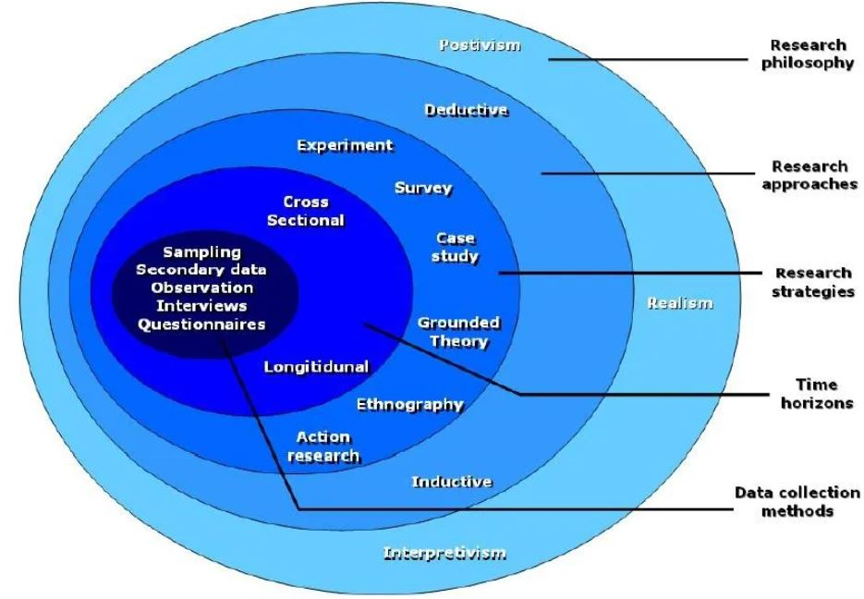
Figure 1: the research onion

The research philosophy
The research philosophy is related to understanding the nature and reality of the research topic which dictate the choice of the research philosophy being used. The main three important philosophies in research are:

Ontology:
Ontology is the study of reality and it describes the nature of reality and its impact on the society and surroundings which clarifies the difference between the reality and our perception of the reality which leads to grasping how it influence the behaviour of people. There are three philosophies related to the ontology which are objectivism, constructivism and pragmatism.

Epistemology:
Epistemology is mainly used in scientific research as it assists finding unquestionable and undoubtable information by finding a common acceptable knowledge and addressing the facts accordingly.
Epistemology is a wide umbrella for positivism, realism and interpretivism. Positivism: work on finding explanations using generally accepted knowledge and testable questions of the research topic.
Realism: offers the ability to use new research methods without scientific support. Interpretivism: it helps understanding people’s actions and culture and how people participate in social life.

Axiology
Axiology assists the researcher to learn the impact of the valuables and opinions on the collection and analysis of the research.

The research approaches
This is the second layer of the research onion and it has two types of which are the deductive and the inductive approach

The deductive approach
The deductive approach creates the hypothesis built on the pre-existing theories and creates the research approach to test it. The deductive approach is suitable for the positive approach. The deductive approach uses questionnaires to develop an understanding of some observations which in return allows the researcher to compare and contrast different understandings through empirical data.

The inductive approach
The inductive approach allows the researcher to develop and create a theory unlike the deductive approach which based on adopting a pre-existing theory.

The research strategies
The research strategy illustrates the methodology of the researcher of carrying out the research process and achieving success, which include different approaches such as: experimental research, action research, case study research, interviews, surveys and a systematic literature review.

Experimental
The experimental research is the process of developing a research plan by examining the results of an experiment and compare the results to the expected results of that experiment. This process is applicable to all areas of research and has a limited number of factors to be considered.

Survey
The survey strategy is connected to the deductive approach and it is one of the best and economical research strategies where the researcher is able to collect valuable and reliable data. Surveys are used in quantitative projects which includes sampling and representative proportion of the population.

Case study
The case study strategy is the evaluation and assessment of a portion or a unit by pointing out its key features and generalizing that on the other units, which offers an insight into the specific nature of the research topic, this strategy is more beneficial in financial research such as comparing the operation of two companies, or comparing the effect of investment on the cashflow of the company or any different area related to the company.

Action research
The action research strategy is used to develop a solution for a certain issue and it is common in teaching and nursing where the practitioners can develop ways to enhance their professional approach and concept.

Research choice
The research choice is the fourth layer of the research onion and it assists the researcher to decide using the quantitative methodology or the qualitative methodology or both. There are three research approaches which are mono, mixed and multi method.

Mono method:
This method requires using only either the quantitative or the qualitative methodology but no together and it collects information of one type only.

Mixed method:
This method allows the researcher to combine using the quantitative and the qualitative methodology in the research in order to develop accurate data. unlike the multi method which allows the researcher to divide the research into segments and produce data sets for each segment, the mixed method produces a single data set for the whole research.

Multi- method
The multi method is similar to the mixed method in combining the quantitative and the qualitative methodology but it differs in in the outcome as the multi method produces only one set of data while the mixed method produces many sets.

The time horizon
The time horizon points out the time frame required to complete the project and there are specific time horizons within the research onion which are the cross sectional and the longitudinal.

Cross sectional
The cross-sectional time horizon is used where the research is related to a specific incident in specific time.

Longitudinal
The longitudinal time horizon is used to collect data over long time period and some factors of the research are changing over time.

Analysis and data collection
The analysis and data collection are the sixth layer of the research onion and it is the internal layer. The data collection and analysis depend on the approach followed in collecting the data, this layer also explains how the data is used in research and explains the source of data and the research design, the sample and its size, ethics and limitations, and the research reliability and validity.
The primary data is the data collected from the source through questionnaires, oral or written interviews. While the secondary data is the data taken from opinions and research. [2]

Chapter Four: market research

RS PRO 1384 temperature logger
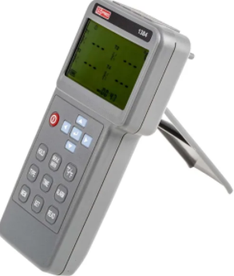
Figure 2: RS PRO 1384 temperature logger
This temperature data logger has four digital inputs, in addition it is compatible with several types of thermometers such as K, J, E, T, R, S, N, L, U, B and C type thermometer. Any two inputs are isolated using the 350 VP-P isolation protection features. Also, it has four inputs functions for temperature display, which displays the minimum and maximum values of the four inputs and has programmable alarms for each input with independent input setup.
In addition, the device also has memory of 512KB for data logging capacity and
USB interface to secure the communication between the data logger and a PC in order to get access to the logging information.

Applications
This data logger can be used in a wider range of applications such as environmental and weather monitoring, livestock and agricultural industry, food and drinks production, building and site monitoring, HVAC systems, health care facilities, accommodation and offices and warehouses and greenhouses. [3]

MCR-4TC temperature logger
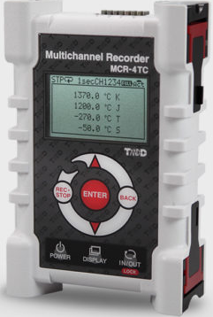
Figure 3: MCR-4TC temperature logger
This is a low-cost data logger, includes four channels, SD card, USB and LCD display. It has a unique design allows it to be expanded from four channels into 16 channels by connecting four of MCR-4TC together.
The MCR-4TC is the perfect solution for a wide range of industrial and medical applications as it has fast recording rate and ability to measure the temperature from -200 to 1300$℃$ when using the K type thermometer as well as having LCD display to provide the user with real time data and a USB port to enable it to connect to a pc allowing fast communication.

Applications
The MCR-4TC is widely used in food and industrial ovens, food processing, monitoring and validation medical appliances such as fridges, freezer, also it is used in HVAC and pipe monitoring. [4]

TRIX-8
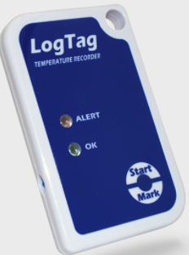
Figure 4: TRIX-8
The TRIX-8 is a stablished standard data logger because of its reliable temperature data collection and affordable cost. For audit and analysis, the TRIX-8 data logger records 8000 temperature readings followed with the time on which the readings taken.
The device has visual indications for the functions and the operation status, if the collected data is in or out of the temperature threshold this is demonstrated by a green and red flashing lights.
The TRIX-8 comes in IP65 or IP67 protective enclosure and has a very compact size which makes it easier to be mailed, it also supported with a wall mounting bracket to enable it to be mounted on surfaces.

Applications
The TRIX-8 has been used through the NHS for monitoring the temperature in fridges, freezers and incubators, also it is used for generating temperature mapping surveys for buildings or storage conditions and product sensitive to time and temperature. [5]

ITAG4
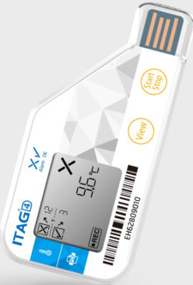
Figure 5: ITAG4
ITAG4 is a single use temperature data logger, uses secure pdf reporting via USB and cloud utility, it also shows the functionality of the calibrated data logger on a clear LCD display.

Applications
ITAG4 is a disposable temperature data logger designed and manufactured specifically to be used in the field of pharmaceutical, biological and clinical trial, it is also used in validation and verification exercises [6]

Examples for the temperature loggers available in the market
Sensor type | Thermocouple  B,C,E,J,K,L,N,R,S,T,U | K, J, T, S, R | Thermistor
Number of channels | 4 | 4 channels up to 16 by connecting 4MCR-4TC | 1
interface | USB | USB | USB | USB
Maximum temperature | 1760(B)$℃$, 1760(C)$℃$, 760(E)$℃$, 999.9(J)$℃$, 1370(K)$℃$, 900(L)$℃$, 1300(N)$℃$, 2912(R/S)$℉$, 752(T)$℉$, 600(U)$℃$ | 1370(K)$℃$, 1200(J)$℃$, 400(T)$℃$, 1760(S)$℃$, 1760(R)$℃$
Minimum temperature | 0$℃$ | 0$℃$
Maximum operating temperature | 50$℃$ | 0 to 50$℃$ | -40$℃$ to +85$℃$ | -30$℃$ to +70$℃$
Display type | LCD | LCD
Number of readings per channel | 100,000 (1 input), 36000 (4 inputs), 99(set) | Channel1=960,000  Channel2=480,000  Channel3=320,000  Channel4=240,000 | 8000 readings | 14400 readings
Battery type | AA | 2*AA or USB power supply 5V and 250 mA | 3V battery | 3V battery
Resolution | 0.1$℉$, 0.1$℃$ | 0.1$℃$ | 0.5$℃$ | 0.1$℃$
Accuracy |  |  |  | +-0.3$℃$
Battery life | Two days |  | 365 -900 days
Logging interval |  |  |  | 2 hours
Humidity operation range |  | 90%
Dimensions |  | H120, W75, D32 mm | H 86, W 54.5, D8.6 mm | L93, W45, H7mm
Features | USB, LCD | SD card, USB, LCD | USB | LCD, USB, encrypted pdf report
Protection |  |  | IP65, IP67
Compatibility |  |  |  | Windows pc
Weight |  |  |  | 22g
price | 296.74£ | 270£ | 17.99£ | 19£
Table 6: examples for the temperature loggers available in the market

Chapter Five: Investigation of the components

The temperature sensor options
Type | 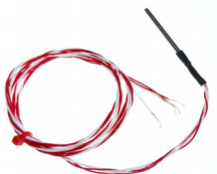 | 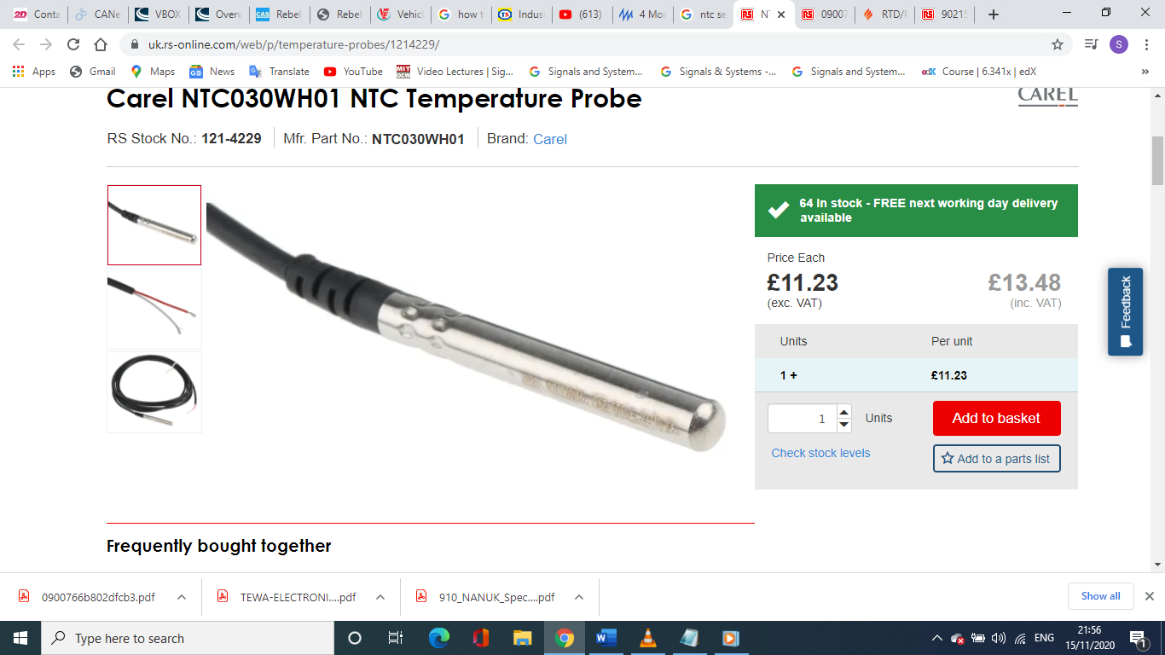 | 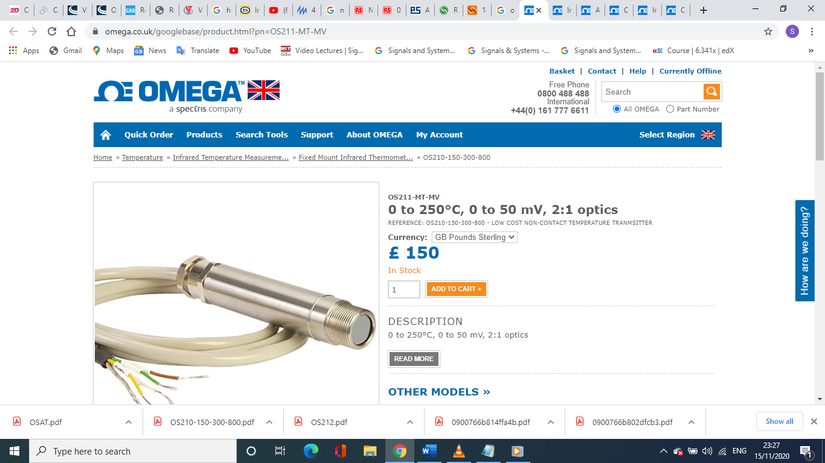
Description | Push in RTD temperature prop | Carel NTC030WH01 thermistor | OS210 non-contact optical sensor
Resolution | -50$℃$ to 200$℃$ | -50$℃$ to 105$℃$ | -20$℃$ to 500$℃$
Protection | The tube is stainless steel | IP68 | IP65
Response time | 3 m/s in the air  And 0.4 m/s in water |  | 240 mS
Number of pins | four wires | Two wires | Two wires
Price | 29.92 £ | 13.48 £ | 150 £
Dimensions | 3mm*100mm | $∅$ 6 mm*50 mm | 103L*18mm*D (4.06*0.71”)
Accuracy |  |  | +-1$℃$
Supply voltage |  |  | 24 to 28 VDC
Current output |  |  | 4 to 20 mA
Positives | - Wide sensing range up to +200.  - It has high response time.  - Small size.  Reliable and durable. | - High accuracy.  - High reliability.  - Inexpensive.  - It is not sensitive to polarity. | - It can measure the temperature of moving objects.  - Easy to mount.  - It is reliable and linear.  - Robust as most of them have IP65 protection.
Negatives | - . Susceptible to radio frequency and electromagnetic interference.  - Has very small signal which requires amplification. | - It has a big usage limitation as it is nonlinear and not robust. | - It measures only the surface temperature not the inside.  - They can be affected by frost, dust, moisture and smoke.  - It could be affected by radio frequency waves.
[7] [8] [9]

 | 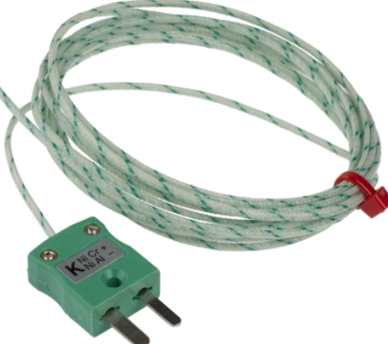 | 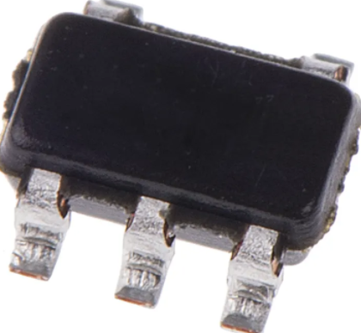
Type | Thermocouple type K | IC: LM71QCIMF
Probe diameter | 1/0.2mm
Probe length | 2m
Maximum temperature | +350$℃$ | +150$℃$
Minimum temperature |  | $$-40℃$$
Termination type | Miniature plug
Cable length | 2m
Interface |  | SPI
Out put type |  | Digital
Accuracy |  | -2$℃$,+3$℃$
Pin count | 2 | 5
Operating voltage |  | 2.65 – 5.5V
Resolution |  | 14 bits
Dimensions |  | 3.5*1.75*1.3 mm
Price | 10.54£ | 0.409£
Table 7: highlights the key differences between temperature sensor types
[10] [11]

The selected temperature sensor
 |  | 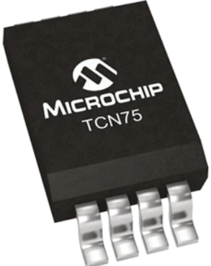 | 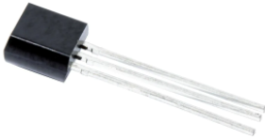
Type | IC: LM71QCIMF | IC: TCN75 3.3MUA | IC: LM35DZ
Maximum temperature | +150$℃$ | +125$℃$ | +150$℃$
Minimum temperature | $$-40℃$$ | $$-55℃$$ | $$-55℃$$
Interface | SPI | I2C, SM bus
Output type | Digital | Digital | Analogue
Output current |  |  | 10mA
Accuracy | -2$℃$,+3$℃$ | +-3$℃$
Pin count | 5 | 8 | 3
Operating voltage | 2.65 – 5.5V | 2.7 – 5.5V | 4-30V
Current supply |  |  | 60µA
Resolution | 14 bits
Dimensions | 3.5*1.75*1.3 mm | 3 *3* 0.85 mm
Price | 0.409£ | 0.403£ | 1.58£
Table 8: highlights the different types of the semiconductor temperature sensors and the selected sensor
[12] [13]

The selected display
 | 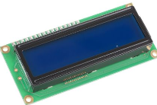 | 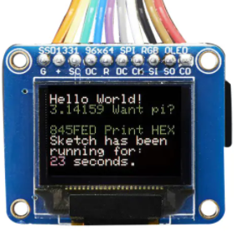 | 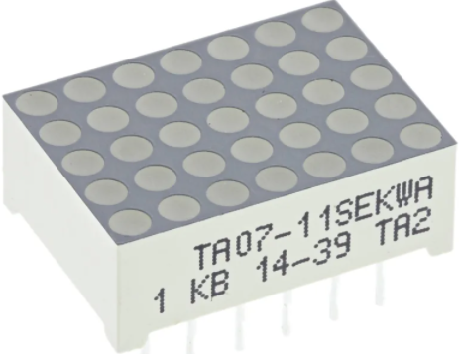
Type | LCD | OLED | Dot matrix
Supply voltage for logic | 5V | 2.8V | 2.1V
Supply voltage for LCD | 3.7V | 2.8V | 2.1V
Supply current | 1.2mA | 25mA | 30mA
View angle | 20-40 degrees
Contrast ratio | 3
Response time | 200mS
Interface | Analogue | SPI | Analogue
Temperature range |  |  | -40$℃$ to +85$℃$
Power dissipation |  |  | 75mW
Number of pins | 16
Price | 8.80£ | 27.41£ | 2.57£
[14] [15] [16]

 | 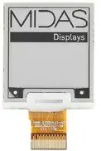 | 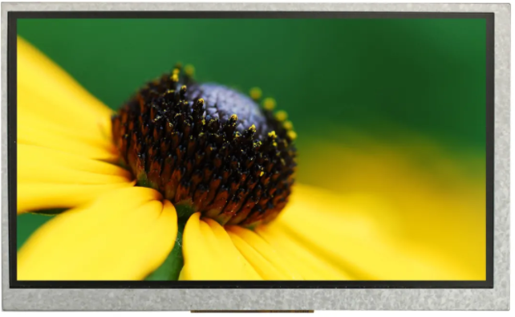 | 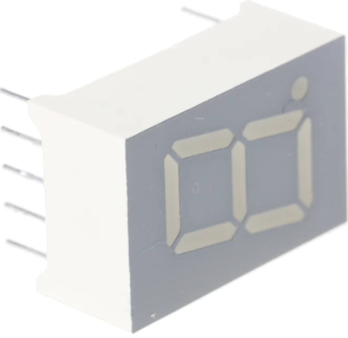
Type | E-paper display | TFT display | 7 segment display
Supply voltage for logic | 3.3V
Supply voltage |  | 30V | 2V
Interface | SPI | I2C | analogue
Operating temperature | 0$℃$ to 50$℃$ | -20$℃$ to +70$℃$ | $-40℃$ to +85$℃$
Resolution |  | 800*480 pixels
Response time |  | 30 to 50mS
Current supply |  | 8mA | 30mA
Brightness |  | 1500cd/$m^{2}$
Power dissipation |  |  | 75mW
Price | 10.82£ | 59.02£ | 1.36£
Table 9: highlights the key differences between display types
[17] [18] [19]

The LED selection
Type | 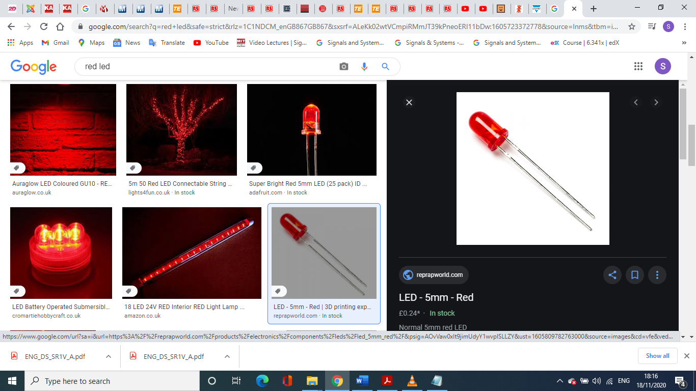 | 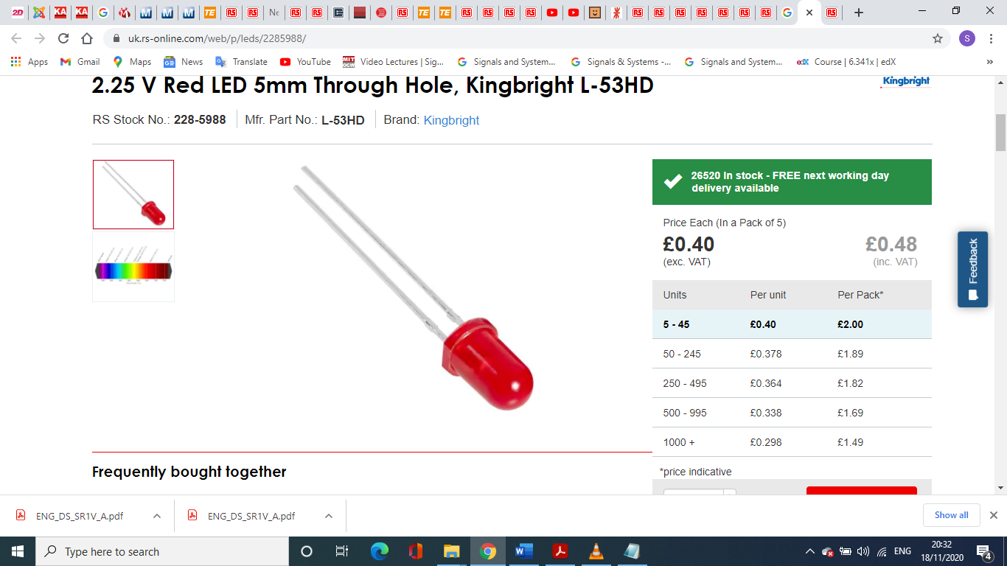
Description | TLUR6400 | L-53 HD
Max forward voltage | 3 V | 2.5 V
Reverse voltage | 6 V | 5 V
Operating temperature | -40$℃$ to +100$℃$ | -40$℃$ to +85$℃$
Max forward current | 20 mA | 20 mA
Price |  | 0.48 £
Table 10: highlights different types of LEDs and the selected one
[20] [21]

The push button options
 | 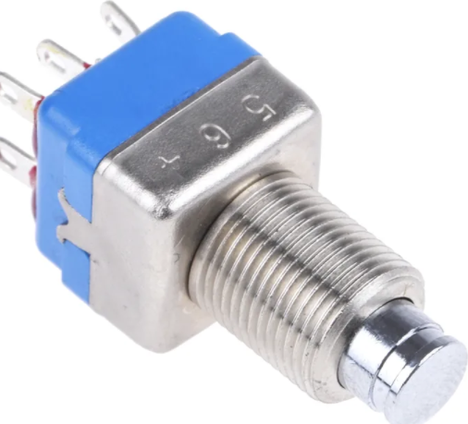 | 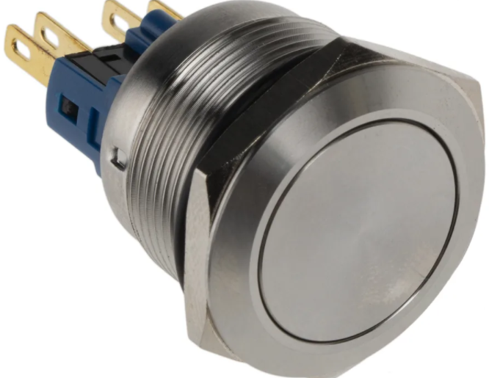 | 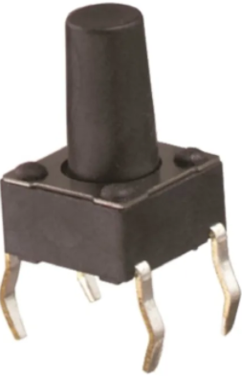
Description | APEM DPDT | Rs pro SPDT
Contact rating | 220Vac/ 24VDC | 250Vac | 12V
Operating temperature | -40$℃$ to +85$℃$ | -20$℃$ to +55$℃$ | -40$℃$ to +85$℃$
Contact configuration | DPDT | SPDT | SPST
Current rating | 3A at 24VDC | 5A | 50mA
Protection | IP67 | IP67
Price | 10.37£ | 11.98£ | 0.61£
Table 11: highlights the different types of push buttons available
[22] [23] [24]

Chapter six: Memory sizing
 | Measurement range | Resolution | Logging rate | Number of bits | A/D conversion depth | Signal | Memory size
Temperature | -50$℃$ to 150$℃$ | 1$℃$ | 1/S | 8bits | 8 bits | Analogue | 1byte
Table 15; highlights the design specifications

The memory structures
Time mS | temperature
0mS
10
20
30
40
50
60
70
80
1 S
Figure 6: demonstrates the memory structure

The memory sizing

 | Memory for one reading | Logging rate | Number of readings in a record | Memory for a record
Temperature | 1 byte | 1/S | 1 | 1 byte
Table 12: demonstrates the process of memory sizing
For the time duration of one days, it requires 86,400 bytes which is nearly 100 Mbytes.

Chapter seven: The microcontroller selection

Microcontroller specifications

ROM size approximation
The size of the programme memory could be determined by checking the size of a similar programme been written already such as 4KB, and as a rule of thumb the size has to be doubled twice to get extra overhead allowances which yield in 16KB.

RAM size approximation
The RAM deals with the temporary files such as reading the inputs and executing the outputs, which in this case roughly 1 byte input in a speed of 1/S, therefore, to execute the programme, read the inputs, display on the screen, write them on the SD card and prepare for the next reading this will take 1byte*4=4 bytes round it up to 10 bytes.
For more allowances, as a rule of thumb, the approximate RAM size has to be doubled twice ending in 40 bytes.

CPU speed approximation
PIC microcontroller has quadrature architecture which means it take 4 clock cycles to execute one instruction and in order to select the input, read the value, convert it then store it in the SD card and display it on the screen, this could take 25 instructions five for each step.
As a reading takes 25 instructions, therefore, as total it takes 25 instructions per second, and as every instruction takes 4 clock cycles, then it will take 4*25 which is 100 clock cycles which is 100HZ processor and as a rule of thumb for more allowances, the approximate CPU size has to be doubled twice ending in 400HZ. But as the CPU speed in PIC microcontroller is in MHZ, then the speed will be rounded up to 4 MHZ which is the minimum available.

The required number of pins on the microcontroller
 | Number of signal pins
Temperature | 1
Display | 12
USB module | 3
RS232 module | 2
SPI | 3
Start button | 1
Digital tell | 1
power | 1
Ground | 1
Total | pins
Table 13: demonstrates the number of pins required

Minimum specifications of the microcontroller
USB | SPI | UART | I2C | ADC inputs | ADC resolution | RAM | ROM | CPU speed | Pin count
1 | 1 | 1 | 1 | 1 | 10 | 40 bytes | 16 KB | 4 MHZ | 25
Table 14: demonstrates the minimum microcontroller required

Microcontroller selection
 | 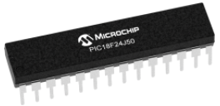 | 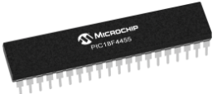 | 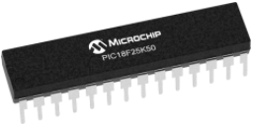
Description | PIC18F66J55 | PIC18F66J50 | PIC18F25K50
Family | 8bit MCU | 8bit MCU | 8bit MCU
ROM | 96KB | 64KB | 32 KB
RAM | 3904 bytes | 3904 bytes | 2048 bytes
Pin count | 49 | 49 | 28
CPU speed | 48 MHZ | 48 MHZ | 48 MHZ
ADC inputs | 8 | 8 | 14
ADC resolution | 10bits | 10bits | 10bits
UART | 2 | 2 | 1
SPI | 2 | 2 | 1
USB | 1 | 1 | 1
I2C | 2 | 2 | 1
Temp operation | -40$℃$ to +85$℃$ | -40$℃$ to +85$℃$ | -40$℃$ to +125$℃$
current | 25 mA | 25 mA | 25 mA
Price | 2.72$ | 2.59$ | 1.76$
Table 15: highlights the different specifications of microcontrollers and the selected one
[25]

The external memory
 | 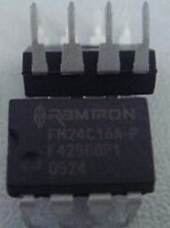
Type | IC
Operating temperature | -40$℃$ to +85$℃$
Number of pins | 8 pins
Capacity | 16K bit
Interface | I2C
Supply voltage | 5V
Price | 5.02£
Table 16: highlights the selected external EEPROM
[26]

RS232 to USB convertor
 | 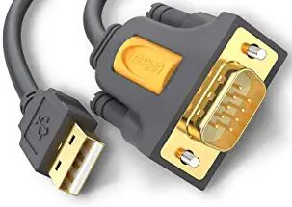
Type | IC
Operating temperature | -40$℃$ to +85$℃$
Number of pins | 9 pins
Data transfer rate | 0.001Gbits/s
Supply voltage | 5V
Price | 9.89
Table 17: the chosen RS232 to USB convertor
[27]

Chapter eight: the battery and the voltage regulator sizing and selection

Voltage regulator

Component | Supply voltage
Temperature sensor | 4– 30V
Display | 2V
LED | 2.5V
Controller | 5V
Total
Table 18: demonstrates the voltage and current consumption of the circuit
From the table it is clear the highest voltage required for the circuit is 5 volts, therefore, the voltage regulator has to be 5V voltage regulator.

Voltage regulator selection
Type | 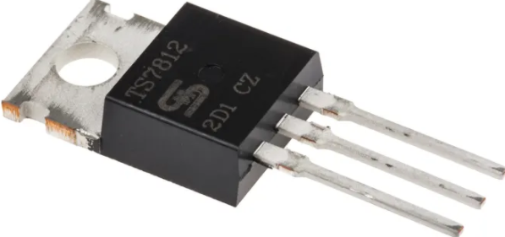 | 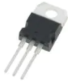 | 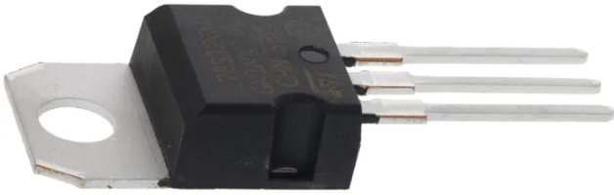
Description | L7805ACV | L7805CV | LM1085IT-5.0/NOPB
Output voltage | 5 V | 5 V | 5 V
Max input voltage | 35 V | 19V | 35 V
Max output current | 1A | 1 A | 1.5A
Operating temperature | 0$℃$ to +150$℃$ | $-40℃$ to +125$℃$ | 0$℃$ to +125$℃$
Dropout voltage | 2V |  | 2V
Price | 0.54 £ | 1.73£ | 0.36£
Table 19: highlights the different types of 5V voltage regulators and the selected one
[28] [29]

The battery options
Component | Supply voltage | Supply current
Temperature sensor | 4– 30V | 60µA
Display | 2V | 30mA
LED | 2.5V | 25mA
Controller | 5V | 25mA
Total |  | 81 mA
Table 20: illustration of the battery sizing
From table above the highest voltage is 5V and the total current supply is 81 mA, therefore, in order to power the circuit during one day, the power calculation will be as follows (81*24) + (81*24)*50%= 2,916 mAh at least.
 | 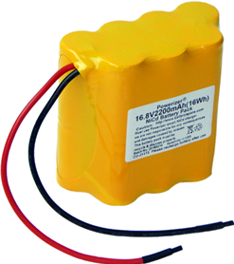 | 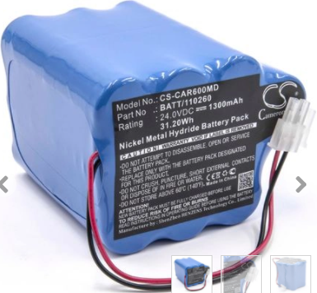 | 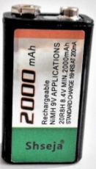
Description | NiCd battery | NIHM | Lithium-Ion
voltage | 16.8V | 24 V | 9V
capacity | 2200mAh | 1300mAh | 2000mAh
Discharge rate | 2.0A | 1.3A
Dimensions | 89*41*85 mm
Weight | 654 g
Price | 39.95$ | 35.38 £ | 14.90 £
Table 21: highlights the different types of batteries and the selected type
[30] [31] [32]

Chapter nine: the design

The operational flowchart
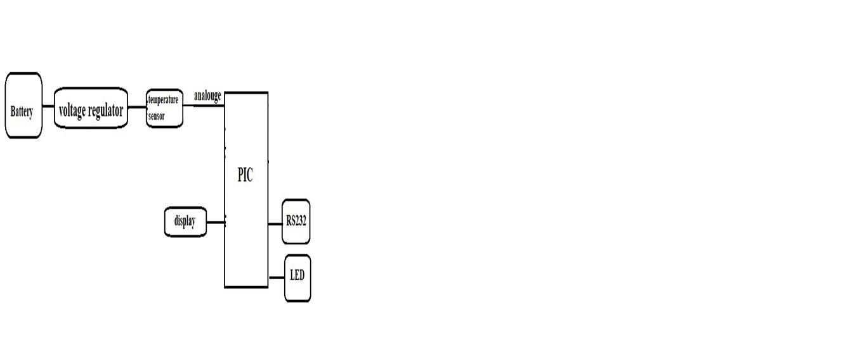
Figure 7: block diagram shows the operation of and the layout of the device

The operational schematics for the simulation
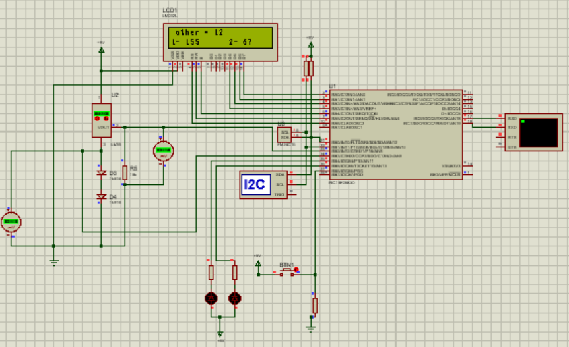
Figure 8: the operational schematics for the simulation

The terminal
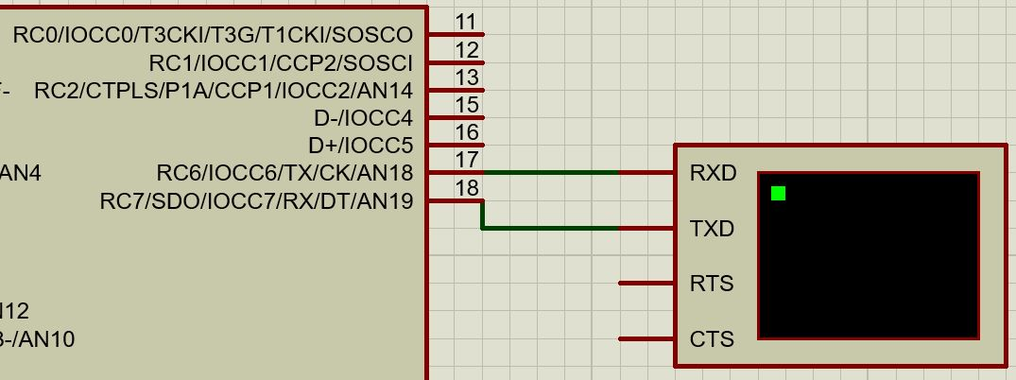
Figure 9: the terminal connection
The terminal is connected to the microcontroller through the pins RC6 which is TX on the microcontroller and RC7 which is RX on the microcontroller to RXD and TXD respectively on the terminal, which simulates the operation of the USB to RS232 convertor serial cable which is used to transfer the logged data from the microcontroller to the required PC.

The LCD
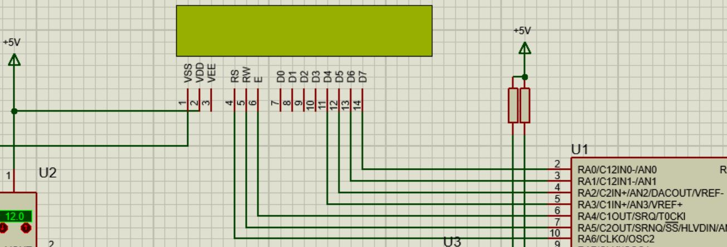
Figure 10: the LCD connections
The LM032L LCD screen has the pins D7, D6, D5, D4, enable pin, RW pin and RS pin which are connected to RA0, RA1, RA2, RA3, RA4, RA5 and RA6 on the microcontroller respectively, in addition, the supply voltage pin VDD and the ground pin VSS are connected to the supply (5V) and ground (0V).

The EEPROM connection
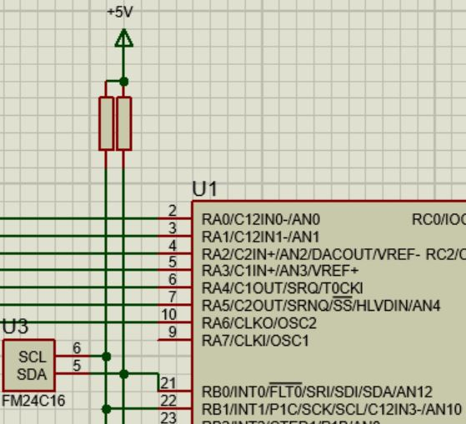

Figure 11: the EEPROM connections
The external EEPROM which is FM24C16 is through the data pin SDA and the clock pin SCL to pin RB0 and RB1 on the microcontroller, also the two connections are connected to the supply voltage through two separate 10K resistors as its recommended on the FM24C16 datasheet as shown on the graph below.
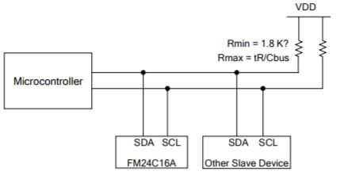
Figure 12:EEPROM connections from the datasheet

The LEDs connection
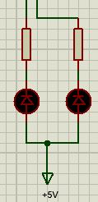
Figure 13: the Led connection
The LED is connected by connecting the anodes to the supply voltage (5V) and the cathode to microcontroller on PIN RB4 and RB5 through a voltage reduction resistor of 220 ohms as the LED consumes only 2.3V, Pin RB4 and RB5 has to be put to zero in order for the LEDs to light up.

The push buttons
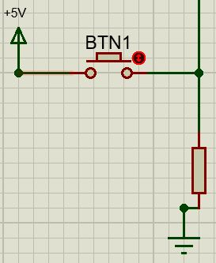
Figure 14: the pushbutton connection
In order to connect a push button as an input of 5V and 0V to the microcontroller, it has to be connected to the supply voltage on one end and to the ground through a pull-down resistor on the other end and the output will be connected to pin RB6 on the microcontroller.

The temperature sensor
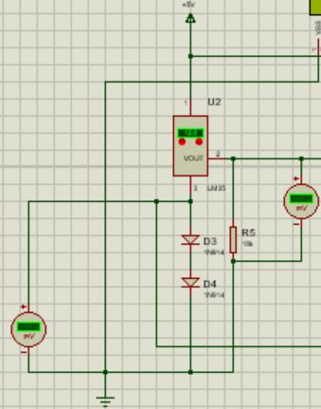
Figure 15: LM35 connections for positive and negative temperature
The temperature sensor LM35 according to the datasheet can be connected in two ways either to get an output of (0 to 150) or (-55 to 155) which is either positive temperature output or positive and negative temperature output but, on this simulation, LM35 is connected to measure positive and negative temperature, as shown on the graphs below.

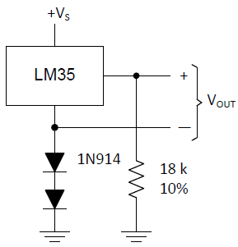
Figure 16: LM35 connections for positive and negative temperature from the datasheet
in the simulation the temperature sensor LM35 is connected in a setup which measures the positive and negative temperatures which leads to having two separate deferential temperature inputs to the microcontroller and in order to get the final temperature, a mathematical calculation has to be done.
The analogue temperature readings will be passed through analogue to digital convertor inside the PIC microcontroller which has to be at least 10bits as the resolution of the LM35 is 10 mV per 1$℃$ and as the input voltage is 5V then the input voltage divided by the ADC resolution which is 1023 then it results in 4 mV per division which is good as long as it is less than LM35 resolution 10mV. But if 8bit ADC is used then dividing the input voltage 5V by the ADC resolution 255 yields in 19 mV per division which is higher the required resolution. Therefore, at least 10bit ADC must be used.

The voltage regulator
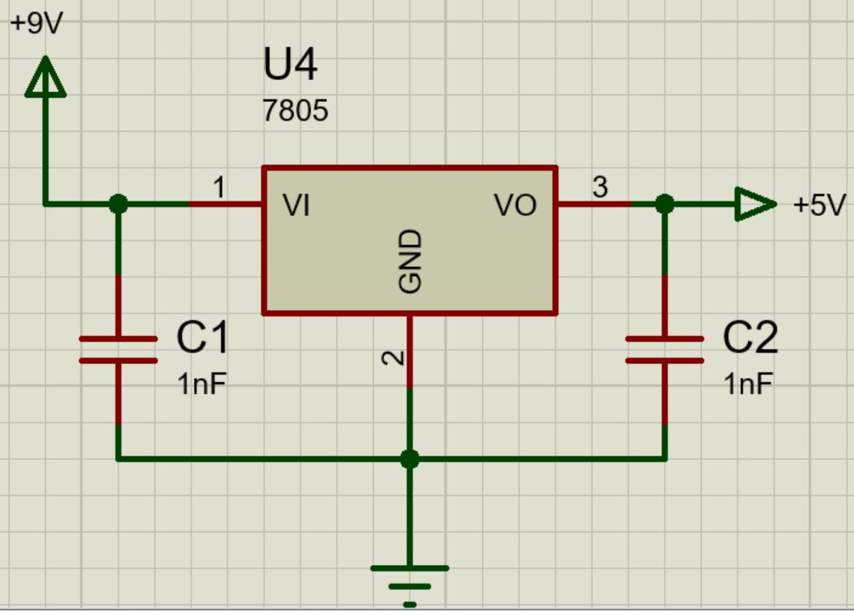
Figure 17: the voltage regulator connectionns
As the battery voltage supply is 9V, then a 5V voltage regulator is used in order to obtain a fixed 5V output voltage. The connections and the capacitors values are obtained from the graph below which obtained from the datasheet.
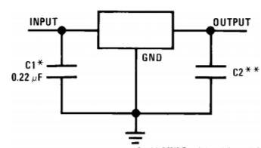
Figure 18: the connections of the voltage regulator from the datasheet

The software flowchart
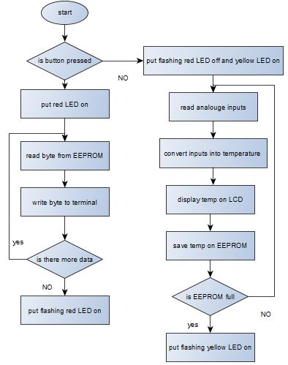
Figure 19: the software flow chart
The flowchart is constructed of two sections, the data acquisition mode and the data transfer mode. The transition between the two modes is achieved with the help of a pushbutton as when it is pressed, the operation will be on the data transfer mode indicated by the red LED, the loop starts with reading the data from the EEPROM then writing the data into the terminal and keeps repeating until there is no more data on the EEPROM then the red LED starts flashing.
If the pushbutton is not pressed, then the flashing red LED will stop and the yellow LED will light up indicating the transition of the system into the data acquisition mode where the loop starts with reading the analogue inputs, then converting them into temperature readings and displaying them on the LCD, and finally saving the readings into the EEPROM, this loop will repeat until the EEPROM is full where the yellow LED will turn into a flashing LED.

The code for the simulation
#include <main.h>

#include <2416.C>
#define LCD_ENABLE_PIN PIN_A4
#define LCD_RS_PIN PIN_A6
#define LCD_RW_PIN PIN_A5
#define LCD_DATA4 PIN_A3
#define LCD_DATA5 PIN_A2
#define LCD_DATA6 PIN_A1
#define LCD_DATA7 PIN_A0

#include <lcd.c>

long adc1,adc2,other;
float vd = 0.89;
float temp;
unsigned long int location = 0;
int data = 0 ;
short negative;

int reading1;
int reading2;
int state = true;

void main()
{
setup_adc_ports(sAN8|sAN9);
setup_adc(ADC_CLOCK_INTERNAL|ADC_TAD_MUL_0);
init_ext_eeprom();

lcd_init();

while(TRUE)
{

set_adc_channel(8);
delay_us(30);
adc1 = read_adc();

set_adc_channel(9);
delay_us(30);
adc2 = read_adc();

if(adc1 > 1)
{
other=(adc1-adc2);
other/=2;
}
else
{
other =adc2/2;
other*=-1;
}
other+=55;

printf(lcd_putc,"\f other = %ld",other-55);
lcd_gotoxy(1,2);
printf(lcd_putc,"1- %ld 2- %d",adc1, read_ext_eeprom(location-1));;

printf("other = %ld\n\r",other-55);

printf("1- %ld 2- %d\n\r",adc1, read_ext_eeprom(location-1));;

delay_ms(1000);

write_ext_eeprom(location,other);

location ++;
}
}

The operational schematics for the prototype
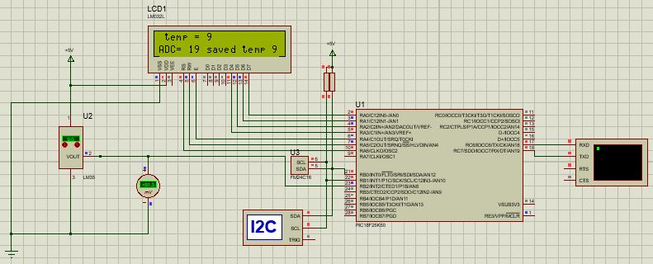
Figure 20: the operational schematics for the prototype
In the prototype LM35 with range from 0$℃$ to 100$℃$ is used instead of -55$℃$ to +150$℃$ as it was not available at the time, and therefore, only one input reading is needed as shown on the graph below and the software is slightly adjusted to suit this set up.
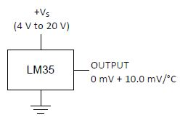
Figure 21: LM35 connections for only positive temperature

The code for the prototype
#include <main.h>

#include <2416.C>
#define LCD_ENABLE_PIN PIN_A4
#define LCD_RS_PIN PIN_A6
#define LCD_RW_PIN PIN_A5
#define LCD_DATA4 PIN_A3
#define LCD_DATA5 PIN_A2
#define LCD_DATA6 PIN_A1
#define LCD_DATA7 PIN_A0

#include <lcd.c>

long adc1,adc2,temp;
float vd = 0.89;
unsigned long int location = 0;
int data = 0 ;
short negative;

void main()
{
setup_adc_ports(sAN8|sAN9);
setup_adc(ADC_CLOCK_INTERNAL|ADC_TAD_MUL_0);
init_ext_eeprom();

lcd_init();

while(TRUE)
{
set_adc_channel(8);
delay_us(30);
adc1 = read_adc();

set_adc_channel(9);
delay_us(30);
adc2 = read_adc();

if(adc1 > 1)
{
temp=(adc1);
temp/=2;
}

printf(lcd_putc,"\f temp = %ld",temp);
lcd_gotoxy(1,2);
printf(lcd_putc,"ADC= %ld saved temp %d",adc1, read_ext_eeprom(location-1));;

printf("temp= %ld\n\r",temp);

printf("ADC= %ld saved temp %d\n\r",adc1, read_ext_eeprom(location-1));;

delay_ms(1000);

write_ext_eeprom(location,temp);

location ++;
}

}

The prototype
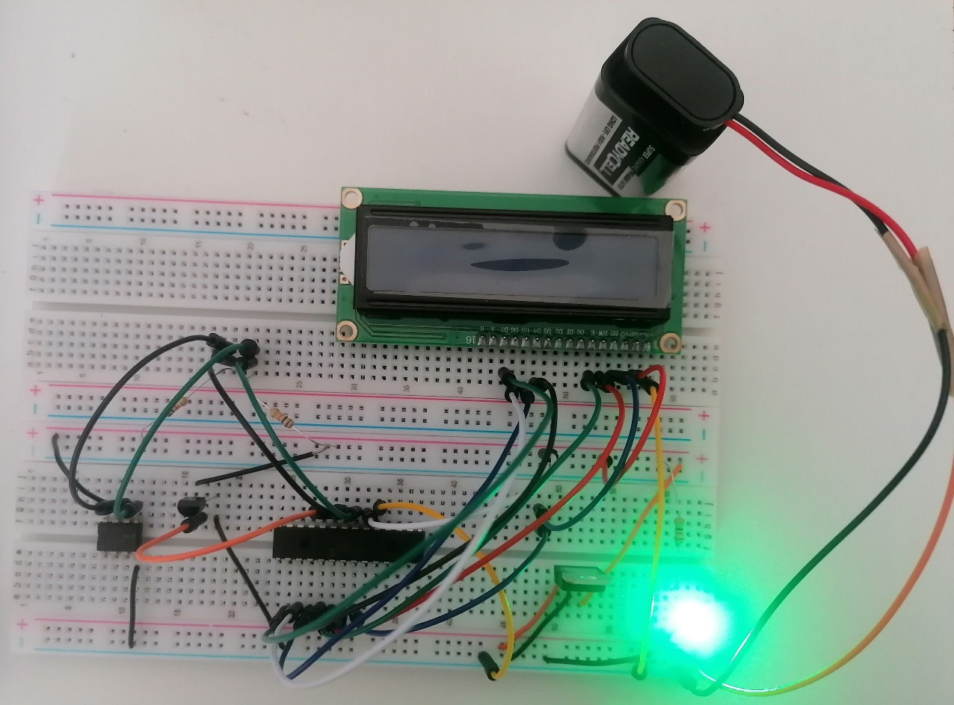
Figure 22: the prototype

The connections of the voltage regulator
The legs connections on the voltage regulator are made according to the graph shown below which originated from the voltage regulator LM7805 datasheet.
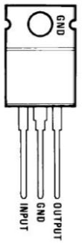
Figure 23: the legs connections for the voltage regulator
Also, the voltage regulator can be added to it two capacitors in order to obtain smooth voltage output and the values and connection should be as in the graph below which taken from the datasheet.
Figure 24: the connections of the voltage regulator from the datasheet

The connections of the microcontroller
The names and positions of the pins of the microcontroller are obtained from the graph below which obtained from the datasheet of PIC 18F25K50.
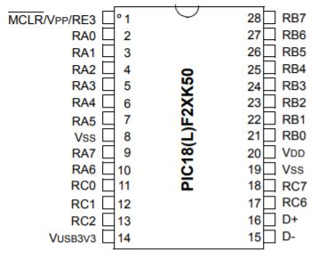
Figure 25:PIC 18F25K50 pins layout from the datasheet

The connections of the EEPROM
The names and positions of the pins of the EEPROM are obtained from the graph below which obtained from the datasheet of FM24C16 EEPROM datasheet.
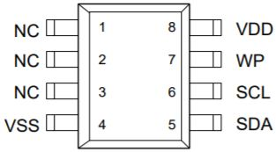
Figure 26: FM24C16 pins layout from the datasheet

The LCD connections
The LCD is connected the same way it is wired on the simulation as the pins are numbered.

Chapter ten: The analysis

Testing the program on the simulation
The program written was to read the analogue temperature input and convert it into temperature then display the temperature on the LCD display and on the terminal and also storing the temperature and displaying the stored value on the LCD. This program function as intended

Testing the prototype
Using the findings from the market research and the components investigation research to decide which sensors should be used, a prototype was build based on the simulation and sadly when tested it did not come to life and didn’t function as intended and because of the lack of the inspection equipment’s for fault finding, the fault was not found.

Chapter eleven: evaluation
The specifications set on the planning stage was designing a battery powered temperature data logger which stores the data into an external non-volatile memory and has the feature to be connected to a PC and transfer the data into the PC.
All these objectives were met on the simulation but the prototype was not built successfully as well as the PCB, therefore this project had a considerable amount of success to some limit.

Chapter twelve: the conclusion
Chapter one: introduction
The introduction is a brief discretion of the project and its outlines and objectives giving the reader an insight of what expected to be in this project.
Chapter two: planning
This chapter breaks the project down into milestones and objectives for each chapter separately, and then tying these objectives into a timescale using a Gantt chart.
Chapter three: research methodology
This chapter illustrates the research technique used to perform this research which is the research onion where every layer of the onion represents a layer of the research topic.
Chapter four: market research
This chapter provides information about the similar products available in the market and comparison between them.

Chapter five: components investigation
This chapter details all the sensors available for the temperature and also all the components of the circuit.

Chapter six: memory sizing
In order to choose a suitable microcontroller, the memory size for the microcontroller has to be estimated and this is what this chapter is about.

Chapter seven: microcontroller selection
This chapter details the process of selecting the microcontroller.

Chapter eight: battery and voltage regulator
This chapter details the process of calculating the required size of the battery according to the intended operation time of the circuit, then details the selection of the suitable battery and the voltage regulator.

Chapter nine: the design
This chapter includes the operational schematics of the system, and the flow chart for the software and also the details of the program.
Chapter ten: analysis
It includes the test done to the simulation and to the prototype.
Chapter eleven: evaluation
This chapter points out the objectives and goals set out on the planning stage and highlights to what degree these objectives have been met and how successful the project was.

Chapter thirteen: recommendations
The project in general has not got to the physical functionality yet but in terms of the main design and developing it, many things can be added to it such as adding WIFI module in order to transfer data to a PC without the need of stopping the data logging and connecting the device to a PC.
In addition, a real time clock can also be added to log the data in accordance with the time and date, and also a GPS module can be added to locate the position of the device if needed to be left away to log data for long period of time then it is easier to find it.

Chapter fourteen: reflection
“The journey of one thousand miles starts with one step”, I am certain I have not finished this journey, but I am glad I started it and glad I got this far. And it has been rewarding and satisfying in terms of the knowledge and understanding has been acquired throughout this project as I have learnt a lot in terms of taking an idea and developing it into a design and then converting it into a product, where I needed to learn and use software like CCS compiler and MPLABX which I never used before which gave me confidence dealing with such software and writing code, but still need more practise and sharpening to my skills.
This journey will not stop here with a non-functioning prototype, I will get it to work and proceed to producing a PCB design and building a PCB prototype.

References

[1] | [Online]. Available: https://www.biz4intellia.com/blog/temperature-monitoring/. [Accessed 1st December 2020].
[2] | [Online]. Available: https://thesismind.com/analysis-of-saunders-research-onion/. [Accessed 7th April 2021].
[3] | [Online]. Available: https://uk.rs-online.com/web/p/data-loggers/1232302/. [Accessed 6th January 2021].
[4] | [Online]. Available: https://www.loggershop.co.uk/product/mcr-4tc-4-channel-temperature-data-logger/. [Accessed 10th January 2021].
[5] | [Online]. Available: https://www.loggershop.co.uk/product/trix-8-temperature-data-logger/#calibration-certificate. [Accessed 13th January 2021].
[6] | [Online]. Available: https://www.loggershop.co.uk/product/itag4-temperature-data-logger/. [Accessed 14th January 2021].
[7] | [Online]. Available: http://www.farnell.com/datasheets/2548174.pdf. [Accessed 15th January 2021].
[8] | [Online]. Available: https://uk.farnell.com/carel/ntc015wh01/probe-ntc-steel-ip68/dp/940021?gclid=Cj0KCQiAwMP9BRCzARIsAPWTJ_HSpNWu_WhPwnO6qvzHefeDNqycRZZA5pZWREJXXgi-0PuFRflH5dsaAv19EALw_wcB&gross_price=true&mckv=s8eEQuhKS_dc|pcrid|459864482336|plid||kword||match||slid||produ. [Accessed 15th January 2021].
[9] | [Online]. Available: https://www.omega.co.uk/pptst/OS136A.html. [Accessed 18th January 2021].
[10] | [Online]. Available: https://uk.rs-online.com/web/p/thermocouples/3630294/?cm_mmc=UK-PLA-DS3A-_-google-_-PLA_UK_EN_Automation_%26_Control_Gear_Whoop-_-Thermocouples_Whoop+(2)-_-3630294&matchtype=&pla-299966119340&gclid=CjwKCAiAgJWABhArEiwAmNVTB6O4ww44nmSFR8ZgYkqxRrbsHmyU0UJ1q. [Accessed 18th January 2021].
[11] | [Online]. Available: https://uk.rs-online.com/web/p/temperature-sensors-humidity-sensors/8115696/?cm_mmc=UK-PLA-DS3A-_-google-_-CSS_UK_EN_Provisioned_Stock_2020-11_Whoop_PO4700161482-_-Temperature+Sensors+%26+Humidity+Sensors_Whoop-_-8115696&matchtype=&pla-338669851589&gclid=. [Accessed 18th January 2021].
[12] | [Online]. Available: https://uk.rs-online.com/web/p/temperature-sensors-humidity-sensors/6687325/?cm_mmc=UK-PLA-DS3A-_-google-_-PLA_UK_EN_Provisioned_Stock_2020-11_Whoop_PO4700161482-_-Temperature+Sensors+%26+Humidity+Sensors_Whoop-_-6687325&matchtype=&pla-541160430637&gclid=. [Accessed 18th January 2021].
[13] | [Online]. Available: https://www.mouser.co.uk/ProductDetail/Texas-Instruments/LM35DZ-LFT4?qs=QbsRYf82W3FEZkSvxC%252BtOg==&mgh=1&vip=1. [Accessed 18th January 2021].
[14] | [Online]. Available: https://uk.rs-online.com/web/p/display-development-tools/7916476/?cm_mmc=UK-PLA-DS3A-_-google-_-PLA_UK_EN_Raspberry_Pi_%26_Arduino_%26_Development_Tools_Whoop-_-Display+Development+Tools_Whoop-_-7916476&matchtype=&pla-477731620556&gclid=CjwKCAiAo5qABhBdEi. [Accessed 19th January 2021].
[15] | [Online]. Available: https://uk.rs-online.com/web/p/display-development-tools/1245443/?cm_mmc=UK-PLA-DS3A-_-google-_-CSS_UK_EN_Raspberry_Pi_%26_Arduino_%26_Development_Tools_Whoop-_-Display+Development+Tools_Whoop-_-1245443&matchtype=&pla-305146622098&gclid=CjwKCAiAo5qABhBdEi. [Accessed 19th January 2021].
[16] | [Online]. Available: https://uk.rs-online.com/web/p/led-displays/7192569/?cm_mmc=UK-PLA-DS3A-_-google-_-PLA_UK_EN_Provisioned_Stock_2020-11_Whoop_PO4700161482-_-LED+Displays_Whoop-_-7192569&matchtype=&pla-341239172775&gclid=CjwKCAiAo5qABhBdEiwAOtGmbv-n5Mr2NZHW4urqlB7edhj-YJdP. [Accessed 19th January 2021].
[17] | [Online]. Available: https://uk.farnell.com/midas/mde0154a152152bw/e-paper-display-152-x-152-pixels/dp/3154925?gclid=CjwKCAiAo5qABhBdEiwAOtGmbt0MBbRkgAa-nX4DovJ-AwXAfjP1FMhg56HhTrWHVZNmAk0XBC76dBoCcAEQAvD_BwE&gross_price=true&mckv=sUze9ZIu5_dc|pcrid|459864482282|plid||kword||. [Accessed 19th January 2021].
[18] | [Online]. Available: https://uk.rs-online.com/web/p/lcd-colour-displays/1685715/?cm_mmc=UK-PLA-DS3A-_-google-_-PLA_UK_EN_Provisioned_Stock_2020-11_Whoop_PO4700161482-_-LCD+Colour+Displays_Whoop-_-1685715&matchtype=&pla-328237179358&gclid=CjwKCAiAo5qABhBdEiwAOtGmbulY39VglyvIVo. [Accessed 19th January 2021].
[19] | [Online]. Available: https://uk.rs-online.com/web/p/led-displays/2358777/?cm_mmc=UK-PLA-DS3A-_-google-_-PLA_UK_EN_Displays_%26_Optoelectronics_Whoop-_-LED+Displays_Whoop-_-2358777&matchtype=&pla-341193698068&gclid=CjwKCAiAo5qABhBdEiwAOtGmbt95vtrZziHoXZNOOwTs1ixYvv08L3Uwki5U7F. [Accessed 19th January 2021].
[20] | [Online]. Available: https://www.vishay.com/docs/83171/tlur640.pdf. [Accessed 18th January 2021].
[21] | [Online]. Available: https://uk.rs-online.com/web/p/leds/2285988/. [Accessed 18th January 2021].
[22] | [Online]. Available: https://uk.rs-online.com/web/p/push-button-switches/0320994/. [Accessed 20th January 2021].
[23] | [Online]. Available: https://uk.rs-online.com/web/p/push-button-switches/8118480/. [Accessed 20th January 2021].
[24] | [Online]. Available: https://uk.rs-online.com/web/p/tactile-switches/7856273/?cm_mmc=UK-PLA-DS3A-_-google-_-PLA_UK_EN_Provisioned_Stock_2020-11_Whoop_PO4700161482-_-Tactile+Switches_Whoop-_-7856273&matchtype=&pla-341994789282&gclid=CjwKCAiAxp-ABhALEiwAXm6IyZPnqPHC8gFNCCRRUc-Z. [Accessed 20th January 2021].
[25] | [Online]. Available: https://www.microchip.com/ParamChartSearch/Chart.aspx?branchID=30048. [Accessed 18th January 2021].
[26] | [Online]. Available: https://uk.farnell.com/analog-devices/ad22100ktz/temperature-sensor-22100-to-92/dp/9605320?MER=sy-me-pd-mi-alte. [Accessed 9th Arril 2021].
[27] | [Online]. Available: https://www.amazon.co.uk/UGREEN-20210-Converter-Connecting-Controller-grey/dp/B00QUZY4UG/ref=sr_1_3?adgrpid=58804212648&dchild=1&gclid=Cj0KCQjwvYSEBhDjARIsAJMn0li3G7SnSyMNL1m-YhcQVmyqQgk0CZwwhrtNnypnNKo4ThKugJCOmy8aAgxlEALw_wcB&hvadid=259053146073&hvdev=c. [Accessed 20th April 2021].
[28] | [Online]. Available: https://uk.rs-online.com/web/p/low-dropout-voltage-regulators/5455764/. [Accessed 18th January 2021].
[29] | [Online]. Available: https://www.mouser.co.uk/Semiconductors/Power-Management-ICs/Voltage-Regulators-Voltage-Controllers/LDO-Voltage-Regulators/_/N-5cgac?P=1yx5k7vZ1z0shyuZ1z0wcrx. [Accessed 16th January 2021].
[30] | [Online]. Available: https://www.batteryspace.com/nicd-battery-pack-16-8v-2200mah-37wh-14xsc-hump-with-16awg-wire.aspx. [Accessed 19th January 2021].
[31] | [Online]. Available: https://www.manomano.co.uk/p/vhbw-nimh-battery-1300mah-24v-for-medicine-technologyekg-device-cardioline-delta-60-ecgdelta-60-ecgdelta-60plus-ecg-replaces-batt-1102607741715-13652914. [Accessed 19th January 2021].
[32] | [Online]. Available: https://eclats-antivols.fr/en/9v/24884-sofirn-1100mah-large-capacity-low-selfdischarge-9v-rechargeable-battery-technology-manufacturing-in-japan-with-security-3663275007838.html?gmc_currency=2. [Accessed 19th January 2021].

