Individual Business Model Canvas
with entrepreneurial reflection using appropriate
academic models

Word count: 1679 + 509
Student name: Ovidiu – Mario Trasc
Student ID: 2206244
Module title: Entrepreneurship
Module code: BMIH5001
Lecturer name: Neil Dyer

Part 1: 1500 Word Essay
In this essay it will be discuss and justify the proposal for a hospitality business concept using the Business Model Canvas. The idea is to open a “Gourmet Picnic” and to offer a unique and convenient dining experience by providing gourmet picnic packages delivered to various scenic locations, parks, or even customers' homes.
First step in planning to start a business is to create a business plan that will help with a lot of aspects. For this it is very helpful to use a business model. The most used business model frameworks are: New Venture Creation Framework, the Lean Canvas and the Business Model Canvas. (Burns, 2022)
According to (Blackwell, 2011) a business plan must be clear, brief, logical, truthful and in order with numbers. Working on Business Model Canvas, each chapter will be presented and analised for the proposed business of Gourmet Picnic.
Key partnerships are the main partners that are crucial to develop the business. In the case of Gourmet Picnic, local food suppliers are playing an essential role because to sell fresh and well-presented picnic baskets, it is very important to keep a good collaboration with local farmers, artisanal food producers, and specialty markets to source fresh and high-quality ingredients for the gourmet picnics.
Another important partnership it is venue Partnerships - it is essential to collaborate with scenic venues, parks, or event spaces to offer curated picnic experiences at their locations, in this way the business is promoted, a lot of people can access the products.
Key partners are the entities or people who will contribute to the success of the business, they are crucial for a proper development.
For Gourmet Picnic the key partners are local food suppliers, partnership with local farmers, artisanal food producers, and specialty markets to source fresh and high-quality ingredients for the gourmet picnics.
At the inauguration of the business, a series of partnerships will be started. Of these, the most important will be with: Welshcheesecompany (Welshcheesecompany.co.uk, 2024) Welsh cheese from a large range of selected Welsh producers like Brooke’s Dairy, The Blaenafon Cheddar Company, The Snowdonia Cheese Company, Trefan Dairy and others.
Trealyfarmcharcuterie (trealyfarmcharcuterie.co.uk, 2024) are producers of a range of over forty different products; from air-dried meats, salami and chorizo to cured and cooked meats and will be one of the key partnerships.
Spiritofwales Distillery (spiritofwales.com, 2024) a craft distillery located Newport, South Wales, home of commemorative Steeltown Welsh Gins, award-winning Welsh Vodka and Dragon’s Breath, vodka, 70% ABV Absinthe and curiously Welsh Rums.
Corporate Partnerships because it is important to establish partnerships with corporations for corporate events and team-building activities. This kind or relationship can help to promote the business and attract more customers.
Key activities, refer to the core operations and tasks a business must undertake to create and deliver its value proposition, reach customers, and maintain ongoing relationships.
To offer exceptional picnic experiences, it is essential to use premium ingredients, creative menus, and thoughtful details.
Quality ingredients and sourcing by offering customization options for customers to tailor their picnic experiences based on preferences, dietary restrictions, and special occasions. In this way Gourmet Picnic can become a suitable option for a lot of people with a variety of tastes, with allergies and intolerances. Also, it is recommended to have gluten-free products, lactose free and vegan options in the menu. (Smith, 2021).
Given the online nature of most orders, a pivotal strategy involves investing in and developing a user-friendly online platform, facilitating easy ordering and payment processes. (Wilson, 2023)
Key resources are the critical assets, capabilities, and elements required to execute key activities effectively. These can include physical, intellectual, human, and financial resources that are essential for the business to operate efficiently and deliver value to its customers.
The first and main resource for any food producer is the quality of the ingredients, so people can be satisfied with their picnic basket will be used only fresh, high-quality ingredients, premium and artisanal products.
Another key resource for this business plan is to build a team of skilled chefs and culinary professionals. In this way it is ensured that hygiene rules will be respected, ingredients will be highlighted in the best form, tastes and mixtures of ingredients will be perfect so that customers will return with orders. (Thompson, 2021)
Aspect can convince people to buy, that’s way unique picnic setups and decor including comfortable blankets, stylish picnic baskets, and elegant tableware will be used to decorate the picnic baskets and a collaboration with Picnicshop will be done (Picnicshop.co.uk, 2024)
Having a massive promotion at least at the beginning of the business can attract more customers. Invest in professional branding materials, including a visually appealing logo, marketing collateral, and a well-designed website can be a good decision.
Value proposition: represent what makes the business attractive, special, what can offer new to the market or different to what exists already.
Design diverse and appealing picnic menus can be one of the most attractive parts because people are curios, they want to try something new, products from other countries, ingredients that they never combined before, so a diverse and special menu will attract clients. (Jackson, 2021)
To allow customers to customize their picnic experience can be for some people just pleasure, but for others can be essential because of some people it may just be pleasure, while for others it is necessary because of certain diseases, allergies or food intolerances. (Smith and Davis, 2022)
Emphasize sustainability by using eco-friendly and reusable packaging for the picnic items.
Online ordering platform, easy to use, to save your orders so you can remember what you have tried, to give you suggestions based on previous orders and offer discounts or certain gift products so that customers return more and more often with orders.
Customer relationship represent the way of communication with people, with new customers and future customers.
Nowadays, social media is an easy way to keep in touch with a wide variety of customers, from teenagers to parents and even grandparents. Use the social media to share customer testimonials, showcase picnic setups, and encourage customers to share their experiences. (Smith, 2021)
No matter on which way, but it is very important to regular communicate with clients, to keep customers informed about new offerings, seasonal specials, or promotions through regular newsletters, email updates.
Loyalty Programs make people feel engaged, so implement a loyalty program where customers earn points or receive exclusive discounts for repeat business.
Gives customers the opportunity to provide feedback. No matter how it is, positive or negative, an opinion from a client can only help.
Channels, represent the way of communication with customers with the scope of promoting the products, to share new products, to find their opinions and to create a connection to become loyal to the business.
Social Media Marketing through the most accessible ways like Facebook, Instagram, Pinterest is a common way that become very used for companies that are targeting young generation but not only. Being active on social media, can improve sells, gain new customers and attract new ones by posting, giving messages and keep in touch with customers. (Wilson, 2023)
Partner with local influencers can be e very easy method to promote the products, because teenagers just want to be like their idols, and they will go as well to a new shop or restaurant or try different products.
Flyers and banners can make a good publicity if they are attractive, in colors, message or other ways.
Radio advertising is another useful channel to communicate because it is used by a lot of people.
Customers segments refers to the different groups of people or organizations that a business aims to reach and serve.
First category targeted are couples (between 20 and 40 years old) looking for a romantic and intimate dining experience: picnic packages designed for two, featuring gourmet dishes, elegant setups.
Other can be families with medium-high income looking to enjoy quality time together outdoors (provide family-friendly picnic options with a mix of both adult and kid-friendly gourmet offerings).
An important target is corporate and team building events (tailored picnic packages suitable for outdoor meetings, team-building activities, or office celebrations) because they can become regular clients, they can order bigger quantity and can be more profitable. LittlePicnicCompany are a company that deals with the same type of picnic baskets, and their target audience consists of families, corporates and weddings.
Cost Structure: the cost it is divided into initial cost to start the business and running cost that will be more or less the same each month.
For the gourmet picnic, the startup costs will include the location and venue fees, picnic equipment, including high-quality blankets, baskets, tableware, and decorations, licenses and permits, investment in developing a user-friendly website and online ordering platform, costs for creating a brand identity.
Running Costs will include high-quality ingredients, staff wages, continued investment in marketing and advertising, utilities, technology or software solutions used in business operations, such as a Point of Sale.
A budget to cover the initial cost and 3 months of non-profit operation was considered to start the business. The source of budget is savings and selling a property.
Revenue Streams represents the avenues through which a business generates income. Identifying various revenue streams involves understanding how customers are willing to pay for the value provided.
The main revenue will come from selling customized picnic experiences and offering corporate picnic events.
Other way to make revenue can be selling branded merchandise such as picnic accessories, reusable items and selling gift cards or vouchers for your gourmet picnic services, encouraging customers to purchase experiences for friends, family, or colleagues.
In conclusion, the key is to create memorable experiences and make customers feel valued. Building a strong and positive relationship with the customers will not only encourage repeat business but also generate positive word-of-mouth, contributing to the success and growth of Gourmet Picnic.

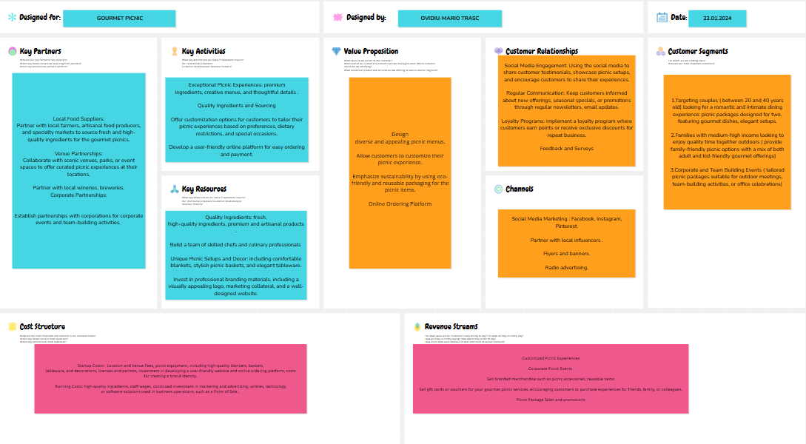
Figure. 1: Business Model Canvas ( Business Model Canvas ‒ Conceptboard )

References
App.conceptboard.com (2024) Available at: Business Model Canvas ‒ Conceptboard , Accessed on: 23.01.2024
Blackwell, E. (2011), How to Prepare a Business Plan: Planning for Successful Start-up and Expansion, (5th Ed) Sunday Times Business Enterprise Series, Kogan Page
Burns, P. (2022) Entrepreneurship and Small Business, 5th Ed., Palgrave Macmillan: Basingstoke.
Jackson, M. (2021). Innovative Menu Design: A Catalyst for Attracting Culinary Adventurers. Journal of Culinary Trends.
Picnicshop.co.uk (2024). Picnic Baskets. Available at: Find picnic baskets, hampers, backpacks, cool bags and rugs - PicnicShop. Accessed on: 27th January 2024.
Smith, A., & Davis, B. (2022). Customization in Culinary Experiences: Pleasure and Necessity for Diverse Consumer Needs. Journal of Gastronomic Research.
Smith, J. (2021). Enhancing the Picnic Experience: A Focus on Quality and Customization. Journal of Culinary Tourism, 25(2), 45-62.
Smith, J. (2021). Social Media Marketing Trends: Insights into Effective Strategies for Businesses. Journal of Digital Marketing Insights.
Spiritofwales.com (2024) SPIRIT OF WALES DISTILLERY. Available at: Home - Spirit of Wales. Accessed on: 27th January 2024.
Thompson, K. (2021). Quality Ingredients as a Competitive Edge in the Food Industry. Journal of Culinary Arts.

Trealyfarmcharcuterie.co.uk (2024) Award Winning Artisan Charcuterie Made in Monmouthshire. Available at: Trealy Farm Charcuterie - Artisan British Cured Meat, Salami, Chorizo Accessed on: 27th January 2024.
Welshcheesecompany.co.uk (2024) Our Welsh Cheese Producers. Available at: Welsh Cheese Producers - The Welsh Cheese Company. Accessed on: 28th January 2024.
Wilson, M. (2023) The Digital Picnic: Strategies for Building a User-Friendly Online Platform in the Culinary Industry. Journal of Business and Technology.
Wilson, M. (2023). The Influence of Social Media on Consumer Purchase Intentions: A Comprehensive Review. Journal of Business and Technology.

Part 2: 500 Word reflective essay
The main purpose of the essay is to critically evaluate my entrepreneurial and management motivations starting from the test results of personal entrepreneurial test taken on get2test.net. In this essay I will make my analysis using Gibbs reflective cycle, that is a popular model for structured reflection with 6 components: description, feelings, evaluation, analysis, conclusion and action plan. (Gibbs, 1988)
Other known methods of reflection are: Kolb's Experiential Learning Cycle, Borton's Reflective Model, Johns' Model for Structured Reflection, Schön's Reflective Practice (Moon, 2004).
Entrepreneur is an individual who takes initiative, organizes, and manages a business, assuming financial risk for the purpose of achieving profit and growth with innovation and creativity. (Stevenson & Gumpert, 1985)
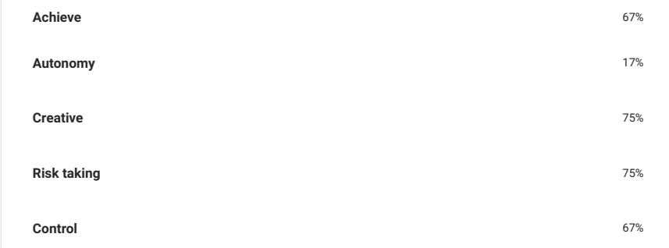
Figure 1 – Test score ( get2test.net)
Description:
GET2 Test is an online test where after you answer several questions you can get some results telling you about your entrepreneurial capabilities and giving you some guidance for improving your skills.
Feelings:
During my work journey I had some moments when I thought maybe it is the moment to become more independent and start my own business. Now that I made the entrepreneur test, I felt impatient to discover what the results are. I was honest and I tried to answer without thinking about anything else, just about myself.
Evaluation:
A general score of 65% in the GET2 entrepreneur test indicates a moderate level of performance across the assessed areas. It suggests that I have a solid understanding of various aspects related to entrepreneurship, but there may be room for improvement or refinement in certain areas and I am more than agreeing with this evaluation.
Analysis:
I will focus on two of the results. I received a score of 17% on Autonomy in the GET2 Test. This indicates that there is room for improvement in my ability to work independently and take initiative. This feedback is valuable to me as it highlights an area where I can focus on growth. I am committed to enhancing my autonomy-related skills by actively seeking opportunities to work independently, improving my time management, and developing stronger problem-solving abilities. I believe that with dedication and a proactive approach, I can make significant strides in this aspect of my professional journey.
I achieved a score of 75% in the Creative category of the test. This result reflects my ability to think innovatively and approach challenges with a creative mindset. I have a passion for exploring new ideas, finding inventive solutions, and embracing creativity in my work. I am confident that my creative skills will contribute positively to projects and tasks, bringing fresh perspectives and innovative approaches to the table. I wasn’t so sure about my creative capacity, but I will try to make some real actions soon as I am motivated and ideas.
Conclusion and action plan:
Taking into consideration the test results, I will try to identify the specific skills crucial for entrepreneurship, like strategic planning, marketing, financial management and work on enhancing them through practical applications and further learning. Also, I will start to develop my own business plan.

References:
Get2test.net (2024) Get2 test for enterprising potential. Available at: General Measure of Enterprising Tendency v2 - GET2 (get2test.net) Accessed: 09th January 2024
Gibbs, G. (1988). Learning by Doing: A Guide to Teaching and Learning Methods
Moon, J. (2004). A Handbook of Reflective and Experiential Learning: Theory and Practice.
Stevenson, H. H., & Gumpert, D. E. (1985). The Heart of Entrepreneurship.

