

Employee Job Dissatisfaction In UK

Name: Mariana Larisa Neagoe
Student ID: 1921885

Lecturer: Gasso Wilson Mwaluseke
Contents
Abstract 3
Introduction 3
Literature review 4
Analysis of their findings 6
PESTLE analysis 7
Fishbone diagram 8
Plus/Minus/Interesting – PMI 10
ADKAR – model of change management 11
Employees job dissatisfaction in Gist ltd 13
PESTLE analysis 14
FISHBONE diagram 14
Solution to the problems 16
Conclusion 17
References 18

Abstract

The purpose of this report is to emphasise the job dissatisfactions of UK employees and to reveal the decision-making tools and problem-solving strategies for employees. Analysing the literature review, it is shown that there are several issues that are causing employees dissatisfaction, issues like: poor pay, poor life balance, not enough recognition by employees.
In this report it will be conducted a secondary research based on findings from other authors regarding the employee dissatisfaction at the workplace and a primary research conducted in a logistic company, GIST LTD.

Introduction

Job dissatisfaction is the expression of negative feelings about the work environment.
There are many factors which leads to employee’s dissatisfaction:
- Poor working condition
- Low payment
- No opportunities to career development.
- Lack of recognition

The aim of this report is to initiate us in the decision making and problem-solving process, and to use of the tools that are available for the employees in order to address employees’ issues.
I will introduce here notions like PESTLE analysis, Fishbone diagram and PMI brainstorming technique and how they are used by companies in order to take the right decision that will increase the employee’s job satisfaction and thus the productivity.

Literature review

According to Half (2019), the employer’s main objective should be to maintain their staff happy because when the employees are not satisfied with their job the retention of qualified personnel is poor and so is the productivity level.
Here are some reasons that are causing job dissatisfaction:
- Workers do not interact with each other – considering that UK working people are spending around 40 hours at work every week, a total of almost 2000 hours per year and if the work environment is not positive it will affect the people in a bad way. If a friendly work environment is missing, the concept of team building is abstract is very difficult to build positive relationships between people.
- Employees are not empowered – if the employees or managers don’t give the workers the opportunity to show their creativity, their capabilities this will result in job dissatisfaction.
- Lack of work-life balance – Burnout is one of the main causes of employee dissatisfaction. Lately, more than a half of millions of people admitted that they suffer from work-related stress which has a direct impact on their productivity rates. Most of them could not switch off from work problems not even when they are in the middle of their families and this is affecting their personal life as well.
According to Hales Job (2021) as a result of a wide survey that they conducted on UK job dissatisfaction, poor management is one of the main reasons of the worker unhappiness, almost half of the respondents. 20% consider that they pay is low and 13% think that their employers are not giving them the chance to progress.
South East employees are the most unsatisfied ones, follow by the East Midlands ones and the employee’s opinion is that businesses in this region are not meeting the employees’ standards.
In almost 40% of the cases, the employees want to change the management, and over 20% considers that the organizational culture needs to be improved in order to increase their satisfaction at the workplace.
Kirsty Walpole, Director of Sales an Operation at Hales group says that bad management has overtook the low salary and the main reason that people want to leave from their job is the fact that they don’t feel valued at the workplace.
The dissatisfaction at the workplace is a fact, some of the employees are pursuing g greater opportunities while others choose to remain unsatisfied in the same workplace. The problem is that the unhappy workers performance is poor, motivation is missing, and this is affecting the company in a negative way. (Johnson, 2018).
According to Johnson (2018), the key reasons for job dissatisfaction are:
- Being underpaid
One of the main dissatisfactions for UK workers is being underpaid by their employers. They are living on National Minimum Wage and there are times when they literally struggle with daily life. The stress of unpaid bills creates a big unhappiness among UK workers.
- The career growth or advancement is limited.
Employees feel that they are stagnant at their workplace, they don’t feel valued, and they don’t want to commit with the company for long term. That is why their productivity is low and they do not have the desire to participate at the achievement of the companies’ goals.
- Poor Management
The managers that do not have leadership skills or they are poor, are not able to offer feedback to employees, to guide and motivate them. They behaviour is rather dictatorial, and people’s productivity will decrease.
- People are not heard
If the manager doesn’t know how to listen the employee, the communication process is altered resulting in job dissatisfaction. The employees need to give employees the chance to speak their mind, they need to hear from managers that they perform well.

Analysis of their findings

All the above-mentioned issues can be addressed by the help of decision-making and problem-solving tools. The employees need to tackle the problems and to put in place solutions that will bring employees satisfaction, increasing their productivity and achieving the companies’ purposes.
What tools they can use?

PESTLE analysis

According to JOBBER ACADEMY (n.d.), the PESTLE acronym stands for Political, Economic, Social, Technological, Legal an Environmental factor.
The PESTLE analysis is helping the companies to plan and decide over their next steps having a clear picture of the external factors that are affecting their business.
When a business is affected, the employees will be as well, that is why even when we are analysing the employees job dissatisfaction in UK, we need to consider the external factors as well.
- Political factors – there are factors like governmental decisions or laws that are affecting a business: Income taxes, National Minimum Wage dispositions, Union influences, international policies.
- Economic factors – are represented by the financial fluctuations that are so difficult to control: inflation rates, GDP loss or growth, income of possible clients in your zone, the trends of employee’s salary in your business sector.
- Social factors – are related to the cultural norms of the employees, their characteristics: age, norms and traditions, attitude towards the service career, diversity, Public health and safety, Religion.
- Technological factors: these ones are directly influencing the cost of the business and its efficiency. Not keeping up with the technology trends, using old software or equipment, these are reason enough for a business to step fall back.
- Legal factors may have a clear impact on the business environment through insurance laws and mandates, antitrust laws, OSHA policies.
- Environmental factors are represented by all the reason that can affect a business from ecological and environmental standpoint. Here we can consider environmental impact of service business, geography, access to the business (road, rail, air), waste management and attitude to pollution.

Fishbone diagram

According to Boi (2021) the Fishbone diagram is a tool used to discover the cause of a problem by organizing the ideas and the theories related to the problem.
It was created by Kaoru Ishikawa in 1960 and it had the form of a fish. The head of the fish is representing the problem and the other bones the possible causes for the problem.
It is mainly based on brainstorm and there are 4 steps that needs to be taken in order to create this diagram:
- Write the problem that need solution.
- Discover as many as factors that might be responsible for the problem. Choose around six categories at the beginning and them develop from there.
- Through brainstorm identify possible reasons of the problems and place them under the category they fit.
- Prioritize what seems to be more urgent and analyse the cost that may imply the other one’s solutions.
In our case study, the employee’s job dissatisfaction is the head of the fish, and we must discover what is representing the other bones.
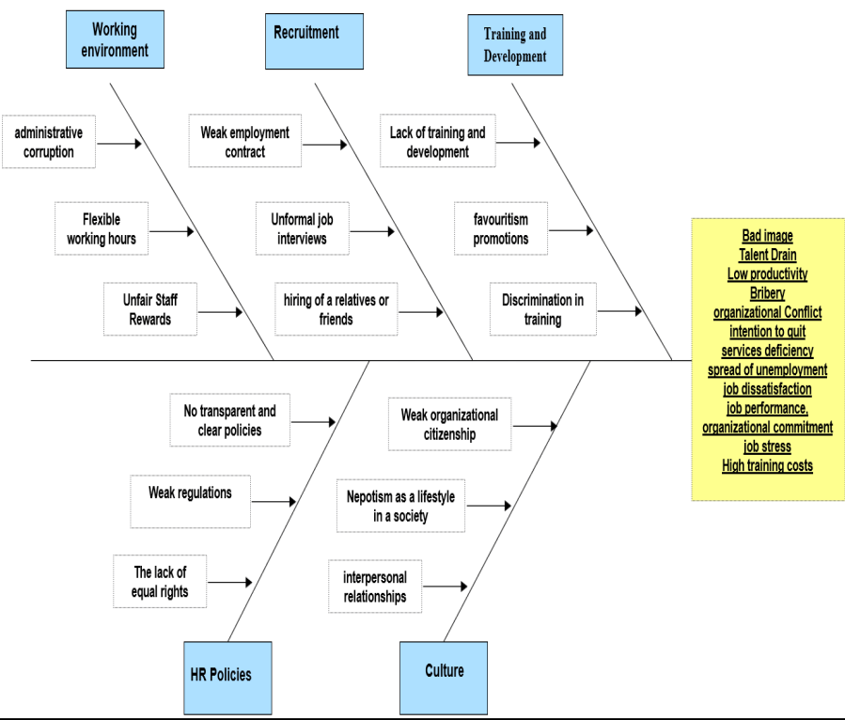
Fig.1: http://jthmnet.com/journals/jthm/Vol_7_No_2_December_2019/2.pdf

Even though the Fishbone diagram categorises multiple causes for job dissatisfaction it does not provide solution to solve the problems.
Another minus would be that the use of creativity is rather limited as you must refer strictly to the main categories that were mentioned from the beginning.

Plus/Minus/Interesting – PMI
According to Virtual Library (n.d.) PMI is a brainstorming tool very important in decision making and creative thinking. It was developed by Dr. Edward de Bono and it can help the organisations to:
- Brainstorm ideas
- To take decisions fast by analysing Pros and Cons
- Evaluate a process.
- Identify strengths and weaknesses in order to improve the productivity.
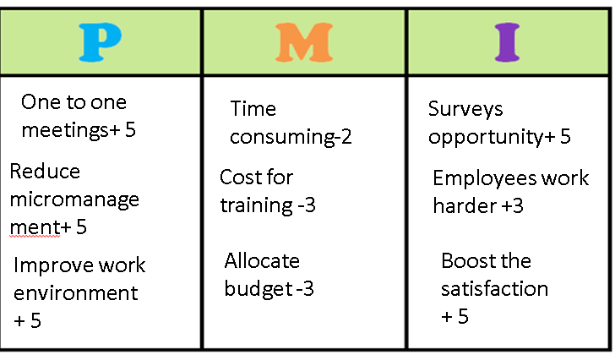



The Plus Points - in this column must be written all the positive aspects of a situation
The Minus Points – in this column we will find the negative features
The Interesting Points – here are points of interest that should be paid attention to.
After the column are filled and analysed a conclusion must be draw.
As we can see the result is 20, a positive result, the decisions that we want to take in order to increase job satisfaction are good decisions.
PMI is good for critical thinking, focussing the attention, evaluating and analysing the outcome.

ADKAR – model of change management

According to MobbieTrain (2020) ADKAT is a decision-making and problem-solving model created in 1994 by Jeff Hiatt, founder of Prosci and its purpose was to help employees to accept and engage with change. It a clear instruction for managers regarding the strategic changes on the workforce. Also, it is helping them to see employee’s needs, being more willing to meet them.
It is described by the below acronym:
- A – awareness, the change is taking on individual level, but for organizational wellbeing.
- D – desire, to change.
- K – knowledge, of what represent the change and how to implement it.
- A – ability, getting the skills and abilities by learning and practicing them.
- R – reinforcement, the changes will be maintained through practice and avoiding the staff getting back at old practice.

How does it work?

As a part of Awareness step, company needs to communicate to employees clear what is the change? Engage them in the change by being clear and honest with them.
Then the workers need to understand Why – make sure they understand the change, how they are involved into it and why this will benefit them and the company.
The next question that needs an answer is How? Offering them the right technology, training and know-how, reinforce the idea of changing now and then in order to help the employees make the switch.
ADKAR model is ideal for boosting the employee’s engagement and Knowledge retention, the organisational changes will take place faster and in a better working environment.

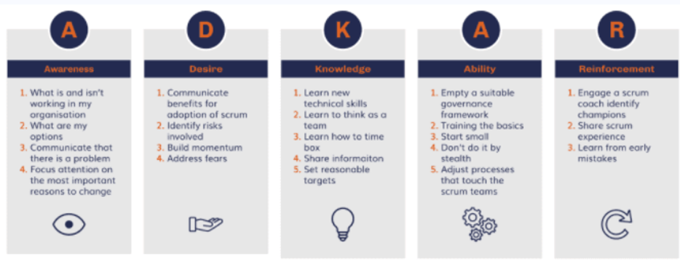
.

Employees job dissatisfaction in Gist ltd
I conducted a survey over 150 people that are working for a logistic company, Gist Ltd and the results showed that the potential causes of this job dissatisfaction are:
- Salary does not reflect the amount of work they provide – the life is getting more expensive, bigger tax to pay, food and housing are more expensive.
- Feeling unappreciated recent study showed that two thirds of UK workers don’t feel valued and many of them would consider leaving for a new opportunity because of this.
- Poor workplace relationships – barriers between employees are not overcome due to different culture and poor involvement of management.
- Lack of work-life balance without a distinct line between work and home life, employees can quickly become overwhelmed and unable to switch off. THE FAMILY LIFE WILL BE AFFECTED AS WELL.
- Poor management and No growth prospects
When there are no interests in investing in employees’ skills, managers did not held appraisals meeting not only the staff, but the business is affected as well. All the employees have the desire of developing their career, participate in training and Gist is not offering that.
Which are the possible factors that create this unhappiness?
The best way to find out is to use the specific tools that employers and managers have: SWOT (strength, weaknesses, opportunities and threats), PESTLE analysis, Fishbone diagram, PMI and ADKAR model in order to implement the changes and offer a viable solution to the problems that were raised.

PESTLE analysis

The external factors that may lead to employee dissatisfaction at GIST are:
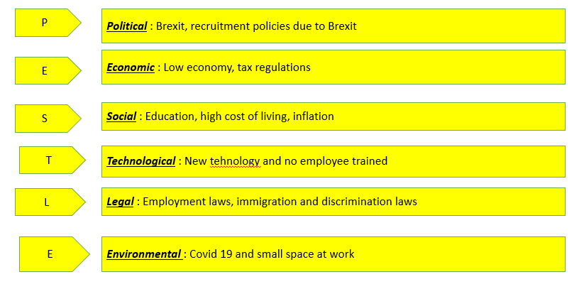

FISHBONE diagram
Fishbone diagram is a result of the Cause effect analyses we conducted for this
purpose:
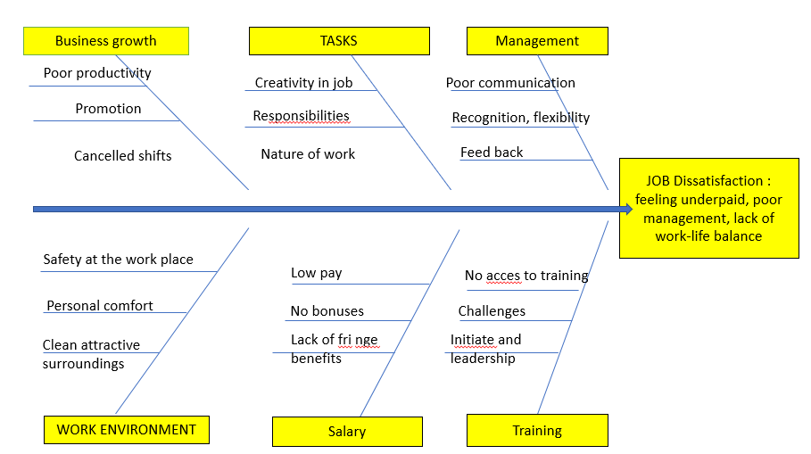
As we could see, the poor management, the repetitive work, nor empowering the employees, extra hours of work and the poor work-life balance it is visible in Fishbone diagram too. Now we have the data, we need to go through the whole decision-making process and solve the problem.

PMI

Another tool we used was the brainstorm PMI analysis. It was o good opportunity to bond and work together for the same purpose: achieving the mission of the company. The result of the PMI was positive, the changes can be implemented with certain positive results.

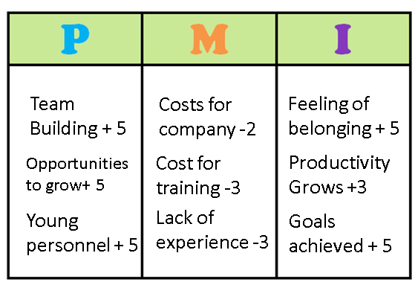

Solution to the problems
As employers there are several ways to meet the expectations of your employees.
The remedy for unhappy workers can be something as simple as verbal praise, and even go as far as promotions, awards and salary increases. Also offer flexible hours so that the employees are able to spend time with the families as well.
Organise regular team lunches, summer picnics, Christmas parties, and team building activities to forge more positive relationships with one another. Try to create a positive working environment.
People look for an employer who wants to invest in their training and development. Making time to meet with workers on regular basis, to discuss their career plan and to provide them with clear targets to work towards.
All this needs a change of management and ADKAR is the best way to implement this change.
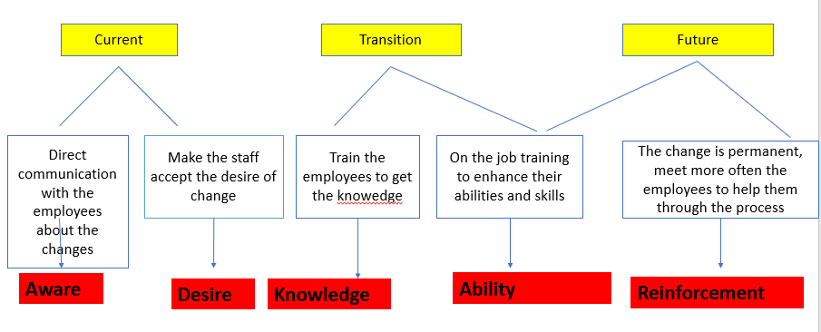

Conclusion

The secondary research and the primary one, conducted in this report, makes very clear the idea that the decision-making and problem-solving process is similar in most of the cases. Even the reasons of job dissatisfaction, at National Level, talking about UK, or company level, talking about Gist Ltd, are mainly the same. The important step remains the implementation of solutions that are found in order to bring employees satisfaction at a higher level, thus increasing the productivity of the work force, the company’s goals will be achieved, and the involved parties will be pleased with the outcome.

References

Boi, L. (2021), Fishbone Diagram: A Tool to Organize a Problem’s Cause and Effect, Available at: https://accelerate.uofuhealth.utah.edu/explore/fishbone-diagram-a-tool-to-organize-a-problem-s-cause-and-effect , [Accessed: 12 APR2021]
Half, R. (2019), The 6 main causes of unhappy staff and job dissatisfaction, Available at: https://www.roberthalf.co.uk/advice/people-management/6-main-causes-unhappy-staff-and-job-dissatisfaction, [Accessed: 20 APR2021]
Hales Jobs, (2021), UK Employees Say Poor Management Is Making Them Unhappy at Work, Available at: https://halesjobs.co.uk/uk-employees-say-poor-management-making-unhappy-work/, [Accessed: 18 APR2021]
Ionos, (n.d.), Fishbone diagram: Solving problems properly, Available at: https://www.ionos.co.uk/startupguide/productivity/fishbone-diagram/, [Accessed: 05 MAY2021]
JOBBERACADEMY, (n.d.), PESTLE ANALYSIS FOR YOUR SERVICE BUSINESS, Available at: https://academy.getjobber.com/resources/articles/pestle-analysis/, [Accessed: 18 APR2021]
Johnson, R. (2018), Key Reasons for Job Dissatisfaction and Poor Employee Performance, Available at: https://smallbusiness.chron.com/key-reasons-job-dissatisfaction-poor-employee-performance-25846.html, [Accessed: 12 APR2021]
MobbieTrain, (2020), ADKAR Change Model: what is it and how can it help you?, Available at: https://www.mobietrain.com/employee-engagement/adkar-change-model/, [Accessed: 05 MAY2021]

