

Change and Stability Management
(HKBM7015_HKMA)

An Analytical Report to Evaluate the Organisational Change

Cathay Pacific:
Embracing Change for a Brighter Future

Student Name | ： | Shuk Man, Chau (Kathy)
Student ID Number | ： | 2322640
Date of Submission | ： | 28 April 2024
Lecturer | ： | Dr. Joe Leung

Table of Contents

 |  |  |  |  | Page
 | Abstract |  |  |  | 3
1. | Introduction |  |  |  | 3
2. | Force Field Analysis for the Organizational Change |  |  |  | 4
 | 2.1 | Driving Forces |  |  | 4
 | 2.2 | Restraining Forces |  |  | 5
 | 2.3 | Analysis Results and Immediate Solution |  |  | 7
3. | John Kotter's 8-Step Change Model |  |  |  | 7
4. | Recommended Leadership Style in Successful Organizational Change
 | 4.1 |  | Conclusion
 | 4.2 |  | Recommendations
5. | Six Core Themes and Practices of Effective Leadership in Successful Organizational Change |  |  |  | 13
6 | Managing Resistance to Change
 | Conclusion and Recommendations
 | Reference
References |  |  |  |  | 24

Abstract
This analytical report assesses Cathay Pacific’s organizational change, focusing on various aspects crucial for successful implementation. The report includes a Force Field Analysis to understand the driving and restraining forces affecting the change, an application of a John Kotter’s Change Model, an examination of the leadership style during the change process, strategies for driving successful organizational change and effective methods for managing resistance to change. By examining these aspects, insights into the effectiveness of the change initiative and areas for improvement can be identified, highlighting the potential benefits of embracing the transformation.

- Introduction
Established in 1946 in Hong Kong, Cathay Pacific has evolved into a globally renowned airline. Cathay Group is a testament to diversity, encompassing not only the flagship Cathay Pacific but also Cathay Cargo, Hong Kong Express Airways Limited and AHK Air Hong Kong Limited. The subsidiaries in laundry, catering, ground-handling, and cargo terminal operations reflect the commitment to comprehensive service excellence. According to the financial reports in the past 10 years (Cathay Pacific Airways Limited, 2014 - 2023), except the period of COVID-19 pandemic, approximately 60% to 70% of Cathay Group’s revenue came from Cathay Pacific passenger service. Hence, this report focuses on Cathay Pacific passenger service (referred to as “CX” hereafter unless specified).
Despite being the market leader in Hong Kong, CX is facing the imperative for change in an evolving aviation industry. Drivers such as shifting customer expectations, technological advancements and intensified competition necessitate CX's transformation. To remain competitiveness and thrive in the dynamic environment, CX must recognize the need for change and take proactive steps to adapt its strategies, operations and culture, targeting for being the leading airline in digital innovation and customer service.

- Force Field Analysis for the Organizational Change
Force Field Analysis (Lewin, 1947) is utilized to evaluate the driving and restraining forces influencing the organizational change at CX. The analysis in Diagram (1) reveals the dynamics of change and identifies areas requiring intervention for successful implementation.
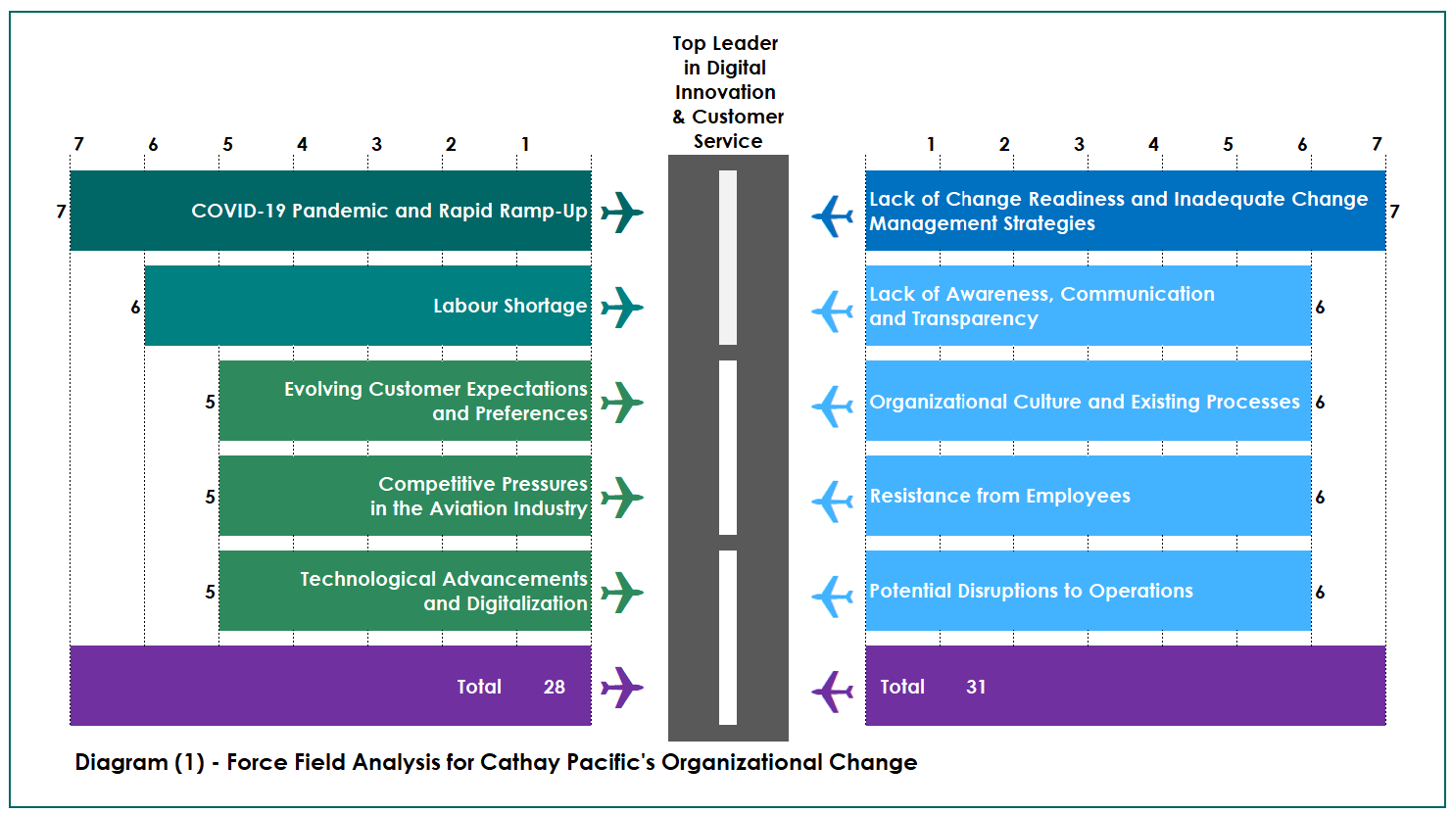

  - Driving Forces
- COVID-19 Pandemic and Rapid Ramp-Up
CX faced significant challenges in resuming operations after the COVID-19 pandemic. By the end of 2023, CX only managed to operate 70% of their pre-pandemic passenger flights (Cathay Pacific Airways Limited, 2023). Additionally, over 780 flights were cancelled from December 23 to February 24 (Lee, 2024). These risks stem from various factors, including workforce capacity, labor shortages (Ihara & Ye, 2024), lack of experience and digital capabilities, delays in reactivating aircraft and difficulties in managing the global supply chain to ensure service delivery.
- Labour Shortage
The aviation industry necessitates a skilled workforce comprising experts and well-trained professionals to support airline business and operations. Intense competition for talent, exacerbated by the global labour shortage in the aviation and travel sector (Lam & Westbrook, 2024), poses a threat to the CX's recovery.
- Evolving Customer Expectations and Preferences
COVID-19 pandemic and technological advancements have shifted customer demands such as personalized experiences, seamless digital interactions (Bovenizer, 2023), prioritized hygiene and safety and emphasis on convenience and flexibility. To meet the expectations of discerning travelers, CX must adjust their strategies to enhance competitiveness (D2 Flight Academy, 2024).
- Competitive Pressures in the Aviation Industry
Rival airlines, emerging low-cost carriers and Chinese carriers, along with the expansion of their networks, challenge CX's market share (Ihara & Ye, 2023). Chinese airlines such as China Eastern Airlines, China Southern Airlines and Air China and low-cost airlines such as Hong Kong Airlines and Peach Aviation (Westbrook, 2023) have made significant investments in fleet expansion, route development and improved service offerings, posting a direct challenge to CX's position as the preferred choice for travelers.
- Technological Advancements and Digitalization
The digital revolution offers opportunities for enhanced connectivity, data-driven decision-making, and automation (Capital Technology University, 2023). CX needs to leverage technologies such as artificial intelligence and big data to streamline processes and enhance operational efficiency.

  - Restraining Forces
- Lack of Change Readiness and Inadequate Change Management Strategies
Unpreparedness for change at both the employee and organizational levels can lead to resistance driven by fear, uncertainty, and a lack of understanding about the need for transformation. Insufficient change management strategies can exacerbate this resistance by failing to address employee concerns, provide clear guidance, or engage stakeholders effectively.
- Lack of Awareness, Communication and Transparency
When employees are unaware of the reasons behind the changes or the expected benefits, they may resist due to uncertainty and skepticism. Insufficient communication can lead to misunderstandings, rumors, and a lack of buy-in. When transparency is lacking, employees may perceive hidden agendas or feel excluded from the decision-making process.
- Organizational Culture and Existing Processes
Established organizational cultures and ingrained processes in CX can hinder the adoption of new initiatives. Maintaining tradition and status quo, attachment to corporate norms and value, hierarchical structure and lack of empowerment as well as silo mentality and lack of collaboration are the common phenomena during transformation.
- Resistance from Employees
Employee resistance, reluctance, opposition, or pushback can manifest in concerns about job insecurity, uncertainty about new roles and responsibilities, the need to acquire new skills, unfamiliarity with new processes or systems, and a lack of understanding of the change's benefits (Olmstead, 2024).
- Potential Disruptions to Operations
Concerns about operational efficiency, financial implications, resource allocation, employee resistance, negative morale, customer impact, and stakeholder management arise due to potential disruptions during the transition period. Management worries about temporary setbacks, delays, or increased workloads may hinder the smooth functioning of the airline.

  - Analysis Results and Immediate Solution
Currently, the restraining forces outweigh the driving forces, highlighting the need to address resistance to change. The immediate solution to reduce restraining forces is through effective communication. By implementing clear and transparent communication channels, CX can address concerns, provide information, and emphasize the benefits of the change initiative to all parties involved. Open dialogue, active listening, and timely feedback with employees, management, and stakeholders help alleviate uncertainty, build trust and encourage engagement. Improved communication at all levels can gradually reduce restraining forces, increase acceptance, and facilitate a smoother implementation of the desired changes as depicted in Diagram (2).
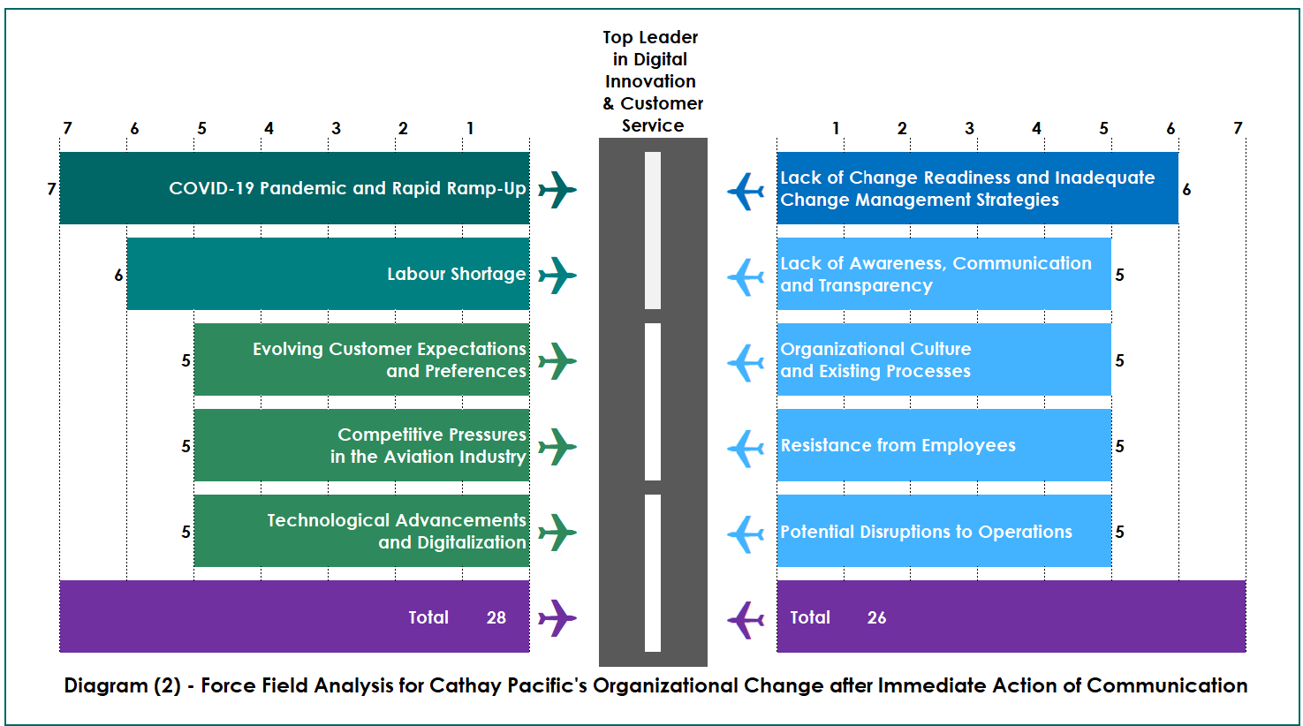

- John Kotter's 8-Step Change Model
The John Kotter's 8-Step Change Model (Kotter, 2012) is an ideal framework for facilitating CX's transformation. It offers a comprehensive approach that emphasizes leadership, employee engagement, clear vision, effective communication, flexibility, and cultural integration. This model provides a clear roadmap for implementing change.

- Create a Sense of Urgency
CX should effectively communicate the need for transformation, highlighting market trends such as digitalization, competitive pressures, the post-pandemic customer experience and the significant drop in Skytrax Annual World Airline Award’s ranking. Encouraging a shared understanding of the urgency for change among employees and stakeholders is very critical.
- Build a Guiding Coalition
A team of influential leaders from various departments and change agents from different professional aspects should be formed to drive the transformation, ensure diverse representation and provide strong leadership support to guide the change effort.
- Form a Strategic Vision
A compelling vision should be created to outline the desired future state for CX and has to be communicated effectively to inspire and align employees and stakeholders. The vision which aligns with this report is to become the leading airline in digital innovation and customer service.
- Communicate the Vision
Various channels such as staff communication meeting, management meeting, newsletters, company’s intranet and portal should be utilized to consistently and transparently communicate the vision to engage employees and stakeholders, addressing their concerns and emphasizing the benefits and opportunities the change will bring. Hence, all parties will proactively contribute to the transformation to achieve the common goals together.
- Enable Action by Removing Barriers
Barriers can be removed by providing the necessary resources, training and authority for employees to act on the transformation vision. Innovation, experimentation and risk-taking should be encouraged to drive change at all levels.
- Generate Short-Term Wins
Creating milestones and achievements, which demonstrate progress, helps to enhance confidence, build momentum, create a sense of achievement and provide evidence that the change’s efforts are producing positive results. It creates a positive environment for embracing further change initiatives that will contribute to the long-term success .
- Sustain Acceleration
Solidifying and integrating the changes implemented by reinforcing new practices, empowering employees, monitoring progress, addressing resistance and celebrating success can ensure long-term sustainability, the culture of continuous improvement and iterating to drive larger scale transformation.
- Anchor the Change in Culture
Embedding the changes into the CX's culture, systems, and processes help to ensure they become the new norm. This involves reinforcing the value of changes through success stories, rewarding those who embrace change and incorporating changes into training and development programs to make the changes sustainable and enduring over the long term.

Overall, John Kotter's Change Model offers a structured and proven approach for successful transformation at CX. It provides a roadmap for navigating the complexities of change management, engaging stakeholders, and driving sustainable organizational change.

- Recommended Leadership Style in Successful Organizational Change
Successful change requires strong leadership. The style which CX currently adopts is Authoritarian Leadership (Lewin, Lippitt & White, 1939) which is the general impression in the public. However, to implement the transformation effectively, CX should adopt Authoritarian Leadership and Transformational Leadership (Base,1985) in various aspects and at different stages.

  - Authoritarian Leadership
Due to its top-down and directive nature, the following situations where CX should utilize elements of this style:
- Crisis or Urgent Situations
In times of crisis or urgent situations where quick decisions and immediate action are required, CX should take charge, provide clear instructions and make decisive decisions to address the crisis efficiently.
- Safety and Security
Safety and security in the aviation industry are paramount. In cases where safety protocols and procedures need to be strictly enforced, CX has to ensure compliance and adherence to regulations.
- Hierarchical Structures for Control and Order
High level of discipline and order as per hierarchical structures in certain areas of aviation industry is necessary as the operation involves human life. CX needs to exercise a degree of authority to ensure efficient coordination and execution of tasks.
- New or Inexperienced Teams/Staff
When leading new or inexperienced teams/staff, an Authoritarian Leadership style is necessary to establish structure, provide clear instructions and set expectations.
An Authoritarian Leadership style is appropriate in certain situations, especially at the initial stage of launching the transformation to express the clear direction. Nevertheless, it should be used sparingly and with caution. Over-reliance on this style can lead to disengagement, resistance, and limited creativity among employees.

  - Transformational Leadership
To foster employee engagement, motivation, innovation and adaptability during the change process, CX should emphasize a participative and collaborative leadership style. The transformational leadership style is recommended due to its effectiveness in driving change initiatives, and developing a shared vision.
- Visionary Leadership
CX should articulate a compelling vision for change, connecting it to the organization's mission and values. By painting a clear picture of the desired future state, they inspire employees and create a sense of purpose and direction.
- Inspirational Communication
CX should engage in open and transparent communication, emphasizing the benefits and opportunities associated with the change. They should effectively communicate the rationale, goals, and progress of the change effort, addressing concerns and providing regular updates to keep employees informed and aligned.
- Empowerment and Trust
CX should empower employees by providing resources and support and delegating decision-making authority. Trusting the teams to make decisions and take ownership of the change process fosters a sense of accountability and commitment.
- Collaboration and Teamwork
Encouraging collaboration and teamwork promotes inclusiveness and cooperation. CX should provide opportunities for employees to contribute ideas and perspectives, fostering a sense of ownership and collective responsibility.
- Coaching and Development
CX should provide guidance, support and coaching to help employees adapt to change. Investing in developing the skills and capabilities of their teams, identifying training needs and providing learning opportunities help employees navigate the change process and build resilience.
- Recognition
Recognizing individual and team achievements during the change process is important. CX should acknowledge and appreciate the employee efforts, reinforcing positive behaviors and fostering a culture of recognition and appreciation.

Different situations may require different leadership styles, and a flexible approach should be warranted. In summary, for CX, adopting multiple leadership styles is a cruial first step before launching any changes.

- Six Core Themes and Practices of Effective Leadership in Successful Organizational Change
By incorporating the following six core themes and practices (Hodges & Gill, 2011), CX leaders can enhance their ability to lead organizational change effectively. These provide a comprehensive framework which aligns stakeholders, inspire commitment, and creates a cohesive and engaged workforce throughout the change journey.
- Vision for Change
Leaders should establish a clear and captivating vision (i.e. leading airline in digital innovation and customer service) for the desired future state of CX. This vision should articulate the direction and goals of the change and be communicated across CX and among employees.
- Purpose for Change
Leaders should clearly articulate why transformation is necessary and how it aligns with CX's strategic objectives. This helps employees realize the significance and relevance of the change. The purpose for CX should be to enhance customer experience, improve operational efficiency and increase market competitiveness.
- Shared Valued Associated with Change
Identifying and communicating the values associated with the change is important. Leaders should highlight the values that underpin the change effort such as customer-centricity, innovation, excellence and sustainability. Reinforcing these values helps to align behaviors and guide decision-making during the change process.
- Strategy for Change
Leaders should develop a well-defined strategy for change implementation and provide a roadmap by outlining the key objectives, short-term and long-term initiatives, action plans, and milestones required to achieve the vision. The strategy should be flexible and adaptable to market changes and customer needs. Digitalization for enhancing customer experience and reducing flight delays or cancellations are some of the key objectives.
- Empowering People for Change
Providing training and resources, decision-making authority can encourage innovation and drive contribution to the change. Creating an environment where employees feel valued as well as inspiring autonomy and ownership can help to foster a sense of empowerment.
- Engaging People in Change
Employees should be actively engaged throughout the change process through two-way communication, feedback solicitation, involvement in decision-making, recognition and rewarding. By fostering a culture of inclusion and participation, CX can gain valuable insights and increase engagement and commitment to change.
This framework is exhaustive, addressing the strategic, cultural and human aspects of change as well as ensuring alignment, commitment, and successful outcomes.

- Managing Resistance to Change
CX employees may resist change due to fear of uncertainty, loss of familiarity, perceived lack of control, past negative experiences, lack of trust and communication, organizational culture, and workload/resource concerns. Effectively managing this resistance is crucial for successful change implementation. The following strategies can be employed:
a. Communication and Transparency
Open and transparent communication is essential in addressing resistance to change. CX should clearly communicate the reasons behind the change, its benefits, and its impact on individuals and CX. Providing regular updates, addressing concerns, and actively listening to employees' feedback can build trust and alleviate resistance.
b. Employee Involvement and Engagement
Involving employees in the change process can reduce resistance. CX should create opportunities for employees to participate, input and contribute to decision-making. By involving employees from the early stages, their concerns and ideas can be addressed, making them feel valued and increasing their ownership of the change.
c. Education and Training
Providing education and training on the change helps employees understand the need for change and build the necessary skills to adapt. CX should offer training programs, workshops, or resources that enable employees develop the knowledge and capabilities required to embrace the change successfully.
d. Addressing Concerns and Fears
Proactively addressing concerns related to job security, increased workload, or loss of familiarity is essential. CX should provide reassurance, clarification of expectations, and support during the transition. Managers should be trained to address individual concerns and provide guidance throughout the change process.
e. Celebrating Wins and Recognizing Contributions
Recognizing and celebrating early wins and successes helps to overcome resistance. CX should recognize and appreciate the efforts and contributions of employees who embrace the change. This reinforces positive behaviors, boosts morale, and encourages others to follow suit.
f. Leadership Support and Role Modeling
Strong leadership support is crucial in managing resistance to change. Leaders should champion the change, communicate its importance, and demonstrate commitment through their actions. By role modeling the desired behaviors, leaders can inspire and influence others to embrace the change.
g. Continuous Feedback and Adaptation
Establishing mechanisms for continuous feedback and evaluation of the change process is vital. This enables CX to identify and address emerging resistance, make necessary adjustments, and refine the change implementation strategy as needed.
By employing these strategies, CX can effectively manage resistance to change and foster a more positive and supportive environment for successful change implementation. Managing resistance requires ongoing effort, addressing individual concerns and adapting the change approach as necessary.

- Conclusion and Recommendations
  - Conclusion
CX, as a leading airline, has faced numerous challenges in the rapidly changing aviation industry, especially after COVID-19 pandemic. To cope with market dynamics, enhance operational efficiency, and improve customer experience, CX should implement several key changes such that CX can position itself for long-term success and maintain its competitive edge in the aviation industry.

  - Recommendations – Four Priorities
Based on the analysis, the following four priorities are suggested for changes that CX should consider implementing:
- Digital Transformation
CX should not only invest in but also should accelerate the adoption of advanced digital technologies and solutions to streamline operations, enhance customer experience, and improve efficiency. This includes implementing advanced booking systems, enhancing online and mobile platforms, utilizing data analytics for personalized offerings, and employing automation in various processes.
- Customer Service Excellence
CX should shift towards a more customer-centric approach by focusing on understanding and meeting the evolving needs and preferences of travelers. This involves investing in customer experience initiatives, improving communication channels, personalizing services to create memorable and differentiated experiences for passengers and enhancing loyalty programs.
- Employee Empowerment and Development
A culture of empowerment and continuous development for employees should be fostered. Providing training and development programs, career advancement opportunities, and avenues for innovation and idea-sharing can encourage employees to take ownership of their work and contribute to the organization's success.
- Collaborative Partnerships
CX can explore strategic partnerships and alliances with other airlines, travel agencies, and technology providers to expand market reach, offer seamless travel experiences, and leverage shared expertise and resources.

  - Recommendations – Monitoring the Changes
McKinsey 7S framework (Waterman, Peters & Phillips, 1980) can be used to monitor CX's implementation of changes by assessing the alignment and interaction of seven key elements:
- Monitoring Strategy ensures alignment with goals.
- Assessing Structure ensures effective communication and collaboration.
- Systems evaluation focuses on resource allocation and measurement.
- Assessing Skills involves training and development initiatives.
- Leadership Style is evaluated for effective communication and empowerment.
- Staff engagement and commitment are monitored.
- Shared values and culture are monitored to ensure alignment with change.
This 7S framework also helps in understanding the complex interdependencies within CX. Regular assessment helps CX to identify misalignment and gaps and enable necessary adjustments for successful change implementation. It provides a holistic view of CX and helps in maintaining alignment and coherence during the change process.

By embracing these proposed changes and advancements, Cathay Pacific can improve operational efficiency and organizational agility. This will enable the airline to position itself as a top leader in digital innovation and customer service, ensuring long-term competitiveness and sustained success.

Bass, B. M. (1985), Leadership and Performance Beyoud Expectation, New York: Free Press.

Bovenizer, N. (2023), Airline customers favour digital customer service channels after pandemic, Airport Technology, 3 May

Capitol Technology University (2023), The Top Aviation Industry Trends of 2023 and What 2024 May Bring, 18 December
Available at: https://www.captechu.edu/blog/aviation-industry-trends
(Assessed: 8 April 2024)

Cathay Pacific Airways Limited, Annual Report 2014
Cathay Pacific Airways Limited, Annual Report 2015
Cathay Pacific Airways Limited, Annual Report 2016
Cathay Pacific Airways Limited, Annual Report 2017
Cathay Pacific Airways Limited, Annual Report 2018
Cathay Pacific Airways Limited, Annual Report 2019
Cathay Pacific Airways Limited, Annual Report 2020
Cathay Pacific Airways Limited, Annual Report 2021
Cathay Pacific Airways Limited, Annual Report 2022
Cathay Pacific Airways Limited, Annual Report 2023

D2 Flight Academy (2024), Navigating the Future: Trends Shaping the Aviation Industry in 2024, 15 Mar
Available at: https://www.linkedin.com/pulse/navigating-future-trends-shaping-aviation-industry-2024-jbyye
(Accessed: 18 April 2024)

Hodges, J. and Gill, R. (2011), Sustaining Change in Organizations, SAGE Publications.

Ihara, K. and Ye, P. (2023), Cathay Pacific on recovery track but Chinese rivals loom, Nikkei Asia, 21 August
Available at: https://asia.nikkei.com/Business/Transportation/Cathay-Pacific-on-recovery-track-but-Chinese-rivals-loom
(Accessed: 18 April 2024)

Ihara, K. and Ye, P. (2024), Cathay Pacific Airways plagued by flight disruptions, Nikkei Asia, 6 February
Available at: https://asia.nikkei.com/Business/Transportation/Cathay-Pacific-Airways-plagued-by-flight-disruptions
(Accessed: 18 April 2024)

Kotter, J. (2012), Leading Change, Harvard Business Review Press

Lam, J. and Westbrook, L. (2024), Too few pilots, chaotic rosters. Why Hong Kong’s Cathay Pacific is cancelling flights and its vow that worst is over may be too optimistic, South China Morning Post
Available at: https://www.scmp.com/news/hong-kong/transport/article/3247975/too-few-pilots-chaotic-rosters-why-hong-kongs-cathay-pacific-cancelling-flights-and-its-vow-worst
(Accessed: 18 April 2024)

Lee, J. (2024), Cathay Pacific lacked ‘experience and digital capability’ to predict manpower crunch, Hong Kong gov’t says, Hong Kong Free Press, 18 March
Available at: https://hongkongfp.com/2024/03/18/cathay-pacific-lacked-experience-and-digital-capability-to-predict-manpower-crunch-hong-kong-govt-says/
(Assessed: 6 April 2024)

Lewin, K., Lippitt, R.& White, R.K. (1939). Patterns of aggressive behavior in experimentally created social climates. Journal of Social Psychology 10: 271–301.

Lewin, K. (1947), Field Theory in Social Science, New York: Harper & Row

Olmstead, L. (2024), Resistance to Change: 7 Causes & How to Overcome Them, Whatfix, 6 March
Available at: https://whatfix.com/blog/causes-of-resistance-to-change/
(Assessed: 18 April 2024)

Waterman, R. H., Peters, T. J., & Phillips, J. R. (1980), Structure is not organization. Business Horizons, 23(3), 14-26.

Westbrook, L. (2023), Recovery of Hong Kong aviation sector ‘stronger than expected’, IATA chief says, pointing to Greater Bay Area initiatives, 6 December
Available at: https://www.scmp.com/news/hong-kong/transport/article/3244115/recovery-hong-kong-aviation-sector-stronger-expected-iata-chief-says-pointing-greater-bay-area
(Assessed: 8 April 2024)

