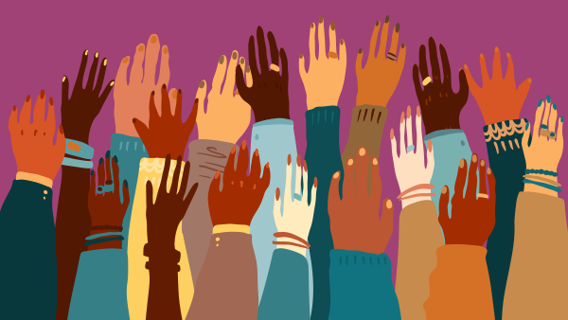
The Imperative for Change https://sway.office.com/nYruEQrnXi1EcoqG?ref=Link
What is injustice? According to the Cambridge dictionary, Injustice is ‘(an example of) a situation of which there is no fairness and justice.’ (Cambridge.org, n.d.). Being such a complex topic with so many different things to branch out on, social injustice and discrimination can be seen as a taboo topic, especially across older and younger generations. I believe this to be the biggest threat to humankind due to the impact it has on the potential development of a person and how they see themselves compared to other people. Did you know that individuals that reported the highest levels of discrimination in an experiment conducted by the NIH, have greater odds of reporting lifetime suicidal thoughts, plans and attempts, compared to people not subject to discrimination? (National Library of Medicine, 2018). Injustice manifests in various forms, such as oppression, discrimination, inequality, and marginalization. A complex web of factors, including political, economic, and cultural systems, beliefs, and attitudes, contribute to social injustice, and throughout this blog I will be going into depth on each attribute and concluding with ways in which we as people can tackle this threat.
Though apparent throughout the years and generations, discrimination is the most prevalent form of social injustice worldwide. Examples on why people may be discriminated are due to their, race, gender, sexual orientation, disabilities, and ethnicity. Blind spotting plays a huge roll in how we as people discriminate other groups of people. When someone is part of the ‘in’ group, they can form a ‘blind spot,’ this meaning them not being able to see past the privileges of which they are a part of and ultimately not consider those who are part of the ‘out’ group. This, more than often, leads to discrimination and inequality.
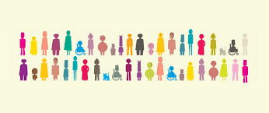
Racial discrimination is a widespread problem that has existed for centuries. It entails the unfair treatment based of people based on the colour of their skin, ethnicity, religion, and beliefs. People that fit these categories' can be subject to acts of inequality such as prejudice, stereotyping, bias, and harassment. The effects of these can be devastating and can cause economic, social, and emotional stress. An example of racial discrimination that has gone down in history is the Jim Crow laws that took precedence in the US. This being said, racism and segregation were still prominent throughout the entire world. This law included the segregation of black people in order to keep them away from white people. In schools, this would involve black African American children to be separated, though these rules were announced to be ‘equal but fair,’ they were far from it. Black children received lower standards of education and opportunities, along with the abuse and bullying they would face on a daily basis. Within Jim Crow schools, students were taught only agricultural work skills that would ‘fit the white economy and society’ and ‘any education beyond the rudiments of literacy and figuring would not be wasted on them’ (aft.org, 2014). You may be shocked to learn that the last segregated school in Mississippi, was desegregated in only 2016, due to the case going to a federal judge. Racism is obviously a huge threat to humankind due to the violence and pure evil that it entails.
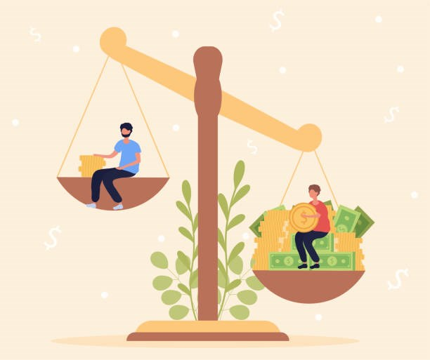
Another highly common form of inequality is due poverty discrimination. This problem is extremely problematic due to the domino effect it can have, with the poverty causing discrimination, yet the discrimination faced leading to worse poverty. The school environment is one where unequal treatment can be faced due to poverty significantly. Students that live below the bread line or are subject to a tough life at home because of neglect, are far less likely to be able to have access to educational resources for things such as homework and according to the ChildrensSociety,org, ‘they have to work harder to overcome the obstacles that modern life puts Infront of them.’ Neglect may also be the root of malnutrition for some children, and so when attending school, they are unable to concentrate as well as other students. Though massively prominent in all ages, bullying is a massive factor of living in poverty, especially in the education setting. When children do not have the facilities for basic hygiene and the latest technology, children can be subject to bullying and being left out from peers, resulting in poor mental health and low self-esteem, not to mention the impact this will have on their learning quality, due to being conscious of other peers the whole time they are in school. It has been proven that children that receive free school meals are 28% less likely to leave school with 5 A*-C GCSE grades than wealthier peers (neu.org.uk, 2021).
Due to the complexity of social injustice within the education setting, it is important that the approach taken to tackle it takes into consideration every aspect. Recognising that there is injustice within education is the first step to overcoming. By doing this, any blind spotting that is taking place is disregarded and solutions can be thought of. Alongside this comes being able to address the situation of discrimination within the classroom and how, as humans, we are able to stop this. A key factor of social injustice stems from children with special educational needs, and so in order to start to tackle this, we must promote inclusive education. This has already started to take place, however, there is still a huge call for help to find teachers that are suited to SEN children. Misdiagnosis is a massive component in this, as some children are forced to stay in mainstream schools and deemed as ‘naughty’ and unable to behave, when in reality they have been failed by the education system, and their needs have not been catered for. The percentage of students with SEN was 16.5% in 2022, however, the percentage of pupils with a statement of Education, Health and Care plan was only 4% (gov.uk, 2022). This speaks volumes due to the lack of involvement in schools to provide children with a correct statement. Diversity within the teaching profession is something that needs to be taken into account as this is where we lead by example. Education quality can be advanced when the professors are from diverse backgrounds and are of different genders, however, according to gov.uk, in 2021,’75.7% of teachers were women, and there were more female than male teachers in every ethnic group’. Advocacy is another fantastic way of overcoming social injustice in the education setting, supporting programs, and having things like fundraisers brings more attention to the issue of inequality and influences people to form a change.
Promoting inclusive education is something that really hits home for me due to having relatives that have special educational needs, and so this is one of the most significant skills in order to overcome social injustice in education. SEN children can sometimes struggle to integrate with the other students, and so to overcome this, it could be an idea to have days in the week or times in the day where activities take place in groups such as outdoor sports, art classes or even activities involved in the curriculum. By doing this in small doses, they are able to feel more comfortable, but also not left out of what everyone else is doing. Of course, this would be in a mainstream school environment, so that the children who need extra support are not segregated from the others.
From working as a Learning Support Assistant in multiple mainstream schools, I noticed that quite a few schools had what is called ‘sensory rooms. These rooms can consist of different coloured lights, textures, beanbags, and more interactive things, that are used when an overwhelmed child needs support. These rooms are a brilliant way in which to calm a mind that is overstimulated with one thing, by also stimulating it by a completely different thing. Along with this, schools that I know of that are designed to accommodate SEN pupils, often have things such as outdoor learning, disguised learning, and also things such as trips to dog shelters, bike riding, swimming, and trampolining. Some people may argue that this defeats the whole object of attending school as they believe minimal academic activity is going on, however, just by taking a child out into different settings and giving them unknown every day scenarios such as using money to pay in a shop, walking a dog, ordering their own meal, and managing their own time, can teach them an equal amount, just without the child being conscious of actually learning, as this is what can be a challenge for some children.
According to Harvard University, design thinking is ‘a mindset and approach to learning, collaboration, and problem solving.’ (Harvard.edu, n.d.) In short, design thinking tries and tests solutions to problem solve, and helps students and teachers to create innovative solutions to complex problems. Design thinking is being used within contemporary education in a number of ways in order to enhance the educational experience for students. One example of this being the d.school K12 Lab Network at Stanford University. It consists of a community of educators, researchers and designers who use design thinking to create innovative educational solutions. They claim to ‘constantly develop ways to build the creative confidence of educators’ (dschool.stanford.edu, 2022). The way in which they do this is by conducting experiments, one being how they keep their schools safe, for example for American schools, instead of having traumatic active school shooter drills which would traumatise children, they met with both students and teachers in order to grasp what it was the majority thought they could do differently so that everyone had a say.
Just like everything else, design thinking has both its merits and shortcomings that should both be considered when using this method.
Merits of Design thinking include:
- Iterative Process: Design thinking included trying and testing innovative ideas and techniques in order to involve everyone and learn through feedback and mistakes.
- Collaboration: Design thinking encourages teamwork and so there will be a common goal that both students and teachers will decide on and work towards.
- Creativity: Design thinking introduces the idea of thinking outside of the box and encourages people to produce unconventional solutions in order to be unique.
- User-Centred approach: Design thinking ensures that all ideas are catered towards each individual so that needs are met for everyone involved
Shortcomings of Design thinking include:
- Over-emphasis on Innovation: Design thinking may override the importance of equity and inclusion, while innovation is important, all students must have the same qulaity of learning and opportunities within education.
- Lack of evidence: Design Thinking has become more popular throughout the education sector however there is not enough evidence to prove that there is enough effectiveness in the outcomes from it.
- Time consuming: Design thinking can be difficult for educators that are under a time limit or do not have enough time to plan and do significant amounts of resourcing.

Reference List
Department of Education (2022). Special educational needs and disability: an analysis and summary of data sources. [online] Gov.uk. Available at: https://assets.publishing.service.gov.uk/government/uploads/system/uploads/attachment_data/file/1082518/Special_educational_needs_publication_June_2022.pdf.
dictionary.cambridge.org. (n.d.). injustice. [online] Available at: https://dictionary.cambridge.org/dictionary/english/injustice.
Fischer, F. (2020). Continuing the Fight for Educational Justice - TAF. [online] TAF - Technology Access Foundation. Available at: https://techaccess.org/continuing-the-fight-for-educational-justice/ [Accessed 10 Apr. 2023].
GOV.UK (2018). School teacher workforce. [online] Service.gov.uk. Available at: https://www.ethnicity-facts-figures.service.gov.uk/workforce-and-business/workforce-diversity/school-teacher-workforce/latest.
Harvard.edu. (2014). Design Thinking in Education. [online] Available at: https://tll.gse.harvard.edu/design-thinking.
Irons, P. (2014). Jim Crow’s Schools. [online] American Federation of Teachers. Available at: https://www.aft.org/periodical/american-educator/summer-2004/jim-crows-schools.
iStock. (n.d.). Concept of richness and poverty. Weight scale between rich man and... [online] Available at: https://www.istockphoto.com/vector/concept-of-richness-and-poverty-gm1282703437-380356850.
National Education Union (2021). Child Poverty - the Facts. [online] National Education Union. Available at: https://neu.org.uk/child-poverty-facts.
Oh, H., Stickley, A., Koyanagi, A., Yau, R. and DeVylder, J.E. (2019). Discrimination and suicidality among racial and ethnic minorities in the United States. Journal of Affective Disorders, 245, pp.517–523. doi:https://doi.org/10.1016/j.jad.2018.11.059.
Stanford d.school. (n.d.). K12 Lab. [online] Available at: https://dschool.stanford.edu/programs/k12-lab-network.
The Children's Society (2020). Effects Of Child Poverty | The Children’s Society. [online] www.childrenssociety.org.uk. Available at: https://www.childrenssociety.org.uk/what-we-do/our-work/ending-child-poverty/effects-of-living-in-poverty.
www.unesco.org. (n.d.). Fight against Racism & Discrimination | UNESCO. [online] Available at: https://www.unesco.org/en/no-racism-no-discrimination.

