Amina Ganni
STUDENT ID: 2319000
Electromagnetic radiation
Design and Analysis of Electromagnetic Systems
Contents
Abstract ......................................................................................................... 1
Introduction .................................................................................................. 2
Task 1: Methodology
3.1. Rectangular Waveguide with Vacuum .................................................... 4
3.2. Rectangular Waveguide with Teflon ....................................................... 5
Task 2: Methodology
4.1. Half-Wave Dipole Antenna Design ......................................................... 6
Results
5.1. Task 1a: Rectangular Waveguide (Vacuum) ........................................... 7
5.2. Task 1b: Rectangular Waveguide (Teflon) .............................................. 9
5.3. Task 2: Half-Wave Dipole Antenna .........................................................11
Discussion
6.1. Waveguide Results and Analysis ............................................................ 13
6.2. Dipole Antenna Results and Analysis ..................................................... 15
Conclusion .................................................................................................... 17
References .................................................................................................... 18

Table of figures

Figure 1 Gamma plot for vacuum-filled waveguide ................................... 6
Figure 2 Gamma plot for Teflon-filled waveguide ..................................... 6
Figure 3 Port 1 field display of TE₁₀ (Mode 1) — vacuum .......................... 7
Figure 4 Port 2 field display of TE₁₀ (Mode 1) — vacuum .......................... 7
Figure 5 Port 1 field display of TE₁₀ (Mode 1) — Teflon ............................ 8
Figure 6 Port 2 field display of TE₁₀ (Mode 1) — Teflon ............................ 8
Figure 7 E-field magnitude and vectors for Mode 1 — vacuum ................ 9
Figure 8 H-field magnitude and vectors for Mode 1 — vacuum ............... 9
Figure 9 E-field magnitude and vectors for Mode 2 — vacuum ............... 10
Figure 10 H-field magnitude and vectors for Mode 2 — vacuum ............ 10
Figure 11 E-field magnitude and vectors for Mode 3 — vacuum ............. 11
Figure 12 H-field magnitude and vectors for Mode 3 — vacuum ............ 11
Figure 13 E-field distribution for Mode 1 — Teflon ................................. 12
Figure 14 H-field distribution for Mode 1 — Teflon ................................. 12
Figure 15 E-field distribution for Mode 2 — Teflon .................................. 13
Figure 16 H-field distribution for Mode 2 — Teflon ................................. 13
Figure 17 E-field distribution for Mode 3 — Teflon .................................. 14
Figure 18 H-field distribution for Mode 3 — Teflon ................................. 14
Figure 19 S₁₁ plot of half-wave dipole antenna ......................................... 16
Figure 20 3D far-field gain pattern of half-wave dipole antenna ............. 16

2500 words
Task 1a and 1b:
Abstract
Wave propagation and antenna radiation characteristics are important components in Electromagnetic systems requiring high-frequency applications In this paper, we explore designing a rectangular waveguide model with Perfect Electric Conductor (PEC) walls filled with vacuum in one task comparing the cutoff frequencies with another rectangular waveguide filled with Teflon. We’ll also design an antenna with PEC. The findings were in line with theoretical formulas derived from Maxwell’s equation proving the efficiency of such systems
Introduction
Rectangular waveguides and half-dipole antennas play an integral role in the application of high-frequency electromagnetic systems. Despite having different roles in electromagnetic systems, they work in conjunction as waveguides confine and guide the electromagnetic waves minimising loss of signals, whilst the antenna receives and transmits the signal to the system.
This report delves into the concepts of the rectangular waveguide using two different materials (vacuum and Teflon) and the half-wave dipole antennas and testing their operating characteristics, by way of designing and simulating using ANSYS HFSS, a 3D electromagnetic field solver. The simulations are then analysed and then compared with the theoretical predictions enabling the analysis of the metrics to predict its efficiency in real-life applications.
A waveguide is a structure that uses its high refractive index within its cross- section relative to its lower refractive index outer material to minimise propagation [1]. Thus, proving how useful it is in high power applications in systems requiring low energy transmission and sensing [2]. Real-life applications include use in radar, telecommunications, satellite and space communications. These are all electromagnetic systems in which attenuation can be an issue affecting the efficiency of the overall system.
Wave propagation within a rectangular waveguide is explained by Maxwell’s equations. Whereby the waves propagate the different modes once the operating frequency is above the cut-off frequency. This can be calculated using the theoretical formula below:
$$f_{c}=\frac{c}{2}\sqrt{{\left(\frac{m}{a}\right)}^{2}+{\left(\frac{n}{b}\right)}^{2}}$$

The cut-off frequency is also affected by the waveguide’s geometry whereby the dominant TE₁₀ mode exhibits a cutoff frequency determined by the waveguide’s width a, []. The dimensions of the waveguide are critical: increasing the width or height lowers the cutoff frequency, allowing lower frequency modes to propagate.
A higher relative permittivity (εr) or permeability (μr) reduces the phase velocity of the wave, thereby decreasing the cutoff frequency [2].

The characteristics of the half-wave dipole antenna are fundamentally governed by Maxwell’s equations, which describe its ability to transmit and receive electromagnetic waves. The half-wave dipole antenna is commonly used in radio and communication systems due to its high efficiency. Its structure facilitates resonance at a specific frequency when the antenna's total length is approximately half the wavelength of the operating frequency [1].
The efficiency of the antenna’s ability is maintained by the feed’s operating frequency matching the resonant frequency and this is also ensured by way of proper design, thus increasing radiation and reducing reflections.
Task 1: Methodology
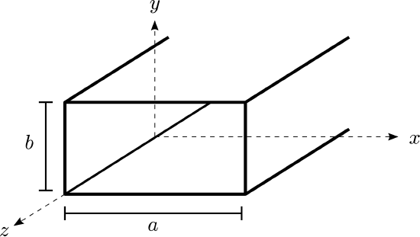

Design parameters | Dimensions
Ports assigned | port 1 and port 2
modes assigned | 3 modes - TE10, TE20, TE01
width a | 23 mm
length b/2 | 19/2 = 9.5 mm nearest int b = 10mm
height | 50 mm
Frequency sweep | 2 GHz - 30 GHz
Table 1: Design Parameters and Dimensions for Rectangular Waveguide

The design and simulation of the rectangular waveguides are conducted using Ansys-HFSS which is a high frequency simulation software used to visualise the different modes inside the waveguides.
Both tasks 1 and 2 involve the use of Ansys high frequency structure stimulator (HFSS) which is a popular tool used to design and simulate 3D electromagnetic components, it has been the gold standard in industry for its accuracy and rapid design in a multitude of RF microwave and high-speed digital applications. It does this by way of finite element method (FEM), whereby the fields derived from the 3D- structure are used to solve Maxwell’s equation across inter element boundaries. The measurements were derived from the student ID = 2319000 to carry out simulations as specified by the tasks.
A rectangular waveguide was designed with the measurements in the table below, the wall of the rectangular waveguides was modelled with perfect electric conductor (PEC) to confine the electromagnetic field; this in turn forms the boundary, as it perfectly reflects the electromagnetic waves.
The interior of the first waveguide is filled with a homogeneous material (dielectric) is filled with vacuum and in the second waveguide Teflon material was used (relative permeability is 1 and relative permittivity is 2.1), to support wave propagation. The parameters and dimensions of the simulations were kept the same and the wave ports and modes were assigned for both simulations to define the direction of wave propagation. Using this data, HFSS analyses the simulations displaying the port fields, generating field overlays for each of the modes and plots the cut-off frequency.
Task 2: Methodology
The half-wave dipole antenna is designed and simulated in ansys HFSS using a PEC material with an excitation applied to a 50 Ω lumped port at the feed gap.
The total antenna length is calculated using:
$L =$ λ/2
The antenna is built using two cylindrical arms, each with a radius of 1 mm, aligned along the z-axis. A small feed gap is introduced between the arms to connect the lumped port.
The operating frequency is found using the theoretical formula:
$f=c / λ$
whereby c = 3×10^8m/s and λ = 231x10^-3.
The dipole is placed inside a rectangular radiation box, with boundaries set about λ/2 away from the antenna to reduce reflections. A radiation boundary condition is assigned to the outer surfaces.
A discrete frequency sweep from 1 GHz to 5 GHz is set up to capture the antenna's performance across the range of these frequencies.
Design parameters | Measurements
Wavelength λ | 231 mm
Dipole radius | 1mm
Dipole length $L =$ λ/2 | 115.5 mm
Frequency sweep range | 1 GHz - 5 GHz
Table 2: Cut off Frequencies for Vacuum and Teflon-Filled Waveguides
The performance of the antenna can be measured by observing scattering parameter S11 (S parameter plot), gain and radiation efficiency.

Results
Task 1a/1b
This section presents the simulation results for the rectangular waveguide analysis conducted using two different homogeneous dielectric materials vacuum (task 1a) and Teflon filling (task 1b). The waveguide was evaluated for propagation modes, cutoff frequencies, port field distributions, and electromagnetic field characteristics across a frequency sweep from 2 GHz to 30 GHz.
The cut-off frequencies for the theoretical simulations were calculated using the equation:

$$f_{c}=\frac{c}{2}\sqrt{{\left(\frac{m}{a}\right)}^{2}+{\left(\frac{n}{b}\right)}^{2}}$$

Gamma plot:
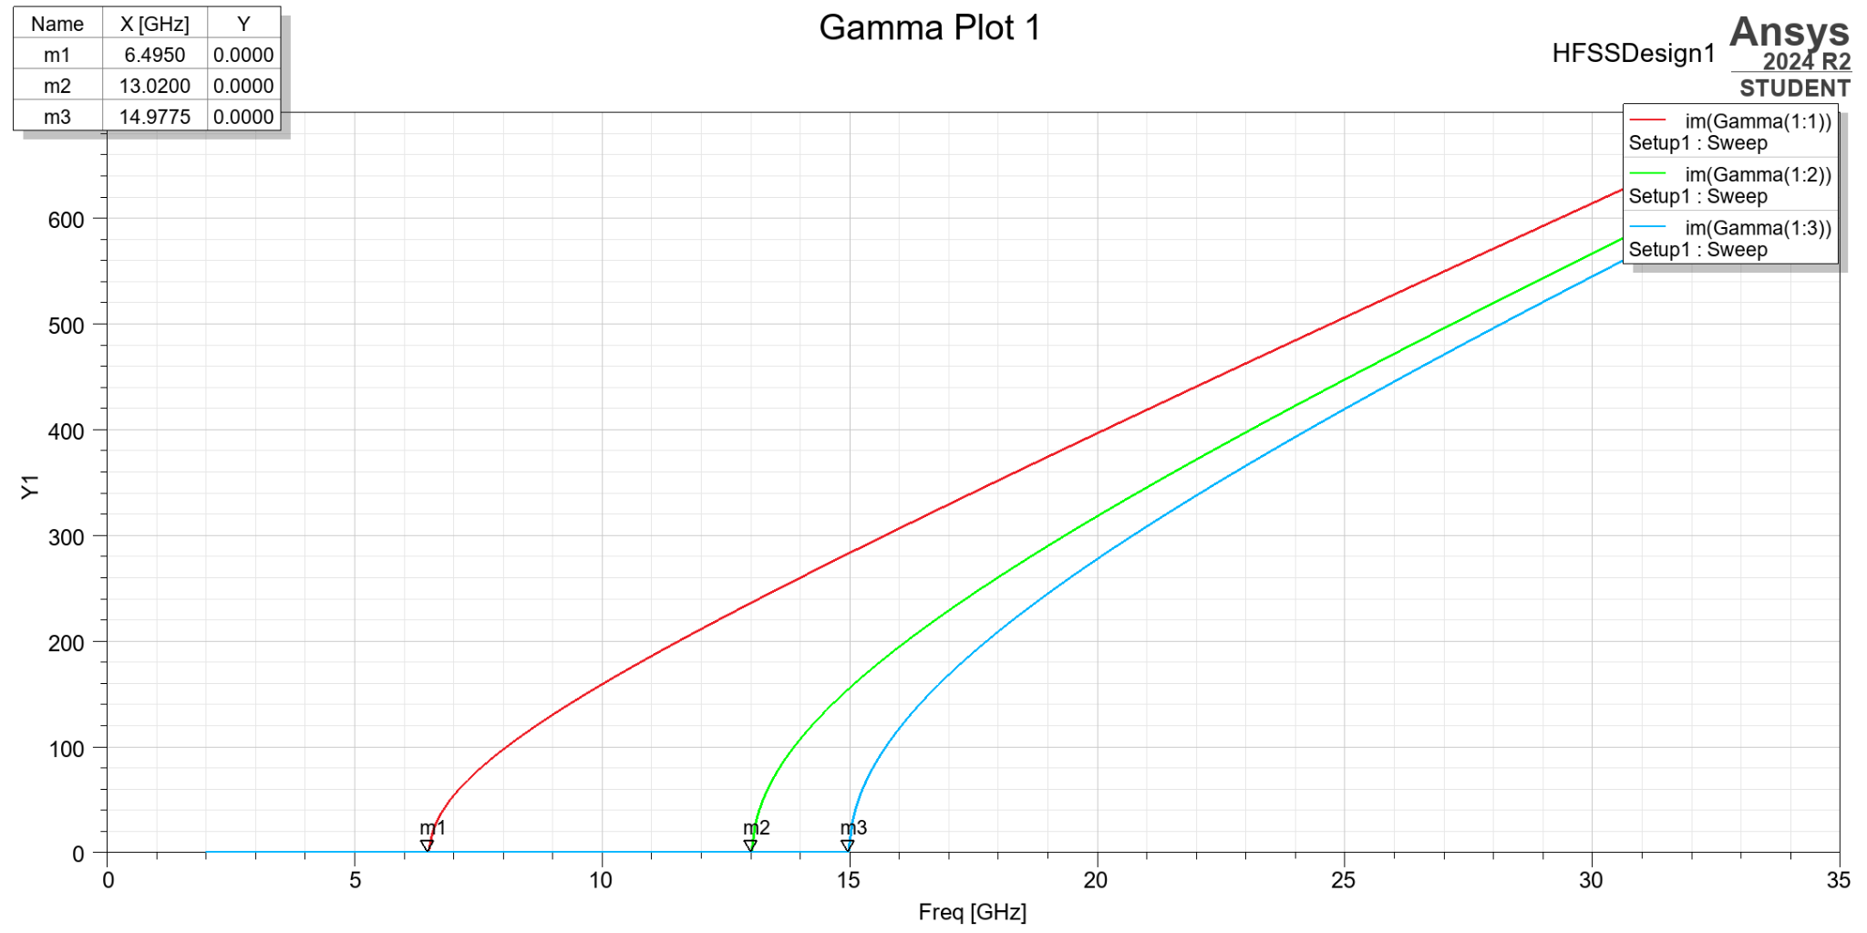
Figure 1: Gamma plot vacuum

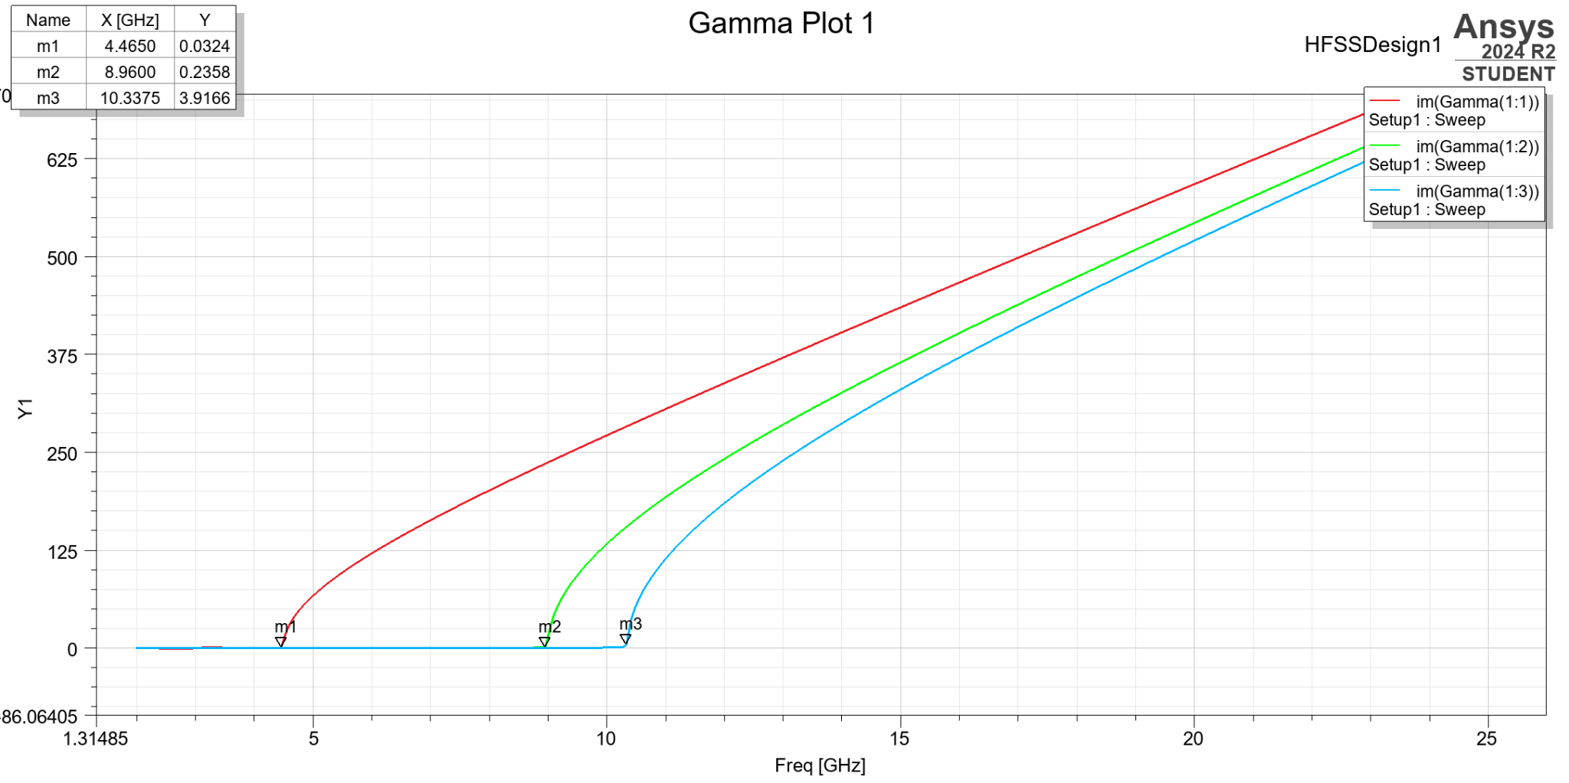
Figure 2: Gamma plot of Teflon

Port field displays:
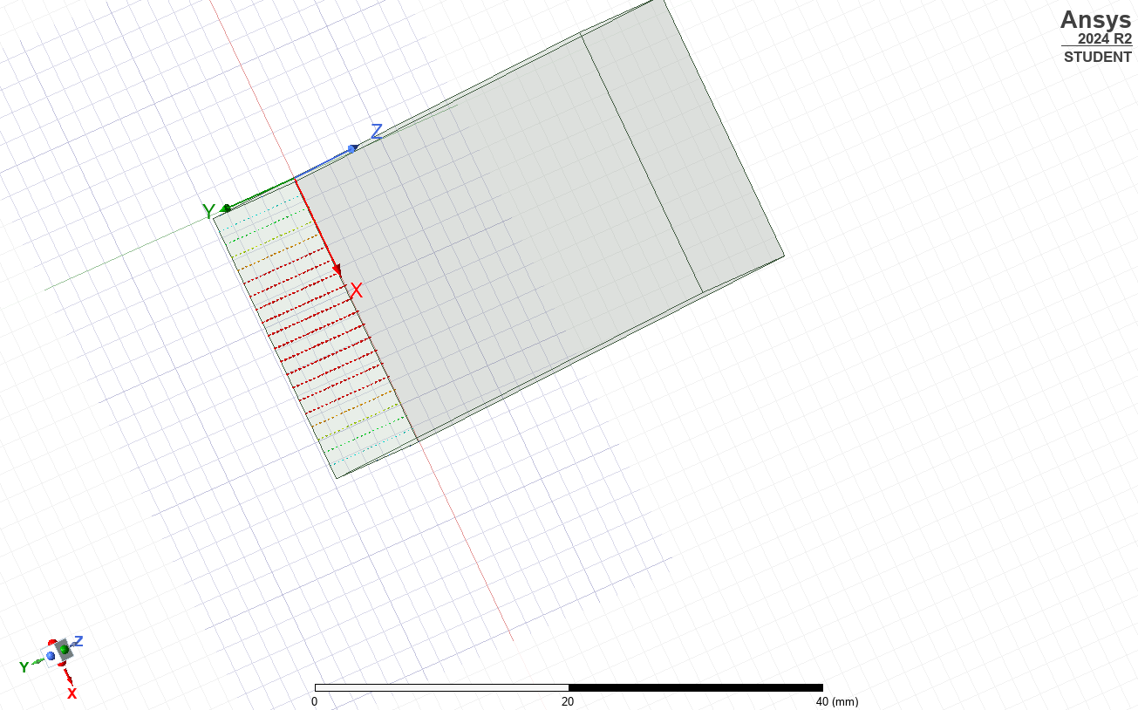
Figure 3: Port 1 field display of TE10(Mode 1) vacuum
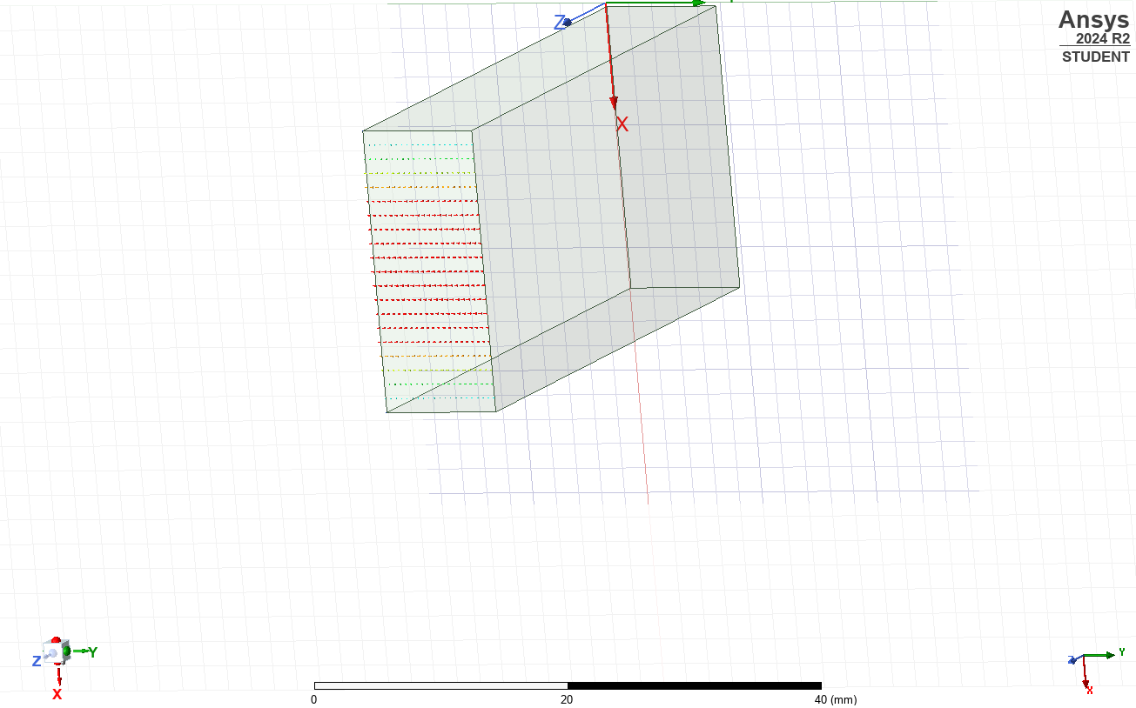
Figure 4: Port 2 field display of TE10(Mode 1) Vacuum

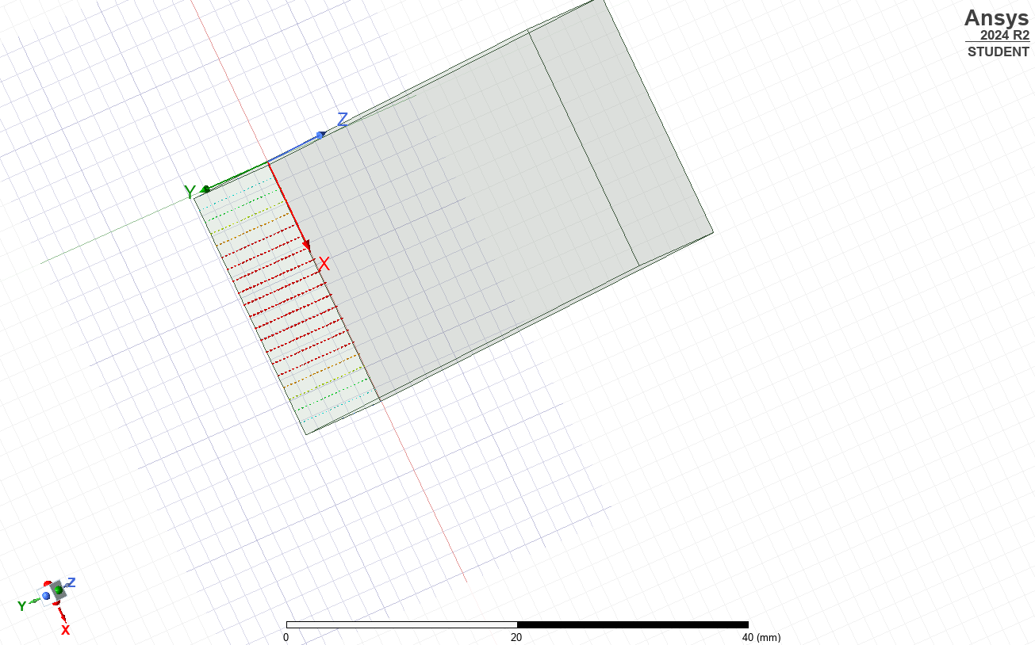
Figure 5: Port 1 display of TE10 Teflon
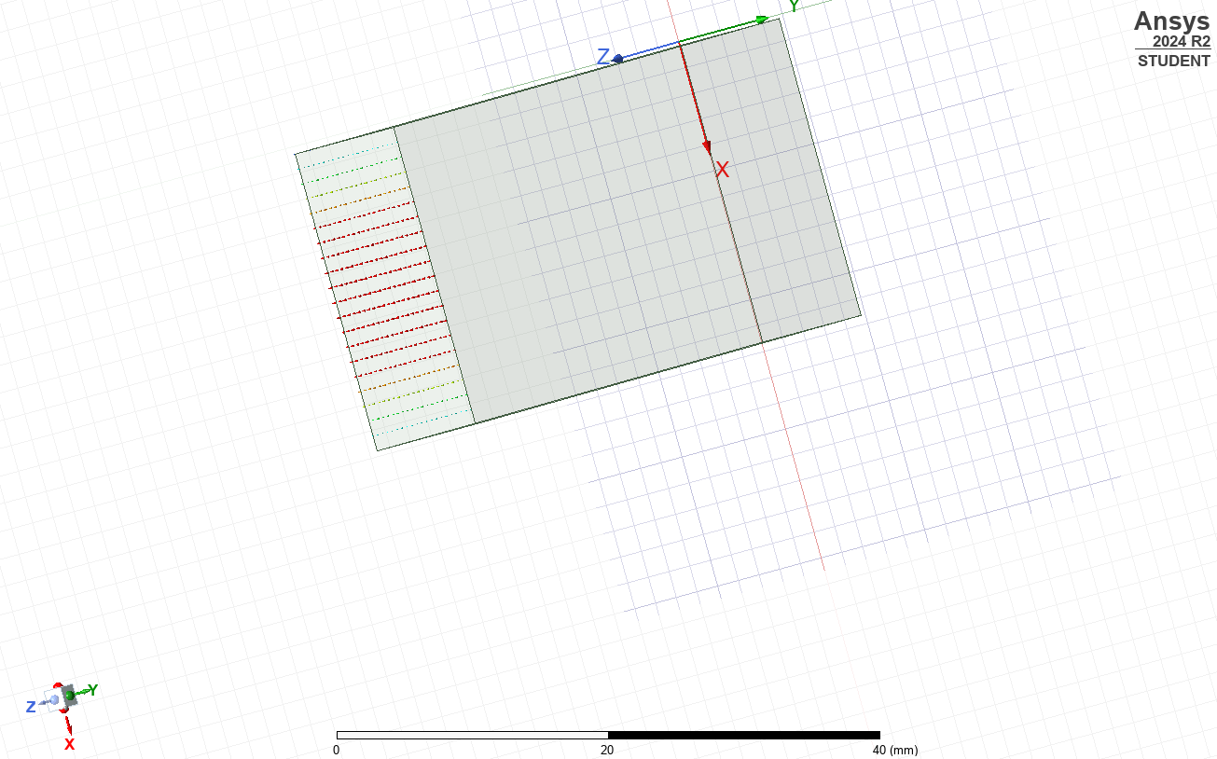

Figure 6: Port 2 display of TE10 Teflon

Electric field magnitude and vector distributions(E-Field) for vacuum:
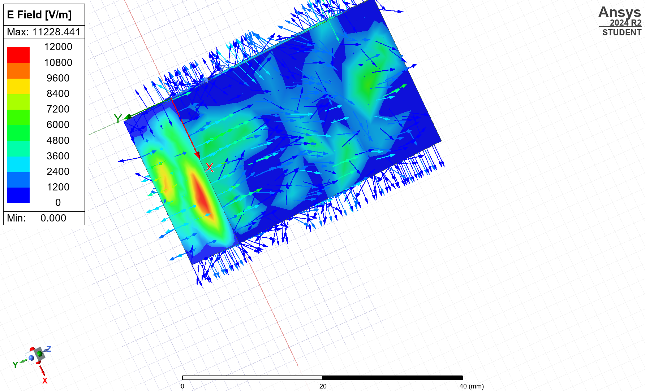
Figure 7: E-field for Mode 1 vacuum

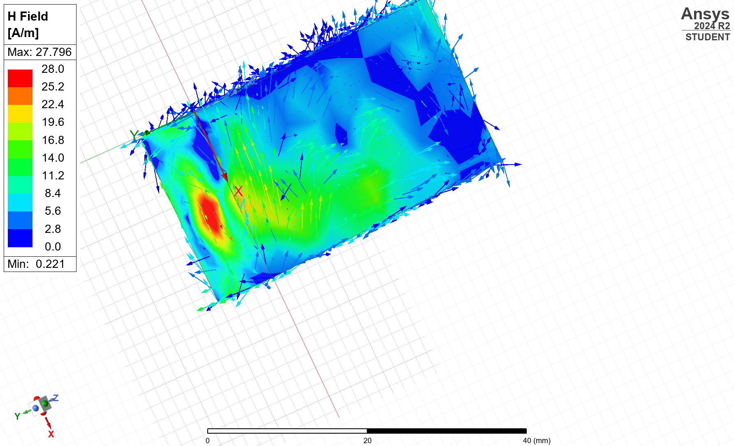
Figure 8: H-field for Mode 1 vacuum
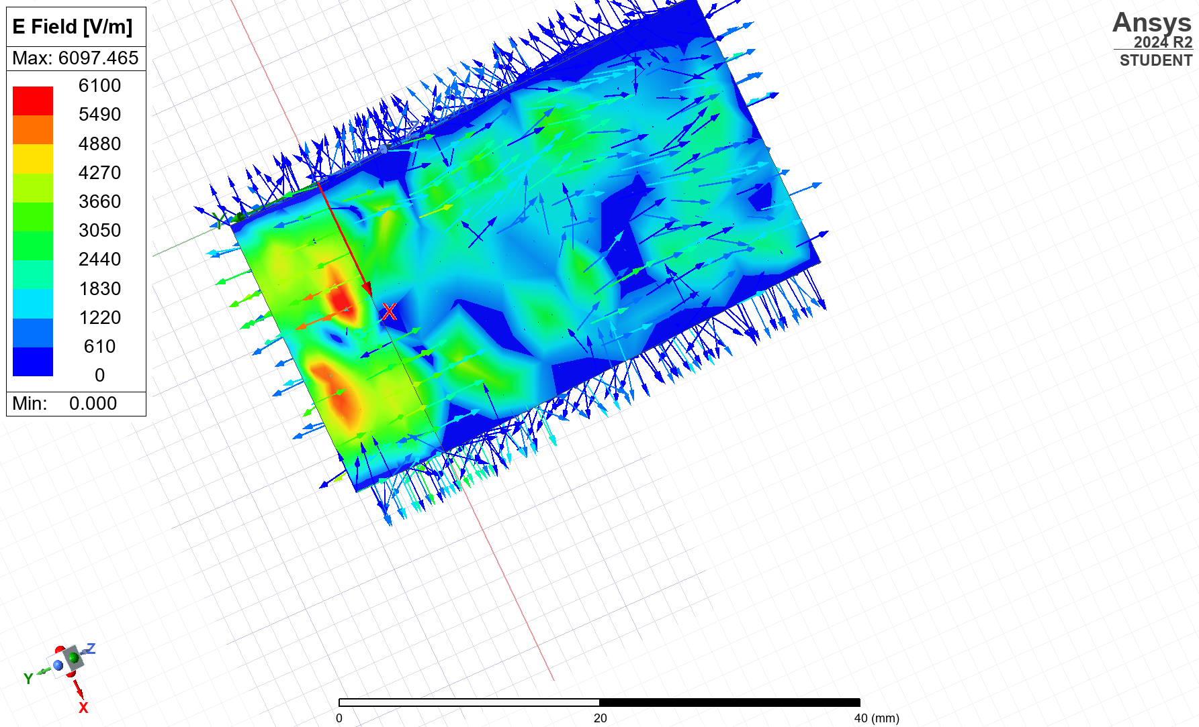
Figure 9: E field for Mode 2 vacuum
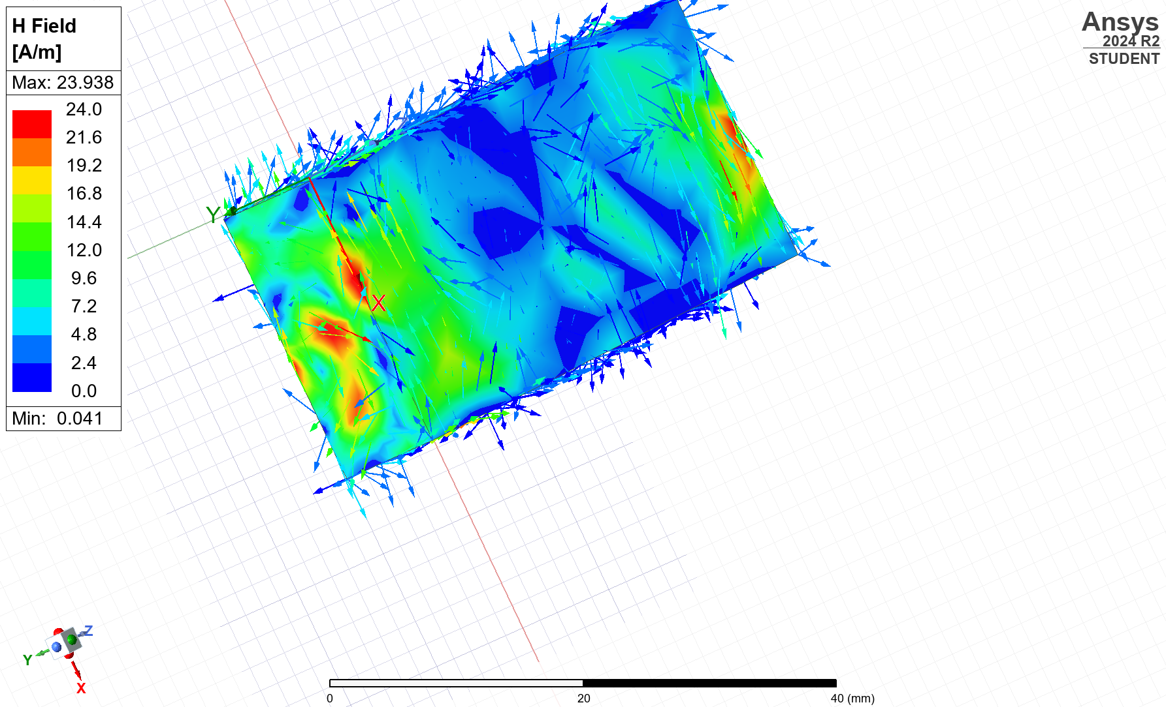
Figure 10: H fields for Mode 2 vacuum
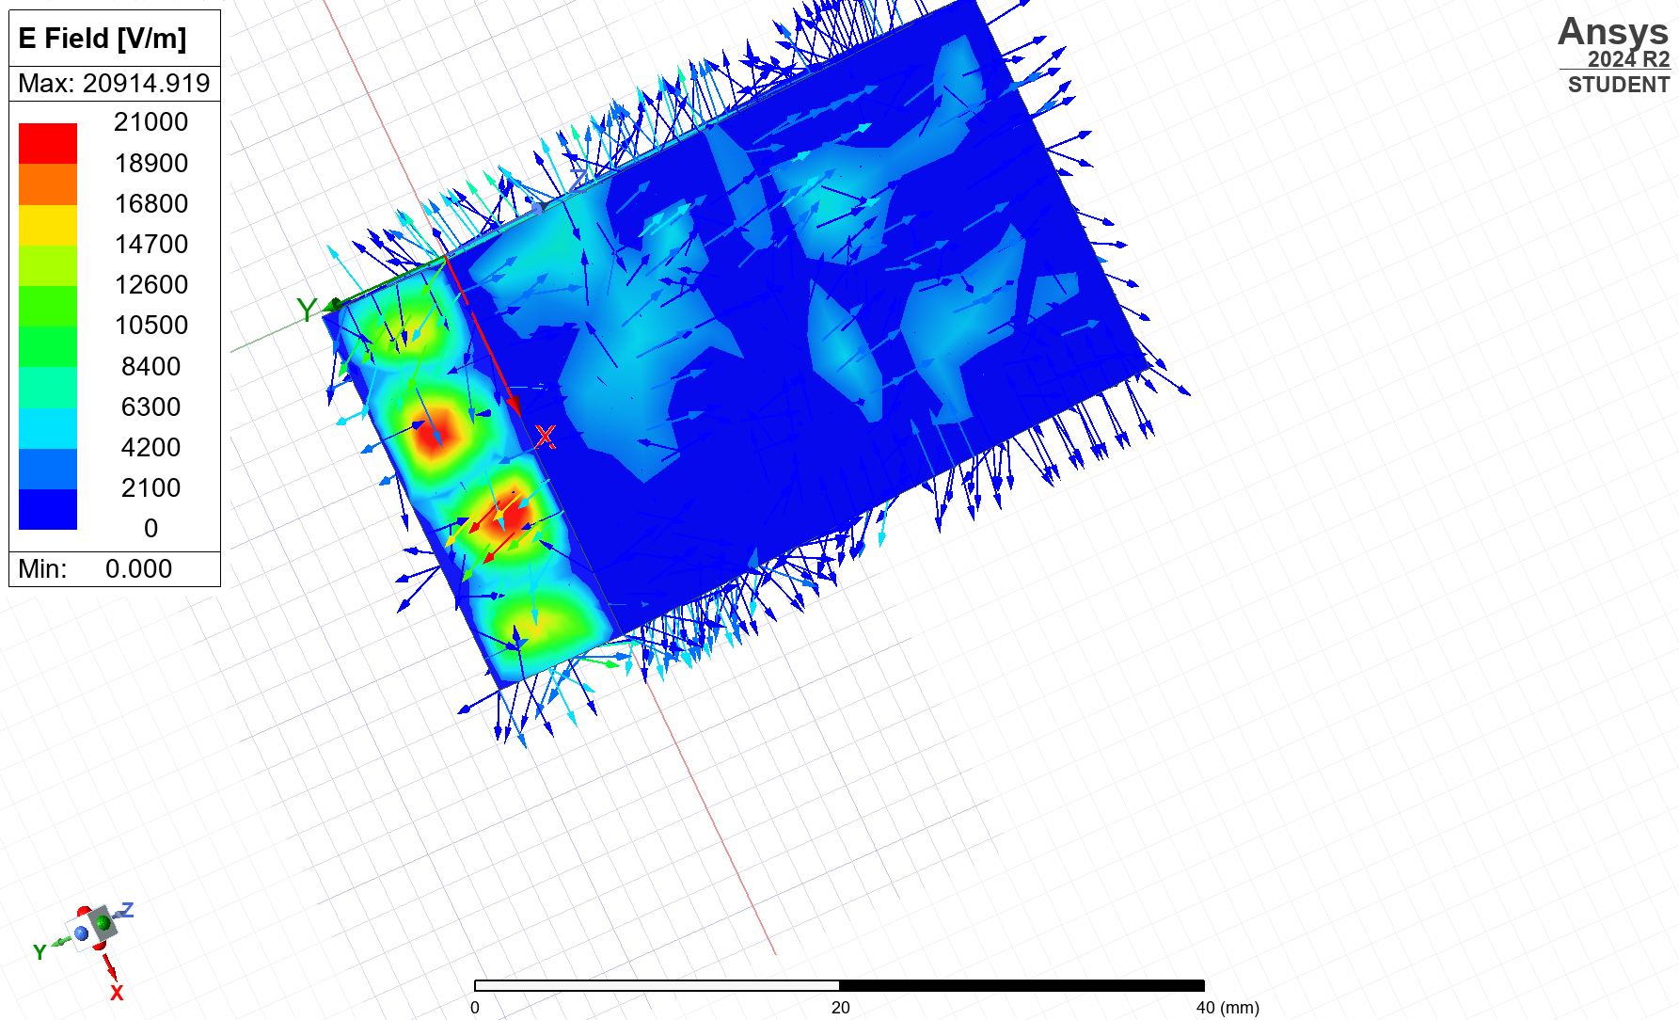
Figure 11: E-fields for Mode 3 vacuum
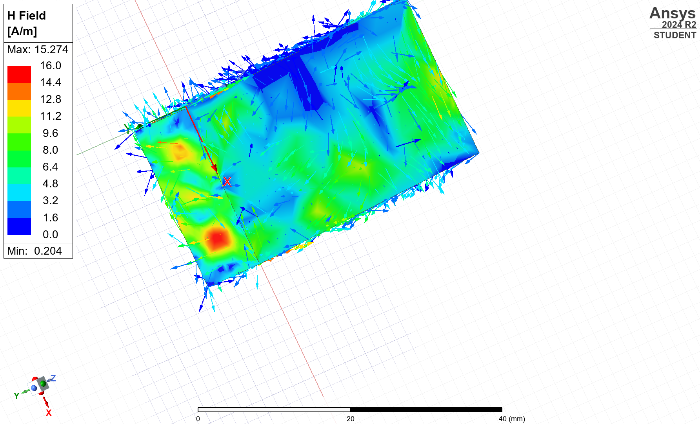
Figure 12: H field for Mode 3 vacuum

E-field and H-field distributions for Teflon:

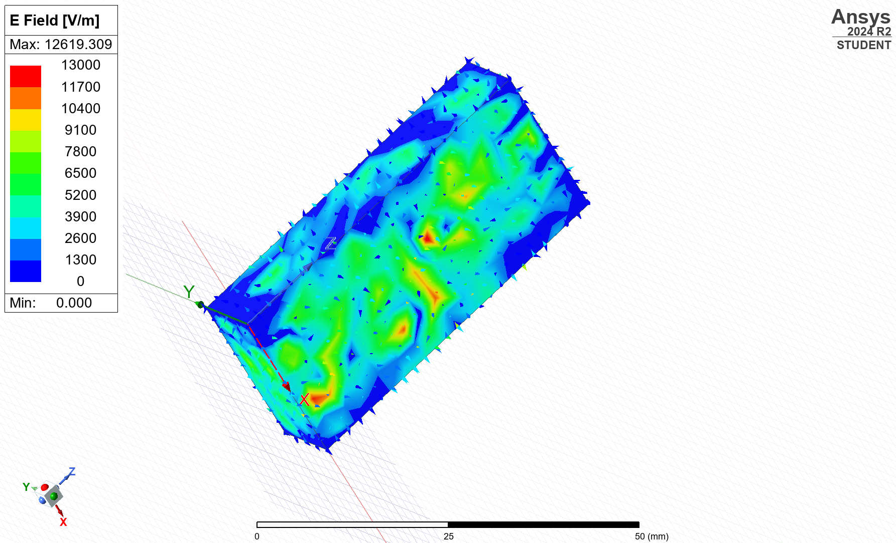Figure 13: E-field distributions for Mode 1
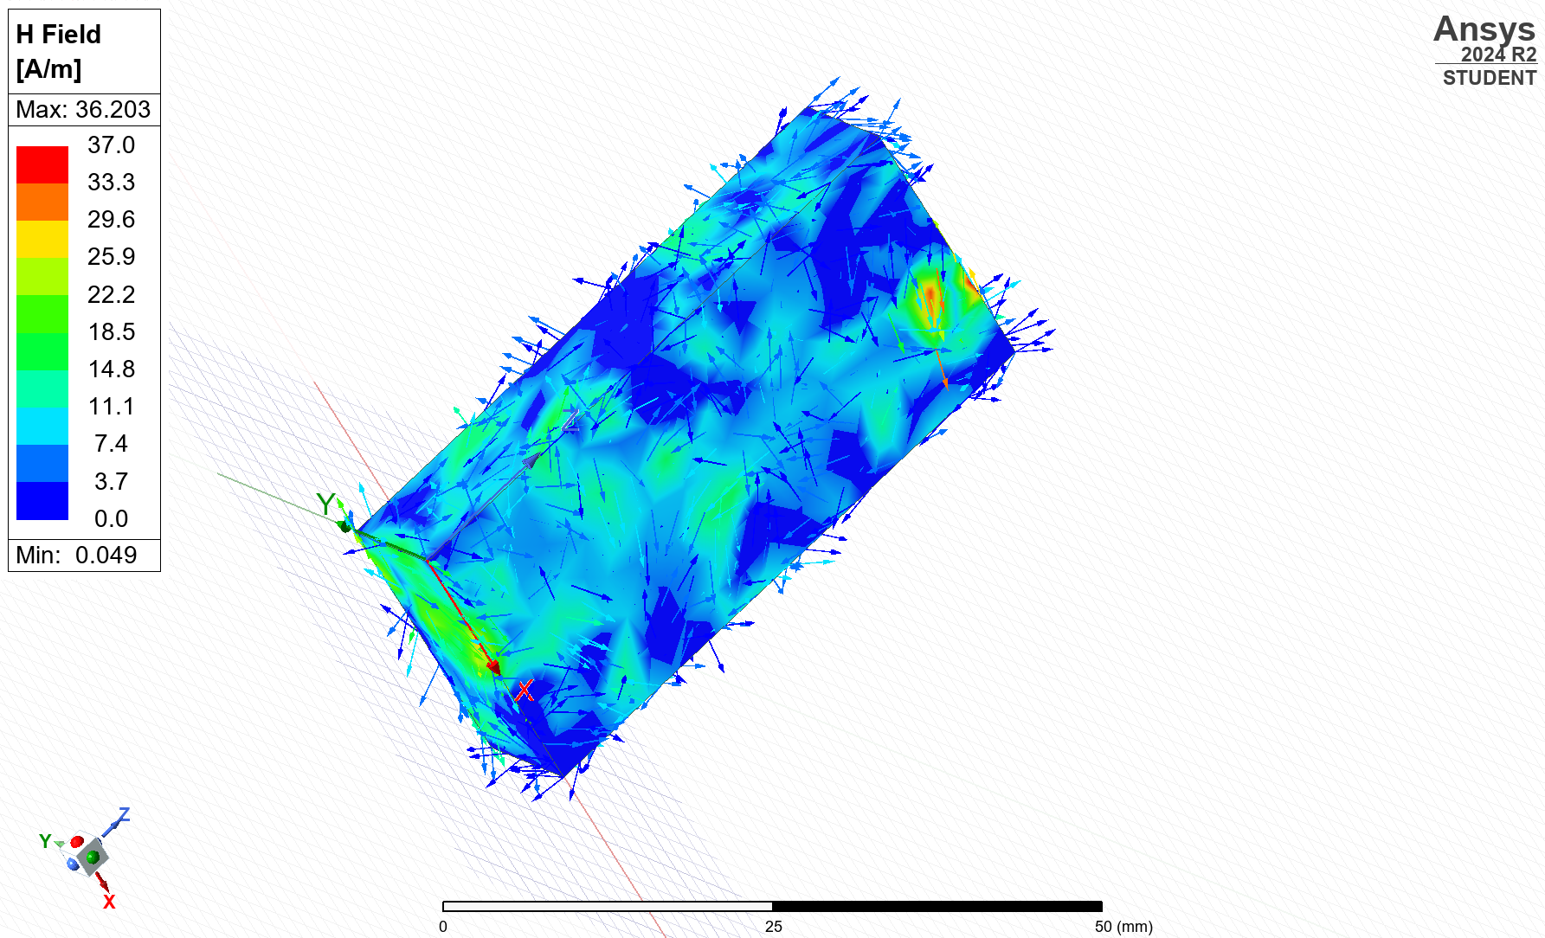
Figure 14: H-field Teflon for Mode 1

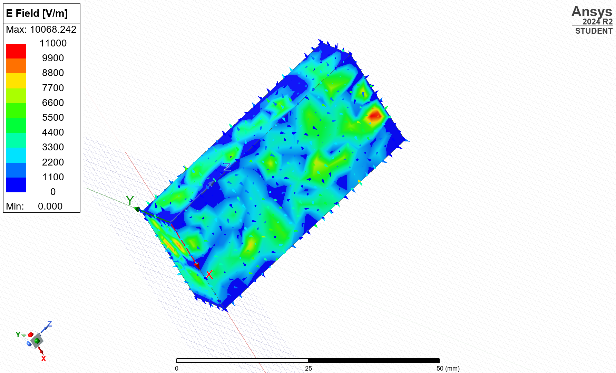
Figure 15: E-Field Teflon for Mode 2
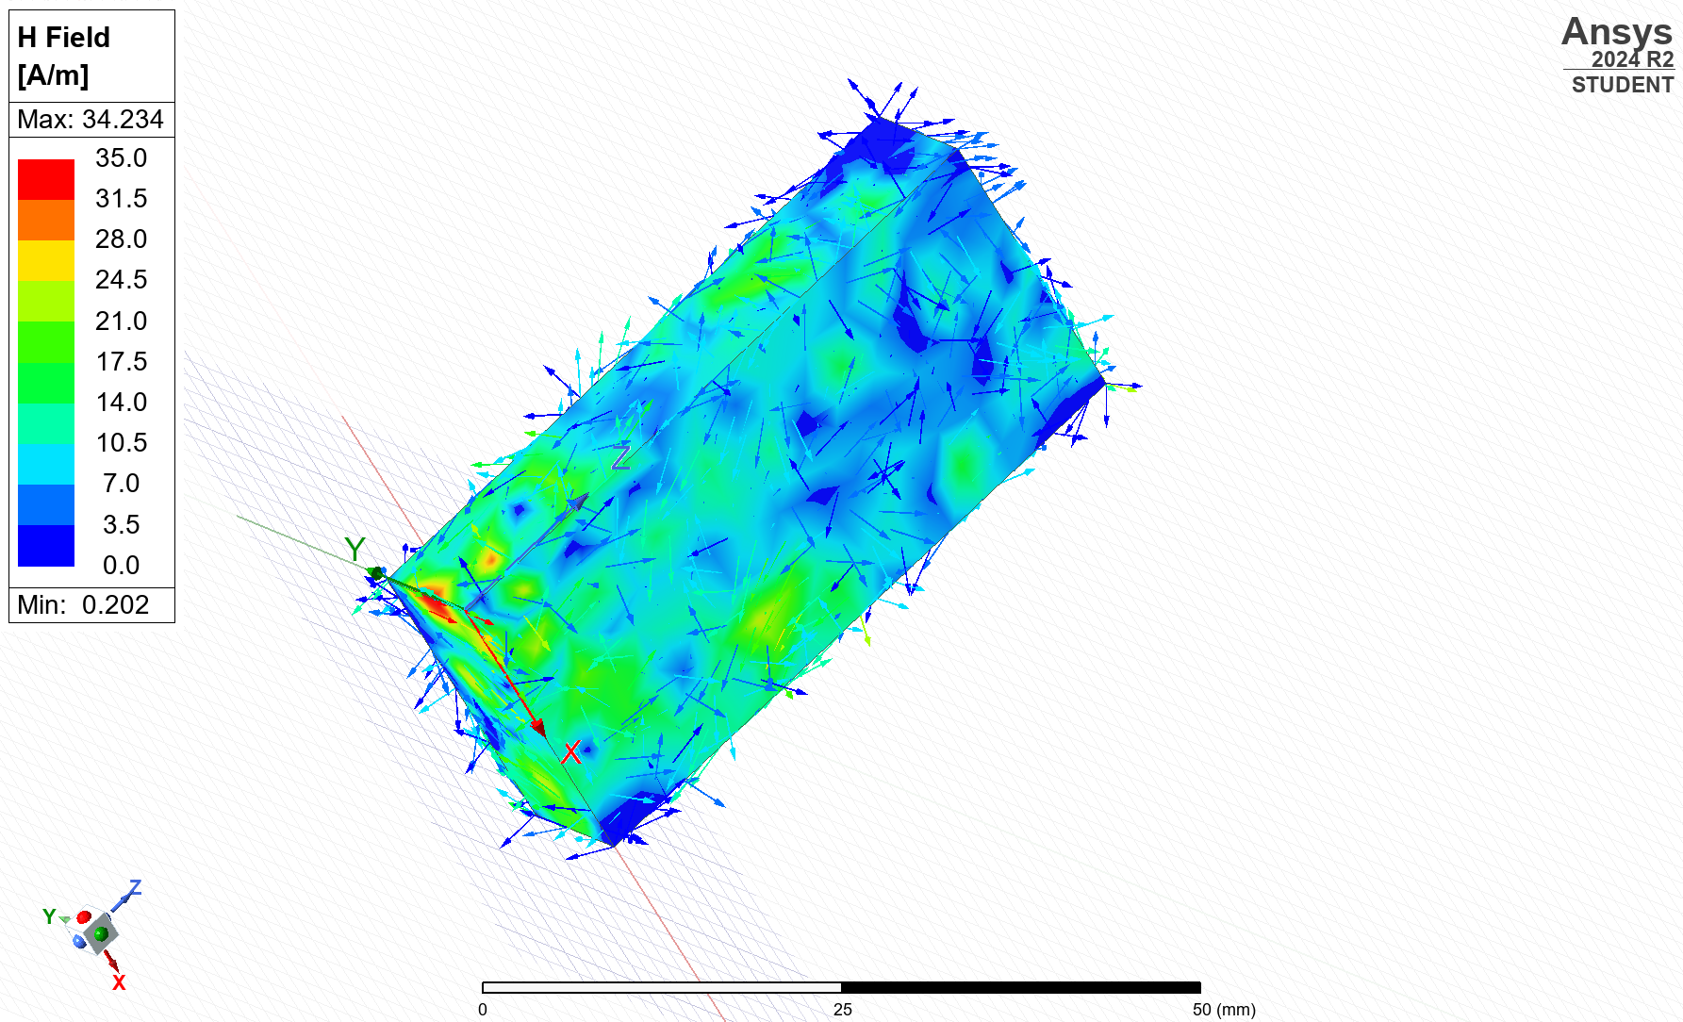
Figure 16: H-Field Teflon for Mode 2

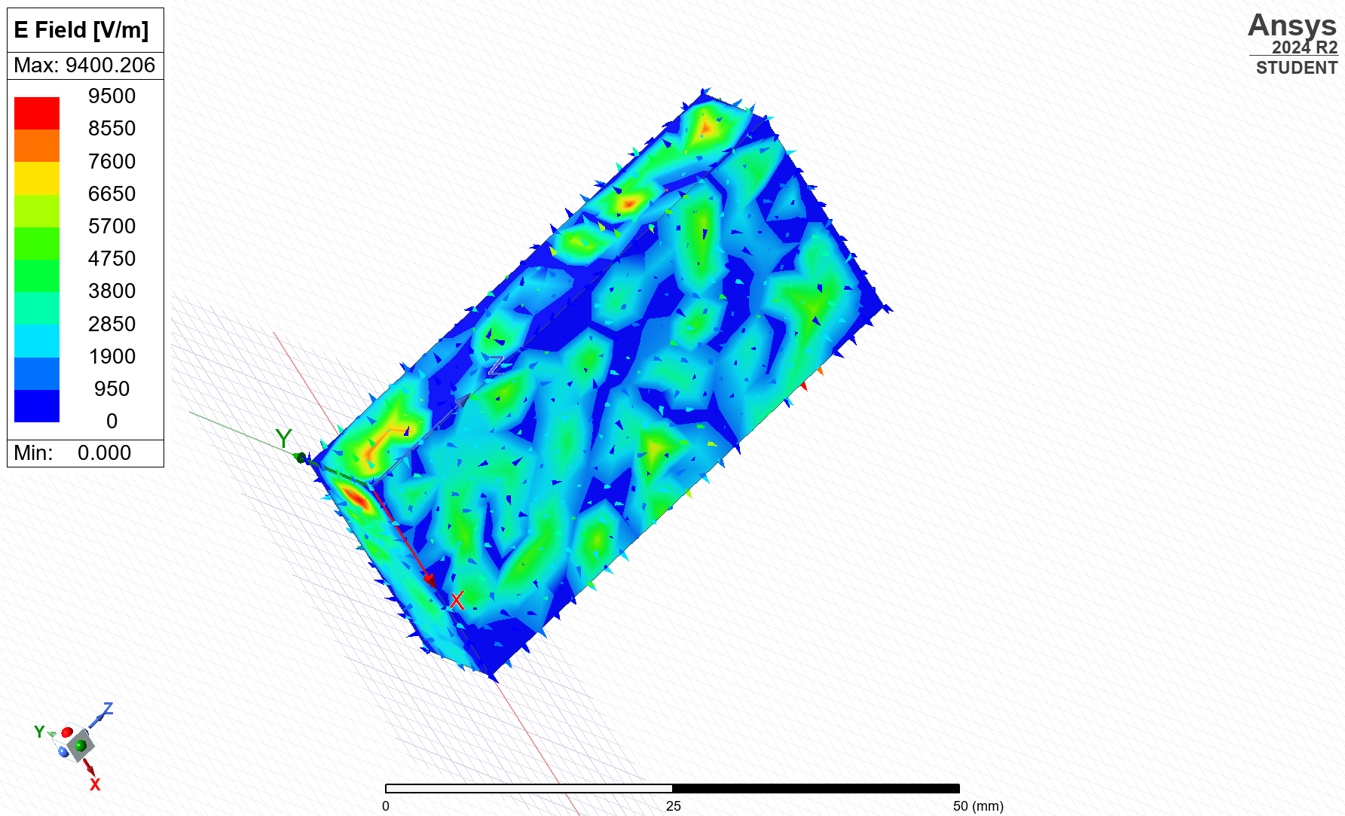
Figure 17: E-field Teflon for Mode 3

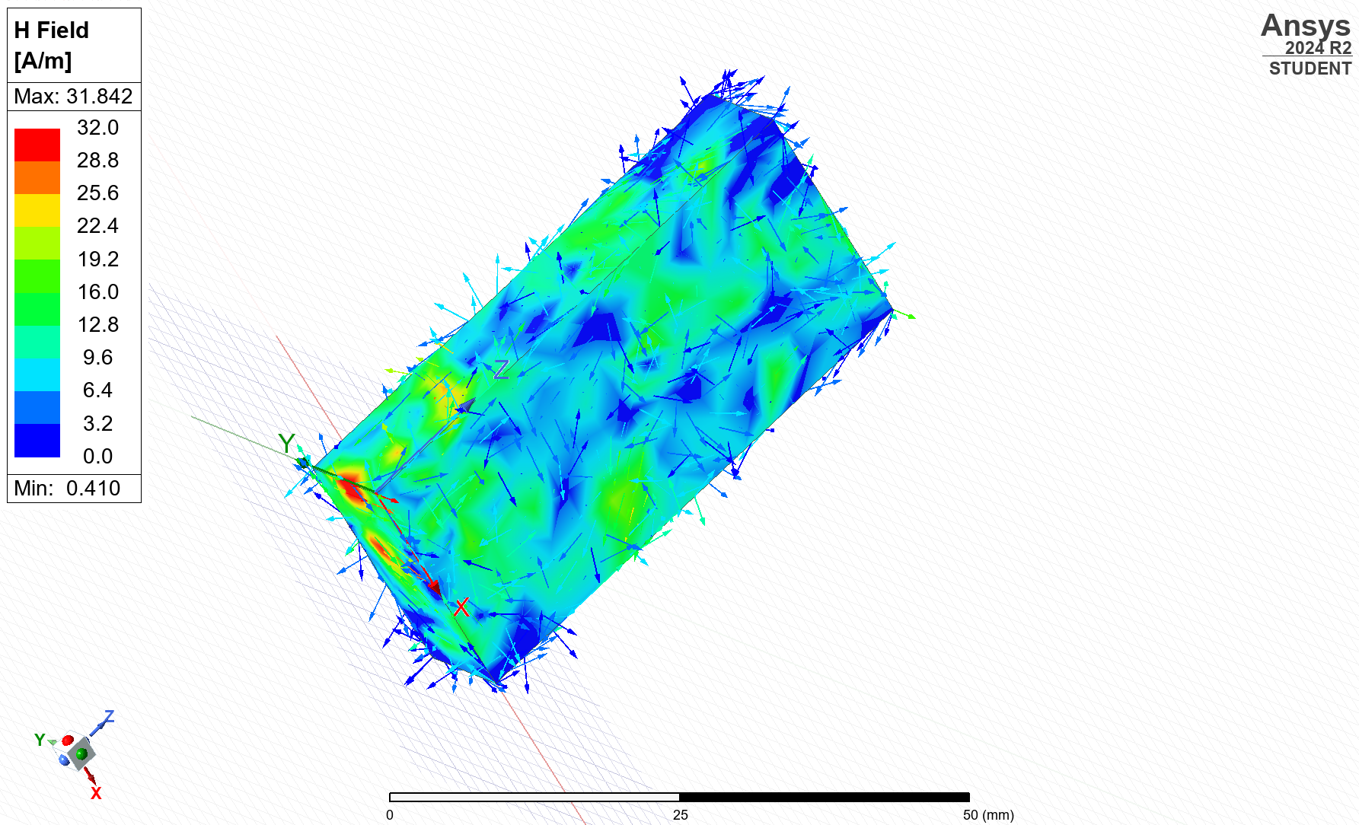
Figure 18: H-field Teflon for Mode 3

Cut-off frequencies:

Modes | Theoretical cut-off frequency (Vacuum) | Simulated cut-off frequency  (Vacuum) | Theoretical cut off frequency (Teflon) | Simulated  cut-off frequency  (Teflon)
Mode1-TE10 | 6.52 GHz | 6.48 GHz | 4.5 GHz | 4.53 GHz
Mode 2-TE20 | 13.04 GHz | 12.99 GHz | 9.01 GHz | 8.96 GHz
Mode 3-TE01 | 15 GHz | 15.72 GHz | 10.35 GHz | 10.84 GHz
Table 3: illustrates the cutoff frequencies obtained from the simulation for TE₁₀, TE₂₀, and TE01. These values are compared to theoretical predictions in Table 2. The similarity between simulation and theory confirms expected waveguide propagation.

Results: Task 2
The operating frequency of the antenna was calculated using the theoretical formula above and was calculated at 1.298 GHz.
This section presents the simulation results for the half-wave dipole antenna, including S11 scattering parameter and far-field radiation patterns.
This section presents the simulation results for the half-wave dipole antenna, including S11 scattering parameter and far-field radiation patterns.
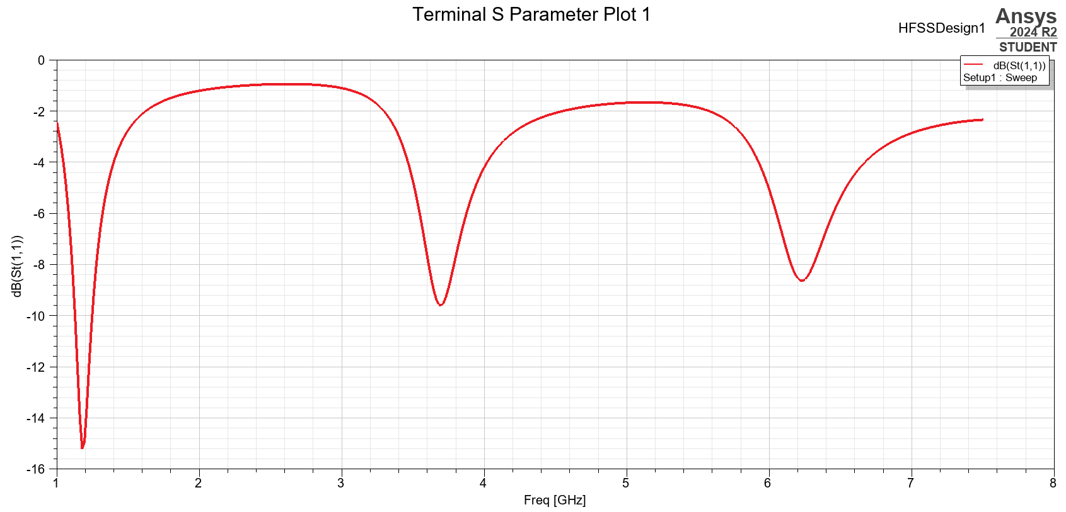
S11 parameter analysis:
Figure 19: S11 Parameter Plot of the Half-Wave Dipole Antenna showing primary resonance at approximately 1.3 GHz.

Far-field radiation pattern
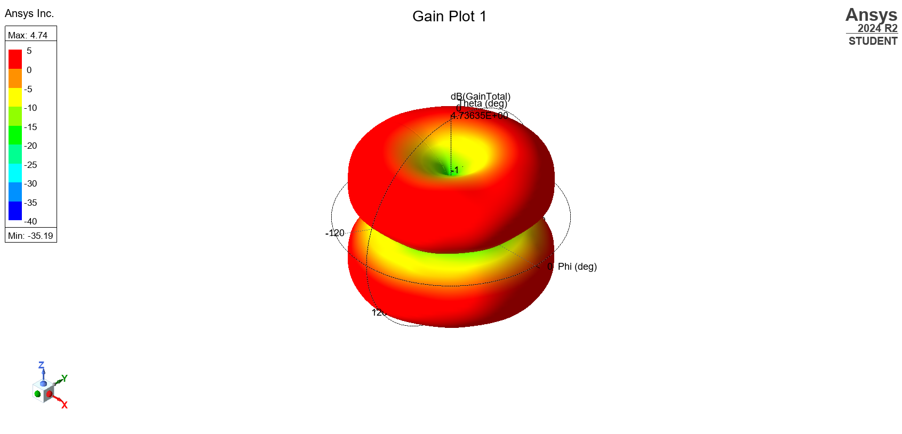
Figure 20: 3D Far-Field Gain Pattern of the Half-Wave Dipole Antenna shows the expected toroidal radiation shape with broadside maximum and nulls along the antenna axis.

Discussion
Task 1
For Tasks 1a and 1b, we focused on the TE₁₀, TE₂₀, and TE₀₁ modes inside a rectangular waveguide. The TE₁₀ mode is the dominant mode has the lowest cutoff frequency, while TE₂₀ and TE₀₁ propagate at are at higher frequencies.
The theoretical cutoff frequencies for each mode were calculated using the standard formula, and the results matched expectations:
In the vacuum-filled waveguide (Task 1a) cutoff frequencies were calculated to be 6.52 GHz for TE₁₀, 13.04 GHz for TE₂₀, and 7.89 GHz for TE₀₁.
When the waveguide was filled with Teflon (Task 1b), which has a relative permittivity of ϵr=2.1ϵr=2.1, the cutoff frequencies were lower compared to vacuum filling to about 4.50 GHz, 9.00 GHz, and 5.45 GHz respectively.
This shift makes sense because adding a dielectric material like Teflon slows down the wave propagation, causing the modes to start at lower frequencies. It’s a simple but important effect: materials inside a waveguide can completely change how and when electromagnetic waves are able to travel through it.
In both materials the TE₁₀ mode showed the expected electric field pattern: a half-sine variation across the waveguide width, and no electric field component in the direction of wave travel (z-axis).
As we increased the frequency, higher propagating modes like TE₂₀ and TE₀₁ started appearing, and the electric field patterns changed with more lobes and more complex variations, exactly as theory predicts.
The fact that the field distributions matched so well between simulation and theory shows that the waveguide was behaving properly under the simulation setup.
When we looked at the S₁₁ plots from the simulations, we saw clear dips at the frequencies where each mode was supposed to start propagating:
In the vacuum-filled waveguide, this was 6.5 GHz (TE₁₀), 7.8 GHz (TE₀₁), and 13 GHz (TE₂₀).
In the Teflon-filled waveguide, this was to about 4.5 GHz, 5.4 GHz, and 9 GHz.

When we introduce a material like Teflon, which has a higher permittivity causing the cutoff frequencies to drop, meaning that the waveguide can support the same modes but at lower operating frequencies.
In conclusion, the simulation results and theoretical calculations clearly show the impact of permittivity on cutoff frequency. The results obtained from the waveguide simulations in Tasks 1a and 1b further reiterate the effects of material properties on electromagnetic wave propagation within rectangular waveguides.
The use of HFSS proved how useful simulating both the field distributions and the frequencies not just reiterating the significance of Maxwell’s equations within electromagnetic theory, but making it easier to prove efficiency in real-life applications requiring high frequencies.

Task 2
The simulated half-wave dipole antenna demonstrated excellent radiation characteristics. Designed using Perfect Electric Conductor (PEC) material, the antenna exhibited high efficiency, minimal loss, and ideal current distribution along its arms. PEC, being a well conducting material, ensures no resistive loss, thereby maximising the antenna’s radiation performance.
During simulation, the antenna showed strong resonance near the expected operating frequency with a clean, symmetric current distribution. In practical applications, however other materials would slightly reduce performance leading to small loses and reducing efficiency
The analysis of the s11 plot shows a clear dip of the simulated frequency as 1.3 GHz as expected, as the resonant frequency was theoretically calculated at 1.298 GHz. Thus, proving efficient antenna design during simulation and the expected behaviour of the antenna [3].
While the theoretical predictions and simulation results were very similar, minor discrepancies were noticed. This could be due to parameters and dimensions despite not having another antenna to compare to within this task[4].

The radiation pattern observed during simulation showed:
- Slightly cinched at centre
- Nulls were observed along the axis of the dipole
- broadside

Conclusion

In conclusion, the simulation results and theoretical calculations clearly show the impact of permittivity on cutoff frequency. The results obtained from the waveguide simulations in Tasks 1a and 1b further reiterate the effects of material properties on electromagnetic wave propagation within rectangular waveguides.
The use of HFSS proved how useful simulating both the field distributions and the frequencies not just reiterating the significance of Maxwell’s equations within electromagnetic theory, but making it easier to prove efficiency in real-life applications requiring high frequencies.
The analysis of the S11 plot in task 2 clearly shows a dip at 1.3 GHz, very close to the calculated theoretical resonant frequency of 1.298 GHz. This result strongly validates the antenna design process during simulation and confirms the expected operational behaviour of the half-wave dipole antenna.
Additionally, the radiation pattern observed signified an efficient radiation distribution, despite it not showing typical toroidal shape due to minor discrepancies which could have been caused by minor deviation in the design of the gap, that have had minor to none effects on results. Thus, similarity in resonating frequency between theory and simulation proves the efficiency of the dipole antenna[5].

References

