

Student Name: Mihir Sudhirbhai Patel

Student ID:2504998

Module Name: Human Capital Managment

Module Code: LCMB7023

Lecturer’s Name: Dr Gladius Kulothungan

Work Count: 2618

Term 1

Executive Summary
This study critically examines how technological, demographic, and geopolitical factors are transforming HRM and IHRM strategies and labour markets. The first segment highlights how automation, AI, and digital platforms create and replace jobs. HRM should prioritise predictive analytics, reskilling, and ethical AI governance. HR professionals must manage global talent mobility, compliance, and cultural integration due to demographic and geopolitical concerns such ageing populations, migration, workforce diversity, and political instability in the second part. The third part proposes “build, buy, borrow, and bind” HRM solutions to develop, attract, and retain technology, healthcare, and hospitality workers due to technical skills shortages. A Gibbs' Reflective Cycle assessment of personal capacities indicates good adaptation, communication, and teamwork but space for leadership and time management improvement in the final part. These abilities can be improved through targeted learning and practice to satisfy 21st-century workplace skill needs.

Table of Contents
Introduction 3
1.0 Question 1: Technology & Labour Markets 4
1.1 Cause-and-effect relationship between technology and HR strategy 4
1.1.1 The Reshaping of Labour Markets 4
1.1.2 Implications for HRM/IHRM Strategies 5
2.0 Question 2: Demographic & Geopolitical Factors 7
2.1 Key macro-environmental factors and analysing the specific challenges they pose for HR 7
2.1.1 Key Demographic Factors 7
2.1.2 Key Geopolitical Factors 7
2.1.3 Challenges for HR Professionals 8
3.0 Question 3: Skills Gaps & Strategic HRM 10
3.1 Strategic solutions driven by HRM 10
3.1.1 Understanding the Causes 10
3.1.2 Strategic HRM Approaches 10
3.1.3 Sector-Specific Examples 11
4.0 Question 4: Reflective Report on Capabilities 13
4.1 Self-assessment and a proactive plan for development 13
4.1.1 Introduction 13
4.1.2 Self-Assessment 13
4.1.3 Development Plan 15
Conclusion 16
References 17
Appendix 19

Introduction
Context of the Report
World economic integration has increased cross-border movement, global talent pools, and business competitiveness for top people. Trade wars, political instability, and public health crises can disrupt supply chains and jobs. HRM and IHRM must adapt by employing flexible workforce techniques, managing multicultural teams, and obeying different labour laws and ethical norms across jurisdictions. Global HR leaders must be strategic partners who combine local responsiveness and global uniformity.
Global and Technological forces on labour markets and HRM
AI, robotics, and digital communication are changing global employment. As manual tasks are automated, cognitive, digital, and creative abilities are needed. By 2030, technology disruption will need nearly half of jobs to retrain. People management must be replaced by strategic talent orchestration using predictive analytics, AI-driven recruitment, and personalised learning. International IHRM must secure data, manage remote personnel, and coordinate digital change across cultures and laws. Global and technology challenges are transforming work and making HRM proactive, data-driven, and human-centric to compete.

1.0 Question 1: Technology & Labour Markets

1.1 Cause-and-effect relationship between technology and HR strategy

1.1.1 The Reshaping of Labour Markets
Automation and AI: Job Displacement vs. Job Creation
AI and automation are rapidly changing global job supply and quality. Over 43% of jobs will be automated by 2030, lowering demand and productivity. Automation creates high-skilled jobs for data scientists, AI ethicists, and automation engineers. AI could raise efficiency and create 300 million jobs, boosting global GDP by 7% (World Economic Forum, 2025). HRM and IHRM must focus on predictive talent analytics, reskilling, and job redesign instead of workforce management. To maintain equity and employability, automation's efficiency advantages must be balanced with proactive human capital measures.
The Gig Economy and Digital Platforms
Growing digital labour platforms provide global project-based work. Upwork, Uber, and Fiverr have grown the gig economy to $582 billion. From traditional employment to contractorship, HR worries about worker classification, salary equality, and legal compliance. HRM initiatives increasingly integrate freelancers and remote workers into performance and engagement platforms. International teams' taxation, legal responsibilities, and cultural integration are handled by IHRM. Digital platforms boost global talent and labour flexibility, but HR must create a fair and efficient hybrid employment model.
Skills Churn: Accelerating Half-Life of Skills
Rapid technological change has shortened skill half-life, compelling workers to adapt. Digitalisation will change 25% of jobs and need 50% retraining by 2027 (Hogarth and McCartney, 2024). Flexibility and emotional intelligence are valued STEM and soft talents. To prepare future workers, HRM needs lifelong learning ecosystems, internal mobility, and educational provider partnerships. Unifying training across jurisdictions and cultures is another IHRM difficulty. Thus, skill obsolescence promotes HR approaches that prioritise learning agility and worker resilience as technology changes.

1.1.2 Implications for HRM/IHRM Strategies
Talent Acquisition
AI has transformed commercial talent acquisition. Automation and predictive analytics can help HR departments screen candidates at scale and discover high-potential candidates based on behaviour and performance. 74% of HR directors decrease hiring bias with AI. Human oversight for transparency and diversity is needed to avoid ethical and fair algorithm abuse. To maximise future potential, HRM policies must stress adaptability and learning agility above static competencies. Cross-border AI-driven IHRM recruitment is subject to regional data protection standards like the GDPR, emphasising ethical global hiring.
Learning and Development (L&D)
Technology changes job requirements quickly, necessitating constant learning. By 2027, 50% of digitally intensive workers will need retraining. Flexible, self-paced HRM skill development requires micro-learning, digital badges, and AI-personalised learning. Businesses employ Coursera, LinkedIn Learning, and Degreed for just-in-time learning. IHRM must standardise global subsidiary learning frameworks and address cultural and language disparities. Effective L&D initiatives encourage lifelong learning and make upskilling important for job progression in an AI-driven economy.
Strategic HR Planning
Strategic data-driven staff planning replaces reactive headcount. Human resource planning with workforce analytics deploys personnel 25% faster and makes companies more nimble during market transitions. HRM must forecast skill needs, manage full-time, part-time, and gig workers, and plan staff with automation forecasts. Data analytics may help HR predict talents and plan tech-aligned succession. For global HR planning utilising IHRM, consider labour regulation differences, regional automation readiness, and talent mobility (Brynjolfsson and McAfee, 2014). Strategic HR planning integrates organisational change and sustainable workforce design.
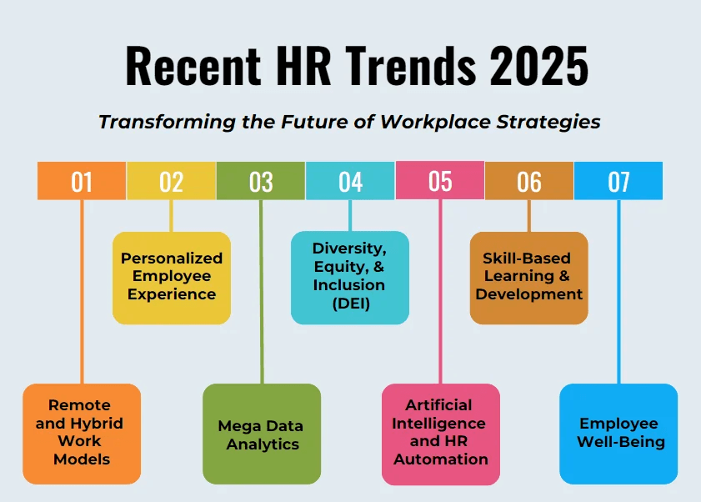
Fig 1: HR Trends of the company
Source: (E-Learning Infographics, 2024)
IHRM Specifics
HRM issues arise from digital workforce globalisation. Remote work employing cloud-based collaborative technology has increased global employment but complicated compliance, taxation, and data protection. 62% of multinationals have mixed labour laws. GDPR, India's Digital Personal Data Protection Act (2023), and gig-economy laws affect IHRM. Global HR strategy must consider cultural communication, motivation, and performance variables. IHRM plans must be flexible, tech-enabled, and ethical to assure justice, data security, and global HR governance (CIPD, 2024).

2.0 Question 2: Demographic & Geopolitical Factors

2.1 Key macro-environmental factors and analysing the specific challenges they pose for HR

2.1.1 Key Demographic Factors
Ageing Populations
Japan, Germany, and the UK are rapidly ageing, reducing work and increasing dependence. One in three advanced economy workers will be over 55 by 2030, straining pensions and productivity (Deloitte LLP, 2025). Company multi-generational workforce practices like flexible retirement, age-group mentorship, and systematic knowledge transfer are important during this transition.
Changing Migration Patterns
With 281 million individuals, or 3.6% of the world, living abroad, global migration affects workforce availability and skills distribution. Wealthy nations use immigrants for healthcare, building, and technology, while impoverished ones lose talent. HR professionals must monitor immigration, fair hiring, and integration.
Increasing Workforce Diversity
Collaboration and creativity are affected by gender, ethnic, disability, and culture diversity in modern businesses. Companies that prioritise inclusion innovate twice as much and meet financial targets almost twice as often. To reflect this evolving workforce, HR must include diversity, equity, and inclusion in recruitment, development, and leadership pipelines.

2.1.2 Key Geopolitical Factors
Trade Wars and Protectionism
Rising trade tensions and protectionist policies undermine supply chains and investment, affecting global employment (EY, 2025). Recent tariff rises between major economies have caused corporations to rethink manufacturing and sourcing, causing job relocations and recruitment priorities.
Political Instability and Sanctions
International sanctions and geopolitical conflicts affect multinational labour deployment and mobility. Political upheaval in Eastern Europe and the Middle East affects expatriate security and worldwide missions. Sanctions and laws delay projects and change markets by burdening payroll, taxation, and compliance. The World Economic Forum's Global Risks Report for 2025 ranks state-based military conflict (23%) and geo-economic antagonism (8%) as the main threats to global security and business continuity.
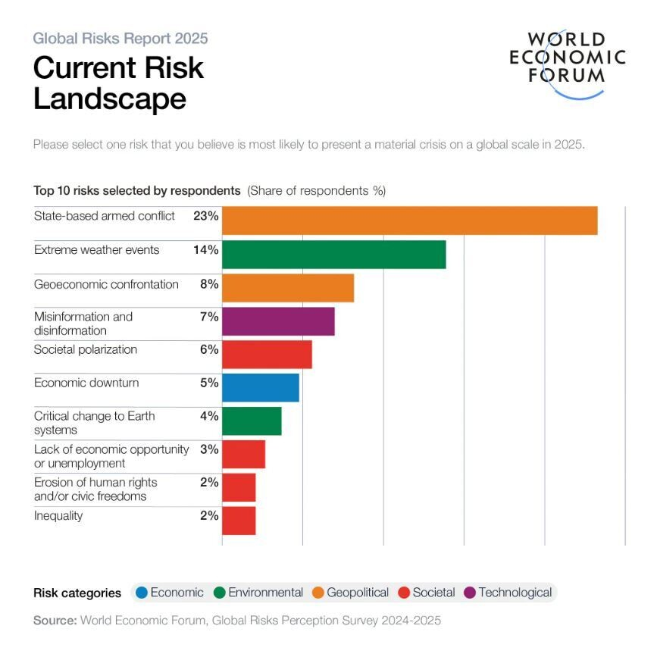
Fig 2: Risk Landscape
Source: (Whiting, 2025)
Pandemics and Global Health Crises
Global health crises have made remote and hybrid work common. Post-pandemic labour market reveals over 60% of enterprises provide hybrid work arrangements, indicating global team shift (PwC, 2024). HR must design new mental health, occupational health, digital collaboration, and data security policies for this shift.

2.1.3 Challenges for HR Professionals
Talent Mobility
Global talent movement is complicated by visas, immigration, and geopolitics. Some governments encourage remote workers with digital nomad visas, while others tighten work permit regulations to protect domestic labour markets. These trends must be monitored by HR experts for prompt onboarding, regulatory compliance, and easy abroad assignments.
Risk Management
Global market instability, conflicts, and health crises make risk management a top HR problem. Companies need multinational staff duty-of-care and crisis management. Evacuation planning, mental health care, and high-risk employee real-time communication are examples (PwC, 2025). HR must work with security and compliance to protect expats and global teams.
Compliance
Companies expanding abroad face national employment, salary, data protection, and tax laws. Lawsuits, fines, and reputational damage can result from noncompliance. HR experts must update contracts, payroll, and benefits to comply with all jurisdictions. Follow GDPR and regional privacy rules as AI and data analytics grow.
Cultural Integration
With the growth of companies worldwide, it offers the challenges and prospects of managing culturally diverse and geographically remote teams. The differences in language, work ethic and leadership may hamper teamwork. The HR employees require cross-cultural mentoring, cross-cultural leadership, and cultural intelligence training (The Economist, 2024). There is increased efficiency and lack of misunderstanding since the communication and teamwork between departments is enhanced.

3.0 Question 3: Skills Gaps & Strategic HRM

3.1 Strategic solutions driven by HRM

3.1.1 Understanding the Causes
Technology outstrips education and industry, and causes lack of skills. The fast development of AI, robots and data analytics has increased the need of digital and cognitive skills that the traditional curriculum can overlook. A lot of industries have problems with educational and professional qualifications. This is aggravated by irregular investment in learning and development in particular the small and medium companies with minute training budgets. The imbalance between supply and demand of labour market is intensified as companies find it hard to recruit the necessary positions as well as employees become less skilled.

3.1.2 Strategic HRM Approaches
“Build” Strategies: Internal Development
Corporate academies, apprenticeships, and partnerships with educational or ed-tech companies help “build” companies nurture talent. LinkedIn Corporation Workplace Learning Report 2025 found that 36% of companies had good internal mobility and upskilling programs. Comprehensive training boosts employee pay by 21.8% (ManpowerGroup, 2025). Internal capability growth is competitive and necessary, according to statistics.
“Buy” Strategies: Strategic Recruitment
Buy strategies Buy-based strategies have become popular in regions where companies are short of talent, as an effort to obtain essential capabilities. The ManpowerGroup Talent Shortage Survey 2025 states that 74 percent of businesses in the world are not able to fill vacancies because of the shortage of skills. A limited number of 16% CEOs feel that organisations possess adequate IT resources to transform digitally. HR must enhance employer branding, apply talent analytics to seek unconventional talent, and provide competitive payments and career opportunities in order to recruit unique workforce.
“Borrow” Strategies: Accessing External Talent
Skills shortages in the short term may be borrowed by companies by hiring consultants, gig workers, freelancers or outsourced teams. This flex-model is required as a result of shortage of talent. Firms should strategize contingent labour as the skills gap worldwide is increasing (85 million unfilled jobs by 2030). The role of the HR is to onboard, manage and integrate gig workers in teams of theirs (Cappelli, 2008).
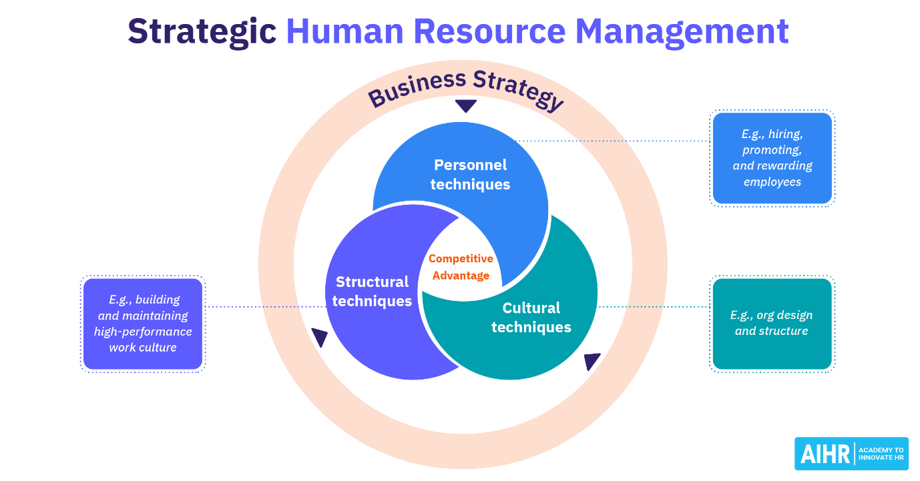
Fig 3: Strategic Human Resource Management
Source: (AIHR, 2025)
“Bind” Strategies: Retention
To retain employees, the “bind” strategy encourages mentoring, work rotations, appealing career paths, and a learning-focused culture. When given development chances, 90% of employees stay; 45% if told. It is found that “career development champions” are 71% confident in attracting top candidates, compared to 58% for other companies. Thus, HR strategy must include retention in talent-management frameworks, align growth and career design with organisational goals, offer internal mobility, and let people grow rather than do chores.

3.1.3 Sector-Specific Examples
Tech Sector
IT has one of the largest AI, cybersecurity, and software engineering skills gaps. Many companies nurture in-house talent using “build” approaches like internal coding bootcamps and ed-tech alliances. Companies may stay agile and competitive in a fast-changing digital world by “borrowing” freelancing AI professionals and data scientists for short-term initiatives.
Healthcare Sector
Nursing and clinical staff are scarce worldwide. Companies increasingly use “buy” to fill key positions and eliminate domestic deficits (Deloitte LLP, 2022). Staff retention is achieved through “bind” initiatives including better working conditions, career ladders, and mental health support. The strategies stabilise staffing and boost service.
Hospitality Sector
Due to frequent turnover and seasonal employment, hospitality needs “build” and “buy” tactics. Companies train internal managers for frontline executives. Competitive benefits and branding attract new hires in a tight labour market. These solutions boost labor-sensitive firms' service quality and resiliency.

4.0 Question 4: Reflective Report on Capabilities

4.1 Self-assessment and a proactive plan for development

4.1.1 Introduction
MBA graduates need global and flexible skills to succeed in varied markets in today's technology-driven corporate world. Professionals must be flexible, digital, and cross-cultural. Leading and innovating in international environments requires agile, cross-cultural, and strategic problem-solvers. These attributes boost employability and prepare future leaders to handle instability and maintain global performance.

4.1.2 Self-Assessment
Description
The MBA develops technology, communication, teamwork, leadership, and self-directed learning through courses and group activities. MS Teams, Excel, Turnitin, ChatGPT, and online databases enable autonomous and collaborative study. Multicultural team presentations, written assignments, and peer collaboration measured and improved these professional skills.
Feelings
Adapting to advanced learning technologies and multicultural teams was tough due to different work styles and communication preferences. Learning digital platforms and team respect enhanced confidence (Martin, 2018). Mentors and peers valued clear, analytical writing for inspiration, confidence, and leadership.
Evaluation
The experience helped me to think critically, collaborate in a team, and embrace technology. Efficiency and research analysis were enhanced through artificial intelligence. Communication was enhanced through the use of organized reports and presentations. It was necessary to work on leadership, especially on the team conflict resolution. Time management was also not that simple since the project deadlines were to be met simultaneously, and additional priorities and planning were needed.
Analysis
Modern multinational management supported the use of information to make decisions and collaborate through technology. Intercultural proficiency which is critical in international business was enhanced through interaction and cooperation with other employees of other cultures. Emotional intelligence and delegation enhanced performance in the context of leadership and self-management (The University of Edinburgh, 2024). The results reinforce international employability models that emphasize on MBA outcomes such as agility, communication and lifelong learning.
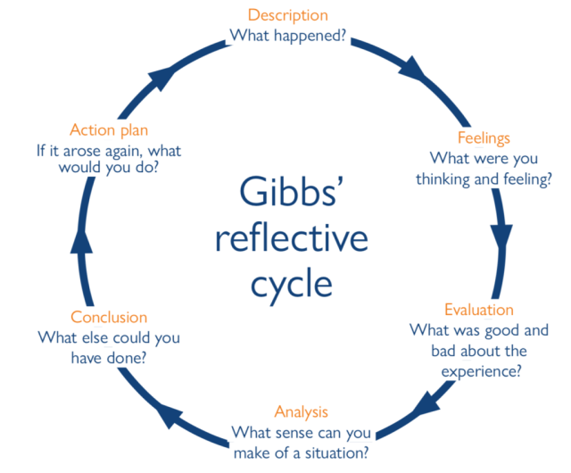
Fig 4: Gibbs Reflective Cycle
Source: (CommunityMedicine4Assess, 2025)
Conclusion
Technology, teamwork, and communication were strengths, whereas leadership aggression and time management were shortcomings. The insights highlight professional readiness and worldwide competencies.
Action Plan
Motivational and transformative leadership and voluntary decision-making strengthen project leadership. Weekly planning and digital productivity tools increase time management. AI-driven learning systems and worldwide case studies enable self-learning. Balanced professional competency will train leaders for varied, technology-enhanced global workplaces.

4.1.3 Development Plan
Leveraging Strengths
Global IT jobs require personality to succeed. Multicultural communication and digital adaptability are most valuable. Strategic growth involves digital transformation and data-driven decision-making, therefore technological adaption is essential. Quick mastery of software, analytics platforms, and AI-integrated systems enables early efficiency and innovation. Collaboration, LMS, and research-based AI capabilities empower flexible, innovative digital workers. International organisations value varied team communication for cooperation, leadership, and client relations. Teamwork improves with good communication, cross-functional project clarity, negotiation results, and multicultural inclusion. Companies desire tech-savvy, socially adept CEOs. They enable confident performance in hybrid and cross-border workplaces, meaningful professional connections, and organisational success through innovation and cooperation.
Addressing Weaknesses
Ineffective cross-cultural team leadership may hurt global corporate performance. First, volunteer for MBA multicultural group project leadership roles to learn diverse perspectives and communication methods. Team members and mentors' feedback after each project will help leadership grow. Before March 2026, Coursera's “Leading Global Teams” course will assist manage diversity, conflict, and virtual cooperation. International networking and webinars boost cultural awareness and global leadership confidence. Combining experiential learning with formal education will turn a shortfall into a professional capacity for international management careers.

Conclusion
The nature of labour markets requires HRM and IHRM to be tactful, evidence-based, and centre-staged to compete due to the limitations of labour markets in regard to demographics, geopolitics and technological factors. The ageing populations and migration issues are these factors that require multi-generational approaches to workforce, whereas the artificial intelligence and automation present a challenge of the constant need to reskill people. The HRM strategy of build, buy, borrow, and bind can assist companies in sealing skills gaps and creating pipelines of talent at the sector level. The given findings indicate that the HR leadership of the 2025 and further should be technologically innovative and humanistic, adaptable, and supportive of lifelong learning. Long term resiliency in a rapidly evolving global labour market will be determined by human capital and alignment on the strategy.

References
Brynjolfsson, E. and McAfee, A., (2014). The second machine age: Work, progress, and prosperity in a time of brilliant technologies. WW Norton & company.
Cappelli, P.H. (2008). Talent on Demand: Managing Talent in an Age of Uncertainty. Boston, MA: Harvard Business Press. Available at: https://store.hbr.org/product/talent-on-demand-managing-talent-in-an-age-of-uncertainty/4478?srsltid=AfmBOop_g9fWsqr2YUv0o0r2tUuGJLgDMlzmLN1pG9CQzqOvTMRS8g60
Chartered Institute of Personnel and Development. (2024) ‘Analysis | Quantifying the impact of generative AI on HR’. London: CIPD. Available at: https://www.cipd.org/en/views-and-insights/thought-leadership/insight/quantifying-impact-generative-ai/ (Published: 27 August 2024)
Deloitte LLP (2022). ‘Skills-based organisations: A new operating model for work and the workforce’, Deloitte Insights. London: Deloitte. Available at: https://www.deloitte.com/us/en/insights/topics/talent/organizational-skill-based-hiring.html
Deloitte LLP (2025) ‘On ageing, migration and growth’. London: Deloitte UK. Available at: https://www.deloitte.com/uk/en/blogs/monday-briefing/on-ageing-migration-and-growth.html
Ernst & Young (EY) (2025) ‘Employee mobility critical to addressing talent gaps amid rising cost pressures, EY reports’. London: EY. Available at: https://www.ey.com/en_gl/newsroom/2025/04/employee-mobility-critical-to-addressing-talent-gaps-amid-rising-cost-pressures-ey-reports
Hogarth, A. and McCartney, C. (2024) Resourcing and Talent Planning Report 2024. London: Chartered Institute of Personnel and Development. Available at: https://www.cipd.org/globalassets/media/knowledge/knowledge-hub/reports/2024-pdfs/8662-resource-and-talent-planning-2024-report-web.pdf
ManpowerGroup (2025). Talent Shortage Survey. Milwaukee, WI: ManpowerGroup. Available at: https://go.manpowergroup.com/talent-shortage
Martin, J.P. (2018) ‘Skills for the 21st Century: Findings and policy lessons from the OECD survey of adult skills’. OECD Education Working Papers, No. 166. Paris: OECD Publishing. Available at: https://www.oecd.org/en/publications/skills-for-the-21st-century_96e69229-en.html
PricewaterhouseCoopers (PwC) (2024) Global Workforce Hopes & Fears Survey 2024. London: PwC. Available at: https://www.pwc.com/gx/en/news-room/press-releases/2024/global-hopes-and-fears-survey.html
PricewaterhouseCoopers (PwC) (2025) 28th Annual Global CEO Survey 2025. London: PwC. Available at: https://www.pwc.com/gx/en/ceo-survey/2025/28th-ceo-survey.pdf
The Economist (2024) ‘Trade in Transition: Labour trends’. London: The Economist Impact. Available at: https://impact.economist.com/projects/trade-in-transition/labourtrends/
The University of Edinburgh (2024) ‘Gibbs’ Reflective Cycle | Reflection Toolkit’. Edinburgh: The University of Edinburgh. Available at: https://reflection.ed.ac.uk/reflectors-toolkit/reflecting-on-experience/gibbs-reflective-cycle
World Economic Forum. (2025) The Future of Jobs Report 2025. Geneva: World Economic Forum. Available at: https://reports.weforum.org/docs/WEF_Future_of_Jobs_Report_2025.pdf
Image References
Academy to Innovate HR (AIHR) (2025) ‘Strategic Human Resource Management 101: Your Essential Guide’. Available at: https://www.aihr.com/blog/strategic-human-resource-management/
CommunityMedicine4Assess (2025) ‘Reflection: A Basic Guide’. [online] Available at: https://communitymedicine4asses.wordpress.com/2025/01/10/reflection-a-basic-guide/
e-Learning Infographics. (2024) ‘HR Trends In 2025: Transforming the Future of Workplace Strategies — Infographic’. [online] Available at: https://elearninginfographics.com/recent-hr-trends-2025-transforming-the-future-of-workplace-strategies/
Whiting, K. (2025) ‘Inflection points: 7 global shifts defining 2025 so far — in charts’, World Economic Forum. Available at: https://www.weforum.org/stories/2025/08/inflection-points-7-global-shifts-defining-2025-so-far-in-charts/

Appendix
SWOT Analysis
Strengths | Weaknesses
Strong adaptability to digital tools and AI-assisted research. | Limited experience in leading cross-cultural teams.
Effective communication and collaboration in multicultural settings. | Occasional difficulty asserting authority during group projects.
Excellent teamwork and problem-solving skills. | Need for improved time management during multiple deadlines.
Opportunities | Threats
Global demand for tech-savvy managers and data-driven decision-makers. | Rapid technological change could make current digital skills obsolete.
Access to international learning networks and leadership development courses. | High competition for global leadership roles among MBA graduates.
Expanding remote and hybrid work opportunities across industries. | Economic or political instability affecting international career prospects.

