

BA BUSINESS MANAGEMENT
Data Handling and Business Intelligence
LCBB5000

Component 2
Coursework (Essay)

Student: Sorina-Iulia Cosa
Lecturer: Dr Sharin McDowall-Emefiele

Table of Contents
Section 1 3
1.1 Introduction 3
1.2 Coffee consumption data 3
1.3 Data spread 6
1.4 Statistical analysis with Excel 8
1.4 Statistical analysis with SPSS 10
1.6 Conclusion 14
Section 2 14
2.1 Introduction 14
2.2 Advantages and disadvantages of using Excel 15
2.3 Meaning and importance of Data Mining Cycle 16
2.4 Conclusion 17
Section 3 – References 17

Section 1

1.1 Introduction

Starting the job as a data analyst, I have been handed a study titled "Coffee_Consumption_and_Effects_2024" and based on the data findings while using SPSS and Excel, I will interpret the outcomes. The company I work for provided Microsoft Excel in order to analyse the data from the study, and recently they also acquired SPSS Software, in which I will explore the dataset to gain the most of the relevant information for the business. In the current business climate, data analysis is one of the fastest growing disciplines as companies worldwide strive to make sense of their data. Many data analysis tools are available on the market to help data analysts perform their duties. One such tool is SPSS, a suite of software applications designed to evaluate scientific data pertaining to the social sciences. SPSS offers a fast, visual modeling environment that can handle even the most complex models. Surveys, data mining, and market research all use the information gathered from SPSS. (Williams, 2022)
Below can be seen the findings and interpretation of the mean value, median value and mode for coffee consumption (in cups) per day, the standard deviation for effects on the human body and the variance, all while using SPSS, then Excel will help me create and analyse a line chart, followed by creating the correlation between coffee consumption and the health index score and producing a scatterplot in SPSS.

Coffee consumption data

Coffee_Consumption_and_Effects_2024 dataset
Having the data set for the Coffee Consumption and Effects, the mean, median and mode will be analysed with the help of SPSS.
The mean, median, and mode all provide distinct measurements of the centre in a numerical data collection. Each attempt to represent an "usual" point of data from a dataset by reducing it to a single number. By adding up each data point and dividing the total number of data points, one may find the mean, or "average" value. Sorting each data point to see which one falls in the middle generates the middle number, or median. If there are two middle numbers, the mean of those two numbers is obtained. The mode, on the other hand, is the most common number, or the number that appears the most frequently. (Mean, median, and mode review (article), no date)
It is shown below in the table made by using SPSS that the mean value for the given data set is 3.63 for the coffee consumption and 70.18 for the health index score. That means the average person consumes 3 to 4 coffee cups per day and their average health score is 70. The median shows that 3.5 cups of coffee it is the middle value for which a person consumes per day, and the middle health index score for the same person is 70.50. From the data set it can be seen using the mode that the most people consume 2 cups of coffee per day and their health index score is 59.

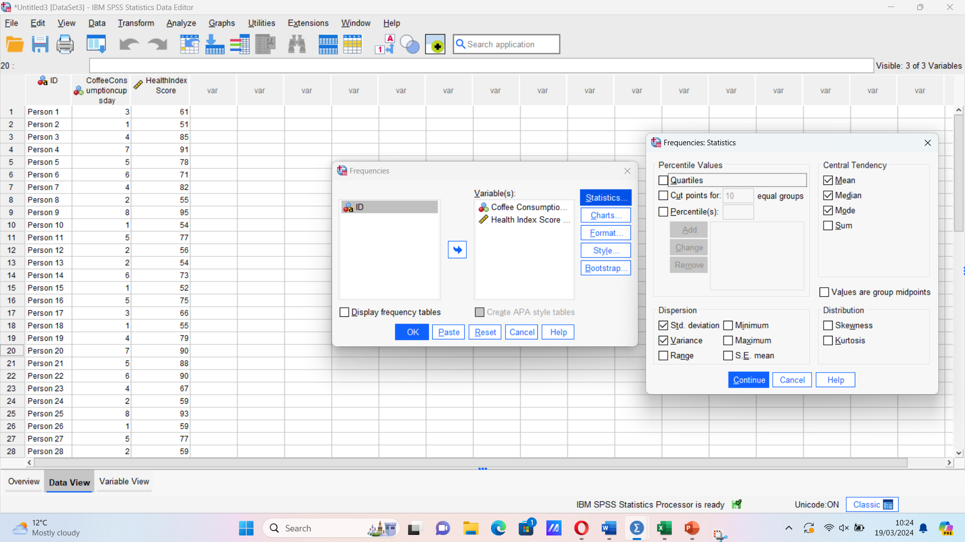

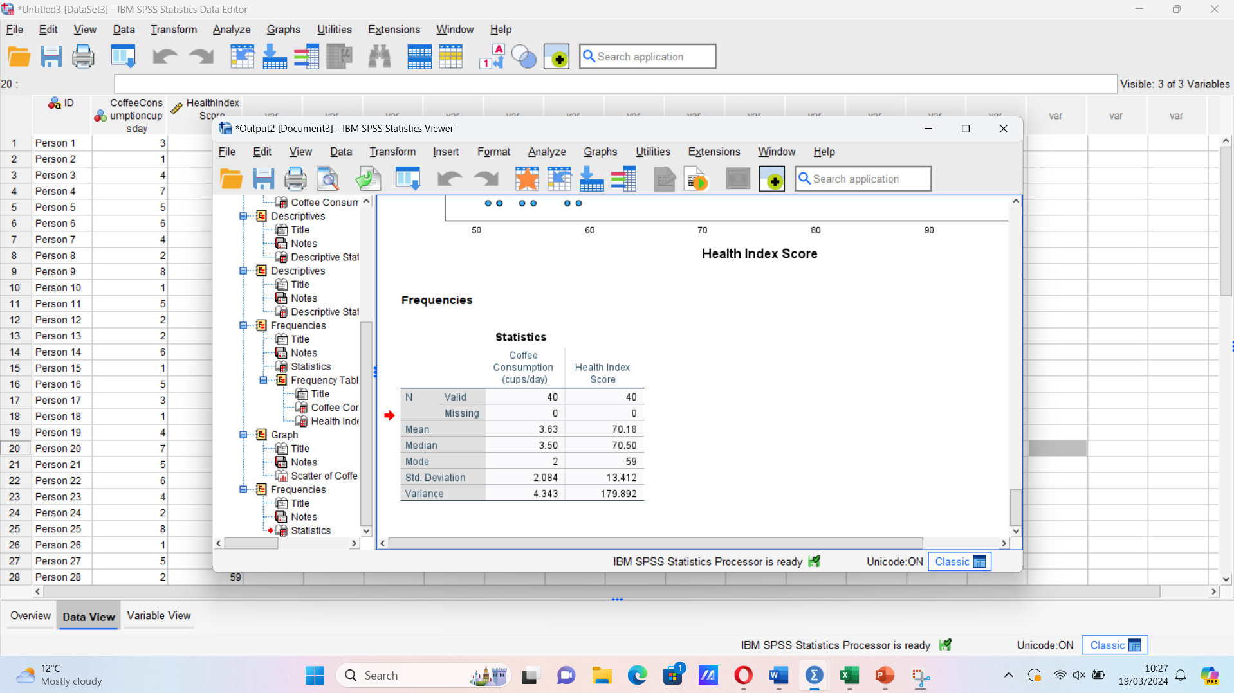

Statistics
 |  | Coffee Consumption (cups/day) | Health Index Score
N | Valid | 40 | 40
N | Missing | 0 | 0
Mean |  | 3.63 | 70.18
Median |  | 3.50 | 70.50
Mode |  | 2 | 59
Std. Deviation |  | 2.084 | 13.412
Variance |  | 4.343 | 179.892

Data spread

Two fundamental mathematical ideas, variance and standard deviation, are crucial to many aspects of the financial industry, including accounting, economics, and investment. Both use the mean of a certain collection of numbers to calculate the variability of figures within a data set. Although they are useful in determining volatility, the two are not the same in and of themselves. The variance is the average of each point deviating from the mean, whereas the standard deviation calculates the variance's square root. A statistical metric called the standard deviation examines how much a set of values deviates from the mean. There is a larger variance in the data if the points are farther apart from the mean. However, the deviation is smaller if they are nearer the mean. (Standard deviation vs. Variance: What’s the difference?, 2015)
The average degree of departure or spread of health index scores from the mean of 70.18 is shown by the standard deviation of 13.412. The standard deviation of 13.412 in this dataset indicates that there is an average variance of 13.412 units between the mean and individual health index values. Given that the standard deviation is higher than the mean, there may be some significant variation or dispersion in the health index values throughout the sample. This may indicate that some people's health index scores are much higher or lower than the average of 70.18. Additionally, a large percentage of the health index values in the sample lie within around one standard deviation of the mean, as indicated by the standard deviation of 13.412. Looking at the effects on the human body, comparing to those with scores above the mean, those whose health index scores are considerably below the mean may be more susceptible to developing specific medical disorders. While people with higher scores may have healthier habits, those with lower scores may participate in less healthful activity. Additionally, those who have a genetic tendency to particular diseases or chronic illnesses may have lower average health index scores.

The statistical metric of variance is a deviation from the average or mean. The total number of values in the data set is divided by the sum of the squares, which is then divided by each value in the data set divided from the mean. To make the discrepancies positive, this method squares them. Variance is a tool used by statisticians to examine the relationships between individual values in a data collection. (Hayes, 2003)
In the given dataset, the average squared variation of coffee consumption from the mean is measured by the variance for coffee consumption, which is equal to 4.343 squared, the square of the standard deviation. Similarly, the variance, or average squared variation of health index scores from the mean, is 179.892 for the health index score. By comparing these figures, we can observe that the variance for coffee consumption (4.343) is much smaller than the variance for the health index score (179.892). As a result, the variance of the variable "Health Index Score" is higher than that of the variable "Coffee Consumption."
This indicates that, in comparison to the variability in coffee intake, there may be more variability or dispersion in the health index scores across the participants in the coffee consumption dataset.

By comparing the values found, it can be seen that the standard deviation for the Health Index Score (13.412) is larger than the standard deviation for Coffee Consumption (2.084). Consequently, the standard deviation of the variable "Health Index Score" is higher than that of the variable "Coffee Consumption."

Since there is less variation in the coffee consumption data (4.343) than there is in the health index score data (179.892), it may be concluded that there is greater variability or dispersion in the data points around the mean. Given that the standard deviation represents the average amount of deviation or spread of data points around the mean, the standard deviation for coffee consumption (2.084) is comparatively smaller than the standard deviation for the health index score (13.412). This could be interpreted as the following: the health index score variable has more variability or dispersion than the coffee intake variable, according to assessments of the variance and standard deviation. This implies that the heterogeneity in coffee drinking patterns among the individuals in the sample may not fully account for the range of health outcomes or illnesses that exist.

1.4 Statistical analysis with Excel

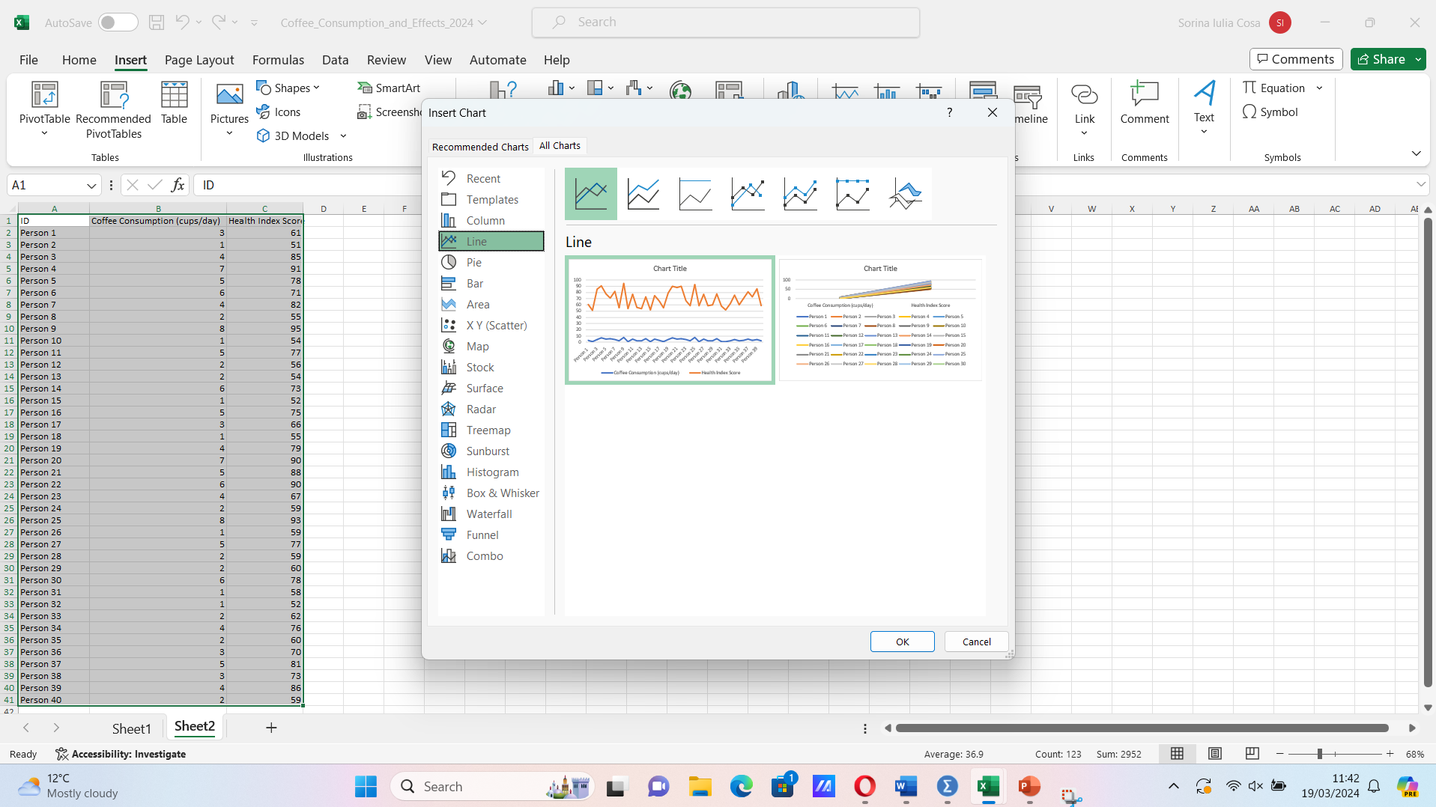
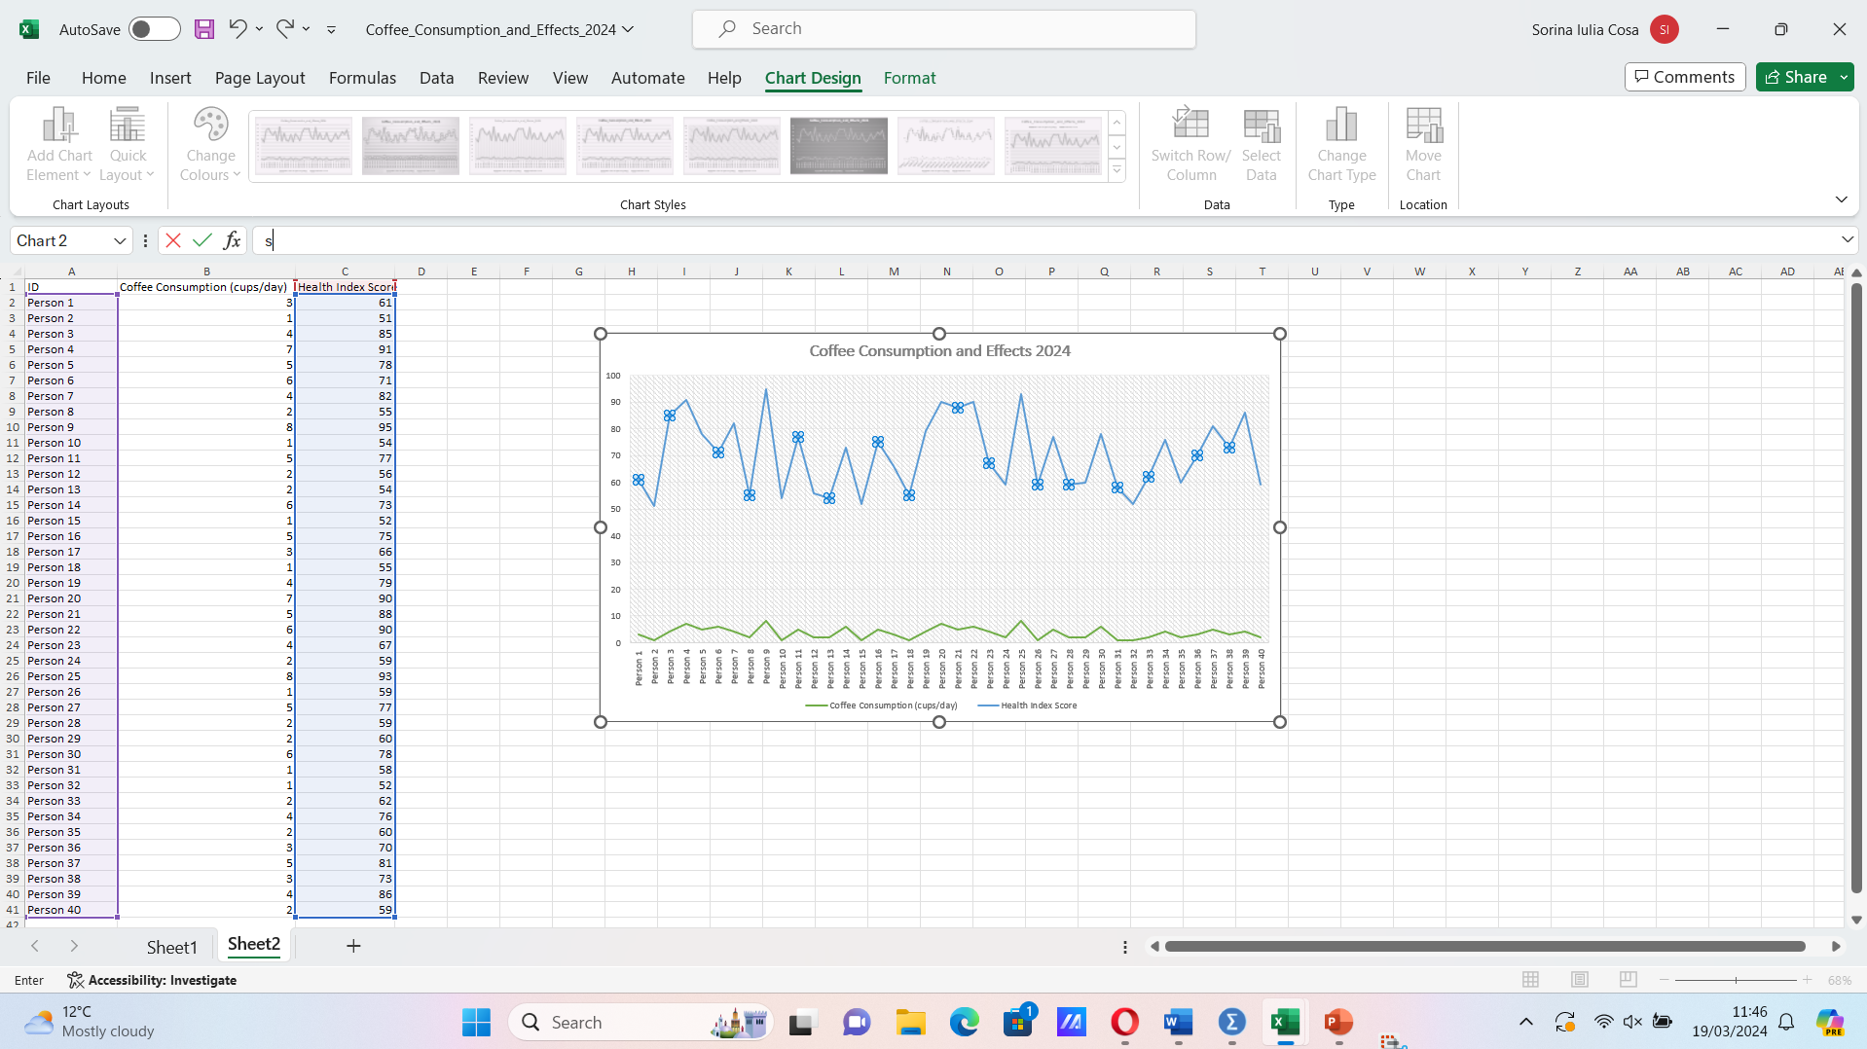

In this line chart created by using Excel, the horizontal axis shows the number of people with their coffee consumption daily and the vertical axis represents their health index score. The presented line chart shows the Coffee Consumption and Effects in 2024 study run on 40 people, and it can be interpreted by checking how many cups of coffee per day each person has drunk and how it affected their health index score. The more coffees per day a person consumed, the more their health index score increased.

The data points show significant fluctuation, suggesting that factors other than coffee consumption probably affect people's health index scores. Variations in lifestyle, nutrition, exercise routines, genetics, and other health-related activities that were not taken into consideration throughout the analysis may be the cause of this heterogeneity. There may be a threshold effect whereby moderate coffee consumption is linked to better health outcomes, while excessive consumption may have detrimental effects, according to the association between coffee consumption and health index scores.

Statistical analysis with SPSS

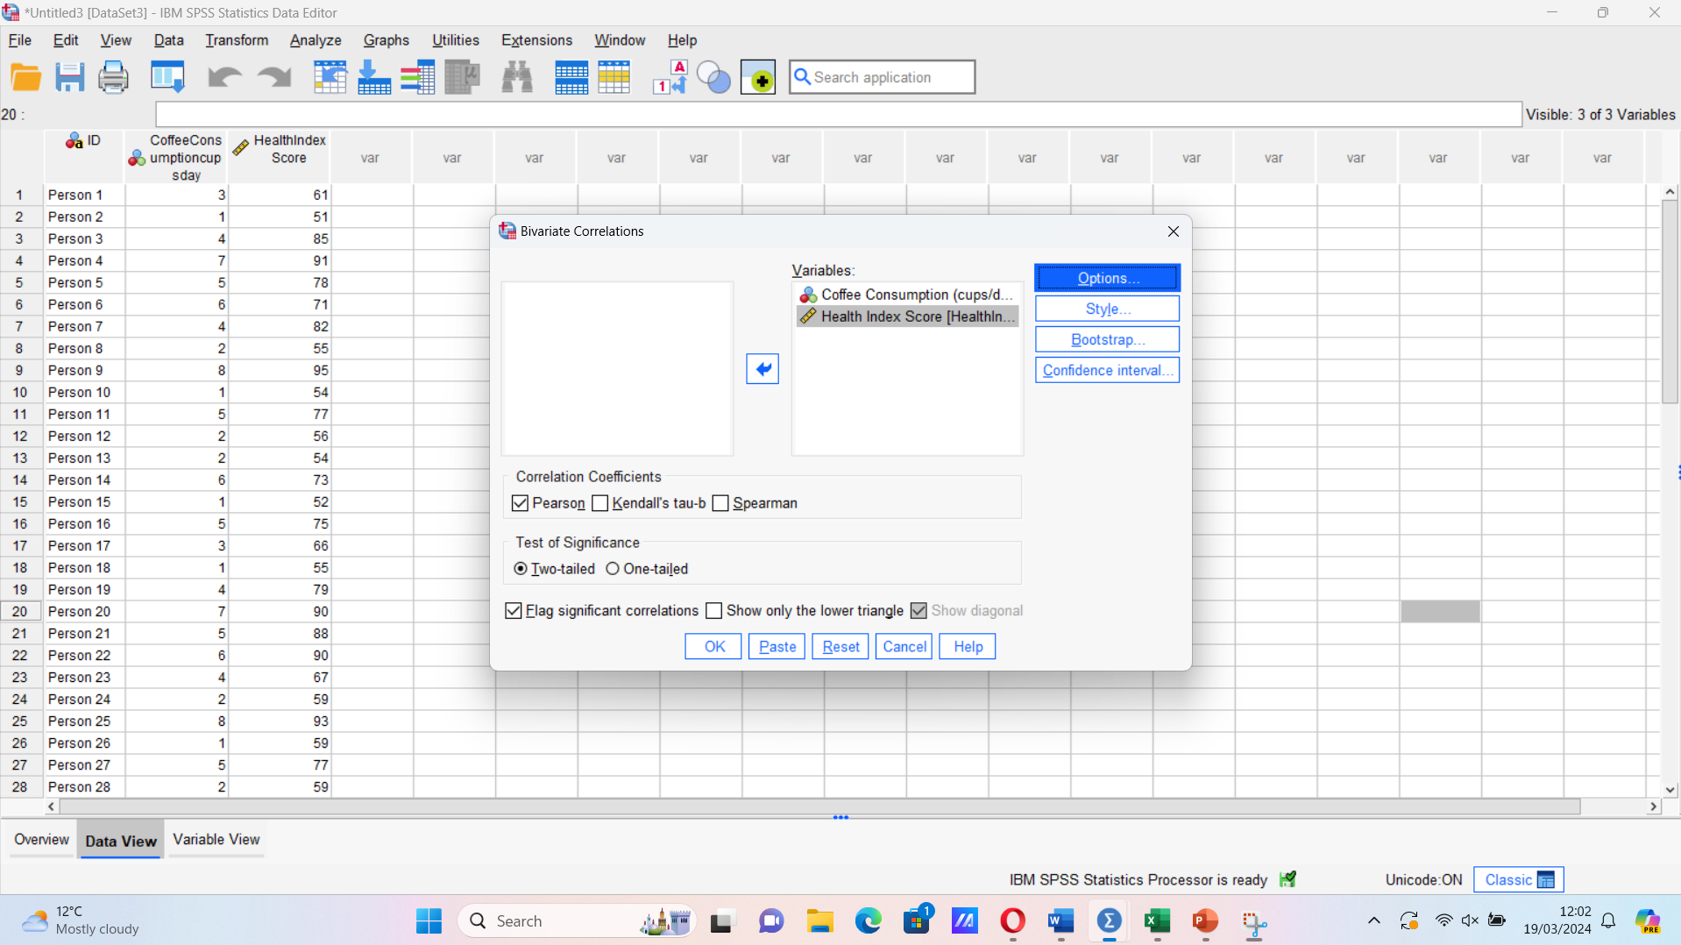
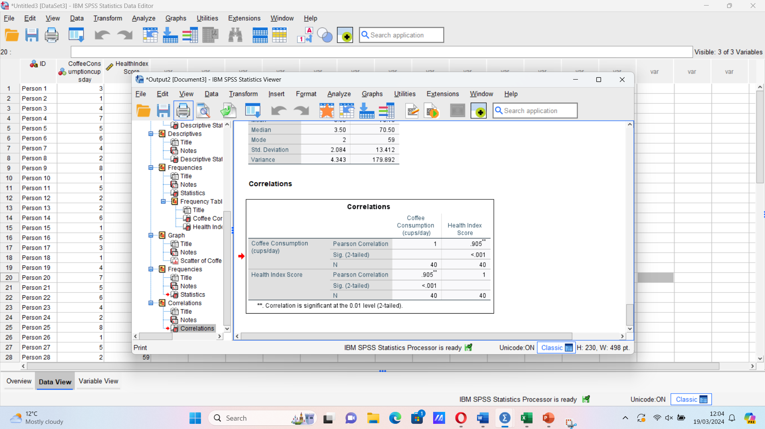

Correlations
 |  | Coffee Consumption (cups/day) | Health Index Score
Coffee Consumption (cups/day) | Pearson Correlation | 1 | .905**
Coffee Consumption (cups/day) | Sig. (2-tailed) |  | <.001
Coffee Consumption (cups/day) | N | 40 | 40
Health Index Score | Pearson Correlation | .905** | 1
Health Index Score | Sig. (2-tailed) | <.001
Health Index Score | N | 40 | 40
**. Correlation is significant at the 0.01 level (2-tailed).

A statistical tool used to indicate the level in which two variables are connected linearly is correlation. It is a common technique for summarizing simple relationships without proving cause and effect. When expressing straightforward links between data, correlations might be helpful. Additionally, scatterplots may be used to identify any unexpected patterns, such as a curvilinear connection or an extreme outlier, that could skew the results and prevent an accurate correlation. (Correlation, 2020)
Using SPSS, the analysis showed that the correlation coefficient between Coffee Consumption (cups/day) and Health Index Score is very high, at 0.905, so it means it is a positive one. The health index score and coffee intake have a very significant positive linear association. Coffee consumption is positively correlated with health index scores; lower health index scores are often associated with decreased coffee consumption.
Given the strong statistical significance of the association found, it is improbable that this link could have developed by accident. The present research indicates a robust correlation between coffee intake and health index score; nevertheless, it does not establish causation between the two variables. In addition, lifestyle choices, genetics, exercise, and food may have an impact on coffee consumption patterns and health effects.

The connection between two continuous variables, x and y, is displayed in a scatter plot. Each variable's values correlate to points on the x- and y-axes, respectively. For every pair of variables, the (x, y) coordinates are marked with a dot or another symbol. There are hints about the relationship between the two variables in the dot pattern. Relationships are displayed using scatter plots. Scatter plots for correlation assist in illuminating the degree of the linear relationship between two variables. (Scatter plot, 2024)

The scatter plot created for the coffee consumption dataset shows a positive correlation in a linear relationship. It is showing that the relationship between the coffee consumption per day in cups and the health index score of a person it is strongly related.

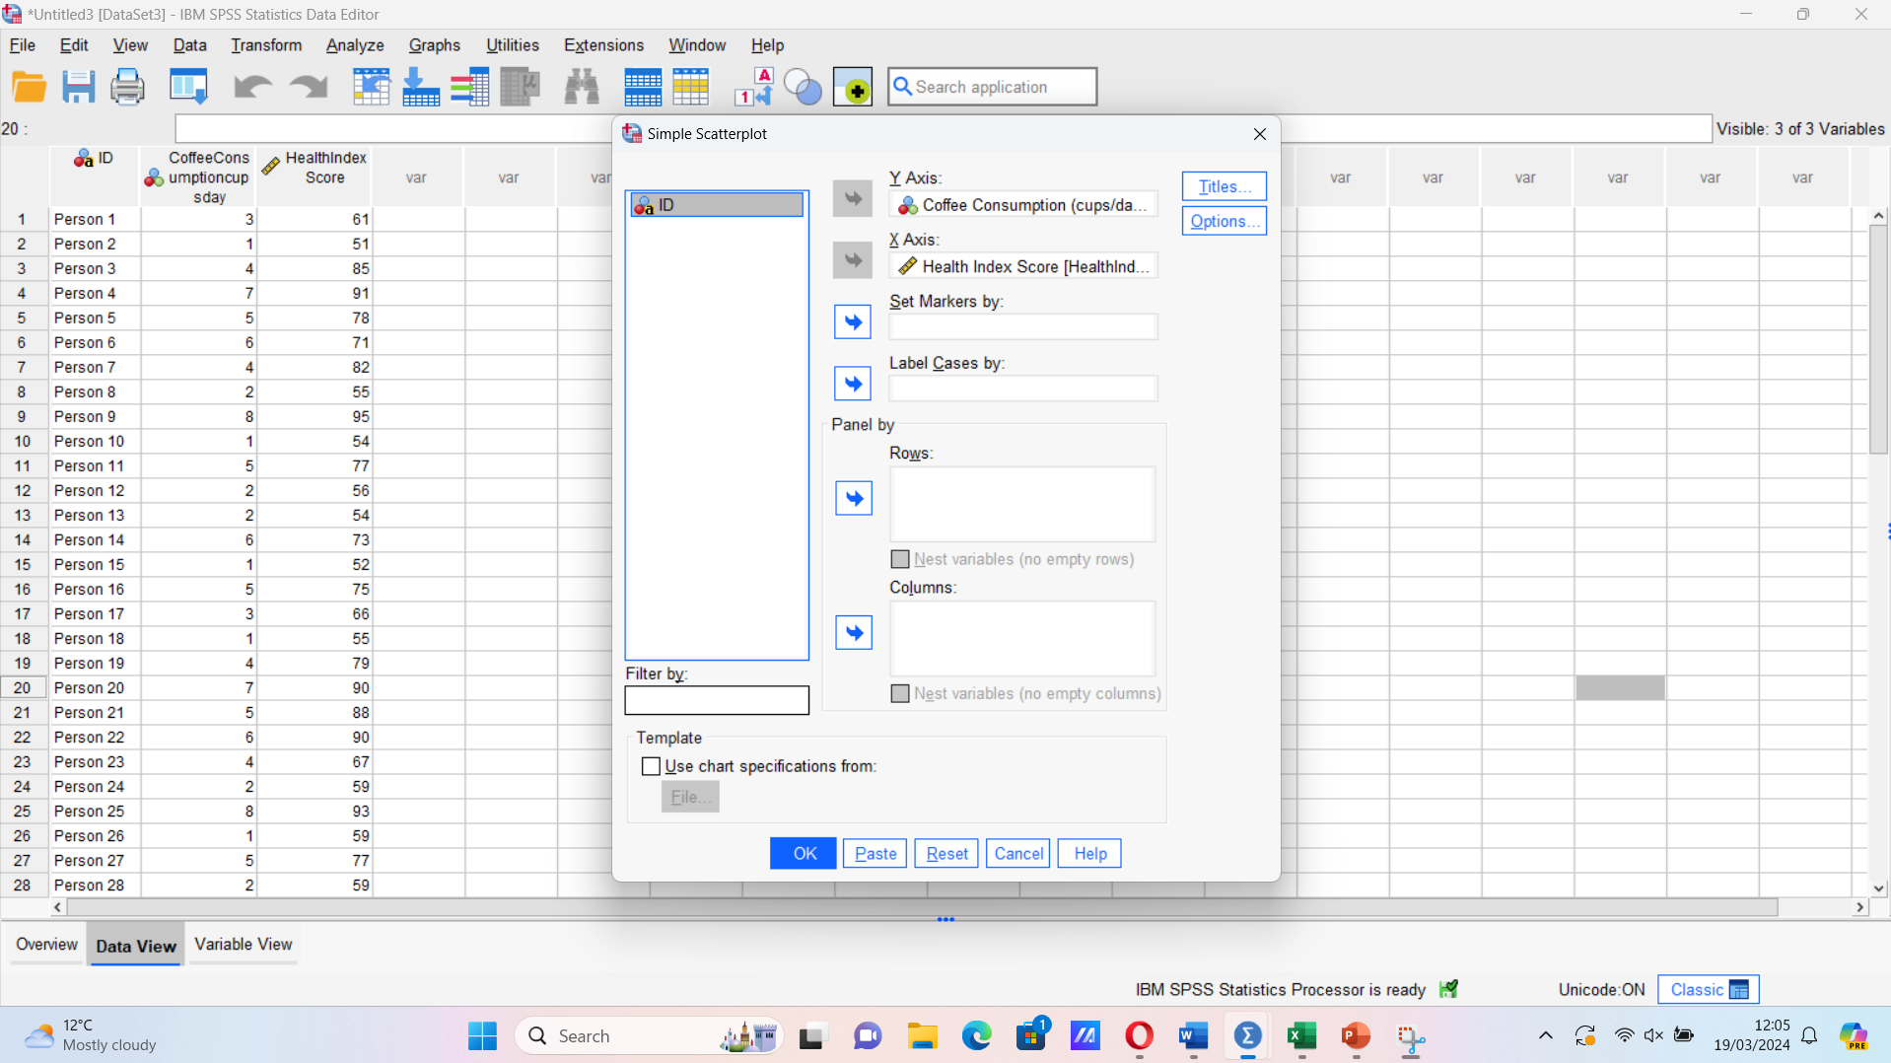
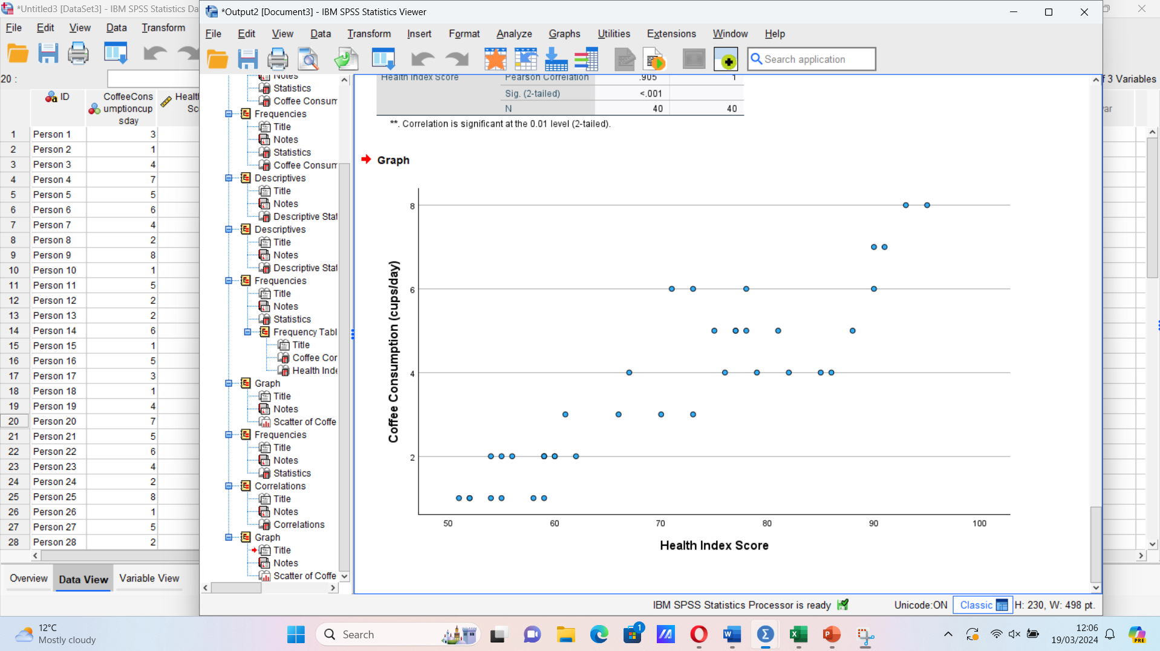

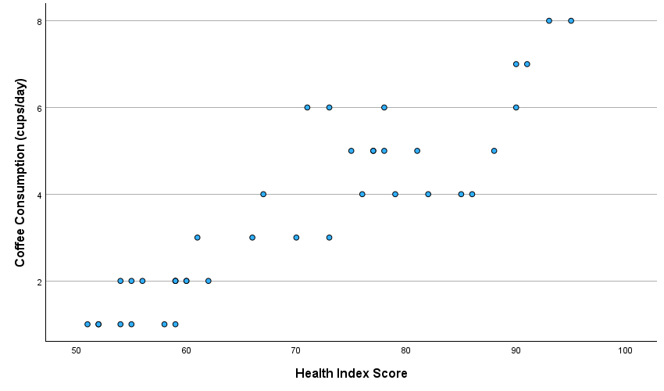

1.6 Conclusion
Analysing the job skills and knowledge needed in the data analyst and business intelligence (BI) analyst job market is vital given the rapid pace of technological advancements and the requirement for IT workers to be up to date with the sector. (Dong and Triche, 2020). As a data analyst, I understood that using the Excel and SPSS I can work with any dataset, and by working with the coffee consumption dataset I helped my company get a detailed analysis of the data, finding the mean, median, mode, standard deviation and the variance, also the line chart, the correlation table and the scatter plot helped in realising that there is a connection between the amount of coffee a person consumes a day and their health index score.

Section 2

2.1 Introduction

Gaining a competitive edge for organizations in today's data-driven world requires them to be able to extract important insights from massive amounts of data. Excel, a powerful spreadsheet software developed by Microsoft, serves as a foundational tool for data analysis and management. Its user-friendly interface and versatile functionalities make it widely adopted across various industries for tasks ranging from simple data organization to complex analysis. (Mehar, 2023)
Alongside Excel, the Data Mining Cycle provides a systematic framework for extracting knowledge and patterns from data to inform decision-making processes. This cycle encompasses several stages, including data collection, preprocessing, modeling, evaluation, and deployment. By integrating Excel with the Data Mining Cycle, organizations can efficiently navigate through these stages to uncover actionable insights and drive strategic initiatives. (Mobasher, 2007)
In this report, we explore the synergy between Excel and the Data Mining Cycle, examining how Excel's features complement each stage of the cycle to streamline the data analysis process. We'll delve into practical examples and best practices to illustrate how businesses can leverage Excel as a powerful tool for data mining and analytics, ultimately enhancing their decision-making capabilities and driving business success.

2.2 Advantages and disadvantages of using Excel

Spreadsheet tools like Microsoft Excel are a component of the Office product group, which also includes business applications. Microsoft Excel is a tool for formatting, organizing, and computing spreadsheets that contain data. By structuring data using tools like Excel, data analysts can make information easier to read as it is added or changed. Excel contains several boxes, sometimes called cells, that are arranged in rows and columns. (Gillis, 2021)
Given that it can conduct the majority of basic analyses, make easily customisable graphs with its Chart Wizard function, and lead the market in its product category, Excel is an obvious choice for a statistics course. Excel can answer both simple and complex equations, just like any other spreadsheet application. (Meehan, 2001)
Between Excel’s advantages there is versatility, usability, customization, data analysis tools and graphical representation. Excel gives users the ability to do a wide range of operations on a single platform, including mathematics, data analysis, graphing, and more. Formulas, functions, pivot tables, and charts are just a few of the effective data analysis tools that Excel offers, facilitating perceptive data interpretation. Users of different skill levels can utilize it because of its intuitive UI. Simple operations are easily learned and put to use. Excel's capabilities can be enhanced by users by customizing it using macros, add-ins, and customizable functions to meet unique needs. Additionally, it provides a number of charting tools that let users see data and make it easier to grasp. (Mehar, 2023)
There are also disadvantages when using excel, such as data loss, as it becomes difficult to keep track of modifications and preserve a single "version of the truth" when numerous people make changes to the same file. Important data can frequently be erased or lost, which might cause serious problems. Although there are many charting and data visualization capabilities available in Excel, they are frequently insufficient for intricate data analysis requirements. For instance, developing dynamic, interactive visualizations required for consumer data analysis could be difficult for a marketing analyst. Excel has a tonne of functions and shortcuts, but it can be difficult to remember them all because of their sheer quantity. For instance, an accountant can be aware that there is a shortcut for a particular task but waste time looking for it. It can be difficult when Excel is rigid when it comes to some areas of data management, such how to handle blank rows when sorting or updating pivot tables. For example, an accountant might have trouble with pivot tables that don't update properly, which results in financial reports that aren't accurate. (Raymond, 2023)

As an example of a business which chose Excel as a main tool for data analysis, Amazon has shown how important Excel is for analysis and data sortation. Amazon uses pivot tables and VLOOKUP formulas often. (Hamada, 2020) In my current Amazon job I am using Excel every day, analysing the data pulled out of one Amazon’s websites and it helps analyse and sort the data in a very effective way which does the job way easier. Excel is also used for documents that we share between shifts and we all work on the same file, and in this way the data can be shared and viewed easily.

2.3 Meaning and importance of Data Mining Cycle

Data mining is the process of extracting information from massive database systems by combining statistical analysis, machine learning, and database management. It gathers, organizes, and saves data for use in a variety of fields, including finance, intelligence, law enforcement, healthcare, logistics, teaching, and process control. Data mining is widely used in marketing, sales, and promotion applications. Data mining help the users by classifying, clustering, predicting, estimating and deviating the data received, helping businesses and not only in their approach to positive outcomes (Thuraisingham, 2000) Data mining is beneficial to many different types of businesses and can be used to boost revenue or decrease expenses in order to boost profits. Several common ways that data mining can achieve those goals include reducing costs during the early stages of product development and research, doing away with costly direct mail campaigns to customers who are unlikely to respond to offers, and enabling mass customization and one-to-one advertising possibilities in the management of customer relationships. (Jackson, 2002)
Microsoft Excel, with its plethora of data analysis features, may be used to undertake multiple data mining techniques, even though there are a number of specialized applications available for data mining. Spreadsheet software like Microsoft Excel is quite common in business and is used for many different purposes, including data mining. Excel offers numerous built-in features for data mining, which makes it a helpful tool for companies looking to glean insightful information from their data. Businesses can use Excel's data analysis features to undertake a variety of data mining techniques, including clustering, regression analysis, and classification. (Jodha, 2023

2.4 Conclusion

Excel is an important tool for data processing, having its advantages and disadvantages. Businesses still chose to use Excel for their data handling, such as Amazon. Large datasets may be imported and analysed more easily in Excel because to its ability to link to external data sources like databases and online services. Additionally, Excel has data visualization features like graphs and charts, which can aid companies in presenting their data in a more clear and meaningful manner. (Jodha, 2023) There is a close relationship between excel and data mining because businesses are gathering the data which they later on use it with Excel’s help.

Section 3 – References
Correlation (2020) Jmp.com. Available at: https://www.jmp.com/en_au/statistics-knowledge-portal/what-is-correlation.html (Accessed: 28 March 2024).
Correlation (2020) Jmp.com. Available at: https://www.jmp.com/en_au/statistics-knowledge-portal/what-is-correlation.html (Accessed: 28 March 2024).
Dong, T. and Triche, J. (2020) “A longitudinal analysis of job skills for entry-level data analysts,” Journal of Information Systems Education. (Accessed: 25 March 2024).
Gillis, A. S. (2021) Excel, Enterprise Desktop. TechTarget. Available at: https://www.techtarget.com/searchenterprisedesktop/definition/Excel (Accessed: March 23, 2024).
Hamada, A. (2020) Working with Amazon data in Excel, Reason Automation. Available at: https://www.reasonautomation.com/content/working-with-amazon-seller-data-in-excel (Accessed: March 23, 2024).
Hayes, A. (2003) What is variance in statistics? Definition, formula, and example, Investopedia. Available at: https://www.investopedia.com/terms/v/variance.asp (Accessed: 28 March 2024).
Jackson, J. (2002) “Data mining; A conceptual overview,” Communications of the Association for Information Systems. (Accessed: 25 March 2024).
Jodha, R. (2023) “Data mining in Excel,” Scaler Topics, 2 June. Available at: https://www.scaler.com/topics/data-mining-tutorial/data-mining-in-excel/ (Accessed: March 24, 2024).
Mean, median, and mode review (article) (no date) Khan Academy. Available at: https://www.khanacademy.org/math/statistics-probability/summarizing-quantitative-data/mean-median-basics/a/mean-median-and-mode-review (Accessed: 28 March 2024).
Meehan, C. B. W. A. (2001) Microsoft ExcelTM as a tool for teaching basic statistics, Sagepub.com. Available at: https://study.sagepub.com/sites/default/files/microsoft_excel_as_a_tool_for_teaching_basic_statistics.pdf (Accessed: March 23, 2024).

Mehar, A. (2023) What are the Advantages and Disadvantages of MS Excel, AlmaBetter. Available at: https://www.almabetter.com/bytes/articles/advantages-and-disadvantages-of-ms-excel (Accessed: March 23, 2024).
Mobasher, B. (2007) “Data mining for web personalization,” in The adaptive web: methods and strategies of web personalization, (Accessed: 23 March 2024).
Raymond, D. (2023) Top 10 cons & disadvantages of using Microsoft Excel, Projectmanagers.net. Available at: https://projectmanagers.net/top-10-cons-disadvantages-of-using-microsoft-excel/ (Accessed: March 23, 2024).
Standard deviation vs. Variance: What’s the difference? (2015) Investopedia. Available at: https://www.investopedia.com/ask/answers/021215/what-difference-between-standard-deviation-and-variance.asp (Accessed: 28 March 2024).
Thuraisingham, B. (2000) A Primer for Understanding and Applying Data Mining. (Accessed: 23 March 2024).
Williams, K. (2022) “What is SPSS? Definition, features, types, and use cases,” SurveySparrow, 25 January. Available at: https://surveysparrow.com/blog/what-is-spss/ (Accessed: March 28, 2024).

