Student name: Saveta-Victoria Stefan
Student number: 2216451
Course name: LCBB4010_BIRM Global Business Environment
Lecturer : Abdi Rahman
Submission date : 17/07/2024

Contents
Introduction 3
P – Political Analysis 3
E – Economical Analysis 4
S - Sociocultural Analysis 4
T - Technology Analysis 5
E - Environmental Analysis 6
L - Legal Analysis 6
Conclusion 7
References 9

Introduction
The general environment has a significant effect on shaping competitive strategies businesses pursue. Even though companies do not have control over what happens in the political, economic, technological, social, environmental, and legal spheres of a country, the resulting forces create opportunities and threats. Consequently, strategic managers react to opportunities to create economic and stakeholder value. The essay paper explains important variables by considering how each component of PESTLE is important. Moreover, the paper contextualises the discussions to determine their impact on businesses. Porter’s Five forces model also explains the forces that helps companies develop strategy for competitive advantage.
PESTLE ANALYSIS – External Business Environment Variables

P – Political Analysis
The political environment is shaped by policies government leaders implement to share the market and, eventually, business strategic choices (Hesterly and Barney, 2014). The political landscape in the UK remains democratic, with a stable governance system that support consistent policies. The MarketLine (2023) UK has effective governance, and political stability and ranks high against Europe average in government integrity with a score of 84.1 (achieved a free country) on political policies to support businesses. UK’s policy on corporate tax covers a standard value-added tax (VAT) of 20% for the majority of goods and services, 5% on a reduced rate for some goods and services including, home energy children car seats, and 0% for zero-rated goods and services for companies that manufacture children’s clothes (Government of UK 2024). Zero-rated and 5% on reduced rate, facilitated the formation of many companies. A similar case with Five Forces model, the threat of entry makes government policies facilitate the formation of companies by removing limitations in the market (Porter, 2008). As a result of this, many companies now have opportunities to increase production and employment rates.
When the UK left the European Union market on 31 December 2020, it succeeded in replacing numerous trade relations. In 2021, the UK formulated 36 UK Free Trade Agreements. Some of the agreements include the EU-UK Trade and the Corporation Agreement (TCA) (Berg, 2024). The new FTAs have facilitated potential cost savings for all industrial exports from the UK. For example, companies that export to New Zealand, Australia, and Malaysia now save 1.7%, 2.6%, and 6.4%, respectively (Loannides, 2023). FTAs with the EU helped create an opportunity for a majority of companies in the UK to export their goods and services. Similarly, free trade attracted many companies to important products from EU markets (UK Government, 2024). As shown in Figure 1 below, many companies adjusted their initial strategies in 2019 in preparation for the UK exit from the EU. Besides, it took almost one year to adapt its strategy to the new trade agreements, leading to increased business exports and imports from 2021 to date.
(Figure 1 - EU trade in goods and services, p.8)

E – Economical Analysis
Major economic factors that affect business operations include the country’s gross domestic product, government debts, economic growth, interest rates and inflation. Figure 2 below shows the UK experienced higher than four interest rates for the period between 1995 – 2009. Many companies passed inflation on buyers whose disposable income was lower already. According to Five Forces model, Porter argues that rivalry among competitors occurs based on pricing because of economic measures such as interest rates, marginal costs, and other fixed costs from the economy. Hence, the recent policy to begin raising interest rates seeks to lower inflation. The policy created an opportunity for many companies to adopt lower cost strategies by lowering the pricing charged to products and services. Consequently, increased demand meant companies with lower capacity devised a strategic choice to recruit move employees to meet the ever-increasing demand.
(Figure 2 - Historical performance of bank rates, p8)

S - Sociocultural Analysis
Hesterly and Barney (2014) define demographics as a general environment that covers the distribution of people in a society defined by their personal attributes like ethnicity, cone, marital status, age, and sex. These factors significantly determine buying behaviour. A firm that understands these factors can easily determine the appeal of its products. The life expectancy is estimated to be 80.42 years with women having more years at 82.68 while men had 78.26 years. Moreover, the ethnic composition of the country has a majority of people as white (87.2%), Black/African/Black British/Caribbean at 3%, Asian/Asian British Indian at 2.3%, while Asian British from Pakistan account for 1.9%. The major religion comprises of Christians (59.5%), Muslims (4.4%), the unspecified accounts for around 7.2%. The UK also has one of the high-quality educational infrastructures and historically continues to attract students who come from across the world.

With an aging population, the country’s population falls within the baby boom generations between over the period between 1946 and 1964. Many of them have adopted the “buy now, pay later attitude towards money. They are yet to save enough for their retirement. While Generation X have been found to be conservative when dealing with finances. They have aggressive behaviours when saving for their future. Businesses that manufacture products targeting Gen X are conscious of spending. Francis and Hoefel (2018) note that Gen Z are first generations with true digital natives. According to Five Forces Model, the power of buyers brings into focus different customers businesses serve. Customers are likely to have higher negotiating leverage in a case where they are few in number, the industry has standardized products, and face few switching costs. Young people in the UK value expression, avoid labels, mobilise for various causes, and believe in dialogue to solve conflicts affecting them (Bazzoni, 2023). Companies are now responding to this move through digital transformation to meet their needs.

T - Technology Analysis

The UK government has formulated policies supporting R&D and property rights funding. The government has shown commitment towards R&D with ambitious funding of over £20 billion annually by the end of 2025. The government seeks to boost that to hit £22 billion in 2030. Such objectives offer solid foundations to drive future innovation (MarketLine, 2023). According to the Five Forces framework, Porter argues that competing firms depend on technology as one of the factors when they want to create competitive advantage. Various forms include tax credits, funding programs, and grants. For example, the R&D Tax Scheme implemented in 2000 remains significant in encouraging businesses to invest in innovation. In 2000, the government invested £61.8 billion in R&D (UK Research and Innovation [UKRI], 2023).
The growth of technology in the UK has contributed towards many businesses adopting digital transformation efforts. The number of businesses on online platforms has more than doubled in the last three years. Consequently, most of the country’s population now use digital platforms whenever they want to buy their products. Statista (2023) states this number will increase with 80% of brick-and-mortar moving to digital platforms to offer innovative products.

E - Environmental Analysis
The 2023 report done by the Climate Change Committee (2023) revealed the successes and failures of the UK government to achieve net zero across many industries. The core polluting industries in the country since 1990 to 2020 include agriculture, building, transport, waste disposal, F-gas, and power. However, the government has succeeded in influencing businesses to progress toward decarbonisation. However, emission reduction depends highly on the changes occurring in each sector. The 2016 Energy Act was formulated to help businesses invest in efficient business operations to reduce carbon emissions (Spragg and Evans, 2017; Climate Change Committee, 2023).
Part of the country’s growth efforts includes the use of natural resources. The UK government works closely with businesses to identify effective practices for achieving Green Growth. For example, a majority of companies operating in the North and South have begun to tape the government assistance to achieve net zero by 2030. Compared to 1990, the government has successfully formulated a carbon budget up to 2016 (Burggraaf, 2023). The government’s policy has also shaped the desire of many businesses to adopt efficient practices.

L - Legal Analysis

The legal analysis for the UK depends on the overall freedom for foreigners and nationals to conduct business in the country. The UK scored 82.7, achieving the status of the most accessible country to conduct business globally. The freedom to do business comes from the formulation and implementation of laws that seek to benefit businesses (Heritage, 2024). This move has helped in attracting many domestic and foreign players to establish businesses in the country. For example, many of the multinational corporations that are located outside of Europe, like to have control of UK operations. The 2024 Index from Heritage Organisation revealed an overall score of 68.6 and a ranking at position 30. This places the country as the freest environment where investors can easily set up a business. The country ranks above the European average (67.2) and a global average of 58.6. Some of the factors that contribute to the freedom of conducting businesses include freedom to invest, financial freedom to access funding from banking institutions, trade, and monetary freedom. The government has tried to eliminate all factors contributing to economic challenges. Porters Five Forces model states governments use laws to ease the rate of market entry and doing business.

Conclusion
The general environment where businesses operate defines opportunities and threats for businesses to thrive. Policies from local and central governments inform the general environment implement policies around economics, trade, technology, social, and legal to shape what companies can do. Similarly, Porter’s Five Forces framework allow businesses to understand the forces that are likely to affect them.

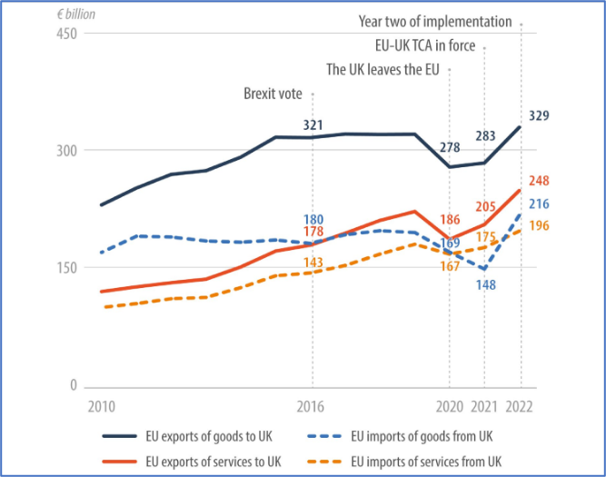
Figure 1: UK – EU trade in goods and services for the period 2010 – 2022
Source: (Loannides, 2023, p. 35)

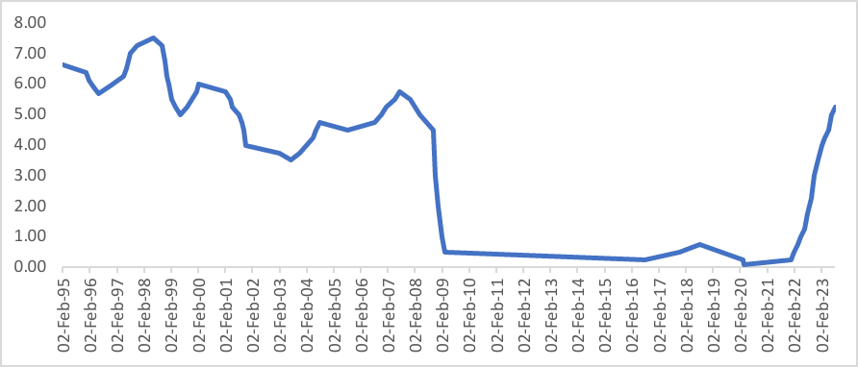
Figure 2: Historical performance of bank rates in the UK for the period between 1995 – 2023

Source: Author analysis

References
Bank of England. 2024. Monetary Policy Report - May 2024. Retrieved from: https://www.bankofengland.co.uk/monetary-policy-report/2024/may-2024#report-may (Date Accessed: 30th June 2024)
Bazzoni, E. 2023. How current events are shaping UK consumer behaviour. Retrieved from: https://www.mckinsey.com/capabilities/growth-marketing-and-sales/our-insights/survey-uk-consumer-sentiment-during-the-coronavirus-crisis (Date Accessed: 31st June 2024)
Berg, A. 2024. Weighted down by gravity: UK trade policy after Brexit. Retrieved from: https://www.cer.eu/sites/default/files/insight_AB_trade_brexit_11.3.2.pdf (Date Accessed: 30th June 2024)
Burggraaf, B. 2023. Empowering businesses to build green futures. Retrieved from: https://business.senedd.wales/documents/s145231/Evidence%20paper%20- %20Net%20Zero%20Industry%20Wales.pdf (Date Accessed: 29th June 2024)
Climate Change Committee. 2023. Progress report: Reducing emissions in Wales. Retrieved from: https://www.theccc.org.uk/wp-content/uploads/2023/06/Progress-Report-Reducing-emissions-in-Wales.pdf(Date Accessed: 28th June 2024)
Government of UK. 2024. Tax on shopping and services. Retrieved from: https://www.gov.uk/tax-on-shopping (Date Accessed: 10th July 2024)
Heritage. 2024. Economic Freedom Country Profile: United Kingdom. Retrieved from: https://www.heritage.org/index/pages/country-pages/united-kingdom (Date Accessed: 10th July 2024)
Hesterly, W. and Barney, J., 2014. Strategic management and competitive advantage. Pearson/Education. Retrieved from: http://teaching.up.edu/BUS580/bps/Barney%20and%20Hesterly,%202008,%20ch3_VRIO%20internal%20analysis.pdf (Date Accessed: 30th June 2024)
Loannides, I. 2023. The EU-UK Trade and Cooperation Agreement two years on: Unpacking early evidence. Retrieved from: EPRS_STU(2023)747433_EN.pdf (europa.eu) (Date Accessed: 14th July 2024)
MarketLine. 2023. Country Profile Series United Kingdom In-depth PESTLE insights. Retrieved from: United Kingdom (UK) In-depth PESTLE Insights - Marketline (Date Accessed: 4th July 2024)
Porter, M.E., 2008. The five competitive forces that shape strategy. Harvard business review, 86(1), p.78. https://www.blueoceanstrategyaustralia.com.au/wp- content/uploads/2023/08/HBRs-10-Must-Reads-on-Strategy.pdf#page=26 (Date accessed 15th July 2024)
Spragg, J., and Evans, S. 2017. The National Assembly for Wales is the democratically elected body that represents the interests of Wales and its people, makes laws for Wales, agrees Welsh taxes, and holds the Welsh Government to account. Retrieved from: https://senedd.wales/Research%20Documents/17-010%20Low%20Carbon%20Energy%20in%20Wales/17-010-Web-English.pdf (Date Accessed: 29th June 2024)
UK Government. 2024. UK trade agreements in effect. Retrieved from: https://www.gov.uk/guidance/uk-trade-agreements-in-effect (Date Accessed: 29th June 2024)
UK Research and Innovation. 2023. Research and development (R&D) support in the UK. Retrieved from: https://www.techuk.org/resource/navigating-the-complex-landscape-of-innovation-finance.html#:~:text=In%202020%20alone%2C%20an%20astounding,diverting%20funds%20towards%20unintended%20recipients
(Date Accessed: 30th June 2024)

