Portfolio



MODULE NAME: Academic Skills for the Digital Era (BMSW4013)
Student Name: DANIELA ESTEFANIA MALDONADO RUIZ
Lecturer Name: Ffion CumberpatcH

I acknowledge the use of Grammarly (https://www.grammarly.com/) to check my work using the prompt(s):
Please check the following text for readability, grammar and syntax.
I confirm that I have not presented any AI generated text as my own work. I confirm I have copies of my drafts, notes, and other resources I used before, and after the use of AI tools which I may be asked to provide in evidence.

Table of Contents
Component 1: Development of Academic Skills 4
1. Evaluating Academic Sources Using the CRAAP Test 4
References 4
2. Synthesis of Academic Sources 5
3. Identifying a Key Challenge and Opportunity 5
4. Academic Planning 5
Component 2: Application of Academic Skills 6
1. Introduction 6
2. Challenges for Students in the Digital Era 7
3. Opportunities in the Digital Era 7
4. How Students Can Adapt to Succeed 8
Strategy 1: Strengthening Digital Literacy and Critical Evaluation 8
Strategy 2: Developing Self-Regulated Learning Skills 8
Strategy 3: Engaging Strategically with AI and Learning Analytics 8
5. Conclusion 9
Component 3: Academic Poster: Communicating Academic Skills 10
Reference List 11

Component 1: Development of Academic Skills

1. Evaluating Academic Sources Using the CRAAP Test
First source: Scheel, Vladova, and Ullrich (2022), found on SpringerLink at the university library. Currency's new piece examines how digital higher education has altered since the pandemic. Relevance: It uses the Technology Acceptance Model to analyse college students' digital learning acceptance, making it a great tool for higher education research. Authors from the University of Potsdam publish Authority in the peer-reviewed International Journal of Educational Technology in Higher Education. For accuracy, the study used regression analysis, verified measurement scales, and reliability tests, demonstrating a clear and logical approach. The Purpose uses research and analysis to provide real-world evidence rather than promote an agenda. This improves objectivity.
Suntharalingam (2024) was found in an open-access magazine by Google Scholar. Currency is a new notion that explores AI's usage in digital learning. It examines how AI-driven platforms, intelligent teaching systems, and adaptive learning effect learning. Authority doesn't have as good an academic image as other educational technology magazines. On accuracy, the article cites well-known researchers but lacks systematic review methodological transparency. It informs and explores, understanding ethics and implementation challenges, in a balanced discourse.

References
Al-Azawei, A., Parslow, P., & Lundqvist, K. (2017). Investigating the effect of learning styles in a blended e-learning system: An extension of the Technology Acceptance Model (TAM). Australasian Journal of Educational Technology, 33(2), 1–23. https://doi.org/10.14742/ajet.2741
Scheel, L., Vladova, G., & Ullrich, A. (2022). The influence of digital competences, self-organization, and independent learning abilities on students’ acceptance of digital learning. International Journal of Educational Technology in Higher Education, 19(44). https://doi.org/10.1186/s41239-022-00350-w

2. Synthesis of Academic Sources
Both studies focus on how student categories affect higher education digital learning. Scheel et al. (2022) claim students' digital skills, ability to manage their own learning, and willingness to learn independently all affect their digital learning acceptance. Their findings suggest that implementation depends on students' attitudes and abilities as much as technology. Suntharalingam (2024) also discusses how adaptive learning systems and intelligent teaching technologies might make students more engaged and learn better using AI. Scheel et al. (2022) discuss how internal learning affects technology acceptance. However, Suntharalingam (2024) discusses how new technology can boost performance. Overall, the research suggest that technology and human factors affect digital learning efficiency. Combining these perspectives shows that digital education must link student skills with modern instructional technology to survive, not merely technological improvement.

3. Identifying a Key Challenge and Opportunity
One major issue that both studies revealed is that pupils' computing skills and self-control vary. Scheele et al. (2022) indicate that poor digital abilities and organisation can make digital learning tools less accepted and useful. According to Suntharalingam (2024), AI-enhanced systems have great potential but may fail due to technological challenges and unprepared students.
Modern technologies' ability to personalise learning is a tremendous chance. According to Suntharalingam (2024), adaptive learning systems may customise lessons for each learner. Strong learner competences can improve digital learning and academic performance, according to Scheel et al. (2022).
4. Academic Planning
The discussion part will be given extra attention because it lets us think deeply about how student skills and AI technologies affect how well digital learning works. The Technology Acceptance Model, digital competences, self-regulated learning, and AI-driven adaptive systems are some important scholarly ideas that need more work. These will be compared using the sources that were chosen. The report will have a clear structure: an introduction and study focus, an analysis of the literature, a critical discussion of challenges and opportunities, and a conclusion. Before writing the first
draft, research will be done. The draft will then be revised and edited one last time.

Task | Date / Deadline
Finish research | 25 February
Draft first section | 27 February
Complete first draft | 2 March
Final editing | 4 March

Component 2: Application of Academic Skills

1. Introduction
Online tools, artificial intelligence (AI), and learning analytics systems have made digital learning an important part of modern higher education. Digital tools are being used more and more by universities to make learning more flexible, accessible, and individualised. But studies show that using technology does not promise success in school by itself (Scheel, Vladova, and Ullrich, 2022). Instead, how well students learn depends on how technological systems work with their academic skills, especially their ability to use technology well and learn on their own. Because of this, it is important for students to understand both the pros and cons of digital education. This report looks at the main problems students face in the digital age, the chances that digital and AI technologies offer, suggests ways to adapt based on data, and shows that academic skills are still very important in higher education.

2. Challenges for Students in the Digital Era
One major challenge in the digital era is the uneven level of digital competence among students. Scheel, Vladova and Ullrich (2022) show that digital competences, including information literacy, communication skills and problem-solving, significantly influence how students accept and use digital learning tools. Students who lack these skills may struggle to navigate online platforms, evaluate sources critically, or complete digital tasks effectively. Tinmaz (2022) further argues that digital literacy education remains inconsistent across institutions, leading to differences in student preparedness. Limited digital competence can reduce confidence and negatively affect academic performance.
A second challenge relates to the demands of self-regulated learning. Digital environments require students to manage their own learning with reduced supervision. Zimmerman (2002) defines self-regulated learning as the ability to plan, monitor and reflect on learning processes. Lan, Liu and Pan (2025) highlight the strong link between digital skills and self-regulation in higher education. Students with weak self-regulation may show lower engagement and achievement. Additionally, technology acceptance depends on perceived usefulness and ease of use (Davis, 1989), meaning complex systems can discourage student participation.

3. Opportunities in the Digital Era
Despite these challenges, digital learning provides significant opportunities. One key opportunity is personalisation through AI-driven adaptive systems. Suntharalingam (2024) explains that intelligent tutoring systems and adaptive platforms adjust content according to student performance, offering targeted feedback and individualised learning pathways. These systems can increase engagement and support deeper understanding.
Learning analytics also offer data-driven opportunities for improvement. Siemens and Gasevic (2017) show that analysing patterns in student behaviour and performance can inform better academic decisions. When students engage meaningfully with feedback, these tools can enhance metacognitive awareness.
Scheel, Vladova and Ullrich (2022) found that students with strong digital competences and self-organisation skills are more likely to accept digital learning technologies. Similarly, Vladova et al. (2021) demonstrate that perceived flexibility and usefulness improve adaptation. However, outcomes are influenced by user characteristics and contextual factors (Šumak, Heričko and Pušnik, 2011). Therefore, technology acts as an enabler, with effectiveness depending on students’ academic skills.

4. How Students Can Adapt to Succeed
Students must match their academic skills to technology to succeed in the digital age. Three tactics are crucial.

Strategy 1: Strengthening Digital Literacy and Critical Evaluation
Learn how to analyse information and use digital sources appropriately to improve digital literacy. Digital literacy frameworks give kids online learning skills, according to Tinmaz (2022). According to Scheel, Vladova, and Ullrich (2022), information understanding makes consumers assume digital systems are easier to operate. Structured review approaches improve academic judgement and reduce misinformation. This method targets technology complexity.

Strategy 2: Developing Self-Regulated Learning Skills
Students must manage their time and operate independently in digital contexts. Self-regulated learning involves planning, goal-setting, and reflection, according to Zimmerman (2002). Lan, Liu, and Pan (2025) show that technology-enabled self-regulated learning improves school performance. Structured study schedules, goals, and feedback promote student performance and engagement. Stronger self-regulation makes items seem more helpful and easy to use (Davis, 1989), boosting desire.

Strategy 3: Engaging Strategically with AI and Learning Analytics
Use AI tools instead of inactivity. Suntharalingam (2024) states that adaptive systems personalise courses based on user connection. Siemens and Gasevic (2017) argue critical analytics can help individuals think about and improve things. AI technologies become metacognitive supports when students analyse their success dashboards, identify areas for improvement, and adjust their study habits. Research indicates that consumers are more likely to adopt new technologies if they perceive them as useful and simple to use (Šumak, Heričko, and Pušnik, 2011). Strategic interaction maximises technology.
These tactics educate digital skills, assist people govern their digital use, and help them choose the best ways to use technology to solve issues and take advantage of digital opportunities.

5. Conclusion
Digital learning presents huge challenges and opportunities in higher education. Online platforms might be difficult to utilise due to digital literacy and self-regulated learning (Scheel, Vladova, and Ullrich, 2022; Lan, Liu, and Pan, 2021). Adaptive systems and learning analytics can improve school achievement and customisation when utilised strategically (Suntharalingam, 2024; Siemens and Gasevic, 2017). According to the study, technological advancement does not ensure success. Instead, long-term success requires intellectual abilities like using technology well, critically evaluating ideas, managing time, and knowing how you think. These abilities prepare students to handle technology's complexity and employ new tools to succeed in school. Academic skills are still crucial for college success today.

Component 3: Academic Poster: Communicating Academic Skills

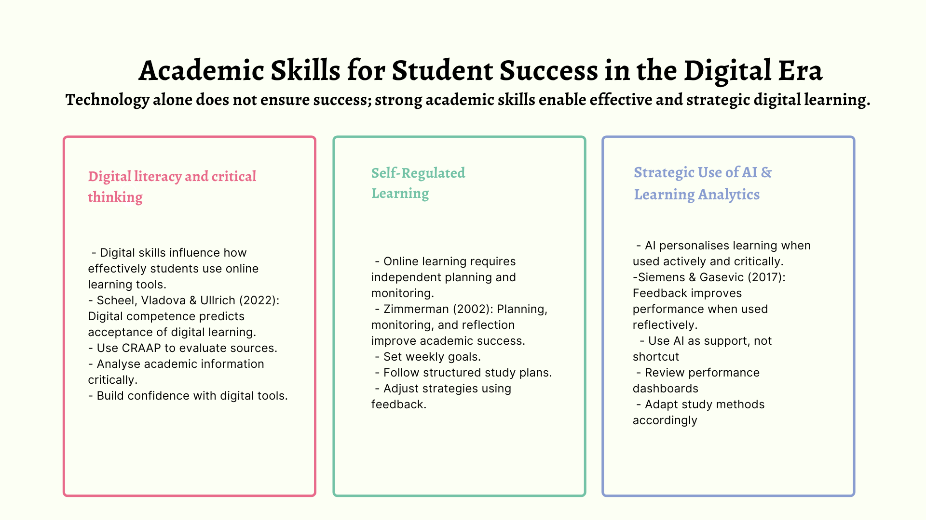

WORD COUNT: 1518

Reference List
- Al-Azawei, A., Parslow, P. and Lundqvist, K. (2017) ‘Investigating the effect of learning styles in a blended e-learning system: An extension of the Technology Acceptance Model (TAM)’, Australasian Journal of Educational Technology, 33(2), pp. 1–23.
- Davis, F.D. (1989) ‘Perceived usefulness, perceived ease of use, and user acceptance of information technology’, MIS Quarterly, 13(3), pp. 319–340.
- Lan, M., Liu, H. and Pan, Q. (2025) ‘Unpacking the digital literacy–self-regulated learning nexus: A systematic review and meta-analysis’, Educational Research Review, 48, 100713.
- Scheel, L., Vladova, G. and Ullrich, A. (2022) ‘The influence of digital competences, self-organization, and independent learning abilities on students’ acceptance of digital learning’, International Journal of Educational Technology in Higher Education, 19(44).
- Siemens, G. and Gasevic, D. (2017) ‘Learning analytics and educational data mining: Towards communication and collaboration’, Proceedings of the 7th International Learning Analytics & Knowledge Conference, pp. 1–5.
- Suntharalingam, H. (2024) ‘Enhancing digital learning outcomes through the application of artificial intelligence: A comprehensive review’, International Journal of Innovative Science and Research Technology, 9(4), pp. 718–723.
- Šumak, B., Heričko, M. and Pušnik, M. (2011) ‘A meta-analysis of e-learning technology acceptance: The role of user types and e-learning technology types’, Computers in Human Behavior, 27(6), pp. 2067–2077.
- Tinmaz, H. (2022) ‘Digital literacy frameworks and models: A systematic review’, PLoS ONE, 17(3), e0265329.
- Vladova, G., Ullrich, A., Bender, B. and Gronau, N. (2021) ‘Students’ acceptance of technology-mediated teaching – How it was influenced during the COVID-19 pandemic’, Computers in Human Behavior Reports, 3, 100056.
- Zimmerman, B.J. (2002) ‘Becoming a self-regulated learner: An overview’, Theory Into Practice, 41(2), pp. 64–70.

