University of Wales Trinity Saint David
School of Engineering

Six Sigma Principles for Process Improvement
Quality & Business Improvement
ACMA4004

Adam Dolloway
2312274
20/05/2024

Table of Contents
1 Introduction 3
1.1 Aims 3
1.2 Objectives 3
2 Main Body 4
3 Conclusions 12
4 References 13
2-1 Image of Pareto chart example from (ASQ, 2024).............................................7
2-2 Example of a Histogram from (Dequeant, et al., 2016)......................................8
2-3 Example of a FMEA Chart from (ASQ, 2024)......................................................9

Introduction
This report will focus to improve the defect rates as well as the quality in the manufacturing processes within the company PESC. The high defect rates reported suggest a lack of knowledge in quality tools, whilst suggesting no continuous improvement initiatives within the company. This report will give vital information along with a better understanding of the six-sigma set of methodologies and tools, which when applied to manufacturing processes minimise defect rates, lowers costs and increases efficiency. The quality tool this report will focus on is the DMAIC tool, this is highly effective when finding root causes of defects within processes as well as other quality tools such as FMEA and pareto charts, which will be discussed further within the literature review section and the methodology section.

Aims
The aim of this report is to improve the overall quality in the manufacturing processes of the company PESC by suggesting the implementations of the six-sigma tool DMAIC. Which in turn will improve the manufacturing processes under inspection.

Objectives
- Research Six Sigma methodologies and tools.
- Suggest Six Sigma tools to be implemented.
- Give examples of the quality tools suggested.
- Support the Six Sigma tools with references.
- Demonstrate DMAIC quality tool and show benefits with countering points.

Main Body
In this section of the report the quality tool DMAIC taken from the six-sigma framework and other tools will be broken down step by step throughout the corresponding subjects to give PESC a clear understanding of the quality tools uses and benefits to mitigate the defective component rates.

Whilst investigating the issue causing defective components within the manufacturing processes under inspection it is detrimental to clearly define the problem statements, this is due to the possibility of incorrect measures being implemented whilst also targeting the incorrect root cause at hand. In my opinion the problem statement is the most essential step within this activity this is supported by (Dusim, 2021) who states that a the problem statements gives vital information to the reader about the process and the issues in question and defines the point of the research clearly, this section of the process falls under the D in the quality tool DMIAC, the D in this quality tool relates to the define phase, (Mittal , et al., 2023) states that there are three factors to each defining phase which is identifying the root cause, determine project objective along with defining the customers requirements. To complete this task of identifying the defects this report would suggest using a root cause analysis tool such as a FMEA chart, or the Ishikawa diagram, the reasoning behind the use of these tools are they are all highly visual and easily understandable, whilst being effective in finding the main issue causing the defective components. A pareto chart can also be used to identify the root cause of a defect although its greatest strength is the prioritisation of the defects. To support this statement (Barsalou, 2023) states that the Pareto chart is greater used as a prioritisation tool than a root cause analysis tool.

Once the problem statement is complete the company must move onto the next step in the DMAIC process. In my opinion the ways to gather information and metrics on the current state of the manufacturing process is to observe the process in question and keep track of the type of defect and occurrence, to gather information whilst adopting the Six Sigma mindset within the working environment it is suggested to implement the following data gathering techniques, such as the Gemba Walk, Bottleneck Analysis. The Gemba technique is beneficial to the company whilst gathering data simply because this technique encourages a walk with the product from start to finish to increase the level of knowledge of the processes whilst stating the company should converse with machine operators to learn the real issues that happen whilst manufacturing. To further support this statement of the benefits of Gemba walks (Mičieta, et al., 2021) “Benefits for the selected company are for example increasing the efficiency of work in the cutting room department in the company, minimization of the use of storage means, improving cooperation between picking and shearing, acceleration of the production process and reducing the risk of accidents at work and health problems”. Another tool used to measure manufacturing processes is the Bottleneck Analysis technique which advises that the process is only as strong as its weakest link, by carrying this technique out it will give the information of the weakest manufacturing step within the company which will then allow the company to mitigate that weakness therefore strengthening the processes in question. Although this techniques benefits seem detrimental the main issue of this tool is its constant application ability, meaning that the bottle neck analysis tool will always be applicable to the working environment since there will always be a weakest process whilst manufacturing components, this can cause a constant improvement to a process which is a good benefit, although this suggest that with every implementation the improvements will become larger and larger furthermore it will be harder to implement, causing machine down time and a stop to production. (Westrom, 2021) suggests that “A bottleneck analysis is an important process in manufacturing that can help remove or mitigate production holdups, drive efficiency, and improve overall equipment effectiveness (OEE).”. This will allow the company to create a root cause analysis tool to help narrow the issue down to a single cause. This section of the main body also falls within the DMAIC quality tool, in this case it corresponds with the M of DMAIC meaning measure, the importance of this step in the DMAIC framework is ensuring that the process is being measured and controlled correctly, also when the results are concluded it will show the level of variation within the process outputs, therefore leaving the opportunity to reduce variation in the process and decrease the risk of a variation falling into a defect. (Lean Manufacturing Implementation through DMAIC Approach: A Case Study in the Automotive Industry, 2021) states that the measuring process of the DMAIC framework should be used to measure the overall performance of the process by generating an evaluating system for the process whilst also gaining a deeper understanding of the process. This will help the company measure and asses the current state of the manufacturing process.

To analyse the data that was recorded in the last segment of the framework, quality analysis tools are by far the most effective, these can be found within the six-sigma framework or the lean manufacturing frameworks, in this case this refers to the A in the six sigma tool DMAIC which has been used throughout this report, the A section of the DMAIC tool refers to the analyse stage (MSI, 2024) states that “the Analyse stage takes a deeper dive into the data to uncover the underlying causes of issues.”. The previous examples used within this process improvement initiative are also suitable to analyse the data collected, an example of the tools that can be used are Pareto chart as mentioned previously, this will prioritise the defects within a process to give the company the most effective outcome. Another tool which is suitable for the task at hand is the 5 whys system, you may ask what the 5 whys technique is and how can it resolve the companies issues. The 5 whys technique is a root cause analysis technique which will assist the company in understanding the reasons for the poor process statistics, it is used by the user asking why to the questions on why the processes are failing to comply with quality standards. Although it is a common misconception that the question “why” can only be asked five times within this technique this is untrue as the user should ask the question “why” until a clear root cause is identified. To support the previous statements on the 5 whys technique (University, 2024) states that “A series of why questions can unearth root causes, rather than wasting a team’s time dealing with symptoms of the problem”. Another technique used within manufacturing to analyse data to identify root causes of defects or discrepancies and bottlenecks of production are histograms. Histograms are used to organise the data found and identify a pattern within the data. This will allow the company to visually identify where and when the processes under inspection are performing less productively and when the processes are outputting the highest level of defective components. (Editor, 2017) states that the histogram tool is a highly visual tool that can enable a team to quickly identify patterns that are unusual within the data set. In my opinion the tools mentioned in this analysis phase of the DMAIC framework are highly effective, although the FMEA quality tool is in my opinion more difficult and time consuming to complete it has the highest benefit rate whilst identifying root causes, this is due to its in depth layout which is highly visual allowing users to read with ease whilst giving the chosen problems overall scores on categories such as severity, occurrence and detection, which will assist the company in defining the main issues or the defects and how to prevent them. (Sharma & Srivastava, 2018) states that “FMEA is a systematic method of identifying and preventing system, product and process problems before they occur.”, although this report disagrees with its suggested use singularly for “problems before they occur” this report does agree with this statement and therefore this quote supports the previous opinions.
The following attachments are examples of a Pareto Chart, 5 whys technique, Histogram and FMEA Chart.
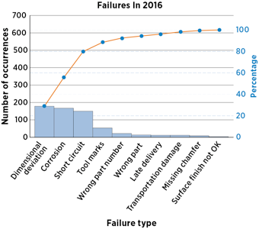

Image of Pareto chart example from (ASQ, 2024)

5 whys technique example: This example will show the basic use of this technique, this example depicts components burning after being finish ground.
Problem: Component is burning whilst being finish ground to size.
1st why? – Why is the component burning?
Answer – The product could be burning due to a lack of coolant during grinding operations.
2nd why? – Why isn’t the coolant cooling the component during operation?
Answer – It’s possible the concentration of the coolant is to weak or strong.
3RD why? – Why does the coolant not correspond with the recommended concentration values?
Answer – This could be due to lack of routine checks and a lack in maintenance.
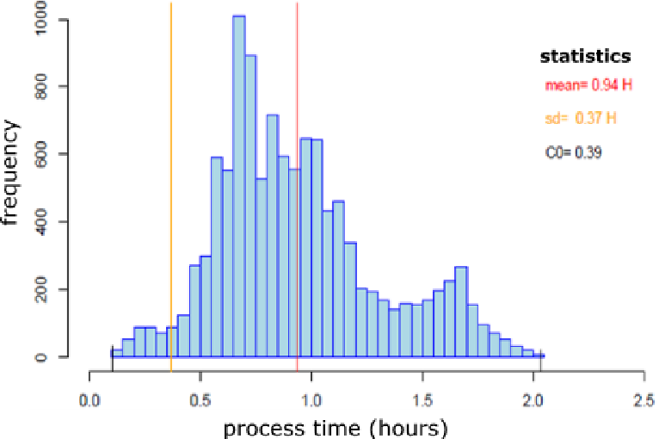

Example of a Histogram from (Dequeant, et al., 2016).
This histogram shows the time spent on manufacturing a product with a peak of components taking from 0.5 hours to 1 hour to machine to completion.

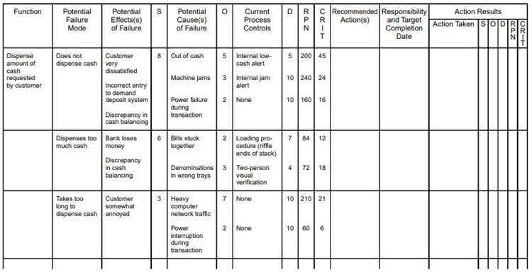
Example of a FMEA Chart from (ASQ, 2024).
This FMEA Chart depicts the potential failures of an ATM machine, although the recommended actions and foreword have not been completed this section of the chart is where the company will have recommended actions to mitigate the defects.

The improvement strategies that which will be suggested to be implemented within the company PESC and will make a positive impact on the production and manufacturing operations are all six sigma and lean methodology quality tools that were developed to track and improve operations whilst also corresponding with the DMAIC methodology used in this report. In this segment of the report the I in DMAIC is used meaning improve, this is used to implement quality tools to improve the quality, efficiency along with productivity of the manufacturing processes. These tools include the Kanban system, the Kaizen technique also including the 5S system. The Kanban system is a technique that allows cards or tickets to indicate when a machine or process has run out of material or when the component can be moved on through the shop floor, this can be an electronic or manual system. By the implementation of the Kanban system within manufacturing the company should see an increase in productivity and efficiency, whilst reducing wasted which would be classed as any non-value adding procedure. (Rahman N. A. A., 2013) states that the Kanban system is a minimal inventory and reduced cost lean manufacturing tool, this suggests that the implementation of this system is a low-cost improvement and can be implemented with little spare inventory. The Kaizen technique is a technique used within manufacturing to reduce the idle times of processes, reduce the non-value adding activities and to eliminate over production whilst improving the quality and efficiency. This is due to the kaizen technique being purposely for continuous improvement (Daniel, 2021) suggests that “Kaizen is based on the belief that everything can be improved, and nothing is the status quo.” This quote suggests that the Kaizen mindsets aim is to improve all processes no matter the size of the changes made all improvements are welcomed. The 5S system is a waste reduction system, meaning all non-value adding activities should be reduced after implementation whilst also having a more organized and clean working environment. (EPA, 2016) identifies the meaning behind the 5s system with this quote “The 5S pillars, Sort (Seiri), Set in Order (Seiton), Shine (Seiso), Standardize (Seiketsu), and Sustain (Shitsuke), provide a methodology for organizing, cleaning, developing, and sustaining a productive work environment.” This strategy would cause the working environment to become more organised workplace which will therefore create an improved, smooth, and efficient flow through each process. All techniques above aim to reduce waste in different ways, each quality tool will reduce the risks of defects by creating a continuously improved working environment, with the implementation of the organisation and orderliness of the working environment opportunities for improvement will rise.

The next step to this improvement strategy would be the C in the DMAIC framework, this represents the control section of the framework which is used to track and uphold the improvements implemented. The control measures this report recommends to the company PESC are the cost to benefit technique, this technique will help calculate the length of time an improvement implementation will take to start creating profit, however this tool is heavily circumstantial due to the issue an improvement which has been installed into the manufacturing process might not have cost any money to buy or install, but on the other hand the production downtime that was caused by the installations could be considered a loss of capital, this could replace the buying and installation price whilst calculating cost to benefit ratios. To monitor the implements made it would be suggested to use a scatterplot diagram, this will give the company the information on the deviation of the performance of the new installations or can give the company a good visualisation of the reaction of the product to the changes made. (Harvin, 2024) state that the main objective of a scatter plot is to visualise and establish a relationship between two defects. Whilst the previous tools spoke of monitoring and strategizing, this next tool will focus on maintaining the quality of the improvements, this tool is a control chart. A control chart relays the information of a process and identifies whether the process is meeting the needs demanded, such as deadlines or customer requirements. The benefit of using this type of chart is it will be easily to visually identify whether the process or processes in question have changed over time. (Slyngstad, 2021) suggests that control charts are renowned for being visually easy to understand whilst having the ability to demonstrate the performance and stability of the process.

Conclusions
In conclusion this report suggests using the six sigma and lean manufacturing framework DMAIC, whilst using all tools described within this report, this will greatly decrease the defects and issues raised within the company PESC and will improve the level of quality outputs from each manufacturing processes under inspection. Whilst saving the company time and therefore money, by implementing the thoughts of this report, also because of the improved quality levels, your company’s reputation and therefore clientele will increase.

References

ASQ, 2024. ASQ. [Online]
Available at: https://asq.org/quality-resources/pareto
ASQ, 2024. ASQ. [Online]
Available at: https://asq.org/quality-resources/fmea
Barsalou, M., 2023. Determining which of the classic seven quality tools are in the quality practitioner’s RCA tool kit. Cogent Engineering, Issue 10, p. 11.
Daniel, D., 2021. TechTarget. [Online]
Available at: https://www.techtarget.com/searcherp/definition/kaizen-or-continuous-improvement#:~:text=Kaizen%20is%20a%20compound%20of,with%20lean%20methodology%20and%20principles.
Dequeant, K., Vialletelle, P., Lemaire, P. & Espinouse, M. L., 2016. A Literature Review on Variability in Semiconductor Manufacturing: The Next Forward Leap to Industry 4.0. Washington, D.C., s.n.
Dusim, H. H., 2021. Statement of Problem Template. Research Gate, p. 52.
Editor, M. B., 2017. Minitab. [Online]
Available at: https://blog.minitab.com/en/understanding-statistics/5-critical-six-sigma-tools-a-quick-guide
EPA, U., 2016. Lean Thinking and Methods - 5S. [Online]
Available at: https://www.epa.gov/sustainability/lean-thinking-and-methods-5s#:~:text=The%205S%20pillars%2C%20Sort%20(Seiri,sustaining%20a%20productive%20work%20environment.
Harvin, H., 2024. Henry Harvin Education. [Online]
Available at: https://www.henryharvin.com/blog/7-basic-qc-tools-for-six-sigma-projects/#:~:text=Six%20sigma%20QC%20tools%20are,solutions%20to%20avoid%20future%20defects.
Lean Manufacturing Implementation through DMAIC Approach: A Case Study in the Automotive Industry (2021).
Mičieta, B. et al., 2021. Increasing Work Efficiency in a Manufacturing Setting Using Gemba Walk. European Research Studies Journal, XXIV(4), pp. 601-620.
Mittal , A. et al., 2023. The performance improvement analysis using Six Sigma DMAIC methodology: A case study on Indian manufacturing company. Heliyon, 9(3).
MSI, 2024. MSI Management and Strategy Institute. [Online]
Available at: https://www.msicertified.com/blog/six-sigma-dmaic-analyze-stage/#:~:text=The%20Analyze%20stage%20is%20the,the%20underlying%20causes%20of%20issues.
Rahman N. A. A., S. S. M. E. M. M., 2013. Lean Manufacturing Case Study with Kanban System Implementation. Procedia Economics and Finance .
Sharma, K. D. & Srivastava, S., 2018. Failure Mode and Effect Analysis (FMEA) Implementation: A Literature Review. Copyright Journal of Advance Research in Aeronautics and Space Science J Adv Res Aero SpaceSci, 5(2).
Slyngstad, L., 2021. The Contribution of Variable Control Charts to Quality Improvement in Healthcare: A Literature Review. Journal of healthcare and leadership, Issue 13, pp. 221-230.
University, V., 2024. VillaNovau University. [Online]
Available at: https://www.villanovau.com/articles/six-sigma/tools-six-sigma-analyze-phase-dmaic/
Westrom, D., 2021. Machine Metrics. [Online]
Available at: https://www.machinemetrics.com/blog/bottleneck-analysis#:~:text=A%20bottleneck%20analysis%20is%20an,designed%20to%20eliminate%20the%20issues.

