

BACHELOR OF ARTS BUSINESS MANAGEMENT

INTERNATIONAL BUSINESS COMMUNICATION
(LCBB6001_LON)

LECTURER
Dr. AFZAL SAYED MUNNA

LLOYDS BANK IN JAPAN

STUDENT NAME : DIANA VERONICA NEGRU
STUDENT ID : 2233646

Table of Contents
Introduction 3
Cultural Context: Lloyds Bank in China and Japan 4
Theoretical Frameworks - Hofstede and Trompenaars Cultural Dimensions Theory 5
Impact on Business Communication 9
Differences in communication styles between the UK and Japan 10
Communication and Integration Challenges 10
Strategies for Effective Cross-Cultural Communication 11
Conclusion 13
References 14

Introduction
Lloyds Bank is one of the UK’s most recognized financial institutions and has recently launched a major partnership with a leading Japanese company in Japan. Such expansion means growth, but it also comes with challenges in terms of communication due to cultural differences. British and Japanese approaches to communication are different, and this can create problems. This article examines these differences from the perspective of cultural theory, such as Hofstede’s dimensions and high context versus low context communication. By understanding these differences and adopting good practices, Lloyds Bank can collaborate in Japan and execute projects well.

Cultural Context: Lloyds Bank in China and Japan
As part of the expansion of Mizuho Financial Group's existing IT contracts in Japan, Lloyds Bank has allied with local financial institutions, following the expansion of Mizuho Financial Group in China and Japan. Such joint ventures allow Lloyds to provide banking and international trade facilities and gain a foothold in the growing financial markets of Asia (Tabata and Vrij, 2022). Japan is home to a unique metaphorical environment with its diverse cultural norms, particularly in terms of business hierarchy and communication methods. In contrast to the UK’s low-context culture that encourages more direct and explicit business communication, Japan practices a high-context culture that relies on indirect and more nuanced communication. Understanding these differences is vital for seamless integration and successful project management (Dhawan, 2023). Japan, one of Asia’s largest economies, has a highly developed financial sector and a business culture that embraces tradition, hierarchy and collectivism. Mizuho, ​​Mitsubishi UFJ and Sumitomo Mitsui Financial Group are among the largest banks in Japan. Lloyds Bank’s partnership with Mizuho will help leverage local market knowledge while developing market-best financial products and services (Mizuho Group, 2022). However, the success of the partnership depends on proper communication and integration between the two cultures (Niemeier, Campbell and Dirven, 2018). Individualism, low power distance and direct communication are characteristics of the UK business culture. There is a tendency to express views independently, and decisions are made relatively quickly. In contrast, Japan relies heavily on consensus, formality and indirectness, so Lloyds Bank needs to adjust its focus when working with Japanese counterparts. Understanding these cultural differences is crucial to maintaining a well-functioning project and a healthy investment climate (Pascal, 2023).

Figure 01: A branch of Lloyds TSB Bank (Chatwin, 2024).

Theoretical Frameworks - Hofstede and Trompenaars Cultural Dimensions Theory
The patterns of communication, workplace dynamics and general business activities are largely influenced by the cultural differences that exist between two multinational groups. Considering the example of Lloyds Bank entering China, understanding these cultural differences becomes important as it can ensure the success of the working relationship between the UK and Chinese locals (Brodowicz, 2024). This section uses Hofstede and Trompenaars cultural dimensions, looking at the main differences in communication as well as business interactions and points out the main differences between the two nations.

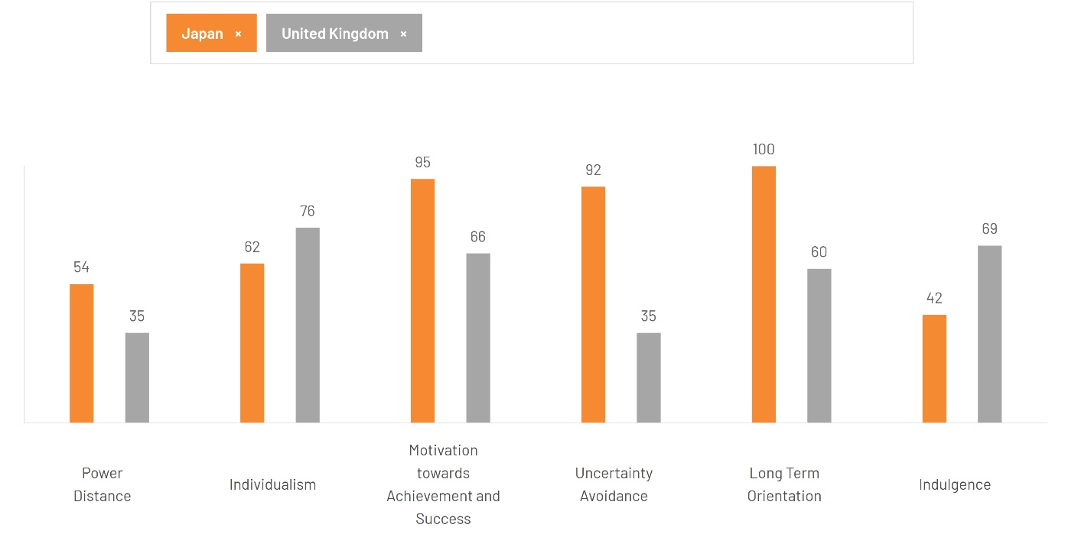
Cultural Dimensions of Hofstede
Figure 02: Geert Hofstede’s Cultural Dimensions (2024)

Power Distance Index
Japan has high power distance, which forecasts respect to hierarchical structures and hardly challenges authority. Workers want clear direction from their bosses and are accustomed to an organised, hierarchical approach to management. On the other hand, the UK is a low-power distance culture with much more egalitarian relationships in the workplace, where employees are more likely to feel they can express their opinions and have open discussions with management. This can cause communication issues, as it can mean employees in the UK may expect to be directly involved in more decision-making, whereas in Japan, this may be considered tantamount to insubordination.
Individualism vs. Collectivism
The UK has a high level of individualism, meaning that the UK places a greater emphasis on the personal and professional achievements of each individual, as well as on self-reliance in the workplace. An environment where employees are encouraged to take initiative, speak up independently and strive for personal career growth. In contrast, Japan is a more collectivist society where group cohesion, consensus-based decision-making and organisational loyalty are core values (Thomas, 2024). This difference is reflected in communication styles, with UK employees more inclined towards clear, assertive communication, whereas japanese employees may not be open to confrontation, as this can lead to tension and conflict (Piotrowska and Piotrowski, 2023).
Motivation towards Achievement and Success
At 95, Japan is among the world's most decisive societies. However, they don't display the competitive and forceful individual behaviours that we typically identify with a decisive culture, especially when combined with their modest collectivism. What you observe is intense group competition. Children learn to compete on sports days for their groups (usually the red team against the white team) from an early age in kindergarten.
Britain, at 66, is a decisive society that is very determined and focused on success. The seeming discrepancy between the British culture's emphasis on modesty and understatement and its underlying success-driven value system is a major source of confusion for foreigners.
Uncertainty Avoidance
Japanese culture has a high level of uncertainty avoidance, so employees prefer systems where everything is planned, systems with clear boundaries, and systems with minimal uncertainty. They prefer predictability and generally rely on established work methods and processes to limit uncertainty (Brodowicz, 2024). The UK plays a lower role in uncertainty avoidance; in contrast, it welcomes flexibility, adaptability, and innovation. UK employees may bring up ad hoc or trial ideas in a conversation that may not sit well with japanese colleagues, who may object that this needs to be properly voted and planned first (Thomas, 2024).
Long-term vs. Short-term Orientation
Japan is a country with a long-term orientation that saves for the future and values ​​perseverance, patience, and long-term rewards. In Japan, business relationships are built over the long term and strategic planning is designed to achieve sustainable growth rather than short-term gains (Scroope, 2021). In contrast, the UK has a short-term mindset, where immediate results are important. On the other hand, this can have an impact on how expectations about projects are managed and communicated, with UK workers tending towards their japanese counterparts in terms of immediacy and stability and the idea of ​​gradual reform (Piotrowska and Piotrowski, 2023).
Indulgence vs. Restraint
While the UK is all about indulgence, it encourages relaxation, enjoyment and work-life balance. Above all, outside of the workplace, employees feel free to express emotions and pursue personal gratification. Japan, on the other hand, is more restrained, prioritizing self-control, social responsibility and obligation over personal pleasure (Scroope, 2021). These contrasting values ​​can translate into the workplace, with UK employees expecting a more relaxed work environment than their japanese counterparts, who may work in a more formal, structured environment.
Cultural dimensions of Trompenaars
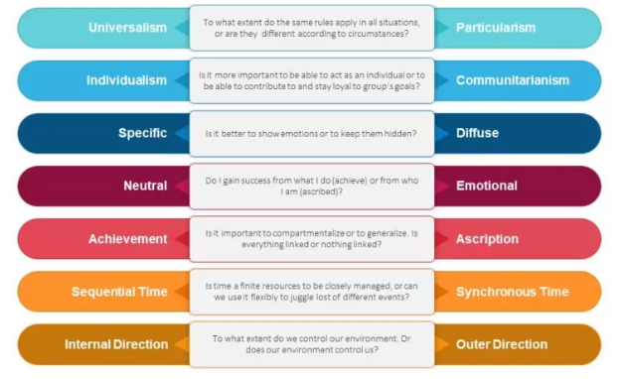
Figure 03: Trompenaars 7 Cultural Dimensions (Gerguri, 2023).
Universalism vs. Particularism
The UK has a Universalist culture where similar business situations are governed by the same rules, standards and procedures. On the other hand, Japan has a particularism, where business decisions are dependent on context, relationships and circumstances. This difference can affect communication because UK employees may assume that rules are followed to the letter, whereas their Japanese colleagues may prefer flexibility based on contingency.
Communitarianism between individualism and communalism
Trompenaars noted that the UK is an individualist culture like Hofstede’s cultural dimensions, which is an individualist culture that prioritizes personal goals and achievements first. On the other hand, Japan practices communalism, which prioritizes group cohesion and the common good. These cultural differences can affect team dynamics, with UK employees preferring independent work and personal recognition more than Japanese employees, who value collaboration and shared responsibility (Trompenaars and Hampden-Turner, 2021).
Objective (Neutral) vs. Emotional Communication
The UK prefers a more neutral approach to communication, valuing professional discussion over logic and emotion during business-to-business communication. Japan, while neutral, communicates through non-verbal cues and indirect speech, particularly through the use of body language, pauses, and context. UK employees who expect or prefer direct formality may misinterpret the more implicit gestures of their Japanese counterparts. Lack of clarity can create a real risk of misunderstanding (Saarni, 2019).
Specific vs. Diffuse Relationships
The UK has a very professional and personal approach to relationships, meaning that work and social life are kept separate with no crossover. In Japan, business relationships often blend with personal and work life, which necessitates the development of more important relationships outside of the workplace. This cultural habit can lead to miscommunication, as UK employees may be strictly work-focused, while their Japanese counterparts may expect to develop more personal relationships with potential business partners before engaging in a business relationship (Mind Tools, 2022).
Achievement vs. Accretion
The UK is achievement-focused, with attributes such as achievement, skill and performance determining a person's status. In contrast, Japan has an accretion-based culture where seniority, age and experience determine how much status a person has in an organisation. This has a huge impact on a leader and how employees interact with each other, as in the UK employees can often sit back and watch a boss who is superior to them in terms of experience and skills but is also challenged by the role, whereas in Japan, employees tend to support employees without ever questioning them due to the more horizontal environment and social class issues (Trompenaars and Hampden-Turner, 2021).
Sequential Time and Concurrent Time
The UK is a sequential time-based country where deadlines are emphasized and tasks are completed in a set order in the most efficient time. On the other hand, the Japanese have a concurrent time perspective where many tasks can occur simultaneously and where flexibility is preferred to a rigid schedule (Thomas, 2024). Such differences can create tension in project schedules because UK workers generally adhere to strict deadlines, whereas their Japanese counterparts are flexible depending on the situation.
Internally-driven versus externally-driven
In the UK, there is an internally-driven culture, that is, people believe that they can master the environment through effort and strategy. Japan, on the other hand, is more externally-driven, that is, Japan focuses more on aspects such as nature, the market, and the outside world in general. This has implications not only for the global workplace but also for strategic planning and leadership styles, as UK workers may want to make proactive decisions while Japanese teams may strive for balance and consensus.

Impact on Business Communication
The communication styles between the UK and Japan are very different due to the differences in these elements. The Japanese are also known for indirect communication, which can lead to misinterpretations by British employees. Meanwhile, Japanese employees may find it difficult to respond if British communication styles are too direct, as they may find it rude or disrespectful. Also, in Japan, decision-making is usually by consensus (the Ringi system) and requires lengthy discussions to implement, whereas in the UK, decision-making tends to be quick and effective (Rizvi, 2024). To succeed in Asia (such as China and Japan), Lloyds Bank needs to understand these differences. However, these gaps and misunderstandings can be bridged and avoided by adopting strategies such as intercultural training, mediation techniques and hybrid communication styles (Liskonih, 2024).

Differences in communication styles between the UK and Japan
The UK adopts a low-context communication style where honesty and direct communication are respected. Messages are kept simple, and people are not shy about sharing their opinions. However, in Japan, which is a high-context culture, implicit messages, body language and indirect communication are used a lot. In Japan, silence often indicates agreement or thoughtful consideration, whereas in the UK, the same level of silence can mean disinterest or disagreement (Liskonih, 2024). Furthermore, British professionals tend to think about skills rather than the content of the discussion, whereas their Japanese counterparts prefer a more relationship-oriented and harmonious style. This difference makes miscommunication inevitable. UK employees expect immediate feedback, whereas Japanese colleagues will need some time to think and respond. Second, during meetings, the British may openly challenge each other on ideas while Japanese teams may instead prioritize harmony and avoid confrontation. Awareness of these differences is important for collaborating with different cultures at Lloyds Bank (Rizvi, 2024).

Communication and Integration Challenges
Working with Japanese companies in the UK can present challenges in cross-cultural communication with UK-based companies, for example, in terms of decision-making processes, feedback processes, structures, control strategies and other forms of communication. Knowing the differences between the two is crucial for collaboration (Laukötter and Stahl, 2017).
Decision-making
Another major challenge is the difference in the approach to decision-making. As UK teams focus on fast, results-oriented decision-making, the same applies to competition, and speed is essential. On the other hand, Japanese businesses adopt a consensus-building approach called nemawashi, where decisions are not made until all stakeholders are on board. This alignment process is lengthy and leads to frustration in the UK when foreign professionals wait months for a solution instead of weeks (Ferrell, 2019).
Feedback and Criticism
Another important issue is how feedback is provided. The British are straightforward and constructive when it comes to criticism, as they value transparency and efficiency. But in Japan, group cohesion (wa) is all-important, with indirect communication being preferred over direct communication. If UK workers don’t clearly understand a problem, they can often hear it that way or read between the lines, even when it’s a comment made non-verbally (Liskonih, 2024).
Hierarchy vs. collaboration
Organizational structures also vary widely. UK companies typically operate with a flat hierarchy that encourages employees at all levels to participate in discussions. In contrast, Japanese companies operate within a rigid hierarchy, where decision-making is based on seniority. This can be limiting for UK workers and may seem like a conflict with authority for Japanese workers. Such diversity imposes constraints that require some cultural knowledge and coordination to work together (Liskonih, 2024).

Strategies for Effective Cross-Cultural Communication
Lloyds Bank in the UK and Japan needed to implement strategic cross-cultural communication systems for effective collaboration between the two teams.
Cultural training:
Providing cultural awareness training can teach employees the basics of Japanese business etiquette, hierarchy, and communication practices (Dima, 2020). Being aware of the Japanese preference for indirectness, politeness, and respect can help dispel misconceptions and make it easier to communicate with the Japanese (Tabata and Vrij, 2022).
Change communication medium:
Since the UK is a low-context country while Japan is a high-context culture, UK citizens should learn to use a more implicit style of communication, which includes both verbal and non-verbal information and context. On the other hand, Japanese employees can be encouraged to express their positions more clearly to eliminate confusion (Laukötter and Stahl, 2017).
Relationship building:
Strong relationships can be built, as understanding is part of the Japanese style, where trust and long-term business relationships are observed. By hosting informal events, team-building activities, or networking events, HR can build stronger relationships and better collaboration between teams (Dima, 2020).
Adaptive decision-making:
Japan mandates a multi-faceted and consensus-driven approach to decision-making, whereas the UK takes a more direct and person-centered approach. Incorporating both styles, structured discussions that allow for individual opinions but welcome hierarchical perspectives, is key to facilitating efficiency without disrupting cultural etiquette (Tabata and Vrij, 2022).
With these strategies, Lloyds Bank can overcome cultural barriers and increase cohesion in the workplace, smoothing project implementation between its teams in the UK and Japan.

Conclusion
Different perspectives on language, communication styles and decision-making processes identified the most acute cross-cultural communication challenges Lloyds Bank faced when it entered Japan. Japan has a high-context communication style and a strict power-distance culture, which can clash with the UK’s low-context, high-simplicity communication and low-power-distance culture, leading to misunderstandings (Chatwin, 2024). Nevertheless, differences are inevitable but can be strategically identified and managed using Hofstede’s cultural dimensions and Trompenaars framework mentioned above, and better collaboration can be achieved (Cheng, 2020). Strategies such as cultural training, communication coordination, trust-building initiatives and creating autonomy in decision-making can enhance mutual understanding and efficiency. Providing cultural training grants equips them with the necessary awareness to operate within Japanese business norms and adjust communication methods so that their words are clear, thereby reducing the potential for misinterpretation. Furthermore, prioritizing relationship building builds trust, which is crucial for successful business transactions in Japan, and hybrid decision-making approaches combine the strategies of each culture to arrive at a solution. By using these strategies, Lloyds Bank can better collaborate between its UK and Japanese employees. Effective cross-cultural management can avoid misunderstandings and facilitate communication. In this way, it will smooth business operations and lead to efficiency. If Lloyds Bank wants to be successful in the Japanese market in the long term, it must be culturally strong so that it truly leads the market (Mizuho Group, 2022).

References
Brodowicz, M. (2024). A Critical Assessment: Hofstede vs. Trompenaars Essay. aithor.com. Available at: https://aithor.com/essay-examples/a-critical-assessment-hofstede-vs-trompenaars-essay . (Accessed 26th February 2025).
Chatwin, P.B. (2024). Lloyds Banking Group. www.britannica.com. Available at: https://www.britannica.com/money/Lloyds-Banking-Group . (Accessed 28th February 2025).
Cheng, E. (2020). Designing for Different Cultures — Hofstede’s Cultural Dimensions. Medium. Available at: https://medium.com/@eviecheng/designing-for-different-cultures-hofstedes-cultural-dimensions-5d5a369e99ee . (Accessed 2nd March 2025).
Dhawan, R. (2023). Leading the AI Revolution at Lloyds Banking Group. Lloydsbankinggroup.com. Available at: https://www.lloydsbankinggroup.com/insights/leading-the-ai-revolution-at-lloyds-banking-group.html . (Accessed 4th March 2025).
Dima, N. (2020). Cross Cultural Communication. Washington: Institute For The Study Of Man.
Ferrell, O.C. (2019). Business Ethics : Ethical Decision Making and cases. 12th ed. Boston, MA: Cengage Learning.
Gerguri, F. (2023). Understanding Trompenaars Cultural Dimensions - a Complete Guide. Employee Experience Magazine. Available at: https://www.emexmag.com/understanding-trompenaars-cultural-dimensions-a-complete-guide/ . (Accessed 4th March 2025).
Laukötter, E. and Stahl, J. (2017). Collaboration between Management and Communication Professionals: Emergence of Communication Strategies in Small- and Medium-Sized Enterprises (SMEs). Change Management: An International Journal, 17(4), pp.1–12. : https://doi.org/10.18848/2327-798x/cgp/v17i04/1-12 . (Accessed 7th March 2025).
Liskonih, O. (2024). UK-Japan Collaborative Investments in Priority Technologies. Ukri.org. Available at: https://www.ukri.org/news/uk-japan-collaborative-investments-in-priority-technologies/ . (Accessed 8th March 2025).

Mind Tools (2022). The Seven Dimensions of Culture. www.mindtools.com. Available at: https://www.mindtools.com/a5ce21r/the-seven-dimensions-of-culture . (Accessed 8th March 2025).
Mizuho Group (2022). Japan’s Economic Renaissance | Mizuho Insights. Mizuhogroup.com. Available at: https://www.mizuhogroup.com/americas/beyond-the-obvious/insights/japans-economic-renaissance.html . (Accessed 10th March 2025).
Niemeier, S., Campbell, C.P. and DirvenR. (2018). The Cultural Context in Business Communication. Amsterdam ; Philadelphia: John Benjamins Pub.
Pascal, A. (2023). Regulatory Reform in Japan Regulatory Reform in Japan. Available at: https://www.oecd.org/content/dam/oecd/en/publications/reports/1999/07/oecd-reviews-of-regulatory-reform-regulatory-reform-in-japan-1999_g1gh144d/9789264173712-en.pdf . (Accessed 11th March 2025).
Piotrowska, M. and Piotrowski, J. (2023). Hofstede’s Cultural Dimensions Theory. ResearchGate. Available at: https://www.researchgate.net/publication/371822907_Hofstede . (Accessed 13th March 2025).
Rizvi, H. (2024). Cultural Differences in Business between UK and Japan - Hidayat Rizvi. Hidayat Rizvi. Available at: https://hidayatrizvi.com/cultural-differences-in-business-between-uk-and-japan/ . (Accessed 13th March 2025).
Saarni, C. (2019). The Development of Emotional Competence. New York: Guilford Press.
Scroope, C. (2021). Japanese Culture - Business Culture. Cultural Atlas. Available at: https://culturalatlas.sbs.com.au/japanese-culture/japanese-culture-business-culture .(Accessed 15th March 2025).
Tabata, N. and Vrij, A. (2022). Differences between Japanese and British participants in self-reported verbal strategies to appear convincing. Psychiatry, Psychology and Law, 30(2), pp.1–15. : https://doi.org/10.1080/13218719.2021.2003269 . (Accessed 17th March 2025).
The culture factor group (2024) Country Comparison Tool . Available at : Country comparison tool. (Accessed 21st March 2025).
Thomas, L. (2024). A Guide to Understanding Diverse Work Cultures in Asia. Internsinasia.com. Available at: https://www.internsinasia.com/blog/exploring-diversity-understanding-different-work-cultures-in-asia . (Accessed 21st March 2025).
Trompenaars, A. and Hampden-Turner, C. (2021). Managing People across Cultures. Oxford: Capstone.

