The Psychology of Personal Adventure

The following essay aims to critically evaluate the psychological benefits and potential issues associated with taking part in outdoor adventurous activities.
Outdoor activities that are considered adventurous are those that take place in environments with a sense of adventure or risk (Beedie, 2003). Some examples include rock climbing, walking, or hiking in natural settings like a mountain, a forest, or a desert. Other examples range from kayaking, surfing, bungee jumping, or mountain biking. These pursuits provide an opportunity to see the great outdoors, push physical and mental limitations, and feel the rush of adrenaline (Kerr,2012)
Participating in outdoor adventurous activities has been shown to provide various psychological benefits, including reduced stress and anxiety: being in nature and engaging in physical activity can help reduce stress and anxiety levels, leading to an overall improvement in mood and mental wellbeing, increased self-esteem, and self-efficacy (Bowler, et al., 2010). Studies have shown that being outdoors in nature and engaging in physical activity can lead to an increased levels of endorphins, leading to a boost in mood and overall feelings of happiness and enhanced cognitive function and working memory (Thompson-Coon, 2011).
However, there are also potential issues associated with outdoor adventurous activities. Engaging in outdoor adventurous activities can come with inherent risks, such as falls, accidents, or encounters with wildlife (Rickard, 2014). There are also financial costs to consider, many outdoor adventurous activities require specialized equipment and training, which can be costly. Moreover, outdoor activities can have an impact on the environment if not done responsibly, such as damage to natural habitats or disruption of wildlife (Kallgren, 1990).
Accessibility is another issue. Not everyone has equal access to outdoor spaces or the means to participate in outdoor adventurous activities. The goal is inclusion for all children with disabilities in appropriate activities. This clinical study examines the value of engagement in sports, recreation, and physical activity for kids with disabilities and provides helpful advice for paediatric healthcare professionals to encourage participation (Murphy, 2008).
It has been discovered that nature-based physical activity programming, such as horseback riding, hiking, and country walks, is an effective strategy to help those with mental illness improve their health; “the restorative impacts of walking in natural environments appears to be most beneficial for those with poor health (Roe, 2011). Exercise referral programmes, in which doctors recommend exercise to patients to prevent or treat chronic illnesses, have aided in increasing accessibility to such outdoor activities in the UK (Maier, 2016).
While there are potential issues associated with outdoor adventurous activities, the psychological benefits they provide can make them a worthwhile pursuit for those who have the means and ability to participate safely and responsibly (Bailey, 2005). But according to Roe (2011), outdoor adventurous situations can be very complex, and psychological factors play a critical role for both group members and leaders. These factors can vary significantly from one person to another and are often dynamic, changing over time and in response to different situations.
Motivation is a key psychological factor that influences how people engage in outdoor adventure activities. Different people have different motives for engaging in outdoor adventure, such as seeking a sense of achievement, testing their physical and mental limits, or simply enjoying the beauty of nature. These motives can affect how individuals perceive and respond to challenges and risks in outdoor environments. A wide-ranging, and organised pattern of emotional experience is provided by the reversal theory. It outlines that sixteen fundamental emotions can be experienced in various meta motivational state combinations. For example, transactional emotions are based on the perceived consequence (gain or loss) of interactions with other people or things, whereas somatic emotions are based on an individual's experience of physiological arousal. There are four pleasant (somatic: relaxation, excitement, placidity, provocativeness; transactional: pride, gratitude, modesty, virtue) and four unpleasant (somatic: anxiety, boredom, anger, sullenness; transactional: humiliation, resentment, shame, guilt) emotions resulting from separate combinations of somatic and transactional meta motivational states (e.g., a combination of paratelic and conformist states results in a combination of unpleasant emotions). (Houge, 2009).
Personality traits, such as openness to experience, conscientiousness, and emotional stability, can play a crucial role in how individuals respond to outdoor adventure situations. For example, individuals who are more open to experience may be more likely to embrace novel and challenging situations, whereas those who are more anxious or neurotic may find it more challenging to cope with uncertainty and risk (Langford, 2002). Group dynamics are also critical to outdoor adventure situations, as they can impact individual behaviours and decision-making. Group members may experience social influence, such as conformity, groupthink, which can affect how they perceive and respond to risks and challenges (Reed, 2021).
Bratman (2012) states that outdoor adventurous activities can help build self-confidence as individuals face challenges and conquer them, which in turn can improve their overall self-esteem, they can also help to reduce stress and anxiety. Nature has a calming effect on the mind, and physical activity has been shown to decrease stress hormones in the body (Roe, 2013). There have been numerous studies done to show outdoor activities can also have positive effects on mental health, including reducing symptoms of depression and anxiety and improving overall well-being (Astell-Burt, 2014). According to Dillon (2012), being in nature can improve cognitive function including attention, memory, and creativity, which can positively impact academic and work performance.
However, participating in outdoor activities comes with a certain degree of risk, which can result in physical injury, especially if safety guidelines are not followed. For some individuals, the fear of heights, water, or other elements can be overwhelming, leading to anxiety or panic attacks during the activity. Peer pressure to participate in activities that may be beyond an individual's comfort level or experience can lead to anxiety or feelings of inadequacy. It is important to follow safety guidelines, consider one's level of experience and comfort, and be mindful of the environmental impact of outdoor activities. With the proper planning, outdoor activities can provide a positive and rewarding experience for individuals (Elsrud, 2001).

The rewards, and benefits for taking part in Adventurous Outdoor Activities are numerous and endless, also on the flipside there are numerous risks and barriers which need to be overcome. So as with everything in life its all about balance and weighing up the risk/reward factor and finding out what works for you!

References

Agyeman, J. and Spooner, R., 1997. Ethnicity and the rural environment. In Cloke, P. and Little, J. (Eds). Contested Countryside Cultures: Otherness, Marginalisation and Rurality. Routledge, London. pp 197–217

Astell-Burt, T., R. Mitchell, and T. Hartig, the association between green space and mental health varies across the life course. A longitudinal study. Journal of Epidemiology and Community Health, 2014. 68(6): p. 578-583.

Bailey*, R., 2005. Evaluating the relationship between physical education, sport and social inclusion. Educational review, 57(1), pp.71-90.

Beedie, P. and Hudson, S., 2003. Emergence of mountain-based adventure tourism. Annals of tourism research, 30(3), pp.625-643.

Beringer, A. and Martin, P., 2003. On adventure therapy and the natural worlds: Respecting nature's healing. Journal of Adventure Education & Outdoor Learning, 3(1), pp.29-39.

Bowler, D., et al., A systematic review of evidence for the added benefits to health of exposure to natural environments. BMC Public Health, 2010. 10: p. 456.

Bratman, G.N., J.P. Hamilton, and G.C. Daily, The impacts of nature experience on human cognitive function and mental health. Annals of the New York Academy of Sciences, 2012. 1249(1): p. 118-136.

Chevalier, G., 2015. The effect of grounding the human body on mood. Psychological reports, 116(2), pp.534-542.

Cialdini, R.B., Reno, R.R. and Kallgren, C.A., 1990. A focus theory of normative conduct: Recycling the concept of norms to reduce littering in public places. Journal of personality and social psychology, 58(6), p.1015.

Dillon, J. and I. Dickie, Learning in the Natural Environment: Review of social and economic benefits and barriers. Natural England Commissioned Reports, 2012(092)

Elsrud, T., 2001. Risk creation in traveling: Backpacker adventure narration. Annals of tourism research, 28(3), pp.597-617.

Houge, S. P. (2009). Reversal theory and flow: Toward an integrated framework of optimal experiences in adventure activities. Unpublished Ph.D. thesis in Physical Education. University of Otago, Dunedin, New Zealand. Houge Mackenzie, S., Hodge, K., & Boyes, M. (2011).

Kerr, J.H. and Mackenzie, S.H., 2012. Multiple motives for participating in adventure sports. Psychology of sport and exercise, 13(5), pp.649-657.

Langford, I.H., 2002. An existential approach to risk perception. Risk analysis, 22(1), pp.101-120.

Mackenzie, S.H., Son, J.S. and Eitel, K., 2018. Using outdoor adventure to enhance intrinsic motivation and engagement in science and physical activity: An exploratory study. Journal of outdoor recreation and tourism, 21, pp.76-86.

Maier, J. and Jette, S., 2016. Promoting nature-based activity for people with mental illness through the US “Exercise Is Medicine” initiative. American journal of public health, 106(5), pp.796-799.

Murphy, N.A. and Carbone, P.S. (2008) “Promoting the participation of children with disabilities in sports, recreation, and physical activities,” Pediatrics, 121(5), pp. 1057–1061. Available at: https://doi.org/10.1542/peds.2008-0566.

Richardson, E.A., et al., Role of physical activity in the relationship between urban green space and health. Public Health, 2013. 127(4): p. 318-324

Rickard, L.N., 2014. Perception of risk and the attribution of responsibility for accidents. Risk analysis, 34(3), pp.514-528.

Roe, J., et al., green space and stress: evidence from cortisol measures in deprived urban communities. Int J Environ Res Public Health, 2013. 10(9): p. 4086-103.
Roe, J. and P. Aspinall, The restorative benefits of walking in urban and rural settings in adults with good and poor mental health. Health & Place, 2011. 17(1): p. 103-113.
Thompson Coon, J., et al., Does Participating in Physical Activity in Outdoor Natural Environments Have a Greater Effect on Physical and Mental Wellbeing than Physical Activity Indoors? A Systematic Review. Environmental Science & Technology, 2011. 45(5): p. 1761- 1772.

CA 1 week | Ca morning | SA 1 week | SA morning | SC 1 week | SC morning
19.95 | 26.95 | 13.9 | 24.75 | 19.55 | 16.35
2.76 | 3.46 | 2.49 | 4.15 | 4.12 | 4.82

A mountain bike competition's competitive state anxiety intensity was compared using a paired samples t-test between the week before and the day of the competition. When we look at cognitive anxiety, the mean score was 19.95 (S.D. 2.76), whereas the mean on the day of the event was 29.95 (S.D. 3.46). In terms of somatic anxiety, the mean was 13.9 (S.D. 2.49), while the day of the event was 24.75 (S.D. 4.15). In terms of self-confidence, the week before the test had a mean of 19.55 (S.D. 4.12) and the test day had a mean of 16.35 (S.D. 4.82). One's cognitive anxiety was significantly different from the other's, according to a paired t-test (P>0.001). The day of the occurrence (M=29.95; SD=3.46), one week prior (M=19.95; SD=2.76), and [t (19) = [-9.554, p =.001]. So, the day of the mountain biking competition saw a much higher level of cognitive distress. One week prior (M=13.9; SD=2.49) and the day of the event (M=24.75; SD 4.15) showed a significant difference (P>0.001) in a paired t-test on somatic anxiety; [t (19) = [-15.569, p =.001]. Data demonstrates that on the day of the mountain biking competition, somatic anxiety was much higher in the general population. Next, a paired t-test on self-confidence was conducted sequentially one week prior (M=19.55; SD 4.12) and also on the event day (M16.35; SD 4.82); [t (19) = [3.582, p =.002].

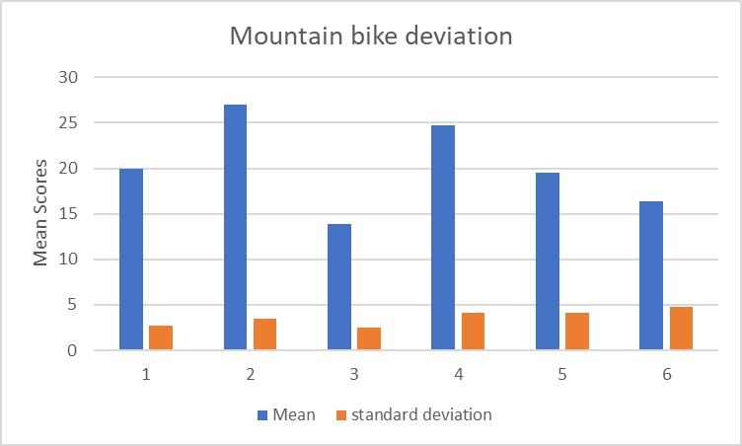

So, as to not leave things to chance in regards to the findings of the data, we need to run a “ T test “. If the significance is less than P<0.05 then that means it is a 95% chance of the data being sound. In the “ T test” below ot shows less than .001, so that is a good outcome and the data is not left to chance.
The physical and psychological capabilities of participants are put under a lot of stress during athletic competition. The vast majority of people who participate in competitive sports, as well as the significance of wins and losses make today's athletic competition more stressful. Many researchers have used an interactional approach to the study of this type of stress in order to understand and predict the effects of competition on athletes' behaviour, sport performance, and emotional reactions (e.g., Sanders, 1983; Jones, 1990; Hardy et al., 1996).
Stress is conceptualized as a process of transaction between individuals and their environment (Lazarus and Folkman, 1984; Lazarus, 1999). Accordingly, important advancements in the discipline include the multidimensional conceptualization of competitive anxiety and the creation of the Competitive State Anxiety Inventory-2 (CSAI-2; Martens, Burton, Vealey, Bump, & Smith, 1990).
Hanton and Jones (1999b) “found that restructuring debilitative thoughts and feelings through an intervention using goal setting, imagery and self-talk was accompanied by considerable increases in self-confidence and improvements in performance”.
As a result of these developments, a vast body of research has been conducted to evaluate athletes' levels (i.e., intensity) of competitive anxiety in relation to variables like situational antecedents, the temporal patterning of the subcomponents, and the relationship between anxiety and performance (for a review, see Woodman & Hardy, 2001).

Appendix 1:

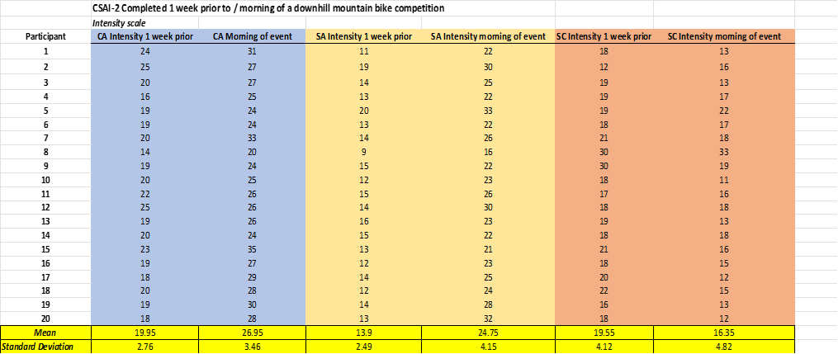

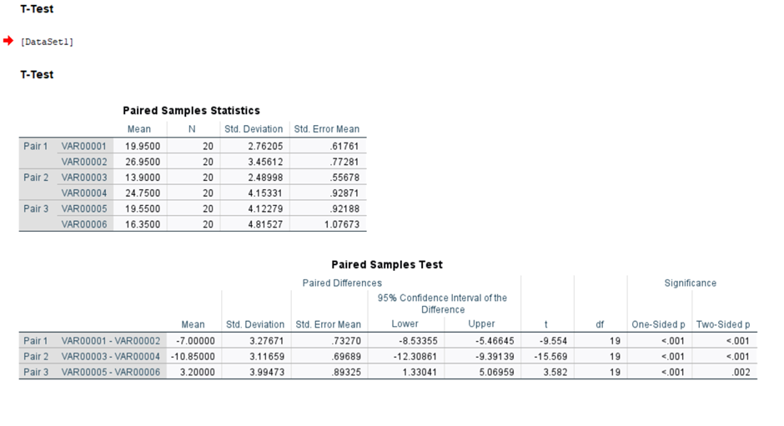

References

Jones, G., Swain, A. and Cale, A. (1990). ‘Antecedents of multidimensional competitive state anxiety and self- confidence in elite intercollegiate middle-distance runners.’ The Sport Psychologist, 4(1), pp.07-118.
Lazarus, R.S. and Folkman, S. (1991). ‘The concept of coping’. In Monat. A., Lazarus, R.S. Stress and Coping, (Eds.), pp. 189-206. New York: Columbia University Press.
Martens, R., Burton, D., Vealey, R. S., Bump, L. A., & Smith, D. E. (1990). ‘Development and validation of the competitive state anxiety inventory-2 (CSAI-2)’. In R. Martens, R. S. Vealey, & D. Burton (Eds.), Competitive anxiety in sport (pp. 117–213). Champaign, IL: Human Kinetics
Sanders, A.F. (1983). ‘Towards a model of stress and human performance.’ Acta Psychological, 53, 64-97.
Woodman, T., & Hardy, L. (2001). Stress and anxiety. In R. Singer, H. A. Hausenblas, & C. M. Janelle (Eds.), Handbook of research on sport psychology (2nd ed.) (pp. 290–318). New York: Wiley.

