The Cambridge Primary Review stated that children’s, ‘opportunities to express themselves creatively had been eroded in the past 20 years...with stifled enjoyment, creativity and imagination in primary education’ (Alexander, 2010, p.99). With Donaldson (2015) asserting this to external forces, and subsequently leaving a void of local creativity and responsiveness to the needs of learners.
However, with the first curriculum documents to be published in March 2019, ‘Successful Futures’ (2015) intends to bring change, a platform for new expression, engagement and innovative teaching and creative learning to develop learners prepared for this era. Furthermore, Robinson (2015) argues that the future depends on the creative capabilities of learners as raising academic standards will not suffice; in line with Our National Mission (WAG, 2017a) objectives.
Wyse and Ferrari (2015), Shaheen (2010) and Craft (1999) all agree that fostering creativity is a life skill, key competency and component of economic prosperity that will create resilience; innovation that will address the demands of a fast-changing world; and with these skills develop characteristics of entrepreneurs (Loughan, 2015). Teachers will have to equip these learners; be themselves innovators, passionate about leading and responding to changing society (Furlong, 2015).
Through research and personal reflection this essay will articulate a definition of creativity and enterprise within an educational context and through discussion critically analyse the benefits, challenges and tensions that exist concerning creativity and innovation. The Entrecomp Framework (Bacigalupo et al, 2016) will be used for personal evaluation focusing on two strands; creativity and risk taking and make future recommendations in order to develop pedagogy and skills within learners.
With Creativity in both thinking and learning established as crucial life skills, there is a need for them to be nurtured and encouraged in education (Dobbins, 2009). However, Ofsted still found that the definitions of creativity differed ranging from, ‘an innate attribute to an approach and set of skills that could be cultivated’ (2015, p. 7). Furthermore, Leggett (2017) ascertained that mis-interpretation of creativity was a key issue in progression with Runco (2003, 2016) arguing that its value could be overlooked if the only creativity recognised was that which was seen and tested.
This is imperative, as Kapadia (2015) argues that critical thinking, problem solving, collaboration and imagination through the arts can support creativity, In contrast, however, viewing creativity in this context alone can prevent the foreseen potential across all domains and contexts (Robinson Report, 1999). In addition, Craft, Jeffrey and Leibling (2001) found that within some schools perceiving creativity which focussed on intellectual aspects and problem-solving left creative learners unable to fulfil their potential. Leadership and stakeholders involved in planning and policy hold the key to making important decisions impacting potential entrepreneurship.
NACCCE (1999) made distinctions between teaching creatively and teaching for creativity. With emphasis on the teacher using appropriate approaches to engage and interest learners and the teacher using their own creativity and pedagogy to foster creative thinking within learners (Woods and Jeffrey, 1996 and Davies et al, 2014). Sharp (2004) suggests that the balance of both are equally important, however, within the new curriculum, learners will begin to move forward, away from pedagogy advancing to Heutagogy as they become more autonomous, knowing how to learn and innovate and acquire competencies and capabilities, enhancing more opportunities for creativity and entrepreneurship to flourish.
Much research suggests that creativity is understood to be a process or imaginative activity that produces both originality and value (NACCCE, 1999; Wyse and Ferrari, 2014; Robinson, 2015, and Craft, Cremlin and Burnard, 2008). In addition, Fisher and Williams (2006) and Runco (2016) suggest its value must be personal, offering a sense of self-enlightenment and satisfaction, in comparison to Hewitt and Tarrant (2015) who argue that the ideas that generate value are for someone other than oneself. However, Gardners’ (1999) view argued that truly creative people make an impact on the world.
Many characteristics of creativity and the creative process can be found; from cognitive skills, personality, motivation (Amabile, 1996; Runco, 2003 and Desailly, 2015), imaginative activity and thinking, (NACCCE, 1999) to innovation, control, relevance, and ownership, (Jeffery and Woods, 2003). In addition ,Wyse and Ferrari (2015) argue that thinking skills relating to reasoning, enquiry and discovery underpin the creative process. Furthermore, it is the bond between divergent and convergent thinking that is the powerful aspect that transpires into creativity (Leggett, 2017 and Robinson, 2015).
An understanding that brings further depth states that the creative process also involves refining, testing and seeing new connections and relationships thus constructing new meaning (Torrance,1969; Koestler,1964; Oliver, 2006; Pound and Lee, 2015 and Runco, 2003). Both Goleman (2015) and Pink (2006) argue that this combination of unrelated ideas and implementation is the innovative part of the creative process. It is the outcome of wonder, curiosity and knowledge that produces this outcome according to Tahirsylaj (2012). This therefore suggests that all learners have the potential to be creative; it can be developed and learnt (NACCEE, 1999; Esquivel, 1995 and Blamires and Peterson, 2014). For teachers, research, critical reflection, sharing good practice and careful planning is therefore essential; aspects agreed by Ofsted (2010).
The term innovation, ‘is used as such in sociology, as Entrepreneurship and enterprise, in an economic environment, and in education mostly referred to as creativity (Craft, Jeffrey and Leibling, 2001). However, The Entrecomp Framework defines entrepreneurship as, ‘a transversal competence, which applies to all spheres of life: from nurturing personal development, to actively participating in society’ (Bacigalupo et al, 2016).
Whatever the definition, creativity can be understood to be multi-dimensional, with Khatena (1982) arguing that this consists of the individual, environment and cosmos, whereas, Seelig (2012) indicates that both attitude, imagination and knowledge and resources, culture, and habitat are all equal components interlinked to culture creativity. However, Beghetto and Kaufman (2009) would argue that intrinsic and extrinsic motivation has the most impact to shape creativity. In comparison, however, Robinson (2015) places more importance on divergent thinking.
The importance of fostering creative and enterprise skills is imperative in order to thrive in the diversity and challenges of the 21st Century. The new curriculum will develop creative skills through critically evaluating information, making connections, solving complex problems and transferring both knowledge and skills to new situations. This will help children and young people on their journey to become enterprising, creative contributors (Donaldson, 2015) and to equip children to have resilience to thrive and flourish and to develop emotional literacy to have the skills to cope with new situations and challenges (Goleman, 1995). Furthermore, fostering creativity in learners can be advantageous as it establishes understanding, empathy and inventiveness (Pink, 2006), with these skills offering society individuals who are innovative, adaptable and flexible, which are key assets for businesses (Quality Assurance Agency, 2012). In addition, it can also enhance academic performance according to Geist and Horn (2009) and Sternberg (1999), however Namia, Hossein and Ashouri (2013) disagree.
For teachers, fostering personal creativity will translate into their planning and pedagogy, consequentially creating a resurgence of passion, a sense of resilience, persistence, grit and motivation for those restrained by the curriculum (Dacey and Lennon, 2000). These restraints, due to a sense of conformity established, time restraints and a fear of inspection (Hayes, 2004; Mishrab and Richardson, 2018; and Dobbins, 2009). However, Jeffery and Wood (2003) state that even in such curriclum practices schools can still foster creativity. This requires a whole school approach and strong leadership with vision, that welcomes innovation, qualities not always evident from experience. The Welsh Government have allocated funds for teachers to ensure sufficient time for them to understand and interpret the new curriculum, (Williams, 2018) which will support and alleviate much anxiety and prepare teachers to be active agents of change.
The challenge remains, however, that with assessment we are killing creativity (Robinson, 2015; Beghetto, 2005). Objectivity becomes an issue, with an un comparable personal idea or product (Runco, 2003). However, Ofsted) stated that, ‘Assessment that is used to encourage, guide and evaluate creative learning was highlighted as a priority’ (2015, p. 3). In addition, Beghetto (2005) emphasises the importance of using high-quality feedback; formative assessment to motivate learners in order for their creativity to thrive, a key message from Donaldson (2015).
The Entrecomp Framework has been developed as a tool of reference to develop entrepreneurial skills, and in education to support teachers in assessing their current levels of competencies and identify next steps for progression. This is a critical component as OECD (2018) argue that teachers lack of understanding leads to barriers to assessing progress. Synthesising the framework for a classroom context has been challenging as there are many elements to decipher, also acknowledging that it has not been tested in any actual setting thus far (Bacigalupo et al, 2016). It could be used, however, alongside the OECD (2012) ‘The Five Creative Dispositions Model and the current Skills Framework for 3-19 years in Wales (WAG, 2008).
Schools have the ability to ether foster or hinder an environment of creativity, with the learning environment being essential to support creativity (Mishrab and Richardson, 2018; Beghetto and Kaufman, 2009 and Sternberg, 2010). The role of the teacher in creating an atmosphere in which their own creativity abilities are engaged with passion and fun, impacts the responsive creative abilities of the learners (Craft and Jeffrey, 2004). Furthermore, creativity is fostered where the conditions are favourable; motivation is high, emotions are stable and inclusion and encouragement (see appendix 1) draw the best from learners (Cowley, 2005 and Craft, Cremlin and Burnard, 2008). A curriculum and pedagogy that fosters play as central to child development and offers opportunity to develop and apply imagination (Fumoto et al, 2012) in which time and resources are provided as children have a natural tendency to fantasise and explore their environment (See appendix 2) will also foster creativity (Sharp 2004, Root-Bernstein, 2006). This highlights the teacher’s role as observational and participative, encouraging independence and autonomy and knowing which approach is most appropriate to employ and when. This allows the children to work uninterrupted, making choices spontaneously and independently, all elements that can support creativity (Oliver, 2006).
On reflection, experience in the classroom has shown evidence that the author has the ability to use personal creativity through her pedagogy to develop the creative skills in learners in a natural way (see appendix 3). However, supporting them to develop their creativity into innovation and enterprise within learners requires further development.
‘Coping with uncertainty, ambiguity and risk;’ (Bacigalupo et al, 2016) is a competence within the Framework, where Level 5 has been attributed to the teacher in, ‘Make decisions dealing with uncertainty, ambiguity and risk’ (see appendix 4). A year four lesson (see appendix 5) undertaken supported an opportunity to foster creativity through a collaborative approach within a rich literacy lesson which promoted this competency in both teacher and learner.
The teacher modelled divergent and convergent thinking as the learners were asked to spend the first few minutes thinking and sharing ideas on paper on their tables before discussing their arguments. By hot seating one member from each group representing a person from the production line, questions and arguments were hotly debated as learner’s problem solved to choose which individual deserved to be paid the most and offering reasons for their response.
The personal reflection (see appendix 6) and teacher observational assessment (see appendix 7) indicated that the planning had been thoroughly researched utilising appropriate prepared resources. The physical environment had been organised to ensure all groups had room to collaborate in problem solving and that through the imaginative, positive and persistent attitude the learning had been planned for any eventuality; with the desire to follow the lead of the children in their debate. An important aspect to encouraging creativity supported by Seelig (2012). On reflection, creativity of the teacher was reflected in the ethos of all aspects of the environment, and their approach.
In fostering creativity within learners, Csikszentmihalyi (2013), Acar and Ucus (2018) believe that talent may be less important than encouragement and that in time, encouragement from adults, children develop creative talents, thus ensuring the pastoral role of the teacher is paramount, ensuring encouragement and patience, supporting the learners to try new things creating a positive mindset (Dweck, 2012). In addition, Craft (2009), and Cremlin, Burnard and craft (2004) agree that through their planning creative teachers afford risk taking, ownership, and autonomy. However, Ofsted (2003) reported that creativity observed in pupils is a willingness to listen, observe and support learners to develop their ideas, and not some new pedagogy.
To foster creativity in learners, the classroom environment must be one that is non-judgemental and allows for opportunities without fear of making mistakes (Craft, 2009 and Fisher and Williams, 2006). Moreover, risk taking is an essential component in order to succeed, as it means refining, testing and evaluating in order to move forwards which also fosters ownership (Hartford, 2011; Robinson, 2015; Kapadia, 2015; Beghetto, Plucker and Dow, 2004). This may cause the child to become anxious, (Sharp, 2004) so the teacher must therefore know the children in order to know when and how to promote risk, but also culture resilience.
In Estyn’s good practice Ysgol Cynwyd Sant (2016a) encouraged a growth mindset in staff and pupils to remove the fear of being wrong. This is part of the natural ethos that has been taken into all classrooms during teaching practice, with a natural pastoral role being foundational to create such a culture. This climate of positive wellbeing generates creative learning on all levels (Barnes, 2015).
This collaborative approach within this active lesson, placed a strong emphasis on open, exploratory space which are essential for enabling creativity (Cremlin, Burnard and Craft 2004; Craft and Jeffrey, 2004 and Blamires and Peterson, 2014). Furthermore, the social constructionist theory would highlight this as a powerful learning environment, (See appendix 8) unlike, De Bono (2015) who argues that creativity need not be a group process, as individuals can be creative on their own which supports Piaget’s theory of independent learning (1952). However, Jones and Wyse (2004) state that both individual and collaborative learning foster creative autonomous learners of which theorists Montessori (1907) and Emilia (1970) would agree both foster creativity. The teachers role therefore becomes one of coach, facilitator, acting spontaneously and flowing with the learner’s interests (Sharp, 2004, Acar and Ucus 2018).
To ensure progression to level 6 in the framework (see appendix 4) reflection indicates that risk was taken by the teacher to promote active, progressive creativity amongst the learners in an environment that had only been known for a few weeks. However, the strategies used were effective as assessed in the teacher’s formative assessment (appendix 7). In future, the teacher would identify how creativity can be encouraged further in a cross curricular approach, and encouraging persistence allowing the children to continue if they are in flow (Csikszentmihalyi, 1990) instead of having to stop due to curriculum timetable restraints. This would have to be a collaborative approach with staff. Further development of personal pedagogy using other strategies such as De Bono’s thinking hats may also stimulate creative and innovation thinking at depth (Costa, and Kallick, 2008).
Within the Creative competence in The Entrecomp Framework (Bacigalupo et al, 2016), ‘being curious and open’ thread, the teacher has been assessed at level five (see appendix 8). A lesson planned and taught in a Foundation Phase reception class supported an opportunity in which to foster and develop creativity in mathematics (see appendix 9). The learners were in groups, collaborating and using problem solving skills as detectives on an outdoor shape hunt (appendix 10). The planning included researching how to use the environment to stimulate and create opportunities that, ‘improve the value-creating opportunities’ (Bacigalupo et al, 2016) for the learners to use imagination, collaboration, and thinking skills. Knowledge of Foundation Phase pedagogy informed the planning as the outdoors was used to extend the learners to use and apply their knowledge in a real-life experiential context creating an authentic memorable experience, theory supported by Montessori (1907), Piaget (1952) and Dewey (1916).
The Resources provided supported the children in their experience, engaging them in the outdoor space, promoting and fostering their creative development (Davies et al, 2014).
The social context planned by the teacher is important in fostering active learning experiences and opportunities for collaboration and independent play (see appendix 10). In addition, this social constructionist approach (Vygotsky, 1978 and Bruner, 1957) offers the teacher an understanding of how these opportunities where knowledge is co-constructed and processing and creative skills are acquired (Sternberg, 1999).
In order to maximise their divergent and convergent thinking, the teacher used an Assessment for Learning strategy; think, pair share, which allowed the learners time to think independently and then share with partners. Runco (1991), Leggett (2017) and Davies et al (2014) argue that modelling creativity by thinking divergently can support children to solve problems and evaluate ideas and see creativity can be valued. This was modelled to pairs of children as the teacher moved between the children. The investigative and experimental outdoors environment also gave children sustained periods of time to develop their creative thoughts (Sharp, 2004) (see appendix 11). This creative process needs to be nurtured in an atmosphere, tone and culture that fosters thinking and inspires creativity, which is key to fostering self-belief (Thorne, 2007). This is crucial as some of the children in the class had little self confidence and needed extra support and encouragement to develop creative skills more than others. An important responsibility of the teacher as argued by Sharp (2004). In addition, individual creativity can be hindered by criticism (Craft, Cremlin and Burnard, 2008). On reflection, ensuring all support staff know this is also critical, along with clear understanding for learners of what constitutes peer assessment.
The use of higher order questioning (Blooms Taxonomy, 1956) and peer assessment during the lesson promoted independent thinking and also supported mathematical reasoning, and conceptual understanding (Driscoll, Lambirth, and Roden, 2015). Ofsted (2015) highlighted that open-ended questions was an effective strategy for teaching and learning whereby teachers promoted creative learning through questioning, challenging ideas, making connections and encouraging critical refection on ideas, actions and results. However, they also found that occasionally, teachers, ‘failed to grasp that creative learning was not simply a question of allowing pupils to follow their interests; careful planning was needed for enquiry, debate, speculation, experimentation, review and presentation to be productive’ (Ofsted, 2015, p.9).
To ensure progression and further personal creativity in order to foster it in the classroom, level 6 in the framework (see appendix 8) suggests, ‘combining my understanding of different contexts to transfer knowledge, ideas and solutions across different areas’ (Bacigalupo et al, 2016). By collaborating with other staff, which is a professional standard in the new framework (WAG, 2017b), sharing resources and looking at best practice, further strategies could be identified to support creative opportunities across the curriculum. Estyn best practice Ysgol Aberystwyth (2016b) utilise a triad method to include peer observations in order to refine their practice. This would support development in understanding how to teach enterprise skills and inspire innovation.
To conclude, The Qualifications and Curriculum Authority (QCA, 2005) suggest that the need with creativity is to, ‘find it, promote it, use it.’ The skills within reflect in the pedagogy used to enhance and develop creativity with the learners.
The research has fuelled the desire to ensure that future personal recommendations consist of searching for opportunities for creativity to be unleashed, to take measured risks, try new pedagogical strategies, and to empower the learners to think. ‘outside the box,’ to provide the tools that encourage innovation and enterprise skills amongst learners.
For the profession, OECD (2018) are currently preparing a Rubric which teachers could use to develop creativity in learners, which will provide them with resources and assessments. This will do doubt give them confidence and a revitalised spirit to embrace the curriculum inspiring them to foster creativity and innovation as foundational to all that they do.

Word Count 3300

Reference List

Alexander, R, J. (2010) Children, their world, their education: Final report and recommendations of the Cambridge Primary Review. London: Routledge.
Available at:
http://www.robinalexander.org.uk/wp-content/uploads/2012/05/CPR-final-report-briefing.pdf
(Accessed 19th December 2018)

Amabile, T. (1996) Creativity in Context. Boulder:Westview Press.
Acar, I. and Ucus, S. (2018) Teacher’s Innovativeness and teaching approach: The mediating role of creative classroom behaviours. ‘Social behaviour and personality’. 46(10), 1697–1712 Scientific Journal Publishers Limited. Available at:
file:///G:/Assignments/Creativity/Creatie%20classroom%20behavioyrs.pdf
(Accessed 13th December 2018)

Bacigalupo, M., Kampylis, P., Punie, Y., Van den Brande, G. (2016). EntreComp: The Entrepreneur-ship Competence Framework. Luxembourg: Publication Office of the European Union.
Barnes, J (2015) Cross-Curricular Learning. London: SAGE Publications Ltd
Beghetto, R. A, Plucker, J. A., and Dow, G.T. (2004) Why isn’t creativity more important to educational psychologists? Potentials, pitfalls, and future directions in creativity research.
Educational Psychologist, 39(2), 83-96.

Baghetto, R. (2005) Does Assessment Kill Student Creativity? The Education Forum. Volume 69, 263. Available at:
https://files.eric.ed.gov/fulltext/EJ683512.pdf (Accessed 15th December 2018)

Beghetto, R, A. and Kaufman, J, C. (2009) Beyond Big and Little: The Four C Model of Creativity. Review of General Psychology 13(1)
Available at:
https://www.researchgate.net/publication/228345133_Beyond_Big_and_Little_The_Four_C_Model_of_Creativity(Accessed 19th January 2019)

Blamires, M and Peterson, A. (2014) Can creativity be assessed? Towards an evidence-informed framework for assessing and planning progress in creativity, Cambridge Journal of Education, 44:2, 147-162. Available at:
file:///G:/Assignments/Creativity/assesssing%20creatuvity%20in%20the%20classroom.pdf
(Accessed 13th December 2018)

Costa, A., Kallick, B. (2008) Learning and Leading with Habits of Mind, Virginia: ASCD
Cowley, S. (2005) Letting the buggers be creative. London: Continuum.
Craft, A. (1999). Creative development in the early years: Some implications of policy for practice. The Curriculum Journal, 10, 135-150.

Craft, A. (2000) Creativity Across the Primary Curriculum, Abingdon: Routledge.
Craft, A., Jeffrey, B and Leibling, M. (2001) Creativity in Education. London: Continuum
Craft, A and Jeffrey, B. (2004) Teaching creatively and teaching for creativity: distinctions and relationships, Educational Studies, 30:1, 77-87. Available at:
https://www.tandfonline.com/doi/pdf/10.1080/0305569032000159750?needAccess=true
(Accessed 17th December 2018)

Craft, A., Cremin, T. and Burnard, P. (2008) Creative Learning 3-11 and How We Document It. Stoke-on-Trent: Trentham.
Craft, A. (2009) Creativity in Schools Tensions and Dilemmas. Oxon: Routledge.

Cremin, T., Burnard, P. and Craft, A. (2004). Pedagogy and possibility thinking in the early years. Thinking Skills and Creativity, 1, 108–119.
Csikszentmihalyi, M. (1990) Flow: The Psychology of Optimal Experience. New York and London: Harper Perennial
Csikszentmihalyi, M. (2013) Creativity: Flow and the Psychology of Discovery and Invention. New York: HarperCollins.
Dacey, J. and Lennon, K. (2000) Understanding Creativity: The interplay of biological, psychological and social factors. New York: Creative Education Foundation.
De Bono, E. (2015) Serious creativity How to be creative under pressure and turn ideas into action. London: De Bono Global Pty Ltd
Davies, D, Jindal-Snape. Digby, R, Howe, A, Collier, C Hay, P (2014) Creative learning environments in education – A systematic literature review. Thinking Skills and Creativity. July 2014, Vol. 8, pp.80-91. Available at:
http://researchspace.bathspa.ac.uk/502/12/CLE.pdf (Accessed 13th December 2018)

Desailly, J. (2015) Creativity in the Primary Classroom. 2nd Ed. London: SAGE.
Dobbins, K. (2009) Teacher creativity within the current education system: a case study of the perceptions of primary teachers, Education 3–13, 37:2, 95-104. Available at:
https://www.tandfonline.com/doi/pdf/10.1080/03004270802012632?needAccess=true
(Accessed 17th December 2018)

Donaldson, G. (2015) Successful Futures. An independent review of the Curriculum and Assessment Arrangements in Wales. Cardiff: Welsh Government.
Drisoll, P. Lambirth, A and Roden, J. (2015) The Primary Curriclum: a creative approach. London: SAGE
Dweck, C. (2012) Mindset: How you can fulfil your potential. London: Robinson.
Esquivel, G. B. (1995). Teacher behaviours that foster creativity. Educational Psychology Review, 7, 185-201. Available at:
https://www.researchgate.net/publication/226199428_Teacher_behaviors_that_foster_creativity (Accessed 24th January 2019)

Estyn (2016a) A report on Ysgol Cynwyd Sant. Available at:
https://www.estyn.llyw.cymru/sites/default/files/documents/Ysgol%20Cynwyd%20Sant.pdf
(Accessed 15th January 2019)

Estyn (2016b) A report on Ysgol Gymraeg Aberystwyth. Available at:
https://www.estyn.gov.wales/sites/default/files/documents/Ysgol%20Gymraeg%20Aberystwyth%20eng_0.pdf (Accessed 12th January 2019)

Fisher, R and Williams, M. (2006) Unlocking creativity Teaching across the Curriculum. Oxon: Routledge

Fumoto, H., Robson, S., Greenfield, S., Hargreaves, D. (2012) Young Children’s Creative Thinking. London: SAGE Publications Inc.

Furlong, J. (2015) Teaching Tomorrows Teachers. Options for the future of initial teacher education in Wales. Available at:
https://beta.gov.wales/sites/default/files/publications/2018-03/teaching-tomorrow’s-teachers.pdf (Accessed 19th January 2019)
Gardner, H. (1999). Intelligence Reframed: Multiple Intelligences for the 21st Century. New York: Basic Books.
Geist, E, Hohn, J. (2009) Encouraging Creativity in the face of administrative convenience: How our schools discourage divergent thinking. Project Innovation, Inc.Education, 2009, Vol.130 (1), p.141-151. Available at:
https://content.ebscohost.com/ContentServer.asp?T=P&P=AN&K=508099568&S=R&D=eue&EbscoContent=dGJyMNLe80Sep7E4wtvhOLCmr1CeprNSr6y4S7SWxWXS&ContentCustomer=dGJyMPGqtVGxp7FRuePfgeyx44Dt6fIA (Accessed 13th December 2018)

Goleman, D. (2015) What’s the difference between creativity and innovation? Available at:
https://www.weforum.org/agenda/2015/01/whats-the-difference-between-creativity-and-innovation/ (Accessed 17th December 2018)

Hayes, D.(2004) Understanding creativity and its implications for schools. Improving Schools 7, no. 3: 279–86. Available at:
https://journals-sagepub-com.ezproxy.uwtsd.ac.uk/doi/pdf/10.1177/1365480204048930
(Accessed 17th December 2018)

Harford, T. (2011) Adapt: Why success always starts with a failure. London: Little Brown.

Hewitt, D and Tarrant, S. (2015) Innovative Teaching and Learning in Primary Schools. London: SAGE Publications Ltd

Jeffrey, B. and Woods, P. (2003) The creative school: A framework for success, quality and effectiveness. London: Routledge/Falmer.

Jones, R., Wyse., D. (2004) Creativity in the Primary Classroom. London: David Fulton Publishers.

Kapadia, S (2015) . Childhood into the 22nd Century Creativity, the Finland Example, and Beyond. Childhood Education; Olney Vol. 90, Issue. 5, 333-342
Available at:https://search-proquest-com.ezproxy.uwtsd.ac.uk/docview/1612319008/fulltextPDF/F2C6D8AF7E024778PQ/1?accountid=130472 (Accessed 17th December 2018)

Khatena, J. (1982) ‘Myth: creativity is too difficult to measure!’ Gifted Child Quarterly, 26, 1982, pages 21-23.
Koestler, A. (1964) The art of creation. London: Macmillan

Leggett, N. (2017) Early Childhood Creativity: Challenging Educators in Their Role to Intentionally Develop Creative Thinking in Children. Early Childhood Education Journal (2017) 45:845–853. Available at:
https://link.springer.com/content/pdf/10.1007/s10643-016-0836-4.pdf (Accessed 17th January 2019)

Loughan, K. (2015) How to introduce enterprise into your school's curriculum. Teachers Blog ‘Citizenship’ The Guardian. Available at:
https://www.theguardian.com/teacher-network/teacher-blog/2013/nov/23/teaching-enterprise-school-curriculum (Accessed 19th December 2018)

Mishrab, C..Richardson, P. (2018) Learning environments that support student creativity: Developing the SCALE. Thinking Skills and Creativity. Available at:
https://ac.els-cdn.com/S1871187117300196/1-s2.0-S1871187117300196-main.pdf?_tid=f91b77e8-2390-493d-97ad-47e07ad308b5&acdnat=1544692606_53dc6d76f021b813f08ae57cca9e16c9 (Accessed 13th December 2018)
Nami, H; Hossein, M; Ashouri,M. (2013) The Relationship Between Creativity And Academic Achievement. Procedia – Social and Behavioural Sciences 114 (2014) 36-39
Available at:
https://www.researchgate.net/publication/275220253_The_Relationship_Between_CreativityAnd_Academic_Achievement (Accessed 20th January 2019)

National Advisory Committee on Creative and Cultural Education (1999) All Our Futures: Creativity, Culture and Education. Available at:
http://sirkenrobinson.com/read/all-our-futures/ (Accessed 19th January 2019)

Ofsted (2003) Expect the unexpected: Developing creativity in primary and secondary schools. London: HMSO. Available at:
https://dera.ioe.ac.uk/4766/1/Expecting_the_unexpected_(PDF_format).pdf (Accessed 19th December 2018)

Ofsted (2010) Learning: Creative Approaches that Raise Standards. London.
Available at:
https://dera.ioe.ac.uk/1093/1/Learning%20creative%20approaches%20that%20raise%20standards.pdf (Accessed 19th January 2019)

Ofsted (2015) Learning: creative approaches that raise standards. Available at:
www.readyunlimited.com/wp-content/uploads/2015/09/Learning-creative-approaches-that-raise-standards-Ofsted.pdf (Accessed 17th December 2018)

Oliver, A. (2006) Creative Teaching Science in the Early Years and Primary Classroom. London: Fulton Publishers Ltd

OECD (2012) Progression in Creativity: Developing new forms of assessment. Background Paper for the OECD conference "Educating for Innovative Societies"
Available at:
http://www.oecd.org/education/ceri/50153675.pdf (Accessed 19th January 2018)

OCED (2018) Fostering and assessing students’ creative and critical thinking skills in higher education. Available at:
https://www.oecd.org/education/ceri/Fostering-and-assessing-students-creative-and-critical-thinking-skills-in-higher-education.pdf (Accessed 17th January 2019)

Pink, D. (2006 ) Daniel Pink in his book, A Whole New Mind: Why Right-Brainers Will Rule the Future. New York: Penguin Group

Pound, L. Lee, T. (2015) Teaching Mathematics Creatively 2nd Edition. Oxon: Routledge.
Quality Assurance Agency (2012) Enterprise and entrepreneurship education. Guidance for UK education providers.

Quality Assurance Agency (2018) Enterprise and Entrepreneurship Education: Guidance for UK Higher Education Providers. Available at:
https://www.qaa.ac.uk/docs/qaa/about-us/enterprise-and-entrpreneurship-education-2018.pdf?sfvrsn=20e2f581_10 (Accessed 17th December 2018)

Qualifications & Curriculum Authority (QCA) (2005) Creativity: Find It, Promote It
Available at:
https://www.scirp.org/(S(351jmbntvnsjt1aadkposzje))/reference/ReferencesPapers.aspx?ReferenceID=1298536 (Accessed 14th January 2019)

Robinson Report. Department for Education and Employment , Department for Culture, Media and Sport, National advisory committee on Creative and Cultural Education (1999)). All Our Futures: Creativity, Culture and Education. London: DfEE
Available at:
http://sirkenrobinson.com/pdf/allourfutures.pdf. (Accessed 15th January 2019)

Robinson, K. (2001) Out of Our Minds: Learning to Be Creative. Oxford: Capstone.

Robinson, K. (2015) Creativity Is In Everything, Especially Teaching
Available at:
https://www.kqed.org/mindshift/40217/sir-ken-robinson-creativity-is-in-everything-especially-teaching (Accessed 15th December 2018)
Root-Bernstein, M; Root-Bernstein, R. (2006) Imaginary Worldplay in Childhood and Maturity and Its Impact on Adult Creativity. Creativity Research Journal, 2006, Vol.18(4), pp.405-425. Available at:
https://web-a-ebscohost-com.ezproxy.uwtsd.ac.uk/ehost/pdfviewer/pdfviewer?vid=1&sid=f1520b30-0907-4a38-ab16-049b1e5ef790%40sdc-v-sessmgr02 (Accessed 15th January 2019)

Runco, M. (1991). Divergent thinking. Norwood NJ: Ablex Publishing Corporation

Runco, M. A. (2003) Education for creative potential. Scandinavian Journal of Educational Research, 47(3), 317–324. Available at:
https://content.ebscohost.com/ContentServer.asp?T=P&P=AN&K=9930298&S=R&D=eue&EbscoContent=dGJyMMvl7ESep7U4wtvhOLCmr1CeprRSsqq4Sa%2BWxWXS&ContentCustomer=dGJyMPGqtVGxp7FRuePfgeyx44Dt6fIA (Accessed 18th December 2018)

Runco, M.A. (2016) Navigating the Tensions Inherent in Understanding Creativity: An Interview with Mark Runco. TechTrends (2016) Available at:
https://search-proquest-com.ezproxy.uwtsd.ac.uk/docview/1812269722?accountid=130472&rfr_id=info%3Axri%2Fsid%3Aprimo (Accessed 17th December 2018)

Seelig, T. (2012) Ingenius: A crash course on creativity. London: Hay House UK Ltd.
Shaheen, R. (2010) Creativity and Education. Creative Education 2010. Vol.1, No.3, 166-169
Available at:
http://file.scirp.org/Html/3369.html (Accessed 17th December 2018)

Sharp, C. (2004) Developing young children’s creativity: what can we learn from research?
Readership – Primary. Issue 32. Available at:
https://nfer.ac.uk/publications/55502/55502.pdf (Accessed 19th January 2019)
Sternberg, R. J (1999) Handbook of Creativity. Cambridge: Cambridge University Press.

Sternberg, R. (2010) The Nature of Creativity. Creativity Research Journal, 18:1, 87-98. Routledge. Available at:
https://www.tandfonline.com/doi/pdf/10.1207/s15326934crj1801_10?needAccess=true
(Accessed 19th January 2019)

Tahirsylaj, A (2012) Stimulating creativity and innovation through Intelligent Fast Failure.

Thinking Skills and Creativity. Volume 7, Issue 3, pp 265-270. Available at:
https://www.sciencedirect.com/science/article/pii/S1871187112000442?via%3Dihub
(Accessed 14th January 2019)

Thorne, K. (2007) Essential Creativity in the Classroom, Abingdon: Routledge.
Torrance, E.P. (1969) Creativity. What research says to the teacher. Series no.28, National Education Association, Washington, DC.
Vygotsky, L. S. (1930, 1978). Mind in society: The development of higher psychological processes. Cambridge, MA: Harvard University Press

WAG (2008) Skills Framework fo3 3-19 years in Wales. Available at:
learning.gov.wales/docs/learningwales/publications/140626-skills-framework-for-3-19-year-olds-en.pdf (Accessed 18th January 2019)
WAG (2017a) Education in Wales. Our National Mission. Education Action Plan 2017-21. Cardiff. Welsh Assembly Government. Available at: http://gov.wales/docs/dcells/publications/171212-welsh-in-education-action-plan-2017-21-en.pdf (Accessed 5th December 2018)
WAG (2017b) Professional standards for teaching and leadership. Available at:
http://learning.gov.wales/docs/learningwales/publications/170901-professional-standards-for-teaching-and-leadership-en.pdf (Accessed 12th January 2019)

Williams, K. (2018) Twitter blog 21st November 2018. Available at:
@wgcs_education 21/11/2018 (Accessed 4th December 2018)

Wilson, A. (2015) Creativity in Primary Education 3rd Edition. London: SAGE

Woods, P. and Jeffrey, B. (1996) Teachable moments: The art of creative teaching in primary school, Buckingham: Open University Press.
Wyse, D and Ferrari, C. (2015) Creativity and education: comparing the national curricula of the states of the European Union and the United Kingdom. British Educational Research Journal Vol. 41, No. 1, February 2015, pp. 30–47. Available at:
https://onlinelibrary.wiley.com/doi/full/10.1002/berj.3135 (Accessed 18th December 2018)

APPENDIX 1

Teacher assessment

Creating an environment that fosters ENGAGEMENT and MOTIVATION

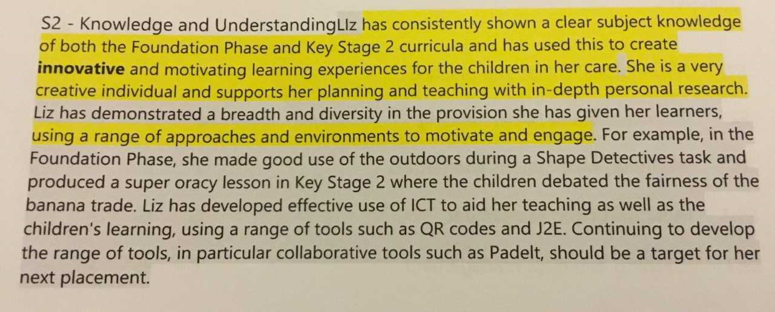

APPENDIX 2

Teacher assessment

Creating an environment that fosters CURIOSITY

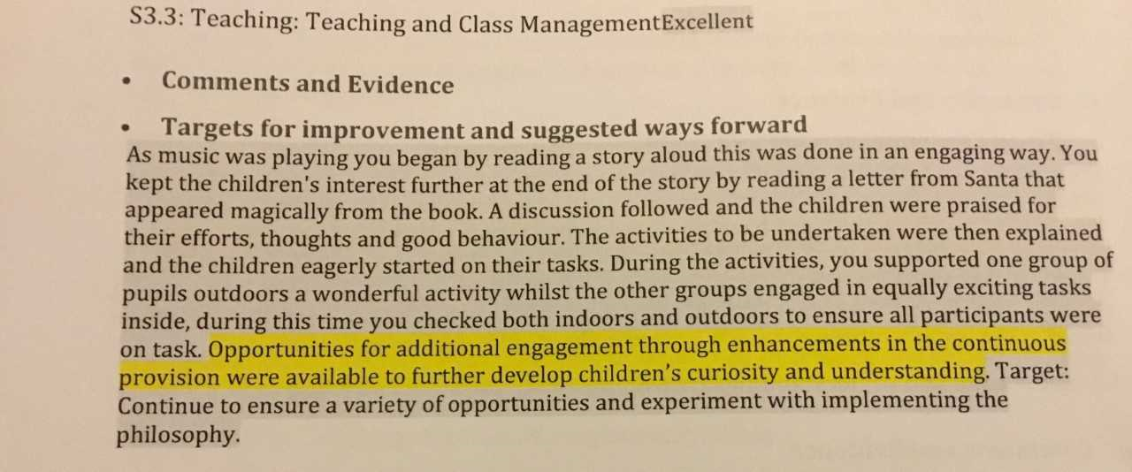

APPENDIX 3

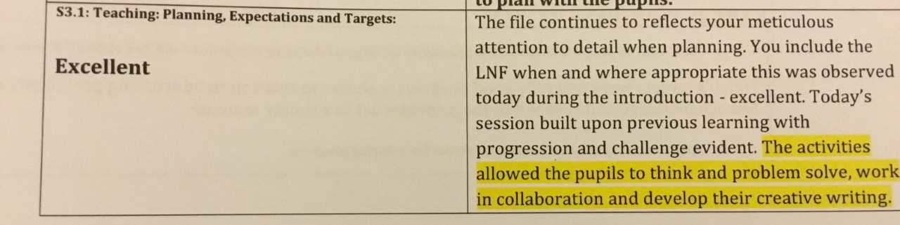

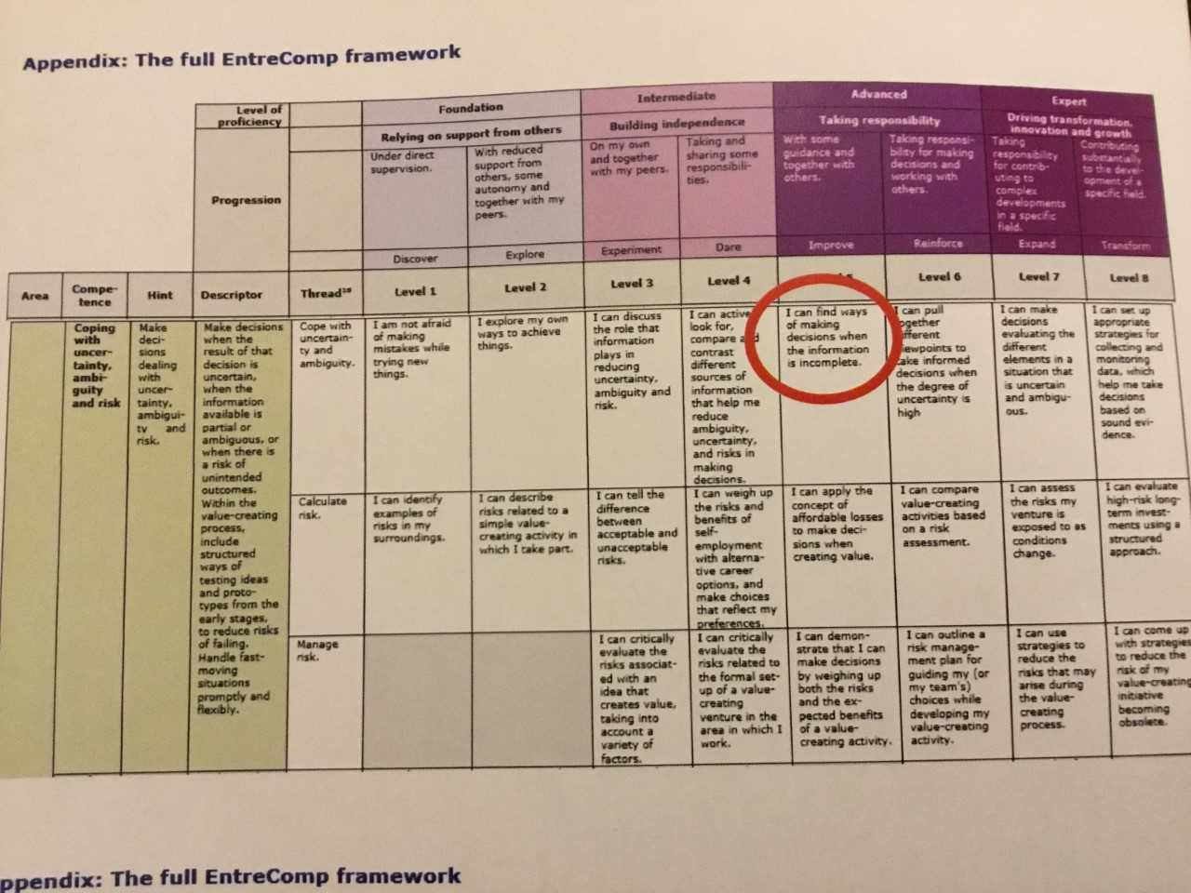
APPENDIX 4

APPENDIX 5

APPENDIX 5

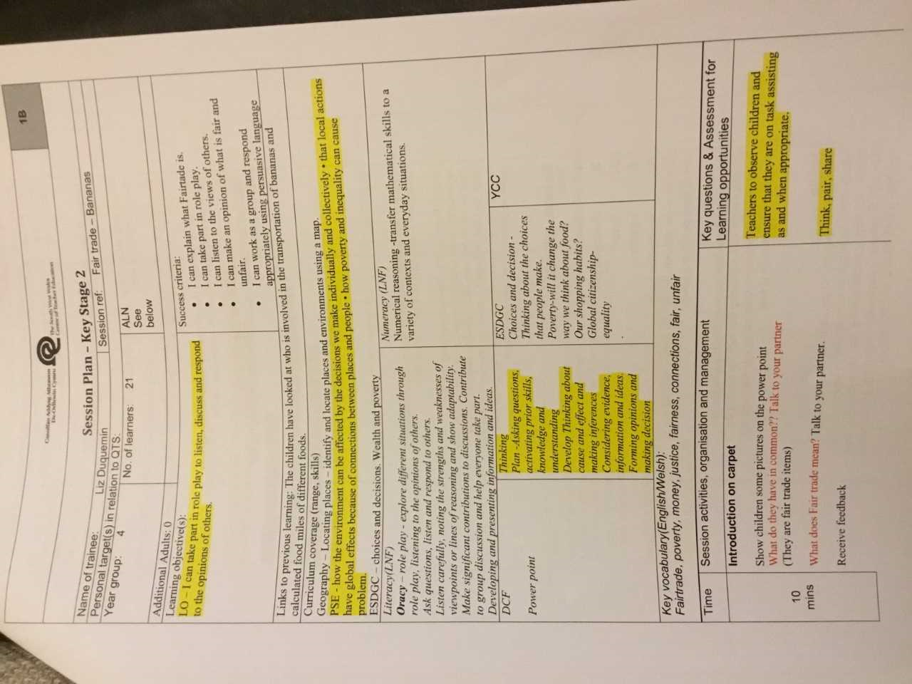

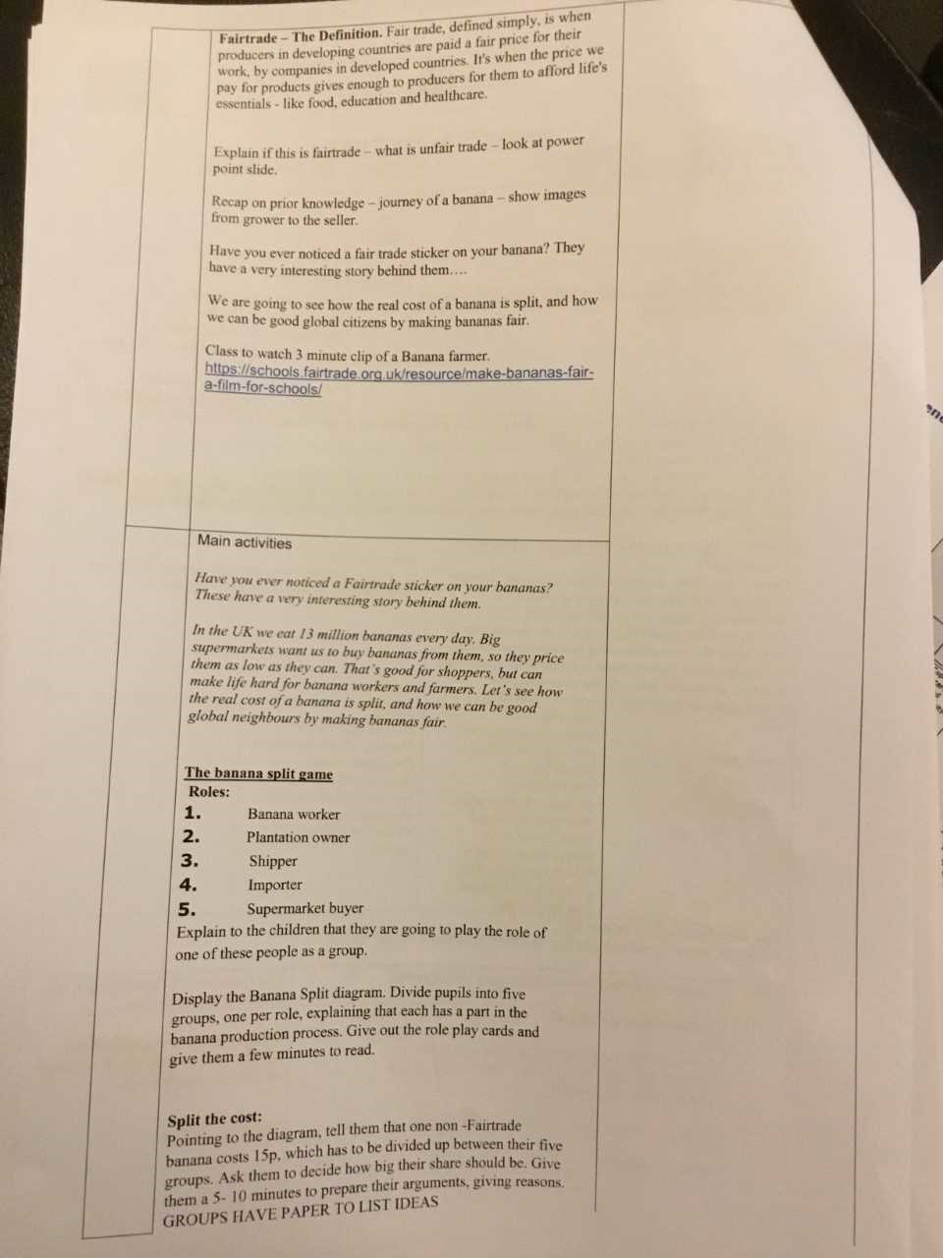
APPENDIX 5

APPENDIX 6

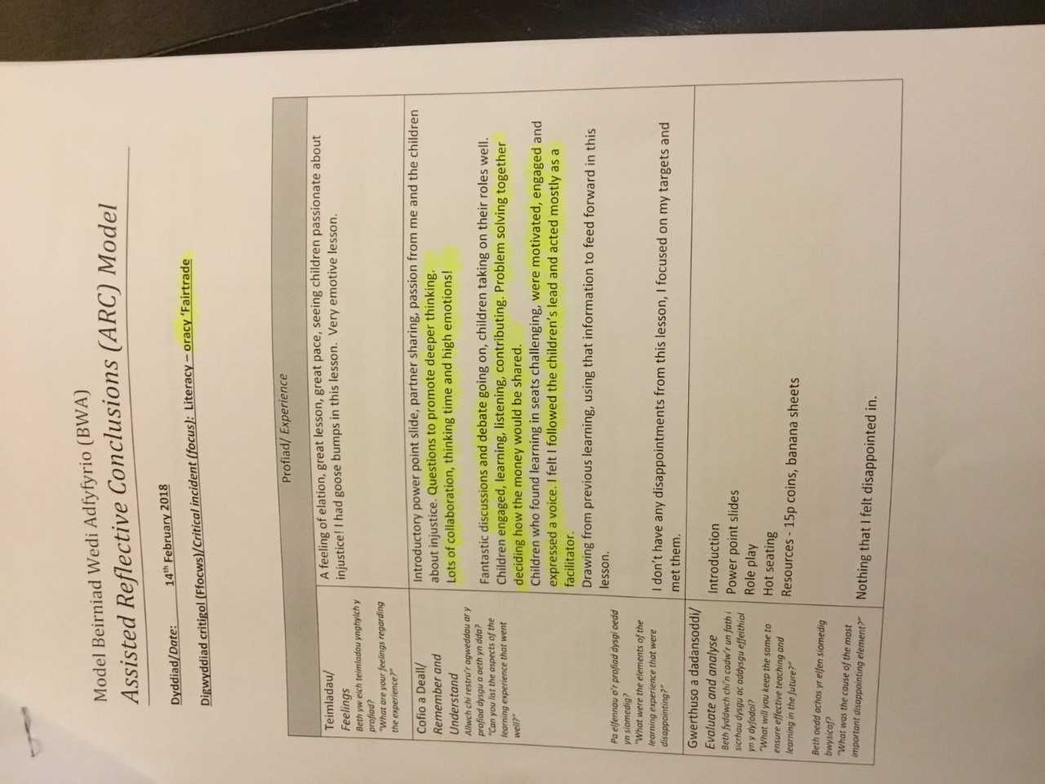
APPENDIX 7
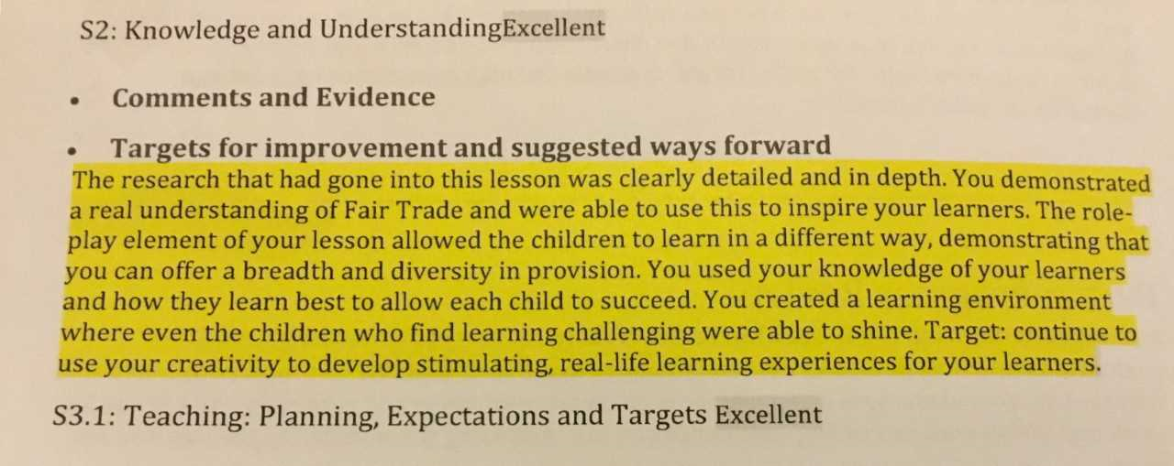

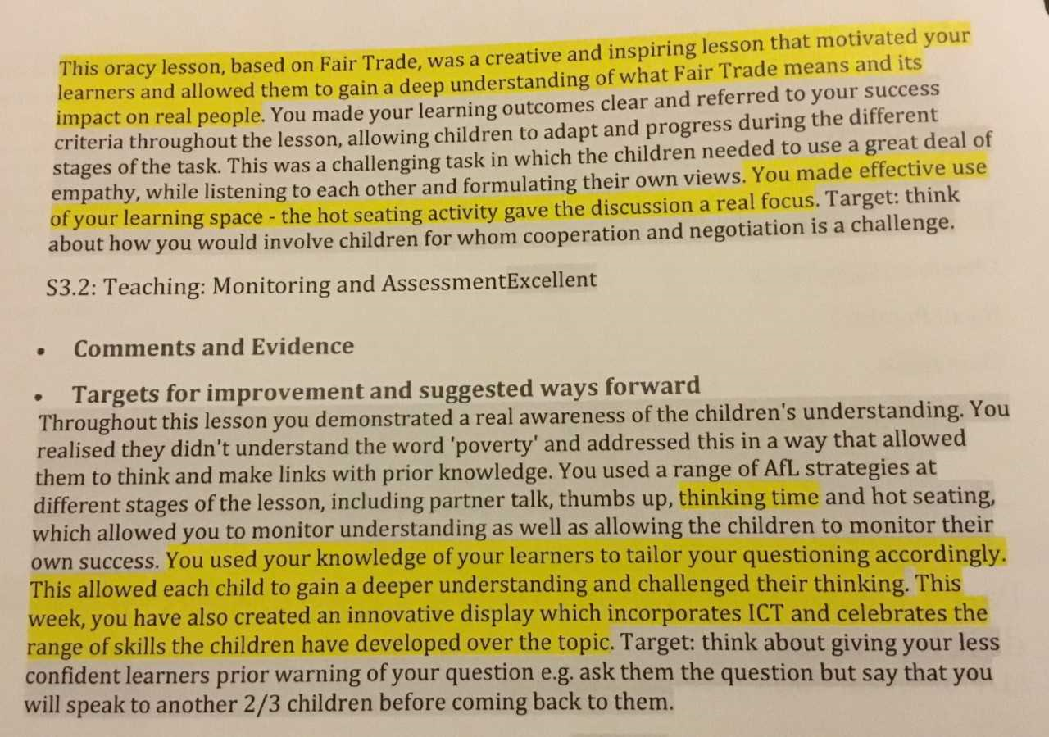

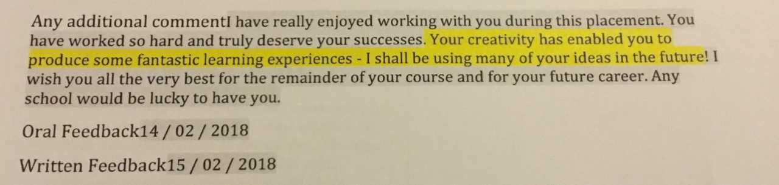

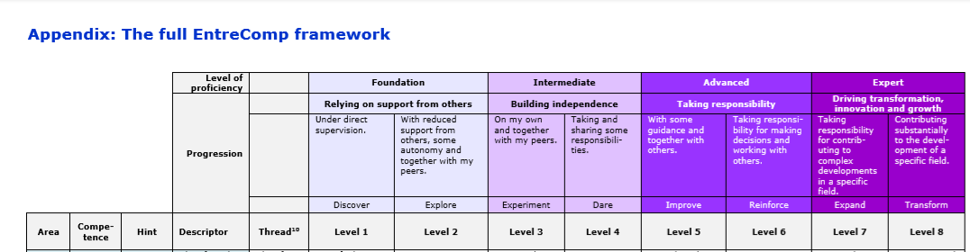
APPENDIX 8

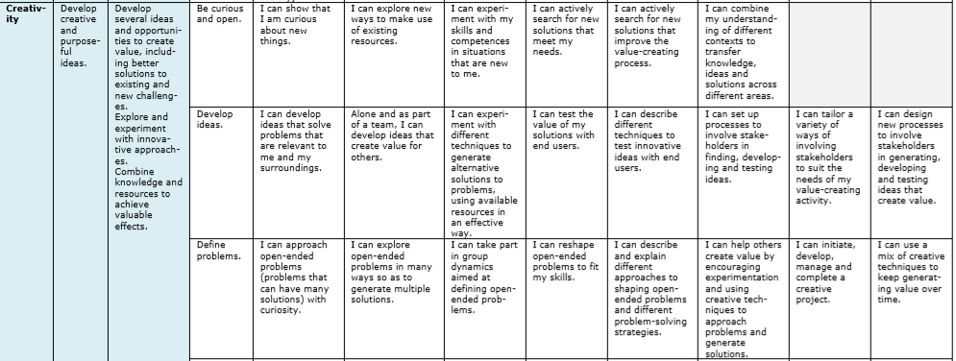
APPENDIX 9
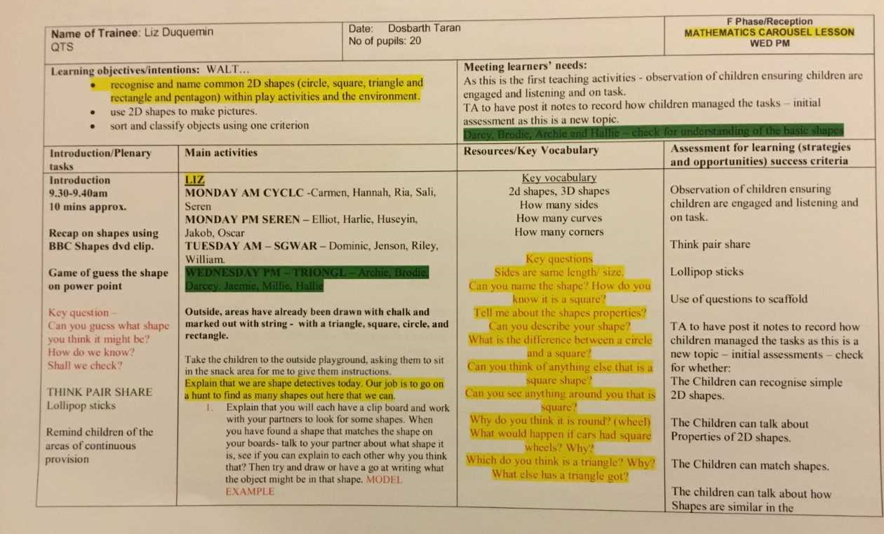
Key questions
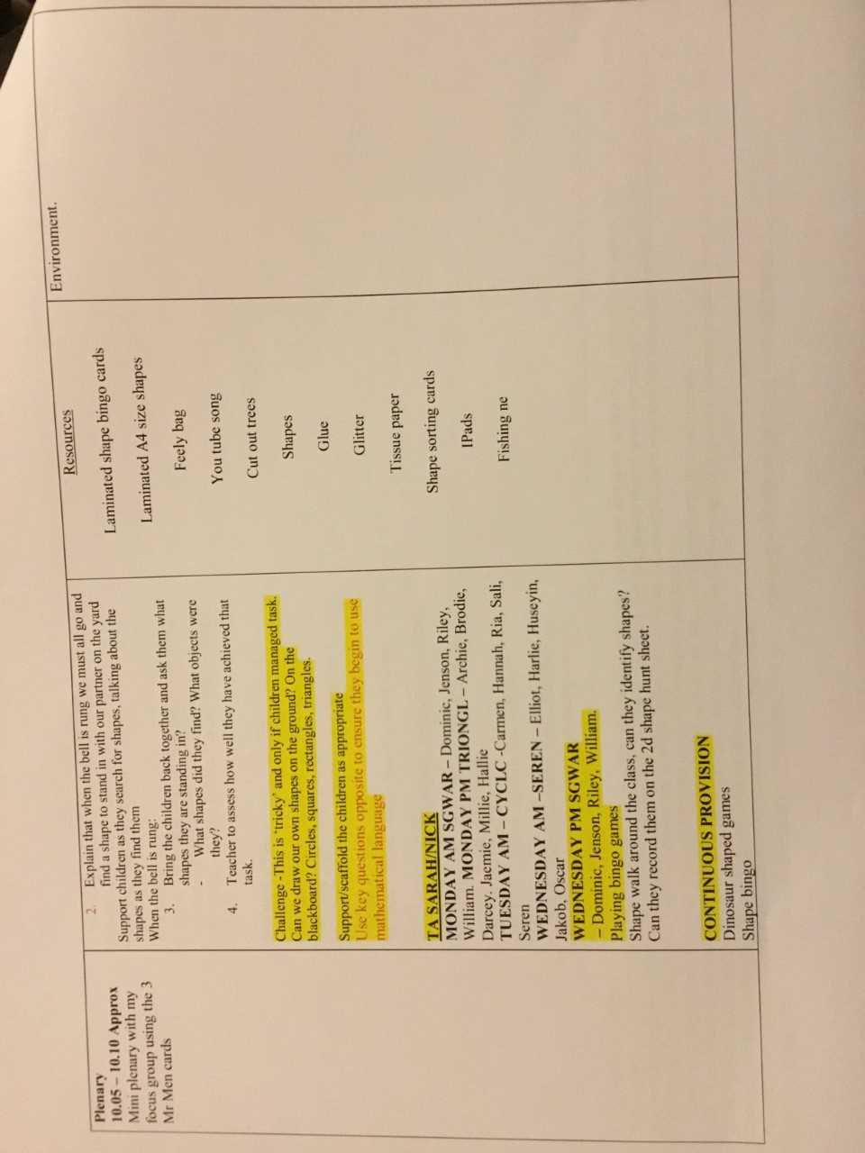
APPENDIX 9

APPENDIX 10

A child recognised that the drain was not just circular, but made up of other shapes, making connections. There was a sense of wonder as she began to call her peers with excitement at what she had discovered. The teacher used that as a springboard to ask the children to explore the remainder of the yard to see if they could make further connections. A further challenge was given – to see on their journey home whether they could see any other shapes that fitted together to make another shape.

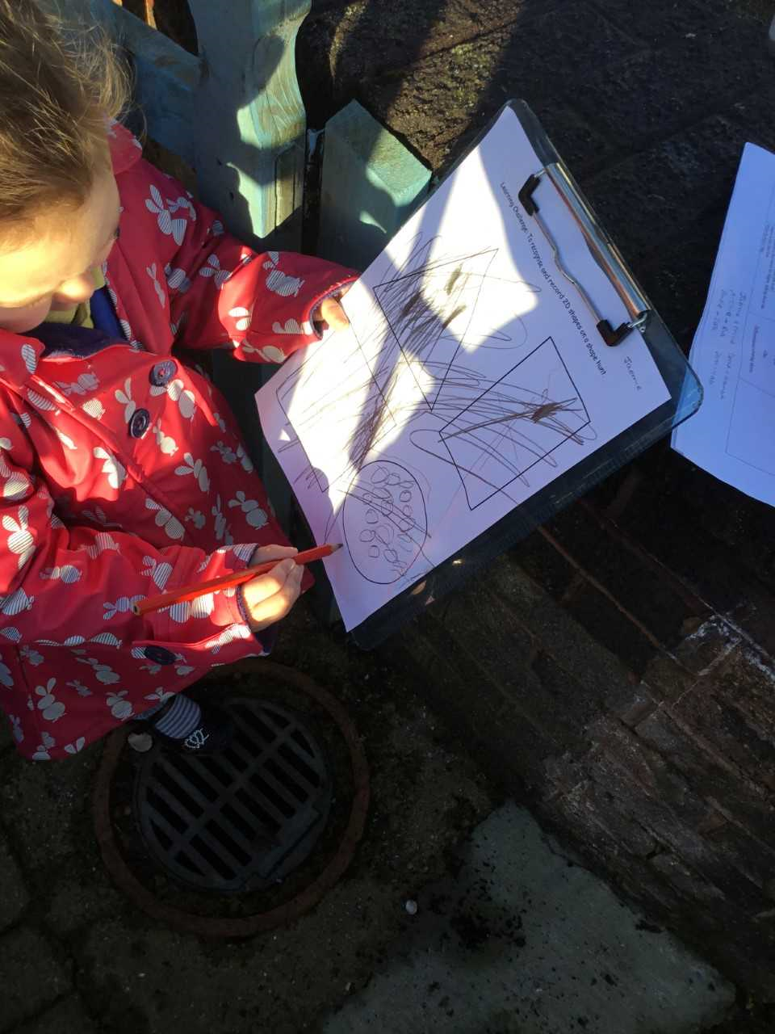

APPENDIX 11
Teacher assessments


