

BMIH6007
International Meetings Management for the Hotel Industry
Event Theme: Equality, Diversity and Inclusion within Industry
Event: International Eid Celebration
Student Name: Salam Al-Masoud
Student ID: 2235444
Lecturer Name: Chris Wilkin
Declaration
I confirm that I have not used any AI tools in the research and creation of this assignment. I confirm that I have not presented any AI-generated materials as my work. I confirm I have copies of my drafts, notes, and other resources I used, which I may be asked to provide in evidence.

Executive Summary
This report analyses an International Eid Celebration event, and its strategic planning and execution. For the workplace inclusion event, Mercure Sheffield St Paul's Hotel & Spa will host 250 foreign participants. Culture and career progress differentiate the event. Assignment 1's feasibility study assessed event potential. Next, the study investigates EMBOK and Maslow's Hierarchy of event planning and execution strategy frameworks. Event delivery depends on attendees, EDI, and logistics. The curriculum will emphasise workplace diversity, networking, professional development, and cultural exchange. A thorough financial research confirms the event's viability, while industry trends indicate an increasing demand for variety. The post ends with situational and cultural issues to satisfy guests and teach global diversity.

Table of Contents
Executive Summary 2
Introduction 4
The Event Cycle 5
Event Concept 7
Aim and Objectives 8
Event Management 9
Event Budget 11
Industry Trends, Issues and Impacts 13
Situational and Cultural Considerations 15
Conclusion and Recommendations 17
References 18
Appendix 21
Marketing 7Ps 21
SWOT Analysis 21
PESTEL Analysis 21
Gantt chart 22

Introduction
The MICE event on the International Eid Celebration theme will highlight EDI's (Equality, Diversity, and Inclusion within Industry) importance in modern enterprises during an event. Global professional learning, networking, and workplace inclusion knowledge exchange are event goals. The Mercure Sheffield St Paul's Hotel & Spa's downtown Sheffield location makes transportation and lodging easy for international travellers. This indoor and outdoor venue is great for multicultural gatherings that encourage diversity and inclusion. A thorough feasibility study examined Assignment 1's event potential. The researcher assessed (A1) market demand, target audience, venue options, resource availability, and budget. The feasibility study investigated these critical components to determine the event's viability, exposing potential impediments and opportunities for informed decision-making and successful event implementation. This paper adds strategic planning and delivery and uses EMBOK, Marketing 7Ps and Maslow's Hierarchy of Needs for event production.

The Event Cycle
EMBOK Event Cycle includes the Initiation, Planning, Execution, and Evaluation stages (Rogers and Wynn-Moylan, 2022). Each planning and delivery stage impacts event success and strategy. Workplace equality, diversity, and inclusion are promoted by International Eid. Examine this with the Event Cycle. From inspiration to analysis, this cycle carefully manages event development.
Initiation Stage: In the Event Cycle's Initiation stage, goals and stakeholder approval are set. This stage evaluates event concept organisation and industry fit (Fenich, 2019). Global industry EDI problems are acknowledged in the International Eid Celebration's Initiation phase. Numerous specialists discuss and show successful EDI strategies at the event. Event support and alignment are sought from sponsors, cultural institutions, and industry leaders. Event feasibility studies assess money, resources, and attendance (Heuchert, 2021). This stage is crucial for event setup. Know your audience and make sure the event meets cultural and professional goals. Initial permissions, venue, and budgets guide the event.
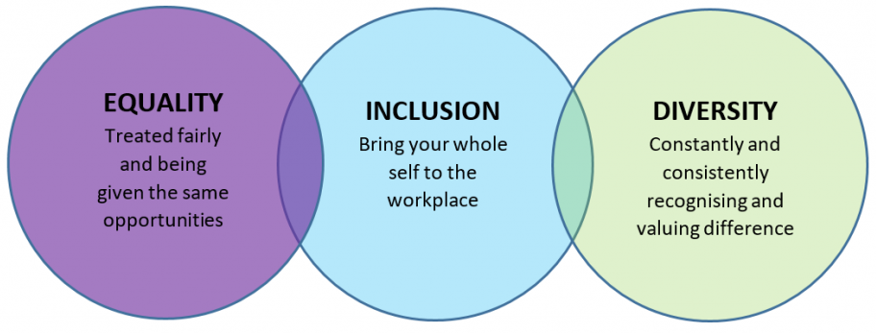
Figure 1: EDI
Source: (Hassanli, Walters and Williamson, 2020)
Planning Stage: Logistics are coordinated for event success during planning, the main step of the Event Cycle. Initiation phase event design aspects are refined in this phase. International Eid preparation encompasses cultural and professional development (Dassah, 2023). EDI-themed keynotes, panels, breakouts, and Eid performances are planned. Foreign delegations are reviewed by diversity and inclusion experts. Halal catering and accessibility are event customs. Plans include marketing tactics. The promotion targets workplace inclusion professionals, businesses, and organisations (Getz and Page, 2019). Promote the event to relevant audiences beforehand. Plan implementation by coordinating food and technology vendors. The organiser evaluates risk thoroughly. Technology, logistical, and last-minute issues may cancel. Contingencies mitigate risks and ensure event success from impediments.
Execution Stage: Event management requires planning, organisation, and prep. This level requires precise planning and teamwork. The International Eid Celebration is run from start to finish (Bowdin et al., 2023). Registration, delegate check-in, and last-minute requests and adjustments are our responsibility. For participant expectations and interests, moderators and presenters address EDI throughout the session. Carefully planned cultural events blend professional conversation with cultural celebration. Event organisers manage food, tech, and venues (Duffy and Mair, 2021). Event time and schedule must be observed for participant enjoyment. Fixing difficulties quickly keeps events on schedule and meets goals. Live attendance is tracked here. Post-session surveys and conversations improve future sessions. The event must respond to real-time needs and challenges since execution tests earlier planning.
Evaluation Stage: Evaluation ends the Event Cycle. This phase compares results to Initiation and Planning goals. Speakers, attendees, and sponsors improve events. How well the International Eid Celebration fostered EDI awareness, networking, and culture will be evaluated. Event satisfaction surveys will emphasise learning and networking. Comparing actual expenses and income to budget will determine financial success (Hassanli, Walters and Williamson, 2020). The evaluation examines logistics and execution. Are any issues affecting the experience? Could future events be arranged better? This analysis will improve event planning and execution by building on past successes.

Event Concept
Cultural and professional development will accompany international Eid delight. The programme promotes equality, diversity, and inclusion (Calver et al., 2023). Eid celebrations and entertaining sessions will encourage workplace diversity and cross-cultural understanding. EDI best practices and cultural interchange will be promoted with Eid-themed keynotes, panel discussions, and interactive workshops.
Time Slot | Event Activity
09:00 AM - 09:30 AM | Registration & Welcome Drinks
09:30 AM - 10:00 AM | Opening Ceremony & Keynote Address by Professor Amina Ba
10:00 AM - 11:00 AM | Panel Discussion: EDI in Global Workplaces
11:00 AM - 12:00 PM | Breakout Sessions on Sector-Specific EDI Strategies
12:00 PM - 01:00 PM | Cultural Lunch: Halal & International Cuisine
01:00 PM - 02:00 PM | Speaker: Dr Tanvi Shah on Business and Diversity
02:00 PM - 03:00 PM | Workshop: Building Inclusive Workplaces
03:00 PM - 04:00 PM | Speaker: Professor John Doe on Corporate Success & EDI
04:00 PM - 05:00 PM | Networking Break and Cultural Activity
05:00 PM - 06:00 PM | Closing Remarks & Future EDI Goals
06:00 PM - 07:00 PM | Gala Dinner & Entertainment
Registration, Welcome Drinks Participants are invited and the day begins at 9:00–09:30 AM. Professor Amina Ba will discuss professional and cultural EDI at the Opening Ceremony. Global EDI integration panel from 10:00 to 11:00 AM. Leading experts will explore removing barriers and creating inclusive spaces (Wolbring and Lillywhite, 2021). Next are sector-specific EDI Breakout Sessions. To encourage cultural understanding, a cultural lunch will feature authentic halal and cosmopolitan food. Dr Tanvi Shah will discuss business success and diversity in the afternoon, followed by an inclusive workplace workshop. Professor John Doe will address how EDI initiatives affect firm performance in the day's last session. Delegates will network, attend cultural events, and contemplate before the Gala Dinner, a delightful and fulfilling conclusion.

Aim and Objectives
Aim
- The International Eid Celebration event aims to offer a platform for professionals to explore and discuss global EDI integration practices.
SMART Objectives
Objective | S | M | A | R | T
Objective 1 | Increase awareness of EDI in workplaces globally. | 80% of attendees report an increased understanding of EDI in surveys. | Global EDI experts and case studies. | Global need for diversity in business practices. | By the end of the event.
Objective 2 | Foster networking and collaboration among industry professionals. | At least 50% of delegates make meaningful professional connections. | Designated networking sessions and workshops. | EDI-focused networking helps build relationships. | During the event.
Objective 3 | Highlight sector-specific best practices for EDI integration. | 3 detailed case studies were presented. | Invitations extended to leading scholars and professionals. | Industry EDI integration is vital for success. | By the end of the event.
Objective 3 | Highlight sector-specific best practices for EDI integration. | 3 detailed case studies were presented. | Invitations extended to leading scholars and professionals. | Industry EDI integration is vital for success. | By the end of the event.

Event Management
Operational Skills and Resources: Effective international Eid Celebration events and resources are needed. Event management must prioritise registration, guest services, and crowd control. Event organisers should streamline registration and check-in, according to Chandler et al. (2023). Large guest lists need halal and vegetarian options. Respecting cultural differences and greeting guests is important. Technical professionals supervise speaker and presentation audio-visual equipment. Set up credentials, programs, signage, presenting tools, and virtual participation. Meeting event accessibility regulations mandate ramps, sign language interpreters, and accessible seating for all guests (Purdy et al., 2023). The event prioritises accessibility and organisation for everyone's safety and enjoyment to meet Maslow's hierarchy of needs, particularly physiological and safety needs (Maslow, 1943). Operational planning makes guests feel welcome and valued, making events memorable.
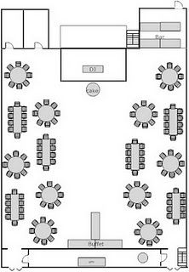
Figure 2: Event Hall Layout
Source: (Chandler et al., 2023)
Planning Skills and Resources: The International Eid Celebration success demands planning. Pre-plan event objectives, speakers, and logistics. Schedule, finance, and venue preparation necessitate project management. Sponsors, hotel personnel, and keynote speakers need strategic coordination. Everyone must communicate well to be on time (Dolasinski et al., 2020). Culture and networking demand flexible scheduling to accommodate participants. Prepare for technical glitches and speaker changes. Through networking and EDI recognition, organisations must address Maslow's hierarchy and participants' social and esteem needs. Planning the opening ceremony to the closing statements encourages inclusivity and professional growth.
Marketing Activities Skills and Resources: International Eid marketing requires planning, innovation, and data analysis (Sun, Zhai and Yang, 2020). The event will be promoted by dedicated digital, traditional, and industry stakeholder marketers. Event marketing will include the 7Ps (Product, Price, Place, Promotion, People, Process, and Physical Evidence) for broad exposure (attached in the appendix). EDI-focused keynote speakers, seminars, and cultural activities will be the 'Product' and tickets and sponsorship packages the 'Price' (Ramkumar, Raja and Kureethara, 2021). Attendance depends on Mercure Sheffield St Paul's Hotel & Spa. The promotion will include email, social media, and organisation links. From speakers to volunteers, 'People' refers to the event's professionals. 'Process' simplifies registration and event participation, while 'Physical Evidence' displays event branding and signs. To evaluate these efforts, marketing must track ticket sales, social media interaction, and attendee feedback (Evanthi and Azhar, 2023). These activities promote the event, meet inclusivity and professional development goals, and satisfy Maslow's higher-order needs of esteem and self-actualization by bringing industry leaders to the global EDI discourse.
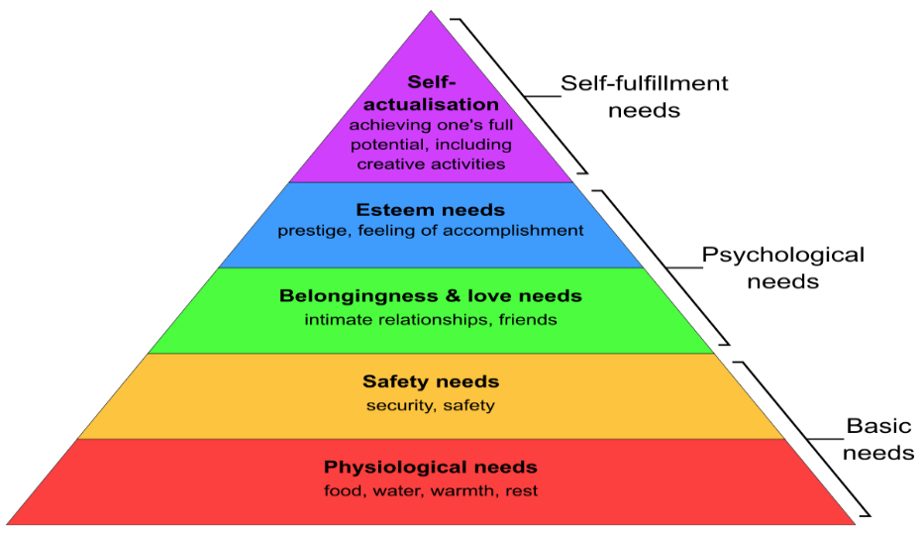
Figure 3: Maslow's hierarchy of needs
Source: (Purdy et al., 2023)

Event Budget
The International Eid Celebration budget shows income, expenses, and profit. Sponsorships and ticket sales fund the event. 250 £100 tickets raise £25,000. Additionally, four £1,000 sponsors raise £4,000. Event expenditures and profit total £29,000. A thorough event cost analysis highlights key areas. The Mercure Sheffield St Paul's Hotel & Spa charges the most for events at £5,000. Next, £10,000 for 250-person catering. Foreign and halal food for ethnic and dietary needs is supplied (Rogers and Wynn-Moylan, 2022). Awarding keynote, panellist, and workshop leaders £4,500 is another major expense. Advertising, social media, and materials will cost £2,000 to promote the event. Management, volunteers, and coordinator provide event workers £2,500. Short-notice event signage, décor, and supplies cost £3,000. With £27,000 invested, the event should make £2,000, exhibiting budget stability. This positive margin means the event was profitable and will fund future events.
Income | Amount
Ticket Sales (250 guests @ £100) | £25,000
Sponsorships (4 sponsors @ £1,000) | £4,000
Total Income | £29,000
Expenditure | Amount
Venue Rental | £5,000
Catering (for 250 guests) | £10,000
Speaker Fees | £4,500
Marketing and Promotion | £2,000
Event Staffing | £2,500
Miscellaneous Costs | £3,000
Total Expenditure | £27,000
Net Profit | £2,000

Industry Trends, Issues and Impacts
New trends and concerns affect event planning and execution, including the International Eid Celebration. Event success and landscape adaptability require knowing these elements.
Rise of Hybrid Events: Major event trend: hybrid. This trend integrates local and remote visitors' in-person and virtual interactions. According to Eventbrite (2025), 67% of event planners want hybrid events after the pandemic. Event planning requires more advanced live broadcasting, interaction, and virtual networking technology. Remote involvement in the International Eid Celebration could make it more engaging.
Focus on Sustainability and Green Events: Sustainability is essential in events. lboro.ac.uk (2024) indicates that 60% of event organisers value sustainability, waste minimisation, and eco-friendly solutions. As environmental concerns grow, event planners must reduce carbon emissions. This might include using digital tickets to reduce paper waste, finding a sustainable location, and serving plant-based International Eid Celebration meals. Recycling and reducing single-use plastic can boost the event's social responsibility.
Demand for Personalization and Experiential Events: Other event trends include personalisation and immersion. Meet-cambridge.com (2019) found that 75% of eventers seek unique experiences. Event planners value interactive customisation. Seminars and cultural events could interest guests at the International Eid Celebration. Event customisation and industry-specific networking can satisfy Maslow's social and esteem needs.
Integration of Technology and Event Automation: Technology changes event management. Speakeragency.co.uk (2024) estimates that 84% of event planners use technology to optimise operations. Event management, apps, and audience participation. Event apps enable international Eid Celebration registration, real-time information, interactive components, and networking. Automating guest lists, attendance, and reminders simplifies gatherings. AR and VR create immersive, interactive environments that fit modern visitor expectations, increasing tourist engagement.
Increased Emphasis on Diversity, Equity, and Inclusion (EDI): Events must prioritise EDI, with a growing emphasis on inclusive settings. 85% of millennials choose diverse and inclusive events, reports Getz and Ziakas (2023). Event organisers emphasise diversity and poverty to achieve this criteria. The International Eid Celebration follows this EDI/Eid trend. Global diversity, diverse speakers, and inclusive attendance promote workplace and community discourse.
Industry advances enable the International Eid Celebration to prosper and stay relevant. By modifying participation, hybrid events may boost accessibility and reach. Sustainability may improve the event's reputation and environment. Event customisation and experiential components fulfil increased demand for bespoke experiences (Stadler, Walters and Jepson, 2022). Automation and tech improve event efficiency and engagement. Finally, the event's focus on diversity, equity, and inclusion aligns with global diversity efforts, making it relevant for leaders.

Situational and Cultural Considerations
Successful International Eid Celebrations involve cultural and situational factors. These traits vary by event culture and other circumstances. SWOT, PESTEL, and SOAR found these (attached in the appendix).

Figure 4: Situational and Cultural Considerations
Source: (Sun, Zhai and Yang, 2020)
Cultural Sensitivity and Inclusivity: Muslim festivity Worldwide, Eid is celebrated. Religious holiday culture must be understood. Cultural inclusion requires understanding Eid rituals. Cultural insensitivity can alienate, diminish involvement, and create negative perceptions, according to SWOT under "Threats". The event must reflect Muslim principles and welcome diverse cultures for diversity (Rossetti, 2023). Cultural entertainment, unusual food, and Eid interpretation seminars distinguish the "Global Muslim Community Festival".
Economic Considerations and Budget Constraints: Budgeting and planning are essential for event success. Budgeting determines event size and quality. The "Economic" PESTEL analysis includes this. Ticket prices, sponsorships, and cost management are economic factors. Know target audience economics and seek sponsorships/partnering (Ghaderi et al., 2023). Tiered pricing or exclusive packages provide event rivals with an income and guest value advantage. At the International Eid Celebration, brand sponsorships may balance accessibility with profitability.
Political and Regulatory Factors: Politics, permissions, and laws affect event planning. "Political" PESTEL stressed this. Event hosts must follow local security, permit, and safety laws. Avoid delays and legal difficulties by understanding local politics (Azara, Pappas and Michopoulou, 2023). Staying attentive and adaptive helps event industry competitors face local regulation or regulatory changes. Political and regulatory changes may impair law compliance preparations for the International Eid Celebration. It can also distinguish the event by showing local and national legislation compliance.
Technological Integration: Virtual and hybrid events use more technology. SWOT showed "Opportunities". Registration apps, live broadcasting, and virtual interaction boost guest experience. Competitive advantages include integrated, engaging in-person and virtual experiences (Wolbring and Lillywhite, 2021). Competitors like the "World Eid Festival" offer virtual Eid prayers, workshops, and networking. The International Eid Celebration will update, access, and create participant experiences with sophisticated technologies, increasing reach and participation.
Social Trends and Attendee Expectations: Planning an event needs socialising and altering visitor expectations. SOAR placed this under "Opportunities". Modern eventers seek customisation, interactivity, and purpose. Social trends demonstrate growing ethics and environmental concerns (Sun, Zhai and Yang, 2020). Competitive events like "The Eid International Conference" promote sustainability, community, and global education. The International Eid Celebration may exceed visitor expectations by personalising experiences, using data to adapt programming, and fostering sustainability. This would exceed audience expectations and show accountability and foresight.

Conclusion and Recommendations
Industry leaders will debate workplace equality, diversity, and inclusion at the International Eid Celebration. The event will teach how to create inclusive and varied workplaces through smart event management, thorough preparation, and cultural immersion. Through keynote speakers, panel discussions, and cultural activities, experts will share best practices and innovative ideas. Events flourish when they attract people, build professional relationships, and promote industry-wide EDI. Making the event inclusive and relevant boosts its impact. Culture can enhance the celebration's appeal and global EDI leadership. The International Eid Celebration's thrilling and informative event supports inclusive, diverse, and equitable workplaces for industry professionals and their communities.

References
Azara, I., Pappas, N. and Michopoulou, E. (2023). Event Innovation and Resilience During Times of Uncertainties : University of Derby Repository. Derby.ac.uk. [online] doi:https://repository.derby.ac.uk/download/848d261e66801f9853d29eb704cce121184c3d06bab43e916e542d02d83779e8/99956/EM%2027%234%20pp%20477-480.pdf.
Bowdin, G., Allen, J., O’toole, W., Harris, R. and Mcdonnell, I. (2023). Events management. Oxford: Butterworth-Heinemann.
Calver, J., Dashper, K., Finkel, R., Fletcher, T., Lamond, I.R., May, E., Ormerod, N., Platt, L. and Sharp, B. (2023). The (in)visibility of equality, diversity, and inclusion research in events management journals. The (in)visibility of equality, diversity, and Inclusion Research in Events Management Journals, pp.1–25. doi:https://doi.org/10.1080/19407963.2023.2228820.
Chandler, S., Fearnshaw, D., Fisher, O., Jones, E. and Kanza, S. (2023). Reflections on an EDI Survey of UK-Government-Funded Research Networks in the UK. NOISE-CON proceedings, [online] 265(5), pp.2519–2526. doi:https://doi.org/10.3397/in_2022_0354.
Dassah, S.S. (2023). Event planning: Crafting the perfect Chale Wote Street Art Festival atmosphere; How event planners are making a memorable event. Handle.net. [online] doi:https://hdl.handle.net/10037/29607.
Dolasinski, M.J., Roberts, C., Reynolds, J. and Johanson, M. (2020). Defining the Field of Events. Journal of Hospitality & Tourism Research, 45(3), p.109634802097826. doi:https://doi.org/10.1177/1096348020978266.
Duffy, M. and Mair, J. (2021). Future trajectories of festival research. Tourist Studies, 21(1), p.146879762199293. doi:https://doi.org/10.1177/1468797621992933.
Evanthi, A. and Azhar, R.M. (2023). Planning and Implementation of Event Marketing in Sociopreneurship. International Journal of Science, Technology & Management, [online] 4(6), pp.1451–1459. doi:https://doi.org/10.46729/ijstm.v4i6.1003.
Eventbrite (2025). Discover Eid Events & Activities in United Kingdom | Eventbrite. [online] Eventbrite. Available at: https://www.eventbrite.com/d/united-kingdom/eid/ [Accessed 15 Feb. 2025].
Fenich, G.G. (2019). Meetings, expositions, events, and conventions : an introduction to the industry. Ny, Ny: Pearson.
Getz, D. and Page, S.J. (2019). Event Studies : theory, Research and Policy for Planned Events. 4th ed. London: Routledge.
Getz, D. and Ziakas, V. (2023). Cases For Event Management and Event Tourism. Goodfellow Publishers Ltd.
Ghaderi, Z., Abdollahi, A., Fatemeh Shekari, Walker, M. and Niloufar Farrokhzad (2023). A Bibliometric Analysis of the Event Industry. Event Management, 27(5), pp.781–807. doi:https://doi.org/10.3727/152599523x16836740488013.
Hassanli, N., Walters, T. and Williamson, J. (2020). ‘You feel you’re not alone’: how multicultural festivals foster social sustainability through multiple psychological sense of community. Journal of Sustainable Tourism, 29(11-12), pp.1–18. doi:https://doi.org/10.1080/09669582.2020.1797756.
Heuchert, M. (2021). Event Information Systems: A Process and Data Reference Model for Event Management. Routledge.
lboro.ac.uk (2024). Creating an inclusive environment during Ramadan | Equity, Diversity and Inclusion | Loughborough University. [online] Lboro.ac.uk. Available at: https://www.lboro.ac.uk/equity-diversity-inclusion/edi-me/inclusive-ramadan/ [Accessed 14 Feb. 2025].
Meet-cambridge.com (2019). Equity, Diversity and Inclusion (EDI) in Events. [online] Meet-cambridge.com. Available at: https://www.meet-cambridge.com/events-services/sustainable-events-toolkit/equity-diversity-and-inclusion-edi-in-events/ [Accessed 16 Feb. 2025].
Purdy, E., Symon, B., Marks, R.-E., Speirs, C. and Brazil, V. (2023). Exploring equity, diversity, and inclusion in a simulation program using the SIM-EDI tool: the impact of a reflexive tool for simulation educators. Advances in Simulation, 8(1). doi:https://doi.org/10.1186/s41077-023-00250-7.
Ramkumar, U.V., Raja, M.A.S. and Kureethara, J.V. (2021). Organisational Agility and 7Ps of the Marketing Mix for the Post-COVID-19 Period: A Case Study of the Indian Informal Food Sector. SSRN Electronic Journal. doi:https://doi.org/10.2139/ssrn.3905082.
Rogers, T. and Wynn-Moylan, P. (2022). Conferences and conventions : a global industry. 4th ed. Abingdon ; New York: Routledge, Cop.
Rossetti, G. (2023). Applying Kolb’s experiential learning theory to an event management course: practical guidelines for educators. Event Management, 27(7). doi:https://doi.org/10.3727/152599523x16896548396752.
Speakeragency.co.uk (2024). The Importance of Diversity and Inclusion in Event Planning. [online] Speaker Agency. Available at: https://www.speakeragency.co.uk/blog/the-importance-of-diversity-and-inclusion-in-event-planning [Accessed 16 Feb. 2025].
Stadler, R., Walters, T. and Jepson, A. (2022). SUSTAINABLE HUMANS: A FRAMEWORK FOR APPLYING SUSTAINABLE HRM PRINCIPLES TO THE EVENTS INDUSTRY. Event Management, 26(8). doi:https://doi.org/10.3727/152599522x16419948694757.
Sun, L., Zhai, X. and Yang, H. (2020). Event marketing, movie consumers’ willingness and box office revenue. Asia Pacific Journal of Marketing and Logistics, ahead-of-print(ahead-of-print). doi:https://doi.org/10.1108/apjml-09-2019-0564.
Wolbring, G. and Lillywhite, A. (2021). Equity/Equality, Diversity, and Inclusion (EDI) in Universities: the Case of Disabled People. Societies, 11(2), p.49. doi:https://doi.org/10.3390/soc11020049.

Appendix

Marketing 7Ps
7Ps | Description
Product | - The event's offerings, including workshops, cultural activities, and keynote speakers focused on EDI (Stadler, Walters and Jepson, 2022).
Price | - Ticket costs and sponsorship packages for attendees and partners.
Place | - The venue, Mercure Sheffield St Paul’s Hotel & Spa, serves as the location.
Promotion | - Marketing strategies, including social media, email campaigns, and partnerships.
People | - Event staff, speakers, and volunteers are involved in organizing and attending.
Process | - Seamless registration, event participation, and feedback collection.
Physical Evidence | - Event branding, signage, and materials that reflect the theme of inclusivity (Ramkumar, Raja and Kureethara, 2021).

SWOT Analysis
Factor | Description
Strengths | - Cultural relevance, diverse offerings, and inclusivity.
Weaknesses | - Budget constraints and reliance on sponsorships.
Opportunities | - Technological integration, hybrid formats, and global reach (Purdy et al., 2023).
Threats | - Cultural misunderstandings, political regulation changes, and economic downturns.

PESTEL Analysis
Factor | Description
Political | Regulatory compliance and local government policies.
Economic | - Financial planning, sponsorship, and ticket sales.
Social | - Attendee expectations for inclusivity, sustainability, and engagement (Heuchert, 2021).
Technological | - Use of technology for virtual/hybrid events and attendee engagement.
Environmental | - Sustainability considerations, such as eco-friendly practices.
Legal | - Ensuring the event meets all legal and safety requirements.

Gantt chart
Tasks | Weeks
Tasks | 2 | 4 | 6 | 8 | 10 | 12 | 14 | 16 | 18 | 20 | 22 | 24
Event Concept Development | X | X | X
Budgeting and Funding | X | X
Venue Selection and Confirmation |  | X | X | X
Marketing Plan Development |  | X | X | X | X
Sponsorship and Partnership Outreach |  |  | X | X | X | X
Speaker Invitations and Confirmations |  |  |  | X | X | X | X
Ticket Sales and Registration |  |  |  | X | X | X | X | X
Event Materials and Supplies |  |  |  |  | X | X | X
Finalizing Event Schedule |  |  |  |  |  | X | X | X
On-Site Setup and Preparation |  |  |  |  |  |  | X | X | X
Event Execution |  |  |  |  |  |  |  | X | X | X | X
Post-Event Evaluation and Reporting |  |  |  |  |  |  |  |  | X | X | X

