

Table of Contents

1.0 Introduction
2.0 Key Functions of Operating Systems
2.1 Process Management
2.2 Memory Management
2.3 File System Management
2.4 Device Management
2.5 User Interface
2.6 Security and Access Control
2.7 Networking
3.0 Windows OS CLI Commands
3.1 Process Management
3.2 File and Directory Management
3.3 Network Monitoring
3.4 User Management and Task Scheduling
3.5 Additional Commands
4.0 Linux OS CLI Commands
4.1 Process Management
4.2 File Management
4.3 Network Commands
4.4 User Management and Task Scheduling
4.5 Additional Commands
5.0 Windows OS Scripting
5.1 Batch Script — Disk Space Logger
5.2 PowerShell Script — Process Monitor
6.0 Linux OS Scripting
6.1 Bash Script — Automated Backup
6.2 Bash Script — CPU/Memory Monitor
7.0 Windows vs Linux: Comparison
8.0 Conclusion
9.0 References
Appendix A Screenshot Evidence
Appendix B CPD Evidence
Appendix C Lecture and Tutorial Logs
Appendix D AI Interaction Transcript

1.0 Introduction
Operating systems (OS) are fundamental software layers that manage hardware and software resources within a computer system. They act as an intermediary between the user and the physical hardware, enabling applications to run efficiently and reliably [1], [2]. Modern operating systems such as Microsoft Windows and Linux support multitasking, memory allocation, process scheduling, file system management, and security all of which are critical to stable and responsive system performance [1], [2].
This report explores the key functions of operating systems and provides a practical demonstration of command-line interface (CLI) usage and scripting in both Windows and Linux environments. It also highlights similarities and differences between the two platforms in terms of usability, flexibility, and automation capabilities [3], [4].
This report has been written independently by the author using academic and official sources. Generative AI tools were used only to support understanding of some concepts and to check grammar and clarity of language. All information has been verified against reliable academic and industry references, and no AI-generated text has been used directly in the report.
The report is structured into nine main sections. Section 2.0 discusses the key functions of operating systems. Sections 3.0 and 4.0 present practical demonstrations of CLI commands in Windows and Linux. Sections 5.0 and 6.0 focus on scripting in both environments, followed by a comparison in Section 7.0.

2.0 Key Functions of Operating Systems

2.1 Process Management
The OS manages the execution of multiple concurrent processes by allocating CPU time through scheduling algorithms [1], [2]. Without process management, competing programs would conflict over processor resources, causing crashes or unresponsive behaviour. Round-robin scheduling assigns equal time slices (called quanta) to each process in a cyclic order, ensuring no single process monopolises the CPU and all active tasks make progress. Priority scheduling assigns numeric priority levels to processes, executing higher-priority tasks first this is essential in real time systems such as industrial control or medical equipment, where certain tasks must complete within strict time constraints [2].
Figure 1 below shows the Windows Task Manager, which provides a real-time visual of process management, displaying CPU and memory usage per process.

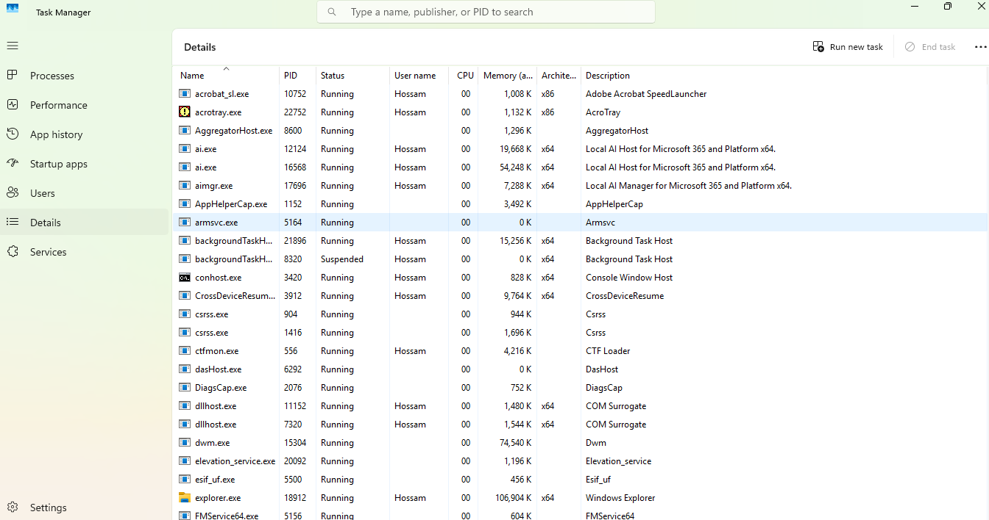Figure 1: Windows Task Manager — Processes tab showing active processes, CPU usage, and memory allocation.

2.2 Memory Management
Memory management is one of the most critical OS functions, as it determines how efficiently applications share the available physical RAM [1], [2]. The OS allocates memory to each process in isolated segments, preventing one application from reading or overwriting another's data a protection mechanism that prevents both crashes and security exploits such as buffer overflow attacks.
When physical RAM is fully utilised, the OS employs virtual memory: a technique that reserves a portion of the hard drive called the page file on Windows, or swap space on Linux as an extension of RAM [1]. The OS transparently moves inactive memory pages to disk (paging out) and retrieves them when needed again (paging in). This allows a machine with, for example, 8 GB of physical RAM to run workloads that collectively require 12 GB, by temporarily offloading inactive data. However, excessive paging known as thrashing severely degrades performance because disk access is orders of magnitude slower than RAM access [2]. The OS therefore uses page replacement algorithms such as Least Recently Used (LRU) to decide which pages to swap out, minimising unnecessary I/O [1].
Figure 2 below shows the Linux System Monitor displaying RAM and swap space usage in real time.

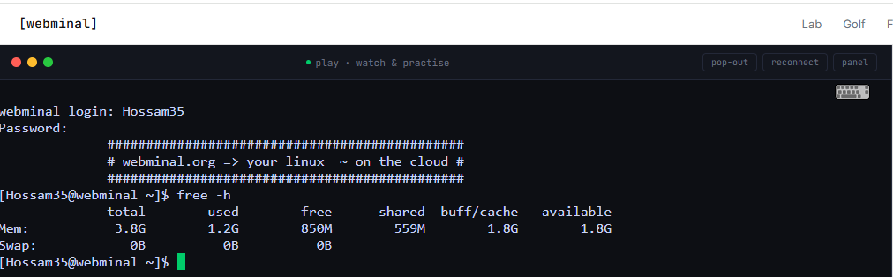Figure 2: Linux System Monitor — Memory tab showing RAM usage and swap space utilisation.

2.3 File System Management
Operating systems provide hierarchical file systems for organising, storing, and retrieving data [4], [7]. Windows uses NTFS (New Technology File System), which supports journaling (recording changes before committing them, protecting against corruption on power failure), file-level encryption via EFS, and granular access control lists (ACLs). Linux primarily uses ext4, offering fast write performance and reliable journaling, or btrfs, which adds snapshotting, data checksumming, and self-healing capabilities [4]. Both systems enforce access control: Windows uses owner/group/ACL permissions managed through Active Directory or local policy, while Linux uses the traditional rwx (read/write/execute) model applied per owner, group, and other users [1].

2.4 Device Management
Device drivers translate between the OS kernel and hardware components such as printers, network cards, and storage devices [2]. The OS communicates with hardware through a Hardware Abstraction Layer (HAL), which standardises hardware interactions so application software does not need to be rewritten for different hardware models. When a device driver is absent or outdated, the OS cannot communicate with the hardware, producing errors this is why driver updates are a routine part of system maintenance. Both Windows and Linux include mechanisms for automatic driver detection (Plug and Play) and provide repositories or update services for obtaining certified drivers [2], [1].

2.5 User Interface
Both Windows and Linux provide Graphical User Interfaces (GUI) for ease of use and Command-Line Interfaces (CLI) for advanced control [3]. The CLI is particularly powerful for scripting, remote server administration, and automation: commands can be combined using pipes (|), redirected to files, and scheduled to run unattended capabilities that GUI interactions cannot replicate efficiently [5]. On Linux, the CLI is the default tool for server administration; on Windows, PowerShell has progressively closed the gap, offering a rich scripting environment with access to the full .NET framework [5].

2.6 Security and Access Control
OS security mechanisms include user authentication (passwords, biometrics, multi-factor authentication), authorisation (permissions, role-based access control), and auditing (event logging) [5], [7]. Windows employs User Account Control (UAC) to prevent unauthorised privilege escalation, requiring explicit confirmation before administrative actions are performed. Enterprise environments integrate with Active Directory for centralised identity management. Linux enforces user and group permissions at the file system level, and supports Mandatory Access Control frameworks such as SELinux and AppArmor, which confine processes to specific allowed behaviours even if an attacker gains access [7].

2.7 Networking
The OS implements the TCP/IP networking stack, enabling communication between devices over local and wide-area networks [6]. Both Windows and Linux include built-in tools for configuring network interfaces, managing firewall rules (Windows Firewall / iptables or nftables), and hosting or accessing services such as DNS, DHCP, HTTP, and SSH. The networking subsystem handles packet routing, connection state management, and protocol negotiation transparently from the perspective of application software, allowing developers to write network-aware applications without managing raw sockets [6].

3.0 Windows OS CLI Commands
Windows provides two CLI environments: Command Prompt (cmd.exe), a legacy interpreter for Batch commands, and PowerShell, a modern object-oriented shell [3], [5]. The following twelve commands demonstrate key administrative tasks, with screenshots of each command and its output as practical evidence [10].

3.1 Process Management
tasklist :lists all active processes, their PIDs, session names, and memory usage [3]:
tasklist

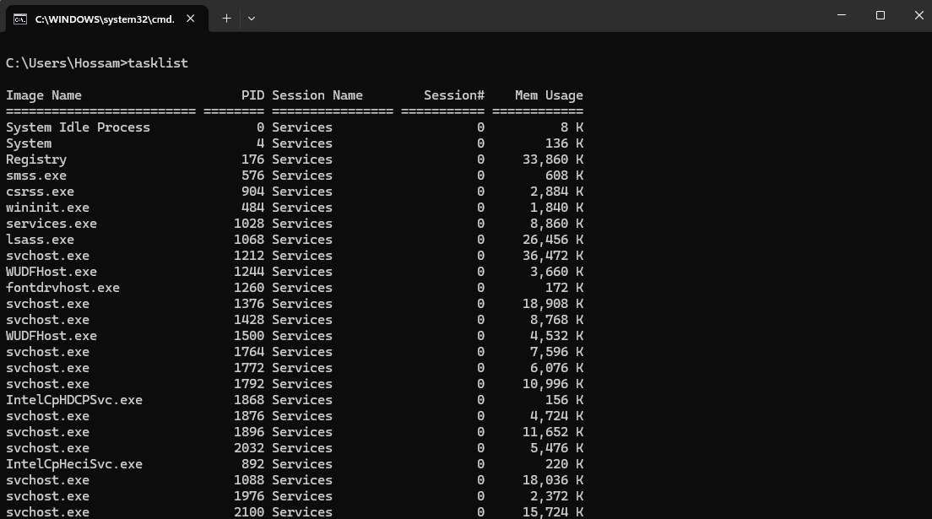
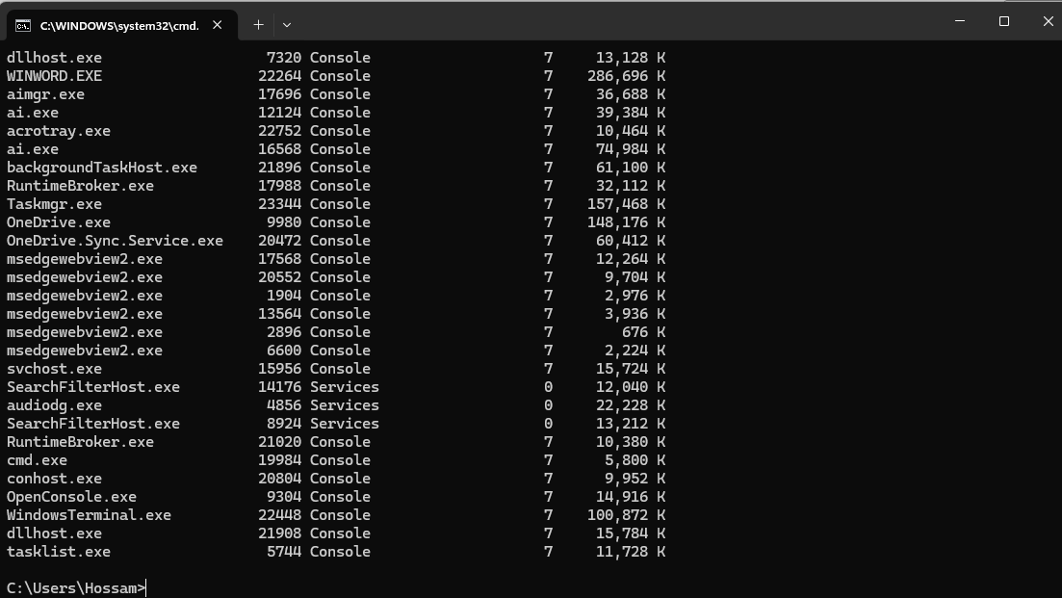Figure 3: Windows Command Prompt — tasklist output showing all active processes and memory usage.

taskkill /PID /F — forcibly terminates a process by its Process ID [3]:
taskkill /PID 1234 /F
The /F flag sends a forced kill signal, bypassing any graceful shutdown handler. This is useful for terminating frozen or unresponsive processes that do not respond to normal close requests.

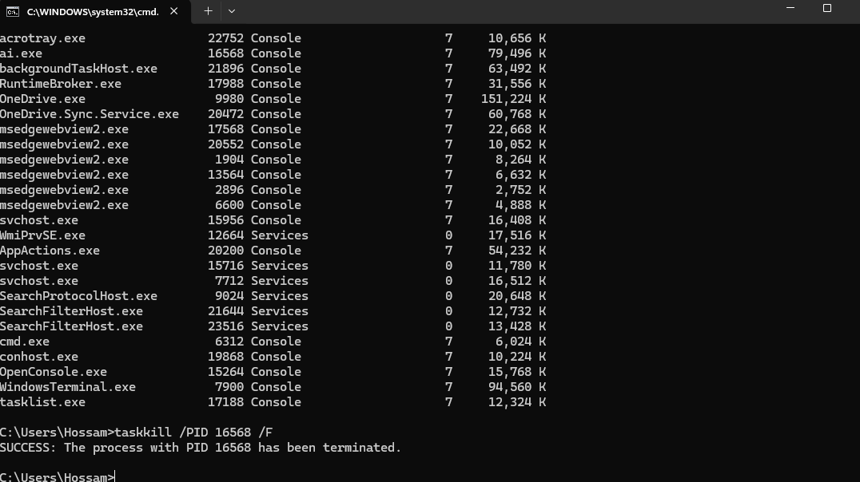Figure 4: Windows Command Prompt — taskkill /PID /F terminating a process with success confirmation.

3.2 File and Directory Management
dir /a — lists all files and folders including hidden items, with sizes and dates [3]:
dir /a

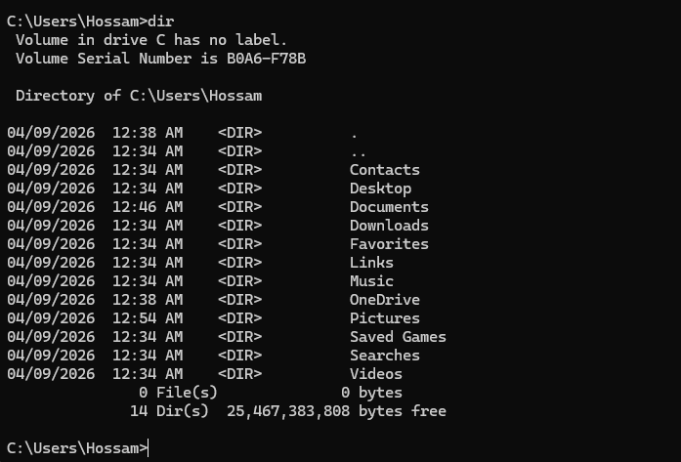Figure 5: Windows Command Prompt — dir /a listing directory contents including hidden files.

mkdir and cd — create a new directory and navigate into it [3]:
mkdir MyTestFolder
cd MyTestFolder

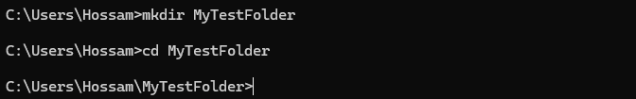Figure 6: Windows Command Prompt — mkdir and cd commands creating and entering a new directory.

copy and del — copy a file to a new location, then delete the original [3]:
copy report.txt backup.txt
del report.txt
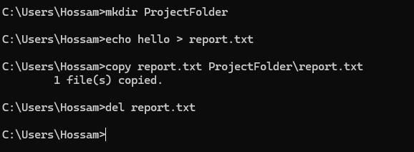

3.3 Network Monitoring
ipconfig /all — displays full network adapter configuration including IP, subnet, gateway, and DNS [3], [6]:
ipconfig /all

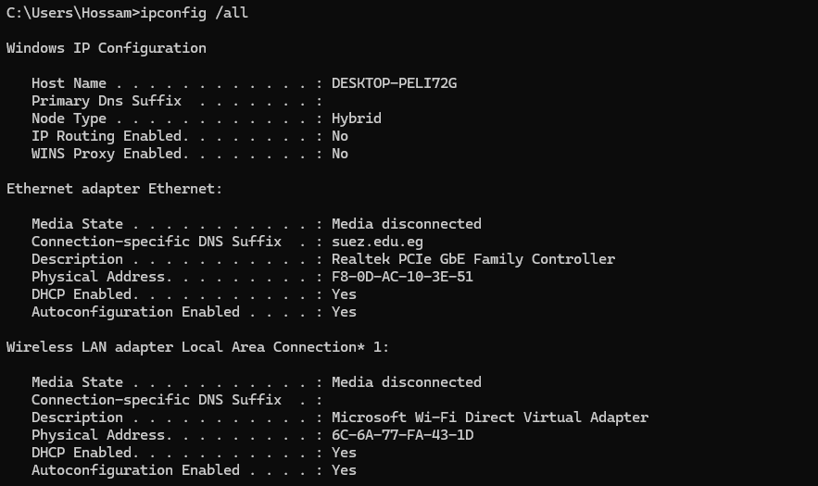 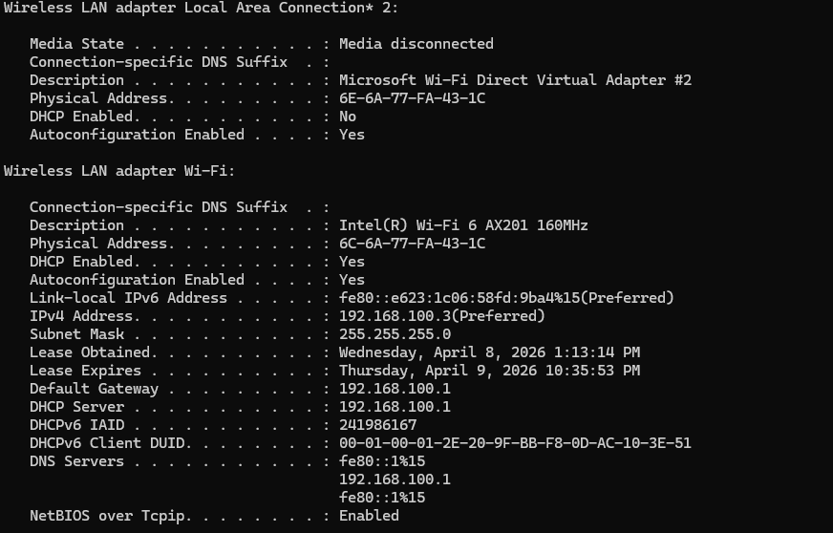Figure 7: Windows Command Prompt — ipconfig /all displaying full network adapter configuration.

ping — tests network connectivity by sending ICMP echo request packets to a host [6]:
ping www.google.com

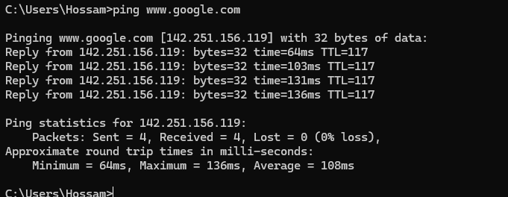Figure 8: Windows Command Prompt — ping www.google.com testing network connectivity with round-trip time.

netstat -an — shows all active TCP/UDP connections and listening ports [6]:
netstat -an

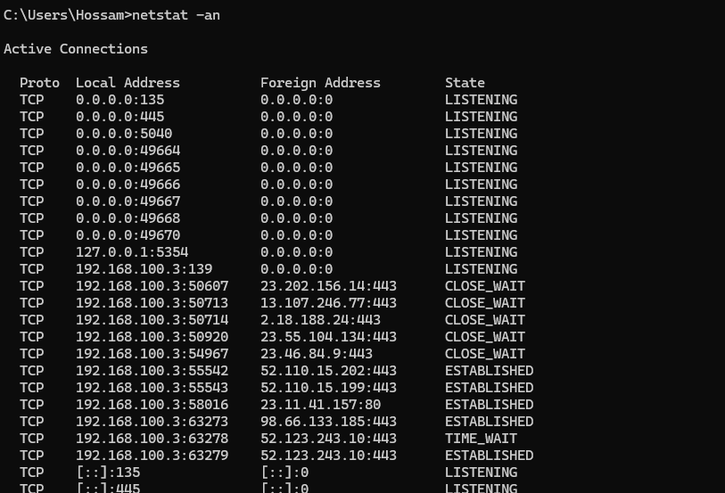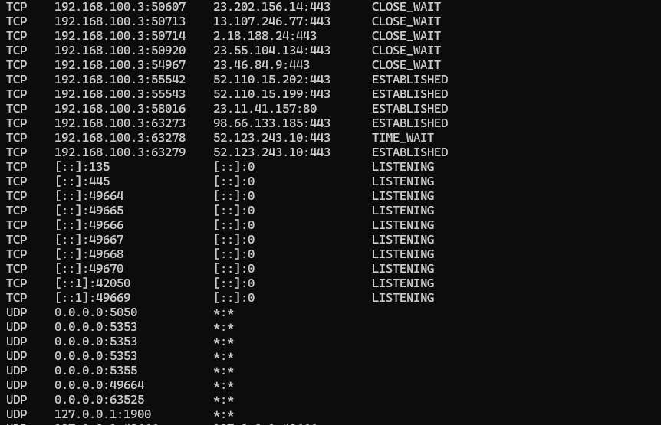
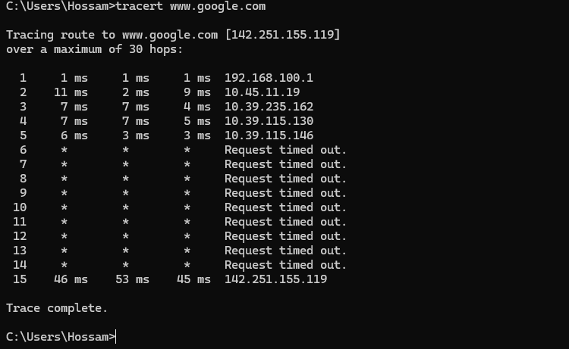Figure 9: Windows Command Prompt — netstat -an showing active connections and listening ports.

3.4 User Management and Task Scheduling
net user — displays all local user accounts; net user /add creates a new account [3]:
net user
net user newstudent P@ssword1 /add

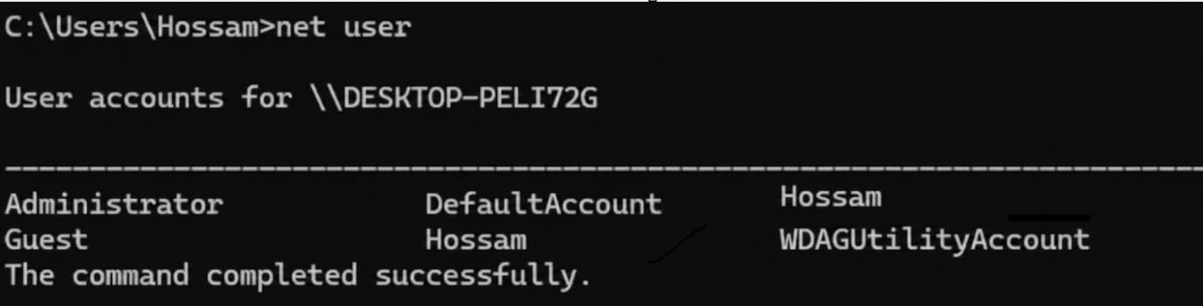
Figure 10: Windows Command Prompt — net user commands listing users and creating a new account.

schtasks /create — schedules a task to run automatically at a specified time [3]:
schtasks /create /sc daily /tn "NewDailyBackup" /tr "C:\scripts\backup.bat" /st 09:00
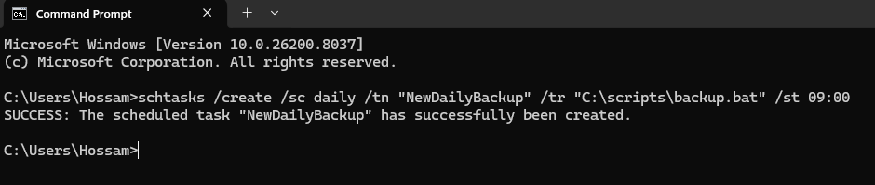

3.5 Additional Commands
systeminfo — displays detailed OS, hardware, and configuration information [3]:
systeminfo

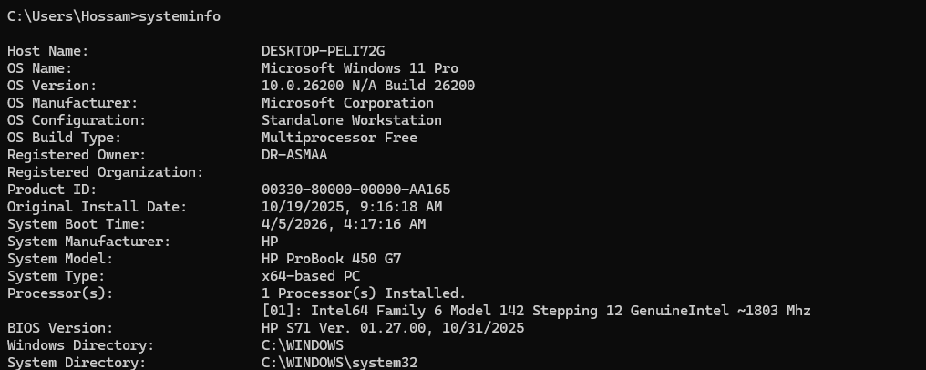 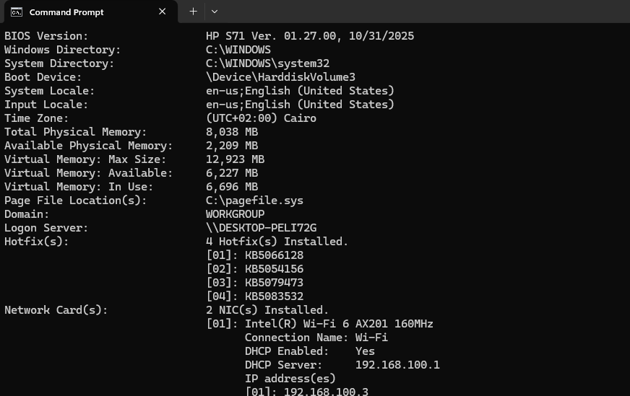Figure 11: Windows Command Prompt — systeminfo displaying OS version, RAM, and system hardware details.
sfc /scannow — scans system files for corruption and repairs them automatically [3]:
sfc /scannow
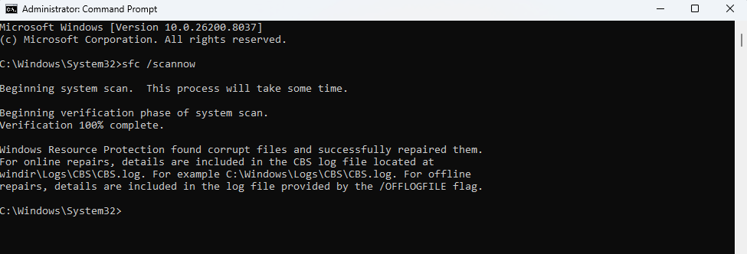

4.0 Linux OS CLI Commands
Linux system administration relies on the Bash shell and its extensive toolset [4], [8], [9]. The following twelve commands demonstrate core administrative tasks, with screenshots as practical evidence.

4.1 Process Management
ps aux — displays all running processes with user, PID, CPU%, memory%, and command [2], [4]:
ps aux

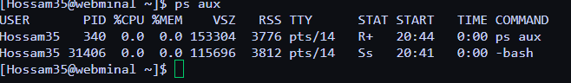Figure 12: Linux Terminal — ps aux command listing all running processes with resource usage statistics.

top — provides a live, continuously updating view of processes and system resource usage [2]:
top

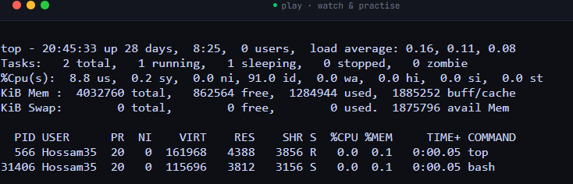Figure 13: Linux Terminal — top command showing real-time process list and system resource utilisation.

kill -9 — immediately terminates a process using signal 9 (SIGKILL) [4]:
kill -9 13911
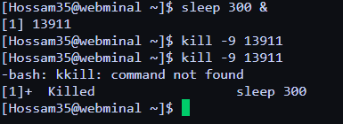

4.2 File Management
ls -la — lists all files including hidden ones with permissions, owner, size, and modification date [4], [9]:
ls -la

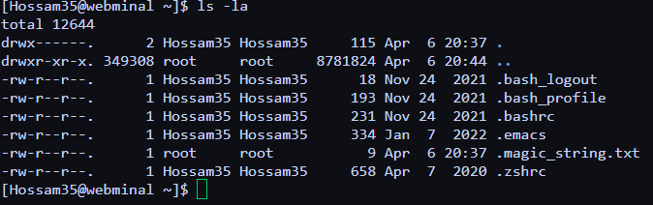Figure 14: Linux Terminal — ls -la showing directory contents with permissions, ownership, and metadata.

mkdir, cp, and rm — create a directory, copy a file into it, and remove the original [4]:
mkdir newproject
cp notes.txt newproject/notes_backup.txt
rm notes.txt

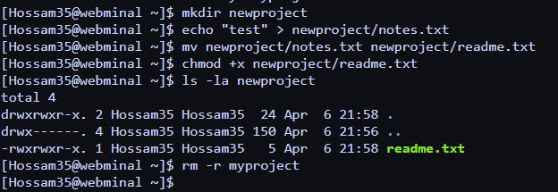Figure 15: Linux Terminal — mkdir, cp, and rm demonstrating file and directory creation, copying, and deletion.

4.3 Network Commands
ip addr show — displays all network interfaces and their assigned IP addresses [6],[9]:
ip addr show

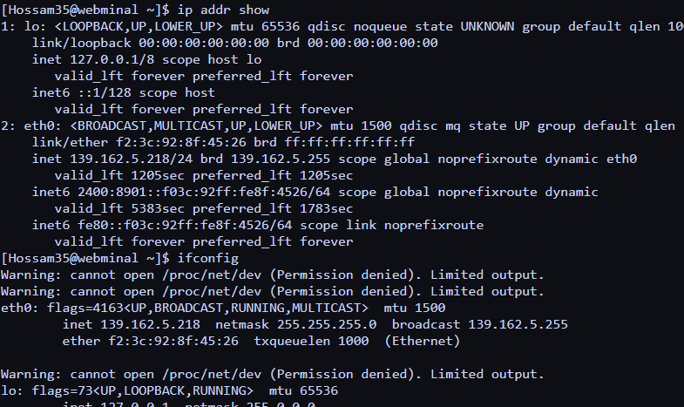Figure 16: Linux Terminal — ip addr show displaying network interface configuration and IP addresses.

ping -c 4 — sends exactly 4 ICMP packets to test connectivity [6]:
ping -c 4 8.8.8.8
netstat -tuln — lists all TCP/UDP ports currently in LISTEN state [6]:
netstat -tuln

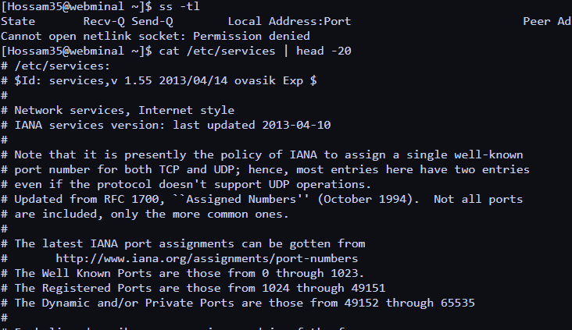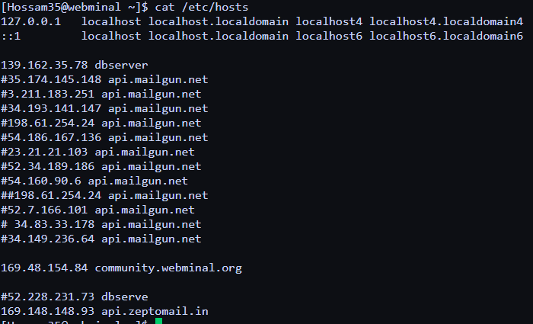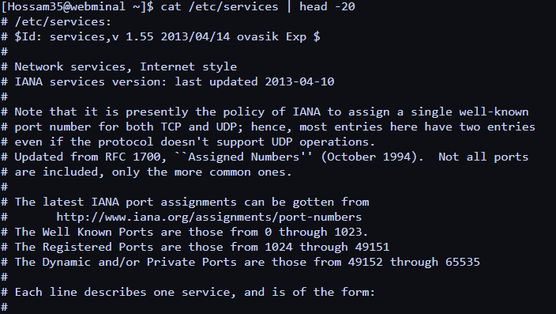Figure 17: Linux Terminal — ping -c 4 and netstat -tuln testing connectivity and showing listening ports.

4.4 User Management and Task Scheduling
adduser and passwd — create a new user account and set their password [8]:
sudo adduser newstudent
sudo passwd newstudent
who — lists all users currently logged into the system [8]:
who

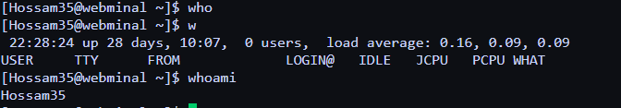Figure 18: Linux Terminal — adduser, passwd, and who commands demonstrating user account creation and session listing.

crontab -e — opens the scheduled task editor for the current user [8]:
crontab -e
# Add the following line to run backup.sh every day at midnight:
0 0 * * * /home/student/backup.sh

4.5 Additional Commands
df -h — displays disk partition usage in human-readable format [4]:
df -h
uname -a — displays kernel version, hostname, and system architecture [4]:
uname -a

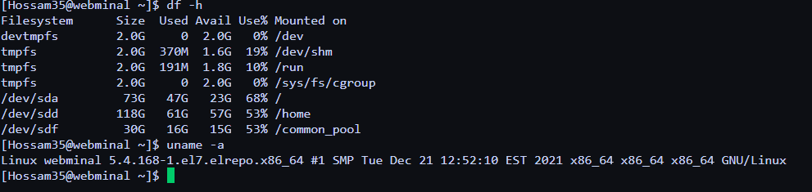
Figure 19: Linux Terminal — df -h and uname -a showing disk usage and kernel/system information.

5.0 Windows OS Scripting
Windows supports two scripting environments: Batch (.bat) for straightforward sequential automation, and PowerShell (.ps1) for advanced scripting with access to the full .NET framework [3], [5], [10]. Scripting eliminates manual repetition, ensures consistency, and allows tasks to run unattended on a schedule / qualities essential in enterprise system administration.

5.1 Batch Script — Disk Space Logger
The following Batch script checks available disk space on the C: drive and appends a timestamped report to a log file [3]:
@echo off
echo Disk Space Report - %date% %time% >> C:\logs\disk_report.txt
fsutil volume diskfree C: >> C:\logs\disk_report.txt
echo -------------------------------- >> C:\logs\disk_report.txt
echo Report complete.

Table 1 below explains each line of the Batch script's syntax:

Syntax / Command | Explanation
@echo off | Suppresses the printing of each command to the terminal as it executes, producing clean output. The @ before echo prevents echo off itself from being printed.
%date% and %time% | Built-in Batch environment variables that expand to the current system date and time at the moment of execution.
>> C:\logs\disk_report.txt | The >> redirection operator appends the preceding output to a file. A single > would overwrite the file each time, destroying the log history.
fsutil volume diskfree C: | A Windows built-in utility that queries and reports the total bytes, free bytes, and total free bytes of the C: drive volume.
echo Report complete. | Prints a completion confirmation to the terminal, providing feedback that the script executed successfully.
Table 1: Line-by-line syntax explanation for the Windows Batch disk space logger script.
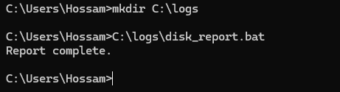
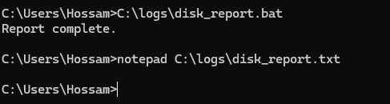
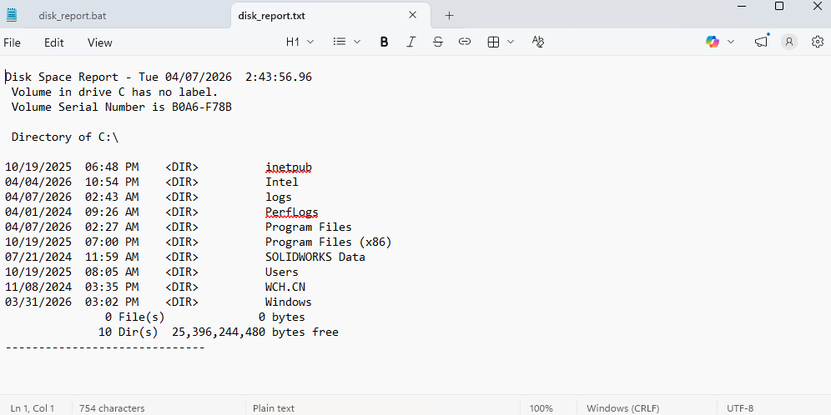
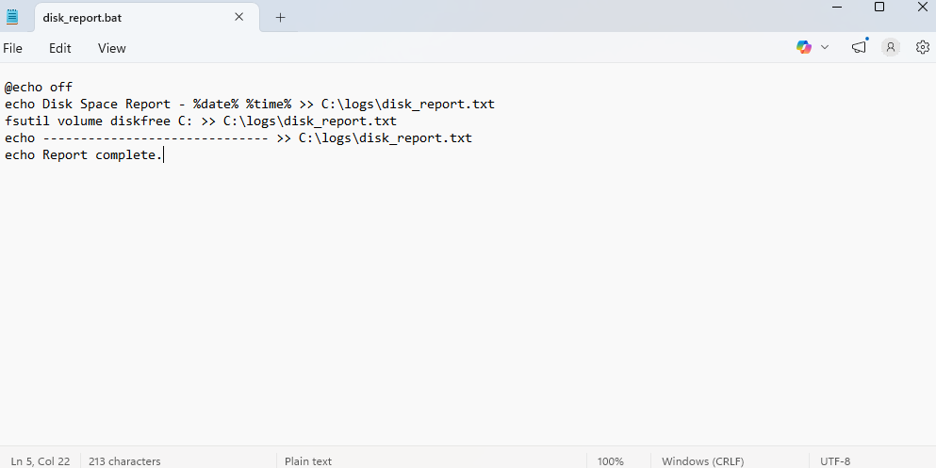
Figure 20: Windows Batch script disk_report.bat — script code in Notepad, successful execution, and log file output.

5.2 PowerShell Script — Process Monitor
The following PowerShell script identifies all processes consuming more than 100 MB of RAM and exports a formatted CSV report [5], [3]:
$processes = Get-Process | Where-Object { $_.WorkingSet -gt 100MB }
$processes | Select-Object Name, Id,
@{Name='MemoryMB'; Expression={[math]::Round($_.WorkingSet/1MB, 2)}} |
Export-Csv -Path C:\logs\high_mem_processes.csv -NoTypeInformation
Write-Output "Report saved to C:\logs\high_mem_processes.csv"

Table 2 below explains the PowerShell syntax used:

Syntax / Command | Explanation
Get-Process | A PowerShell cmdlet that retrieves all currently running processes as structured objects, each containing properties like Name, Id, CPU, and WorkingSet (memory).
| (pipeline) | The pipe operator passes the output objects of one command directly into the next command as input, without writing to disk. This is the foundation of PowerShell's object pipeline.
Where-Object { $_.WorkingSet -gt 100MB } | $_ represents the current pipeline object. .WorkingSet is its memory property in bytes. -gt means 'greater than'. 100MB is automatically converted to 104857600 bytes.
Select-Object Name, Id, @{...} | Selects specific properties to include in output. The @{Name='MemoryMB'; Expression={...}} syntax creates a new calculated property, here converting bytes to MB using [math]::Round.
Export-Csv -NoTypeInformation | Writes the objects to a CSV file. -NoTypeInformation omits the #TYPE metadata header row that PowerShell would otherwise prepend, keeping the CSV clean.
Write-Output "..." | Prints a string to the console, providing confirmation that the script executed and where the output was saved.
Table 2: Line-by-line syntax explanation for the PowerShell process monitor script.

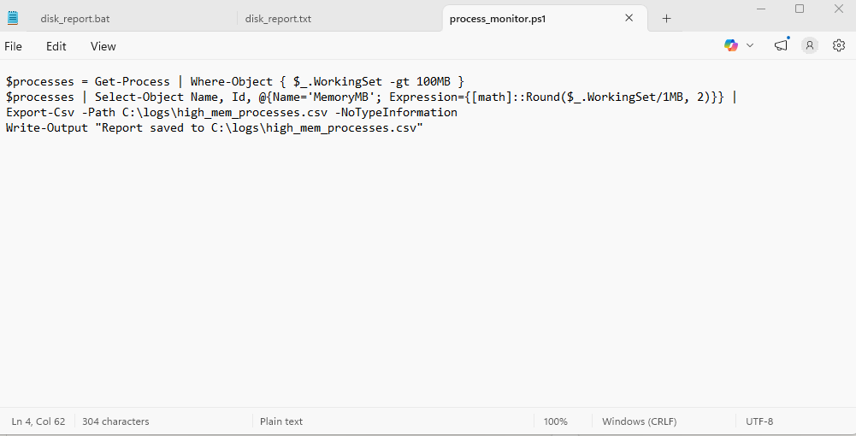
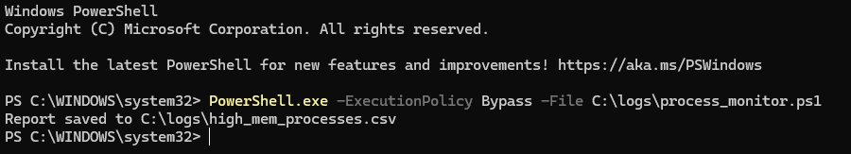
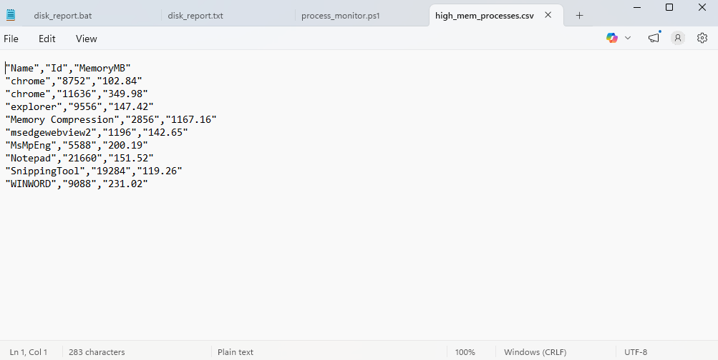Figure 21: PowerShell script process_monitor.ps1 — code, successful execution output, and the exported CSV report.

6.0 Linux OS Scripting
Linux uses Bash (Bourne Again SHell) as its primary scripting environment [8], [4]. Bash scripts are plain text files interpreted line-by-line by the Bash shell, and support variables, conditional statements (if/then/fi), loops (for/while), and functions enabling powerful automation from minimal code. Bash is pre-installed on all major Linux distributions, making scripts immediately portable across systems [9].

6.1 Bash Script — Automated Backup
The following script creates a compressed, timestamped backup of a user's Documents folder and stores it in a dedicated backups directory [8]:
#!/bin/bash
TIMESTAMP=$(date +"%Y-%m-%d_%H-%M-%S")
BACKUP_DIR="/home/student/backups"
SOURCE_DIR="/home/student/Documents"
mkdir -p $BACKUP_DIR
tar -czf "$BACKUP_DIR/backup_$TIMESTAMP.tar.gz" $SOURCE_DIR
echo "Backup completed: backup_$TIMESTAMP.tar.gz"

Table 3 below explains each element of the backup script's syntax:

Syntax / Command | Explanation
#!/bin/bash | The shebang line. Located on the very first line, it tells the OS which interpreter to use when executing this file as a script. /bin/bash means the Bash shell will interpret all subsequent lines.
TIMESTAMP=$(date +"%Y-%m-%d_%H-%M-%S") | $(command) is command substitution — it executes the command inside and assigns its text output to the variable. The date format +"%Y-%m-%d_%H-%M-%S" produces a sortable timestamp (e.g., 2026-04-05_09-30-00).
BACKUP_DIR= / SOURCE_DIR= | Variable assignment in Bash. There must be no spaces around the = sign. Variables are referenced later using the $ prefix (e.g., $BACKUP_DIR).
mkdir -p $BACKUP_DIR | Creates the backup directory. -p means 'create parent directories as needed' and suppresses the error if the directory already exists — making the script safe to run multiple times.
tar -czf "..." $SOURCE_DIR | Archives and compresses the source directory. -c = create a new archive, -z = compress using gzip, -f = write to the specified filename. The result is a .tar.gz compressed archive.
echo "Backup completed: ..." | Prints the backup filename to the terminal, confirming the operation succeeded and telling the user what file was created.
Table 3: Line-by-line syntax explanation for the Bash automated backup script.

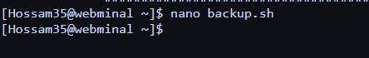
Figure 22: Bash script backup.sh — script code, execution output, and the resulting compressed backup archive.

6.2 Bash Script — CPU/Memory Monitor
The following script measures current CPU and memory usage, prints a summary, and logs a warning to a file if CPU usage exceeds 80% [8], [2]:
#!/bin/bash
CPU=$(top -bn1 | grep 'Cpu(s)' | awk '{print $2}' | cut -d'.' -f1)
MEM=$(free -m | awk '/Mem:/{print $3}')
echo "CPU Usage: ${CPU}% | Memory Used: ${MEM}MB"
if [ "$CPU" -gt 80 ]; then
echo "WARNING: High CPU usage (${CPU}%)" >> /var/log/cpu_alert.log
echo "Alert logged at $(date)" >> /var/log/cpu_alert.log
fi

Table 4 below explains the syntax used in the monitoring script:

Syntax / Command | Explanation
top -bn1 | Runs top in non-interactive batch mode (-b) for exactly 1 iteration (-n1), producing a one-shot snapshot of system statistics instead of an interactive display.
grep 'Cpu(s)' | Filters the top output to find only the line containing CPU statistics, discarding all other output lines.
awk '{print $2}' | awk processes text fields. $2 refers to the second whitespace-separated field on the matched line — the CPU usage percentage value (e.g., '14.3%').
cut -d'.' -f1 | Splits the percentage value at the decimal point (-d'.') and returns the first part (-f1), converting '14.3' to '14' so it can be used in an integer comparison.
free -m | Reports RAM and swap memory usage in megabytes. The awk filter '/Mem:/{print $3}' extracts the 'used' column specifically from the Mem: row.
if [ "$CPU" -gt 80 ]; then ... fi | A Bash conditional block. -gt means 'greater than'. The commands between then and fi only execute if CPU > 80. Quoting "$CPU" prevents a syntax error if the variable is unexpectedly empty.
>> /var/log/cpu_alert.log | Appends the warning message and timestamp to a persistent log file. This creates an audit trail that a system administrator can review later.
Table 4: Line-by-line syntax explanation for the Bash CPU and memory monitoring script.

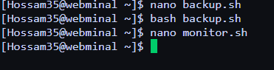
Figure 23: Bash script monitor.sh — code, execution output with resource readings, and the triggered alert log entry.

7.0 Windows vs Linux: Comparison
Both Windows and Linux are mature operating systems that fulfil all core OS functions, yet they differ significantly in design philosophy, licensing model, and practical application [1], [2]. Table 5 provides a structured comparison across key dimensions:

Feature | Windows | Linux
Default Interface | GUI-first; CLI via CMD / PowerShell | CLI-first; GUI optional (GNOME, KDE)
Scripting | Batch (.bat) and PowerShell (.ps1) | Bash (.sh), Python, Perl
File System | NTFS — journaling, ACLs, encryption | ext4, btrfs, xfs — open, flexible
Licensing | Proprietary; commercial licence required | Open-source; free to use and modify
Primary Use Case | Desktop, enterprise, gaming | Servers, cloud, development, embedded
Security Model | UAC, Active Directory, Windows Defender | rwx permissions, SELinux, AppArmor
Package Management | MSI installers, winget, Microsoft Store | apt, yum/dnf, pacman
Remote Access | RDP (Remote Desktop Protocol) | SSH (Secure Shell)
Market Share | ~70% of desktop systems | ~90% of cloud/server workloads
Table 5: Comparative analysis of Windows and Linux across key operating system features.

Windows provides a polished graphical environment making it accessible to non-technical users and dominant in enterprise desktop environments where Microsoft Office and Active Directory integration are essential [3]. Its broad hardware driver support means it operates out-of-the-box on most consumer PCs. However, its proprietary nature means organisations depend on Microsoft for licensing, updates, and security patches_ a consideration in both cost and supply chain risk [5].
Linux offers unparalleled transparency, flexibility, and cost-effectiveness [4], [7]. Its open-source nature allows organisations to audit and modify the OS, and deploy it at scale without per-seat licensing costs. This is why Linux powers the overwhelming majority of web servers, cloud platforms (AWS, Google Cloud, and Azure all run Linux infrastructure), and mobile devices (Android is Linux-based). Its steeper CLI learning curve is offset by powerful scripting capabilities that Windows has only recently begun to match through PowerShell and the Windows Subsystem for Linux (WSL) [5], [8]. In my opinion, Linux is more suitable for technical users and server environments due to its flexibility and scripting capabilities, while Windows is more user-friendly for beginners and general desktop use.

8.0 Conclusion
Operating systems are the backbone of modern computing, managing hardware resources, enabling application execution, and enforcing security policies [1], [2]. This report examined the core OS functions of process management, virtual memory, file system management, device control, user interface, security, and networking, demonstrating how both Windows and Linux fulfil these roles through different but complementary approaches.
Practical CLI demonstrations across twelve Windows and twelve Linux commands confirmed the breadth of administrative control available at the command line, while scripting tasks in both Batch/PowerShell and Bash illustrated how automation can significantly reduce manual workload and improve consistency [3], [4]. The comparative analysis highlighted that Windows remains dominant on the desktop and in enterprise GUI environments [3], [5], while Linux dominates server and cloud infrastructure due to its openness, stability, and scripting depth [7], [8].
Proficiency in both operating systems is increasingly expected of computing professionals across system administration, DevOps, and cybersecurity roles [6], [7]. The skills developed in this report such as CLI fluency, scripting logic, and cross-platform awareness form a practical foundation for professional IT work. This report has helped me develop practical skills in using CLI commands and scripting in both operating systems.

9.0 References
[1] A. Silberschatz, P. B. Galvin, and G. Gagne, Operating System Concepts, 10th ed. Hoboken, NJ: Wiley, 2018.
[2] W. Stallings, Operating Systems: Internals and Design Principles, 9th ed. Hoboken, NJ: Pearson, 2018.
[3] Microsoft, "Windows Commands Reference," Microsoft Learn, 2025. [Online]. Available: https://learn.microsoft.com/en-us/windows-server/administration/windows-commands/
[4] The Linux Foundation, "Introduction to Linux (LFS101)," edX / Linux Foundation Training, 2024. [Online]. Available: https://training.linuxfoundation.org/training/introduction-to-linux/
[5] Microsoft, "PowerShell Documentation," Microsoft Learn, 2025. [Online]. Available: https://learn.microsoft.com/en-us/powershell/
[6] Cisco Networking Academy, NDG Linux Unhatched, Cisco, 2024. [Online]. Available: https://www.netacad.com/courses/os-it/ndg-linux-unhatched
[7] Red Hat, "Linux System Administration Guide," Red Hat Documentation, 2023. [Online]. Available: https://access.redhat.com/documentation/en-us/red_hat_enterprise_linux/
[8] The Linux Documentation Project, "Bash Guide for Beginners," 2024. [Online]. Available: https://tldp.org/LDP/Bash-Beginners-Guide/html/
[9] S. S. Shotts, The Linux Command Line, 2nd ed. San Francisco, CA: No Starch Press, 2019. [Online]. Available: https://linuxcommand.org/tlcl.php
[10] Microsoft, "PowerShell scripting," Microsoft Learn, 2024. [Online]. Available: https://learn.microsoft.com/en-us/powershell/scripting/overview
[11] Anthropic's Claude, private communication, Apr. 2026.

Appendix A: Screenshot Evidence
Screenshots for Figures 1–23 are included within their corresponding sections throughout the report. All screenshots were taken by me during the practical tasks to demonstrate the use of commands and scripts in both Windows and Linux environments. Each image clearly shows the command execution and its output. Additional supporting screenshots are included in this appendix where necessary, with appropriate figure numbers and captions.

Appendix B: CPD Evidence
The following screenshots provide evidence of engagement with Continuing Professional Development (CPD) resources relevant to this module. Self-directed learning beyond taught sessions demonstrates the professional development required under the Transferable Skills criteria.

B.1 Cisco NetAcad — NDG Linux Unhatched
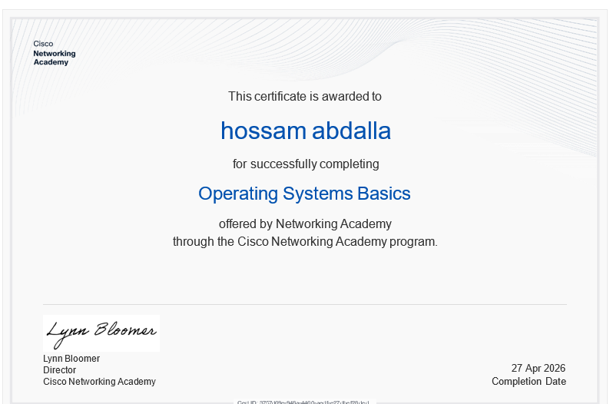

B.2 Microsoft Learn — Introduction to PowerShell
Microsoft Learn provides a free Introduction to PowerShell learning path at learn.microsoft.com. Completing this directly supports the PowerShell scripting demonstrated in Section 5.2.



 Figure B2: Microsoft Learn — Introduction to PowerShell .

Appendix C: Lecture and Tutorial Logs
This appendix contains evidence of attendance and participation in module lectures and tutorial sessions, as required under the Transferable Skills assessment criteria.

C.1 Lecture Activity Log
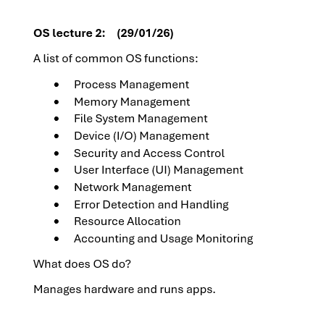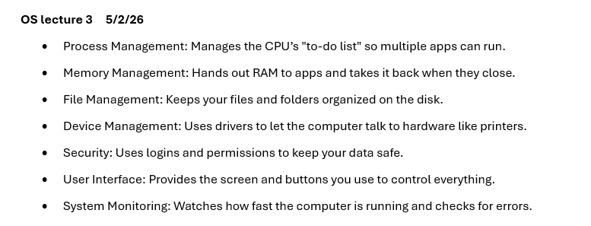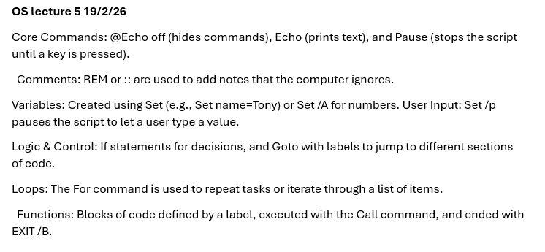

C.2 OS Tutorial 1 — Completed Work
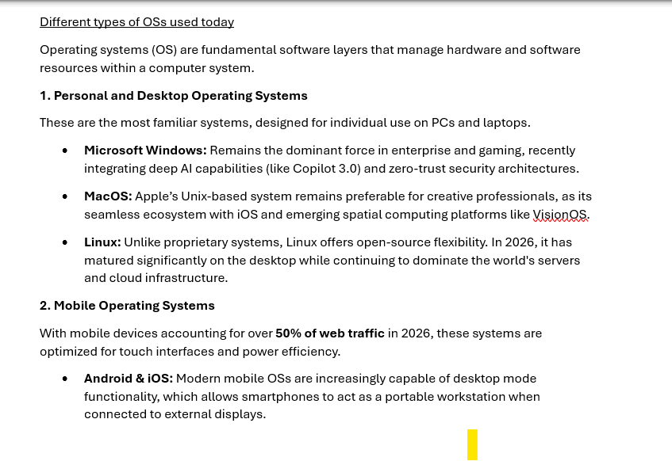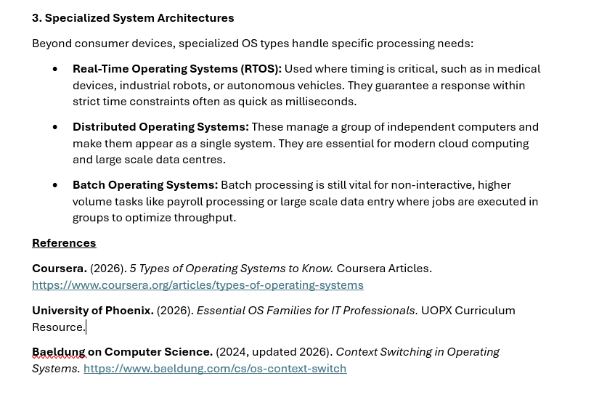

Appendix D: AI Interaction Transcript
This appendix documents the use of AI tools in accordance with the module’s academic integrity policy. AI was used only for limited purposes, including supporting understanding of complex operating system concepts and checking grammar and clarity. All information obtained was verified against reliable academic and official sources. AI was not used for structuring, writing, coding, or scripting. All practical work was completed independently by the author. Full AI transcripts are included in Section D.2.

D.1 Declaration of AI Use
AI Tool Used: Claude (Anthropic) and Gemini
Date(s) of Use: April 2026
Purpose:
• Research Support: Used to support understanding of complex operating system concepts, particularly memory management and kernel behaviour.
• Proofreading: Used to review grammar and clarity of the author’s original writing.
• Technical Troubleshooting: Used to help interpret specific error messages encountered during practical tasks (e.g., permission-related issues).
All practical work, including command-line execution and scripting, was completed independently by the author. The screenshots included throughout the report (Figures 1–23) provide evidence of this work, clearly showing the commands and their outputs as executed.
All information obtained through AI tools was independently verified against academic sources and official documentation. AI was not used for writing, structuring, coding, or scripting the report. All content was produced in the author’s own words.

D.2 Full AI Chat Transcript
The complete transcript of the Claude (Anthropic) and Gemini ai conversations used during the preparation of this report is included below. Screenshots or copied text of the full conversation should be inserted here.


