
Module: LCHS7003 — Community Care and Management of Longer-Term Conditions
Programme: MSc Public Health and Social Care in Practice
Lecturer: Dr Hamdi Hussain

Booklet Topic: Type 2 Diabetes Mellitus (T2DM): Understanding, Management, and Person-Centred Care in the UK

Student Name: Mahir Al Asif Masrur
Student ID Number: 2436075

Word Count: 2850
Submission Date: 14 November 2025

Table of Contents
1. Introduction 4
2. Definition, Prevalence and Aetiology of Type 2 Diabetes Mellitus. 5
2.1 Definition 5
2.2 Global and UK Prevalence 5
2.3 Risk Factors and Aetiology 6
2.4 Public Health Implications 7
3. Effects of Type 2 Diabetes Mellitus: Physical, Psychological, and Social. 8
3.1 Physical Impacts 8
3.2 Psychological Impacts 8
3.3 Social Impacts 9
4. Procedural Level Care Models and Theories. 10
4.1 The UK Model: The NHS Personalised Care Model. 10
4.2 International Model: Australian National Diabetes Strategy. 12
4.3 Incorporating Theoretical Perspectives. 13
5. Political, Health and Social Care Agendas that have impacted in the management of diabetes. 14
5.1 National Context 14
5.2 Local Policy and Service Delivery. 14
5.3 International Influence and Global. 15
6. Person-Centred, Self-Managed, and End-of-Life Care Recommendations. 16
6.1. Improving Person-Centred Care. 16
6.2 Supporting Self-Management 16
6.3 The psychological support should be integrated 17
6.4 End-of-Life Care for Diabetes Patients 18
6.5 Recommendations Summary 21
7. Conclusion 22
References 23

Table of Figures
Figure 1: Type 2 Diabetes 5
Figure 2: global and UK prevalence of Type 2 diabetes 6
Figure 3: The NHS Personalised Care Model. 10
Figure 4: End-of-Life Care for Diabetes Patients 19

Table 1: Recommendations Summary 21

1. Introduction
One of the most urgent long-term conditions (LTCs) in the UK population is Type 2 Diabetes Mellitus (T2DM), and its effects on the health and wellbeing, as well as social care systems, are severe. Being characterised by insulin resistance and relative insulin deficiency, T2DM has both clinical and lifestyle issues that go beyond physiological symptoms into the psychological and social realms (Davies et al., 2018; NICE, 2022). The issue of the complexity of diabetes care predetermines the need to employ a holistic, person-centred, and evidence-based management strategy that should be based on the current priorities of the NHS Long Term Plan and WHO recommendations on the management of chronic diseases (NHS England, 2023; WHO, 2023).
This information booklet will set out to offer a user-friendly but critical review of T2DM, as pertinent to health and care professionals and service users. It will discuss its definition, prevalence, causes, and effect, major models of care, political and social care agendas, and suggestions on how its outcomes can be improved.
Purpose: This paper is aimed at critically examining how Type 2 Diabetes Mellitus is managed in the UK, its physical, psychological, and social consequences, and to suggest evidence-based, person-centred approaches to better long-term management and self-management.

2. Definition, Prevalence and Aetiology of Type 2 Diabetes Mellitus.

2.1 Definition
According to World Health Organisation (2023), T2DM is a long-term metabolic condition caused by insulin resistance and a relative deficit of insulin, which causes hyperglycaemia.
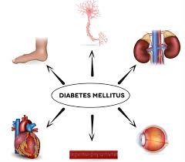
Figure 1: Type 2 Diabetes
Source: (Forbes and Cooper, 2019)
Contrary to Type 1 diabetes that is an autoimmune condition, T2DM generally occurs with time, as a result of a mix of genetic, behavioural, and environmental contributors (Forbes and Cooper, 2019).

2.2 Global and UK Prevalence
Approximately 537 million adults in the world have Type 2 diabetes, and 90-95% of them have Type 2 diabetes (IDF, 2023). It is estimated that the condition will increase to 643 million by the year 2030.
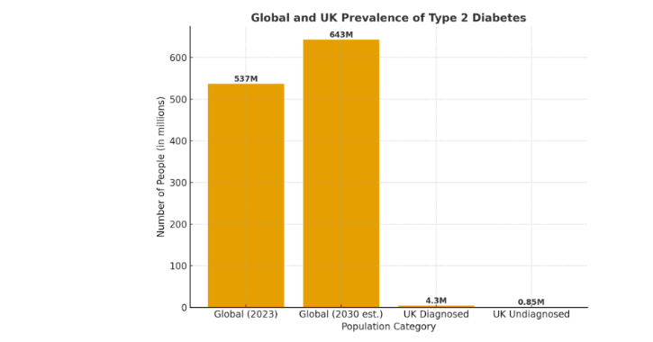
Figure 2: global and UK prevalence of Type 2 diabetes
Source: (NHS England, 2023)
Over 4.3 million individuals in the United Kingdom are known to be diagnosed with diabetes, with an estimated 850,000 of them remaining undiagnosed (Diabetes UK, 2024). Each year, the NHS used approximately 10 percent of its overall spending on diabetes-related care and the figure is estimated to be about 10 billion pounds (NHS England, 2023).
Diabetes does not have even distributions. It is overrepresented among deprived populations and ethnic minorities specifically, people of South Asian and African-Caribbean descent (Public Health England, 2020). Poverty, unhealthy nutrition, lack of physical activity, and inaccessibility to health education are some of the social determinants of the disease.

2.3 Risk Factors and Aetiology
T2DM is a multifactorial condition developed in the interplay of genetic predisposition, environmental factors and behavioural factors. Among the most important risk factors, obesity, inactive lifestyle, poor eating habits, smoking, ageing, and family history should be named (Booth et al., 2017; Wang and Hu, 2023).
On the physiological level, muscle and liver tissue resistance to insulin causes the inability to ingest glucose, whereas the dysfunction of 800 beta-cells in the pancreas impairs the secretion of insulin (Forbes & Cooper, 2019). Persistent hyperglycaemia also helps to cause vascular damages and development of complications including retinopathy, nephropathy, neuropathy, and cardiovascular disease (Skyler, 2018).

2.4 Public Health Implications
The increasing burden of T2DM poses significant problems to the UK population health. In addition to the medical expenses, the disease is also a heavy burden regarding productivity, disability, and premature death (PHE, 2020). Such preventive measures as the NHS Diabetes Prevention Programme (NDPP) have played a significant role in risk reduction with lifestyle interventions based on weight management, physical activity, and diet (NHS England, 2023).

3. Effects of Type 2 Diabetes Mellitus: Physical, Psychological, and Social.

3.1 Physical Impacts
T2DM is physically widespread with and has major implications that have to deal with chronic hyperglycaemia and vascular damage. The ongoing high blood glucose levels can raise the risk of developing microvascular and macrovascular complications, including retinopathy, nephropathy, and neuropathy (Forbes and Cooper, 2019; ADA, 2023) and coronary artery disease and stroke.
Diabetes is among the major causes of blindness, kidney failure, and amputation of lower limbs in the world (WHO, 2023). Approximately one out of six hospital inpatients in the UK is diabetic, and approximately 185 amputations are made each week because of diabetic complications (NHS Digital, 2023). These outcomes can be managed by early identification, regular follow-up, and compliance with evidence-based management guidelines.
NICE (2022) suggests the use of both pharmacological and lifestyle methods of glycaemic control including metformin therapy, balanced diet, and physical activity to avoid complications. Nevertheless, the lack of compliance with lifestyle changes is one of the significant obstacles to ideal management (Shrivastava et al., 2017).

3.2 Psychological Impacts
The psychological weight of the T2DM is high. The studies indicate a high level of correlation between diabetes and depression, anxiety, and diabetes-related distress (Fisher et al., 2019; Nwaneri et al., 2023). The poor mental health and self-management behaviours are frequently caused by emotional exhaustion, fear of hypoglycaemia, frustration with dietary restrictions.
The Diabetes Attitudes, Wishes and Needs (DAWN2) research study found out that one-third of T2DM individuals have moderate to severe diabetes distress that is directly associated with worse glycaemic control and lower quality of life (Nicolucci et al., 2016). Psychological comorbidity hence worsens the disease progression and the use of healthcare.
The promotion of the integration of psychological assessment and counselling into the diabetes care models is gradually becoming a must. NHS England (2024) recommends the use of a whole-person strategy, making emotional and behavioural support one of the key elements of the long-term condition management.

3.3 Social Impacts
In addition to the physiological and emotional factors, T2DM has a serious social and economic impact. People can feel stigmatised, isolated in society, and have difficulties with employment because of the perceived weaknesses of their condition (Speight et al., 2020).
Caregiving roles, emotional stress, and money limitations are some of the issues affecting families due to dietary management and the ability to attend healthcare (Glasper and Rees, 2021). Social deprivation is highly associated with the prevalence and poor outcomes, especially in low-income and urban regions (PHE, 2020).
The underlying significance of these problems is the need to pursue integrated and community-based care models that involve patients, families, and social networks in the continuous management and support (The King’s Fund, 2022).

4. Procedural Level Care Models and Theories.
This part compares one of the UK models and one of the international models about long-term condition management, as well as the related theoretical frameworks to T2DM care.

4.1 The UK Model: The NHS Personalised Care Model.
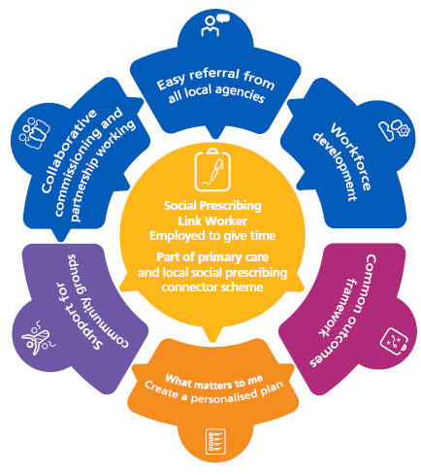
Figure 3: The NHS Personalised Care Model.
Source: (NHS England, 2024)
NHS Personalised Care Model (NHS England, 2024) is a detailed patient-centred model of long-term conditions management, which includes diabetes. It is based on six dependent elements:
- Patient-professional collaborative decision-making.
- Personalised care planning
- Supported self-management
- Community support and social prescribing.
- Choice of treatment options
- Personal health budgets
The model will enable people to have increased autonomy in controlling their condition and empowered co-production of care, where patients are actively involved in setting goals and making health choices.
It is consistent with the Self-Efficacy Theory by Bandura (1997) that assumes that the perception of an individual in being able to perform health-related behaviours directly affects results. As an example of this, patients who have a more positive self-efficacy are more likely to follow a diet and exercise plan (Shrivastava et al., 2017).
The model has been proven to be effective by empirical evidence. Research indicates that the individualised care and systematic education programmes, including the DESMOND (Diabetes Education and Self-Management for Ongoing and Newly Diagnosed) programme, enhance glycaemic control and lessen hospital-admissions (Health Foundation, 2023).
The model also promotes continuity of care, which involves the integration of the services between the primary, secondary to community sector to provide holistic care or what can be termed as the care of a whole person (NHS England, 2023).

4.2 International Model: Australian National Diabetes Strategy.
Globally, a similar yet slightly different model is offered by the Australian National Diabetes Strategy (ANDS) that entails systemic integration, prevention, and innovation (Australian Government Department of Health, 2021).
ANDS emphasises:
- Primary prevention by means of public health campaigns and reduction of risk factors.
- At-risk population screening and its early detection.
- Culturally sensitive services to the Indigenous and ethnic communities.
- Telemedicine and digital health to aid in self-management.
The model resembles the holistic approach in the UK but gives more importance to the equity of health and cultural competence. The solution to structural inequalities is offered by FORC by including the problem of diabetes care into the public health systems, which is an increasing concern in the UK, too (DHSC, 2023).
A comparative criterion reveals that the two models focus on self-management, although the UK system incorporates it in individual care plans whereas Australia goes a step higher to encompass community-based public health programmes.
The Australian model is also based on the Chronic Care Model (CCM) (Wagner et al., 2001), which incorporates community resources, health system organisation, self-management support, and clinical decision-making to attain high-quality and sustainable care.

4.3 Incorporating Theoretical Perspectives.
Both of these models show how the behavioural and health management theories may be applied in a practical manner:
Self-Efficacy Theory (Bandura, 1997): Allows patients to embrace positive health behaviour by empowering them by instilling confidence and setting of goals.
Health Belief Model (Rosenstock, 1974): Postulates that perceived threat and benefit govern the motivation of individual to participate in health behaviour and this is applicable to following of diets and medication regimes.
Framework: Person-Centred Care (McCormack and McCance, 2017): This framework helps healthcare workers to provide empathetic, respectful, and collaborative care.
These frameworks, which should be implemented in concert, support the management of diabetes sustainability and patient empowerment, which is essential to effective long-term care.

5. Political, Health and Social Care Agendas that have impacted in the management of diabetes.

5.1 National Context
The policy environment of the UK healthcare has been changing greatly following the rising burden of T2DM. The NHS Long Term Plan (20192024) states that it would enhance the prevention, early diagnosis, and management of diabetes through national commitments to expand theNHS Diabetes Prevention Programme (NDPP), as well as invest in structured education (NHS England, 2023).
Moreover, the Health and Care Act (2022) highlights the concept of integrated care systems (ICSs) connecting primary, secondary and social care sectors to provide a seamless and patient-centred supportive network (DHSC, 2023). This integration has helped to make sure that multidisciplinary teams (MDTs) such as dietitians, diabetes nurses, podiatrists, and psychologists work together to offer holistic management.
The diabetes area has been also identified by Public Health England (2020) as an important focus in addressing health inequalities, especially via lifestyle changes, which deal with obesity and lack of physical exercise. The behaviour change is reinforced by the national campaign on Better Health which promotes population-level prevention.

5.2 Local Policy and Service Delivery.
In local areas, Integrated Care Boards (ICBs) put in place diabetes care pathways that are based on the local needs. As an example, the NHS RightCare Pathway to Diabetes helps local commissioners to improve the benchmarking of performances and identify care lapses.
It is the responsibility of the local authorities to encourage health literacy, active living and healthy eating using community outreach programmes. Social prescribing (referring patients to local activities such as exercise lessons or support groups) has become a fundamental part of personalised diabetes care (NHS England, 2024).
Access to educational materials and peer connexion also improves accessibility to digital content and platforms like Local Diabetes UK community hubs and Healthy Living for People with Type 2 Diabetes (HLP2D) make individuals feel empowered and socially included.

5.3 International Influence and Global.
The World Health Organisation (WHO, 2023) is proclaiming the Integrated Care for Noncommunicable Diseases (NCDs) Framework that fosters coordinated management, preventive means, and reforms on a systemic level to decrease the burden of diabetes on the world.
In line with this, the International Diabetes Federation (IDF, 2023) advises combining policy measures between primary prevention, clinical care and health system empowerment. The UK diabetes plan fits the above frameworks well, and it demonstrates the desire to have a sustainable approach to chronic illnesses and partnership with other countries.

6. Person-Centred, Self-Managed, and End-of-Life Care Recommendations.

6.1. Improving Person-Centred Care.
Person-centred care (PCC) is also a core to successful T2DM management. It focuses on the development of individualised treatment planning, joint decision-making, and patient autonomy (McCormack & McCance, 2017).
In order to empower PCC in the UK diabetes services:
- Encourage individualised care planning by way of frequent consultations and reviews of goals.
- Enhance structured education (e.g., DESMOND, DAFNE) to improve knowledge and interaction.
- Train medical workers on communication and empathy to develop therapeutic relationships.
There is some evidence that PCC enhances patient satisfaction, glycaemic outcomes, and medication adherence (Health Foundation, 2023).

6.2 Supporting Self-Management
Empowerment of the patients to self-manage their diabetes is essential in sustainability. Self-management interventions promote engagement in monitoring, decision-making, and problem-solving.
Strategies include:
- Digital health tools, e.g., glucose monitoring applications and tele-consultations.
- Integration of motivational interviewing strategy in order to enhance engagement.
- Creating emotional and informational support peer-support groups.
These interventions are based on the Self-Efficacy Theory by Bandura (1997) according to which they show higher adherence and outcomes in the long run when patients believe that they can cope with the condition (Shrivastava et al., 2017).

6.3 The psychological support should be integrated
It is important to incorporate psychological services in diabetes care. CBT and mindfulness-based intervention have been proved to minimise diabetes distress and enhance glycaemic control (Nwaneri et al., 2023).
The model proposed by NHS England suggests primary care networks to incorporate the role of mental health practitioners to provide people with long-term conditions with timely psychological assessment.

6.4 End-of-Life Care for Diabetes Patients
End-of-life management (EoLC) of diabetes is part and parcel of long-term management of conditions even though it is underemphasised. When patients with Type 2 Diabetes Mellitus (T2DM) enter the end of life care, the primary objective of the care unit shifts towards comfort, dignity, and a good quality of life instead of tight glycaemic control (NICE, 2022). The treatment of diabetes at the given stage is to be approached subtly and emphatically to provide equilibrium between relieving the symptoms and avoiding the burdens of treatment. The unreasonable blood glucose goals can cause hypoglycaemia and the patient doing excessive suffering; thus, the clinicians are invited to personalise the insulin dosages and make monitoring less complicated to alleviate suffering (WHO, 2023).
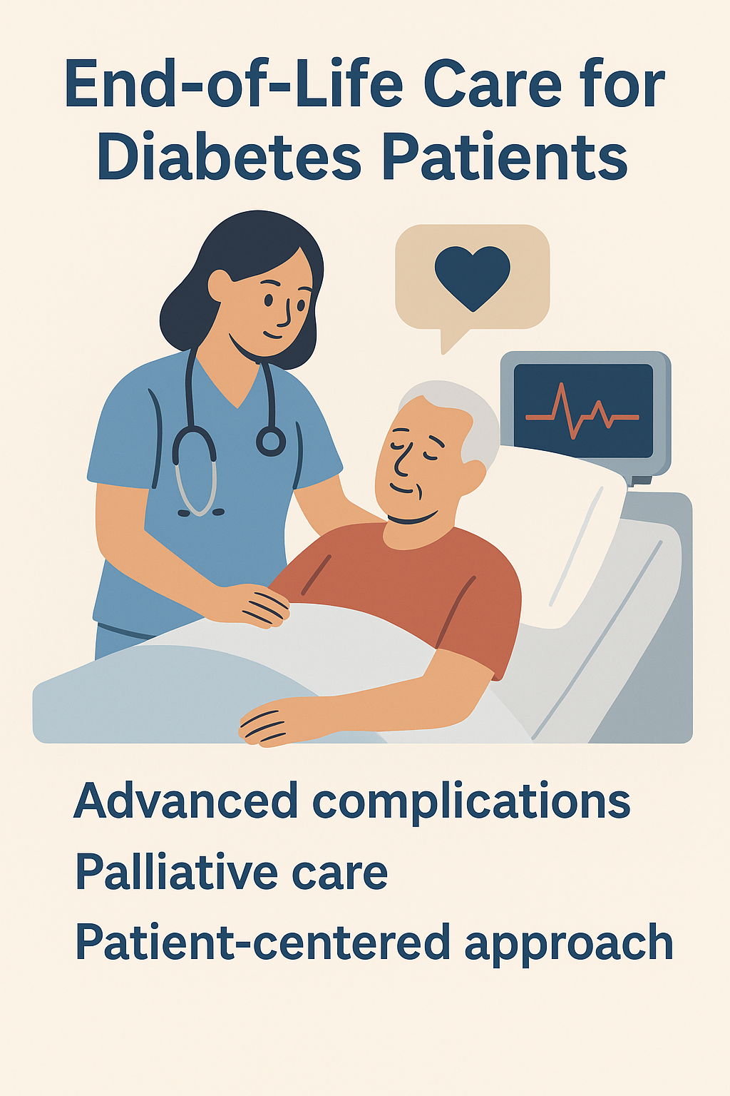
Figure 4: End-of-Life Care for Diabetes Patients
Source: (McCormack & McCance, 2017)
The importance of identifying patients who are nearing end-of-life in an early way, so as to be able to plan in advance and discuss with the patients and families openly, is paramount. The presence of Advance Care Plans (ACPs) will guarantee that care choices are not made based on general principles and do not oppose personal values, religious convictions, or cultural inclinations. Sharing information among healthcare professionals, patients, and carers is beneficial to promote shared decision-making and decrease anxiety during this delicate period (Scottish Government, 2021).
Besides, healthcare personnel should be educated and trained to remain competent on both ethical and cultural aspects of palliative care. Nurse and practitioners are to be prepared to identify emotional distress, spiritual needs, and handle sophisticated medication issues in a sensitive manner. Holistic and person-centre support is guaranteed through the integration of multidisciplinary teams, i.e., palliative care specialists, diabetes nurses, and social workers.
Finally, excellent EoLC to diabetes patients reflects the values of compassion, respect, and autonomy, which can help the individuals to have a dignified and supported end of life.

6.5 Recommendations Summary
Priority Area | Recommended Action | Expected Outcome
Personalised Care | Implement co-produced care plans | Improved patient satisfaction and adherence
Self-Management | Expand structured education and digital tools | Enhanced control and autonomy
Integrated Psychological Care | Embed mental health support within diabetes pathways | Reduced distress, better outcomes
End-of-Life Care | Develop diabetes-specific palliative protocols | Dignified and coordinated care
Workforce Development | Provide continuous professional training | Consistent, high-quality service delivery
Table 1: Recommendations Summary
Source: Author

7. Conclusion
Diabetes Mellitus Type 2 is an intricate combination of medical, psychological and social challenges which are demanding of evidence based practises and person-centred interventions. The progressive frameworks of the UK that are backed by the personalised care programmes funded by the NHS and NICE display significant similarity with the global standards, including those of WHO and the IDF. Nevertheless, the relentless disparities in access and outcomes represent an indication that more attention should be paid to social determinants of health, cultural competence, and psychological wellbeing. This means that sustainable diabetes care should go beyond clinical management to empower, educate, and engage the community to allow patients to live well with diabetes taking into account all life stages including end-of-life care. Finally, a holistic and co-productive care model between patients, families and professionals is already the key to enhancing quality of life and equitable and long-term management of diabetes in the UK.

References
- American Diabetes Association (ADA). (2023). Standards of medical care in diabetes—2023. Diabetes Care, 46(Supplement_1), S1–S200.
- Australian Government Department of Health. (2021). National Diabetes Strategy 2021–2030. Canberra: Department of Health.
- Bandura, A. (1997). Self-efficacy: The exercise of control. New York: Freeman.
- Booth, F. W., Roberts, C. K., & Laye, M. J. (2017). Lack of exercise is a major cause of chronic diseases. Comprehensive Physiology, 2(2), 1143–1211.
- Davies, M. J., D’Alessio, D. A., Fradkin, J., et al. (2018). Management of hyperglycemia in type 2 diabetes: A consensus report. Diabetologia, 61(12), 2461–2498.
- Department of Health and Social Care (DHSC). (2023). Integration and innovation: Working together to improve health and social care for all. London: DHSC.
- Diabetes UK. (2024). Facts and statistics about diabetes in the UK. [online] Available at: https://www.diabetes.org.uk/
- Fisher, L., Polonsky, W. H., & Hessler, D. M. (2019). Depression in Type 2 Diabetes: The role of disease burden and social support. Diabetes Care, 42(2), 282–289.
- Forbes, J. M., & Cooper, M. E. (2019). Mechanisms of diabetic complications. Physiological Reviews, 93(1), 137–188.
- Glasper, E. A., & Rees, C. (2021). Children and young people’s nursing in practice. Wiley.
- Health Foundation. (2023). Supporting self-management for people with long-term conditions. London: The Health Foundation.
- IDF (International Diabetes Federation). (2023). IDF Diabetes Atlas (10th ed.). Brussels: IDF.
- Khunti, K., Seidu, S., Davies, M. J., & Yates, T. (2022). Diabetes and COVID-19: The importance of physical activity. Diabetes Research and Clinical Practice, 183, 109132.
- McCormack, B., & McCance, T. (2017). Person-centred practice in nursing and health care: Theory and practice. 2nd ed. Wiley-Blackwell.
- NHS Digital. (2023). National Diabetes Audit 2023. Leeds: NHS Digital.
- NHS England. (2023). NHS Long Term Plan: Diabetes Prevention and Care. [online] Available at: https://www.england.nhs.uk/
- NHS England. (2024). Personalised Care Model for Long-Term Conditions. [online] Available at: https://www.england.nhs.uk/personalisedcare/
- NICE. (2022). Type 2 diabetes in adults: Management (NG28). [online] Available at: https://www.nice.org.uk/guidance/ng28
- Nicolucci, A., Kovacs Burns, K., Holt, R. I. G., et al. (2016). Diabetes Attitudes, Wishes and Needs second study (DAWN2). Diabetic Medicine, 33(6), 770–783.
- Nwaneri, C., Cooper, H., & Bowen-Jones, D. (2023). The psychosocial impact of living with Type 2 Diabetes: A systematic review. BMC Endocrine Disorders, 23(1), 57–69.
- Public Health England. (2020). Health matters: Preventing Type 2 diabetes. London: PHE.
- Scottish Government. (2021). Diabetes Improvement Plan. Edinburgh: Scottish Government.
- Shrivastava, S. R., Shrivastava, P. S., & Ramasamy, J. (2017). Role of self-care in management of diabetes mellitus. Journal of Diabetes & Metabolic Disorders, 16(1), 14–22.
- Skyler, J. S. (2018). Diabetes complications: The global epidemic. Current Diabetes Reports, 18(10), 47.
- Speight, J., Holmes-Truscott, E., Hendrieckx, C., & Pouwer, F. (2020). Assessing the impact of diabetes on quality of life: A critical review. Diabetes Research and Clinical Practice, 169, 108396.
- The King’s Fund. (2022). Delivering better long-term condition management: Lessons from integrated care systems. London: The King’s Fund.
- Wang, Y., & Hu, F. B. (2023). Dietary patterns and prevention of Type 2 Diabetes: An update. Current Diabetes Reports, 23(5), 145–158.
- WHO. (2023). Global report on diabetes: Progress and challenges. Geneva: World Health Organization.

