
Module Name: Professional Career Development

Module Code: BMBS4005

Student Name: Gemma Louise Bissett

Student Number: 2534826

Lecturer: Scott James

Deadline: Monday 26th October 2026 23.59PM

I confirm that I have not presented any AI-generated text as my own work. I confirm that I have retained copies of drafts, notes, and resources used before and after the use of AI tools.

Contents
Element 1: Career Sector Investigation 3
1.1 My Chosen Sector or Business Area 3
1.2 Sector / Business Area Research 3
1.3 Skills, Qualities and Attributes Valued by Employers 3
1.4 Current Trends Affecting the Sector 3
1.5 Personal Career Fit 4
Element 2: Skills Audit and Professional Development Plan 5
2.1 Personal SWOT Analysis 5
2.2 Emotional Intelligence and Professional Behaviour 5
2.3 Applying Theories or Models 5
2.4 SMART Development Goal 6
Element 3: Recruitment Application Pack 7
3.1 Selected Job Role 7
3.2 Tailored Curriculum Vitae (CV) 7
3.3 Cover Letter 8
3.4 LinkedIn Profile 8
3.5 Application Rationale 8
Reference List 8

Element 1: Career Sector Investigation

1.1 My Chosen Sector or Business Area
I have chosen the further Education (FE) hairdressing lecturing profession, focusing on teaching and assessing learners in vocational hairdressing programmes. I selected this area because I have over twenty years of experience as a hairdresser and salon owner, and I am now developing my academic and digital skills through higher education CertHE Business skills. Teaching appeals to me because it allows me to share my industry knowledge and support learners. Becoming a hairdressing lecturer coincides with my long-term career goal of stepping back from a more demanding physical hands-on role but staying in the same profession by sharing my knowledge that I have already gained along the way.

1.2 Sector / Business Area Research
The FE hairdressing lecturing sector involves delivering practical and theoretical training to hairdressing students studying qualifications such as Level 1–3 NVQs, and apprenticeships (City&Guilds,2026; VTCTskills2026) Lecturers work in colleges, private training providers and specialist academies. The role typically includes lesson planning, delivering demonstrations, assessing practical skills, marking written work, supporting learners to progress, and ensuring they follow standards such as City & Guilds or VTCT.
Common organisations in this sector include FE colleges, independent training academies, apprenticeship providers and employer led training centres. They include school leavers, adult learners, apprentices and employers seeking upskilling for their staff. The role ranges from teaching cutting, colouring and styling techniques to delivering theory on health and safety, consultation, professional behaviour and industry standards. According to Careers Wales further education lecturers teach academic and vocational subjects and require both subject expertise and teaching qualifications (CareersWales,2026)

Vocational teaching continues to be important within the FE sector, vocational teaching continues to be in demand due to skills shortages in technical industries, including hair and beauty. FE providers seek lecturers with strong industry backgrounds who can bring hands on experience into the classroom supporting skills development and economic growth across Wales. (ColegauCymru,2026) is part of the system that encourages and supports lecturer recruitment, but the actual jobs are posted by individual colleges.

1.3 Skills, Qualities and Attributes Valued by Employers
Employers in the FE hairdressing sector value a combination of technical expertise, teaching ability and professional behaviours (CareersWales,2026)
Key skills include:
- Up to date industry knowledge is essential for teaching current techniques and trends.
- Communication and interpersonal skills needed to explain techniques clearly and support diverse learners.
- Organisation and planning are important for preparing lessons, assessments and resources.
- Digital skills are increasingly required for online learning platforms for delivery (MicrosoftEducation2026;Moodle,2026)
Patience, empathy and coaching skills are important for supporting learners with different leaning needs. Job descriptions in FE colleges often emphasise the need for strong safeguarding knowledge, professional behaviour, teamwork and the ability to motivate learners. From my experience I understand how important these expectations are in creating a safe and supportive learning environment. Employers also value additional qualifications such as CAVA or teaching awards like the PGCE or TAQA Level 3 Award in Education and Training, which help strengthen my practice as I move further into the teaching profession.

1.4 Current Trends Affecting the Sector
Several trends are shaping the FE hairdressing sector. Artificial intelligence (AI) and digital learning tools are increasingly used for lesson planning, learner feedback and online resources. Hybrid and blended learning have become more common, with colleges using platforms such as Moodle or Microsoft Teams to deliver theory content (Moodle,2026; Microsoftlearn,2026) Skills shortages in vocational industries mean FE providers are actively recruiting industry professionals to move into teaching roles. Additionally, the hairdressing industry itself is evolving, with trends such as sustainability, advanced colour techniques and social media driven content influencing learning content and industry led qualifications are developed alongside employers (City&Guilds,2026; VTCTskills,2026)

1.5 Personal Career Fit
This sector feels like a natural fit for me because it connects with my interests, experience and the direction I’d like my career to grow. I genuinely enjoy supporting others, explaining techniques clearly and helping people build their confidence, and these are qualities I use every day in hairdressing. With twenty years of industry experience behind me, I know I can offer learners practical knowledge and real insight that they will benefit from. Through my university studies, I’m developing stronger digital skills, academic writing and reflective practice, all of which are helping me prepare for a future in education.
As I progress, I understand the need to continue building confidence with digital teaching tools, work towards assessor or teaching qualifications and strengthen my lesson planning skills. Overall, this sector offers a rewarding career that suits my strengths and matches my long-term career goals.

Element 2: Skills Audit and Professional Development Plan

2.1 Personal SWOT Analysis
STRENGTHS  • Twenty years of professional hairdressing experience  • strong communication and interpersonal skills.  •Supportive, patient | WEAKNESSES / AREAS FOR DEVELOPMENT  • limited experience using digital technology  • no formal teaching qualifications yet.  • organisation, and no lesson planning skills.
OPPORTUNITIES  • I’m at university developing my digital, academic and reflective skills, there are many courses and study sessions I can take to develop skills that I need to move forward in my career.  • clear progression rotes into FE lecturing and assessing.  • There are many qualifications I can gain such as CAVA, TAQA or AET. | THREATS / CHALLENGES  • Fast changing digital expectations in FE.  • competition for lecturing jobs without qualifications and lack of teaching experience  • balancing study, work and personal commitments.

2.2 Emotional Intelligence and Professional Behaviour
Through my work as a hairdresser, I have learned to manage my emotions well. Even when the salon is busy or stressful, I am used to working with a wide range of clients, each with different personalities, needs and confidence levels, so I have developed strong emotional awareness and the ability to stay patient, calm and professional. This helps me communicate clearly and build good relationships. which is important in teaching too.
At university, I show professional behaviour by attending sessions, completing tasks on time and communicating respectfully with tutors and classmates. When I feel unsure or overwhelmed, I try to stay positive, ask for help and break tasks into smaller steps. This helps me stay in control of my emotions instead of letting stress affect my work.
In group activities, I listen to others, share ideas and try to support the people I am working with. My communication style is friendly, clear and encouraging, which helps build good relationships. These behaviours are important for FE teaching because learners need someone who is calm, supportive and able to explain work clearly. Overall, my emotional intelligence will help me create a safe, positive learning environment and act professionally in different situations.

2.3 Applying Theories or Models

The Johari Window has really helped me understand myself in a more realistic way. The model suggests that self-awareness can be explored through four areas the open, blind, hidden and unknown self (Luft and Ingham, 1955). When I look at my open area, I can see the strengths I recognise in myself like being approachable, patient and supportive, which also sits in my blind area because I don’t always recognise the effect I have on others at the time. My hidden area includes concerns that I don’t always share openly, such as doubting my academic and digital skills and putting pressure on myself to archive perfection. Then there’s the unknown area, which is where new parts of me are starting to show. I’ve realised I genuinely enjoy learning and I’m improving my academic and digital skills quicker than I expected. Using the Johari Windows has helped me understand how my emotional intelligence and behaviour influence the kind of learning environment I’d like to create, while highlighting strengths that are already forming the tutor I’m working on becoming.
Gibbs’ Reflective Cycle also helped me understand how I felt when I first started academic learning developed by Graham Gibbs (1988), In the description stage, I could see that I was stepping into something completely new after years away from formal learning. In the feelings stage, I recognised that I felt anxious, unsure and worried I wouldn’t keep up. When I got to the evaluation stage, I realised that I should ask for help and keep going, and what didn’t go well was how I panicked when I didn’t understand something straight away. In the analysis stage, I linked my reaction to my hidden area in the Johari Window that I doubt myself more than I need to. My conclusion was that I need to trust myself more and stop expecting perfection from the start. My action plan now includes practising my academic and digital skills regularly and asking for help and feedback when I need it.

2.4 SMART Development Goal
Specific | What exactly do I want to improve or achieve?  I would like to become confident and skilled in public speaking and professional settings
Measurable | How will I know I have made progress or achieved it?  I will aim to complete 6 speaking opportunities per year.
Achievable | What actions and resources will make this realistic?  I will use university resources, online courses. Small group practice and use reflective feedback to build on my skills.
Relevant | Why is this important to my career or professional development?  Public speaking is important for assessing and tutoring because it allows me to communicate instructions, expectations and feedback clearly.
Time-bound | When will I complete or review this goal?  This will run for 24 months. With progress reviews every 3 months.

Element 3: Recruitment Application Pack

3.1 Selected Job Role
Job Title | Hairdressing assessor/tutor
Organisation | The academy of hair and beauty
Location | Caerphilly
Where the vacancy was found | the internet indeed
Job Role URL | Hairdressing Assessor Jobs in Wales (with Salaries) | Indeed United Kingdom

3.2 Tailored Curriculum Vitae (CV)
Professional profile
Experienced senior hairdresser and salon owner with 20 years of industry experience, advanced technical skills, and a background in mentoring apprentices at the salon and working alongside apprentice workplace learners. Currently completing a CertHE in Business Skills to strengthen academic, digital, and professional communication abilities. Passionate about developing future hair professionals through further education, I’m currently working towards becoming a qualified hairdressing Assessor/ tutor within FE and work-based learning environments (Careers Wales,2026)
Qualifications
CertHE Business Skills University of Wales Trinity Saint David (Currently completing)
NVQ Level 3 Hairdressing Qualification
NVQ Level 2 Hairdressing Qualification
NVQ Level 3 customer service
NVQ Level 2 customer service
Hairdressing experience
- Advanced cutting, colouring, styling and finishing
- Client consultation and communication
- Health & safety, hygiene and professional standards

Professional experience Salon owner/Senior hairdresser
GLHouse of Hair Swansea
2006-present
- Managed daily salon operations, staff and client bookings
- Trained and mentored apprentices and junior stylists
- Delivered in-salon demonstrations and skill-building sessions
- Maintained high professional standards and customer satisfaction
- Developed strong communication, leadership and organisational skills
- Overseen stock control and business decisions

Digital and academic skills
- Problem solving in fast paced environment
- PowerPoint
- Word
- Excel
- Outlook
- Harvard referencing
- Academic writing and research
Professional skills
- Time management and organisation
- Record keeping and documentation
- Team leadership and mentoring
- Problem solving and decision making

3.3 Cover Letter
Gemma Bissett.
Swansea, Wales.
Email: 2534826@student.uwtsd.ac.uk
Date: 19/10/2026
Hiring Manager, Academy hair and beauty, Caerphilly.
Dear Hiring Manager, I am applying for the Hairdressing Tutor/Assessor position at Academy hair and beauty with 20 years of experience as a senior hairdresser and salon owner, I have developed strong practical skills, industry knowledge and a genuine passion for supporting learners.
Alongside my industry experience, I am currently completing a CertHE in Business Skills at the University of Wales Trinity Saint David. This programme has helped with my academic writing, digital skills, and professional communication, this would help me produce teaching materials that will be beneficial in my next steps of completing my TAQA Qualification.
I am particularly drawn to Academy hair and beauty due to your commitment to education and learner achievement. I am confident that my industry background, professional conduct, and learner centred approach would allow me to contribute positively to your team and support students in developing the skills required for successful careers in hairdressing.
Thank you for considering my application. I look forward to the opportunity to discuss my suitability for the role
Yours faithfully,
Gemma Bissett.

3.4 LinkedIn Profile

LinkedIn Profile URL | (11) Gemma Bissett | LinkedIn
Professional Headline | Hairdresser and Beauty therapist at Gl House of Hair
Evidence / Screenshot | 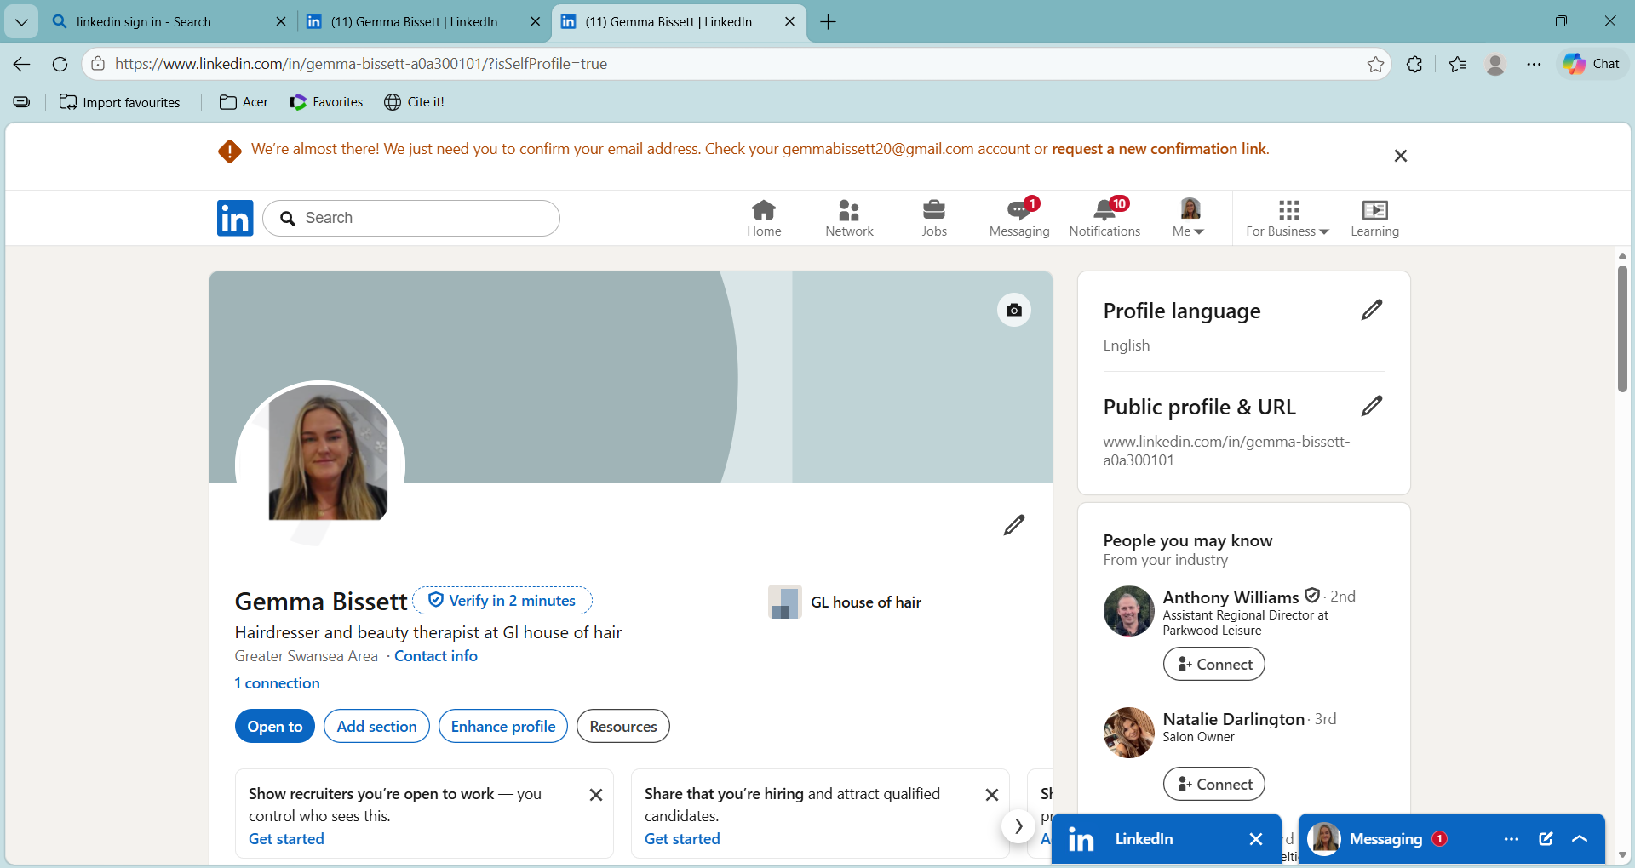

3.5 Application Rationale
I tailored my application to meet the requirements of the Hairdressing Assessor role in Caerphilly, with focus on the fact that the position is aimed at a trainee assessor. The job description highlights the need for someone who is developing their teaching and assessing practice while already possessing strong technical hairdressing skills. For this I prioritised my 20 years of professional hairdressing experience, my Level 3 qualification, and my extensive background mentoring apprentices in the salon. These elements demonstrate that I already have the practical base needed to support learners working towards City & Guilds Level 1–2 VRQ qualifications

Because the role welcomes applicants who are working towards TAQA or PGCE, I ensured my CV and cover letter made clear that I am progressing through my TAQA pathway and actively developing assessor skills. This positions me as an ideal trainee tutor candidate who is committed to professional growth. I also highlighted my CertHE Business Skills studies and recent digital skills development in PowerPoint, Word, Excel, to meet the requirement for IT competency in lesson planning, record keeping and virtual delivery.
The job description outlines communication skills, confidence in explaining technical concepts, and the ability to create a positive learning environment for school age learners. My LinkedIn profile was updated with a headline and summary focused on my transition from salon owner to trainee hairdressing educator.
I believe I have highlighted my strengths and successes to coincide with the job role requirements and have also shown how I plan to move forward into the next steps of my professional career development.

Reference List

Careers Wales (2026) Further Education Lecturer. Available at: https://careerswales.gov.wales/job-information/further-education-lecturer (Accessed: 25 October 2026).
City & Guilds (2026) Hairdressing Qualifications. Available at: https://www.cityandguilds.com/qualifications-and-apprenticeships/hairdressing (Accessed: 25 October 2026).
ColegauCymru (2026) CollegesWales. Available at: https://www.colleges.wales (Accessed: 25 October 2026).
Gibbs, G. (1988) Learning by Doing: A Guide to Teaching and Learning Methods. Oxford: Further Education Unit, Oxford Polytechnic.
Luft, J and Ingham, H. (1955) ‘The Johari Window: A Graphic Model of Interpersonal Awareness’, Proceedings of the Western Training Laboratory in Group Development. Los Angeles: University of California.
Microsoft Education (2026) Microsoft Teams for Education. Available at: https://www.microsoft.com/en/education/products/teams (Accessed: 25 October 2026).
Microsoft Learn (2026) Microsoft Teams for Education. Available at: https://learn.microsoft.com/en-us/microsoft-365/education/guide/2-baseline/applications/baseline-apps-teams-what-is-teams (Accessed: 25 October 2026).
Moodle (2026) Moodle Learning Platform. Available at: https://moodle.org (Accessed: 25 October 2026).
VTCT Skills (2026) Hairdressing and Barbering Qualifications. Available at: https://www.vtctskills.org.uk/qualification-sector/hairdressing-barbering/ (Accessed: 25 October 2026).

