Memory in pieces

I have chosen to use memory as the theme of my exhibition, specifically however, the exhibition is tailored to raise awareness around the subject of Alzheimer’s disease.
It is also to raise awareness for how much people without the disorder take the ability to create new memory’s and to recall old ones for granted.
These issues will have an influence on everyone’s life at some point or another as it is proven that 1 in 6 people over the age of 80 are diagnosed with the disease “Alzheimer’s Society (2014), facts and the media, who is affected”1
I also want to try and resolve some stigmatisation which are associated with the disorder, such as, that you must be over 65 years old to develop the condition. In reality, it can develop at any age though it is very uncommon for those below this age “Alzheimer’s Society (2014), Dementia 2014: Opportunity for change”2. finally this exhibition highlight the work of artists who use their pieces to tell story’s that would otherwise be forgotten such as the story’s that would be lost through the disease. It shall also highlight all the work which is being done to combat the disease.
The three artists that will be exhibited: Rachel Whiteread, Angelica Garcia and finally li Xiaofeng. Each of the artist’s pieces will be placed in separate rooms based on individual themes of the exhibition, for example, the room featuring Angelica Garcia work will focus on how the disease makes people see their loved ones.
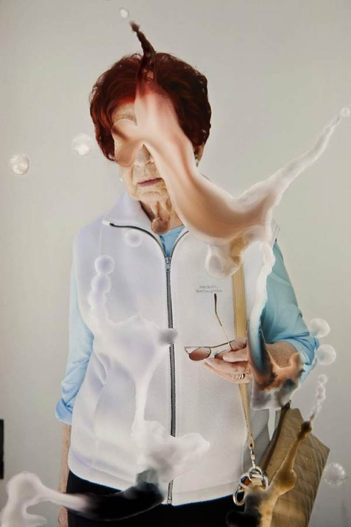


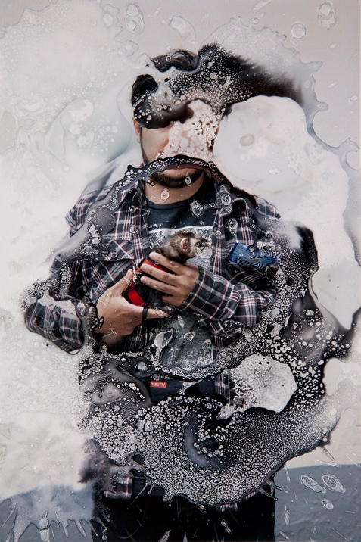
Angelica Garcia (2013) Vacio (emptiness) Series. See me exhibition, New York.

Angelica Garcia (2013) Vacio (emptiness) Series. See me exhibition, New York.

Angelica Garcia (2013) Vacio (emptiness) Series. See me exhibition, New York.

The first artist to be implement into the exhibition is the work of angelica Garcia. The work which will be focused on during the exhibition is her vacio series or emptiness as she has stated. The work is done by taking existing photos and using non digital methods to manipulate the images. The pieces were created in 2013 for a digital project as part of Creative Rising digital exhibition organized by See Me in New York City.

In an article about Angelica’s work she claimed that “She wants her pictures to speak for themselves”. [And that] “the idea to erase the faces of the people came to her in a dream” (Seppe Elewaut (09/03/15) Photographer of the day, paragraph one)3 though these do not give any main narrative it doses make it much easier to link into into the exhibition. Looking at her work there are several indications which could link into the exhibition for example, it may indicate what it may be like for a person who is forgetting the people around them. As you can see in the photos none of the faces are clear similar to how people with Alzheimer will forget a person until their told how they are then they are recognised but they will inevitably forget again.
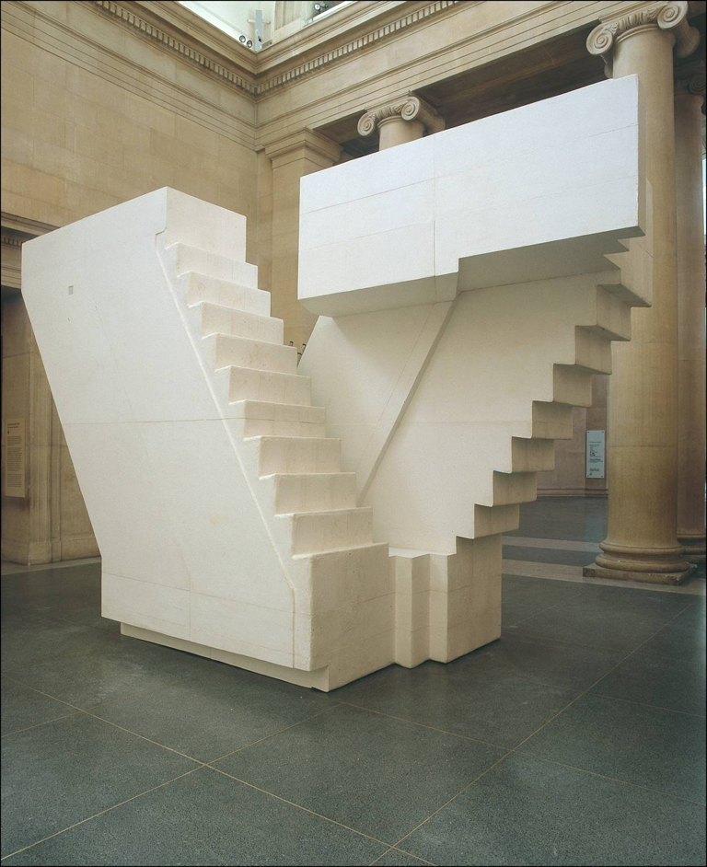
Rachel Whiteread (2001) Untitled (Stares), Tate, modern Medium – Plaster, Fiberglass and wood

the next piece is that of Rachel whitread’s work. The work she is mainly based in the forgotten spaces such as the inside of containers and underneath chair (Catherin wood and Gordon Burn, (2005), Rachel Whiteread Embankment, Tate publishing, page 27). However, one of her most famous pieces is the stair case. The piece is referred to as (unknown) staircase, the piece depicts a cast of a stair case from beneath and above. The piece was made in 2001 using ten separate casted pieces which are bolted together to create the complicated piece (Elizabeth Manchester, (February 2005) Tate, http://www.tate.org.uk/art/artworks/whiteread-untitled-stairs-t07939). The piece is made using a mixture of jesmonite and fiberglass which makes the piece strong but also lighter than using other casting materials such as concrete

In an article by Rachel Whiteread (date) she stated “when I was first thinking about making [it] I didn’t necessarily want to illustrate it as a staircase… [meaning that she wanted to challenge the viewer’s idea and what the piece meant to them this can be seen in the same article where she stated] … I wanted to change the way one might think about how you walk around or through something”. This is exactly what I hope to achieve by displaying this piece I want the audience to see these stairs as the challenges which those with Alzheimer’s must face each day as the condition worsens overtime (Elizabeth Manchester, (February 2005) Tate, http://www.tate.org.uk/art/artworks/whiteread-untitled-stairs-t07939).
Li Xiaofeng (2010) Parade No. 3, Red Gate Gallery, Medium – porcelain

Li Xiaofeng (2010) Parade No. 2, Red Gate Gallery, Medium – porcelain

The third and final artist chosen for the exhibition is the work of li Xiaofeng he is a fashion designer, however, he claimed he wanted to break the mould when it came to the standard creation of clothing. He decided to create his clothe using old pieces of ceramics found from historical digs and stitched them together to make the clothes (Tamare Akcay (2015) Beautiful/Decay, http://www.beautifuldecay.com/2015/08/03/li-xiaofeng-assembles-shards-ceramics-piece-piece-create-elaborate-clothing-can-wear/) 6.

In relation to the exhibition, the pieces could symbolise the fractured memories which are left of those with Alzheimer’s. However, it could equally symbolise the fractures in the person’s personality. showing that the though the person is there physically mentally they may not be and only broken pieces of there personalities remain.

The main theme of the exhibition is memory however the underlying theme is Alzheimer’s awareness. The aim of this exhibition is to make people aware of the signs of the developing condition and what they can do to help in trying to cure the condition.
I also hope to show what the people and there loved ones with the disease go though and how they cope with these issues on a daily basis.

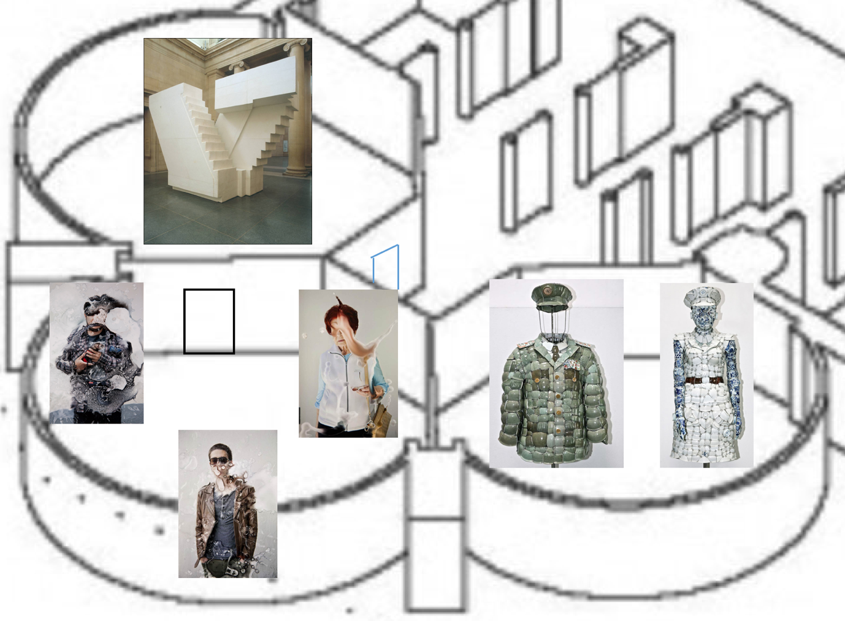
above is a floor plan for the exhibition, the space being the Tate modern in London, however this will be based in the newly built extension to the building. The exhibition will hopefully give the audience a opportunity to understand what the life of a person with Alzheimer’s. the main exhibition will take place within the three large rooms. within each room will be one of the artists. Each of the pieces have been set out in such a way that makes it more and more clear to what the theme of the exhibition. The public would begin by walking through the Rachel whiteread exhibition through to Angelica Garcia’s pieces and finally finish in li Xiaofeng exhibition at the end there will also be a stand for the public to ask questions about the piece’s and what they can do to help raise awareness for Alzheimer’s research and make donations to the work if they wish to do so

https://www.alzheimers.org.uk/about-us/news-and-media/facts-media 1

https://www.alzheimersresearchuk.org/about-dementia/facts-stats/10-things-you-need-to-know-about-dementia/ 2

http://resourcemagonline.com/2015/03/photographer-of-the-day-angelica-garcia-with-her-vacio-emptiness-series/49247/ 3

Catherin Wood and Gordon Burn, (2005), Rachel Whiteread Embankment, Tate publishing, 4

http://www.tate.org.uk/art/artworks/whiteread-untitled-stairs-t07939 5

http://www.beautifuldecay.com/2015/08/03/li-xiaofeng-assembles-shards-ceramics-piece-piece-create-elaborate-clothing-can-wear/ 6

