My name is Miriam Nosworthy; I’m a feminist, an activist, a vegetarian and part of the LGBTQ community. (Pride clip) I’ve grown up in a family full of love for all people; my mother’s hero is Martin Luther King. (Martin Luther King clip) We were taught at a young age that everyone deserved equal rights. We are a family of love and support for anyone and everyone.
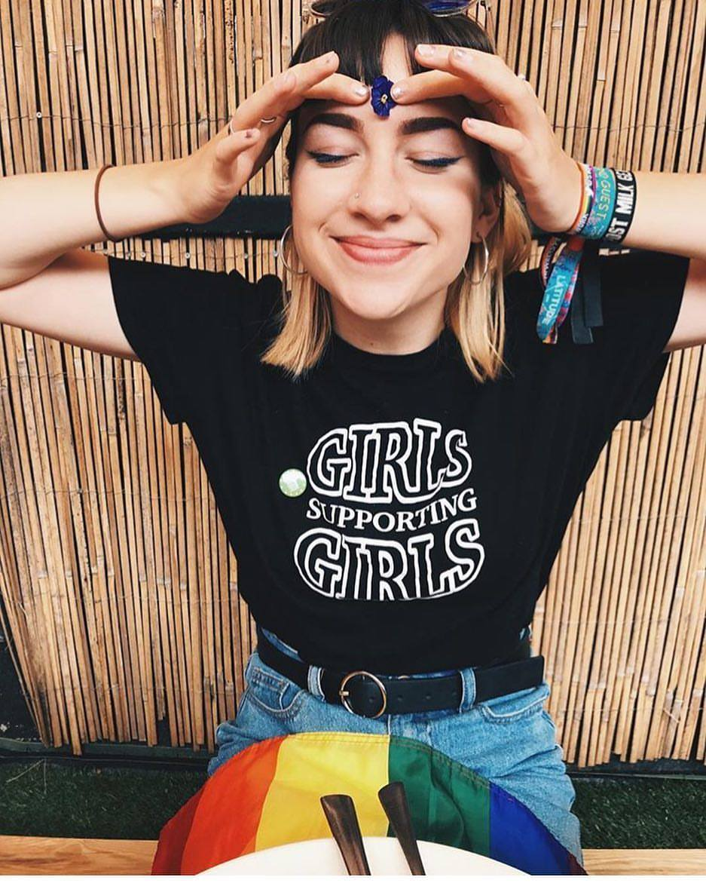


Growing up in a household full of equality, when I became older I began learning more about politics not only in the UK but also all around the world. American politics fascinated me, as it was such an extreme side of politics. Being a believer in equal rights I began to watch left wing documentaries based on the states such as ‘13^{th’}, ‘Gaycation’, ‘I am not your negro’ and ‘White Right: Meeting the enemy.’ It baffled me how these right wing people had so much hate for people who weren’t white, straight and Christian, not only was it the general public that felt this way but actual politicians who were and are working to becoming the President of the United States. I began questioning that if I had grown up in a different home life, would I agree with what these extreme right wing believers were stating? I decided to begin watching right wing documentaries to see if they would change my views on their beliefs. Are both left and right wing documentaries just made as propaganda to push what they believe in and make the other side seen worse then they actually are? Should I believe everything I see in these documentaries? I’m a feminist, a gay rights activist and a vegetarian, change my mind.

At the age of 12 on the 6th November 2008, I watched on the news what my parents called history, the first black President of the United States. I knew little about both the Democrat and Republican Party but was assumed that Barack Obama was the “good guy”. (Clips of Obama) I saw my mothers tears as she feared for a mans life because of the colour of his skin.

At the age of 20, I woke up to the shocking news that Donald Trump had won the 2016 Presidential election, a man who wants to build a wall to keep Mexicans out, who believes all Muslims are terrorists and someone who thinks that because of his fame he can assault women by “grabbing them by the pussy” (Clips of Trump) I didn’t understand why anyone would ever vote for someone who had such a terrible history and awful plans for the United States.

Now ten years after Obama was elected I’m researching into political documentaries to see if whether my opinions on American Politics are actually what I believe. When it comes to political or activist documentaries I automatically watch ones that are based on information I agree with or are interested in, meaning they’re always left wing documentaries. Such as ‘White Right: Meeting the enemy’ (2017) which focuses on the rise of nationalism in a America controlled by Trump, from the “alt-right” to all out neo-nazis. Director Deeyah Khan not only narrates but features in the film herself as she spends time with various leaders from extreme movements, going to meetings and joining movements at protests. Within this documentary Deeyah met a large amount of people from the National Socialist Movement, a neo-Nazi political party based in Detroit, Michigan. I went into watching this documentary with a hot head prepared to be shocked and probably offended by what these people stand for and protest against although there were certain moments I was shocked by, (Jeff Schoep comparing himself to Martin Luther King. Killing Heather Heyer. Ken Parker ‘Jews and Homosexuals, I think they should be exterminated every single one of them.’) However if anything this documentary did the opposite, I actually sympathized with these alt-right movements who had so much hate for diffrernt people but when it came to being in front of those people and listening to how Deeyah has been spoken to in the past it made most of the alt right supporters she had met uncomfortable. I soon realised these people didn’t really know why they hated the blacks, muslims, Mexicans, jews or homosexuals, but were made to believe these people were the reason things were going wrong in their country. In fact after spending time with Deeyah a few had changed their views and even made Brian Culpepper leave the National Socialist Movement and instead worked towards bringing people together.

Feeling that maybe the lower and middle class of America are being fed this information that they’re not getting the jobs and children are being given drugs and being raped because of the ‘foreigners’. With my new view on these extreme right wing supporters I decided to watch some political right-wing documentaries wondering if this will make me understand why these people in White Right: Meeting the enemy, feel the way they do. I started with the 2013 documentary ‘Caucus’ following eight Republicans campaign in the 2011 – 2012 campaign in Iowa. From the beginning of the film I automatically knew this documentary was proud to be showing this side of American politics. With a large amount of people shown in the documentary, white and middle class people living in Iowa who obviously want change, something that seem understandable for certain people such as repealing Obama Care but what shocked me the most was how all eight candidates kept pushing specific things that they all wanted to change to “make America Great again” (Pro Marriage, pro Family, Pro Life. Life is precious from contraception to natural death.) All eight believe in traditional Christian families and way of life. As I watched Caucus I began to realise how many people are pro life, against homosexuals and wanted to make America more safe by removing “the foreigners”, if the candidate pushed these views at there rallies there voting poll would go up. These people were scared of anything not white or Christian but I didn’t understand why. Then I saw it, many people had brought their children to these rallies, these children are growing up in a household where the parents believe these ways of life are the right ways. I may not understand why Rick Perry doesn’t want homosexuals serving in the military but if you have grown up in a right wing house hold then there is a high chance that you will end up voting right wing with no questions asked. But I wonder if we sit these candidates down with a gay couple or a muslim or Mexican family or a young girl who fell pregnant and had an abortion would it change there mind like it did when Deeyah sat down with NSM members.

I was curious to see if anyone had ever tried to speak to these politicians about there lifestyle. In 2016 Ellen Page and Ian Daniel brought a documentary series ‘Gaycation’ looking at gay rights all around the world from Tokyo to Kazakhstan in one episode they travel around USA, just after gay marriage was legalized. They stop off in Iowa the same place that Caucus is based but four years later when Ted Cruz is running for President in 2016. Ted Cruz was one of the strongest right wing candidates for the 2016 election, he opposed marriage equality, urged states and individuals to ignore court ruling of same sex marriage, supported those who denied service to the LGBTQ community and campaigned along side Kevin Swanson, a pastor who preaches on the execution of homosexuals. Ellen Page decides to confront Ted Cruz at the Iowa state fair on his religious beliefs. Cruz defends his beliefs and his rally for religious liberty. Ellen shuts down Ted Cruz after she states Christians are killing homosexuals all over the world. With this information known Ted Cruz doesn’t once change his opinion on gay rights or gay marriage.

Through all three documentaries I have discussed the right wing always comes back to the bible, they state their belief are because the bible tells them that marriage is between one man and one woman, and killing a life is wrong. They want to keep the United States Christian. But the world is no longer just one religion we are a multicultural planet with different religions and different views. However if you look at all these different religions and the books they read to follow their religion whether that be the bible, the Quran or The Torah all have similar lessons, which all come down to love, love your family, love your neighbours.

Watching these documentaries I was expecting to be angered by these people who are against so much of what represents me as a person and that I believe in. I can happily say I still have the same beliefs I had when I started watching these documentaries in fact I may feel stronger about my beliefs after watching these films, however I have more respect for these people then I thought I would, watching ‘White Right: Meeting the enemy” showed me that a lot of these people haven’t spent time with these people they supposedly hate, they’ve decided they’ve hated them for reasons they seem justifiable but once they spent time with Deeyah Khan you could see they were almost upset to see how she had been spoken to in the past in fact you see Jeff Scheop look uncomfortable as Deeyah refers to herself as a shit skin. These people are uneducated, whether it be they’re getting there information from the wrong news station or they were brought up on these beliefs, a lot of them changed their minds once face to face with that terrifying terrorist there told to fear by the man who is sat in the oval office right now. But then who says what I believe in is the right thing?

