Effective Teaching, Learning and Assessment (ETLA)
45min. Peer Group Micro-Teach 2 Reflection M6X02269
Word Count: 2500


Jayne Pierson
1808360 | PGCE (PCET)

Introduction
In this paper, Effective Teaching, Learning and Assessment, I aim to evaluate and examine my second micro-teach lesson and reflect upon my performance along with the use of traditional teaching skills and my inclusion of cross-cutting themes.
I will reflect on my work using Gibbs’ (1988) Framework for Reflection and the reflective cycle and Kolb’s (1984) Experiential Learning Cycle. I will include within my reflection, the development of my lesson plan, the rationale of my chosen subject and the cross-cutting themes, in keeping with the Well-being and the Future of Wales Act 2015 and EntreComp: The Entrepreneurial Competence Framework of 2016 and NESTA The Future of Skills: Employment in 2030. The reflection will also include my peer groups written feedback and how the lesson can be improved upon to further enhance my professional practise and future development.
Following the completion of the reflection, the more traditional teaching styles and the cross-cutting themes that were integrated within the session will be critically reviewed in relation to their appropriation within the lesson planning, learning objectives and outcomes.

Reflecting
This was the second time for me to attempt to condense my teaching into a succinct 45 min. micro-teach session. For my previous micro-teach, I had taught the subject ‘Fashion Trends’ and I had found it particularly difficult to pitch the knowledge level accurately, as my subject is so specialized and skill-based that to make it more generalised was very difficult. It’s particularly difficult to determine my peer groups subject knowledge of fashion as it’s so generally misunderstood in an academic capacity. I didn’t want to overly simplify my lesson and yet I didn’t want to make it so complex that I had lost the attention of my peer group and as such, they wouldn’t be able to complete my task.
Despite my concerns, I prepared a lesson plan that I had developed from previous lessons that I had delivered before but this time on the subject of Fashion Branding and Promotion and I just had to hope that I had it pitched it correctly for their understanding and knowledge.
I selected a lesson subject based around what constitutes a fashion brand and the marketing and promotion that surrounds that. I felt that this would establish a basic understanding of the concept of branding and how brands deliver their product to consumers through ethos, customer, signature and identity.
I chose this subject as I have utilised these skills in my industrial practise and from researching the subject in depth whilst teaching it over previous years. I felt confident that I could discuss the subject academically and from substantial professional experience thus instilling an understanding of how these skills were transferable skills for personal branding and not just suitable for those in fashion branding but all branding. I also hoped that the expertise conveyed in my lesson would inspire a want to learn more of what fashion, as an academic subject, is actually about and thus motivating an active adult learner. As Petty (2014) explains, we, as teachers, must see ourselves as facilitators to encourage students to take responsibility for their own learning. I have personally learnt the most through active experimentation and reflecting systematically with objective evaluation. This has enabled in me a self-belief and resourcefulness that I otherwise would not have had, had I not been taught in an ‘active’ way.
Previously in my first micro-teach lesson, the complexity of the subject should have been broken down into simpler terms. This time, I tried to take into consideration that the fashion world uses particular terminology and phrases and as such, I must explain the subject in a more generalised way prior to discussing specifics. Again, it was paramount to consider the level of knowledge and understanding that was and wasn’t known throughout the cohort and consequently it was very difficult to know where to pitch the lesson or to determine the outcomes from which my peers gained an understanding of the lesson. However, in order to ensure that my micro-teach was a success, it was essential to demonstrate the relevance of my lesson across a number of essential skills such as; industrial practise, sustainability, employability, communication skills and teamwork.
As Ramsden (2003) comments: when our interest is aroused in something whether it is an academic subject or a hobby, we enjoy working hard at it. We come to feel that we can in some way own it and use it to make sense of the world around us. This is especially important in relation to the Welsh European Funding Offices’ Cross Cutting Themes, Key Document – European Social Fund, EntreComp and the three competency areas, the Commissioner for Wales’, Well Being and the Future of Wales’ Well-Being plan. It’s my objective with this micro-teach that the cohort can apply my lesson, however specific, across core, essential skills.
As my micro-teach was mostly creative, it targeted certain competencies such as spotting opportunities, vision, valuing ideas along with ethical and sustainable thinking. This was demonstrated in a variety of ways. Firstly, by exploring how brands have created value with their product and how this could be applied to personal branding across social media. This would be relevant for anyone with a social media profile and could help show personal values such as employability, experience, professionalism and explore further networking opportunities by identifying needs and challenges. Secondly, the use of creative vision and the understanding of key components in branding (personal or otherwise) and specifically in relation to the application of creative ideas and innovations to practical situations. This is a generic concept that can be applied across all areas of education (Well Being and the Future of Wales). Thirdly, defining ethical and sustainable thinking and understanding the different core values between high-end luxury and commercial high-street and the obvious impacts on the environment.
The premise of my lesson was to demonstrate how the core skills were transferable to everyday and everyone’s personal branding and despite pitching it to the largely unknown abilities of the group, I felt that the cohort were still slightly confused as to how this subject area would fulfil the cross-cutting themes outlined in the brief.
Regardless of this, I still felt I perhaps tried to fit in too much information and therefore spoke too long, becoming too teacher-led and not discussion focussed enough as I had intended. Nevertheless, I will know in future to further adapt within the situation if I feel I am discussing the subject in too much detail and allow the students to have more time to debate and discuss their ideas.
Once I had decided on the subject area, content, how I could deliver it and which specific cross-cutting themes would be covered, I set about organising my micro-teach lesson and hoping to improve on the previous one. In hindsight, I would have liked to include more elements of heutagogy and as Bill Ford (1997) advocates, knowledge sharing rather than knowledge hoarding.
My lesson was focused on fashion branding and discovering the inspiration to commercialization. According to Aaker (1993), a brand represents a name, sign, symbol, design that uniquely identify and differentiate particular products or services from others. It incorporates intangibles such as identity, personality, associations and meanings. Branding attempts to reach out to its audience like a best friend, communicating emotionally through values, voice and design choices. One gets a sense of intuition and heutagogy encompasses this. Heutagogy is an approach that accepts that intuition is an integral part of the learning process, drawing upon reflective and double loop learning – it includes aspects of action and reflective learning. This is an approach that responds to the challenge of enabling the development of people, who can cope with a rapidly changing world, (Snowden & Halsall, 2014). As such, the nature of branding, lends itself to the approach of critical consciousness, collective identity and solution-orientated strategies for change.
The context of the session was adapted from my previous lesson plan but with the idea that it would be based upon little, if any, background knowledge and just a passing interest, in social media and branding, was required. My intention was to encourage the students to discuss and formulate their own understanding of the subject area. My lesson and the Learning Objectives (L/O’s) were defined as:
- Define what constitutes a fashion brand.
- Identify key components of fashion branding:
Brand Ethos, Brand Customer, Brand signature and Brand identity.
- Begin to formulate your own branding.

The three L/O’s were then assessed on a simple rating scale for formative assessment (K5) along with general comments. This rating scale had four response options:
- Very Good
- Good
- Satisfactory
- Unsatisfactory

The assessment evaluation for the L/O was given on the day as 1. Very Good: Accuracy of knowledge of subject matter and 2. Good: Understanding of context. I thought this had been a fair assessment of my lesson but definitely room for improvement.
L/01: Define what constitutes a fashion brand. This started the lesson with a clear understanding of the subject. This set the tone of the lesson and would contain the key elements with core knowledge of the subject material (K1). This core knowledge was delivered via a PowerPoint presentation with embedded YouTube films of three very different brands.
This also covers the Entrepreneur Competence Framework by: Advanced Ideas and Opportunities: Spotting Opportunities: Learners can seize and shape opportunities to respond to challenges and create value for others. Valuing Ideas: Learners can develop strategies to make the most of the value generated by ideas. Creativity: Learners can transform ideas into solutions that create value for others.
L/O2: Identify key components of fashion branding ie. Brand ethos, brand customer, brand signature, and brand identity. This was intended to demonstrate to the students how this applies to their own individual understanding of branding and to encourage them to incorporate this understanding into their own world (K1, K3, V4).
This also covers Entrepreneur Competence Framework by using Resources: Advanced Mobilising Resources: Learners can define strategies to mobilise the resources they need to generate value for others. Advanced Into Action: Learning Through Experience: Learners can improve their abilities to create value by building on their previous experiences and interactions with others. Advanced Taking the Initiative: Learners can look for opportunities to take the initiative to add or create value.
L/O3: Begin to formulate your own branding. This was intended to give further knowledge based around wider outside factors. These factors would incorporate an understanding of personal branding and how this builds professional relationships, self-efficacy, working with others, creativity and vision. This would influence knowledge and decision-making. This led into group work and an open discussion based upon their own understanding and evaluations on materials sourced and provided. (K1, K2). This promoted participation and equality based on the fact that the subject was womenswear and menswear fashion branding (V1, V2).
This also covers Entrepreneur Competence Framework by Into Action, Advanced: Working with Others: Learners can build a team and net- works based on the needs of their value-creating activity. Learning Through Experience: Learners can improve their abilities to create value by building on their previous experiences and interactions with others. Resources, Self Awareness & Self-Efficacy: Learners can compensate for their weaknesses by teaming up with others and by further developing their strengths. Ideas & Opportunities, Creativity: Learners can transform ideas into solutions that create value for others.
Finally, I recapped what we had covered in an open discussion. The students had participated with their own opinions and understanding. I demonstrated evidence from my own professional practise including how brands and personal branding can build professional relationships for the individual also. (V3, V4). I feel the lesson was well planned out, perhaps with a little too much information for the peer group as I felt at times they weren’t fully engaged as the subject area which was very specific and I was perhaps attempting to fit in too much information. However, I also felt that the cohort enjoyed the films that I selected to demonstrate how each, very different brand, could engage and connect with an audience in a variety of ways.
Critical Evaluation of Practise
I felt a little more nervous in presenting my second Micro-Teach lesson due to the errors that I had made in my previous one. I was mindful that I had to make quite a few adjustments to the pitch plus it had to be a longer lesson whilst including transferable skills and cross-cutting techniques as outlined by the Well-Being and Future of Wales Initiative, Entre Comp., NESTA’s The Future of Skills: Employment in 2030 and Cardiff Metropolitan Universities’’ EDGE in CSAD.
I did however feel confident that I could deliver a lesson that was creative and well researched. Maslow’s hierarchy of human needs places emphasis on self-esteem and self-actualisation, both of which can be satisfied by creative work. Being creative satisfies a deep human need (Petty, 2014). My idea for the session was to deliver a broad understanding of a very detailed subject in a simple to understand way. This was to include a discussion that would incorporate the concept of ‘heutagogy’, to ensure the cohort could reflect upon what they’ve learnt, how they’ve learnt it and to consider the concept of the subject in their own time by demonstrating how it relates to the understanding of their own ‘world’. I wanted to explain that despite how specific the subject matter could be, it relates to us all, we use these skills every day, even if we aren’t aware of it. We all ‘brand’ ourselves by how we are perceived across social media and how others view us. If we understand personal branding, we can harness it and use it to our advantage. I wanted to explain the learning process as I hoped this would keep them engaged and the subject relatable. Kenyon & Hase (2001) suggest that learning is a learner-centric experience rather than an educator-centric one, where learners who encounter subject matter, in addition to tips on how to learn, increase their overall learning capabilities by becoming highly autonomous and self-determined.
The structure of my lesson was devised to include the pedagogy of Bloom’s Taxonomy (1956) [1]: L/01: to define, memorize the subject and terminology. L/02: to identify and describe a core knowledge. L/03: to interpret and apply to the real world through discussion and to compare, analyze and distinguish through further open class discussion. All of these learning outcomes (L/0’s) would assist the students in understanding how the subject will be of everyday use and how it will help them evaluate the ways in which it will personally impact their lifestyles.
I decided once again to present my lesson using Powerpoint I knew it had its drawbacks as that was a format that was generally used but one that wasn’t the most innovative way to demonstrate a creative lesson however I had previously struggled with SWAY as I couldn’t make the text run smoothly and I still had this issue. With a bit of additional practise I aim to get to grips with this and hope to use this in the future. The internet and furthermore, social media have accelerated a movement toward collaborative content creation, thereby resulting in a need for focused attention at a high level within the context of teaching and learning (Summey, 2013). I was very aware that I needed to improve my digital strategy given my subject matter. I did however aim to make my slides more creative visually and display embedded YouTube iconic fashion films. This helped the creative tone of the lesson and I clearly outlined my L/O’s from the outset.
For this second micro-teach, the first response from the session was of interest and a feeling of ‘a want to learn’. I feel very grateful that my cohort and lecturers are so very encouraging and gave me the feeling that they wanted me to do well. This helped to alleviate my nerves and gave me extra confidence. I had the sense that the cohort also knew that I was teaching from industry experience, as I had led by practise. I spoke from personal knowledge regarding my own work and of my own brand and I think this really helped to establish with my group that I had a sound and experienced knowledge of my core subject. I had previously shown my work as part of the official London Fashion Week, organised by the British Fashion Council. My route to industry was from sheer hard work and determination and I had hoped to impart this industrial practise through my discourse. Despite this, and at times, I felt I was losing their concentration. This made me feel that I wanted to rush through the slides and films. I worried that the films I had selected were too long so I tried to regain their attention by picking up the tone and tempo to get to the group work.
During the task, I split the cohort into two groups and asked them to research, with the magazines I had provided or on their smart devices, a brand’s core values that they could then come back into the group and discuss. During this research time I had decided to trial the fairly new idea of playing music that helps to make one more receptive to creative ideas and thinking. I asked the group if they would like to try it and they agreed. I had already selected to play a YouTube video of a selection of music that helped stimulate alpha brainwaves. As Petty (2014) states, Students need to exercise their imagination, and explore feelings and perceptions. They need to make personal meanings of their experiences, and to express these to others. Once the allocated time for research had elapsed, the discussion started, the groups had surprised me with how well they had responded and how much interest they had in the subject area. Feedback had been very complimentary; they had enjoyed the creativity and especially liked the visuals and the music. The cohort suggested more student-centred learning would be more effective however given the time and the subject; it was tricky to get through it all. Of course, selecting a simpler subject would have enabled me to focus on a task much more but I think it was necessary to choose from my specialised area as it wouldn’t be challenging enough otherwise. The group felt a type of formative assessment would have been helpful to further assess what they had learnt which I could definitely do next time. We did discuss in depth the group task findings and I did ask what they had learnt and demonstrated how it could be applied to their own life in a very practical way for career enhancement.

Keeping it simple but effective was the best strategy and letting the visuals speak for themselves had worked well. The film components were a tad lengthy and perhaps I could have selected shorter films, going forward. I felt the main negative aspect had perhaps been not engaging the students from the outset with a discussion on how the lesson could be applied in many ways to their employability, personal branding, entrepreneurial skills, team work, creativity and vision. Encouraging the inspiration phase by providing the students with an activity helps generate ideas (Petty, 2014). In future I will aim to start the lesson with a creative element that outlines not only their learning outcomes but how they can be applied to their own skill-set, this will further inspire the cohort to enable their own learning through engaging with each other.

References
Aaker, J. L, 1997. Dimensions of Brand Personality, Journal of Marketing Research
Available at:
https://www.researchgate.net/journal/00222437_Journal_of_Marketing_Research
[Accessed 5 November 2018]
Armitage, A., 2012. Teaching and Training in Post Compulsory Education, 4th Ed., Maidenhead: Open University Press.
Bloom, B. S., 1956. Taxonomy of Educational Objectives. Vol 1 ed. New York: McKay.
Crawley, J., 2010. In at the Deep End: A Survival Guide for Teachers in Post Compulsory Education, 2nd Ed.,Abingdon: Routledge, pp. 182.
Curzon, L. B.. & Tummons, J. 2013, Teaching in Further Education: An Outline of Principles and Practise, 7th Ed., London: Bloomsbury Academic, pp. 266
Future Generations Commissioner for Wales (Online)
Available at:
https://futuregenerations.wales/wpcontent/uploads/2017/08/Carmarthenshire-2017.pdf
[Accessed 14 November 2018]
Gibbs, G., 1988. Learning by Doing. In: Learning by Doing: A Guide to Teaching and Learning Methods. s.l.:FEU
Gregson, M. & Hillier, Y., 2015. Reflective Teaching in Further, Adult and Vocational Education, London: Bloomsbury Academic, pp. 327.
Kenyon, C. & Hase, S., 2001. Moving from anadragogy to heutagogy in vocational education. Proceedings of Research to Reality: Putting VET Research to Work. Adelaide, Australian Vocational Education and Training Research Association (AVET).
NESTA (Online)
Available at:
https://media.nesta.org.uk/documents/the_future_of_skills_employment_in_2030_0.pdf
[Accessed 15 November 2018]
Nisbit, J., & Schucksmith, J., 1986. Learning Strategies, London: Routledge.
Petty, G., 2014. Teaching Today, 5th Ed., Oxford: Oxford University Press, pp. 302-305.
Ramsden, P. 2003. Learning to Teach in Higher Education, 2nd Ed, Routledge Falmer, pp.93-94
Snowden, M. & Halsell, P. J., 2016. Cogent. (Online)
Available at: https://www.cogentoa.com/article/10.1080/23311886.2016.1223904
[Accessed 10 October 2018]
Somekh, B., 2007. Pedagogy and Learning with ICT, Manchester: Routledge.
Summey, D. C., 2013. Pedagogy and Learning with ICT, Manchester: Routeledge, pp. 6.

Appendices
{1} BLOOMS TAXONOMY
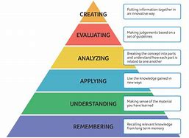
{2} MARLOW’S HIERARCHY
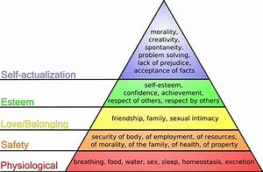

{3}ENTRECOMP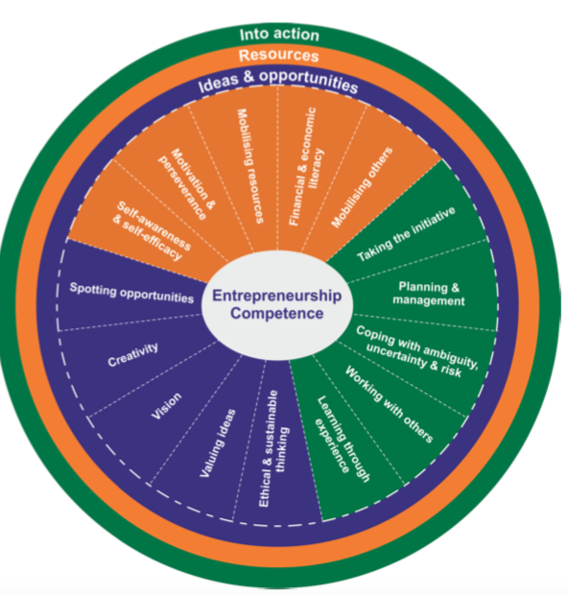.
(4) ENTRE COMP 2.
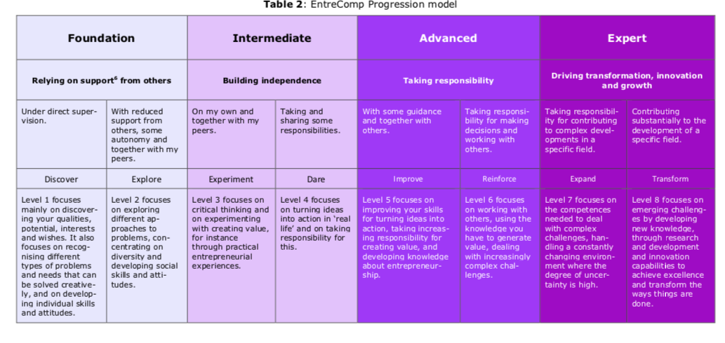

(5) BRAND PERSONALITY


