
A Guidance Handbook for Early Years Keyworkers during childhood transitions.
(Source: Rollins, 2017)

Alissa Jane Gough – 1706412
Human Development
EAEE4003/C

Contents Page No.

- Introduction to transitions in early years 1-7

- How to use the guidance handbook 8-11

- The role of the adult 12-17

- The needs of the child 18-22

- Partnerships 23-26

- Interventions 27-29

- Proposed outcomes 30-31

- Reference List 31-36

- Introduction
The term ‘transition’ within education usually suggests the way in which a child moves from primary to secondary school for example. This is stated by Edglossary (2013).

West Sussex (2020) explored how children go through various transitions within their early years which include anything from moving from one room to another, starting a new activity or moving school. In-order for the transitions to be achieved and effective, planning is essential as it is important for the child’s well-being. The child, parent and other keyworkers should be involved in planning the transitions so it is seen as a process rather than a situation that may only occur once or twice. This enables the transition to become a regular experience in a child’s life instead of a frightening and unfamiliar one.

The role of a practitioner is extremely important regarding a child’s transitioning process. Practitioners need to be aware of how enormous the effect can be on a child through transitions. However, it is normally the parent who struggles with the transition more than the child. Therefore, this can lead to the parent’s anxiety being portrayed onto the child. This means that part of the role of the practitioner is to help parents understand the importance of portraying the transition in a positive way to their child so they can enjoy the change of environment or situation they are in (Thomas, 2019).

Thomas (2019) also shows how good communication should be encouraged by the practitioner with all those involved so that the transition can be as smooth as possible and so the child can feel happy and settled in their new environment. Transitions can either have a positive or negative effect on their development, which will therefore influence their future experiences. The procedures put in place for the transitions need to be clear and strong for all those involved to see and understand.

Bronfrenbrenner has a similar view to this and it best explained through his ecological systems theory according to the website exploring your mind (2020). His idea is made up of five different systems that all include factors that have an impact on the child when transitioning that may influence their experience. Bronfrenbrenner found that those children who transitioned smoothly from their home life and into a learning setting, were more likely to successfully transition in the future and have a positive experience. This is achieved by the environment and relationships encouraging the child to allow them to grow and learn during the transition phase.

His theory shows the importance of the child experiencing transitions positively, as a negative experience could scare them. This is why Bronfrenbrenner explains how his research shows that strong relationships between all the professionals and parents/care givers involved results in a much more effective approach for the child and makes transitions a lot less stressful for all those involved (Exploring Your Mind, 2020).

This is Bronfrenbrenners ecological systems theory. It helps display how each element in each system has a different effect on the child and link in with each other.

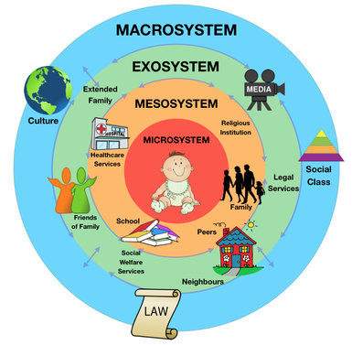

(Source: Psychologydos, 2015)

- How to use this handbook
This handbook is aimed for keyworkers working with children aged two to three years of age in a pre-school environment.
Communication is a key aspect of transitions:
Smooth transitions within the EYFS depend on a commitment from all professionals involved to develop positive communication links. In order to promote continuity for all children experiencing transitions between settings, it is important that there is a shared approach between all those professionals involved.
(Oxford County Council, 2017: 3)

Oxfordshire County Council (2017) suggest that an important adult in a child’s life have the responsibility to help the child progress and achieve throughout education, including any transitions they may encounter. By achieving this, the child has the best opportunity to reach their full potential.

This handbook is to be used by keyworkers as a guide to help understand how to successfully obtain smooth transitions during the early years stage from the home setting into pre-school, as well as moving from pre-school into the foundation stage at primary school. It will look at the needs of the child and how the adult can help achieve these. This handbook will also promote the keyworkers understanding of the importance of effective communication for young children’s learning and development during transitions using a holistic approach (Welsh Government, 2017).
Early Years Matters (2020) states that by following this guidance and through planning effectively, this handbook gives a good understanding on how to make the transition as smooth as possible for both the child and families involved. For this to be completed, the keyworker must build an effective communication platform with the parents/carer’s, so everyone involved is fully aware of the child’s needs during the transition. It also gains trust between the practitioner and parent/carer and support can be in place for the child’s learning and development, resulting in the best possible outcome.

Children tend to express their worries in their home setting so it is vital parents have a trusting communication platform with the practitioners so the appropriate support can be offered and so the issue can be resolved quickly to avoid an ongoing problem for the child (Early Years Matters, 2020).

This guide will help guarantee that the transitions are planned and monitored throughout the period to avoid any needs not being met properly. Commitment is required from the staff in the nursery so that the transition can be completed to a high level.
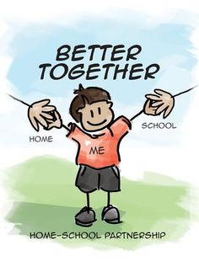
(Source: Educational App Store, 2019)

- The role of the adult
Allingham (2012) believes that there are various ways in which a practitioner can help with a child’s transition. This involves observation and assessments as it enables the practitioner to identify the strengths and interests of the child and therefore, individual needs can be met. When a child has achieved a task in class for example, it is important the child is praised for their achievement to help build their confidence as well as letting the parents/carer know so they can encourage their development further. The practitioner’s role also holds responsibility for preparing the child for moving onto the next stage in education, such as transitioning from pre-school to the foundation stage within a primary school setting. Making families aware of the process will help them feel supported in the transition.

A similar view to this is from the Government (2017) who suggest that for a child to feel supported, the practitioner must encourage their interests through challenging them and helping to develop their thinking and problem-solving skills. Practitioners must also observe the children so they can assess and plan their needs and interests so the child can develop further. Encouraging children to feel confident will help them to engage more in conversations and support their independence. By presenting a strong role model to the child, they are more likely to follow this and grow as an individual. Allowing the child to have opportunities to tackle news tasks that may seem challenging for them helps develop their creativity, imagination and physical development.

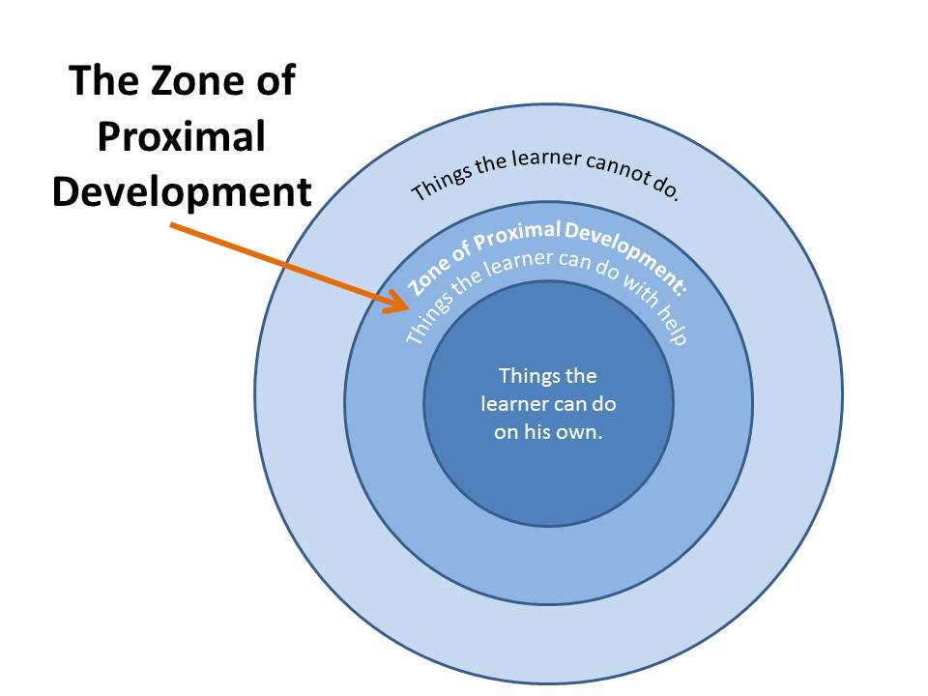
Vygotsky believed a child’s development is influenced by social and cultural matters, so every child varies. His theory of ‘the zone of proximal development’ best explains his this. It is a range of abilities that a child is yet to perform on their own but can achieve through the assistance of a more knowledgeable other (normally being an adult). A child may observe and practice actions and words from another individual. The more knowledgeable other is critical guidance for the child to be able to complete tasks. Giving the child resources to be able to complete the task is known as ‘scaffolding’. This involves an adult breaking down the learning so it can be achieved (Cayli, 2015).
(Source: Joellen, 2014)
As well as helping with their learning, adults play a huge role within a child’s emotional development. This links in with Bowlby’s ‘Attachment Theory’ as children often has a significant figure in their lives who they rely on for support and comfort. This is normally their mother or main carer. He discusses that many of the children will look for a secondary figure to replace the primary one when they are no longer there. This is important in transitions because the child is going to look for security elsewhere in their absence, emphasizing the importance of relationships (Wilson-Ali, Barret-Pugh and Knaus, 2019). Bruce (2012) agrees with this as she found that Froebel had the same idea about giving children warmth and affection and the importance of it.

According to Salkind (2015), Erikson’s theory agrees with this as one of his eight stages of psychosocial developments include trust and mistrust. He suggests that within the early stages of a child’s life, they look for reassurance and comfort from their primary caregiver. If they lack this support, children may become anxious and unsettled in new situations. This shows how adults have a significant role within a child’s development when going through their transition.

Foundation Years (no date) state that early years practitioners must acknowledge children who have special educational needs. Every child has their own needs and requirements within education. Support may need to be given for those who come across barriers during their learning. Practitioners must also identify difficulties that are developing but can be prevented early on. Where possible, they need to work with other agencies to give the child the best possible support. By planning, transitions will become smoother for children as their educational needs will not affect their development. This in return will give the child a more positive outlook on transitions.

- The needs of the child
Children have many needs within a transition process in early years. Many of their needs were believed to have been found at home but according to more recent studies these are now found within a school setting. The most essential requirements children look for within in a care setting is to feel warmth and kindness from the adult that is taking care of them resulting in a trustful relationship. The need to feel important and welcomed when going through the transition phase are crucial as they are more likely to develop their communication skills. For a child to build on their communication, a practitioner must respond to a child’s needs. This includes responding appropriately to a cry or gesture with an action like eye contact or a hug for example, so that it helps build that neutral connection with the key worker and reassure that trust they have with them (Early Years Matters, 2020).
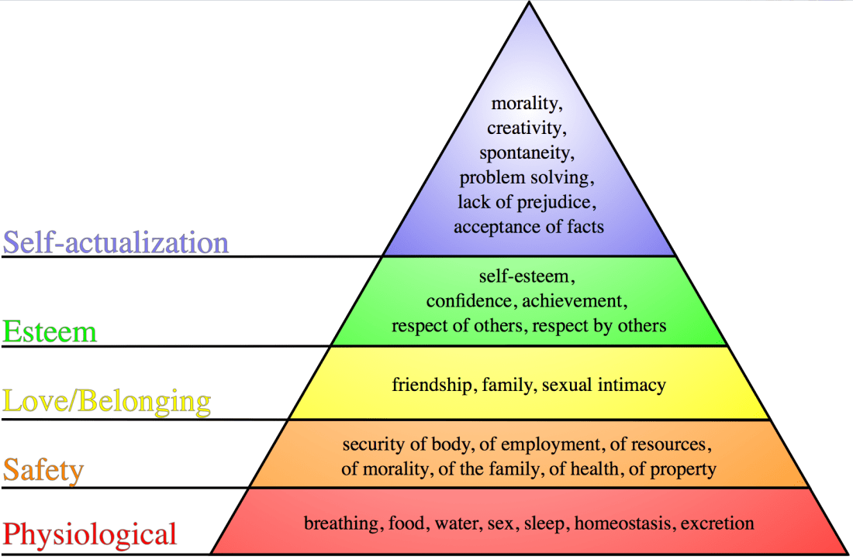
Practitioners are always encouraged to establish the needs of the child. Maslow’s hierarchy of needs explains this further. It shows how each level needs to be met for the child to be able to move onto the high levels (Carley, 2015).
(Source: Carley, 2015)
According to Dobson, play is:
From an early age, play is important to a child's development and learning. It is not just physical. It can involve cognitive, imaginative, creative, emotional and social aspects. It is the main way most children express their impulse to explore, experiment and understand. Children of all ages play.
(Study Mode Research, 2010)

Children need the opportunity to explore through movement and play. Play is a significant aspect of growth and development in early years as it contributes towards the emotional and social skills of a child. According to Welsh Government (2002), play is accountable for aspects of development for a child. It gives children a sense of freedom as they can explore by choosing what they want to play with and how they choose to play with it. Play is fundamentally the focus for a child and part of natural growth, so practitioners need to support this in the setting especially when going through transitions. It is something they are familiar with and feel comfortable in doing.

Play has become a substantial part of early years due to theorists such as Piaget and Vygotsky. Cherry and Gans (2020) explained how Piaget believed that the environment the child is placed in should be full of stimulating objects and activities in order to further their cognitive development. His idea explains how children in the pre-school age group, tend to use objects during their play but represent it as something else. They also begin to use role play. This in return helps build on their language skills. A practitioner may use play as a way of helping a child settle into their new environment when transiting from nursery to reception.

Montesorri’s theory disagreed with this as she believed pretend play was not a part of learning but giving children equipment or tools that would be used in a real-life scenario such as a knife when cooking is a way of learning. She developed these child sized tools so the children could engage with them and understand concepts such as shapes and weight. Montesorri stressed the value of setting up activities for children so they could explore and have freedom with their learning (Daily Montessori, 2020).


(Source: Holly, 2018)
- Partnerships
Partnerships are widely expressed throughout in the National Minimum Standards for Registered Childcare. Partnerships involving the keyworker and parents/carer’s are extremely important. The parent should be informed of their child’s progression within the transition from the very start. This will help establish the best way of communicating between them all. Chats are a good source of keeping the parent updated daily. It is a quick form of information giving which keeps everybody assured with how they are settling in. Parents with children who have additional learning needs may feel anxious and nervous for the child to start a new setting, so communication is key here (Pacey.org, 2020).

Pacey.org (2020) suggests that keyworkers should also be mindful of a language barrier that may occur if the parent/carer’s first language is not English. This is something the nursery practitioner can let the school know before the child transitions. It may be the case that the parent/carer has a learning need so communication may be difficult at times. Keeping the parent/carer’s up to date with the help the child is developing is key so they can learn how they may also be able to help the child at home through advice and support. Margaret McMillan agrees with this as she believes having strong relationships between the parent/carer and child is important in supporting their learning.

UK Essays (2018) demonstrates that a strong relationship between the two will also be beneficial for a child who has a speech deficiency for example, the teacher can be made aware of the problem and use Makaton as a way of communicating so the child understands, in return helping with their sense of security in the care setting. It is essential for the parent to tell the keyworker of any multi-agencies that may be involved already with the child so they can understand the child’s behaviors better. Children need to feel as if they have an importance within their transition. They need to feel they have trust with the key worker to build a positive and secure relationship so they can settle into their new setting smoothly and confidently.

According to Gasper (2009) multi-agencies are important because they can:
- Identify the needs of the child
- Have access to the most suitable help
- Increase the child’s confidence
- Develop their education with new skills
- Live a more full-filled life
Working with multi-agencies is a paramount part of the early years as all those involved should be working hard to meet the needs of the child. Having a well-established relationship with the professionals will help the get the child the right support they need. Multi-agencies that may be involved with the child include learning support workers and health visitors. These different professionals will be able to identify if a child needs support with their development so the issue can be identified early on (Kelly, 2016).
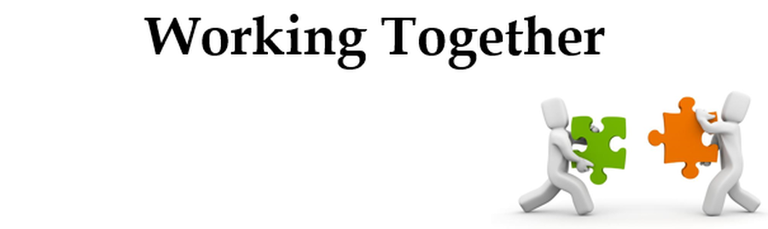
(Bentley Child Care, 2020)

- Interventions
According to Belfast Education (2011), there are interventions that can be put in place in preparation for the transition. This includes giving parents or carer’s a ‘Welcome Pack’ that has useful information regarding the new setting the child is moving to and the key people involved in the new setting. This can be given within plenty of time of the transition so that the parent/carer can plan.

Giving the child an opportunity to visit the setting is a useful way of helping the child to familiarize themselves with the size of the place as well as the kind of activities they can get involved with there. Parents/carer’s also have the chance to adjust to the new setting and meet the practitioners that they will be working alongside with. This links to the child beginning to understand the routine of the new setting by joining the class for lunch or snack with the parent to build that emotional security. Another effective strategy is arranging for the new practitioner to visit the child’s home so they can begin to build a positive relationship with the family and child. This gives the parent a chance to voice any concerns or worries they may have.

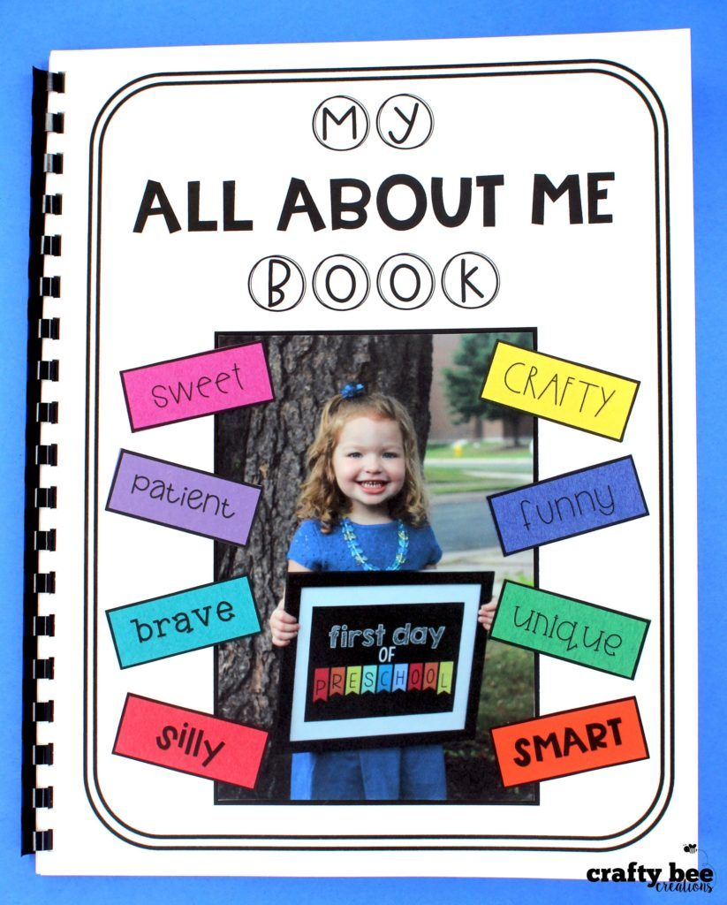
An ‘All About Me’ book is a positive way for the practitioner to gather all the key information about that child. The practitioner can then create different activities and tasks that involve the child’s interests which all contribute to feeling settled when transitioning. Staggering the start times help encourage the child into the new routine hours within the setting. Within the first several sessions the child attends, a parent/carer is welcome at any time. Extended play time will give practitioners the time to help the child form friendships by creating games and rules that will get other’s involved (Belfast, 2011).
(Source: Laura, 2017)

- Proposed Outcomes
All children are unique and have experienced different situations when developing. They all have different interests, characteristics, skills and abilities so this why each individual child will have a different experience with transitions. Every setting should emphasis the importance of positive transitions and have the correct planning and procedures in place.

The proposed outcome is to make certain that the child and parent/carer have the best physical and emotional support through the transition. This ensures that there is support with their progression in developing and learning and have a positive experience when going through the change in setting to facilitate the smoothest of transition. This view is supported by the Welsh Government (2018).
According to Kelly (2016), to help recognize if the practitioners are having a good effect on a child’s transition process, parent feedback forms are a great way of seeing if the parents believe their child is having a positive or negative effect from the transition and why they think this. It is also a crucial part of monitoring and evaluating. It allows practitioners to identify where the issues may be and how they can improve this which contributes to the running of the nursery.
Creating an assessment that requires daily updates on how the child is progressing is a good way to identify areas where the child is settling in and progressing and areas where there may be barriers occurring. It helps determine whether the transition is having a positive or negative effect on the child and how support can be continued to ensure the child is getting the correct provision (Early Years, 2020).

- Reference List

Allingham, S. (2012) Transitions in the early years. London: Andrews Uk Limited.
Belfast Education (2011) Early Years Learner Support Handbook. Available at: https://moodle.uwtsd.ac.uk/pluginfile.php/86467/mod_resource/content/1/Transitions%20handbook.pdf (Accessed: 16th November 2020).
Bentley Child Care. (2020) Partnerships with families. [Image] Available at: https://www.bentleycc.org.uk/parents-carers/working-together (Accessed: 17th November 2020).
Bruce, T. (2012) Early Childhood Practice. London: SAGE Publications Ltd.
Carley, S. (2015) Educational theories you must know: Maslow. St.Emlyn’s. Available at: Educational theories you must know: Maslow. St.Emlyn's • St Emlyn's (stemlynsblog.org) (Accessed: 26th November 2020).
Cayli. (2015) Piaget and Vygotsky [Video]. Available at: https://www.youtube.com/watch?v=hVylJWSaXaw (Accessed: 21st November 2020).
Cherry, K. and Gans, S. (2020) The 4 Stages of Cognitive Development. Available at: https://www.verywellmind.com/piagets-stages-of-cognitive-development-2795457 (Accessed: 21st November 2020).
Daily Montessori. (2020) Montessori Theory. Available at: http://www.dailymontessori.com/montessori-theory/ (Accessed: 21st November 2020).
Early Years Matters. (2020) Effective communication. Available at: Effective Communication (earlyyearscareers.com) (Accessed: 26th November 2020).
Early Years Matters. (2020) Observation, Assessment and Planning. Available at: Observation, Assessment and Planning - Early Years Matters (Accessed: 22nd November 2020).
Edglossary. (2013) Transition. Available at: https://www.edglossary.org/transition/#:~:text=In%20education%2C%20the%20term%20transition%20typically%20refers%20to,experience%20other%20%E2%80%9Ctransitions%E2%80%9D%20during%20their%20educational%20journey%E2%80%94such%20as (Accessed: 5th November 2020).
Educational App Store. (2019) Ways to Promote and Manage Parent-School Communication. [Image] Available at: https://www.educationalappstore.com/blog/ways-promote-manage-parent-school-communication/ (Accessed: 10th November 2020).
Exploring Your Mind. (2020) Bronfrenbrenner’s Ecological Systems Theory. Available at: https://exploringyourmind.com/bronfenbrenners-ecological-systems-theory/ (Accessed: 6th November 2020).
Foundation Years. (No date) Principles for early years education. Available at: foundation_stage.pdf (foundationyears.org.uk) (Accessed: 22nd November 2020).
Gasper, M. (2009) Multi-agency Working in the Early Years. London: SAGE Publications Ltd.
Holly. (2018) Montessori Materials Guide For Your Baby. [Image] Available at: https://thistoddlerlife.com/montessori-materials-guide-for-your-baby/ (Accessed: 21st November 2020).
Joellen. (2014) The Zone Of Proximal Development. [Image] Available at: http://www.cuppacocoa.com/the-zone-of-proximal-development/ (Accessed: 21st November 2020).

Kelly. (2016) Childcare providers working in partnership with Multi Agencies. Available at: http://www.earlyyearscareers.com/eyc/latest-news/childcare-providers-working-in-partnership-with-multi-agencies/ (Accessed: 17th November 2020).
Kelly. (2016) Receiving feedback from parents. Available at: Receiving feedback from parents (earlyyearscareers.com) (Accessed: 22nd November 2020).
Laura. (2017) My all about me book. [Image] Available at: My All About Me Book - Crafty Bee Creations (Accessed: 22nd November 2020).
Oxfordshire County Council. (2017) Smooth Transitions in the Early Years: A Good Practice Guide. Available at: https://www2.oxfordshire.gov.uk/cms/sites/default/files/folders/documents/childreneducationandfamilies/informationforchildcareproviders/Toolkit/goodpractice/EYTransitionPack.pdf (Accessed: 7th November 2020).
Pacey.org. (2020) Partnership with parents. Available at: https://www.pacey.org.uk/working-in-childcare/spotlight-on/partnerships-with-parents/ (Accessed on: 17/11/2020).
Psychologydos. (2015) Urie Bronfenbrenner's Ecological Systems Theory﻿. [Image] Available at: http://psychologydos.weebly.com/psych-journal/journal-8-urie-bronfenbrenners-ecological-systems-theory# (Accessed: 6th November 2020).
Rollins, M. (2017) Start Small and Early Transitioning From Children to Youth Ministry (4 Tips). [Image] Available at: https://www.seedbed.com/start-small-and-early-transitioning-from-children-to-youth-ministry/ (Accessed: 5th November 2020).
Salkind, N. (2004) An Introduction to Theories of Human Development. London: SAGE Publication Ltd.
Study Mode Research. (2010) Play What Is Play? Definition Of Play. Available at: Play What Is Play? Definition of Play. Research Paper - 471 Words (studymode.com) (Accessed: 22nd November 2020).

Thomas, E. (2019) Supporting transitions: Effective partnership working between families, carers and practitioners. Available at: https://www.nurseryworld.co.uk/knowledge-bank/article/supporting-transitions-effective-partnership-working-between-families-carers-and-practitioners (Accessed: 5th November 2020).
UKEssays. (2018) Benefits of working in partnership children and young people essay. Available at: https://www.ukessays.com/essays/young-people/benefits-of-working-in-partnership-children-and-young-people-essay.php (Accessed: 17th November 2020).
Welsh Government. (2017) Foundation Phase Profile Handbook. Available at: https://hwb.gov.wales/api/storage/f9d85dba-85a4-4e87-bb58-a24730ad7e57/foundation-phase-profile-handbook-revised-september-2017.pdf (Accessed: 8th November 2020).
Welsh Government (2017) Flying Start- Transition Guidance. Available at: Flying start transition: guidance for professionals (gov.wales) (Accessed: 22nd November 2020).
Welsh Government (2002) Welsh Assembly Government Play Policy. Available at: https://www.playwales.org.uk/login/uploaded/documents/Play%20Policy/Wales%20play-policy-e.pdf (Accessed: 17th November 2020).
WestSussex. (2020) Early Years Universal Transition. Available at: https://www.westsussex.gov.uk/media/13932/universal_transition_pack_v2.pdf#:~:text=Introduction%20In%20the%20early%20years%2C%20children%20go%20through,transitions%20are%20important%20for%20children%E2%80%99s%20emotional%20wellbeing%20and (Accessed: 5th November 2020).
Wilson-Ali, N. and Barret-Pugh, C. and Knaus, M. (2019) ‘Multiple perspectives on attachment theory: Investigating educators’ knowledge and understanding’, Australian Journal of Early Childhood, 44(3), pp. 215-229. DOI: 10.1177/1836939119855214.

