Curriculum Overview
The following proposed curriculum, the BTEC Level 3 National Diploma in Artificial Intelligence and Machine Learning, focuses on providing Level 3 students with access to knowledge and understanding of Artificial Intelligence and its various components, such as Machine Learning.
The aim of this specific course is to provide students with the skills required to create and maintain training datasets necessary for Artificial Intelligence and Machine Learning models to function. This includes gathering and storing the required data appropriately while ensuring all data is relevant and complies with regulations across the UK, incorporating the most recent Data Protection Act regulation. This area will be covered by the data warehouse units carried out in the proposed course.
In addition to acquiring data, students will need knowledge of computer programming to create and maintain AI and ML models and algorithms. Students are expected to have knowledge of computer programming from the start of the course. However, the programming AI and ML models unit will cover this element from a beginner level for students with limited or no programming skills. This unit will focus on using components such as ML.NET as a starting point for building ML applications.
Furthermore, students will need skills in the use of spreadsheets and databases to aid the data warehousing unit and processes, which the spreadsheet and database management unit will cover. It is recommended that this unit be run over the course of one semester and completed within semester one, followed by the data warehouses unit in semester two. However, they can be run side by side over the course of the year.

Curriculum Reasoning/Need
The world is entering a new era of computing, and we are becoming ever more reliant on Artificial Intelligence and Machine Learning models to assist us in our daily lives, for example, by allowing for “increased efficiency, accuracy, and productivity.” (Blockchain Council, 2024).
Currently, there are limited courses that aim specifically at Artificial Intelligence and/or Machine Learning below undergraduate degree level. This makes accessing teaching materials and knowledge for the future limited to what could or would be touched upon on a basic level in other courses, such as the WJEC GCE AS/A Level in Digital Technologies, which has content topics such as “The development of Artificial Intelligence” (WJEC, 2022, p.9), rather than a course fully dedicated to AI or ML at Level 3.
As of writing this, AL and ML are now used by businesses to provide 24/7 support to their customers, as stated, “Deploying AI-powered chatbots allows customer service teams to deliver convenient, 24/7 support.” (Wren, 2024).

Software Requirements
This course will require the participating centre to provide numerous software packages to the students so that they can successfully complete each unit. The software packages are suggestions that can be swapped with alternatives by the course's supervisor or coordinator at their own discretion, provided the alternatives allow for the same functionality required for completing each unit assessment criteria.
Each unit will have a specific software requirements section within its specification. However, the list below can be used as an overall view of the required software.
- The latest version of Microsoft Office 365
- The latest version of Visual Studio 2022.
- Microsoft .NET 6+ Desktop Runtime and SDK.
- ML.NET Visual Studio 2022 Plugin.
- Access to online tools such as ChatGPT and Microsoft Copilot.
- An up-to-date and relevant web browser.
- Access to either of the latest Microsoft Windows or Apple macOS operating systems.
- Up-to-date required software dependencies for each stated software package.
Failure to provide the listed software or adequate alternatives that meet the assessment criteria could result in students failing the course. All centres conducting this course will be responsible for this failure if it occurs.

Hardware Requirements
In addition to software requirements for this course, centres are expected to have the appropriate hardware to perform the required learning of each unit. To test and run AI and ML models, centres are expected to provide the best possible hardware within their financial constraints. The below list serves as a recommendation of the type of hardware that should be provided by the centre, with alternatives permitted by the course's supervisor or coordinator at their own discretion.
Computers used for this course should have the following:
- An 8-core processor using the latest technology.
- A minimum of 16GB of system memory.
- A minimum of 1TB storage space.
- Either an AMD Radeon, Intel Arc, or NVIDIA GeForce graphics card utilising the latest technology with a minimum of 8GB of graphics memory is strongly recommended that NVIDIA GeForce graphics cards are used for the best performance.
Failure to provide the listed hardware or adequate alternatives that meet the assessment criteria could result in students failing the course. All centres conducting this course will be responsible for this failure if it occurs.

Course Units
The course comprises the following units:
- Unit 1 – Spreadsheets and Databases
- Unit 2 – Data Warehousing and Mining
- Unit 3 – AI/ML Programming
- Unit 4 – AI/ML Research Project
- Unit 5 – AL/ML Hardware
These will be explained in further detail in the below sections. Each unit will detail the credits it is worth, the recommended teaching hours, learning objectives and success criteria, and the recommended scheme of work for the unit to be conducted.

Unit 1 – Spreadsheets and Databases
This unit comprises 24 credits on successful completion of all the assessment criteria for each learning objective stated below. In addition, the recommended teaching hours are 30 hours over the course of either one or two semesters.

Unit Learning Objectives and Assessment Criteria
Below are the learning objectives for this unit. These detail the learning and understanding that the students should receive within this unit. It is recommended that this unit be split into one assignment covering both learning objectives provided. However, it is ultimately up to the unit module lead how they wish to split the assessment criteria up based on this recommendation.
LO1: Apply knowledge and understanding to document and create a spreadsheet for a specific user need
Criteria Number | Pass | Merit | Distinction
1 | Explain what a spreadsheet is and what it does. | Evaluate the design and development process for your spreadsheet. | Critically evaluate your spreadsheet in relation to how well the final design and functionality meet the user requirements.
2 | Explain the design and development process for your final spreadsheet. | Demonstrate the ability to add advanced features and functions to your spreadsheet.

LO2: Apply knowledge and understanding to create an application that uses machine learning to assist a user requirement
Criteria Number | Pass | Merit | Distinction
1 | Explain what a database is and what it does. | Evaluate the design and development process for your database. | Critically evaluate your database in relation to how well the final design and functionality meet the user requirements.
2 | Explain the design and development process for your final database. | Demonstrate the ability to add advanced features and functions to your database.
3 | Explain the many kinds of database software that are available. | Analyse the efficiency and flexibility of the many database software options available.

Suggested Scheme of Work
Week/Lesson | Lesson Aims/Objectives
1 | - Introduction to spreadsheets  - Importance of spreadsheets  - Why and when to use spreadsheets
2 | - Introduction to Microsoft Excel  - Creating a basic table  - Creating first calculations
3 | - Continuation of previous learning  - Introduction to IF statements
4 | - Continuation of previous learning  - Advanced IF statements
5 | - Continuation of previous learning  - Introduction to conditional formatting
6 | - Continuation of previous learning  - Introduction to data validation features within Excel
7 | - Continuation of previous learning  - Importance of spreadsheets for AI and ML  - Assignment 1 spreadsheets overview
8 | - Assignment 1 workshop session
9 | - Assignment 1 workshop session
10 | - Introduction to databases  - Importance of databases  - Why and when to use databases
11 | - Introduction to Microsoft Access  - Importance of database normalisation  - Creating a basic table
12 | - Expanding the databases  - Primary and foreign keys  - Importance of table relationships
13 | - Creating a database user interface  - Importance of database security  - Importance of databases for AI and ML  - Assignment 2 databases overview
14 | - These sessions will be used as workshops for the second assignment of this unit so students have class time to work on it.
15
16

Unit 2 – Data Warehousing and Mining
This unit comprises of 24 credits on successful completion of all the assessment criteria for each learning objective stated below. In addition, the recommended teaching hours are 30 hours over the course of either one or two semesters.

Unit Learning Objectives and Assessment Criteria
Below are the learning objectives for this unit. These detail the learning and understanding that the students should receive within this unit. It is recommended that this unit be split into two assignments in line with the two learning objectives provided.
However, it is ultimately up to the unit module lead how they wish to split the assessment criteria up based on this recommendation.
LO1: Apply knowledge and understanding in relation to the essential practices in Data Warehousing and Mining
Criteria Number | Pass | Merit | Distinction
1 | Explain what data warehousing is. | Analyse how data warehousing is used in the present-day world. | Analyse critically the significance of data warehousing in the present-day world.
2 | Explain what data mining is. | Analyse how data mining is used in the present-day world. | Analyse critically the applications and significance of data mining in the present-day world.
3 | Explain what the Data Protection Act 2018 is. | Discuss why the Data Protection Act 2018 is important for data warehousing and mining

LO2: Apply knowledge and understanding to create an application that uses machine learning to assist a user requirement
Criteria Number | Pass | Merit | Distinction
1 | Provide a written report detailing the algorithm design of the application created. | Evaluate the debugging facilities provided within the chosen IDE. | Critically evaluate the use of algorithms in programming.
2 | Provide the source code of the created application that utilises an ML model. | Evaluate the source code created in relation to how well it meets the set-out user criteria. | Critically evaluate the source code created in relation to how well it meets the set-out user criteria.

Suggested Scheme of Work
Week/Lesson | Lesson Aims/Objectives
1 | - Introduction to data warehousing and Mining  - Importance of data warehousing  - Importance of data mining
2 | - Why and when to use data warehousing and mining  - Why data is important to AI and ML models  - Benefits of data warehousing and mining
3 | - Introduction to the process and procedures of data mining
4 | - Benefits of this process  - Introduction to data mining software  - Introduction to Data Protection Act 2018
5 | - Assignment 1 report on data warehousing and mining overview
6 | - Assignment 1 workshop
7 | - Assignment 1 workshop
8 | - Application of data warehousing and mining  - Practical activities on data warehousing and mining
9 | - Continuation of previous learning
10 | - Continuation of previous learning
11 | - Assignment 2 practical on data warehousing and mining scenario overview
12 | - These sessions will be used as workshops for the second assignment of this unit so students have class time to work on it.
13
14
15
16

Unit 3 – AI/ML Programming
This unit comprises 24 credits on successful completion of all the assessment criteria for each learning objective stated below. In addition, the recommended teaching hours are 60 hours over the course of either one or two semesters.
This unit will require a significant amount of time to cover the basics of programming alongside the teaching of ML.NET, making 30 hours unrealistic within the scope of the unit.

Unit Learning Objectives and Assessment Criteria
Below are the learning objectives for this unit. These detail the learning and understanding that the students should receive within this unit. It is recommended that this unit be split into one assignment covering both learning objectives provided. However, it is ultimately up to the unit module lead how they wish to split the assessment criteria up based on this recommendation.
LO1: Apply knowledge and understanding in relation to the essentials of programming
Criteria Number | Pass | Merit | Distinction
1 | Explain what algorithms are | Evaluate the use of algorithms in programming | Critically evaluate the use of algorithms in programming
2 | Explain the importance of algorithms. | Evaluate the use of coding standards within application development in relation to sustainability and maintainability. | Critically evaluate the use of coding standards within application development in relation to sustainability and maintainability.

LO2: Apply knowledge and understanding to create an application that uses machine learning to assist a user requirement
Criteria Number | Pass | Merit | Distinction
1 | Provide a written report detailing the algorithm design of the application created. | Evaluate the debugging facilities provided within the chosen IDE. | Critically evaluate the use of algorithms in programming.
2 | Provide the source code of the created application that utilises an ML model. | Evaluate the source code created in relation to how well it meets the set-out user criteria. | Critically evaluate the source code created in relation to how well it meets the set-out user criteria.

Suggested Scheme of Work
Week/Lesson | Lesson Aims/Objectives
1 | - Introduction to programming  - Importance of programming
2 | - Introduction to Visual Studio  - Introduction to C#  - Introduction to variables  - Introduction to IF statements  - Introduction to loops  - Practical activities on previous topics
3 | - Introduction to software development life cycles  - Introduction to procedural programming paradigm  - Practical activities on procedural programming paradigm
4 | - Continuation of previous learning  - Additional practical activities on procedural programming paradigm
5 | - Introduction to event-driven programming paradigm  - Practical activities on event-driven programming paradigm
6 | - Continuation of previous learning  - Additional practical activities on event-driven programming paradigm
7 | - Importance of cleaning and sorting data for AI and ML models  - Introduction to ML.NET  - Introduction to different ML models  - Practical activities on creating ML models in C#
8 | - Continuation of previous learning  - Additional practical activities on creating ML models in C#
9 | - Assignment 1 report on programming and ML project overview
10 | - These sessions will be used as workshops for the first assignment of this unit, so students will have class time to work on it.
11
12
13
14
15
16

Unit 4 – AI/ML Research Project
This unit comprises 24 credits on successful completion of all the assessment criteria for each learning objective stated below. In addition, the recommended teaching hours are 60 hours over the course of either one or two semesters.
This unit will require a significant amount of time to cover the basics of action research and provide time to conduct research and progress reviews. Thirty hours is unrealistic within the scope of the unit.

Unit Learning Objectives and Assessment Criteria
Below are the learning objectives for this unit. These detail the learning and understanding that the students should receive within this unit. It is recommended that this unit be split into two assignments in line with the two learning objectives provided.
However, based on this recommendation, it is ultimately up to the unit module lead to decide how to divide the assessment criteria.
LO1: Conduct research into a topic surrounding Artificial Intelligence and/or Machine Learning
Criteria Number | Pass | Merit | Distinction
1 | Explain the research topic chosen. | Analysis findings from the research project. | Critically evaluate the findings from the chosen research topic.
2 | Explain what you found from your research. Including a completed CRAPP analysis. | Evaluate the research methodologies used. | Critically evaluate the research methodologies used.
3 | Explain what research methodologies have been used. | Discuss possible improvements going forward for the research topic chosen.

LO2: Apply knowledge and understanding to create a presentation poster on the chosen research topic
Criteria Number | Pass | Merit | Distinction
1 | Explain the research topic chosen. | Discuss research methodologies used within the research topic chosen. | Critically evaluate the research topic chosen, explicitly stating the research project's strengths, weaknesses, and areas for improvement.
2 | Explain findings from the research topic chosen. | Evaluate research methodologies used within the research topic chosen.

Suggested Scheme of Work
Week/Lesson | Lesson Aims/Objectives
1 | - Introduction to what action research is  - Importance of action research  - Overview of the research subject’s topic
2 | - Overview of what research ethics is  - The significance of research ethics'
3 | - Overview of research techniques  - Creating research questions workshop
4 | - Introduction to the action research cycle  - Importance of referencing  - Introduction to CRAPP analysis
5 | - Continuation of previous learning  - Introduction of assignment 1 research project
6 | - These sessions will be used as workshops for the first assignment of this unit, so students will have class time to work on it.
7
8 | - This session will be used as a workshop for the first assignment of this unit, so students will have class time to work on it. In addition, it will be used to review the progress of students with one-to-ones with each student.
9 | - These sessions will be used as workshops for the first assignment of this unit, so students will have class time to work on it.
10
11 | - Like before, this session will be used as a workshop for the first assignment of this unit, so students will have class time to work on it. In addition, it will be used to review the progress of students with one-to-ones with each student.
12 | - These sessions will be used as workshops for the first assignment of this unit, so students will have class time to work on it.
13
14 | - Introduction to research posters  - Introduction of assignment 2 research presentation poster
15 | - These sessions will be used as workshops for the second assignment of this unit, so students will have class time to work on it.
16

Unit 5 – AL/ML Hardware
This unit comprises 24 credits on successful completion of all the assessment criteria for each learning objective stated below. In addition, the recommended teaching hours are 30 hours over the course of either one or two semesters.

Unit Learning Objectives and Assessment Criteria
Below are the learning objectives for this unit. These detail the learning and understanding that the students should receive within this unit. It is recommended that this unit be split into two assignments in line with the two learning objectives provided.
However, based on this recommendation, it is ultimately up to the unit module lead to decide how to divide the assessment criteria.
LO1: Apply knowledge and understanding to explain what the various pieces of hardware do within a computer system
Criteria Number | Pass | Merit | Distinction
1 | Explain what a Central Processing Unit is | Evaluate the benefits and drawbacks of a Neural Processing Unit in comparison with other processing units for AL/ML tasks. | Critically evaluate the impact computer system hardware and software have on AI and ML workloads. For example, performance, compatibility, and usability.
2 | Explain what system memory and storage is | Evaluate the benefits and drawbacks of a Graphics Processing Unit in comparison with a Central Processing Unit for AL/ML tasks.
3 | Explain what a Graphics Processing Unit is | Discuss why it is important to configure computer systems properly for their usage requirements.

LO2: Apply knowledge and understanding to create a computer system that meets the needs of a user’s artificial intelligence or machine learning use case.
Criteria Number | Pass | Merit | Distinction
1 | Conduct research into building a computer system that needs the user’s AI/ML needs. | Discuss ways in which the suggested computer system could be improved in the future. | Critically evaluate how well the suggested computer system meets the AI/ML needs requested by the user.
2 | Explain why the chosen computer system meets the user's needs.

Suggested Scheme of Work
Week/Lesson | Lesson Aims/Objectives
1 | - Introduction to the unit  - Introduction to what computer hardware is  - Introduction to what computer software is
2 | - Continuation of previous learning  - Introduction to input hardware used by computers  - Introduction to output hardware used by computers
3 | - Introduction to how a CPU functions  - Introduction to how a computer’s memory system works  - Introduction to binary code
4 | - Introduction to computer storage devices and how they work  - Introduction to what an NPU is and how it works  - Introduction to what a GPU is and how it works  - Introduction to the memory system of a GPU
5 | - Continuation of previous learning  - Introduction of assignment 1 computer hardware
6 | - These sessions will be used as workshops for the first assignment of this unit, so students will have class time to work on it.
7
8
9
10 | - How to determine and meet the requirements of users  - The importance of maintaining computer systems
11 | - Continuation of previous learning  - Introduction to maintaining computer systems
12 | - Continuation of previous learning  - Introduction to assignment 2 suggesting computer hardware
13 | - These sessions will be used as workshops for the second assignment of this unit, so students will have class time to work on it.
14
15
16

Assessment Methods
For this course, it is recommended to conduct both formative and summative feedback on work produced by students.

Formative Feedback/Feedforward
It is recommended that formative feedback or feedforward be conducted roughly 10 days before the submission of any work produced by the students. This ensures that students have a higher chance of meeting the assignment criteria on the first go, reducing the load on both students and assessors in the long run.
Formative feedback or feedforward should not provide the students with grades or predicted grades but constructive comments for the students to focus on improving their work. Ideally, this should be provided more for hitting the pass criteria than merits and distinctions.

Summative Feedback/Feedforward
It is recommended that summative feedback or feedforward be used when providing students with their grades for each assignment designed by the module lead based on the assessment criteria above.
It is recommended that any feedback or feedforward be directly linked to each assessment criteria, stating how well the student has completed each or how they could improve going forward. This feedback needs to be constructive, directed at each student, and created especially for each student.
Summative feedback or feed-forward will also need to be internally verified by another member of staff who is also an accessor with the right skills and knowledge applicable to each unit.
This feedback will also need to tell the student if they have put in enough effort to attempt higher assessment criteria if they did not meet them on their first attempt. It will be up to the accessor to determine if the student has accomplished this for a resubmission attempt.

Skills Developed on the Course
Below is a list comprised of all the skills that are expected to be developed while participating in this course:
- Critical thinking, problem-solving, and creative thinking skills through the creation of databases, spreadsheets and C# programs.
- Written communication skills through the written assessments scattered throughout the course.
- Verbal communication skills through presentations and one-to-ones with other students and lecturers.
- Spreadsheet development.
- Database development.
- Programming.
- Self-directed studying.
- Hardware maintenance and design.
- Software maintenance and design.
- Data management.
- Time management.
- Organisational skills.
- Project management.

Word count: 3749

References
Blockchain Council (2024) Benefits of artificial intelligence in our daily lives [updated], Blockchain Council. Available at: https://www.blockchain-council.org/ai/what-are-the-benefits-of-artificial-intelligence-in-our-daily-lives/#:~:text=AI%20offers%20several%20benefits%2C%20including,to%20better%20outcomes%20and%20results (Accessed: 26 April 2024).
Welsh Government (2023). Professional Standards for Further Education Teachers, Work-Based Learning Practitioners and Adult Learning Practitioners in Wales. Available at: https://educators.wales/sites/default/files/2023-07/Professional%20standards%20for%20FE%20%20WBL%20and%20ACL%20Practitioners%20-%20June%202023.pdf (Accessed: 28 February 2024).
WJEC (2022) WJEC GCE AS/A Level in DIGITAL TECHNOLOGY. Available at: https://www.wjec.co.uk/media/0guiggrp/wjec-gce-digital-technology-specification-e-29-06-2022.pdf (Accessed: 26 April 2024).
Wren, H. (2024) 9 ways businesses use AI in Customer Service in 2024, Zendesk. Available at: https://www.zendesk.co.uk/blog/ai-customer-service/ (Accessed: 26 April 2024).

Appendix

Appendix A: Lesson 1 Presentation
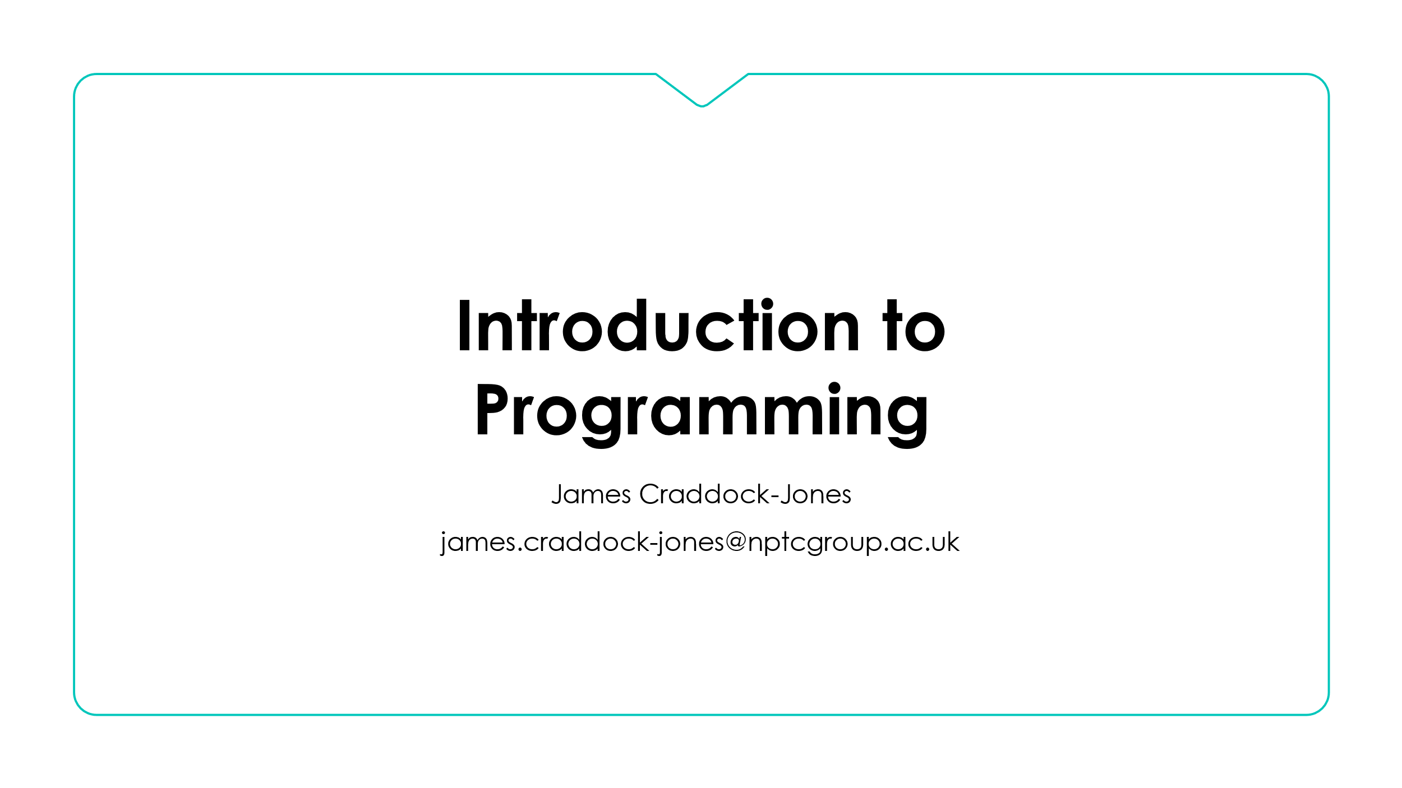



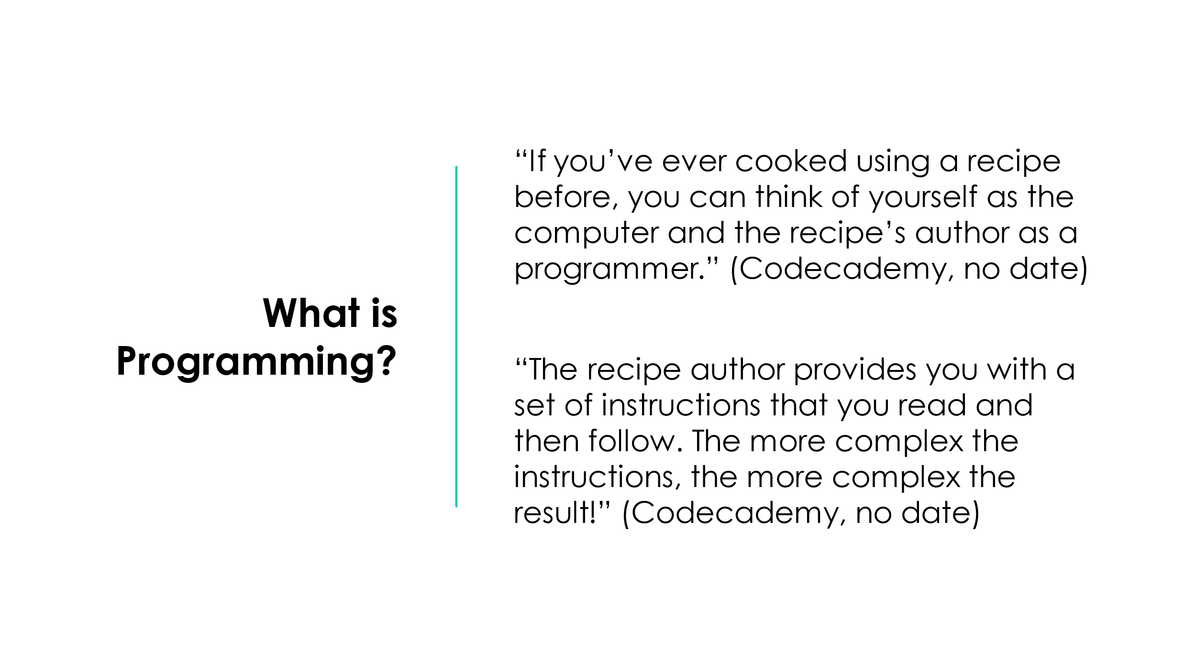

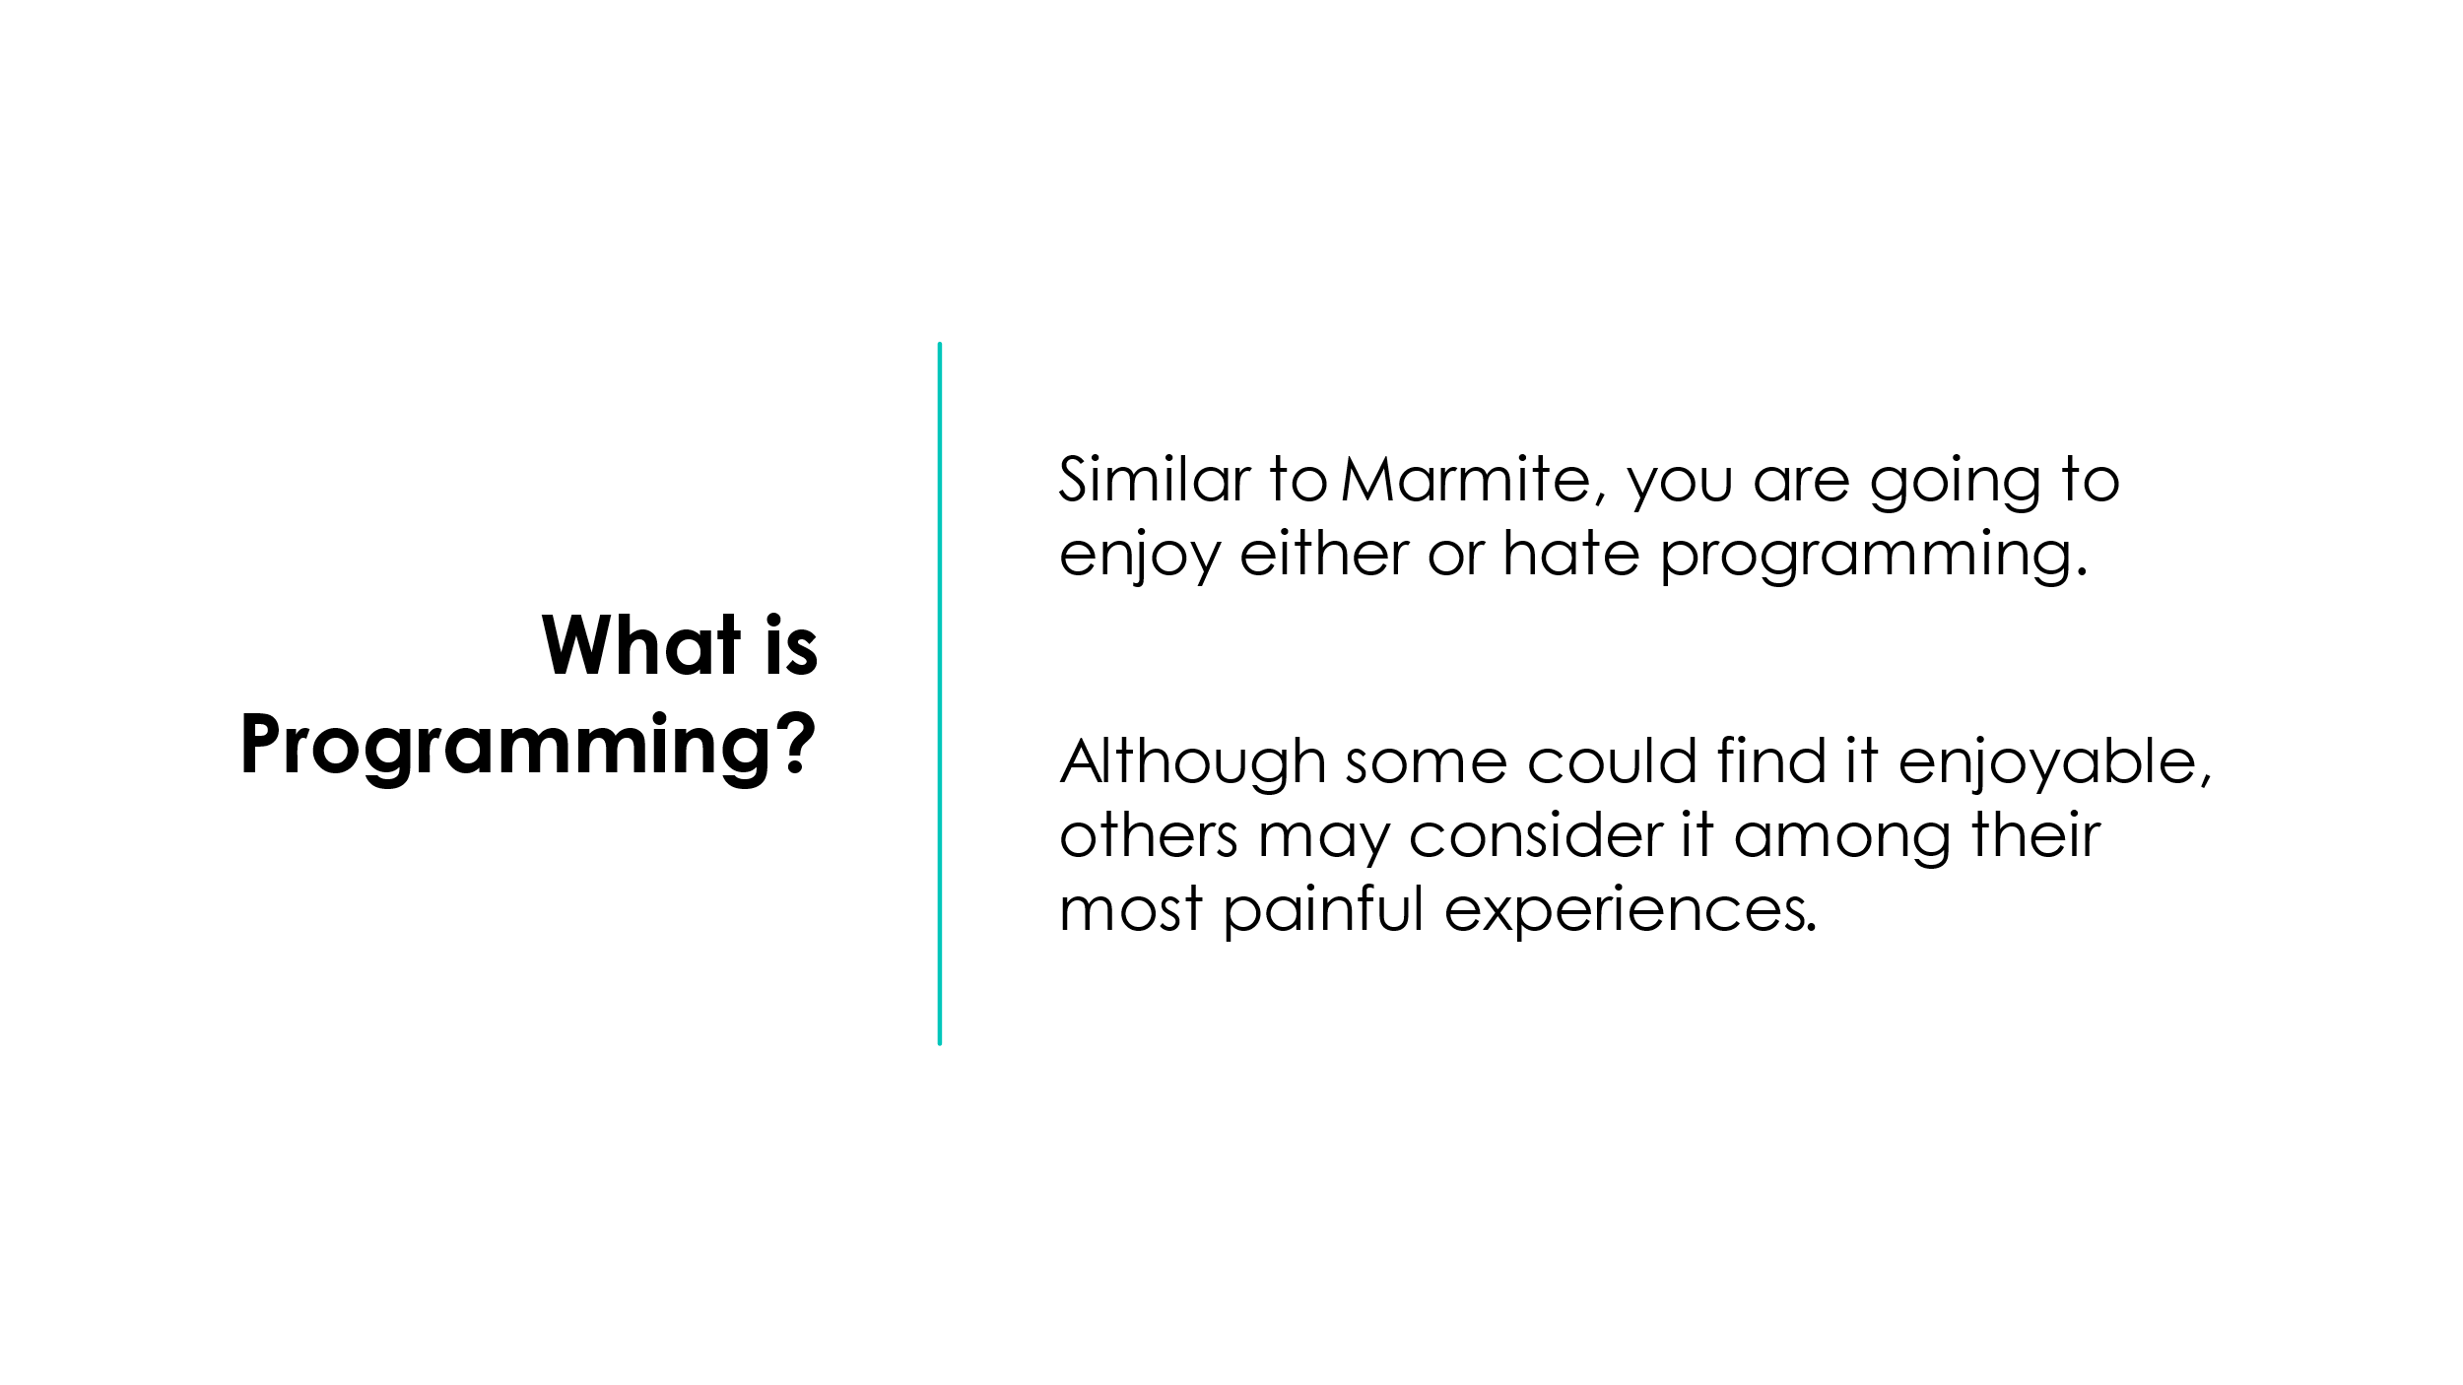

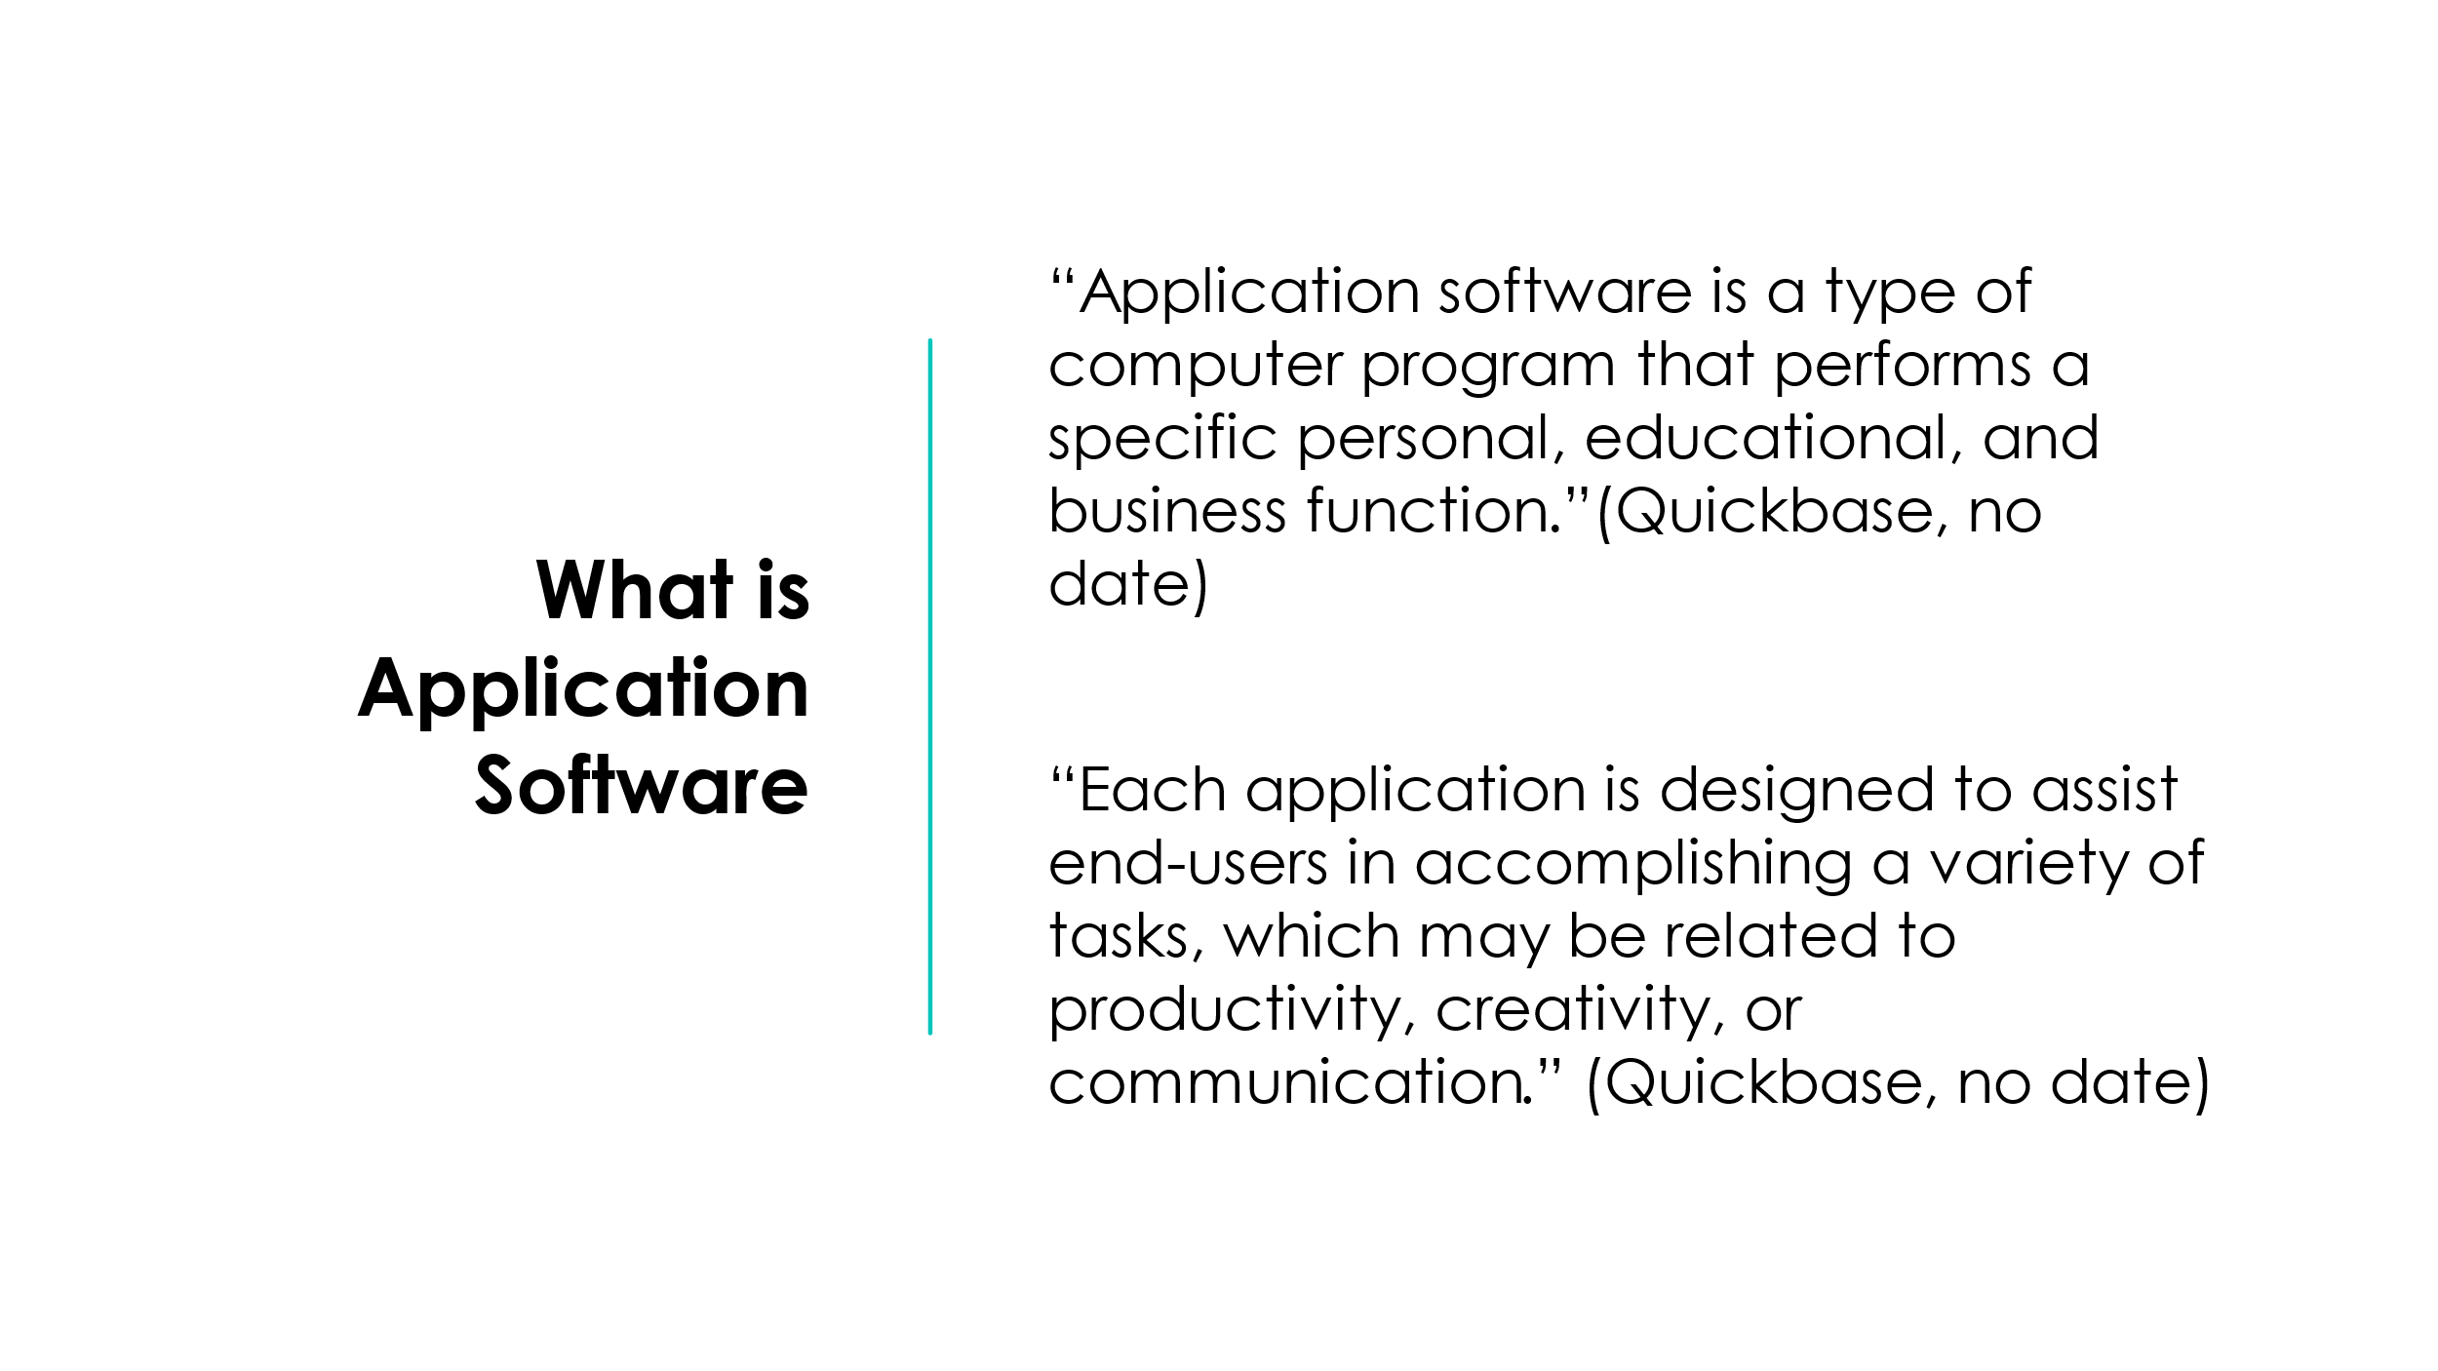
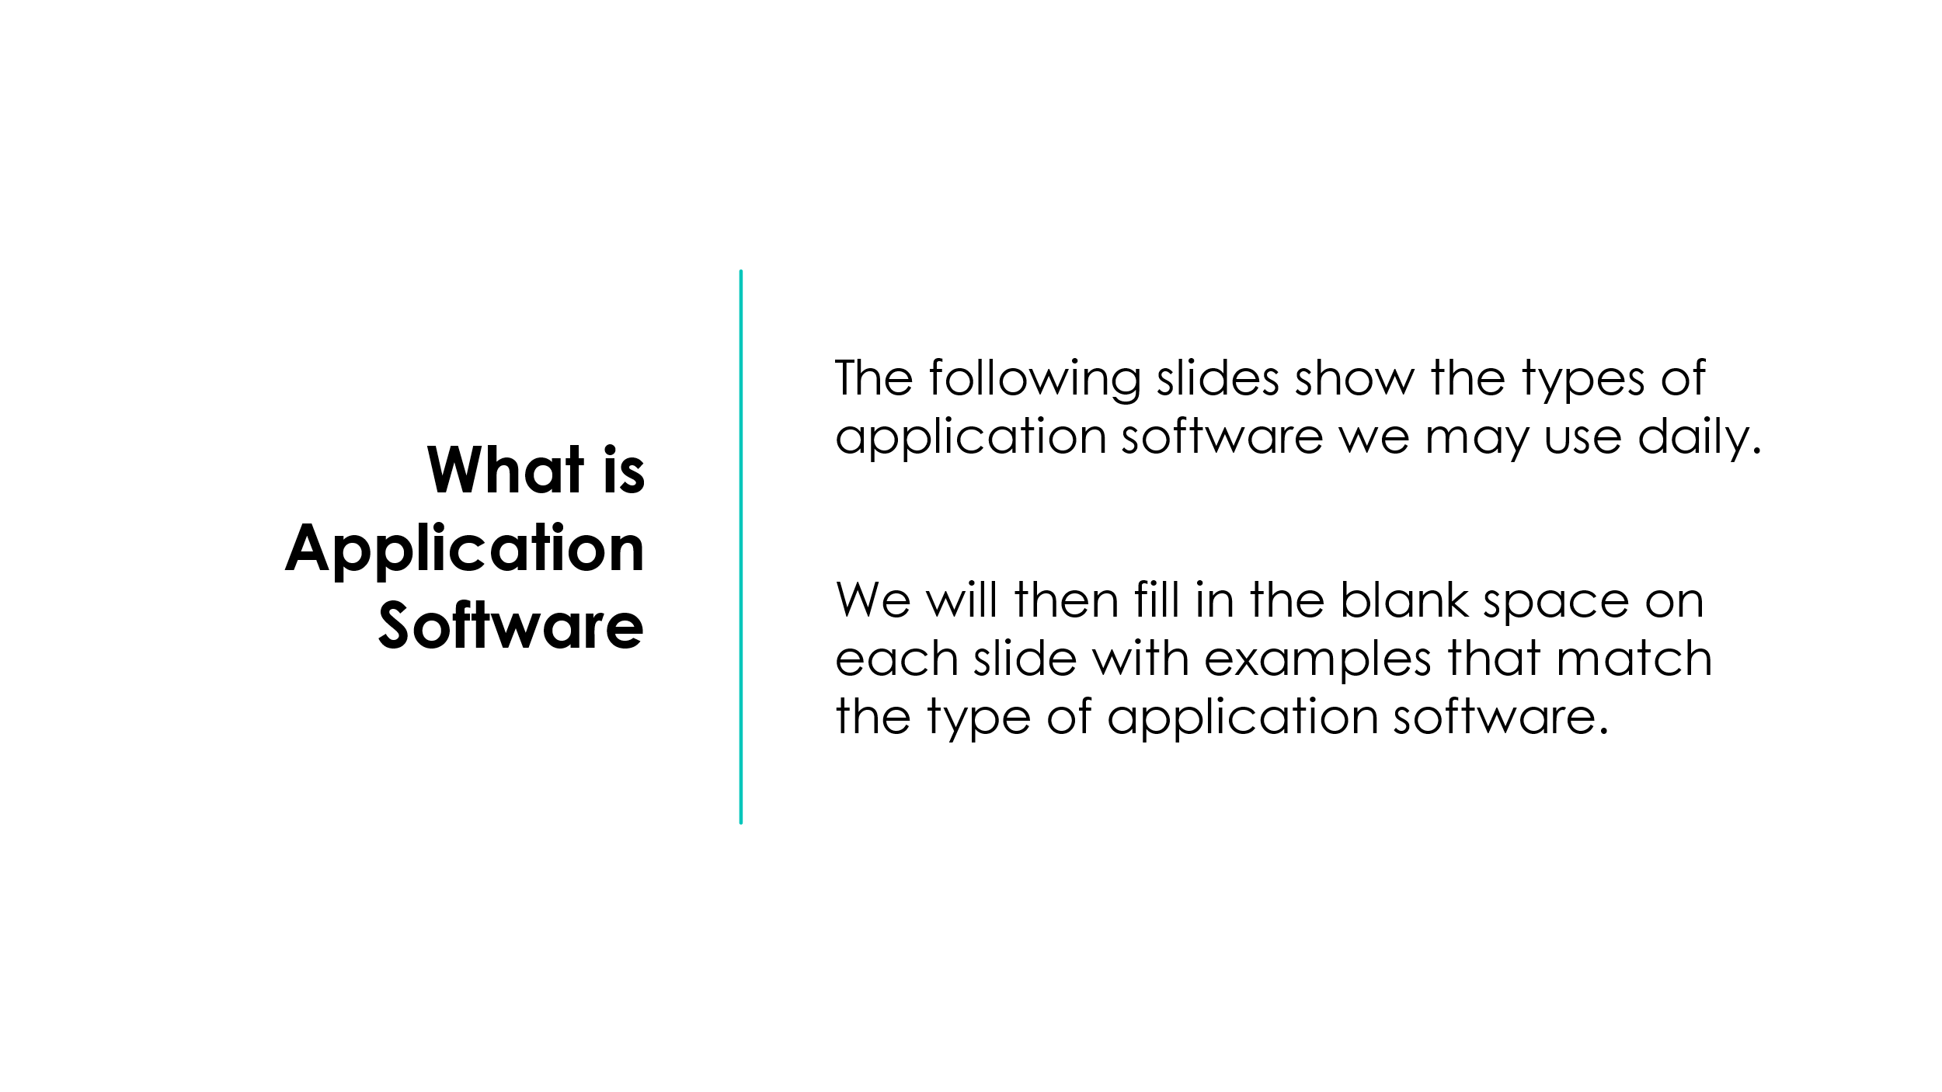





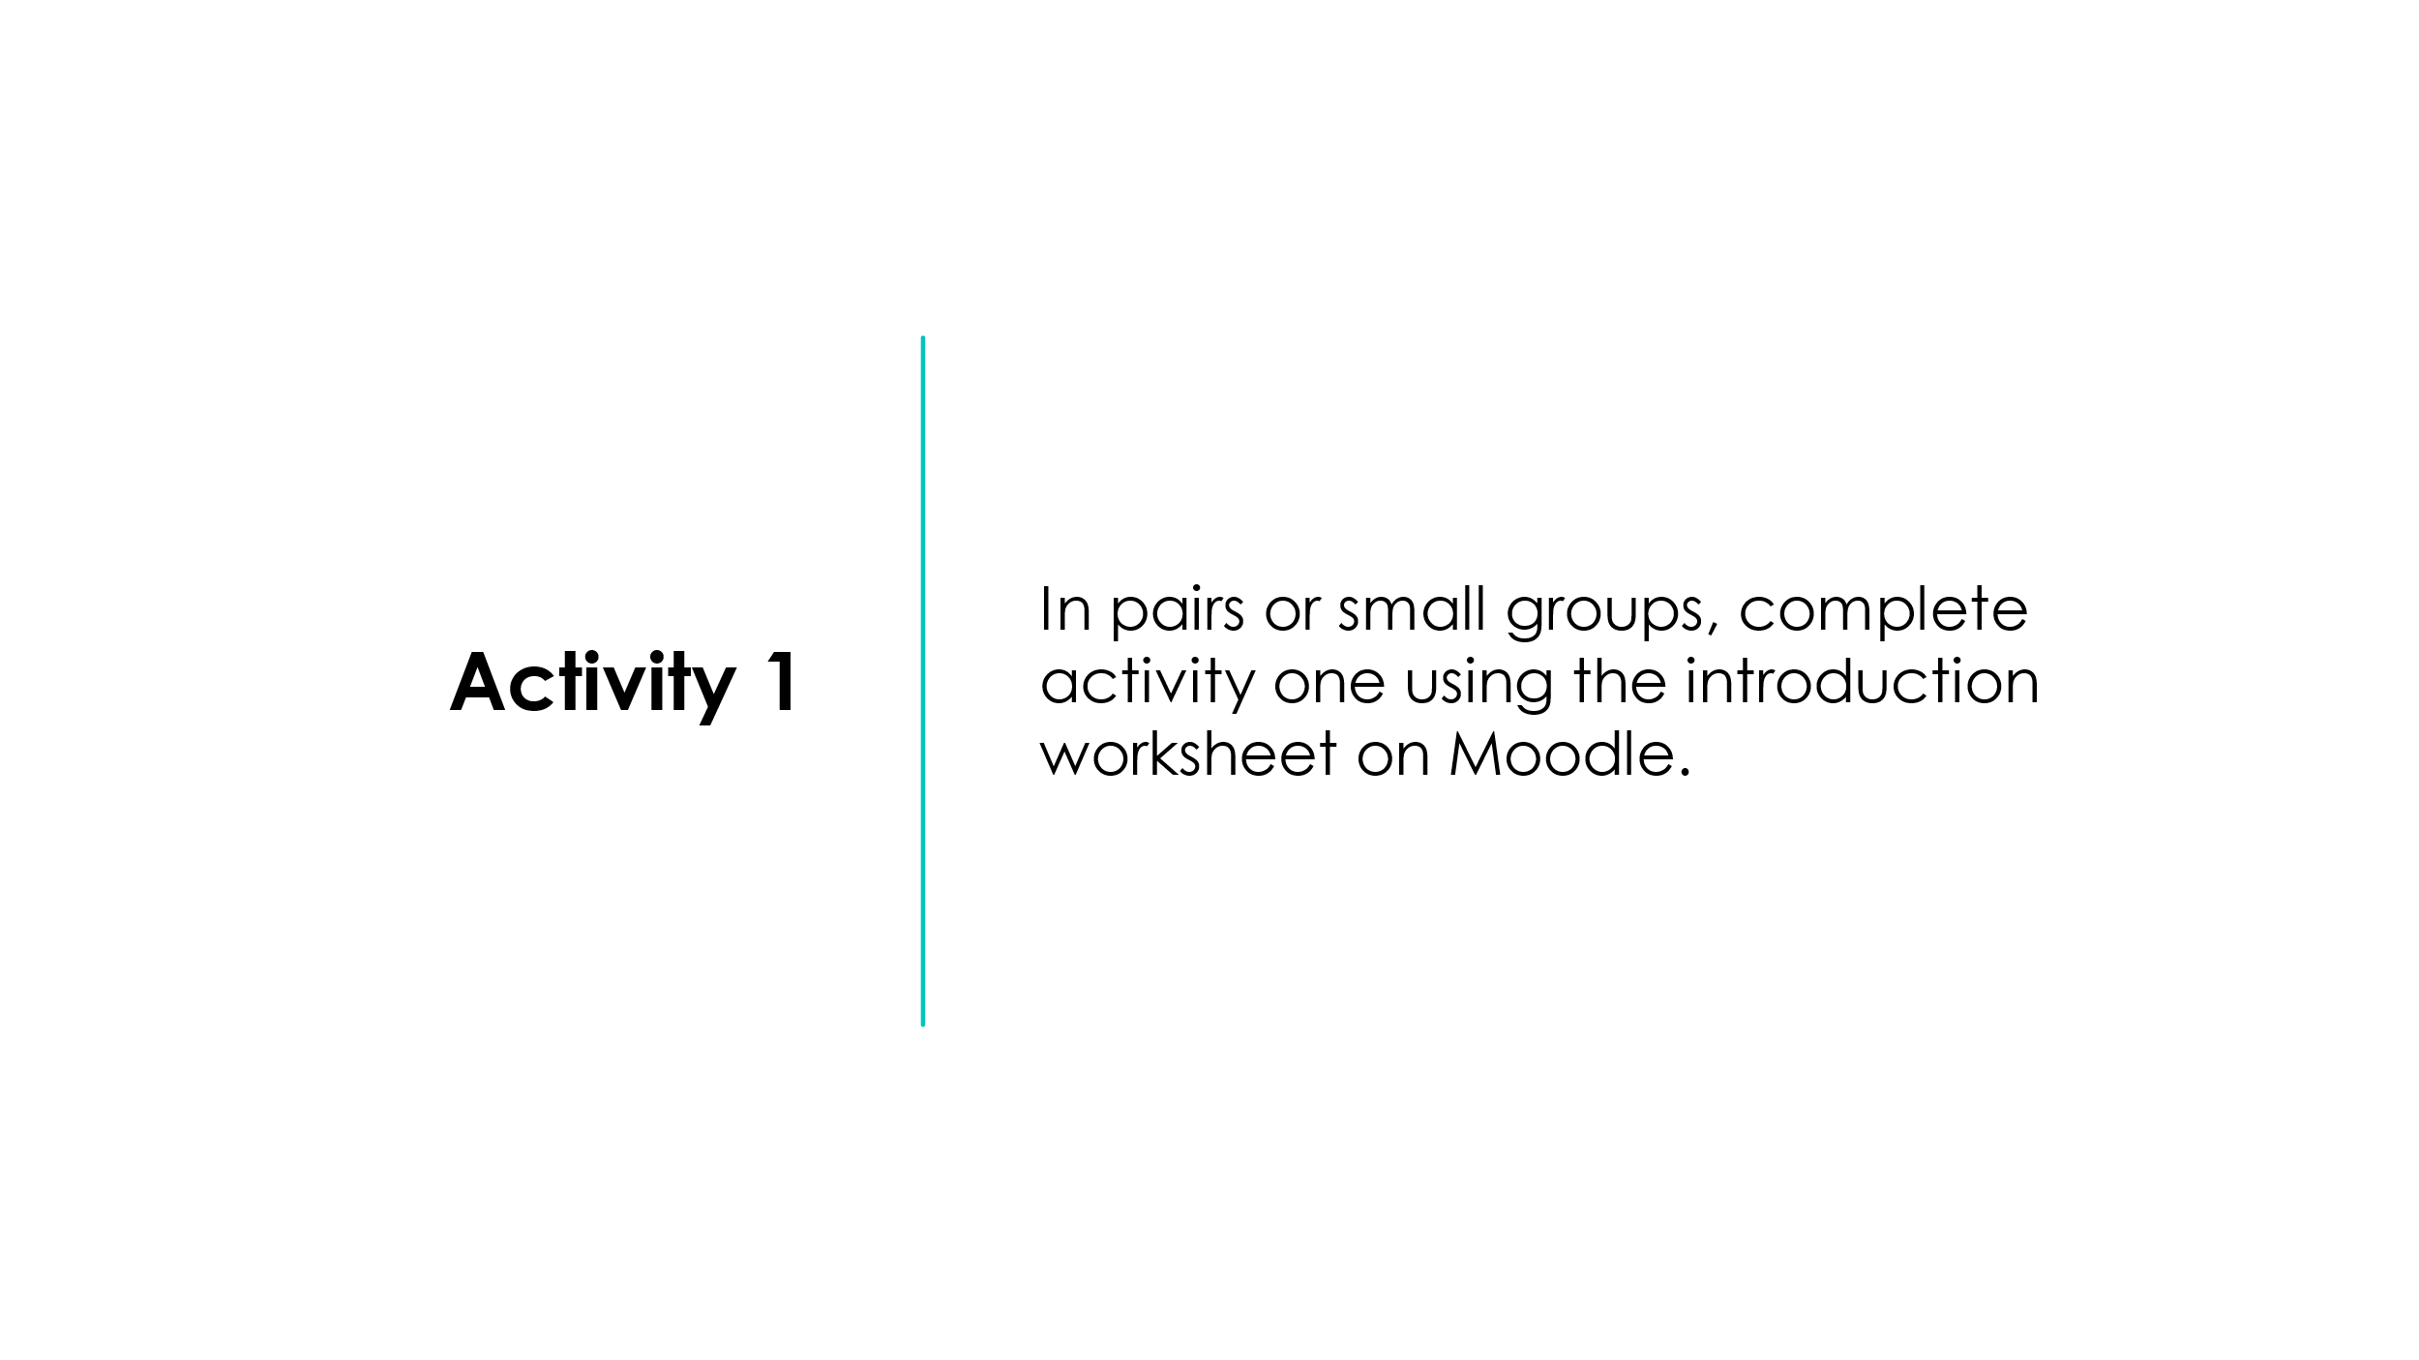

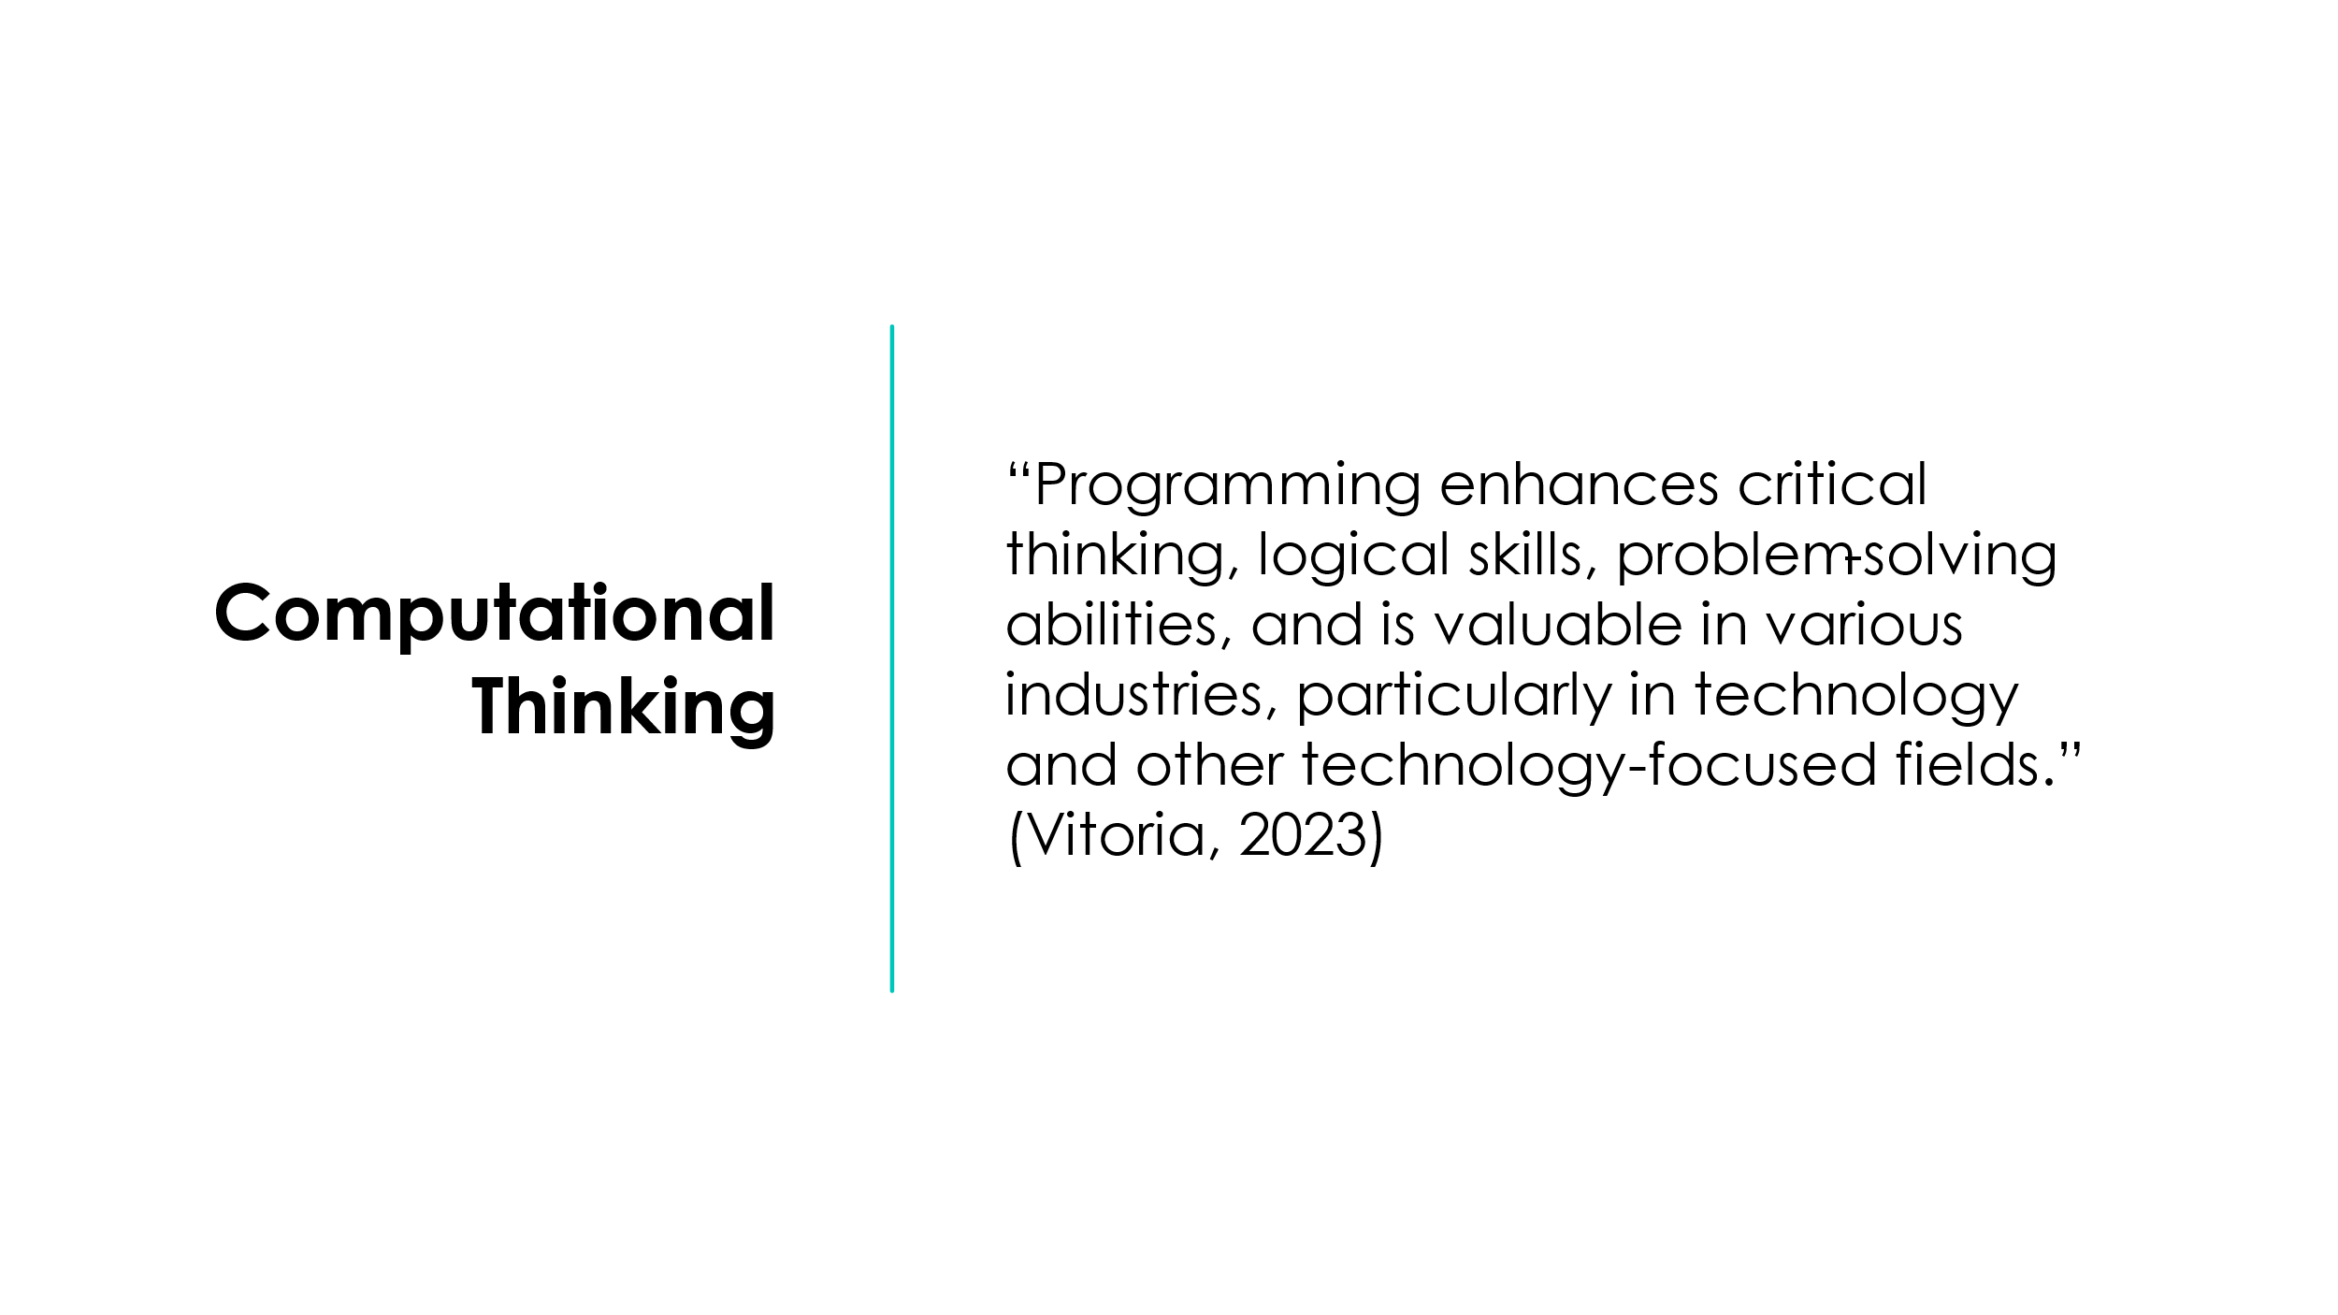

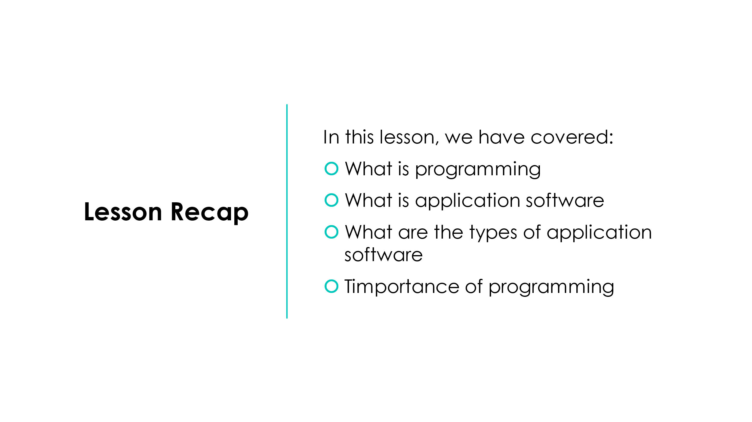



Appendix B: Lesson 1 Plan
Topic:  Unit 3 – AI/ML Programming |  | Class:  Level 3 AI/ML
Date: | Length of lesson:  2 hours |  | Number of students:  14
Resources required:
Students will need access to computers with Visual Studio 2022 installed.

Aim of Lesson
- Introduce what programming and identify its application in the real world
Learning Outcomes – The Learners Should Be Able To:

Previous student knowledge required for the session:
It would be helpful if students had knowledge of programming. However, it is not required.

Anticipated difficulties (if applicable):
Computers having issues loading Visual Studio 2022

Professional Standards (where are these being met within the session)
“Demonstrate dignity, courtesy and respect towards others” (Welsh Government, 2023) by ensuring all views are listened to equally, and all students are provided with the opportunity to voice their opinions.

Lesson Detail:

Stage | Focus | Strategy | Time
Introduction  Development  Plenary/conclusion | Lesson Introduction.  Discussion on what application software is.  Introduction to what application software is.  Examples of application software.  Real-world examples of application software.  Activity 1 – researching application software. Worksheet.  Importance of programming.  Summary of learning. | Lecture  Q&A  Lecture  Lecture, Q&A  Lecture, Q&A  Worksheet, research  Lecture, Q&A  Lecture | 5-10 minutes  10 minutes  15-20 minutes  10-15 minutes  5-10 minutes  15-20 minutes  10-15 minutes  5 minutes

Assessment Strategies: when and how are they included within the lesson?
Throughout the lesson, the students will be given the opportunity to answer a variety of questions and ask their own questions on the topic. In addition, there is a worksheet that has been designed to cover two lessons, which the students will need to complete for the activities within the lessons.

Appendix C: Lesson 1 and 2 Worksheet

Introduction to Programming

Activity 1 - In pairs, complete the following:
Part 1 - In the table below, list as many examples of application software as you can think of while also listing the type they fall under:
Name of Application Software | Application Software Type

Part 2 – Research a definition of what a programming language is and place it in the table below in your own words:
Programming Language Definition

Part 3A - In the table below, research and list at least four different programming languages:
Name of Programming Language

Part 3B – Place either screenshots or direct copies of code snippets based on your list accompanied by the programming language name:

Activity 1 Extension – Time permitting, research the operating systems or platforms supported by your chosen programming languages and place your findings in the table below:
Name of Programming Language | Supported Operating Systems or Platforms

Activity 2 - In pairs, complete the following:
Part 1 - In the table below, list your programming languages and determine whether they are loosely or strongly typed:
Name of Programming Language | Language Type

Part 2 - In the table below, list your programming languages and research how popular they currently are:
Name of Programming Language | Popularity Rating

Part 3 - In the table below, list your programming languages and record facts about each:
Name of Programming Language | Language Facts

Activity 2 Extension – Time permitting, research whether your chosen programming languages are compiled, interpreted, or both:
Name of Programming Language | Compiled, Interpreted, or Both?

Activity 3/Blended Learning:
Complete the following:
- Create a free Codecademy or Sololearn account.
- Begin working through one of their free Java courses over the next few weeks.
- Remember, everyone learns at their own pace. You should learn to walk before you can run!
Links to courses:
https://www.codecademy.com/learn/learn-java
https://www.sololearn.com/en/learn/courses/java-introduction

Appendix D: Lesson 2 Presentation

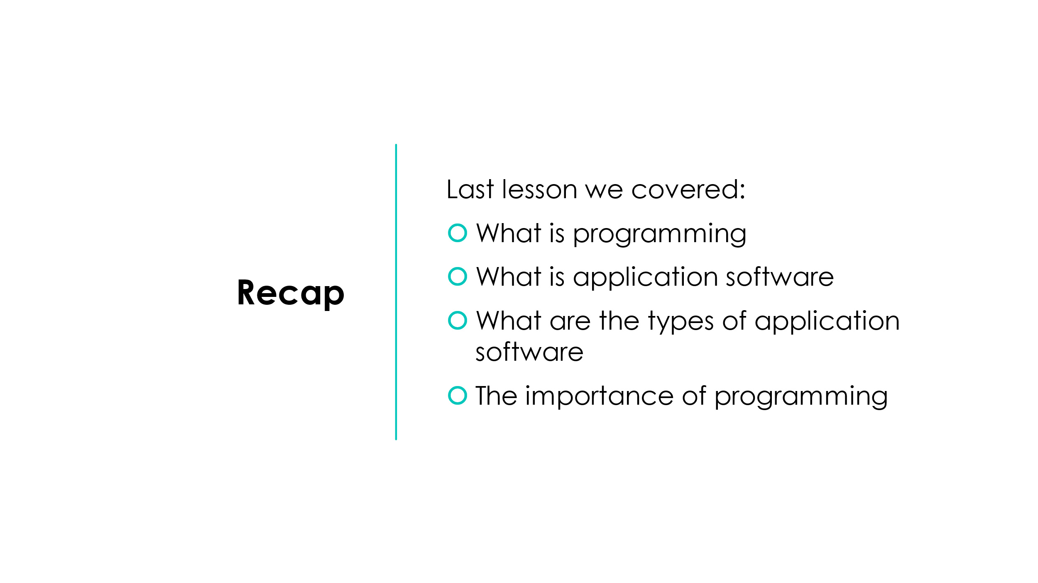


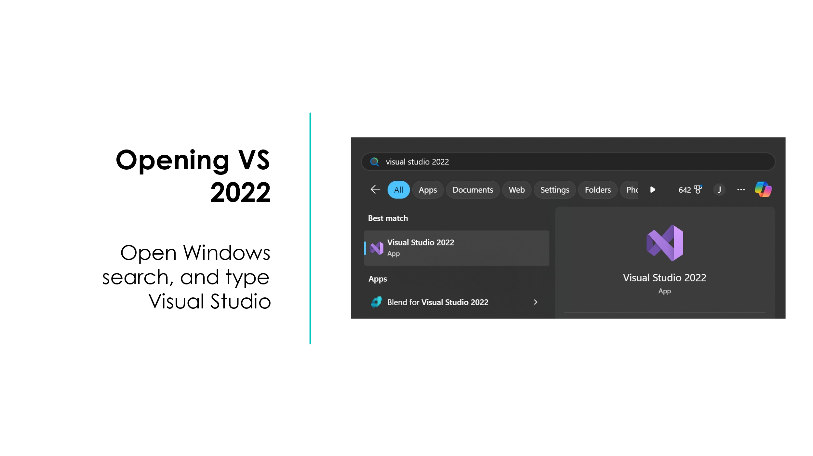

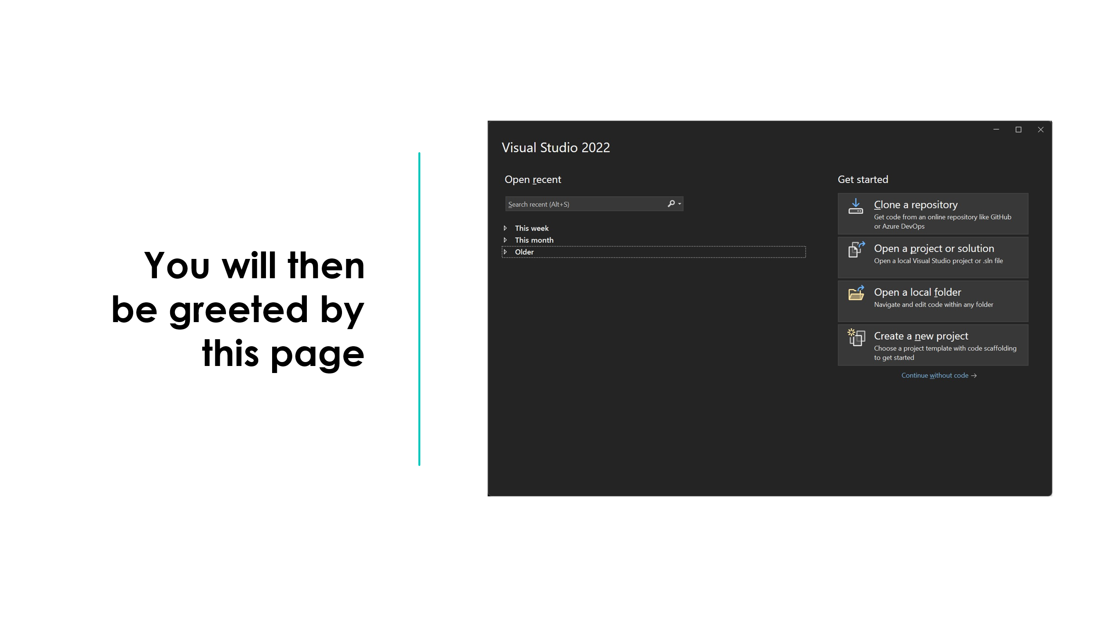

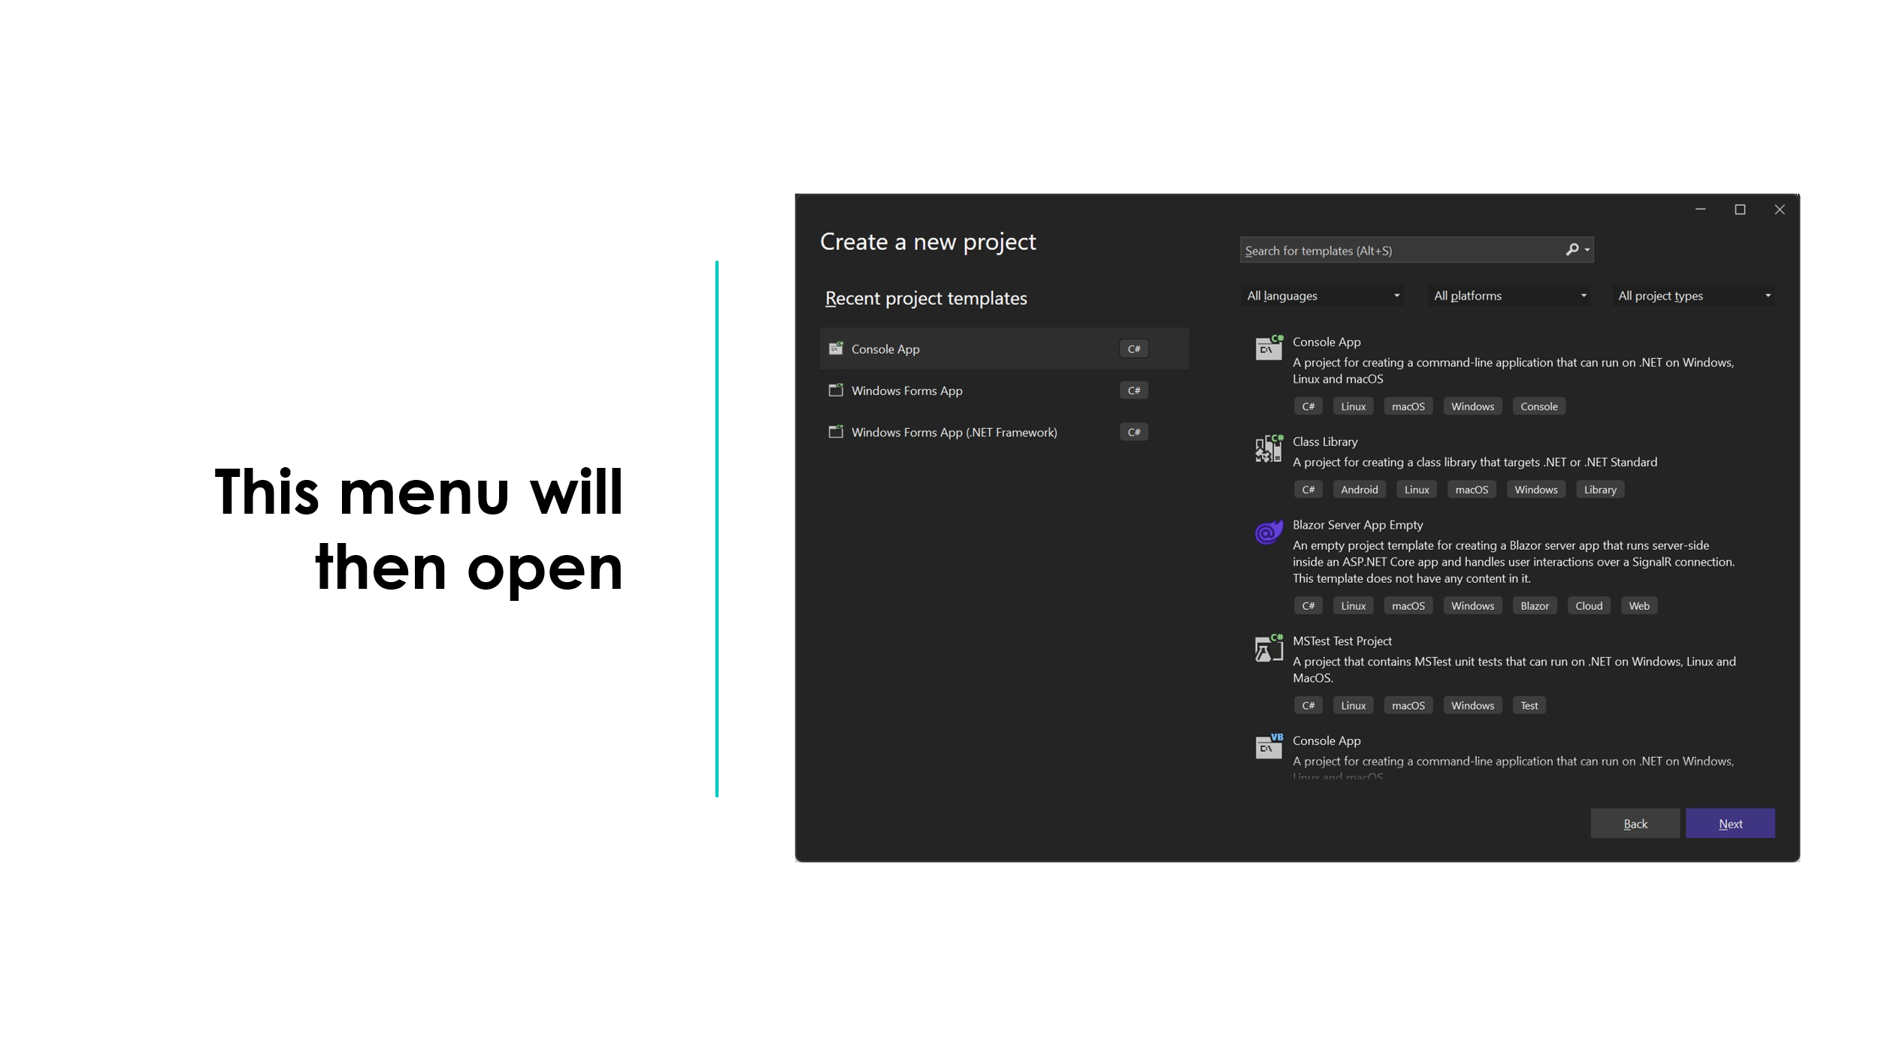
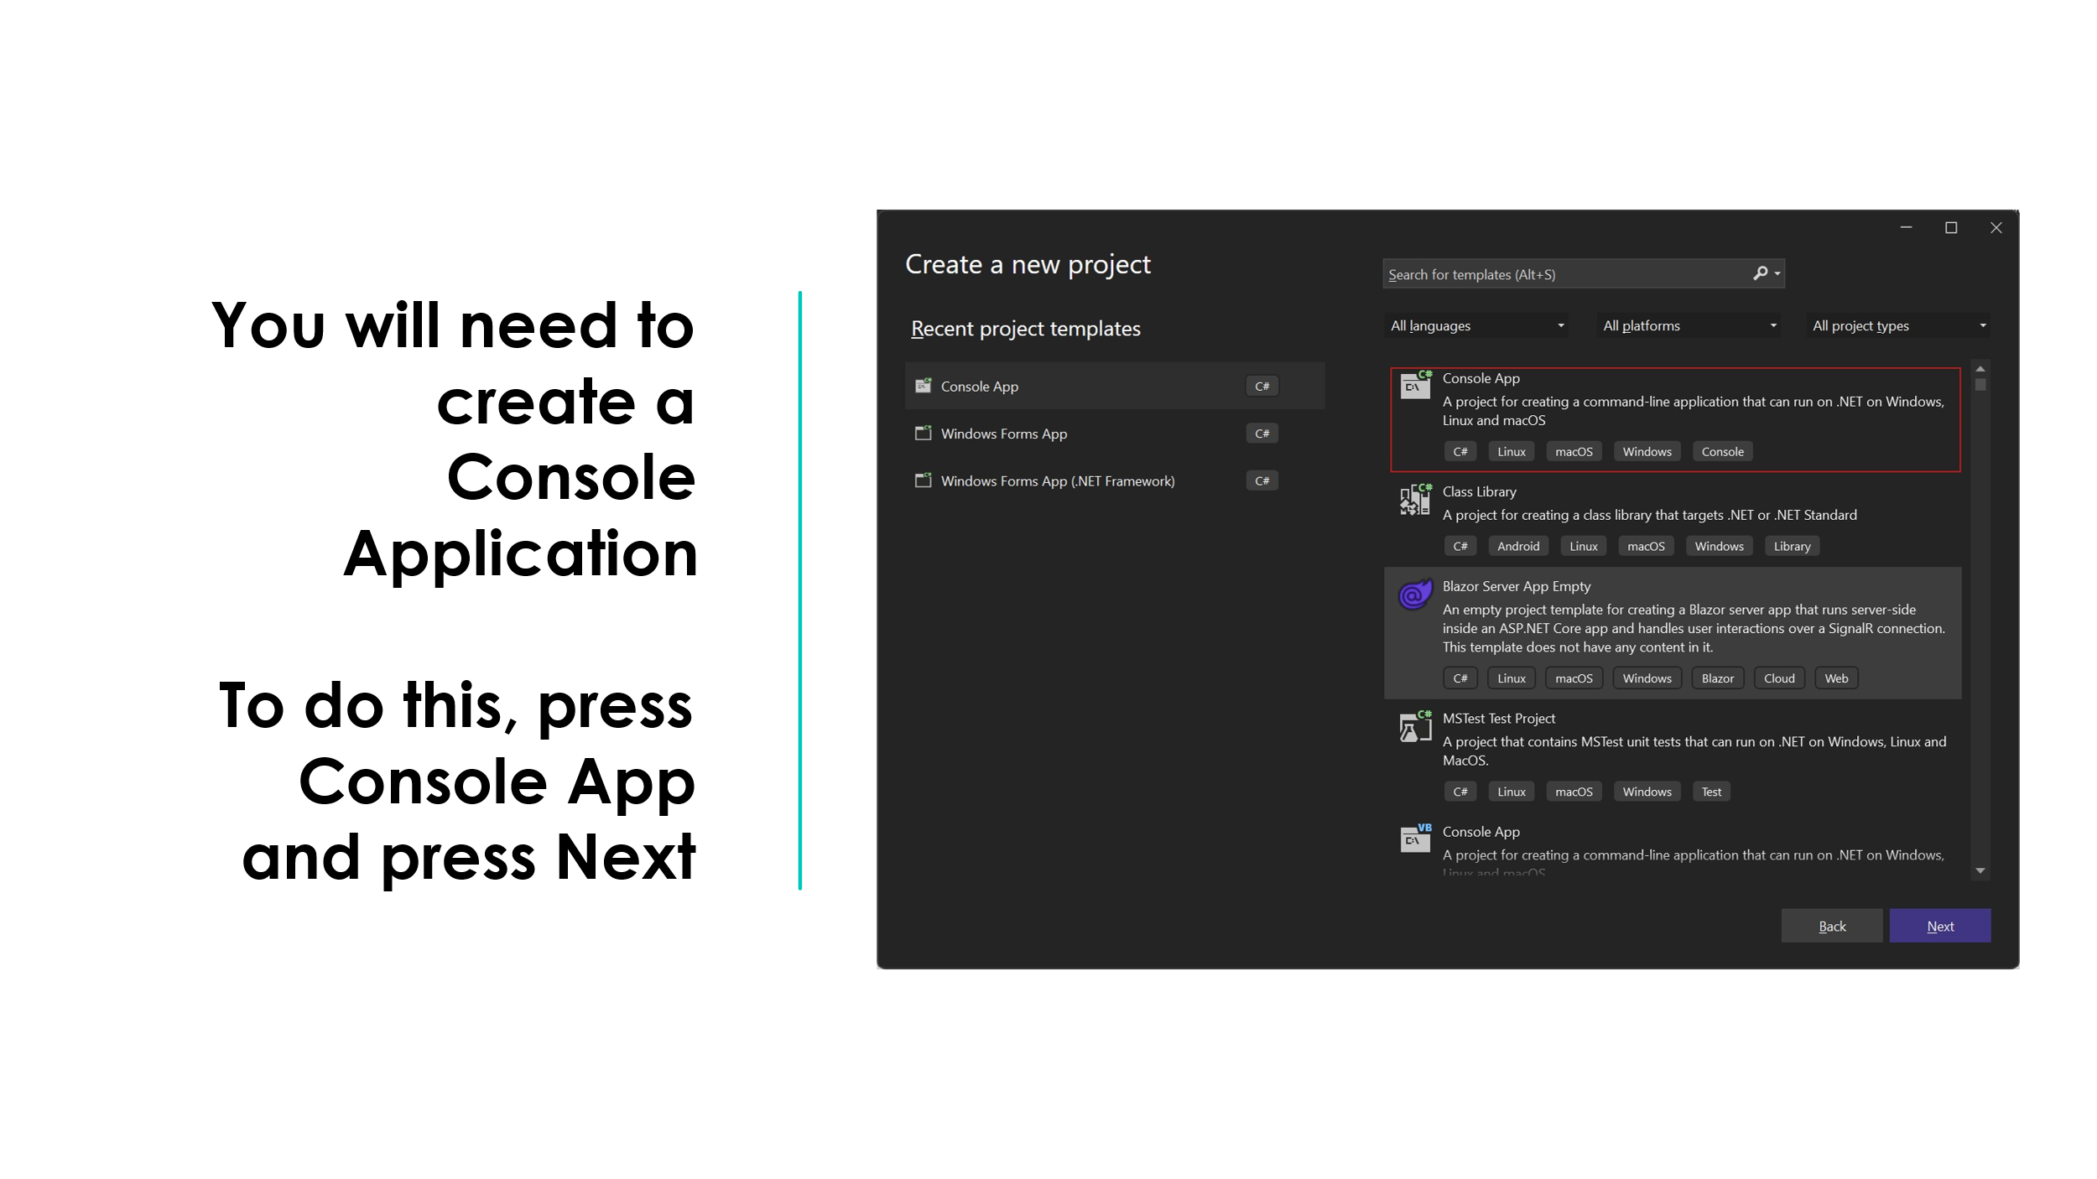
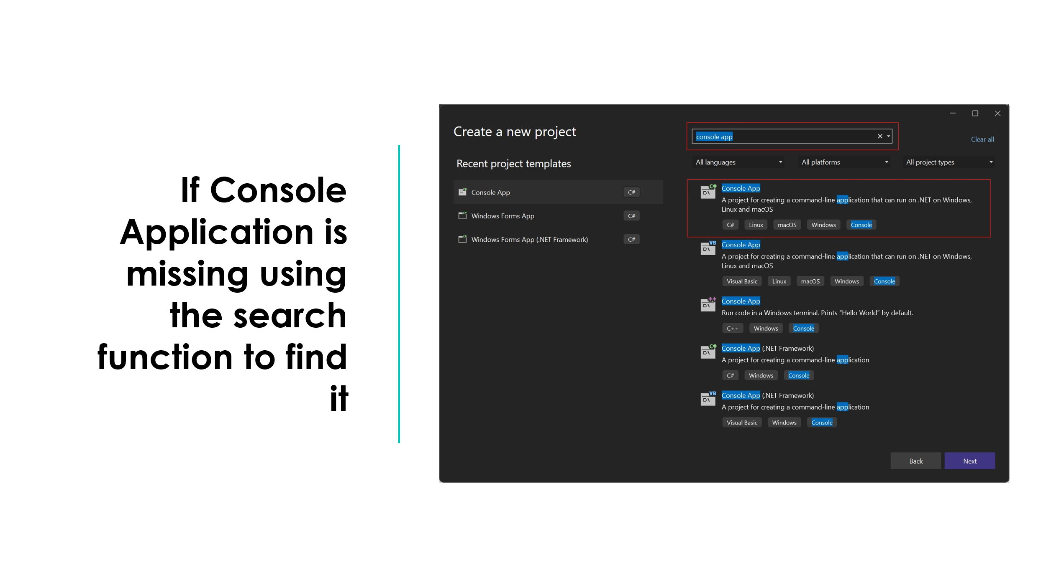
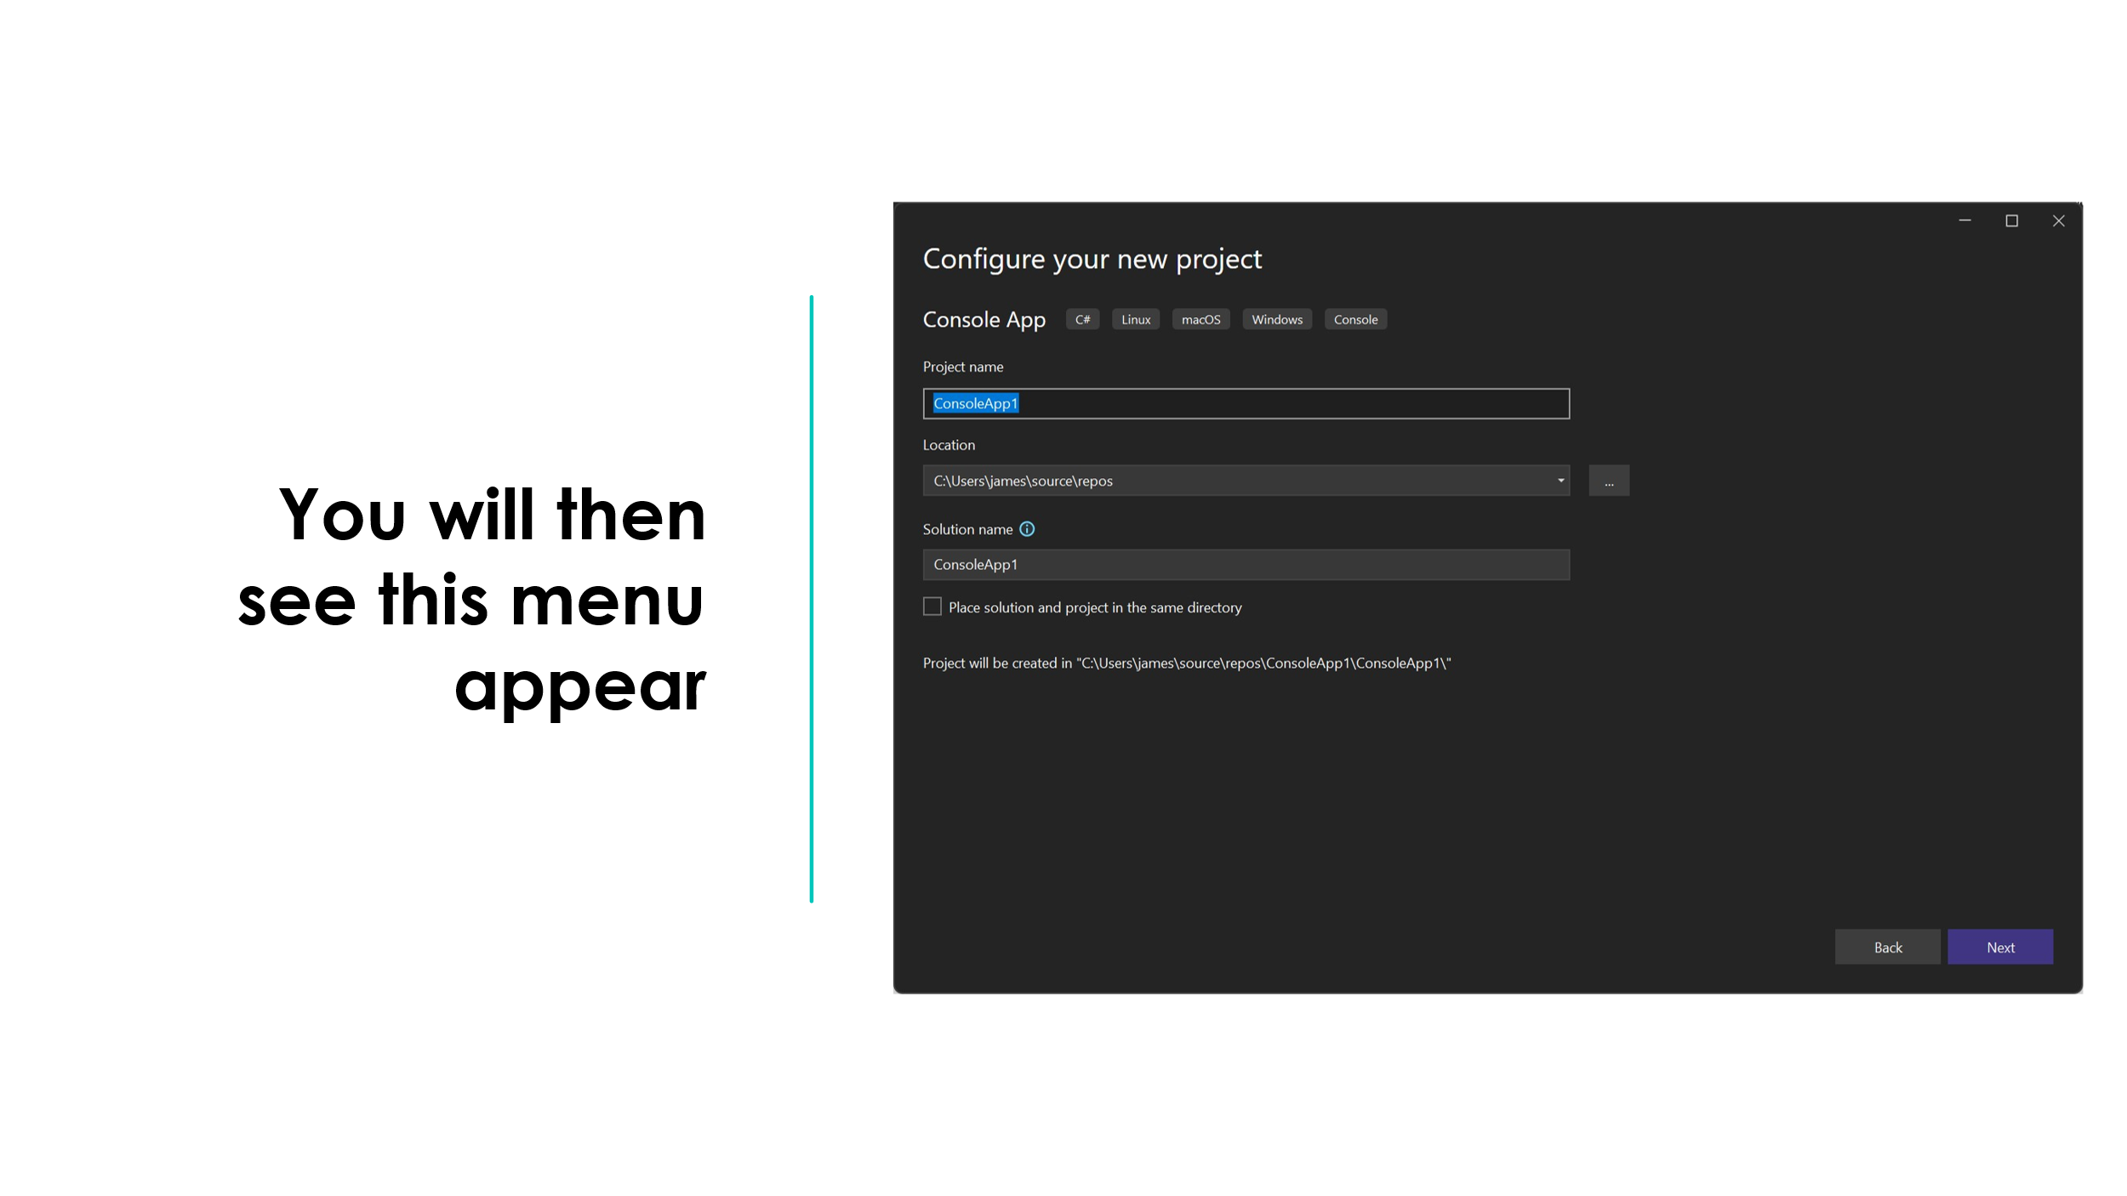
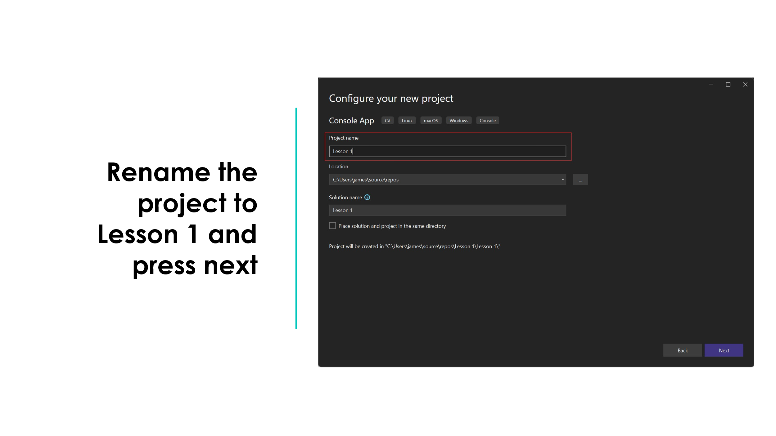

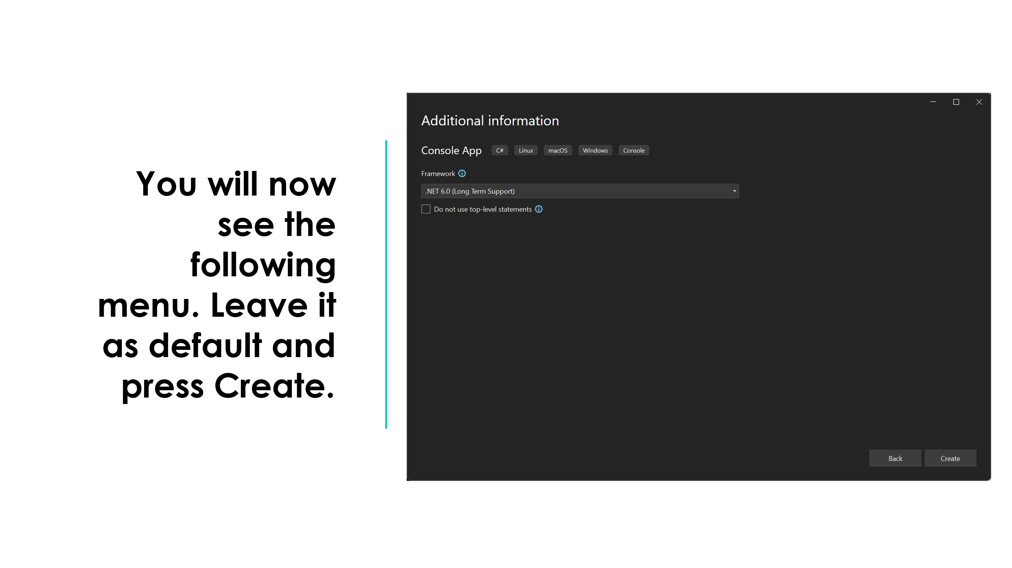
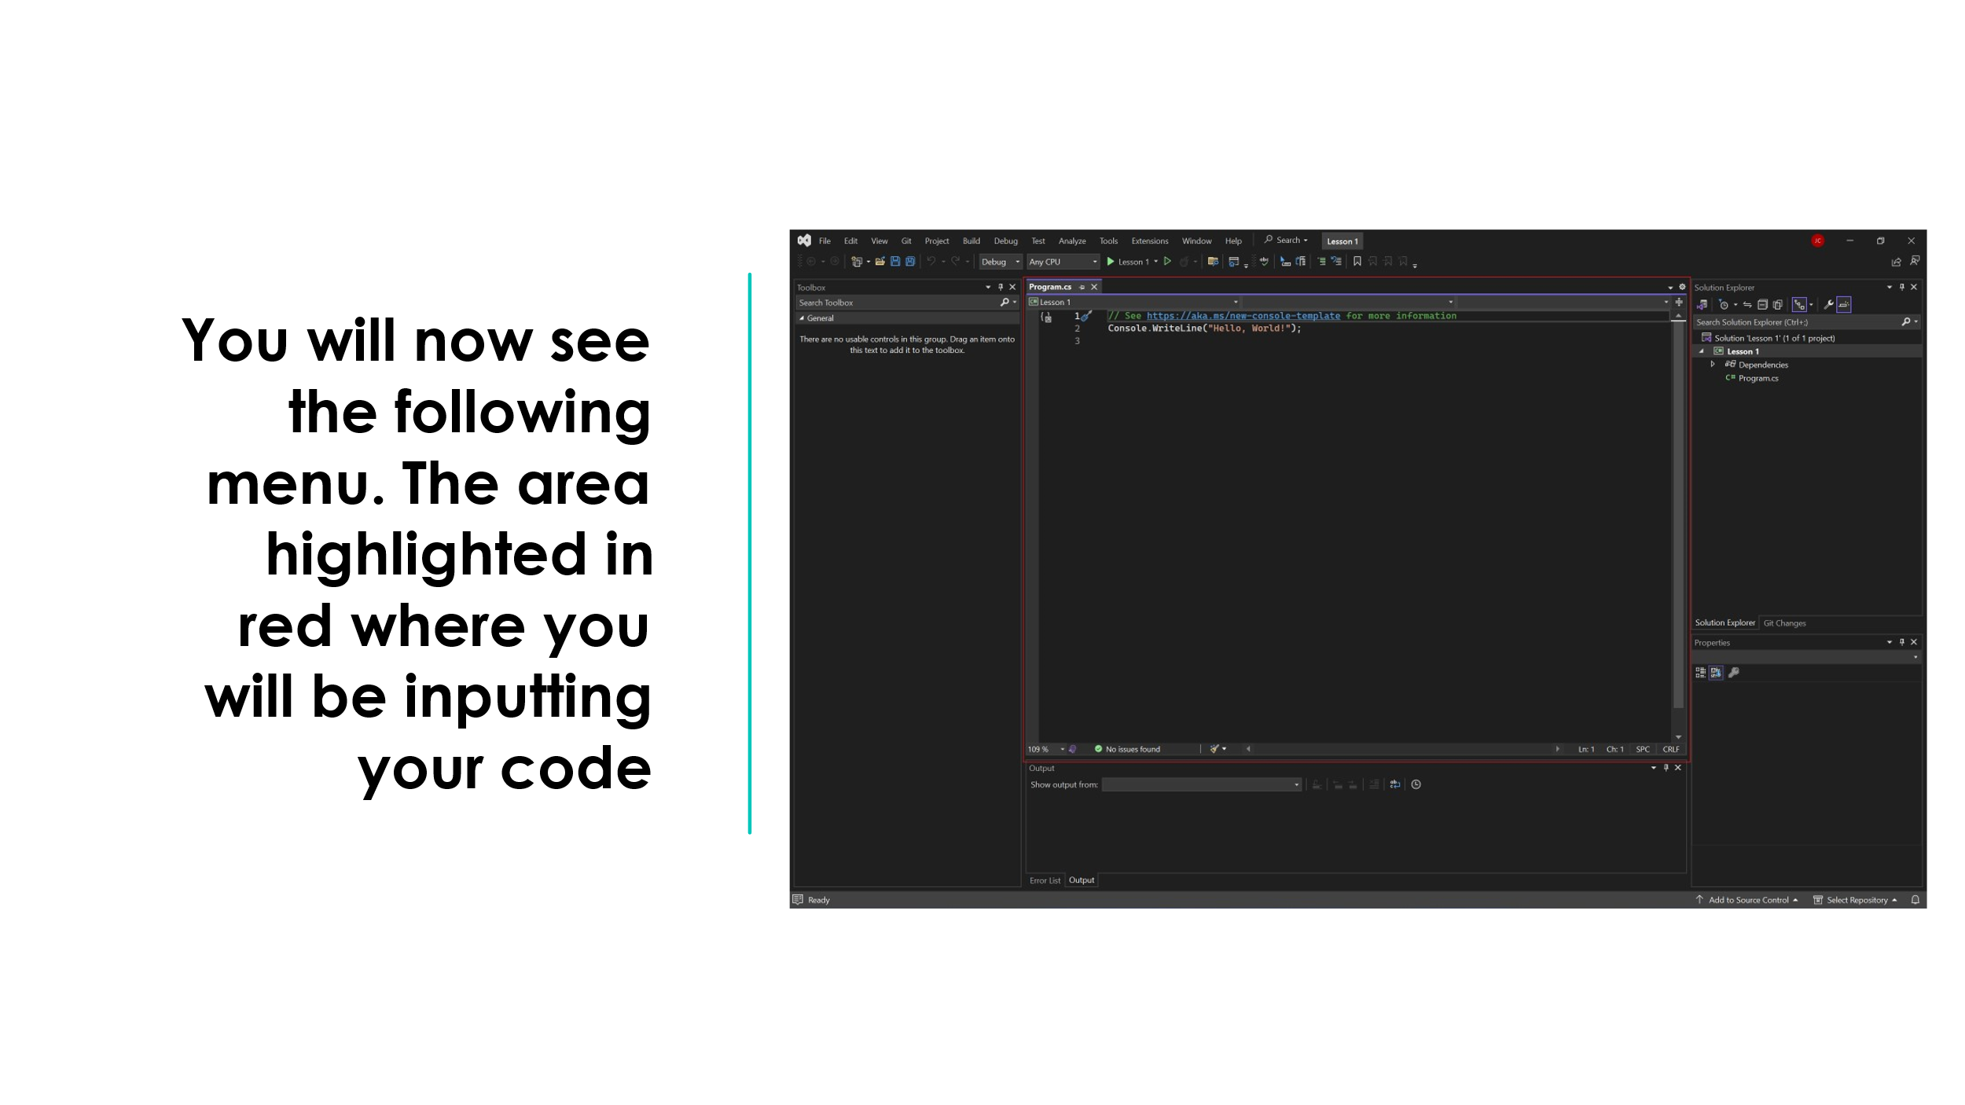
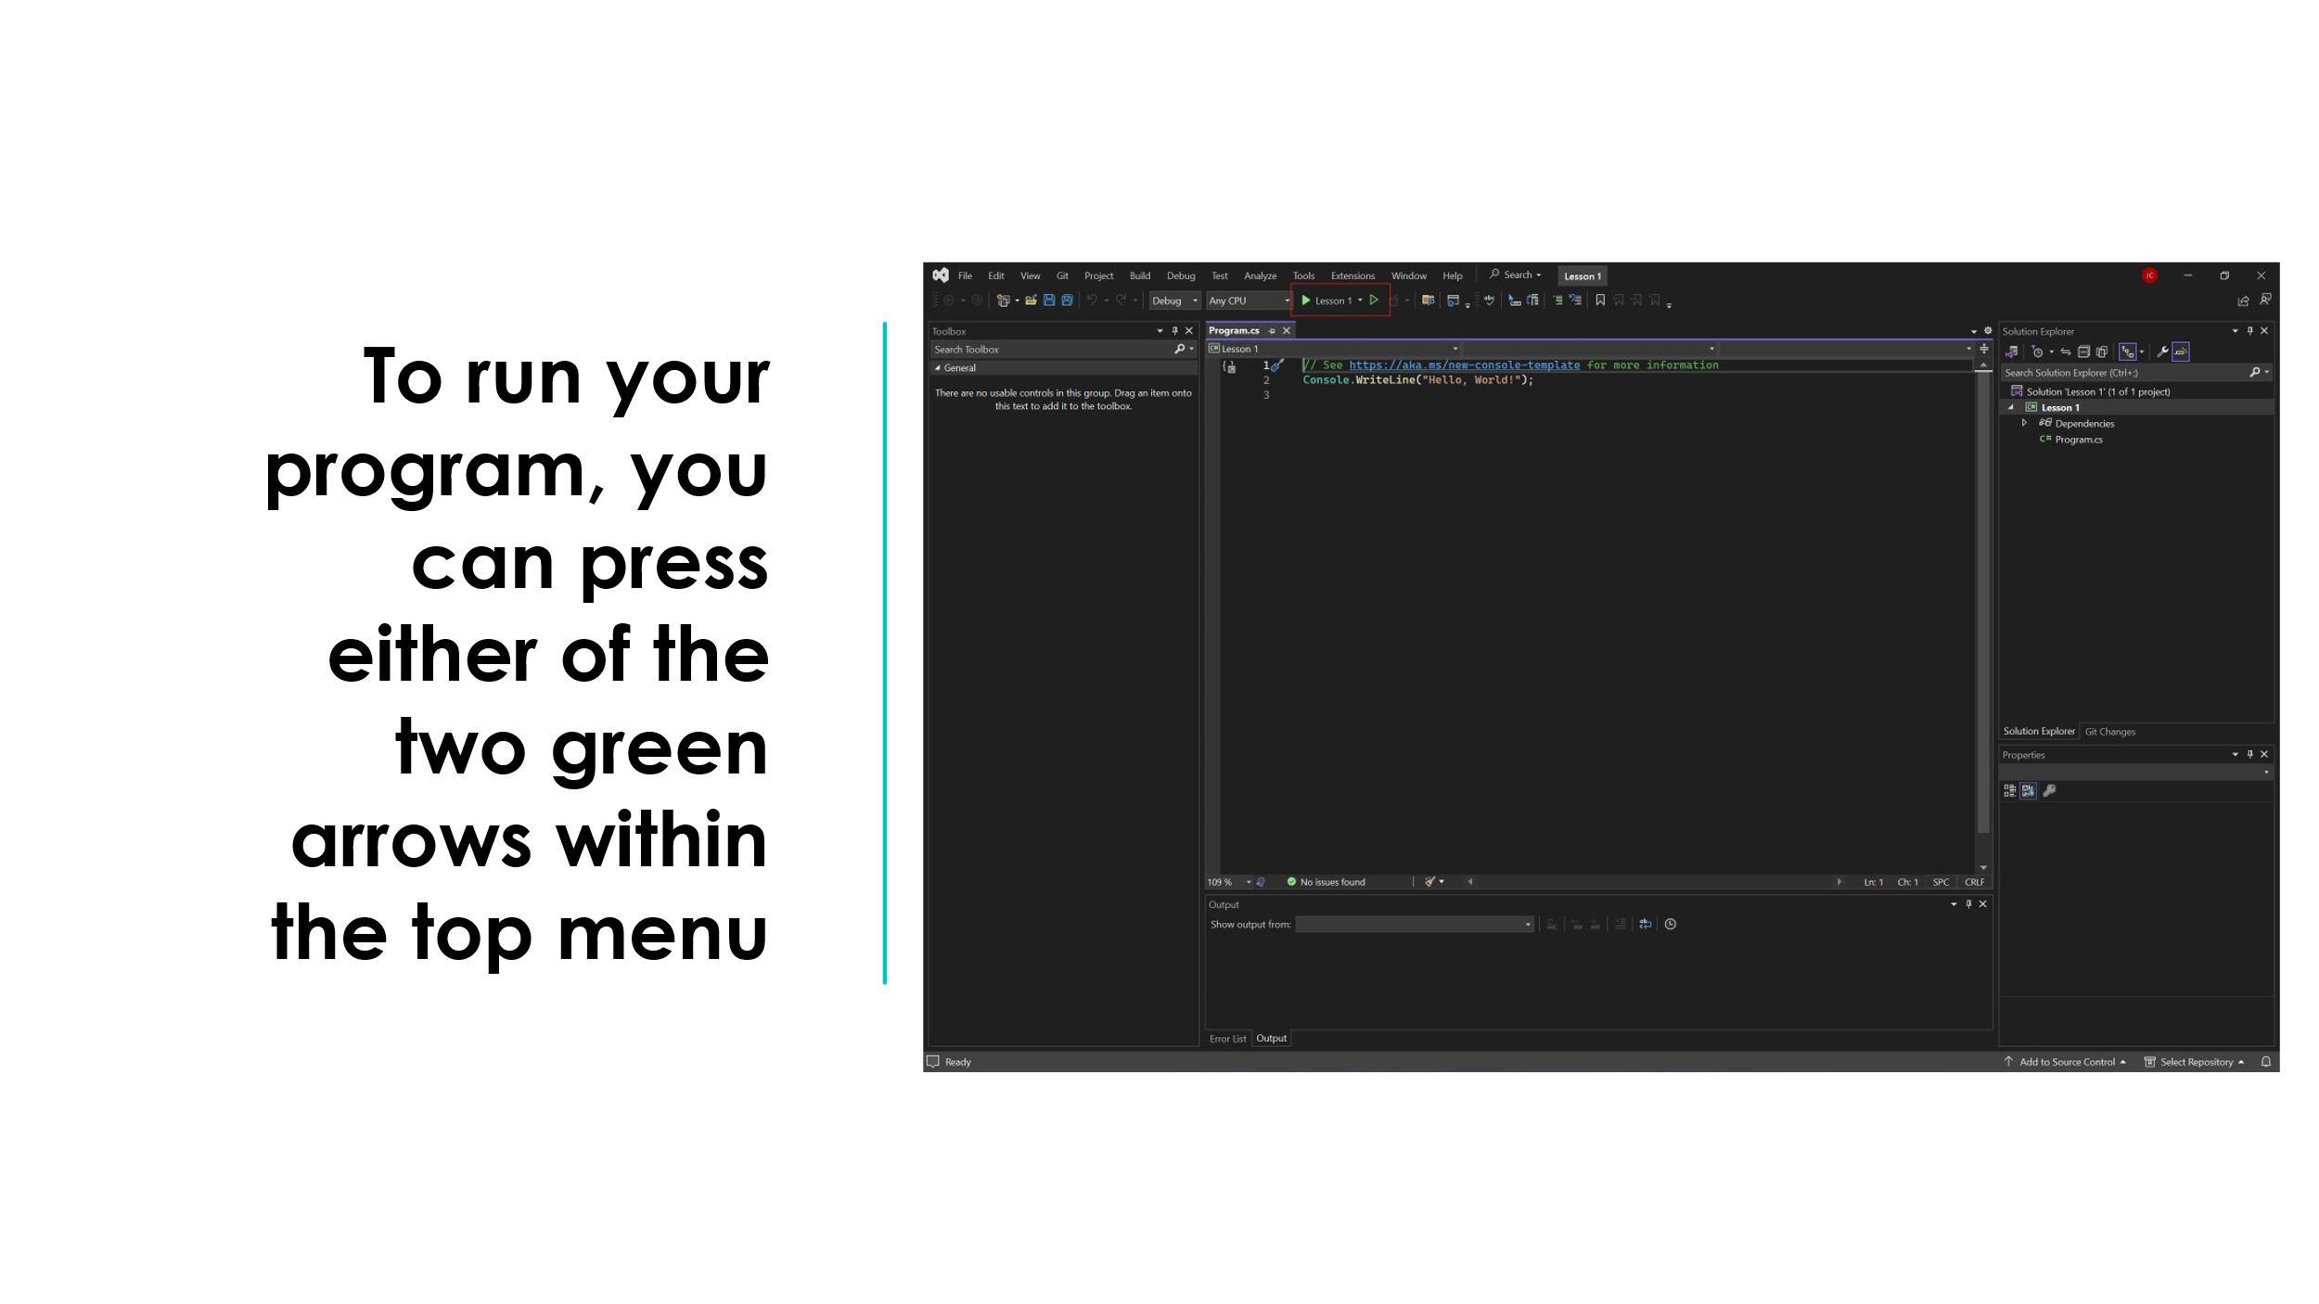
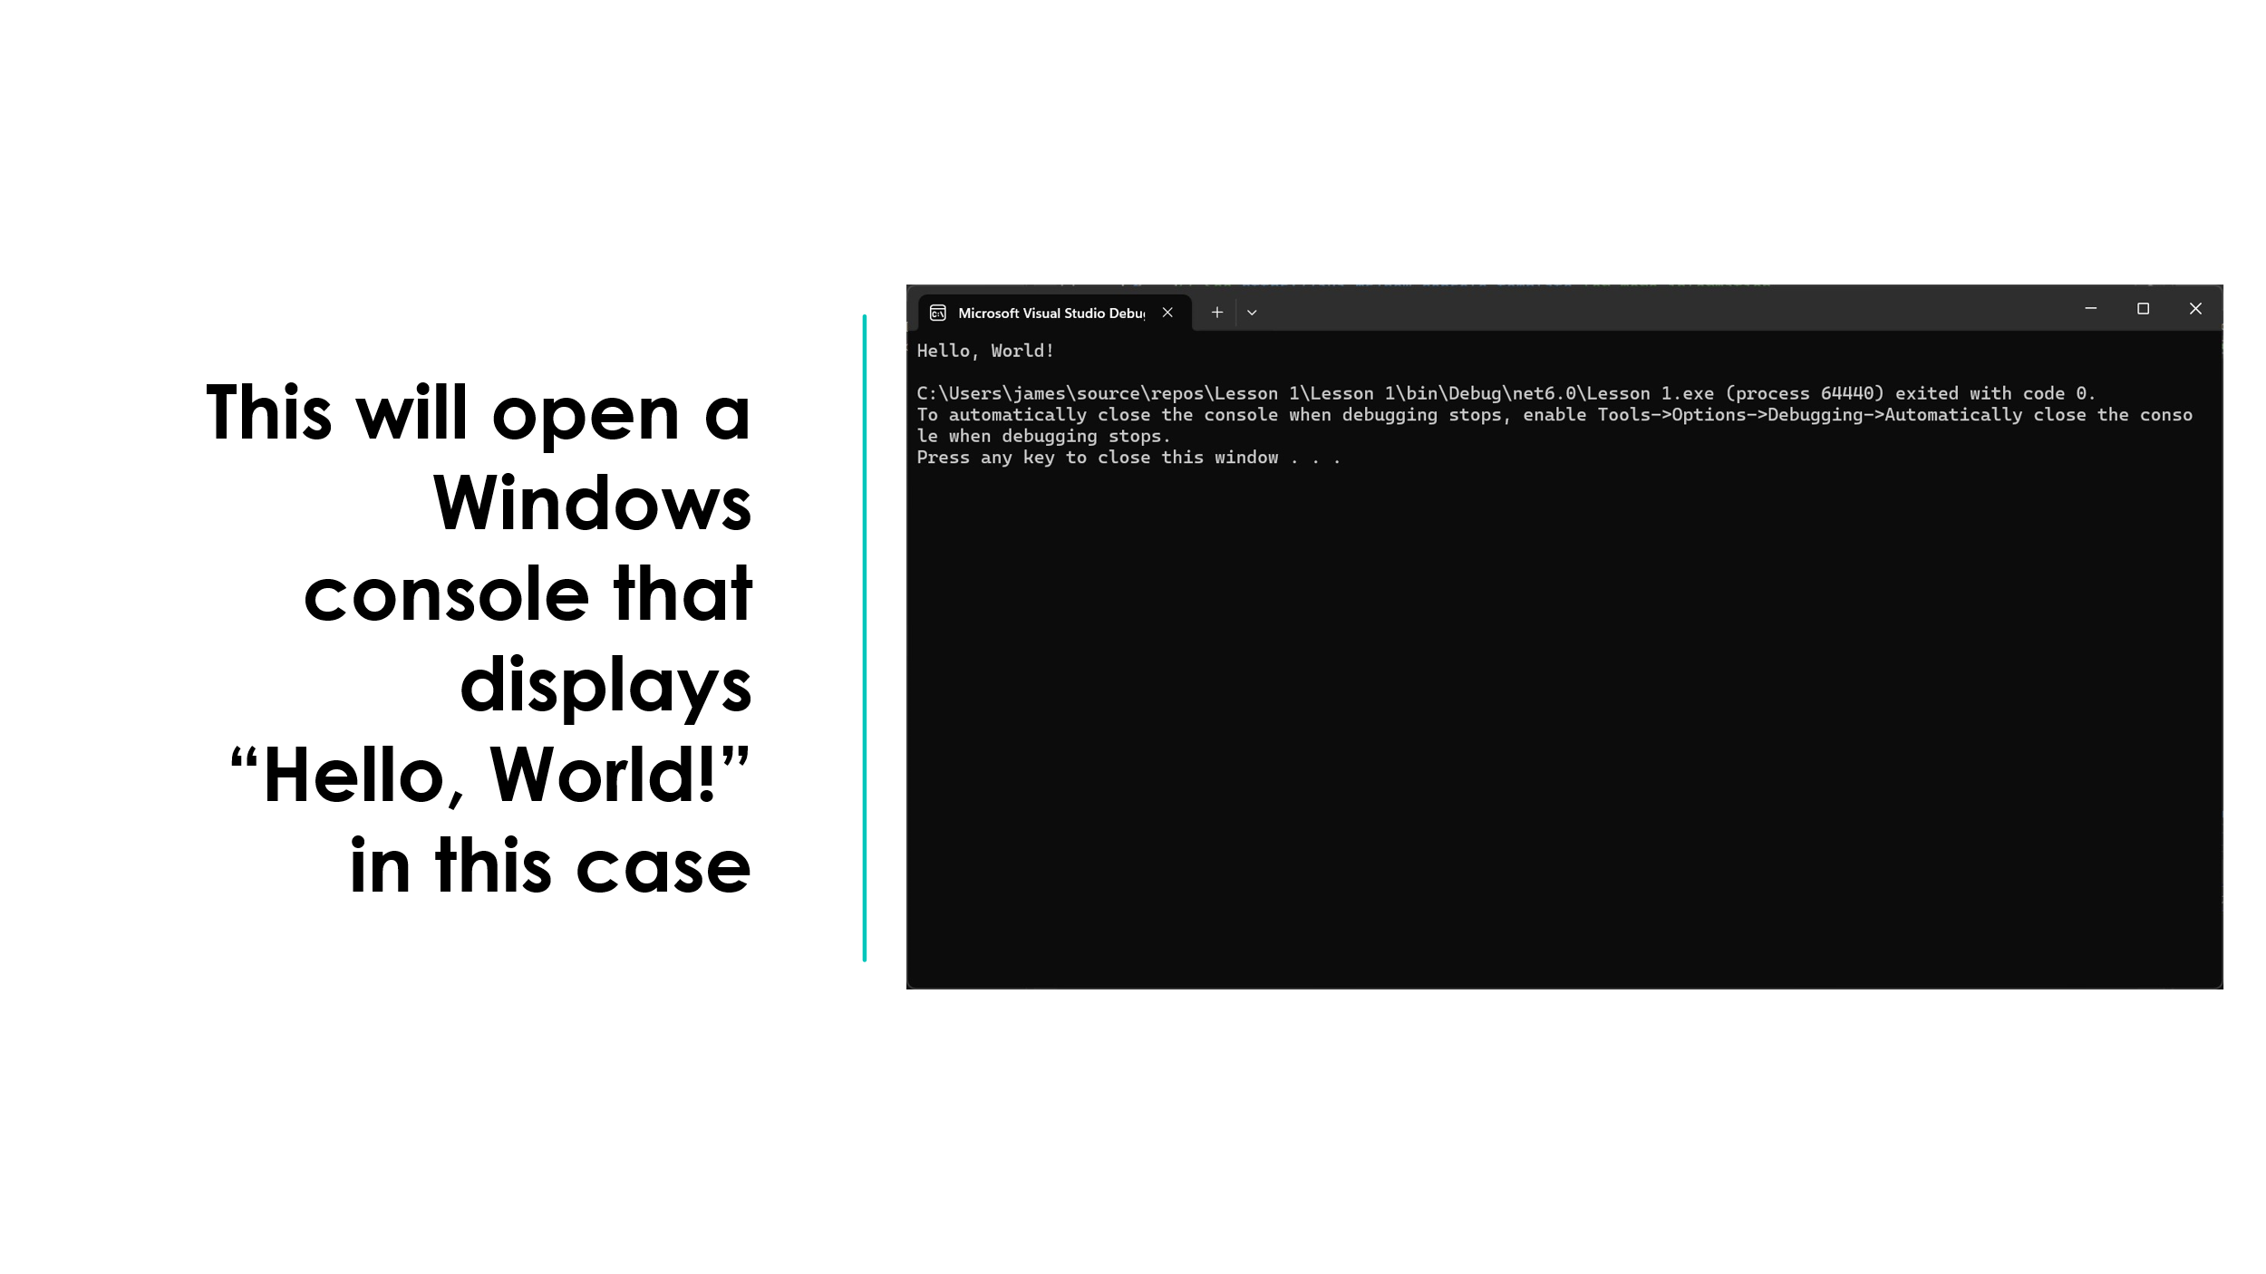
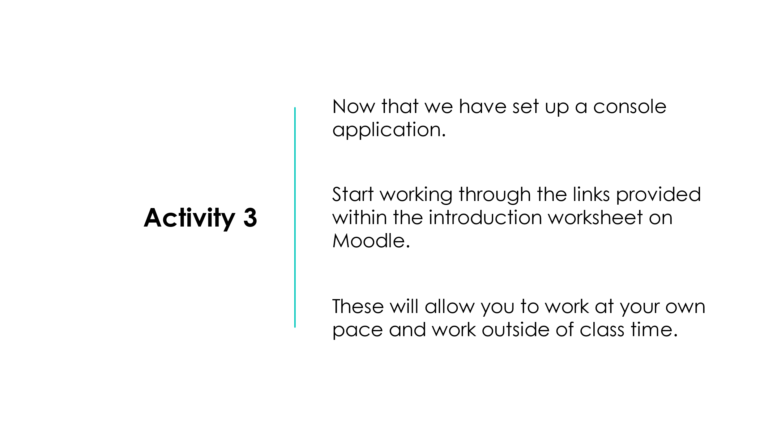

Appendix E: Lesson 2 Plan
Topic:  Unit 3 – AI/ML Programming |  | Class:  Level 3 AI/ML
Date: | Length of lesson:  2 hours |  | Number of students:  14
Resources required:
Students will need access to computers with Visual Studio 2022 installed.

Aim of Lesson
- Introduce creative software used to create computer programs.
- Introduce various programming languages used to create computer programs.
Learning Outcomes – The Learners Should Be Able To:
- Identify various programming languages.
- Apply knowledge and problem-solving skills to create a basic C# program.
- Identify the basic components that make up a computer program’s code.
Previous student knowledge required for the session:
It would be helpful if students had knowledge of programming. However, it is not required.

Anticipated difficulties (if applicable):
Computers having issues loading Visual Studio 2022

Professional Standards (where are these being met within the session)
“Demonstrate dignity, courtesy and respect towards others” (Welsh Government, 2023) by making certain that each perspective's viewpoints are given equal importance and that every student has the chance to express their thoughts.

Lesson Detail:

Stage | Focus | Strategy | Time
Introduction  Development  Plenary/conclusion | Lesson Introduction.  Recap of previous learning.  Introduction to what a programming language is.  Activity 2 – research facts and information about the various programming languages.  Demonstration of what Visual Studio is and how to use it.  Demonstration of how to set up a basic project within Visual Studio.  Activity 3/blended learning – work through online tutorials on C#.  Summary of what has been learnt. | Lecture  Lecture, Q&A  Lecture  Research, worksheet  Lecture, demo  Lecture, demo  Online tutorials  Lecture | 5-10 minutes  5-10 minutes  10 minutes  15-20 minutes  20-25 minutes  10 minutes  The remaining time of the lesson.  5 minutes

Assessment Strategies: when and how are they included within the lesson?
During parts of the lesson, students will complete a worksheet, which they will upload to an online learning environment such as Moodle to track their progress and understanding of the topic area.

Various Q&As will also be conducted throughout the lesson to gauge learner understanding and engagement with the topic.

