

Student name: Laszlo Suba
Student number:2419719
Module: Employability and Career Development
Lecturer: Piyumika Gamage
Assignment title: Selection of in-class tasks

Table of Contents
Task 1: Comparison of Job Adverts 3
Selected job adverts 3
Key skills and knowledge required 6
Task 2: Self-assessment and evidence of readiness 8
SWOT Analysis 8
Evidence of Employability 9
Task 3: Employment Goals and Personal Development Plan 9
Short term and long term employment goals 9
Personal development plan 10
References 11

Task 1: Comparison of Job Adverts
The four job adverts selected all relate to roles involving resin flooring or resin-based work. Each advert highlights different responsibilities, but there are several common skills and knowledge areas across them. All four roles require practical experience with resin materials, whether through installation, mixing, or surface preparation. The use of hand and power tools is mentioned in every advert, showing that technical ability is essential. Health and safety awareness is also a shared requirement, especially when working on active construction sites or handling chemicals like epoxy resin. Most roles require a driving licence and CSCS card, showing the need for site access and mobility. Teamwork and reliability are important soft skills, as well as the ability to work independently and follow instructions.
Despite these similarities, each role has its own focus. The Landscaper role includes a wide range of outdoor tasks such as paving, fencing, and brickwork, with resin-bound surfacing as one part of the job. The Assembler position is based in a manufacturing environment and focuses on detailed work with small components, including mixing epoxy resin and using hand tools for precision tasks. The Resin Floor Layer and Resin Flooring Fitter roles are more specialised, requiring experience with different resin systems like epoxy, polyurethane, and polymer screeds. These jobs involve nationwide travel, surface preparation using grinders and vacuums, and applying resin finishes to commercial and industrial floors.
Overall, the comparison shows that resin flooring roles demand a mix of technical skill, safety awareness, and physical ability. While the settings and tasks may vary, the core skills remain consistent. This analysis helps to understand what employers expect in this profession and provides a clear picture of the requirements for someone pursuing a career in resin flooring.

Selected job adverts
https://uk.indeed.com/viewjob?jk=ff9d46fc6ef2c202&from=shareddesktop_copy
https://uk.indeed.com/viewjob?jk=09219a2a03eeb3a4&from=shareddesktop_copy
https://www.cv-library.co.uk/job/224510061/Assembler?hlkw=resin&sid=09fbac31-4839-43f4-b346-46de8b31c700
https://uk.indeed.com/viewjob?jk=b2ea756612c1a2c1&from=shareddesktop_copy
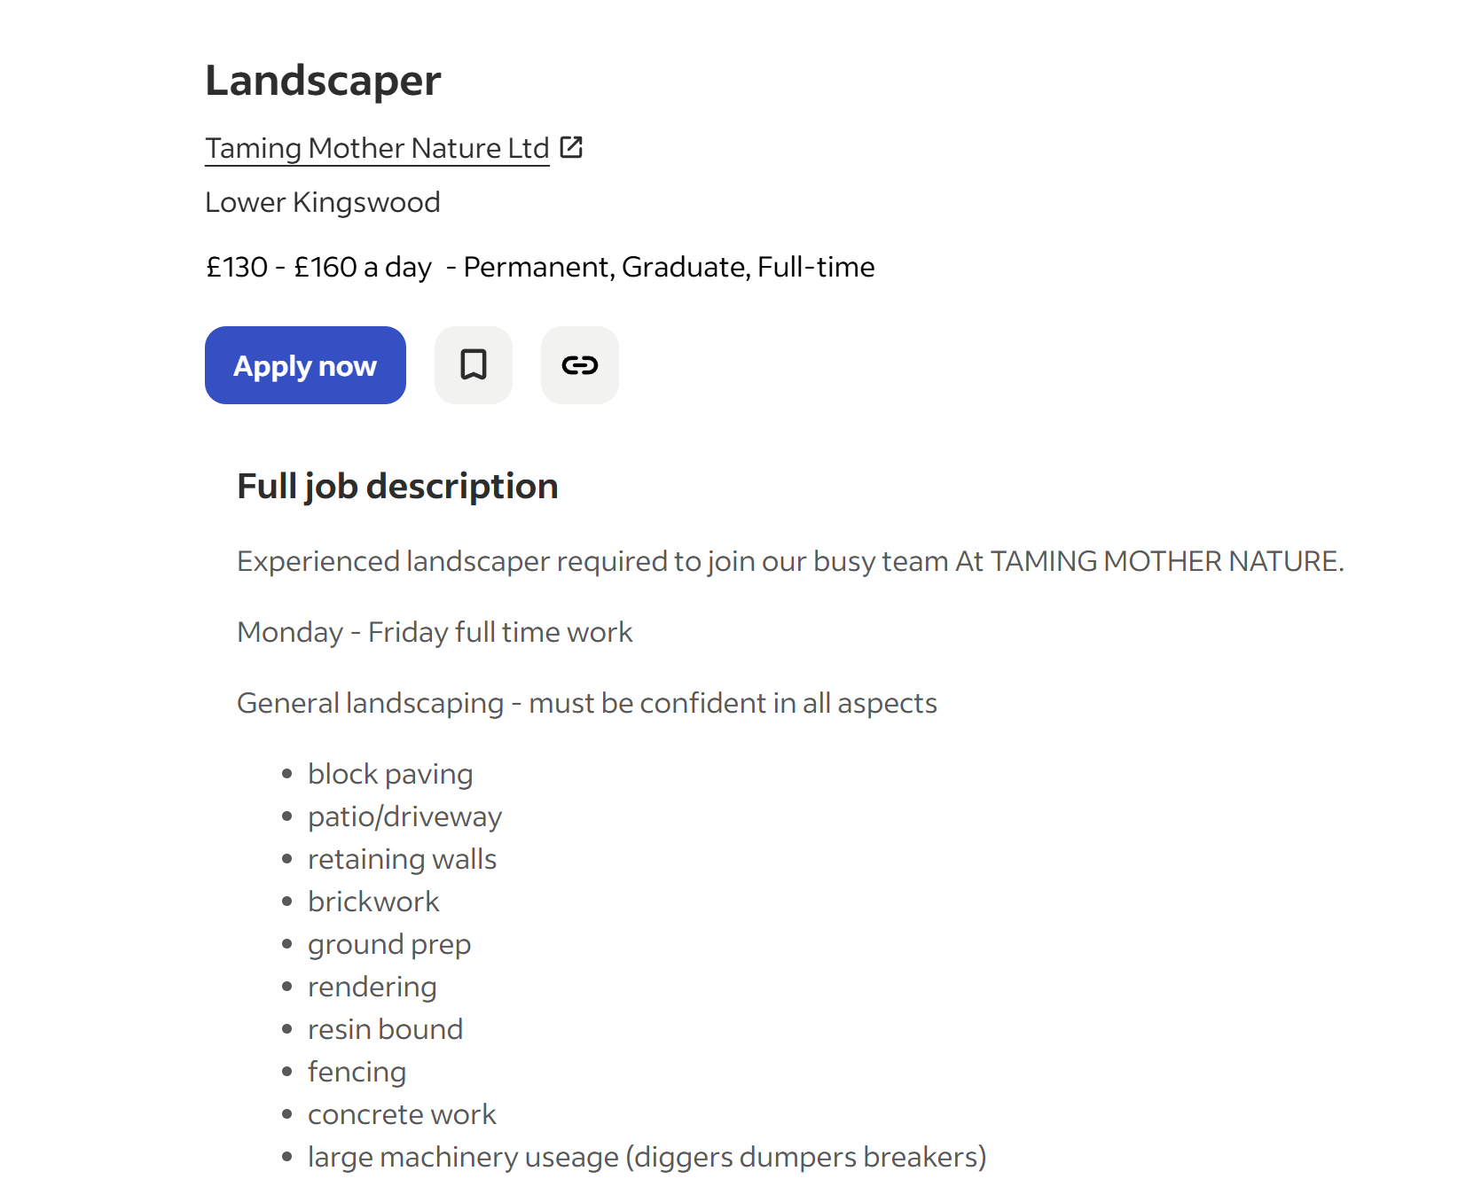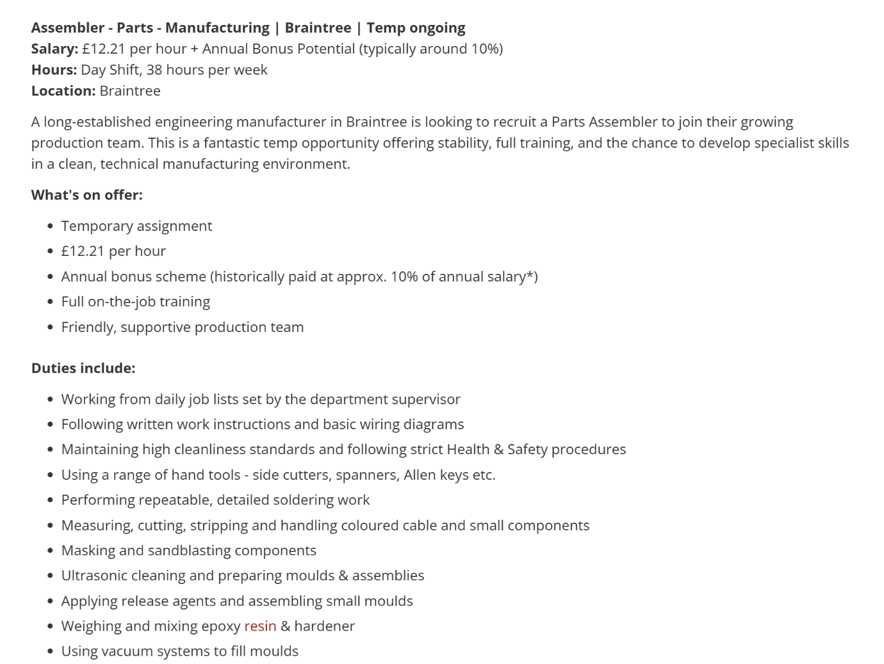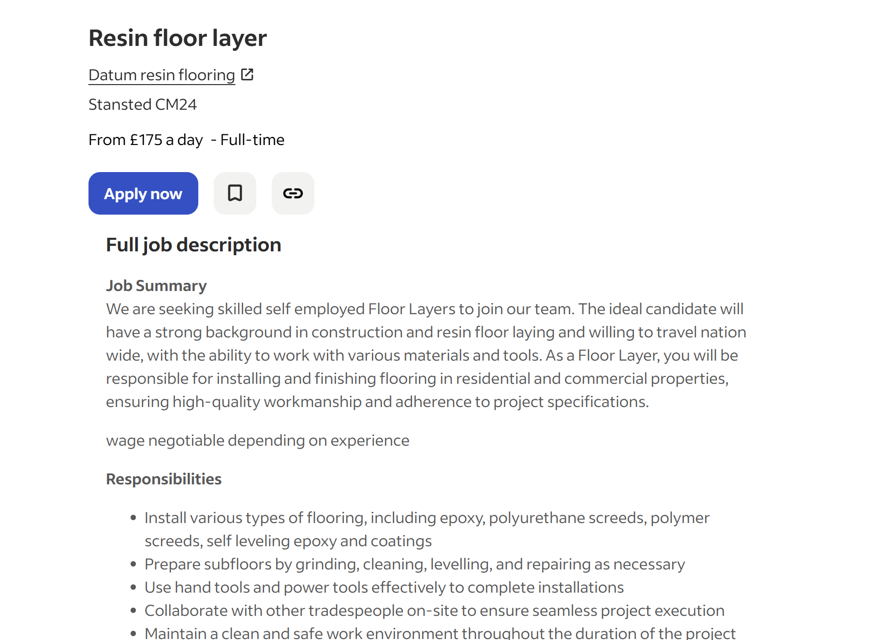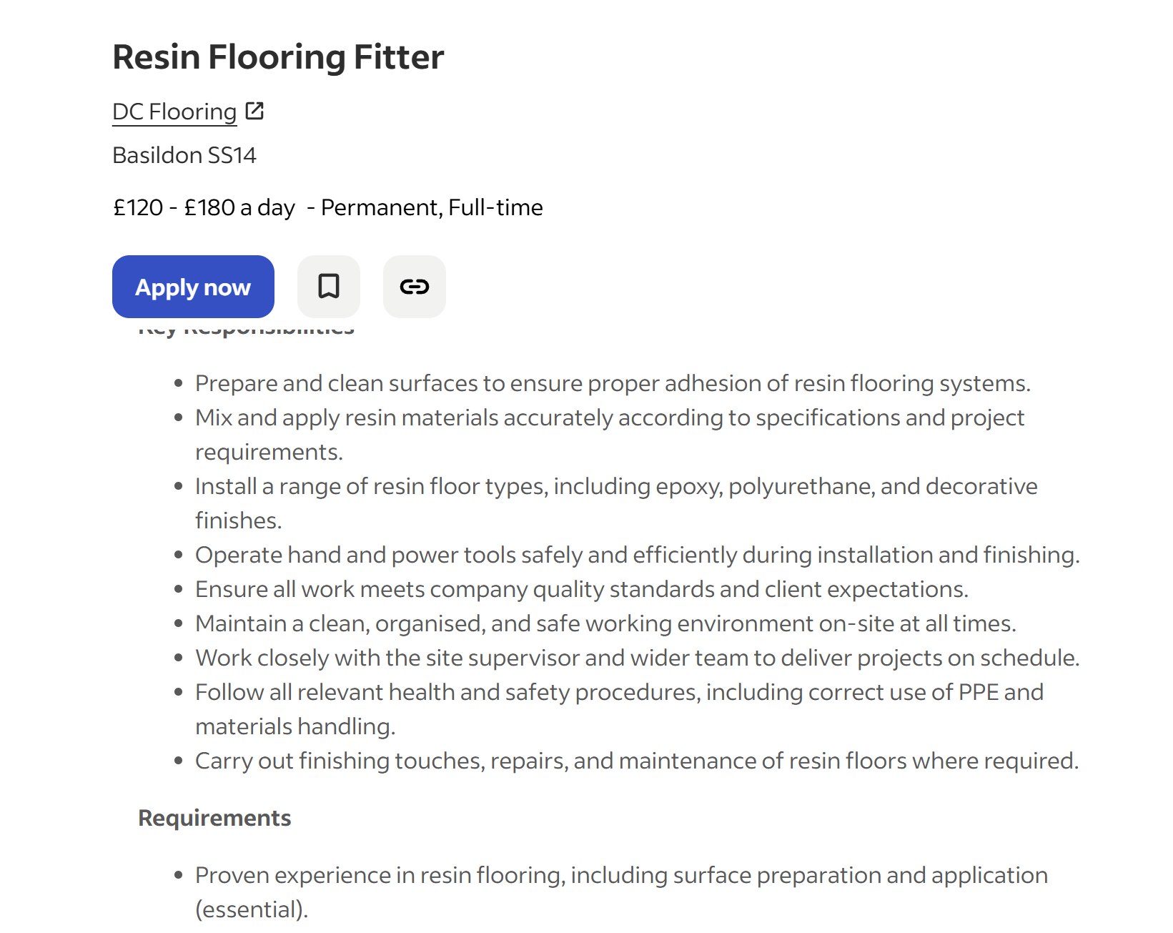

Key skills and knowledge required.
1. Landscaper
- Resin bound installation
- Ground preparation
- Concrete work
- Brickwork, paving, patios
- Use of machinery (diggers, dumpers)
- Driving licence
- Physical outdoor work
2. Assembler
- Mixing epoxy resin & hardener
- Using hand tools
- Following instructions & diagrams
- Soldering small components
- Quality control
- Health & safety procedures
- Precision and diligence
3. Resin Floor Layer
- Installing epoxy, PU screeds, polymer screeds
- Subfloor preparation (grinding, levelling, cleaning)
- Using hand & power tools
- Construction knowledge
- CSCS card
- Driving licence
- Working nationwide
4. Resin Flooring Fitter
- Surface preparation
- Mixing and applying resin systems
- Installing epoxy, PU, decorative finishes
- Using grinders, vacuums, and tools
- Quality control
- Health & safety
- CSCS card + driving licence
Across the four job adverts, several common skills and knowledge areas appear consistently. All roles require practical experience with resin materials, whether through installation, mixing, or surface preparation. Use of hand and power tools, diligence, and adherence to health and safety procedures are essential across the board. Most positions also require a driving licence and the ability to work independently or as part of a team. However, there are clear differences: the Landscaper role includes broader outdoor tasks like paving and fencing, while the Assembler focuses on precision work with small components and epoxy resin in a manufacturing setting. The Resin Floor Layer and Resin Flooring Fitter roles are more specialised, demanding experience with various resin systems, site work, and nationwide travel.

Task 2: Self-assessment and evidence of readiness

SWOT Analysis

Strengths | Weaknesses
- Hands-on experience with epoxy flooring through Lumispell Ltd.  - Strong practical skills from fabrication, stonemasonry, and installation work.  - Confident using hand tools, power tools, and machinery.  - Good understanding of health and safety from training and past jobs.  - Resolute, hardworking, and able to work independently or in a team.  - Full UK driving licence and flexibility to travel for work. | - Limited experience with specialist resin systems such as PU screeds and MMA.  - Need to build more confidence using large preparation machinery like grinders and vacuums.  - CSCS card still in progress, which restricts access to some sites.  - Less experience working on large commercial or nationwide flooring projects.  - Need to improve technical knowledge of curing times and substrate testing.
Opportunities | Threats
- Growing demand for resin flooring in commercial and industrial sectors.  - Chance to gain more qualifications and specialist training.  - Opportunity to gain experience from experienced installers on-site.  - Potential to expand Lumispell Ltd with new services and higher-value projects.  - Networking opportunities through jobs, training, and industry contacts. | - Competition from established resin flooring companies.  - Some roles require nationwide travel, which may affect work-life balance.  - Physical demands of the job could lead to injury if not managed properly.  - Economic changes may reduce construction workloads.  - Employers may prefer candidates with more years of experience.

Evidence of Employability
My work experience and training show that I am ready for roles in the resin flooring industry. Through running Lumispell Ltd, I have gained hands-on experience with epoxy floors, collaborating directly with customers, preparing surfaces, and completing installations to a high standard. This has helped me build confidence with tools, materials, and the full process from start to finish. My background as a worktop fabricator also supports this, as I am used to measuring, cutting, and working with precision while keeping safety in mind. Earlier jobs in carpet cleaning, security, and hospitality show that I am dependable, hardworking, and able to deal with diverse types of people and environments. I also have practical skills from stonemasonry and labouring, which link well to the physical side of resin flooring. The job adverts highlight the need for health and safety awareness, teamwork, attention to detail, and the ability to travel, all of which match my experience. I have a full UK driving licence, health and safety training, and I am always willing to learn new techniques. Even though I still want to improve in some specialist resin systems and machinery, I am motivated, adaptable, and committed to progressing in this profession.

Task 3: Employment Goals and Personal Development Plan

Short-term and long-term employment goals

Short-term goals (next 12 months)
- Gain more experience in resin flooring by collaborating with professional companies.
- Complete CSCS card so I can work on construction sites.
- Improve my skills with specialist resin systems such as PU screeds and MMA.
- Build confidence using larger machinery like grinders, vacuums, and preparation tools.
- Continue developing Lumispell Ltd by taking on small residential epoxy projects.
- Strengthen my knowledge of curing times, substrate testing, and site preparation.
Long-term goals (2-5 years)
- Become a fully qualified and experienced resin flooring installer.
- Grow Lumispell Ltd into a successful, trusted flooring business in Essex.
- Offer a wider range of services, including commercial resin floors and decorative systems.
- Build a strong customer base and collaborate with contractors on larger projects.
- Train others in resin flooring techniques and become a recognised specialist in the field.
- Achieve financial stability and create a business that supports my family long-term.

Personal development plan
To achieve my goals in the resin flooring industry, I need to continue building my skills and experience. My priority is to complete my CSCS card so I can access more job opportunities on construction sites. I also want to improve my knowledge of specialist resin systems such as PU screeds, MMA, and industrial coatings. To do this, I plan to attend additional training courses and learn from experienced installers while working on real projects. Another crucial step is gaining more confidence with preparation machinery like grinders, vacuums, and mixing equipment, as these are essential for professional resin flooring work.
Alongside this, I will continue developing Lumispell Ltd by taking on small residential epoxy projects. This will help me practise my skills, build a portfolio, and improve my customer service and business management. I also want to learn more about curing times, moisture testing, and substrate preparation, as these are key areas mentioned in the job adverts. Over time, I aim to work on larger commercial jobs to gain experience in different environments and build my reputation in the industry.
My long-term plan is to grow Lumispell Ltd into a successful business that offers high-quality resin flooring across Essex and beyond. By improving my technical skills, gaining more qualifications, and learning from experienced professionals, I will be able to take on more complex projects and eventually train others. This PDP will help me stay focused, organised, and motivated as I work towards becoming a fully qualified resin flooring specialist.

References
Indeed. (2025) Landscaper - Taming Mother Nature. Available at: https://uk.indeed.com/viewjob?jk=b2ea756612c1a2c1&from=shareddesktop_copy (Accessed: 21 December 2025).
Indeed. (2025) Assembler - Prime Appointments. Available at: https://www.cv-library.co.uk/job/224510061/Assembler?hlkw=resin&sid=09fbac31-4839-43f4-b346-46de8b31c700 (Accessed: 21 December 2025).
Indeed. (2025) Resin Floor Layer - Datum Resin Flooring. Available at: https://uk.indeed.com/viewjob?jk=09219a2a03eeb3a4&from=shareddesktop_copy (Accessed: 21 December 2025).
Indeed. (2025) Resin Flooring Fitter - DC Flooring. Available at: https://uk.indeed.com/viewjob?jk=ff9d46fc6ef2c202&from=shareddesktop_copy (Accessed: 20 December 2025).

