COMPARING THE MARKETING METHODS AND STRATEGY OF TWO MULTINATIONAL HOTEL BRANDS
(SIX SENSES AND HOLIDAY INN)

Student ID: 2220990
Student Name: Nicoleta Mocanu
Name of the Lecturer: Scott James
Campus Location: Online (IMH)
Date of submission: 17/05/2023

Introduction
The hospitality industry is a highly competitive market, with multinational hotel chains employing various marketing strategies to attract and retain customers. This essay aims to compare the marketing methods of two distinct hotel brands, Six Senses and Holiday Inn, to analyze their effectiveness and identify potential areas for improvement. Six Senses, a luxury resort brand, focuses on wellness and sustainability, targeting affluent customers seeking unique experiences. In contrast, Holiday Inn, a part of the InterContinental Hotels Group, targets a broader audience, offering comfortable accommodations at affordable prices for both business and leisure travelers.
This analysis will employ several marketing theories and frameworks, including SWOT and PESTLE analysis, the marketing mix, and segmentation, targeting, and positioning. The essay will explore the assumption that Six Senses targets wealthy older generations, while Holiday Inn appeals to younger generations with diverse budgets. By comparing the marketing strategies of these two hotel chains, this essay seeks to provide insights into their success factors and potential areas for growth.
To gain a deeper understanding of the marketing strategies employed by Six Senses and Holiday Inn, we will conduct a SWOT and PESTLE analysis for each brand. This will enable us to assess the internal strengths and weaknesses, as well as external opportunities and threats for both hotel chains while considering the broader political, economic, social, technological, legal, and environmental factors that impact their operations (Armstrong et al., 2014).

Six Senses strengths: Distinct selling proposition centered on wellness, sustainability, and luxury experiences (Wirtz et al., 2017). Strong brand reputation and positive customer feedback (Sigala, 2016). High-quality services and facilities (Wirtz et al., 2017) and for Holiday Inn extensive global presence and strong brand recognition (Wirtz et al., 2017). Affordable pricing and value proposition for a broad range of travelers (Sigala, 2016). Consistent service quality and guest experience (Armstrong et al., 2014). Six Senses weaknesses: Restricted market reaches due to exclusivity and high price points (Sigala, 2016). Less attractive to budget-conscious travelers (Armstrong et al., 2014) and for Holiday Inn limited differentiation from other mid-range hotel brands (Wirtz et al., 2017). Potential for inconsistency in service quality across locations (Sigala, 2016). Six Senses opportunities: Expansion into emerging markets (Wirtz et al., 2017). Collaboration with local communities to promote sustainable tourism (Sigala, 2016). Leveraging digital marketing and social media for increased brand exposure (Armstrong et al., 2014) and for Holiday Inn expansion into emerging markets and underrepresented locations (Armstrong et al., 2014). Development of targeted marketing campaigns for specific demographics (Wirtz et al., 2017). Adoption of technological innovations to enhance guest experience (Sigala, 2016). Six Senses threats: Economic downturns and reduced consumer spending on luxury travel (Wirtz et al., 2017). Competition from other luxury hotel brands (Sigala, 2016). Impact of climate change and natural disasters on resort locations (Armstrong et al., 2014) and for Holiday Inn competition from alternative accommodation options (e.g., Airbnb) (Armstrong et al., 2014). Economic downturns affecting travel budgets (Wirtz et al., 2017). Changing traveler preferences and expectations (Sigala, 2016).
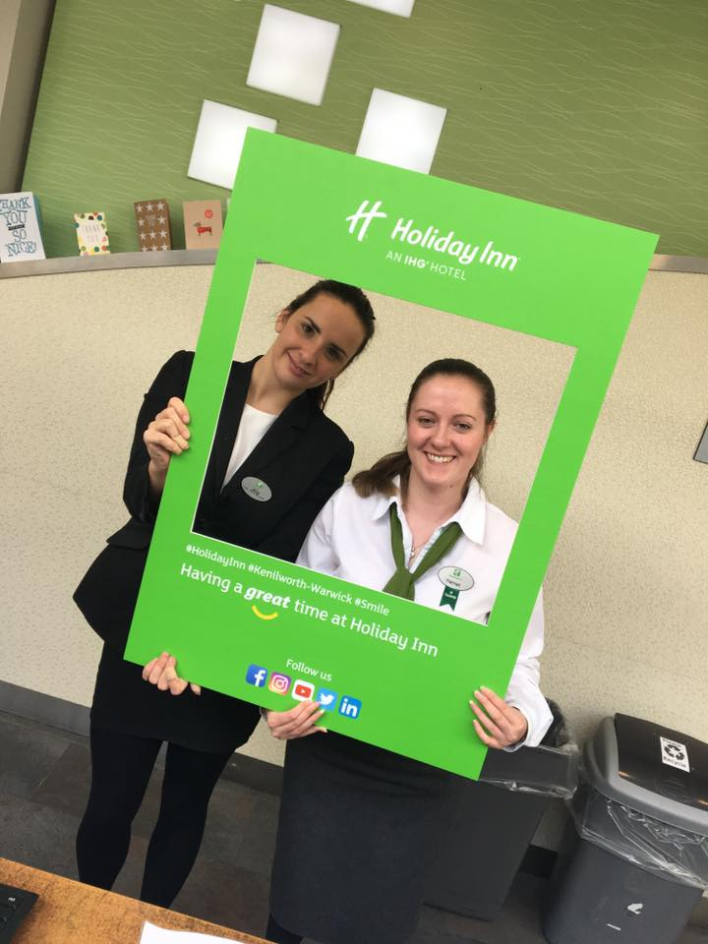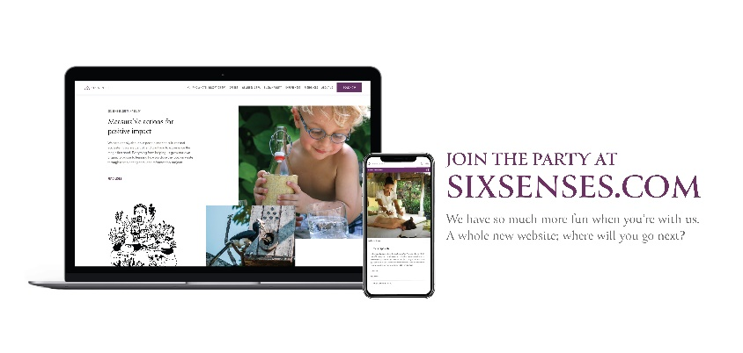
PESTLE Analysis: Political: Six Senses is geopolitical instability affecting tourism in certain regions (Wirtz et al., 2017) and Holiday Inn geopolitical events impacting tourism and travel regulations (Armstrong et al., 2014). Economic: Six Senses has fluctuating exchange rates and potential recessions impacting travel spending (Sigala, 2016) and Holiday Inn Economic: Economic fluctuations influencing consumer spending on travel (Wirtz et al., 2017). Social: Six Senses growing demand for sustainable and wellness-focused travel experiences (Armstrong et al., 2014) and Holiday Inn demographic shifts and evolving traveler preferences (Sigala, 2016). Technological: Six Senses has technological advancements enhancing guest experience and personalization (Wirtz et al., 2017) and Holiday Inn integration of technology to improve efficiency and customer experience (Armstrong et al., 2014). Legal: Six Senses is compliance with local and international regulations (Sigala, 2016) and Holiday Inn compliance with local and international regulations (Wirtz et al., 2017). Environmental: Six Senses increased awareness of environmental conservation and sustainable practices (Armstrong et al., 2014) and Holiday Inn growing consumer demand for environmentally responsible practices (Sigala, 2016).
By comparing the SWOT and PESTLE analyses for Six Senses and Holiday Inn, we can better understand the unique challenges and opportunities facing each brand. These insights will help inform our comparison of their marketing strategies and provide a more comprehensive understanding of their respective target audiences, marketing mixes, and competitive positioning within the hospitality industry (Armstrong et al., 2014).
The 7 Ps of marketing, which encompass product, price, place, promotion, people, process, and physical evidence, can be used to evaluate and compare the marketing mix of both Six Senses and Holiday Inn (Rafiq & Ahmed, 1995).
Six Senses is High-end luxury resorts with a focus on wellness, sustainability, and unique experiences, and for Holiday Inn differs by mid-range hotels, offering comfortable accommodations and essential amenities for business and leisure travelers. Six Senses have premium pricing targeting affluent travelers seeking luxury and exclusivity and at Holiday Inn the prices are competitive aimed at attracting a wide range of travelers with different budgets. The place for Six Senses is exclusive and remote destinations, often in exotic locations but for Holiday Inn have a convenient location in urban centers, near airports, and popular tourist destinations. Promotion at Six Senses, marketing campaigns emphasizing sustainability, wellness, and luxury experiences; leveraging social media and influencer partnerships and at Holiday Inn has mass marketing campaigns emphasizing affordability, convenience, and reliability; utilizing digital channels and loyalty programs. At Six Senses people are highly trained and skilled staff providing personalized services but at Holiday Inn people are friendly and efficient staff focused on delivering consistent service quality. Process at Six Senses is streamlined booking and reservation systems, with a focus on seamless customer experiences but for Holiday Inn the process is easy booking and reservation systems, with an emphasis on customer convenience. Physical Evidence, for Six Senses have a luxurious facilities and sustainable designs, reflecting the brand's commitment to wellness and environmental conservation and for Holiday Inn have a standardized facilities and recognizable branding, ensuring a consistent experience across location.
Identification of Customer Segments and Targeting Strategies: Six Senses targets affluent travelers seeking unique, luxurious, and sustainable travel experiences. Their primary customer segments include wealthy individuals, couples, and families who prioritize wellness and environmental conservation. Six Senses' targeting strategy focuses on appealing to these high-income segments through tailored marketing campaigns and partnerships with luxury travel agencies and influencers (Morrison, 2013).
Holiday Inn, on the other hand, caters to a broader range of travelers, including business travelers, families, and leisure tourists. Their targeting strategy emphasizes affordability, convenience, and reliability, which appeals to various customer segments. Holiday Inn's marketing campaigns often highlight their global presence and the benefits of their loyalty programs to attract repeat customers (Morrison, 2013)
In the competitive hotel market, positioning is crucial for brands to differentiate themselves from their competitors. Six Senses positions itself as a luxury brand offering unique wellness and sustainability-focused experiences. They differentiate themselves from other luxury hotel brands through their commitment to environmental conservation and innovative wellness programs (Morrison, 2013).
Holiday Inn, on the other hand, positions itself as a reliable and convenient mid-range hotel chain that appeals to a wide range of travelers. Their emphasis on affordability and consistency helps them differentiate themselves from both budget and luxury hotel brands (Morrison, 2013).
By comparing the marketing mix, segmentation, targeting, and positioning strategies of both Six Senses and Holiday Inn, we can better understand their respective approaches and identify the key factors that contribute to their success in the competitive hospitality market.
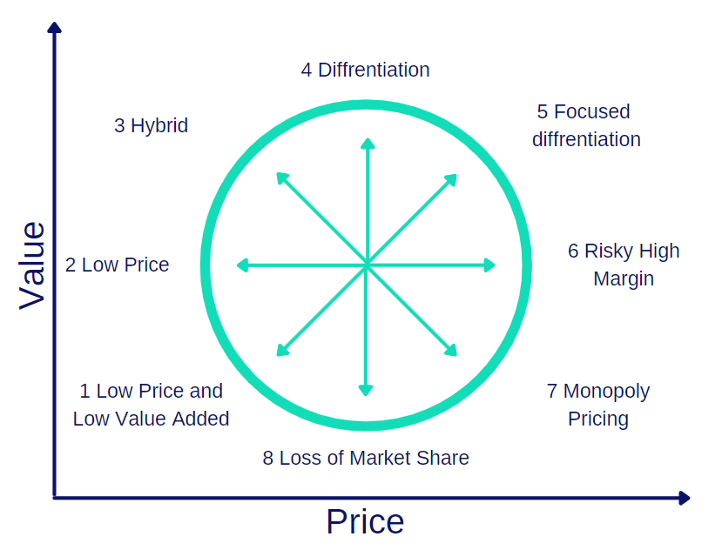

Holiday Inn Six Senses
Brand Message and Identity: both Six Senses and Holiday Inn should refine and strengthen their brand messages, ensuring they resonate with target audiences while setting them apart from competitors (Keller, 2013). This may involve developing unique selling propositions and value propositions that cater to the evolving needs of their respective customer segments and incorporating these messages consistently across all marketing channels (Kotler et al., 2018)
Investing in digital marketing and social media campaigns can help both brands increase exposure, engage with customers, and reach new market segments more effectively (Chaffey & Smith, 2017). Utilizing various social media platforms and employing data-driven techniques for targeting, retargeting, and personalization can enable Six Senses and Holiday Inn to optimize their online presence and foster stronger connections with potential and existing customers (Ryan, 2016).
Balancing digital marketing efforts with traditional advertising methods, such as print, TV ads, and outdoor advertising, can help both brands maximize reach and maintain brand awareness (Fill & Turnbull, 2016). Combining offline and online marketing strategies allows for a more comprehensive approach, ensuring that Six Senses and Holiday Inn effectively communicate their brand messages and offerings to their target audiences through multiple touchpoints (Dahlen & Lange, 2019).
Both brands should remain adaptable to emerging trends, geopolitical events, and evolving consumer preferences, ensuring they stay relevant and competitive in the dynamic hospitality market (Morrison, 2013). By closely monitoring and analyzing the external environment and adjusting their marketing strategies accordingly, Six Senses and Holiday Inn can capitalize on new opportunities, mitigate potential risks, and continuously improve their offerings to meet the changing demands of travelers (Buhari’s & Foerste,)

Conclusion
In this comparative analysis of the marketing strategies employed by Six Senses and Holiday Inn has aimed to examine their effectiveness and identify potential areas for improvement. The initial thesis, stating that Six Senses targets wealthy older generations while Holiday Inn appeals to younger generations with diverse budgets, was confirmed through the exploration of their respective marketing mixes, segmentation, targeting, and positioning strategies. The study has revealed significant differences in their approaches, with Six Senses focusing on wellness, sustainability, and luxury, while Holiday Inn emphasizes affordability and convenience for both business and leisure travelers. Moreover, the situational analysis has shed light on the internal and external factors affecting each brand's performance, providing valuable insights for future strategic decisions. Future research could delve deeper into the role of digital marketing and social media in shaping customer preferences, as well as investigating the impact of contemporary issues and challenges on the hospitality industry. This analysis serves as a starting point for understanding the marketing strategies of two major hotel chains and offers a foundation for further exploration and improvement.

References:
- Adam, S., Armstrong, G., Denize, S., & Kotler, P. (2014). Principles of Marketing. Pearson Australia.
- Chaffey, D., & Smith, P. R. (2017). Online Marketing: Planning, Optimization, and Integration. Routledge.
- Chitty, W., & D'Alessandro, S. (2019). A Customer-Centric Approach to Integrated Marketing Communications. Cengage Learning.
- Dahlen, M., & Lange, F. (2019). A Brand Narrative Approach to Marketing Communications. John Wiley & Sons.
- Fill, C., & Turnbull, S. (2016). Discovery, Creation, and Conversations in Marketing Communications. Pearson Education.
- Hudson, S., & Thal, K. (2013). Implications for Tourism Marketing: The Impact of Social Media on the Consumer Decision Process. Journal of Travel & Tourism Marketing, 30(1-2), 156-160.
- Keller, K. L. (2013). Managing, Measuring, and Building Brand Equity. Pearson Education Limited.
- Kotler, P., Kartajaya, H., & Setiawan, I. (2018). Transitioning from Traditional to Digital: Marketing 4.0. John Wiley & Sons.
- Morrison, A. M. (2013). Destination Marketing and Management in Tourism. Routledge.
- Pappas, N. (2016). Consumer Trust, Perceived Risks, and Online Buying Behavior: Marketing Strategies. Journal of Retailing and Consumer Services, 29, 92-103.
- Ryan, D. (2016). Engaging the Digital Generation with Marketing Strategies. Kogan Page Publishers.
- Sigala, M. (2016). Leading Hotel Chains' Use of Social Media in the Hospitality Industry: A SWOT and PESTLE Analysis for Crisis Management (pp. 295-308). Springer.
- Tsiotsou, R., & Goldsmith, R. E. (2012). Tourism Services: Strategic Marketing Approaches. Emerald Group Publishing.
- Wirtz, J., Lovelock, C., & Chew, P. (2017). Core Concepts in Services Marketing. Pearson Education South Asia.
- Katiana J. (2019): conservation and sustainability

