Name: David-Jay Fisher
Student Number: 1901210

Human Evolution and the Origins of Modern Human Behaviour

Practical exercise 2021

Please indicate your response clearly

Looking at faces 1
Look at the following images and then compare them to the list below. Indicate clearly (circle or highlight) the name of the early hominin skull you believe this to be.
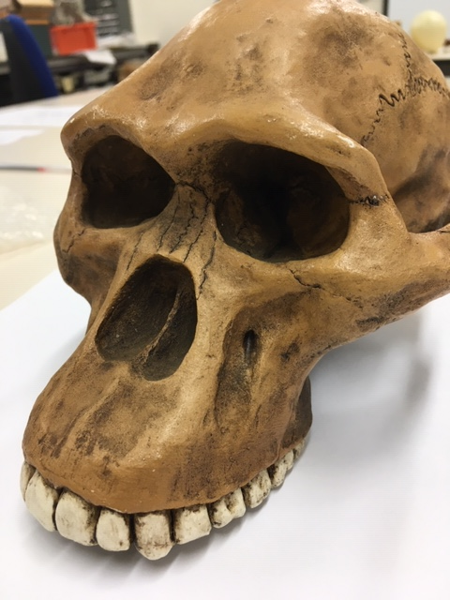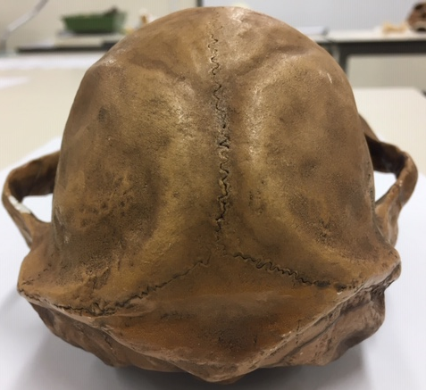

Chimpanzee

Australopithecus afarensis

Australopithecusafricanus

Australopithecus robustus

Homo habilis
Looking at faces 2
Look at the following images and then compare them to the list below. Indicate clearly (circle or highlight) the name of the early hominin skull you believe this to be.
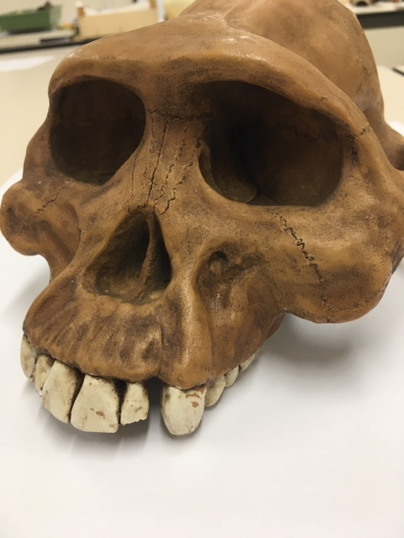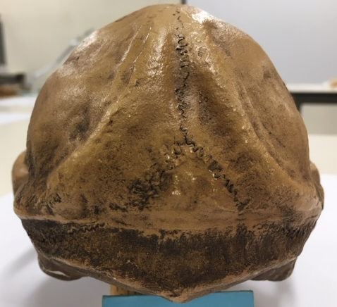

Chimpanzee

Australopithecus afarensis

Australopithecusafricanus

Australopithecus robustus

Homo habilis

Looking at faces 3
Look at the following images and then compare them to the list below. Indicate clearly (circle or highlight) the name of the early hominin skull you believe this to be.
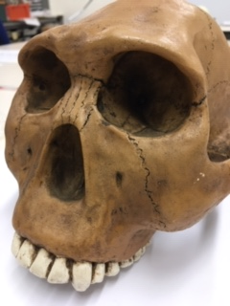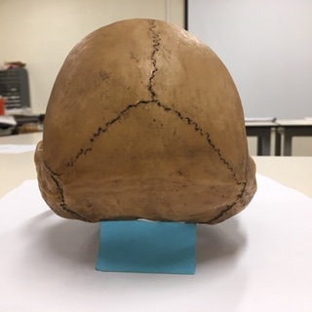

Chimpanzee

Australopithecus afarensis

Australopithecusafricanus

Australopithecus robustus

Homo habilis
Maxilla (upper jaw): Identify the species these belong to
A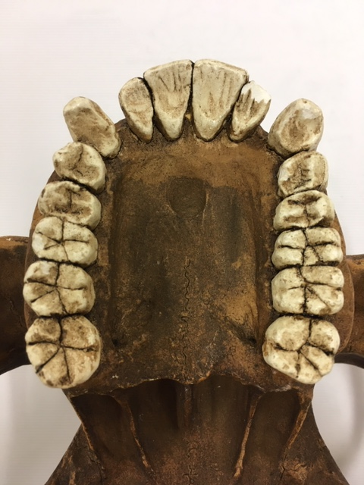B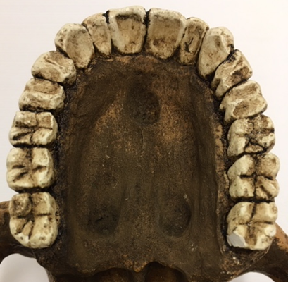
A: Australopithecus Aferensis B : Australopithecus Africanas
Top row left Chimpanzee, Middle Australopithecus afarensis, Right modern human
Lower row Left Australopithecus africanus, Right Australopithecus robustus
Indentify the skull to genus and species level
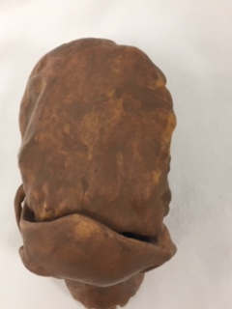
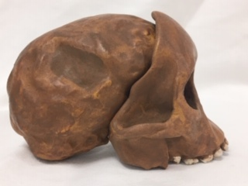
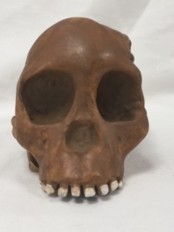
Answer: Australopithecus Africanas or the Tong Child
Indentify the skull to genus and species level
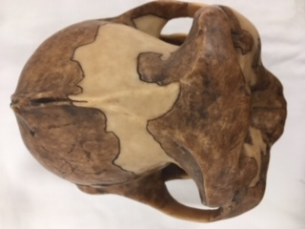
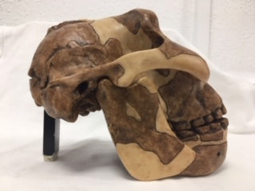
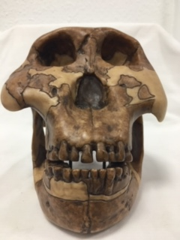
Answer: Paranthropus Boisei
Identify the hominin skull to genus and species level
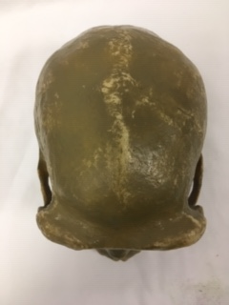

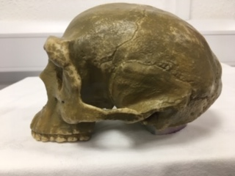

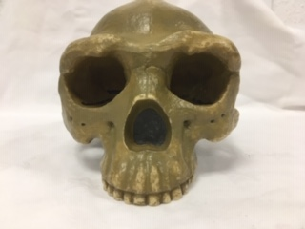
Answer: Homo-Erectus/ Sinanthropus Pekinensis
Indentify the skull to genus and species level
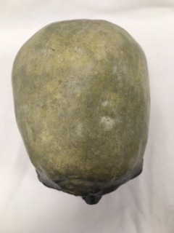
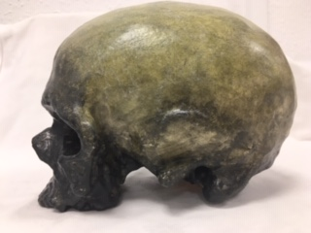
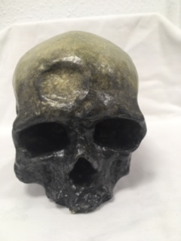
Answer: Homo-Sapien (Cro-Magnon)
Identify, compare and contrast these two mandibles. Use the illustration below to help if you need to.
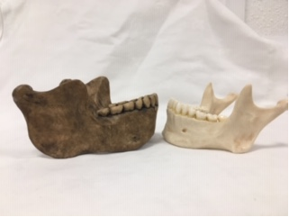
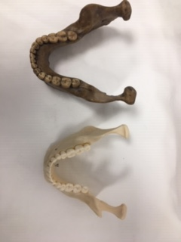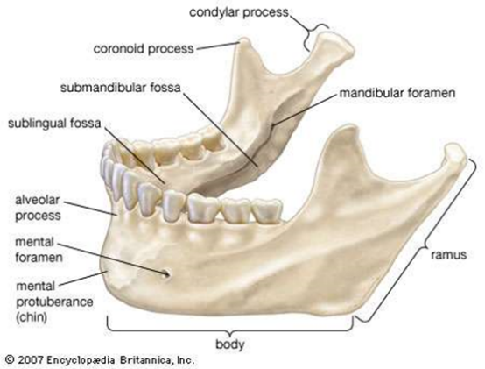

Answer: To the left we have the jaw of a Homo Heidelbergensis and on the right we have the jaw of a Modern day Homo-Sapien Sapien (Human). The jaw of Hidelbergensis fistly has an enlarged frame with an overall much more dense profile. There is a distinct lack of mental protuberance at the front of the Jaw indicating that there is no chin. As we away from the body and move up towards the teeth we will also abserve that the teeth from the insisers to the rear molars have a much larger and thicker profile than that of the Human. The Parabolic Dental arcade of the Homo Heidelbergensis is similar to that of the Human with a Parallel bewtween the right and left sides of the body of the jaw.
Stone tools and tool technology: How to tell a stone is worked.
What suggests this has been worked?
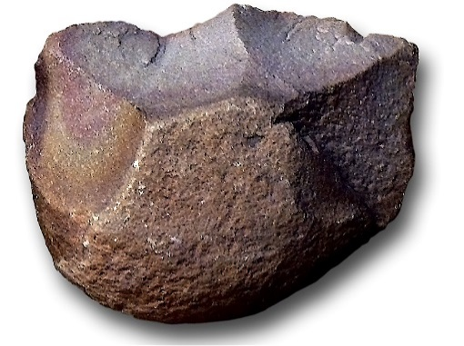
Answer: On this piece we can see that we can see that the top of the item has been napped and worked as we can see areas of contact along the top portion of the piece. There is also a defined edge on the top of the piece that seemes to have either eroded or been used and chipped. The bottom of the piece also appears to be a simple flat holding piece. The symmetry of this piece also suggests aulteration from an individual
Features of stone tool flaking: identify features 1-5
1. Platform
2. Point of percussion
3. Bulb of percussion with bulbar scar
4. Fissures
5. Ripples
Stone tools and tool technology: Stone tools not to scale
Below left: Oldowan Below Right: Acheulean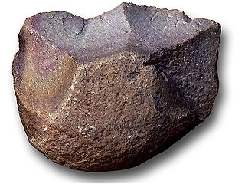 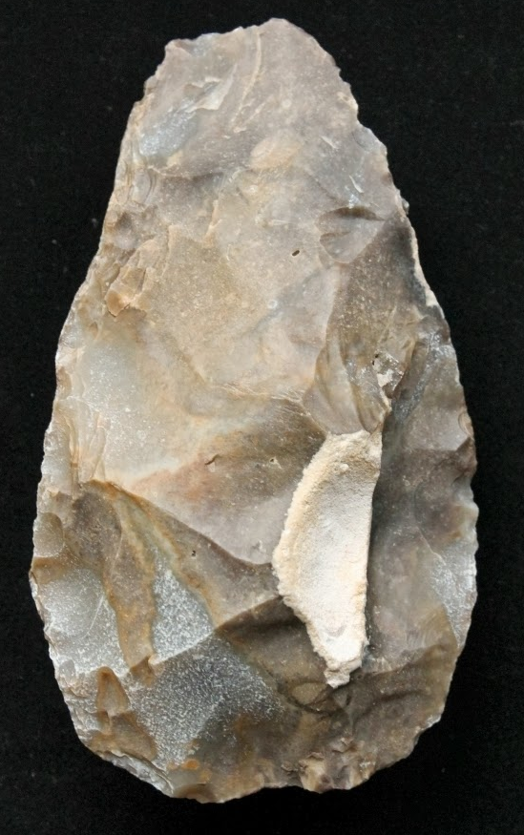
Images taken from https://images.search.yahoo.com

Task: Compare and contrast these two stone tools
Item A on the Left and Item B on the right Seem to be very different Pieces. Item A seems to have less thought put into it as one end is rounded and unshaped whereas item B seems to have been napped all around to create an edge. Item B is also much more symmetrical and seems to have been chipped and napped on almost all of the body as apposed to item A which only has a napped edge one side. This could mean that item A is a Chopping tool and item B is a cutting and slicing tool. The material of item A seems to be a hard stone, whereas item B seems to be made of more brittle flint type material, this would produce a much sharper edge as apposed to Item A’s heavier and more chopper like weight.

