Kamila Khalid – 1809606

Module: BMSW5106

Knowledge and Information Management Skills for the Workplace

Assignment: Mid-Term Formative Assessment Report

Lecturer: Dr. Buddhi Pathak

Due: 22 July 2020

Table of Contents
Page No.

PART 1
- Give an example of how human decision making in business
suffers from limited time, data and information? 3

- Consider five decisions you have made today and in each case
determine the data, information, or knowledge that were involved in the
decision. 4

  - Decision to call the doctor 4
  - Decision to let children play computer games 4
  - Decision to forward information regarding funding for community
Projects 5
  - Making breakfast 5
  - Decision to do the laundry 5

- Does a player in a card game use tacit or explicit knowledge? 5

- Explain the categories of computer-based information systems 7
  - Transaction Processing System (TPS) 9
  - Management Information Systems (MIS) 10
  - Decision Support Systems (DSS) 10
  - Executive Support Systems (ESS) 11

- Explain why organisations have a structure composed of different levels and specialities. How computer-based information systems can support managers
at each level of an organisation. 12

PART 2
- Describe how the overall approach adopted by American Airlines
incorporated Porter’s basic competitive strategies of ‘cost leadership’ and
‘product differentiation’. 13

- In what ways did SABRE provide American Airlines with a competitive
advantage? Your analysis should refer to Porter’s five forces, for example,
‘entry barriers’. 14

- Although SABRE was undoubtedly successful, American Airlines was not
able to maintain its competitive advantage beyond the late 1980s. What
factors played a part in the erosion of the company’s lead over its competitors
and how did the company react? 15

- How are information systems transforming business, and why are they
so essential for running and managing a business today? 16

- Identify three major new information system trends. Justify your answer
with relevant pros and cons of each of the trends. 16

References/Bibliography 20

- Give an example of how human decision making in business suffers from limited time, data and information?
Before answering the question of how human decision making in business suffers from limited time, data and information, firstly we need to understand and define the terms data and information. Generally speaking, data is something that is facts and figures not specific to any person or thing, whereas information is relating to a specific thing or person. AcKoff (1999) defines data as symbols that represent the properties of objects and events and information is making sense of the data. For example, if we say, desk, chair, one, two, that is just data which does not really make any sense by itself. However, if we say there were two chairs and one table in a room, that is information that can give some idea of what is in a room. Information is what gives answers to questions.
An example of decision making in business is that of recruiting the right talent within an organisation. For example, in my previous employment as a HR assistant it was important to ensure we attract the right kind of people for our graduate recruitment programmes. So the initial advertisement that went out had to be spot on with regards to the requirements the firm was looking for in their potential employees. From my experience we had a lot of people who would apply without the necessary experience or qualifications. However all applications had to be sifted through and only those that matched our requirements would be put through to the next phase. This procedure is very time consuming and due to the time limitations we had of the graduates having a set start date each year we had to ensure everything ran smoothly from start to finish. Sometimes the wrong candidates can be put through when you are in a rush to complete the process.
The data provided in this scenario was the demographic information and history of employment, education. The information was the experience and talent that was highlighted on the applicant’s resumes. It is the information that helps with making decisions not just data on its own. Not having enough data and information and the relevant amount of time to make the correct decisions will have negative impacts on the business as the right kind of talent could be lost due to poor collection of information.
In a research study undertaken by Diehl. and Sterman (1995) it was found that due to delays in feedback the efficiency of production was greatly affected. It was found that despite the fact of having knowledge of the structure individuals failed to adapt in complex situations due to delays as this impacts cause and effect and the need for action. Again, in this scenario it can be seen that limited time can have adverse effects on the capabilities of individuals and decision making process.
Another scenario with regards to having lack of data, information, knowledge and time is when lawyers have a new case to deal with. When first a case is brought in front of a lawyer there is very limited data and information for a lawyer to come to any conclusions. It usually takes lengthy telephone calls, meetings to ascertain the full knowledge of a given case. It is also useful to have stored data such as past cases to refer to when reviewing cases. This is also where knowledge plays a crucial part, as an experienced lawyer who has been practicing for a number of years will normally recall cases or be able to easily retrieve cases that can be referred to where as someone who is new may not have the knowledge or take longer to find the necessary information. However, with digital technology it is now a lot easier to find information rather than using physical law books. Gandomi. and Haider (2015) study found that with the use of digital technologies the rate at which data creation there is a growing need for real time analytics and evidence based planning. Particularly with regards to legal cases it is even more crucial as new evidence is incoming regularly.

- Consider five decisions you have made today and in each case determine the data, information, or knowledge that were involved in the decision.

  - Decision to call the doctor
A family member was unwell and I had to make the decision whether to call the doctor or not. The data I had was pain in foot, swelling, elderly, diabetic, heart condition. The information I had was this was an elderly, female individual, not very mobile, on medication. The knowledge I had was that which has been gained over a number of years, that this individual’s health has deteriorated, suffers from multiple health conditions and based on that I made the decision to call the doctor.
  - Decision to let children play computer games
Children have been out of normal routine for a few months due to COVID-19, so asked if they could play computer games. The data in this scenario was computer games, electricity, time, children. The information was I have two boys with quite a bit of spare time on their hands, and the weather being quite wet, they wanted to play computer games for a couple of hours. From past experience I have let them play and they only play for about an hour and get bored, so I decided to let them play until the rain stopped so long as they had done their daily educational work.
  - Decision to forward information regarding funding for community projects
An email arrived with regards to various funding available for local community projects. The decision I had to make was to whether to forward this on to individuals/groups who may benefit. The data was various amounts of grants available for various community projects in Birmingham. The information was that this email came about due to COVID-19 informing people of what funds were available during the crisis. The knowledge I have is there are a couple of not for profit organisations I am a part of to whom I could send this information to.
  - Making breakfast
For breakfast I made the decision to make some toast and tea. The data I had was two pieces of bread, margarine, toaster, kettle, water, teabag, milk, sugar. The information I had was to use the toaster to make the toast and the kettle to boil the water. The knowledge was to put the teabag in the cup, add the boiled water, then the milk and then sugar. With regards to toast, put the toast in the toaster until golden brown, wait for it pop and spread the margarine.
  - Decision to do the laundry
The decision was to whether to do the laundry today or not. The data is a pile of dirty laundry, washing machine, detergent, rain. The information was that it was raining and upon checking the weather online it was likely to be raining for the rest of the day. Given my past knowledge I decided to leave the laundry until the weather was dry as although weather apps are not 100% accurate, it was pretty cloudy outside and already raining, so not likely that it will become dry later on in the day.

- Does a player in a card game use tacit or explicit knowledge?
Tacit knowledge is something that comes with experience and is unique to a particular individual. Explicit knowledge is something that is written down and documented and can be transferred in the written form. A famous quote by Polanyi (1966), “We can know more than we can tell," captures the meaning of tacit knowledge in which he states that tradition, inherited practices, implied values, and prejudgments are a crucial part of scientific knowledge.
Collins (2010) further describes tacit knowledge in terms of an organisation as strategies for capturing indefinable skills or recruiting people that have the relevant tacit knowledge. However, Collins disagrees with Polanyi’s suggestion that all knowledge is tacit or is rooted in tacit and that explicit knowledge is understood or applied through tacit knowledge. Collins argument is that tacit knowledge depends on the explicit. The argument suggests that explicit knowledge can become tacit as well as tacit knowledge becoming explicit when it comes to transferring knowledge. When tacit has been written down it becomes explicit and people are able to read and interpret information.
With regards to a game of cards, if we take the game ‘Uno’ for example, there is explicit knowledge in the set of rules that are in place. Each player is told the rules by someone who knows how to play the game. However anyone can play the game using the explicit knowledge but someone with tacit knowledge, i.e. someone with previous of experience of playing the game before will know how to win. Someone with tacit knowledge can use certain strategies to win. The aim of the game is to play all your cards and only certain cards can be put down if they match the cards that have already been put down either matching in colour or number. Although this is explicit knowledge as per the rules, someone with experience will be quick at determining which cards to put down when and coming up with a strategy. When it comes to strategies having tacit knowledge plays an important role in assisting with such decisions in that a person can rely on their experience to ensure they are coming with strategies that will be effective. (Bennett, 1998)
A player in a card game would need to use both explicit and tacit knowledge in order to have a chance of winning. However, with regards to card games explicit knowledge would need to be acquired first in that one would need to have read or have been taught about the rules of a particular game. However, Stevens et al (2010) state that the root of explicit knowledge is found in tacit knowledge, but that tacit knowledge has been systemised to become explicit knowledge. They further state that the same is true in the opposite direction, in that tacit knowledge has the possibility to become explicit knowledge.
With regards to card games however, unless one makes up their own version of a game, they would need to be told how to play a game by someone with prior knowledge or by reading a manual of some sort, as explicit knowledge is something that is unambiguous and easy to follow in most cases. Whereas tacit knowledge and can also be transferable but is something that is not written down and is formed by way of experience.

- Explain the categories of computer-based information systems.
Computer based information systems (CBIS) consist of hardware and software technologies to enable humans to gather useful information and make effective decisions. Other components of a CBIS are database which are a collection of facts, people managing the system, telecommunications and procedures.
There are many different types of CBIS, as shown in the table below but the major ones that organisations use are Transaction Processing Systems (TPS), Management Information Systems (MIS), Decision Support Systems (DSS) and Executive Support Systems (ESS).
Mentzas (1994) describes CBIS as a system with distinct functional characteristics that provides support in different parts of an organisation. There are different types of CBIS in place for different organisations and some organisations will have more than one system in place depending on the function.
Fig 1. Types of CBIS
Type of CBIS | Function of CBIS
Management Information Systems (MIS); | Used to analyse information, generate reports and provide structured problem solving.
Executive Information Systems (EIS); | Used by top level managers to evaluate information in timely analyses.  .
Executive Support Systems (ESS); | Supports electronic communications and organising facilities and is an extension of the EIS.
Decision Support Systems (DSS); | Use to analyse semi-structured problems using data, models and decision aids.
Group Decision Support Systems (GDSS); | Used in addition to DSS with negotiation and communication tools for groups  .
Electronic Meeting Systems (EMS) | This is used to support groups and participation in meetings by using information systems infrastructure. E.g. Zoom, Microsoft Teams.
Organizational Decision Support Systems (ODSS) | Used for organisational tasks and/or decision-making activities that affect different departments or functions.
Expert Systems (ES) | Used to capture and organise corporate knowledge about an application domain and translate into an expert device.
Office Information Systems (OIS); And | For support of office staff in the effective and timely management of office objects and controls information flow within an office.
Intelligent Organizational Information Systems (IOIS). | Used to assist with all aspects of decision making, information and to support communication in organisations with multiple participants.
(Source: Mentzas !994)

  - Transaction Processing System (TPS)
A TPS is an information system which is designed to process day-to-day transactions at an operational level of an organisation as described by Takahara (2005). An example of these are orders by customers, bills, receipts, payments, etc. Traditionally transaction processing could be done manually using tills and writing pads, nowadays computer systems are used. Mahato and Singh (2017) discuss the on demand computer systems for transaction processing, this kind of system is a platform to share, access, transport, process, and manage large data collections distributed across the globe. For example the use of PayPal, Visa, WorldPay are used worldwide for the purposes of transactions in a variety of different currencies.
Below is a diagram of a simple transaction processing system.
Fig 2. TPS System

(Source: Author)
To give an example of the above system for payroll, the input of data would be the hours worked and the rate of pay, the transaction process would be the function usually performed by HR/payroll department to ensure the individual’s payment is processed into their account, the output is the payslip and the payment being received by the individual.

4.2 Management Information Systems (MIS)
Mason and Mitroff (1973) describe MIS as a system in which a solution is provided backed by evidence for a given problem in an organisation. For example, Human Resources is one of MIS used in many organisations to help with recruitment, benefits and rewards system, career development, training and many more functions to help an organisation to run smoothly. The purpose of MIS is to analyse information, generate requested reports and solve structured problems. The system is meant to be as easy as possible to use with a quick response time and to provide real time access to internal and external databases according to Furduescu (2017).
Furthermore MIS was designed to provide managers with information necessary to monitor and control businesses process to manage further performance. Organisations with functions such as sales, marketing, human resources, accounts, production can benefit from such a system.
Below is a diagram showing how the MIS system is used.
Fig 3. MIS system
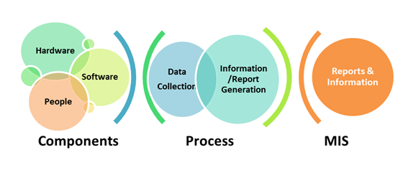
(Source: Whatissixsigma.net)

4.3 Decision Support Systems (DSS)
The DSS system is usually used by managers to analyse data using the TPS and MIS systems as well as gathering information from external sources such as the stock exchange. According to Hashem (2016) there are a variety of factors that play a part in decision making. These are external environmental factors, organisational factors, task related environmental factors and user specific factors.
DSS has evolved over the years due to the advancement of technology. Daniela’s (2019) study shows that the modern DSS systems are sufficient enough to carry out in depth analysis, measure relevant parameters and suggest possible methods of action which offer useful insights to businesses.
The DSS system is to help managers in making effective decisions using computerised tools, especially now with the advancement of AI and Blockchain, if managers are tech savvy they can use these tools to their advantage and make informed strategical decisions within organisations.
There are a variety of factors that will impact on decision support systems such as external environment factors, organisational factors, task-related environment factors, and user-specific factors, factors related to implementation, product-specific factors, and factors related to marketing information. Taking all these into consideration will help managers make informed decisions.

4.4 Executive Support Systems (ESS)
ESS is used by top level managers who oversee operations and develop strategies using MIS and TPS as well as external data. Vandenbosch (1995) states that the ESS system is designed to assist managers in their decision making process by providing top quality information in an easily accessible method. It is considered a flexible tool to provide analytical information for a wide range of decision making processes.
An example of ESS is given in a study done by Jonathan and Warnars (2018) on an aircraft company called PT GMF AeroAsia which focuses on aircraft maintenance report and overhaul. The ESS system was used to manage design and change requests that uses a dashboard to help facilitate decision making by the top level managers. The dashboard is used to identify, control and analyse the conduct of every aircraft maintenance. The ESS system would assist in deciding which areas of any aircraft needed maintenance and providing safe and secure aircrafts for consumers.

- Explain why organisations have a structure composed of different levels and specialities. How computer-based information systems can support managers at each level of an organisation.
Organisations have structures that consist of different levels and specialities to help them manage information and run their businesses efficiently.
Below is a diagram showing strategic, tactical and operational decision making process.
Fig 4 Strategic, tactical and operational decisions
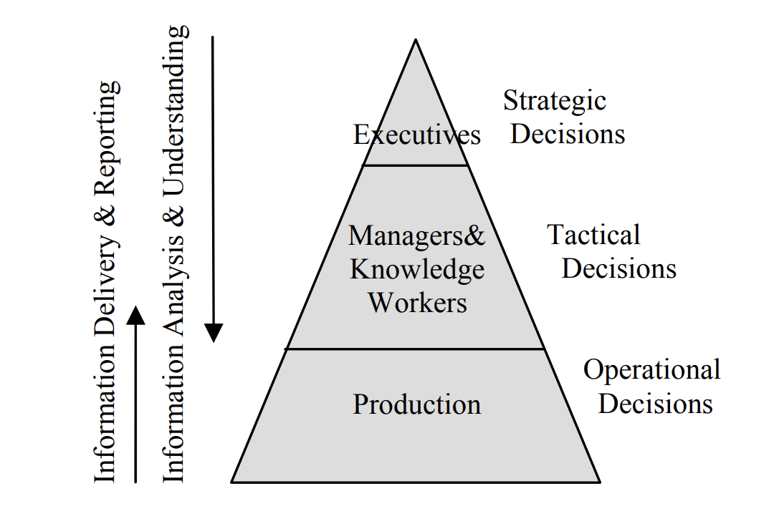
(Source: Varga 2005)
According to Varga (2005) decisions are split into three categories which consist of operational decisions made at the production level, tactical decisions made at the mid managers level and strategic decisions made at the executive level. Depending on what type of organisation it is, they will have a structure to suit their business. For example, a law firm will generally have a functional structure consisting of CEO, partners, associates, functional departments and support staff. Some organisations will have a hierarchical structure or a matrix structure if that suits the way they manage their business.
However, whichever structure an organisation follows, managers will need a system to help with their decision making. Going back to the CBIS systems available, depending on what level the decisions are being made a computer based information system will help. For example, at the operational level a transactional process will help to determine the level of input and output. At the mid-manager level where tactical decisions need to be made the Management Information System will be useful as this can provide easy access to real time information for quick decision making. At the executive level where strategic decisions need to be made a system such Executive Support System can be used to help managers with making strategic decisions using the information from managers provided by using TPS and MIS systems.

PART 2 – CASE STUDY
- Describe how the overall approach adopted by American Airlines incorporated Porter’s basic competitive strategies of ‘cost leadership’ and ‘product differentiation’.
American Airlines was formed on 15 April 1926 and has seen many changes over the decades. (American Airlines 2020). The company teamed up with IBM to design a Semi-Automatic Business Research Environment (SABRE) to help their customers to reserve seats using a web-based system.
Porter’s Five Forces is a framework devised by Michael Porter which consists of five forces that shape industry competition. (Porter 2008). Below is a diagram of the five forces.
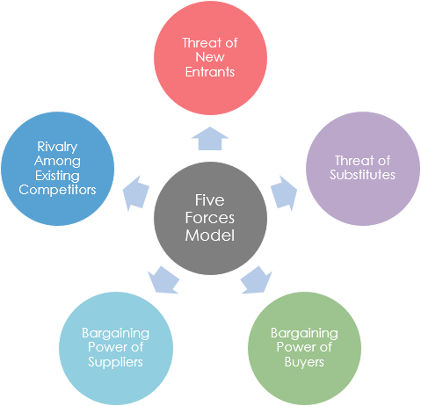
(Source: Kumar 2019)
American Airlines incorporated Porter’s Five Forces with regards to cost leadership and product differentiation by analysing threat of new entrants. According to Porter (2008) “New entrants to an industry bring new capacity and a desire to gain market share that puts pressure on prices, costs, and the rate of investment necessary to compete.” By jointly working with IBM, American Airlines developed a system that helped reduce the cost of making airline seat reservations. By bringing in this new product American Airlines were able to put a cap on the potential profits of the industry.
According to Porter (2008) the threat of entry into any industry will depend on how high the entry barriers are. If entry barriers are low then newcomers expect little retaliation from the entrenched competitors, if the threat of entry is high then industry profitability is moderated and vice versa. Product differentiation is one of the barriers to entry. With American Airlines introducing a new web-based system it has found a unique way of reducing cost and making reservations. Locke (1989) states that American Airlines spent over SI00 million to develop this system which would put them at a competitive advantage because smaller airline companies could not afford such large amounts of investments. However creating web-based systems nowadays is relatively cheap and so threat of new entrants will be low.

- In what ways did SABRE provide American Airlines with a competitive advantage?
SABRE provided American Airlines with a competitive advantage by introducing a system which helped save 30% on investments and increase its revenue. It was the first of its kind to be developed at the time when web-based systems were fairly new and not very widely used. SABRE introduced a service called BargainFinder pricing, unmatched in the industry, which automatically provided the lowest fare for a given itinerary. American Airlines was positioned by SABRE “As one of the most technologically advanced airlines in the world.” (Sabre 2020)
The entry barriers in Porter’s Five Forces in relation to the new system is that for those agents who were lagging behind in the technologies the entry barriers were higher due to the direct reservation booking system which required web-based systems according to Gasson (2003). Furthermore investment in training was high and therefore those who are late to adopt new technologies struggled with this aspect.

- Although SABRE was undoubtedly successful, American Airlines was not able to maintain its competitive advantage beyond the late 1980s. What factors played a part in the erosion of the company’s lead over its competitors and how did the company react?
Although by introducing SABRE, American Airlines gained a lot of success, however by the end of the decade, due to the success of SABRE, the technology was taken to the marketplace, providing software, consulting, and systems management services to other airlines. (Sabre 2020)

According to Gasson (2003) trends in the air travel market that affected American Airlines were the Global Distribution System (GDS) which was the main channel for airline distribution in the USA. SABRE evolved from direct reservations system into a GDS which served airlines, hotels, car rental, rail travel and cruise lines and the like. Due to many GDS systems in operation the cost of entry was lower. The introduction of the GDS changed the balance of power allowing airlines to specialise in dynamic pricing systems. Another issue faced by American Airlines was the increasing use of internet technology.

Companies such as Expedia, Travelocity, Lastminute.com emerged for the convenience of the consumers enabling them to make direct bookings. (ibid) This allowed other airlines to be more competitive and American Airlines had to think of more innovative ways to stay ahead of the game.
In the early ‘90s American Airlines reacted to this erosion by combining the internal technology teams to form The Sabre Technology Group with American Airlines as the majority owner (Sabre 2020). They set up their own website, AA.com, where consumers can book reservations directly. Porter’s competitive strategies would have helped American Airlines to make more efficient decisions going forward such as overall cost leadership, by reducing costs they are more likely to retain customers, they did this by investing in systems such as SABRE to support accurate sales forecast. Another aspect is product differentiation, again American Airlines came up with innovative methods to introduce new technology to enable far reaching consumer base to be able to book using the internet.

- How are information systems transforming business, and why are they so essential for running and managing a business today?

Information systems are transforming businesses in the way knowledge is managed using new technologies. Information systems such as MIS, DSS, TPS are used by managers in decision making and strategic planning. It is essential to have such systems in place today due to the fast paced technologically advanced society that we live in for humans to be able to integrate the systems available in the decision making process. Kitsios and Kamariotou ( 2016) state that due to the competitiveness of industries it is important to have information systems such as SISP (strategic information system planning) or DSS (decision support systems) in place to achieve goals.

Beynon (2020) in his book on Business Information Systems states that knowledge of information systems are not only important for managers but also those at the operative levels. For example, they are just as important for doctors as they are for nurses because data, information and activity are all interrelated in the modern form of employment. Each individual or employee has a part to play in the use of information systems in today’s businesses, right from the operative levels to the top level managerial positions for an organisation to function effectively.

- Identify three major new information system trends. Justify your answer with relevant pros and cons of each of the trends.
In today’s information age the three major information system trends are Artificial Intelligence (AI), Machine Learning (ML) and Big Data. They are all emerging technologies that will play a big part in organisations which will need more sophisticated ways to manage data (Rossi 2019).
Artificial Intelligence and Machine Learning
Siau and Yang (2017) describe artificial intelligence as machines that exhibit human intelligence. In other words machines are programmed to think like humans in some respects. They further break down AI into two elements, by having a strong AI where the machine has consciousness, sentience, and mind, and this machine has intelligence in more than one specific area. There is also weak AI where the machine does a specific task, for example, self-driving cars.
Below is a diagram of what types of factors are considered to enable AI to be effective in today’s world. For example natural language processing is used for Siri and Alexia to function, which is a system that is continuously improving the more it is used and the more data that is collected.
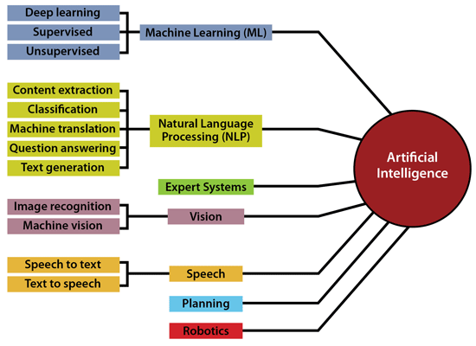
(Source: Datamation 2020)
Machine learning is programming computers to perform at its optimal level by using data or past experience (Alpaydin. 2020). The machines are designed so that data can be stored to enable artificial intelligence so that they can learn information without being programmed explicitly.
The pros of AI are that it is faster, less prone to errors, enables rational decision making. The cons are it is expensive, it does not improve with experience and there will be mass unemployment amongst humans.
Although AI and ML could have many potential benefits in the advancement of human life, such as self-driving cars or reducing overheads in an organisation as they are less likely to be stressed or have time off sick, however machines will need to be maintained and can break down. Another downside is that in the current climate it is very expensive to adopt these technologies and only major firms like Google or Amazon can afford to invest in such technologies.
Big Data
Big Data is considered to be massive amounts of structured and unstructured data. Zhang (2018) describes the source and characteristics of Big Data as coming from the internet where researchers create diverse models for the needs of an organisation. They then extract meaningful information to deal with people in different roles. This is the source and characteristics of big data. Furthermore, Big Data has three categories; types of data that are from people, for example, pictures, videos, use of internet, messaging and so on. Then there is the data generated by the computer whilst using various databases, multimedia, GPS and so on and so forth. Thirdly is the data collected while individuals are using digital devices such as the camera or phone.
Below is an example of how Big Data is used in the retail industry. High volumes of data flows through the relevant channels where it gets transformed and integrated. The data is then analysed to check what the demand is and predict forecasting. This leads to an improved retailor and supplier collaboration, which then leads to better planning and more holistic business planning and improved production line.
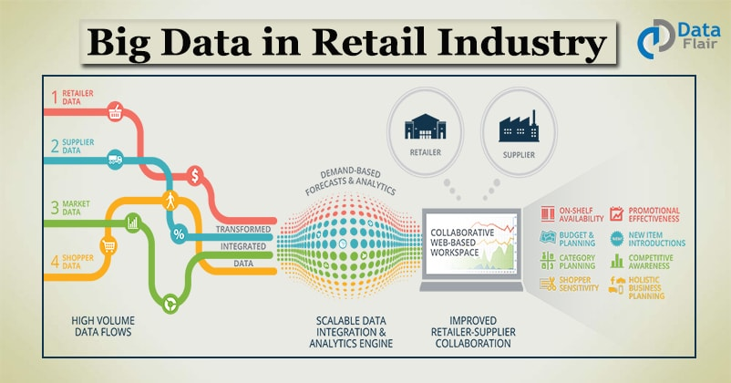
(Source: Sqream.com 2017)
Benefits of Big Data are in business sense you can tailor make products for consumers, you can get tailor made healthcare such as wearable devices that monitor your health. You can monitor crime levels in the city and help reduce it.
Although Big Data is useful for organisations to improve their services and improve strategies when targeting a specific type of consumer, it does come with some potential risks. Security is a major issue. While people are using an internet site data is being collected in the background to see what kind of websites an individual is using so that they can tailor items according to browsing habits. However, criminals are always nearby who may also be viewing such information and can hack into accounts without you knowing and in some cases can steal identities.
All three information systems i.e. AI, ML and Big Data are emerging technologies which are actually linked in some respects to collect huge amounts of data for them function effectively. The more data that is captured the more effectively they will work. The technologies are still in relatively early stages, even though they have been tested for years, and it could take many more years or decades to know to which extent humans will actually see the full benefit from them or perhaps the harm may be greater than the benefit, only time will tell.

References/Bibliography

Ackoff, R. L. (1999) Ackoff’s Best. New York: John Wiley & Sons, pp 170 – 172.
Alpaydin, E., (2020). Introduction to machine learning. MIT press.
American Airlines (2020) Available at https://www.americanairlines.co.uk/i18n/customer-service/about-us/history-of-american-airlines.j (Accessed 19 July 2020)
Bennett, R.H., (1998). The importance of tacit knowledge in strategic deliberations and decisions. Management Decision.
Beynon-Davies, P., (2020). Business information systems. Red Globe Press. P.xxvi
Collins, H., (2010). Tacit and explicit knowledge. University of Chicago Press.
Daniela, Mitran. (2019). Decision Support Systems To Create A Competitive Advantage. Internal Auditing & Risk Management, 14(3), 76-83.
Datamation (2020). Available at: https://www.datamation.com/artificial-intelligence/examples-of-artificial-intelligence.html. (Accessed 21 July 2020)
Diehl, E. and Sterman, J.D., (1995). Effects of feedback complexity on dynamic decision making. Organizational behavior and human decision processes, 62(2), pp.198-215.
Furduescu Bogdan-Alexandru. (2017). Management Information Systems. Holistica : Journal of Business and Public Administration, 8(3), 61-70.
Gandomi, A. and Haider, M., (2015). Beyond the hype: Big data concepts, methods, and analytics. International journal of information management, 35(2), pp.137-144.
Gasson S (2003) The Impact of E-Commerce Technology on the Air Travel Industry. The Impact of E-Commerce Technology 239
Hashem T (2016) Commercial Banks Use of Decision Support System to Achieve Marketing Creativity. International Review of Management and Business Research, Vol. 5, Issue 3.
Jonathan, D. and Warnars, H.L.H.S., (2018), September. Executive Information Systems for Cabin Base Aircraft Maintenance at PT. GMF AeroAsia Tbk. In 2018 Indonesian Association for Pattern Recognition International Conference (INAPR) (pp. 283-288). IEEE.
Kitsios, F. and Kamariotou, M., (2016), September. Decision support systems and business strategy: a conceptual framework for strategic information systems planning. In 2016 6th International Conference on IT Convergence and Security (ICITCS) (pp. 1-5). IEEE.
Kumar S (2019) Porter’s Five forces analysis. Available at: https://medium.com/product-gyaan/porters-five-forces-analysis-868945aa5846. (Accessed 19 July 2020)

Locke L G 1989 FLYING THE UNFRIENDLY SKIES: The Legal Fallout Over the Use of Computerized Reservation Systems as a Competitive Weapon in the Airline Industry. Volume 2, Spring Issue, 1989 Available at: https://jolt.law.harvard.edu/assets/articlePDFs/v02/02HarvJLTech219.pdf (Accessed 20 July 2010)
Mahato, D., & Singh, R. (2017). Balanced task allocation in the on-demand computing-based transaction processing system using social spider optimization. Concurrency and Computation, 29(18), 1-26.
Mason, R.O. and Mitroff, I.I., (1973). A program for research on management information systems. Management science, 19(5), pp.475-487.
Mentzas, G., (1994). A functional taxonomy of computer-based information systems. International journal of information management, 14(6), pp.397-410.
Polanyi, M. (1966). The tacit dimension. (1st ed.]. ed., Terry lectures). Garden City, N.Y.: Doubleday.
Porter, M.E., (2008). The five competitive forces that shape strategy. Harvard business review, 86(1), pp.25-40.
Rossi B (2019) Information Age, available at https://www.information-age.com/3-trends-will-impact-information-management-systems-123459665. (Accessed 21 July 2020)
Sabre (2020) Available at: https://www.sabre.com/files/Sabre-History.pdf. (Accessed 20 July 2020)
Siau, K. and Yang, Y., (2017), May. Impact of artificial intelligence, robotics, and machine learning on sales and marketing. In Twelve Annual Midwest Association for Information Systems Conference (MWAIS 2017) (pp. 18-19).
Stevens, R.H., Millage, J. and Clark, S., (2010). Waves of knowledge management: The flow between explicit and tacit knowledge. American Journal of Economics and Business Administration, 2(1), p.129.
Sqream (2017). Available at https://sqream.com/dead-or-alive-and-kicking-big-data-helps-retail-revive. (Accessed 22 July 2020)
Takahara, Yasuhiko. (2005). Model theory approach to transaction processing system development. International Journal of General Systems, 34(5), 537-558.
Vandenbosch, Betty. (1995). Executive Support Systems and Learning: A Model and Empirical Test. Journal of Management Information Systems, 12(2), 99-131.
Varga, M., (2005), January. Trends in data processing for decision support. In 28th International Convention MIPRO 2005 (Conference Business Intelligence).
Whatissixsigma.net (2020) available at https://www.whatissixsigma.net/management-information-system. (Accessed 19 July 2020)
Zhang, D., (2018), October. Big data security and privacy protection. In 8th International Conference on Management and Computer Science (ICMCS 2018). Atlantis Press.

