

Programme: Master of Business Administration

Module: Marketing Management
Module code: LCMB7024

Assessment component 2: Marketing Portfolio

Name of the student: Akul Shailesh Panchal

Student ID: 2428878
Table of Contents
Element 1: Segmentation, Targeting, Differentiation, and Positioning (STDP) Analysis 3
Introduction of the company 3
Concept behind the proposed new brand 3
Why this new brand would appeal to the current market 3
Identification and description to the key market segments relevant to brand 4
Explanation of the chosen target audience 5
Way the brand will differentiate itself from competitors in the market and outline its desired positioning 5
Element 2: Marketing Mix (4Ps) 7
Product 7
Way the Product Aligns with and Supports Customer Trends 7
Price 8
Place 9
Promotion 11
Element 3: Marketing Strategy Pitch 13
Element 4: Reflection 14
References 16

Element 1: Segmentation, Targeting, Differentiation, and Positioning (STDP) Analysis

Introduction of the company
One of the most well-known manufacturing companies in India, MRF (Madras Rubber Company) is a market leader in the tire sector, catering to passenger cars, two-wheelers, commercial vehicles, and motorsports. Strong operational efficiency, wide dealer networks, and exports to more than 75 countries have all contributed to the company’s steady financial success (MRF Limited, 2024). MRF is one of the most reputable tire companies in India thanks to its long-standing affiliation with performance, durability, and safety. Strong parent-brand reputation puts business in a stronger position to expand into related product categories, according to brand extension theory (Aaker and Keller,1990;Kapferer,2012).

Concept behind the proposed new brand
The proposed sub-brand, Pitstop Gear, is Mrf’s strategic entry into the automobile lifestyle and performance accessories sector. Pitstop Gear will provide protective gear, performance-driven clothing, automobile travel packages, racing-inspired footwear, and driving gloves. The brand emphasizes speed, preparedness, and accuracy, drawing inspiration from the professional pit-stop culture. The idea ensures coherence between the parent brand and the extension by closely aligning with MRF’s technical know-how and motorsport legacy (Keller, 2013). According to research, brand extensions based on real brand extensions based on real brand capabilities improve perceived value and customer acceptance (Aaker, 1991).

Why this new brand would appeal to the current market
According to Belk (1998) and Deloitte (2024), the Indian automotive market is undergoing a behavioural transition as consumers view bikes as more than just functional assets. The market for automotive lifestyle products has increased due to rising disposable incomes, an increased due to rising disposable incomes, an increased due to rising disposable incomes, and a rise in interest in private vehicles ownership, and a rise in interest in road trips and racing. Pitstop Gear has an appealing possibility since the Indian automobile accessories market is expected to increase gradually due to urbanization and e-commerce expansion (IBEF, 2024; Statista, 2024). Consumer confidence in buying lifestyle products under MRF’s brand umbrella is further bolstered by the company’s reliable reputation.
Emerging Trends
The introduction of Pitstop Gear is supported by a number of nre trends. Young drivers’ purchasing decisions are increasingly influenced by digital automotive forums, motorsport content, and influencer-driven platforms like Youtube and Instagram (Hollebeek and Macky, 2019). Furthermore, consumers are increasingly choosing performance-tested, long-lasting goods over inexpensive, generic accessories. Additionally, consumers are being encouraged to invest in durable, high-quality equipment rather than throwaway alternatives due to a growing awareness of sustaniblity due to a growing awareness of sustainability (Deloitte, 2024). The engineering-led brand concept of MRF is highly compatible with these trends.
Changes in consumer behaviour
Modern Bike buyers are more knowledgeable, involved with technology, and experience driven. Online reviews, influencer recommendations, and experiential content rather than just traditional advertising have an impact on consumers’ decisions to buy (Malar et al., 2011). Safety, ergonomic design, and dependability are now top priorities for consumers, especially when it comes to everyday commuting and long-distance travel. Pitstop Gear’s strategic fit under the MRF brand is reinforced by these behavioral shifts, which favor companies that combine technical credibility with lifestyle relevance (Kotler et al., 2024).

Identification and description to the key market segments relevant to brand
Pitstop Gear’s primary market categories include urban millennials and gen z drivers between the ages 21 and 35; young, active working professionals; bike enthusiasts involved in racing culture; and family oriented customers in Tier-1 and Tier-2 cities. Because of their strong involvement with lifestyle brands and increased discretionary expenditure, urban millennials are a particularly appealing demographic (Solomon, 2020). Since authenticity and performance credentials are important to automotive aficionados, MRF’s motorsport affiliation is highly appealing (Kapferer, 2012).

Explanation of the chosen target audience
Urban millennials between the ages of 21 and 35 who own automobiles or motorbikes and actively interact with automotive information online are Pitstop Gear’s main target market. This group is prepared to pay more for goods that improve the driving experience because they prioritize practical advantages, brand authenticity, and aspirational identification (Deloitte, 2024). Young families looking for safe and long-lasting car accessories are a secondary target market, and MRF’s reputation for dependability gives them confidence (Aaker, 1991).

Way the brand will differentiate itself from competitors in the market and outline its desired positioning
Differentiation through Performance-Led Design and Brand Trust
Pitstop Gear will set itself apart with exceptional material quality, engineering driven designs, and performance testing based on motorsport standards. Pitstop Gear will prioritize durability, safety compliance, and ergonomic innovation, in contrast to unorganised accessory brands that compete mainly on price. According to studies, brand loyalty in automotive-related categories is greatly influenced by perceived quality and technological superiority (Pappu and Qyester, 2016). The affiliation with MRF lowers consumer risk and enhances perceived credibility.
Desired Brand Positioning
Pitstop Gear will be marketed as a high end, easily accessible car lifestyle brand that connects everyday riding with professional racing culture. Performance, trust, and lifestyle relevance are all integrated in the positioning statement, “Pitstop Gear Engineered for Every Drive”. Successful brand extensions require a clear and consistent stance, especially in competitive lifestyle sectors (Kotler et al., 2024; Keller, 2013).

Positioning Map
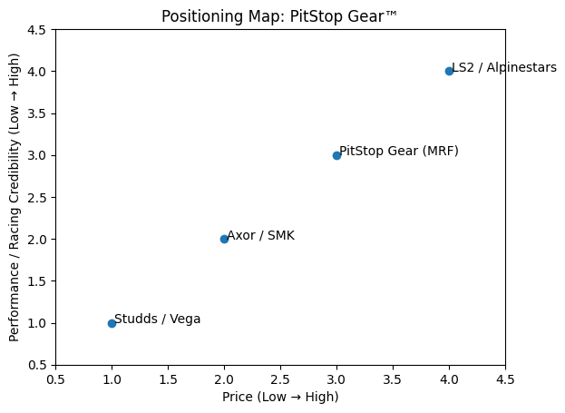
Fig 1: Positioning Map
Source: (Market Watch, 2025)

Element 2: Marketing Mix (4Ps)

Product
Pitstop Gear will provide a carefull chosen selection of automobile lifestyle products made with premium components and ergonomic design concepts. To meet MRF’s technical standards, every product will go through safety and durability testing. Consumer trust and long-term brand equity are strengthened by this product strategy, which is consistent with the brand’s promise of dependability and performance (Aaker, 1991). In markets where quality assurance is a major motivator for purchases, functional differentiation through product design is especially successful (Kotler et al., 2024).Pitstop Gear main product is their sos helmet can be the game changing in the Indian market in terms of safety. It also have in built gps so emergency services can help any riders in case of any accidents.

Way the Product Aligns with and Supports Customer Trends
Pitstop Gear’s product strategy is in line with changing consumer preferences that prioritize performance, safety and lifestyle integration. A transition from simply functional purchases to experience-driven purchasing is seen in the growing desire from modern cyclists for equipment that combines racing-grade safety with every day comfort and aesthetics appeal (Deloitte,2024). In response to this trend, Pitstop Gear offers performance-tested, ergonomically built devices that draw inspiration from motorsport technology while yet being appropriate for long-distance and daily travelling. Additionally, customers are becoming more concerned of quality and credibility as a result of increased digital awareness, favoring brands that exhibit technical proficiency and transparency (Kotler et al., 2024). The product approach enhances brand relevance and long-term customer engagement by meeting customer expectations for durability, safety, and trust by utilizing MRF’s engineering expertise and motorsport credentials.

Price
Pitstop Gear will use an affordable premium price strategy that strikes a balance between high perceived performance value and accessibility. The brand will be priced below international luxury racing names like Alpinestars, but above mass-market helmet and equipment brands like Studds and Vega. Without imposing unaffordable price limits, the pricing strategy reflects the brand’s posture as a high-performance, motorsport inspired offering supported by MRF’s engineering credibility. All product categories will have tiered pricing, with premium versions aimed at performance-oriented customers and entry-leval SKUs encouraging trial among first-time purchasers. Value-based pricing, which is especially successful in emerging areas where customers are looking for the best performance to price ratios, promotes broader market penetration while strengthening quality perceptions (Kotler etal., 2024; Keller, 2013).

Way it Aligns with and Supports the Overall Brand Strategy
Pitstop Gear positioning as a premium accessible, performance-driven automobile lifestyle brand is strengthened by the price strategy, which directly supports the company’s brand strategy. Pitstop Gear enhances its value propositions of great performance without exclusivity by providing motorsport-inspired quality at a more affordable price than international racing brands. This strategy makes use of MRF’s solid technical reputation to foster trust and expand market penetration among performance-conscious riders and urban millennials. Long-term brand adoption is also facilitated by tiered pricing, which promotes both trial and repeat purchases. In order to maintain brand equity and set Pitstop Gear apart from low-cost competitors in the automotive gear market, consistent price value alignment improves perceived fairness and credibility (Aaker, 1991; Kotler et al., 2024).

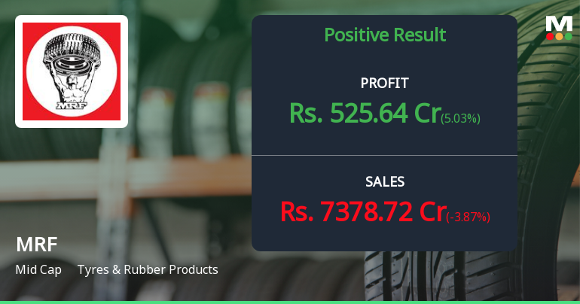
Fig 2: Financial Performance
Source: (MRF, 2025)

Place
Pitstop Gear’s location strategy aims to maximize accessibility while bolstering the brand’s performance-oriented stance. Pitstop Gear team will be marketed through authorized MRF tire dealership, which serve as reliable consumer touchpoints throughout urban and semi-urban regions, by utilizing MRF’s vast nationwide distribution network (MRF Limited, 2024). This guarantees visibility when making decisions about motorbike maintenance and upgrades. To bolster it’s racing reputation and fan appeal, the brand will also be accessible through high-end multi-brand automotive accessories outlets and motorsport-focused boutiques (Kotler et al., 2024.) This strategy is further supported by an omnichannel approach, which aligns with the growing inclination for digital purchasing ease by making products available through MRF’s own website and key e-commerce platforms (Deloitte, 2024). Brand authenticity is strengthened and riding community participation is increased by strategic placement at racetracks, riding academies, and motorcycle events (Kapferer, 2023). Consistency, reach, and strong alignment with Pitstop Gear’s overall brand positioning are guaranteed by this integrated distribution strategy.

Way it aligns with and supports the overall brand strategy
Pitstop Gear’s stance as performance driven yet approachable riding gear brand is reinforced by the location strategy, which directly complements the company’s entire brand strategy. By utilizing current consumer trust in MRF’s engineering prowess and motorsport legacy, distribution through authorized MRF tire retailers enhances brand credibility (MRF Limited, 2024). For safety focused products like riding gear, this controlled distribution guarantees consistent brand presentation and quality assurance (Kapferer, 2023). The brand’s association with high-performance riding culture is further strengthened by the addition of upscale bike accessory stores and motorsport venues, which increases the brand’s perceived racing credibility among enthusiasts (Kotler et al., 2024). Furthermore, by combining physical and digital touchpoints, the omnichannel distribution strategy helps MRF achieve its long-term strategic goal of growing its consumer-facing lifestyle portfolio (Deloitte, 2024). When taken as a whole, this distribution strategy enhances accessibility, builds brand equality, and gives Pitstop Gear a long-term competitive edge in the motorcycle lifestyle market.
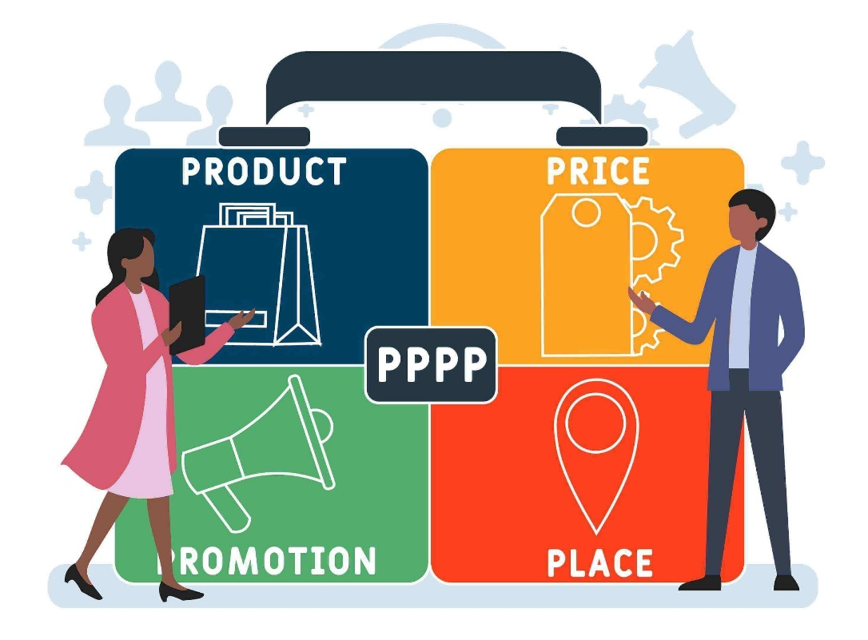
Fig 3: 4Ps of Marketing
Source: (Seoptimer, 2019)

Promotion
To appeal to India’s expanding motorcycle enthusiast market, Pitstop Gear’s marketing strategy places a strong emphasis on performance credibility, safety knowledge, and brand authenticity. Digital marketing will be crucial, with focuses ads on google, youtube, and Instagram emphasizing product performance, longevity, and safety features that mirror the media consumptions patterns of younger riders (Deloitte, 2024). In line with customer confidence in professional endorsements, partnerships with professional racers, riding instructors, and motorcycle influencers will strengthen the brand’s motorsport credibility and technical proficiency (Kotler et al., 2024). Customers will be able to engage with the items directly through on-site activations such racetrack events, rider training programs, and demo zones at motorcycle expos (Kapferer, 2023). Sales campaigns will promote trial and cross category purchases, such as bundled discounts with MRF tires and limited-edition racing apparel. Overall, Pitstop Gear’s stance as a high-performance yet approachable riding gear brand is supported by the promotional mix, which also increases brand memory.
Way it aligns with and supports the overall brand strategy
Pitstop Gear’s fundamental positioning around performance, safety, and motorsport credibility is reinforced by the promotion approach, which provides strong support for the company’s overall brand strategy. The company uses expert-led communication to establish confidence and authenticity, which is crucial for safety-critical products, by giving priority to influencer collaborations with professional racers and licensed riding instructors (Kotler et al., 2024). MRF’s goal of attracting younger, urban bikers who mostly rely on online platforms for peer validation and product research is in line with digital first promotion (Deloitte, 2024). The brand is further linked to MRF’s racing history through experiential marketing like racetrack activations and rider training programs, which strengthen emotional brand connections and perceived expertise (Kapferer, 2023). Cross promotional efforts that combine Pitstop Gear with MRF tires also boost customer lifetime value and promote portfolio synergy. When taken as a whole, this integrated promotional strategy increases market Credibility, builds brand equity, and helps Pitstop Gear become a reputable performance riding gear brand in India’s two wheeler ecosystem.

Element 3: Marketing Strategy Pitch
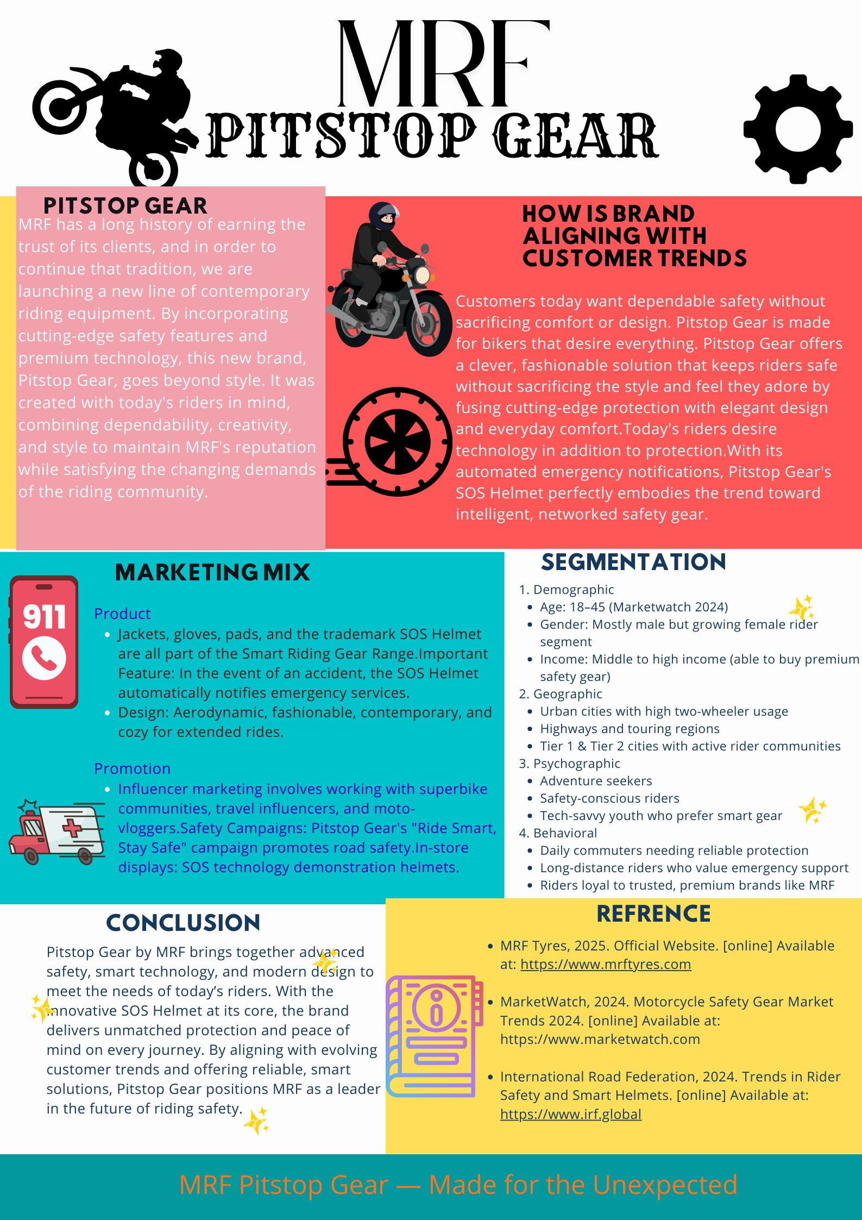

Element 4: Reflection
Reflection
The creation of the Pitstop Gear brand concept offered insightful information about the application of theoretical marketing frameworks to practical strategis choices. The STDP research research reaffirmed how crucial it is to match positioning and segmentation to measurable consumer trends rather than conjecture (Kotler at al., 2024). The interconnectedness of product design, pricing strategy, and distribution choices in attaining brand coherence was brought to light during the marketing mix design process (Keller, 2013).
My analytical and communication skills were also improved by the process, especially when it came to combining market data into a compelling strategic narrative. My capacity to explain complicated ideas to a variety of stakeholders was improved by preparing the marketing pitch (Malar et al., 2011). Financial forecasting and primary research would improve decision-making and commercial reasoning in subsequent initiatives (Deloitte, 2024).
Key skills and insights
Strategic analysis, namely the capacity to combine marketing theory with actual industry facts, was one of the most important abilities acquired through this initiative. Using frameworks for segmentation, targeting, and positioning improved my comprehension of how companies may stand out in cutthroat sectors like the motorcycle accessories sector (Kotler et al., 2024). My analytical and decision-making abilities were also enhanced by examining consumer trends and incorporating them into a cohesive marketing mix. In order to support strategic recommendations, the project also improved my research skills by requiring me to evaluate secondary sources such academic literature, market reports, and business financial data. Additionally, creating a unified brand strategy for Pitstop Gear enhances my capacity to match overall brand goals with decisions about product, pricing, distribution, and promotions. Ultimately, the approach improved my professional communication abilities, especially when it came to clearly, methodically, and academically rigorously presenting difficult strategic insights that were appropriate for stakeholders and academic evaluation.
Way I could enhance the approach and performance
MRF marketing research has yielded insightful information about customer behaviour, brand positioning, and marketing tactics in the automptive industry. Through persistent bbranding, sponsorship, and endorsements, MRF, a well-known tire manufacture, has effectively capitalized on brand equality, quality perception, and emotional response with its audience (Kotler, 2016). Pitstop Gear, a motorcycle riding gear company that sells jackets, helmets, and gloves, might gain practical insights by considering these tactics. One important finding is MRF’s focus on dependability and trust, which has fostered great brand loyalty over many years (Aaker, 2014). This emphasizes how crucial it is for Pitstop Gear to establish credibility with motorcycle riders, with a focus on comfort, durability, and safety in product marketing. This view could be strengthened by utilizing influencer partnership, safety certificates, and client endorsements. Segmentation and targeted marketing are further factors. Based on vehicle type, usage frequency, and performance expectations, MRF creates discrete consumer segments (Kotler et al., 2019). Pitstop Gear can take a similar strategy by dividing the market based on the type of rider-commuters, adventure riders, or racers-and customizing product features and promotions to cater to certain demands.

References
Aaker, D.A., 1991. Managing Brand Equity: Capitalizing on the Value of a Brand Name. New York: Free Press.
Aaker, D.A. and Keller, K.L., 1990. Consumer evaluations of brand extensions. Journal of Marketing, 54(1), pp.27–41.
Belk, R.W., 1988. Extended self in consumer behavior. Journal of Consumer Research, 15(2), pp.139–168.
Deloitte, 2024. Global Automotive Consumer Study: India Insights. London: Deloitte Touche Tohmatsu Limited.
Hollebeek, L.D. and Macky, K., 2019. Digital content marketing’s role in fostering consumer engagement. Journal of Interactive Marketing, 45, pp.27–41.
IBEF, 2024. Indian Automotive Industry Analysis. India Brand Equity Foundation. Available at: https://www.ibef.org (Accessed: 10 April 2025).
Kapferer, J.N., 2012. The New Strategic Brand Management. 5th ed. London: Kogan Page.
Keller, K.L., 2013. Strategic Brand Management. 4th ed. Harlow: Pearson Education.
Kotler, P., Keller, K.L., Chernev, A. and Armstrong, G., 2024. Marketing Management. 16th ed. Harlow: Pearson Education.
Malär, L., Krohmer, H., Hoyer, W.D. and Nyffenegger, B., 2011. Emotional brand attachment: how emotionality drives brand loyalty. Journal of Marketing, 75(4), pp.35–52.
MRF Limited, 2024. Annual Report 2023–24. Chennai: MRF Ltd. Available at: https://www.mrftyres.com (Accessed: 15 April 2025).
Pappu, R. and Quester, P., 2016. How does brand innovativeness affect brand loyalty? European Journal of Marketing, 50(1/2), pp.2–28.
Solomon, M.R., 2020. Consumer Behavior: Buying, Having, and Being. 13th ed. Harlow: Pearson Education.

