

Psychology in Health and Social Care
LCHS4010
Component 2: Written task – report

Student name: Ludia Silva
Student ID: 2429368
Lecturer: Bianca Sanfilippo

Table of contents

1 Introduction
2 Overview of Psychological Theories
2.1 Bowlby’s Attachment Theory
2.2 Vygotsky’s Sociocultural Theory
Application in the Dementia Care Context
3.1 Applying Bowlby’s Theory
3.2 Applying Vygotsky’s Theory
3.3 Challenges and Strategies
4 Conclusion
5 References

Applying Psychological Theories to Support Older Adults with Dementia in a Care Home Setting

1. Introduction

Adults aged 65 and over who live in dementia care homes often experience complex psychological health conditions such as anxiety, depression, confusion, and difficulties coping with memory loss. Dementia impacts cognitive functioning, behaviour, emotional regulation, and social interaction, making evidence‑based psychological understanding essential for high‑quality care. This report provides guidance for health and social care professionals on how psychological theories can inform effective support strategies. It focuses on John Bowlby’s Attachment Theory and Lev Vygotsky’s Sociocultural Theory, demonstrating how both frameworks can enhance care practices for older adults living with dementia.

2. Overview of Psychological Theories

2.1 Bowlby’s Attachment Theory
John Bowlby (1969). Emphasises the human need for security, emotional connection, and stable relationships. Although originally developed to explain infant–caregiver bonds, Bowlby argued that attachment needs continue across the lifespan. In older adults, particularly those experiencing dementia, attachment behaviours may become more pronounced due to cognitive decline, vulnerability, and the loss of familiar environments or relationships. Feelings of insecurity may lead to increased dependency, distress, or agitation when routines change or when familiar caregivers are absent.
Although Bowlby’s work primarily addressed attachment in early childhood, subsequent research has established that attachment dynamics persist throughout adulthood and into later life (Ainsworth, 1989; Magai & Cohen, 1998). In older adults—especially those experiencing increasing frailty or cognitive impairment—attachment needs may re-emerge as reliance on caregivers grows. Dementia can further intensify these processes; the associated confusion, anxiety, and disorientation often lead to behaviours such as seeking reassurance, clinging, or social withdrawal, which mirror early attachment responses (Perrenet al., 2015).

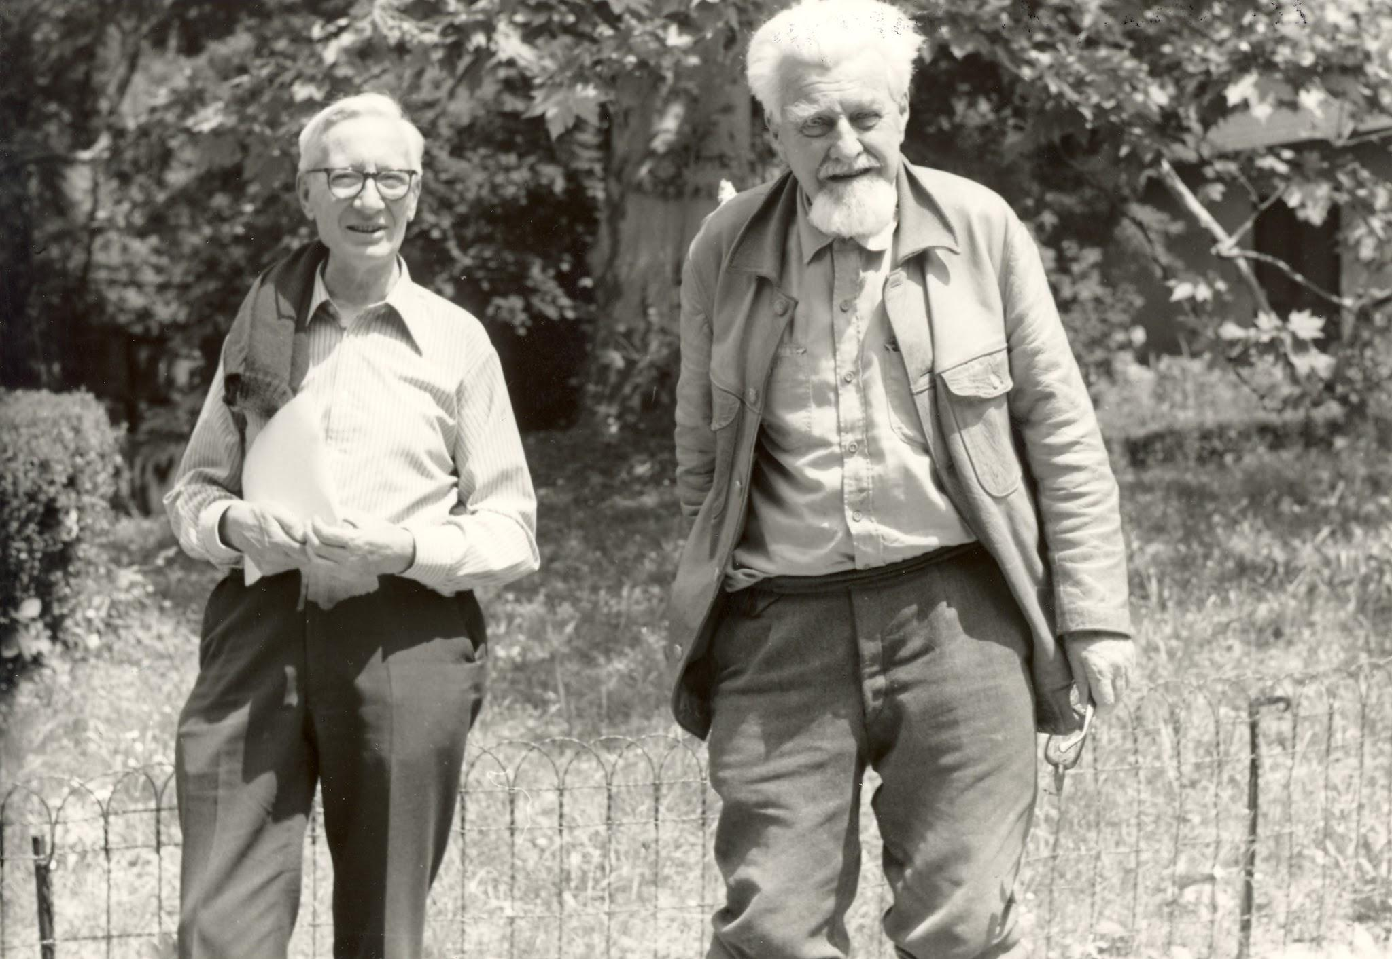

Attachment theory offers a useful framework for understanding why stable, emotionally responsive caregiving promotes reassurance and cooperation among individuals living with dementia. In contrast, sudden alterations in routine or unfamiliar staff can heighten feelings of anxiety and lead to distressed behaviour. In later life, secure attachment relationships continue to function as a “safe base,” enabling individuals to interact more confidently with their surroundings (Bowlby, 1988). In the context of dementia care, this principle underscores the importance of establishing predictable, trusting caregiver–resident relationships that help mitigate the insecurity and disorientation associated with memory loss.

2.2 Application in the Health and Social Care Context

2.3 Applying Bowlby’s Attachment Theory in Dementia Care
Bowlby’s theory highlights the importance of secure relationships, which are vital for older adults experiencing confusion or anxiety. In dementia care homes, residents may show attachment-related behaviours such as calling for family, following staff members, or displaying distress during transitions.

2.4 Creating a Sense of Security and Trust
Consistent, reliable, and emotionally attuned caregiving fosters a secure base for residents with dementia. When care staff respond with warmth, predictability, and patience, residents are more likely to experience reduced stress, improved cooperation, and greater emotional stability. Maintaining familiar routines, minimising abrupt changes, and providing continuity of staff strengthen feelings of safety and reduce confusion.

2.5 Practical Examples

Consistent staffing: Assigning key workers so residents regularly interact with the same caregivers, promoting familiarity and trust.

Stable routines: Implementing predictable daily schedules for meals, activities, and personal care to reduce anxiety and disorientation.

Providing additional reassurance during potentially distressing moments, such as room changes, medical appointments, Reassurance and emotional presence: Using calm communication, gentle tone, and appropriate physical reassurance (e.g., handholding if welcomed) to support emotional regulation.

Personalised care: Incorporating residents’ life histories, preferences, and familiar objects into their environment to reinforce comfort and identity.

Support during transitions: or unfamiliar situations.

2.6 Challenges.
Applying Bowlby’s attachment principles in dementia care homes can be difficult due to high staff turnover, limited time and resources, and inconsistent training. Residents’ fluctuating cognitive abilities and behavioural symptoms may also make relationship-building challenging. Additionally, busy or unpredictable care home environments can reduce the sense of safety needed to form secure, trusting attachments (Koren et al., 2021).

3. Vygotsky’s Sociocultural Theory

Vygotsky’s Sociocultural Theory emphasises that learning and development are shaped through social interaction, cultural practices, and supportive guidance from more knowledgeable individuals. Central concepts such as the Zone of Proximal Development (ZPD) and scaffolding highlight the importance of collaborative support that enables individuals to carry out tasks they cannot manage alone.(Newman & Newman, 2020).

3.1 Applying Vygotsky’s Theory in Dementia Care Homes

Within dementia care settings, Vygotsky’s principles can be adapted to support residents’ cognitive, social, and emotional functioning. Providing structured guidance, meaningful social engagement, and culturally familiar activities allows residents to participate to the best of their abilities. Caregivers act as the “more knowledgeable other,” offering tailored assistance that helps residents maintain independence, identity, and confidence for as long as possible.

This approach encourages the use of supportive interactions, shared tasks, and personalised communication strategies to promote cognitive engagement and preserve remaining abilities.

3.2 Practical Examples

Guided daily tasks: Staff offer step-by-step cues during activities such as dressing or eating, enabling residents to complete parts of the task independently.

Meaningful social interaction: Small group discussions, music sessions, or reminiscence therapy provide opportunities for supported communication and cognitive engagement.

Scaffolded activities: Caregivers break tasks into manageable stages, offering prompts or demonstrations when needed and gradually reducing support as residents gain confidence.

Use of cultural and personal history: Incorporating familiar objects, songs, languages, and routines helps strengthen memory and stimulates engagement through culturally meaningful experiences.

Collaborative problem-solving: Staff and residents work together on simple activities—such as puzzles, gardening, or arts and crafts—promoting shared participation and reducing frustration.

3.3 Challenges

Applying Vygotsky’s Sociocultural Theory in dementia care homes is challenging due to residents’ declining and fluctuating cognitive abilities, which can limit their responsiveness to guided support. Staff shortages and limited time reduce opportunities for personalised engagement, while insufficient training may hinder effective use of scaffolding techniques. Additionally, overstimulating or distracting

4. Conclusion

In the end, understanding theories like Bowlby’s and Vygotsky’s really helps make sense of what older adults with dementia are going through and how we can support them better. These ideas remind us that people still need connection, reassurance, and meaningful interaction, no matter their age or diagnosis. By using these approaches in care homes, staff can create warmer, safer environments where residents feel understood and valued. It shows that even small changes in how we communicate and support someone can make a big difference in their daily life and wellbeing.

5. References
- Vygotsky, L.S. (1978) Mind in Society: The Development of Higher Psychological Processes. Cambridge, MA: Harvard University Press.
- Vygotsky, L.S. (1986) Thought and Language. Cambridge, MA: MIT Press.
- Daniels, H. (2001) Vygotsky and Pedagogy. London: Routledge.
- Wertsch, J.V. (1991) Voices of the Mind: A Sociocultural Approach to Mediated Action. Cambridge, MA: Harvard University Press.
- Bowlby, J. (1988). A Secure Base: Parent-Child Attachment and Healthy Human Development. Routledge.
- Ingersoll-Dayton, B., & Saengtienchai, C. (2019). Attachment in older adulthood. Gerontology, 65(6), 635–644. . Routledge.
- Sabat, S. (2020). Alzheimer’s Disease and Dementia: A Practical Guide for Caregivers. Oxford University Press.

