

Programme: MSc Data and Artificial Intelligence

Module : ACCA7025- L7 – Application of Machine Learning

Student Name: Shivam Sanjivkumar Patel

Student ID: 2435900

Submission Date: 14th November 2025
Index
Abstract: 3
1) Introduction 4
I Background of Neural Networks 4
II Importance of Image Classification 4
III Overview of CIFAR-10 Dataset 4
IV Aim and Objectives of the Study 4
2) Related work 5
I Concept of Artificial Neural Networks 5
II Recurrent Neural Networks and Their Use Cases 5
III Convolutional Neural Networks and Their Use Cases 5
IV Previous Studies Using CIFAR-10 Dataset 5
V Techniques for Neural Network Performance Improvement 6
3) Workflow Methodology 7
I Dataset Description 7
II Data Pre-processing 7
III Data Normalization 8
IV Train-Test Split 8
V Model Implementation 9
a) Artificial Neural Network (ANN) Structure 9
b) Recurrent Neural Network (RNN) Structure 9
c) Convolutional Neural Network (CNN) Structure 10
d) Improved CNN Structure 10
e) Model Training Procedure 11
f) Evaluation Metrics (Accuracy, Precision, Recall, F1 Score) 11
VI Model Training Procedure 11
VII Evaluation Metrics (Accuracy, Precision, Recall, F1 Score) 11
4) Discussion and Recommendation 12
5) Conclusion 17
References 18

Abstract:

The performed study is devoted to the images of the CIFAR-10 dataset being sorted out with the assistance of different models of the neural network. It implements four models, including Artificial Neural Network (ANN), Recurrent Neural Network (RNN), Convolutional Neural Network (CNN), and a superior CNN model. The dataset will consist of 60,000 color images of ten categories of objects, and the dataset will also be trained and tested on each of the models. The ANN and RNN are 58.81 and 39.10, respectively, and such accuracy was limited due to the loss of spatial information. The normal CNN has 71.90% accuracy, which is significantly improved with the acquisition of spatial features. The improved CNN is most accurate with the highest accuracy being 80.3,3 and this indicates that the more the number of convolution and regularization layers, the better the feature extraction and generalization. CNN-based models have been found to be more applicable to the classification of images.

Introduction

Background of Neural Networks

The neural networks are understood to be computing systems that are modeled after the human brain system. These are the mechanisms that are constructed out of connected processing boxes, which detect patterns of data. NNs have also been helpful in any activity that involves prediction, classification, and decisions. They have the capability of learning latent relationships and can be used to perform sensitive data processing.

Importance of Image Classification

Image classification is also coming to be known as an important computer vision task. It is being applied in face recognition, medical diagnosis, self-driving, and security applications. Correct image classification helps computers to identify objects and also helps in automating decision-making mechanisms. Therefore, it is a requirement of plausible models to process visual information.

Overview of CIFAR-10 Dataset

The CIFAR-10 data, consisting of 60,000 color images in ten categories of objects, is one of them. All the images are small and contain a single object. The dataset is currently being used extensively on image classification models analysis as it is heterogeneous and even numbered.

Aim and Objectives of the Study

This paper is aimed at becoming focused on and working with the creation of different models of neural networks and comparing them through image classification. The most important objective is centered on the comparison of ANN, RNN, CNN, and improved CNN with the aim of determining the superior model as far as the classification of CIFAR-10 is concerned.

Related work

Concept of Artificial Neural Networks

An Artificial Neural Network (ANN) is being viewed as a computational model that is inspired by the human brain. It is composed of mutually related units called neurons and input information, which process and activate the output. ANN trains its patterns through the modification of inner weights [1]. It is mostly used in pattern recognition, prediction, and classification. The number of layers, activation, and learning environments are most commonly used to determine the work of an ANN. However, ANN is eliminated in the inference of the classification of images because of the loss of form of an image when flattening the data. It leads to the loss of accuracy, unlike image-specific networks.

Recurrent Neural Networks and Their Use Cases

A Recurrent Neural Network (RNN) is one such model of a neural network that is currently being developed to handle sequential inputs. The result of one step serves as an input in the next stage of this network. The feedback also allows the model to capture the trend that is founded on available data in order. As a result of this purpose, RNN is to a great extent finding use in natural language processing, speech recognition, as well as time-sensitive, order-sensitive, and contextually driven forecasting [2]. RNN can be used in text generation, sentiment analysis, as well as translations. However, in the case of image classification via the RNN, it is found to be performing poorly because, in image classification, no orderly structure exists, but it is spatial data. Even though a higher-order RNN can be used, like LSTM or GRU, an RNN cannot be used with images in place of a CNN.

Convolutional Neural Networks and Their Use Cases

A convolutional neural network (CNN) represents a specialized neural network that is normally applied in image-processing tasks. To maintain the spatial arrangement in the pictorials, CNN relies on filters to move in blocks of pixels to detect the important spots of images, such as edges, shapes, and textures. Pollution of the reduction of the data size while preserving some significant patterns is being utilized through the application of pooling layers [3]. CNN obtains visual information in a hierarchical manner; that is, simple information is obtained initially, then followed by the acquisition of more complex information. It is not a reality where much of the feature handpicking is done, as the features are obtained implicitly. CNN is applicable to the CIFAR-10 and can be more accurate in comparison with ANN and RNN.

Previous Studies Using CIFAR-10 Dataset

The popular benchmark is the CIFAR-10 dataset to compare the deep learning models. Many researchers use this dataset to test a variety of architectures and analyses them. According to the available literature, ANN models, because of the image flattening process, are less precise due to the harm of the process on the spatial details. Among other things, research can establish that RNN models are marginally more efficient but limited because sequence processing does not suit pictorial information [4]. Most of the research indicates that CNN models acquire relatively better accuracy because convolution functions apply the important spatial properties. There were also models with additional layers, data augmentation, batch normalization, and dropout by the authors of the study. The techniques enhance the generalization of the models and curb overfitting. The general findings of the studies, consequently, show that CNN is the most suitable architecture to implement in the image classification of CIFAR-10.

Techniques for Neural Network Performance Improvement

Various performance improvement techniques are being implemented to improve performance. The augmentation of data will improve the diversity of the data and prevent overfitting. The batches become normal to stabilize the training process and improve convergence. Defects by dropout of neurons make the dependency less needy, and make the model stronger [5]. The learning rate is timed in such a way that the learning rate does not experience erratic learning updates. Gradient updates are aided with the help of such optimizers as Adam. In CNN, additional layers, pooling, and averaging are global pooling to improve the generalization of models. More critical and plotting models are a result of a union of such methods.

Workflow Methodology

Dataset Description
- Dataset Description

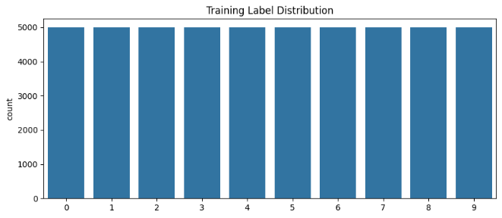

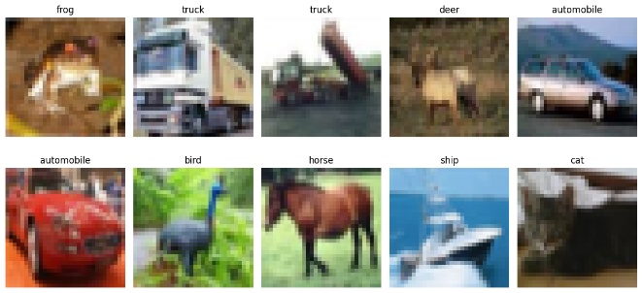

Figure 1: Data Description and Sample Images
The CIFAR-10 dataset is applied in the present study. The 60,000 colored images in 32x322 pixels are used as the sample size. These images are divided into ten classes of objects, which include airplane, automobile, bird, cat, deer, dog, frog, horse, ship, and truck. Among the total number of images, 50K images will be trained and 10K will be tested. The images are categorized under one category, and each category is balanced. This dataset has been selected, as it is one of the general ones that are closely related to machine learning research and can be fairly compared to other models.

Data Pre-processing

There are some pre-processes that are being made prior to the feeding of the data to the models. The images are undergoing conversion into floating-point representation to calculate them. Data augmentation is being done in such a way that data variability is increased. It can zoom, flip horizontally, shift, and rotate, which are augmentations [8]. This will lead to an improvement in sample training and reduced overfitting. The labels are being converted into integer or one-hot format based on the needs of the model.

Data Normalization

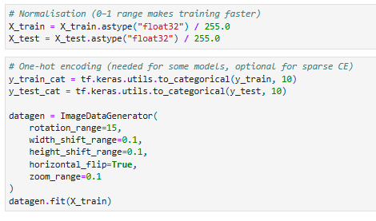

Figure 2: Data pre-processing and normalization
Normalization is being used to perform scaling of pixel values. The pixel values start off with a range of 0 to 255. In order to make the calculations more efficient, it is dividing the values by 255 in a way that the highest possible ranges are 0-1. This is because it is required to make the training process more stable and faster, as large gradients that may arise during the backpropagation of normalized values are not realized.

Train-Test Split
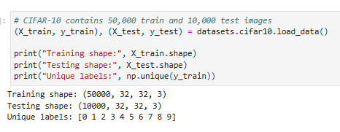

Figure 3: Train test split

The split of the train is already configured and has already set up 50,000 images, which are kept and used as training, and 10,000, which are utilized as testing. The training data is being employed to train each of the models, and the testing data is employed to test their final performance.

Model Implementation

Artificial Neural Network (ANN) Structure
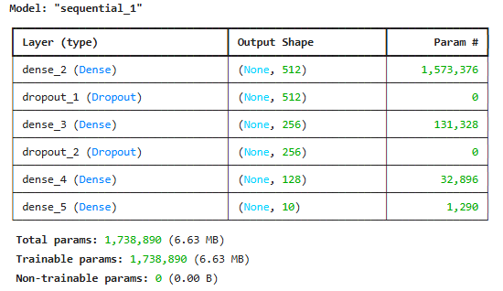

Figure 4: ANN Model Summary
The ANN model is designed through flattening of the image to form a one-dimensional image. Dense layers are learning features and having activation functions. Dropout layers are added by adding dead weight layers. No storage of memory of spatial information of images is, however, being done in this model.

Recurrent Neural Network (RNN) Structure

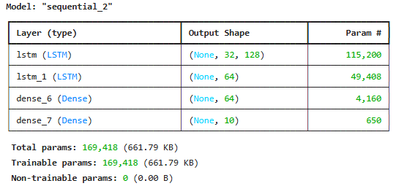

Figure 5: RNN Model Summary
It is transforming all images into a sequence constituting the RNN model. LMST layers are being used to learn sequential patterns. At the output stage, dense layers are being taken on the output stage. A model that follows relationships between the pixels in a chain, but does not give the overall spatial structure of the image, follows.

Convolutional Neural Network (CNN) Structure
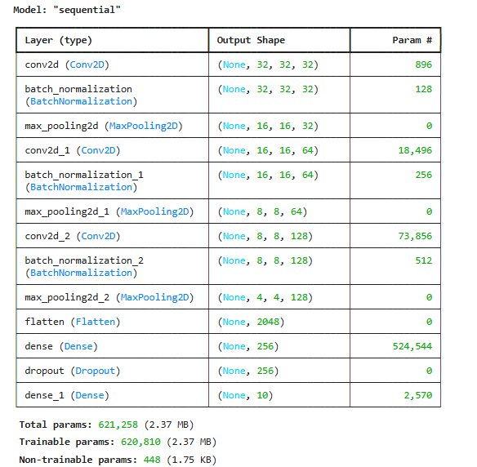

Figure 6: CNN Model Summary
At the same time, the CNN model has been developed through the implementation of the convolutional and the pooling layers. Image characteristics are discovered by convolution layers and reduced in complexity by the pooling layers. The process of training stabilization is achieved through the assistance of batch normalization. The structure is followed by a dense and softmax output layer.

Improved CNN Structure

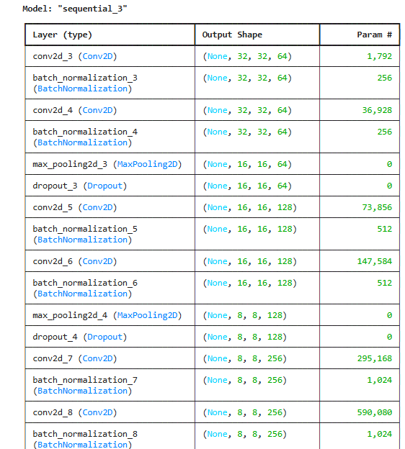

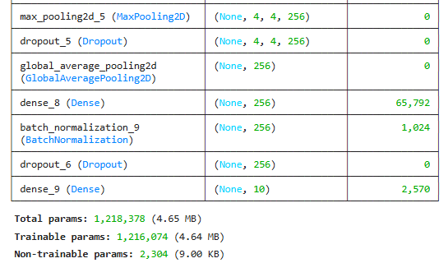

The improved CNN adds a few additional convolutional layers, batch normalization in individual layers, dropout, and global average pooling regularization as some of the measures to ensure reduced overfitting. The structure in this way helps the model to obtain more abstract and high-level properties.

Model Training Procedure

Each of the models is undergoing training with the training dataset. Adam optimizer is being used to accomplish efficient gradient updates. The training process involves an input in the form of batches being applied to the training process over a specified number of epochs. Validation is performed after each epoch so as to monitor the learning progress.

Evaluation Metrics (Accuracy, Precision, Recall, F1 Score)

Measures to determine the performance of models are in the form of accuracy, precision, recall, and F1-score. The accuracy is the measure of the overall accuracy. On positive predictions, precision is correct. The model is regarded as recovering the ability to recognize real positives through recall. F1-score provides a relative measure of the accuracy and recall.

Model Training Procedure

Each of the models is undergoing training with the training dataset. Adam optimizer is being used to accomplish efficient gradient updates. The training process involves an input in the form of batches being applied to the training process over a specified number of epochs. Validation is performed after each epoch so as to monitor the learning progress.

Evaluation Metrics (Accuracy, Precision, Recall, F1 Score)

Measures to determine the performance of models are in the form of accuracy, precision, recall, and F1-score. The accuracy is the measure of the overall accuracy. On positive predictions, precision is correct. The model is regarded as recovering the ability to recognize real positives through recall. F1-score provides a relative measure of the accuracy and recall.

Discussion and Recommendation

ANN Model Performance

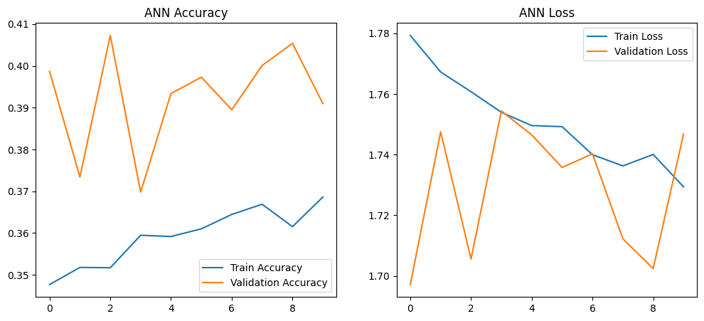
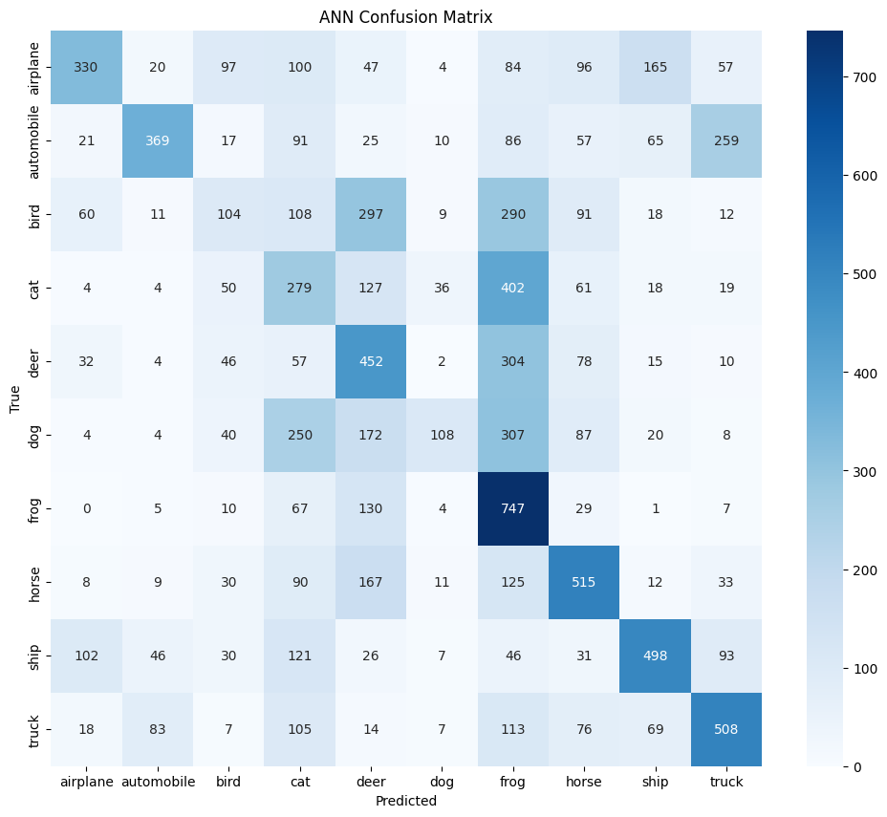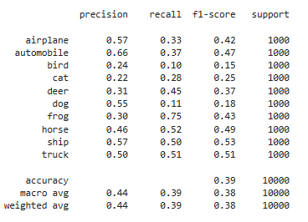

Figure 8: ANN Model Performance
An Artificial Neural Network (ANN) model, in which flattened pixels serve as input, and dense layers serve as the output, is being trained on the scheme of CIFAR-10. The ANN model has a general accuracy of 39.10% on the test data. This statistical value illustrates a poor category of image identification. The model cannot support the spatial patterns as the picture is undergoing a process of transformation into a one-dimensional vector, before the training. This results in the failure to learn vital visual facts. Class-based on the results, there is low recognition with respect to cat, dog, and bird classes, and in such cases, there are different shapes and textures associated with the shapes.

RNN Model Performance

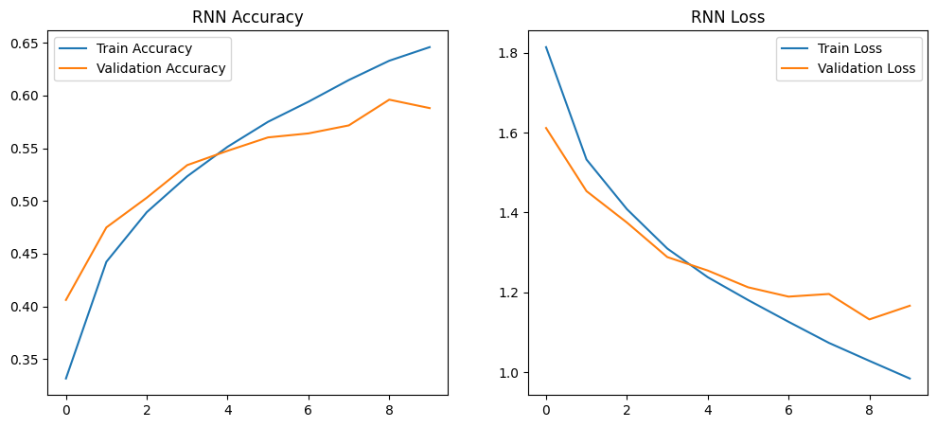
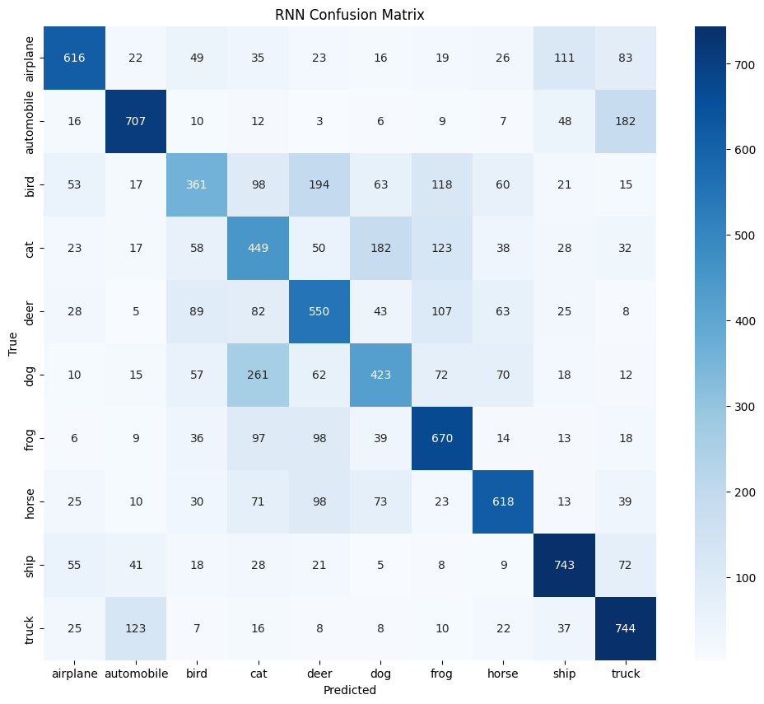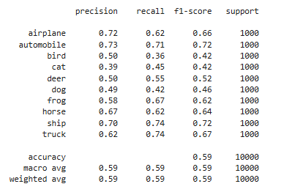
Figure 9: RNN Model Performance
The Recurrent Network (RNN) model is being trained on the utilization of sequence-based image representation. The desirability of the model is 58.81, which is, although greater than ANN, low. The sequential processing will enable the RNN to acquire certain pixel-to-pixel correlations, although the two-dimensional spatial one is not specifically spared. In classes like airplane and automobile, where there is an obvious differentiation of one item over another, the model proves to be effective, but under similar classes, e.g., cat or dog, the model fails.

CNN Model Performance
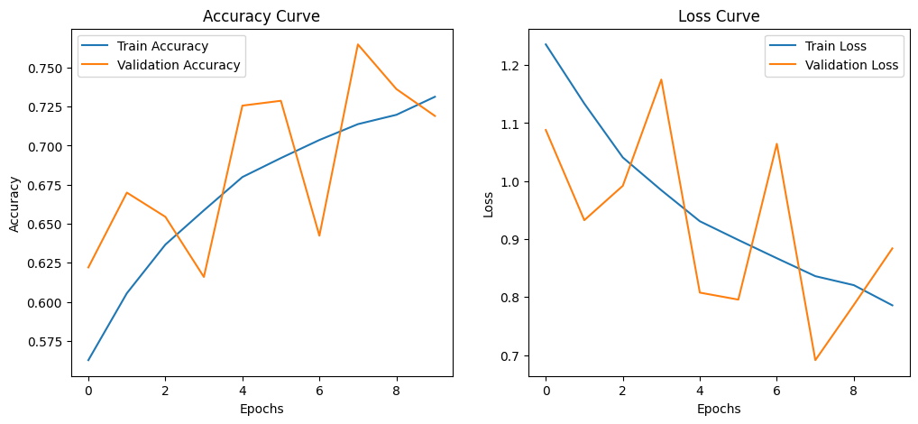
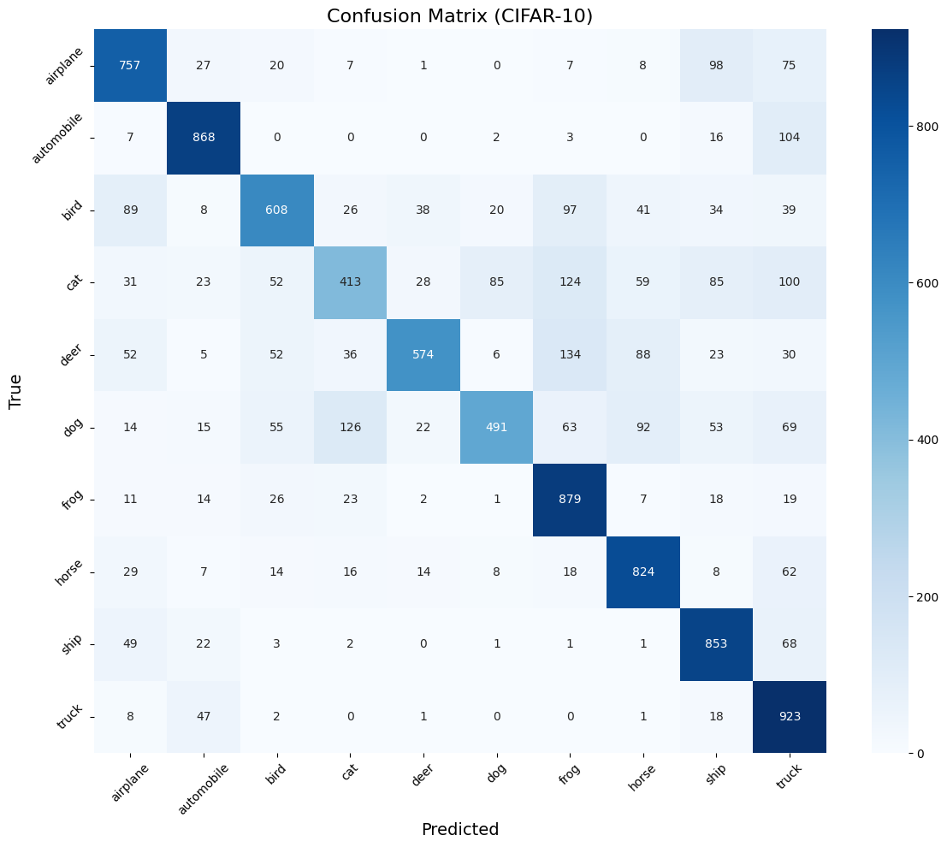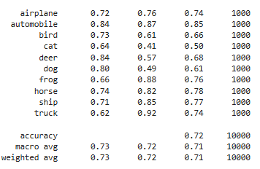
Figure 10: CNN Model Performance
It is 71.90 percent accurate using the Convolutional Neural Network (CNN) model. The convolution layers help in extracting features of the objects in the form of edges, textures, and forms that are significant to the visual representation. Layers engage in pooling so as to get rid of redundant information and get the maximum out of generalization. Most of the classes are balanced both in precision and recall. However, categorization has worked out to be an issue in terms of categories such as cat and dog, whereby there are visual similarities as well as background differences.

Improved CNN Model Performance
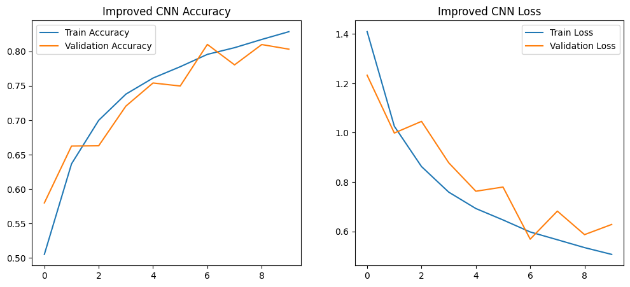
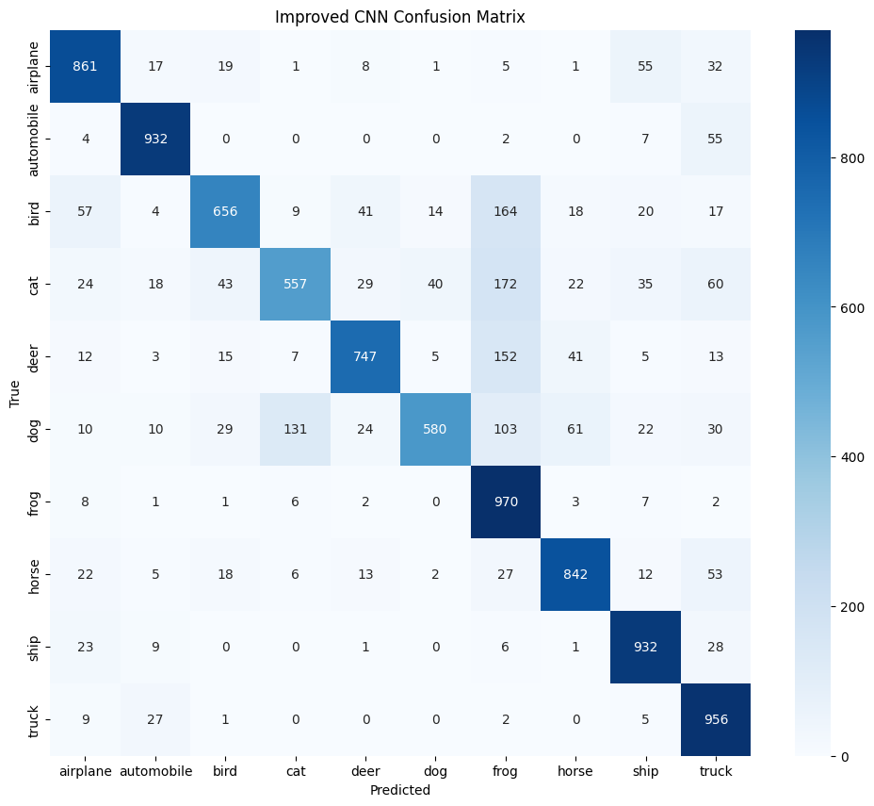
Figure 11: Improved CNN Model Performance
The best accuracy of the enhanced CNN model is 80.33. This model has additional convolution layers, batch normalization layers to ensure consistency in the learning process, and the removal of overfitting by the dropout layers. The global average pooling is being used to eliminate the parameters so that a good representation of features can be defined. This frame would facilitate better visual learning. The improved CNN is very precise and marks a high recall in aspects incorporating airplane, automobile, horse, ship, and truck.

Comparison of Model Accuracies

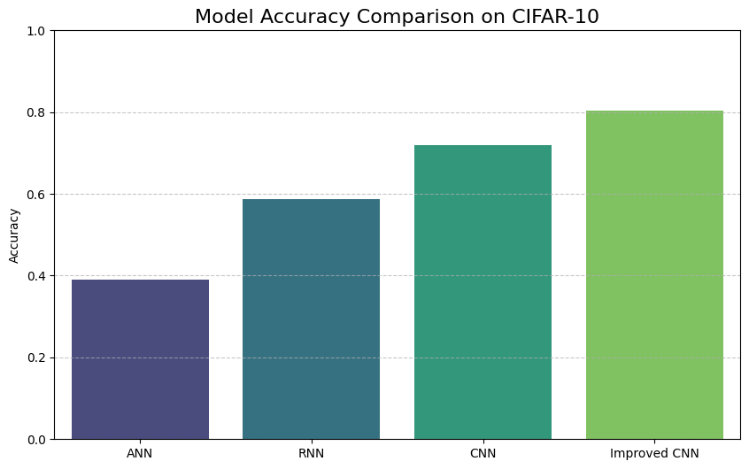

Figure 12: Model Accuracy Comparison on CIFAR-10

The four models have a clear difference in the values of accuracy. The ANN brings out 39.10, the RNN brings out 58.81, the CNN brings out 71.90, and the enhanced CNN brings out 80.33. The trend shows that the models that are to be applied in extracting spatial patterns have better performance. CNN and improved CNN are also more suitable to be used with CIFAR-10, but ANN and RNN are not as likely to work when one has to deal with pictures.

Discussion on Class-wise Performance

According to the performance based on the performance on a case-by-case basis, performance will be more classified by the categories that are strongly shaped, such as airplane, automobile, ship, and truck. More elaborate and overlapping classes (cat, dog, and bird) are less specific and remembered. The improved CNN also reduces this gap, but it cannot close it totally since these scores of the animals are visually close.

Results

Interpretation of ANN Results
ANN provides a model accuracy of 39.10 percent. The value means that the model is not subpar as far as such image data classification is concerned. This is mostly because the ANN fails to retain the spatial image structure. Values that are denoted by the pixels are flattened to a single vector, and hence, the visual shapes and the pattern of objects are not understood.
Interpretation of RNN Results
The RNN model is giving an accuracy of 58.81, which remains a better result devoid of high accuracy. The RNN is actually viewing each image as a sequence, and it is training the association between the positions of pixels. It provides a portion of information, even though in space, there is no spatial correspondence in two dimensions.
Interpretation of CNN Results
The CNN model is 71.90 per cent accurate. Convolutional layers can be used to extract spatial features with the help of the model. The identification of shapes, textures, and edges is being executed in a superior manner compared to ANN and RNN. This results in the classification of the majority of the categories into a better state. Still, the moderate confusion is present in such composites as cat and dog, where the visual borders are not so established.
Interpretation of Improved CNN Results
The best model that is getting the highest accuracy of 80.33 is CNN. The more detailed structure, as well as the additional methods of regularizations, facilitates easier learning of abstract features. The model is in a better position to be able to differentiate classes that are close to the eye and can also cope with the variation in the background and the shape.
Reason for the Improved CNN Superior Performance

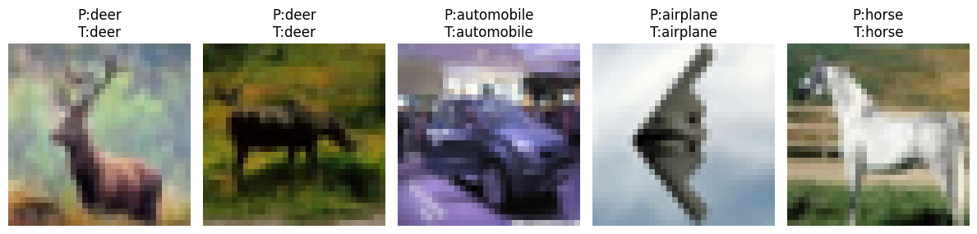
Figure 13: Test the Improved CNN Model on Multiple Images

The successful CNN is better because the dropout and global average pooling guarantee the stability of the training and prevent overfitting. Effectively, multiple convolution layers of different complexities are implemented in order to obtain features of different complexities, which enables greater recognition.
Challenges Observed During Model Training
The sophisticated nature of models requires more computations. It requires more time, memory [6]. Another issue is the threat of overfitting, and, therefore, training conditions must be properly selected.

Recommendation

The comparison of the models shows that the one that is being proposed in image classification is the better version of CNN. The more detailed and abstract visual features could also be learned through this model because of the deeper convolution layers, batch normalization, and dropout. It is also more generalized and consistent during training [5]. In order to perform better in the future, it is being suggested to advance the concept of applying transfer learning to the already trained models, increase training epochs, and emphasize the hyperparameters, i.e., learning rate and batch size. Further data refinement may also be introduced, whereby overfitting and vigor are reduced when dealing with complex or noisy images.

Conclusion

Summary of Work

The four neural network models were used in this work on the use of image classification on the CIFAR-10 databases. ANN, RNN, CNN, and improved CNN are being built and trained under the same conditions on the same dataset. Training and testing are being done to establish how far each of the models can identify the different classes of images.

Key Findings

The ANN model has an accuracy of 39.10, which is not all that impressive when it comes to visual pattern recognition. The RNN model is giving 58.81 and is superior in terms of learning capacity, even though it is still worse in terms of image data. The traditional CNN arrangement obtains 71.90, whereby there is a high enhancement as a result of spatial features extraction. The CNN model has been giving the highest witness of 80.33, which means that an improved convolution layer, dropout, and batch normalization are helpful to improve the learning.

Recommendations for Future Work

Among the suggestions to better the work in the future is to further investigate the architectures, run more training epochs, and train a network as a source of transfer learning [7]. More training and the optimization of hyperparameters were suggested as the means of obtaining a better overall accuracy and improving the image model's generalizability to unseen ones.

References

[1] Al Haris, M., Dzeaulfath, M. and Wasono, R., 2024. Principal Component Analysis on Convolutional Neural Network Using Transfer Learning Method for Image Classification of Cifar-10 Dataset. Register: Jurnal Ilmiah Teknologi Sistem Informasi, 10(2), pp.141-150.
[2] Alam, E., 2024. Enhancing Image Classification With Federated Learning: a Comparative Study of VGG16 and Mobilenet on CIFAR-10. Available at SSRN 4813254.
[3] Brown, H. and Al-Farsi, A., 2025. BRIDGING DEEP LEARNING AND ADAPTIVE SYSTEMS: A PERFORMANCE STUDY ON CIFAR-10 IMAGE CLASSIFICATION. International Journal of Intelligent Data and Machine Learning, 2(03), pp.1-7.
[4] Crulis, B., Serres, B., de Runz, C. and Venturini, G., 2024. An experimental comparative study of backpropagation and alternatives for training binary neural networks for image classification. arXiv preprint arXiv:2408.04460.
[5] de Araújo Moura Filho, C.M. and de Sousa, E.T.G., 2025. Training Neural Networks in Cloud Environments: A Methodology and a Comparative Analysis. Journal of Internet Services and Applications, 16(1), pp.287-298.
[6] Ghafouri, S., 2024. Enhancing Image Classification Accuracy Using Convolutional Neural Networks on CIFAR-10 Dataset.
[7] Rizwan, M., Naveed, H. and Zulqarnain, R.M., 2025. Comparative Analysis of Neural Network Architectures for Image Classification. Journal of Intelligent Decision Making and Information Science, 2, pp.456-471.
[8] Yang, X., Yu, S. and Xu, W., 2025. Enhanced Convolutional Neural Networks for Improved Image Classification. arXiv preprint arXiv:2502.00663.

