Critical and Real-Time Application Programming Assignment 1
Jonathan Evans
P151713
15th March 2019

Contents
1. Introduction 5
2. Real-time Systems 6
2.1 Hard Real-time Systems 6
2.2 Soft Real-time Systems 6
2.3 Car Satellite Navigation Example 6
3. Alpha Blending in Assembly 7
4. Washing Machine timing constraints 9
5. Appendices 13

Introduction
This report will consist of an explanation of soft real-time systems and hard real-time systems, an example of an alpha blending program written in Assembly, and the identification of timing constraints of a washing machine system.

Real-time Systems
A real-time system is a computer application that must complete a given process in a timely manner.
These systems are desired in scenarios where the execution of a process hopefully finishes by a given time (also known as deadlines in real-time system terms). The outcomes of such systems could be fatal in terms of safety or in case of non-safety-critical systems, provide a degradation of application performance.
Real-time systems can be categorised as two different types of system, hard real-time systems, and soft real-time systems.

2.1 Hard Real-time Systems
A hard real-time system is a system that must execute processes before a given deadline. This can be a system where a deadline being missed could be a threat to people’s safety (also known as a safety-critical system).
An example of such a system could be a system to control a nuclear power plant. This would be a safety critical application that demands deadlines to be met. If a deadline is not met, the consequences can cause death, radiation poisoning, and other dangerous outcomes.

Soft Real-time Systems
In contrast to a hard-real-time system, a soft-real time system can afford to miss deadlines. However, this may come at the cost of poor performance as more deadlines are missed.
An example of soft real-time system could be video decoding application.
When someone tries to watch a live streaming video, the video may be decoded using their CPU. Depending on the video format, this may be a difficult task, however, if the user’s computer cannot decode the video in a timely manner, dropped frames will appear and the video will appear to be stuttering, resulting in a degradation of video quality due to the lowered frame rate.

2.3 Car Satellite Navigation Example
A car satnav is an example of a soft real-time system. This is the case because the mechanisms in which the satnav receives satellite communication does not happen in real-time. However, a slight latency of 1.5 seconds is acceptable as it is at the driver’s discretion to drive responsibly, and cater for the 1.5 seconds delay. As the driver does not need an update instantaneously of their route, it does not make a satnav suitable for a hard real-time system, even if the satellite communication time constraint was removed, as it is the driver’s fault if they cause an accident, not the system.

Alpha Blending in Assembly
Assembly language is used to program low level functionalities of a computing system.
Below is an example of an alpha blending program that has been created for execution on ARM platforms which utilise the thumb-16 instruction set.
The functionality of the alpha blend is written in assembly, and called from C. With this, the parameters of the function can be accessed through the values in their registers.
Below is a snippet that shows the creation of two arrays that represent bitmap images in the ARGB colour format. These arrays have been passed into the alpha blend function. Each array consists of values that make up two pixels horizontally, and 5 vertically, resulting in a 2x5 resolution image.
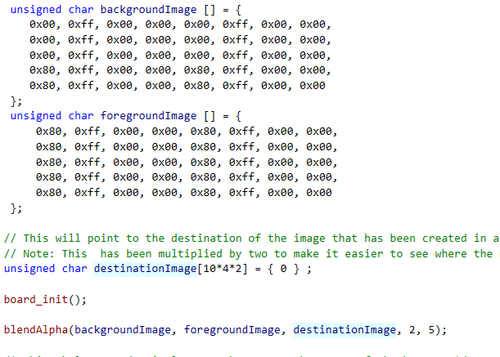
Figure 1 C file snippet (full code available in appendix 1)
The formula to perform an Alpha Blend is shown below

Figure 2 Alpha Blend formula (as seen in assignment brief)
The corresponding code to the function in the C file is shown in appendix 2. This ultimately consists of two loops that load each pixel horizontally in the array, performs an alpha blend, stores the output in a new array, and continues vertically to do this for every line in the array.
The results of the program are shown below.
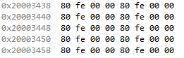
Figure 3 New alpha blended image
Verification for the above results is shown below. For demonstration purposes, the red value of the foreground and background image will be alpha blended, and should yield 0xFE:
0xff == 255 (red)
Figure 4 Alpha Blending formula example
(0x80 * 0xff) + (0xff * (255-0x80))) >> 8
Converted to decimal for convenience:
(128 * 255) + (255 * (255-128)
(32640) + (255 * 127)
32640 + 32385
65025
65025 in hex: 0xFE01
Shifted right by 8: 0xfe

It is important to acknowledge that 0xFE is only one number away from 0xFF (which is the desired result). This has occurred as a result of shifting the value right by 8 (which effectively divides a number by 256). This has been done as it is computationally cheaper than a division of 255.
Meanwhile this may seem undesirable, the difference may be unnoticeable for such a small change in colour values.

Washing Machine timing constraints
This section will analyse the timing constrains involved in a wash and dry cycle on a washing machine system.
The programs that run on washing machines are responsible for a lot of actions. The table below outlines the functions involved in a wash and dry cycle. It includes the time taken for these tasks to be completed and their delays. Explanation of the delays and durations have been included where necessary. Safety critical measures have also been included detailed.
Action | Duration | Delay
- Set Door Lock  The time that the washing machine takes to lock the door is relatively short. This time takes into account the time it takes for the locking mechanism to physically lock the door.  The lock protects the user by preventing them from opening the washing machine during a wash and dry cycle. As a result, the user will not be able to touch the drum if it starts moving. |  | < 1s
- Opening Valve  This will open a valve to allow water to flow into or out of the washing machine.  The delay value is determined by the mechanism in which the valve is opened. |  | 1s
- Start pump  This will start the pump that will drain water from the washing machine.  This will take approximately 20 seconds as this will need to drain the water in the washing machine. | ~20s | 1s

- Stop pump  This will stop the pump when the water has been drained. |  | 1s
- Close valve  This will close a valve, preventing more water from entering or leaving the washing machine. The water level measurements will provide the washing machine with information that will allow it to determine when the valve must be closed.  If the valve did not close, the user is at risk of flooding their kitchen. |  | 1s
- Start turning drum  The drum will begin turning near the beginning of the wash cycle. The delay of 3 seconds is mechanical as the drum will take time to speed up. | 100s | 3s
- Stop turning drum  As with when the drum started turning, slowing down the drum is a mechanical function that takes the time specified. |  | 3s
- Start Spinning drum (for rinse)  Unlike turning the drum, spinning the drum happens when the washing machine needs to rinse the clothes. The duration consists of the time it takes to rinse the clothes. However, this setting may depend on timings specified by the user.  The 10 seconds delay accounts for the delay for the drum to reach maximum speed. | 600s | 10s

- Stop Spinning drum  The drum will stop spinning after the duration of the rinse has been reached, or the user has manually interrupted the washing machine.  The delay accounts for the time it takes for the drum to stop spinning. |  | 10s
- Sounding buzzer  After a wash and dry cycle has been completed (and after the wash portion has been finished), the buzzer will be sounded. This will sound for approximately 10 seconds and will take less than 1 second to trigger. | 10s | < 1s
- Check temperature  Before the drying portion of the wash and dry cycle has finished, a temperature reading will be taken to ensure that the washing machine is safe to open.  This will protect the user from burning their hand on the inside of the machine. |  | < 1s
- Slow/Speed-up/ or Stop drum  The drums speed will vary depending on if it is rinsing clothes, turning them, re-filling with more water, or if the machine has over-heated.  The drum must stop whenever the cycle before the door lock has been released, preventing the user from touching the moving drum. |  | 1s
- Start heater  The heater will help dry the clothes quickly. This will take approximately 20 seconds to heat-up the washing machine to a desired temperature. | ~20s | 1s
- Stop heater  The heater can be stopped for the user to remove their washing, or for the machine to cool down in the situation where it is at the temperature where it may overheat. |  | 1s
- Measure water levels  Measurements of water levels will take one second. This measurement is crucial as it will provide information to the washing machine that will allow it to close the valves when the water level is at the desired level, preventing the user from flooding their room. |  | 1s
- Release lock  The lock will be released when it is safe to do so (and only after the user has requested the machine to stop, or a wash and dry cycle has finished). |  | < 1s

Appendices
(available on following pages)
Appendix 1
Appendix 2 (shown on proceeding pages)

