
University of Wales Trinity Saint David

M4X02196
Transmission Matching
2020

Ethan Johnson
Contents/Figures

Table of Contents
Introduction 3
Research 4
Experimental Procedure 8
Results 9
60 V n p 9
AnalysisConclusion 13
Bibliography 14

Table of Figures

Figure 1 : Demonstration of different gear types 4
Figure 2 : Common transmission gears 4
Figure 3 : Demonstration of a synchroniser 5
Figure 4 : Primary gear set 5
Figure 5 : Ambient air pressure at different altitudes 7
Figure 6 : Tractive effort in all gears 11
Figure 7 : Maximum road speed in all gears 11
Figure 8 : Wheel torque & tractive effort 11
Figure 9 : Torque vs engine speed 12
Figure 10 : Drag vs velocity 12
Figure 11 : Tractive effort vs engine speed 12

Introduction
Engine torque and power are at the core of engine design, these two values dictate the straight line performance of a vehicle. This report investigates not only these two outputs, but also a series of other parameters including Torque at the wheels, aero drag, tractive effort and more. The equipment used to measure the raw data is a chassis dynomometer. This allows for the whole transmission to be included in the testing, for a more realistic data set. The subject in testing is a BMW S1000RR motorbike, capable of speeds over 270kph.

Research

Gearing

Gears are used to change engine drive characteristics, before these characteristics can be explained, the types of gear must be understood. There are a multitude of different gear types used in all types of machinery, allthough only three need to be explained for this report.

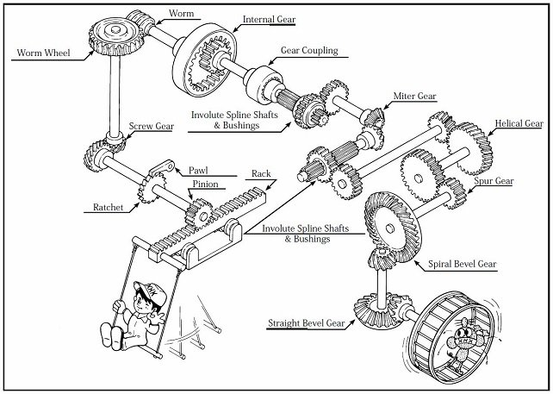
Figure 1: Demonstration of different gear types
Kohara Gear Industry Co.. (2015). Types Of Gears.
Spur Gears:

Spur Gears are simple straight cut gears. These gears can be taken in and out of mesh and are easy to manufacture. These gears are also very strong, hence the regular use in racing gearboxes. The only drawback is the noise generated.

Helical Gears:

Helical gears have teeth cut at an angle, these gears are quiet in operation, these gears however cannot be taken in and out of mesh.

Bevel/Crown Gears

Bevel/Crown Gears are used to change the direction of drive through 90’. These gears are most often used in car differentials.

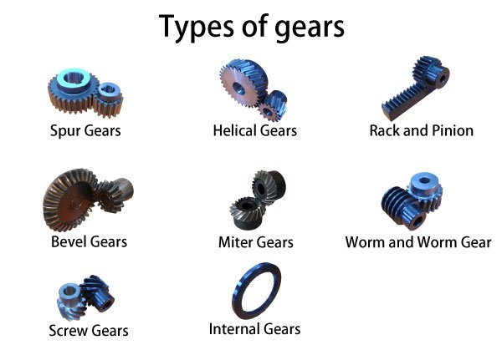
Figure 2: Common transmission gears
Kohara Gear Industry Co.. (2015). Types Of Gears.

Synchromesh Gear selection:

Since helical gears cannot be directly engaged or disengaged when meshed, they have to be indirectly meshed via a secondary straight cut gear. Synchromeshes are used in all types of manual gearboxes. There consists a two helical gears in constant mesh, the gears are not directly attached to the shafts, one of these two gears have a straight cut selector ring running parallel to its meshed gear with a cone shaped surface on its most outer edge. Next to the gear there is the selector ring, this ring is splined to the shaft. Finally in between the gear and the selector lies a synchro cone. When the gear gear is selected, the two cones are pressed together this slows the “dog Teeth” on the synchro to the same speed, since straight cut gears can be engaged and disengaged from mesh, the selector ring sleeves over the two, locking the shaft and gear together therefore allowing the torque to travel through the transmission to the wheels.

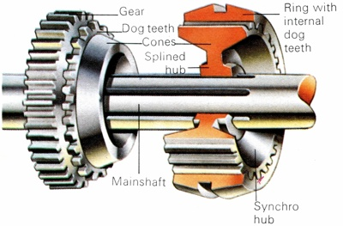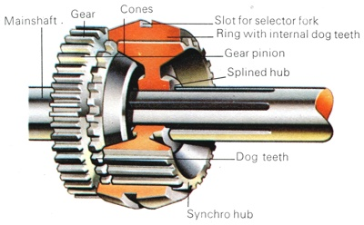
Figure 3: Demonstration of a synchroniser
Anon. (2020). How it works: synchromesh.

Dog Tooth Engagement:

Dog Tooth Transmissions “Dog Boxes” are slightly different in operation, also used in motorcycle transmissions, dog boxes do not have synchroniser cones to slow the gears down to matching speed. Instead they only have large straight cut teeth that lock with eachother when pressed together. This creates an instant change of gear, this is optimal in racing where gear changes can lose time on the racetrack. In a consumer sense, it is not possible to have a H pattern gear lever on a motorcycle, so the dog engagement box allows for a single “up/down” movement to be implemented.

Primary Gear Ratio:

One ratio that is not used in road cars but on bikes, is a Primary gear ratio. A motorcycle’s gearbox cannot be mounted longitudinally for space reasons. Instead it is mounted transversely, there is one problem, in that the drive needs to be transmitted to the gearbox that is adjacent to the engine. To do this there is a set of primary gears at the end of the crank, this is a permanent gear ratio highlighted in red below.

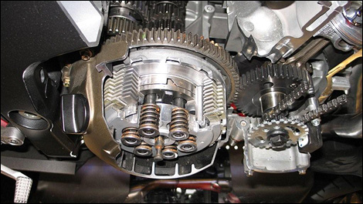
Figure 4: Primary gear set
Anon. (2020). Motorcycle clutch: maintenance and settings.
Gear Ratios:

Gear ratios demonstrate how gears can be used to change drive characteristics. As stated by M, Brain from How Stuff Works“Gears are generally used for one of four different reasons:
- To reverse the direction of rotation
- To increase or decrease the speed of rotation
- To move rotational motion to a different axis
- To keep the rotation of two axis synchronized”
Brain, M. (2020). How Gear Ratios Work.
If a gear has a 2:1 ratio it is known as under-drive, two turns of the input results in one turn of the output. This also increases torque by double, but decreases speed by the same proportion, these underdrive ratios are usually used up to 3rd gear. A 1:1 ratio is used as a direct-drive, 1 input turn is equal to 1 output turn, this ratio is normally used in 4th gear. Finally for example if a gear has a ratio of 1:2, it is an over-drive. This results in the speed doubling and the torque decreasing proportionally, these ratios are used for 5th and 6th gears.

Air Density:

Air density “ρ” is measured in kg/m^3. Air density does not stay the same in all conditions, it can be affected by the temperature, humidity, and altitude. Hence why some investigation into the air density of the test was required. Information sourced from Helmenstine, A, M, Ph.D.. (2020). What Is the Density of Air at STP Shows differences in air density in different locations.

- At Sea level at 15’C, ρ= 1.225 kg/m^3
- At Sea level at 0’C & 100kPa pressure, ρ= 1.275 kg/m^3
- At Sea level at 20’C & 100 kPa, ρ= 1.204 kg/m^3

A graph from the resource site Mammoth Memory. (2020). Pressure shows the relation between altitude and pressure in kPa. As demonstrated, sea level has an ambient air pressure of 100kPa. Since standard ambient room temperature in the UK is 20’C OVO Energy. (2020). What’s the average room temperature and thermostat setting in the UK? for the calculations including room temperature it has been decided that 1.204 kg/m^3 will be used.

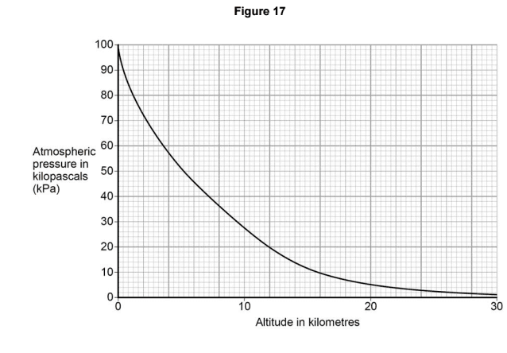
Figure 5: Ambient air pressure at different altitudes
Mammoth Memory. (2020). Pressure.

Experimental Procedure

Chassis Dynomometer Testing

The motorcycle used was a BMW S1000RR, the motorcycle had been fastened down to the rolling road with straps to ensure safety and tyre contact with the road. The rider had been weighed so that the total weight of the bike could be separated from total mass.
The engine was run until warm to ensure optimum performance during the test, the motorcycle was put in 5th gear as soon as possible. The reason being that 5th gear had a ratio of 1.36:1 meaning that it was the closest to direct drive without a risk of stalling at the beginning of testing (theoretical gear ratios show 5th ratio to be 1.09:1).
The motorcycle was opened to 100% throttle and run up to 13,920rpm (Red line). This generated a power/torque graph on the dynomometer screen. This data is what has been used for analysis and for calculating other values of engine characteristics.

Reasoning for tests

The chassis dyno was selected for a number of reasons, the first being the most obvious, it was much easier to place a motorcycle on a rolling road, than remove the engine entirely and set it up with an engine dyno. Secondly the chassis dynomometer can calculate some parameters that an engine dyno cannot, these include drag, velocity and power at the wheels. These additional parameters allow for other characteristics to be calculated.

Results

This section shows the data from the dyno test, and the calculations that were carried out.

The first calculation is for Transmission Efficiency:
The power at the wheels must be divided by the power at the engine, the difference shows how efficient the transmission is at transferring drive as a percentage.

η = Power @ Wheels
Power @ Engine

η = 0.897419
Secondly Wheel Torque:

T= Torque @ Engine x Primary x final Drive x Test Ratio x Transmission Efficiency

T = Results in Table Section
Tractive Effort :
The tractive effort must be calculated by dividing the wheel torque by the rolling radius.

Tractive Effort, TE = Torque @ the wheels
Rolling Radius, R

TE = Results in Table Section
TE in all gears:
This calculation will show how the tractive effort changes with each gear ratio. The top line is what is needed to work out the effect of the transmission on the torque.

TE = Torque x Primary x Final Drive x Test Ratio x Transmission Efficiency
Wheel Radius

Results in Table Section
Speed Ratio:
The speed ratio is calculated by dividing the max torque RPM by the max power RPM. This value is used to work out the theoretical gear ratios.

- Calculate the Speed ratio = Max Torque engine speed
Max Power engine speed

Speed Ratio = 0.800986
Confirming Differential Ratio:
This calculation uses the rearranged version of an output speed equation to confirm the final drive ratio.
f = 2 π R N

60 V n p
Differential Ratio = 2.688:1
Maximum Road Speed:
This value uses the aero drag equation, where ρ= air density and Cd= the coefficient of drag. This equation finds where the force of aero drag is equal to the driving force.

$$P_{drag}=\frac{1}{2}ρC_{d}A{(V+V_{0})}^{2}.V$$
Maximum Road Speed = 140.301 kph

Theoretical Gear Ratios:
This uses the speed ratio that was previously calculated to find out the gear ratios.
1st ratio = n1
2nd ratio = n1 x speed ratio
3rd ratio = n1 x speed ratio x speed ratio
4th ratio = n1 x speed ratio x speed ratio x speed ratio
5th ratio = n1 x speed ratio x speed ratio x speed ratio x speed ratio

1st = 2.65
2nd = 2.12
3rd = 1.70
4th = 1.36
5th = 1.09
6th = 0.87

Excel Results

Maximum tractive effort in all gears:


Figure 6: Tractive effort in all gears

Maximum road speed in all gears:


Figure 7: Maximum road speed in all gears

Wheel Torque & Tractive Effort:

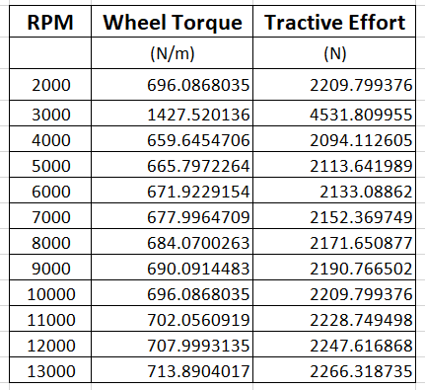
Figure 8: Wheel torque & tractive effort

Graphs:

Figure 9: Torque vs engine speed

Figure 10: Drag vs velocity

Figure 11: Tractive effort vs engine speed

Analysis & Conclusion

Figure 9 shows the torque curve that the motorbike produced, the torque is highest at 10,500RPM, this matches the manufacturers specifications. Most engines are designed to have a flat torque curve across the optimum performance range, from the graph, it is apparent that the optimum torque is between 8000 and 13,000RPM. The torque reading is similar to the manufacturers specifications mostly due to the motorbike only being a few years old. A comparison dyno graph from another S1000RR has been sourced below, the similarities between the torque curve can be more easily seen and the peak is around 113Nm, the same as the test that was carried out. This shows that the motorcycle is performing as expected.
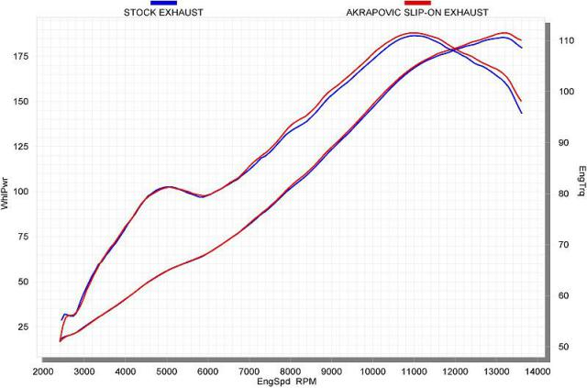
Figure 12: S1000RR torque graph

Enhance Partners, LLC. (2020). BMW S1000RR on the Dyno: Off the Charts!

Figure 10 shows the aero drag on the motorcycle. What can be seen on first glance is an increasing rate of drag force. This is expected since the increased volume of air colliding with the frontal area of the motorbike means more drag in N produced. This explains the increase in steepness of the curve. In the equation, the velocity is shown to be squared, this is also demonstrates why the curve is shaped like it is.
Figure 11 shows the Tractive Effort generated by the motorcycle. This graph shows a steady increase in tractive effort as the engine speed increases. This is not expected since the torque curve is not linear, this graph may show that torque output may not directly affect the tractive effort output.
The gear ratios were calculated by multiplying the 1st gear ratio by the speed ratio, relative to the selected gear. In review of the calculations, there were distinct differences between the manufacturers ratios and the calculated ratios as shown below.
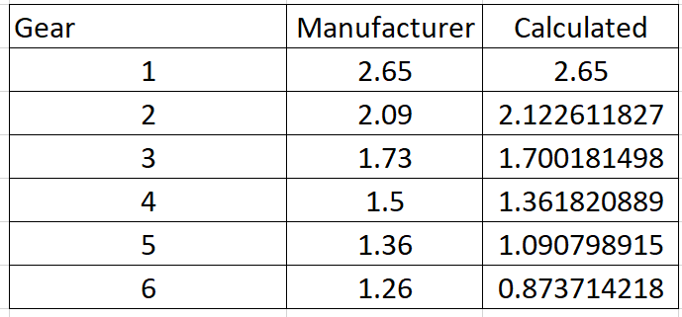
Figure 13: Gear ratios, Test vs Manufacturer
An answer to this difference could be related to the values used to calculate the ratios. When the manufacturers work out the gear ratios, they are calculated by counting the teeth on each gear and then dividing the two. This method uses an unchanging, real, solid number(the number of teeth) to work from. The calculated gear ratios use a speed ratio(taken from the engine speed at max torque devided by engine speed at max power). Since all engines produce slightly different torque and power outputs, the speed ratio may be different for each motorbike. This includes the motorbike used for the specifications, this will create discrepancies in the ratios when compared to the original specifications. In addition to this, torque and power can change whilst the number of teeth on a gear will not, this is a cause for discrepancy.

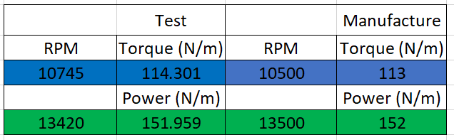

The peak figures differ slightly from specification to the test results, The figures shown in the specifications demonstrate a brand new, off the production line engine with very little or no prior use. The torque figures can be varied because of age, as an engine is used, more wear occurs in the moving parts together with more play in bearings, chains etc. All of this begins to lower the performance of an engine.
The maximum achievable road speed was found to be 140.301kph, this point is where the resistive aero drag matches the driving force, therefore not allowing the vehicle to accelerate further. This figure however may not be completely accurate, this could be partly due to the very rounded value for frontal area. For a motorcycle, it would be expected that the frontal area would not add up to exactly 0.7m². If this figure is in-accurate, there would be definate in-accuracies in the amount of aero drag and in-turn maximum road speed. Also the air density outdoors does not stay the same, therefore there could be errors in that area as well, especially this is affected in higher altitudes shown in Fig5.

Conclusion

This experiment showed some interesting results, the torque graph was in a linear pattern, this was not as expected. Also the calculated gear ratios were not identical to the specified ratios. The maximum road speed was 140.301kph, this result was far below the claimed top speed of 299kph from Corporate Author. (2013). BMW S1000RR.

Report Review
Overall the experiment and results generated showed a good picture of how the motorcycle performs, however the results could have been improved if the following was possible.

Aerodynamic assesement:

Had there been the opportunity to use a wind tunnel, the aerodynamic effect on the motorcycle could have been more closely monitored, allowing for a more accurate top speed results, even a more in depth look at the frontal area could have improved the result.

Top Speed Run:

The best way the top speed could have been found out would be doing an outdoor run of the motorcycle up to top speed. Had this been an opportunity the top speed result would have been closer to the specified top speed.

Torque & Power at the engine:

The best way the Torque and power at the engine could be obtained would have been to use the engine dyno for pure accurate results. This would have increased the accuracy of the calculations.

Bibliography

Miur, A. (2020). How manual gearboxes work. Available: https://www.howacarworks.com/basics/how-manual-gearboxes-work. Last accessed 3/4/20.

Kohara Gear Industry Co.. (2015). Types Of Gears. Available: https://khkgears.net/new/gear_knowledge/introduction_to_gears/types_of_gears.html. Last accessed 3/4/20.

Woodward, C. (2019). Gears - How Do They Work?. Available: https://www.explainthatstuff.com/gears.html. Last accessed 3/4/20.

Anon. (2020). How it works: synchromesh. Available: https://www.uniquecarsandparts.com.au/how_it_works_synchromesh. Last accessed 4/4/20.

Anon. (2020). Motorcycle clutch: maintenance and settings. Available: http://www.moto123.com/motorcycle-news/article,Motorcycle-clutch-maintenance-and-settings.spy?artid=99562&pg=1. Last accessed 5/4/20.

Helmenstine, A, M, Ph.D.. (2020). What Is the Density of Air at STP. Available: https://www.thoughtco.com/density-of-air-at-stp-607546. Last accessed 5/4/20.

Brain, M. (2020). How Gear Ratios Work. Available: https://auto.howstuffworks.com/gears.htm. Last accessed 5/4/20

Mammoth Memory. (2020). Pressure. Available: https://mammothmemory.net/physics/physics-formulas/pressure/pressure.html. Last accessed 5/4/20.
OVO Energy. (2020). What’s the average room temperature and thermostat setting in the UK?. Available: https://www.ovoenergy.com/guides/energy-guides/average-room-temperature.html. Last accessed 5/4/20.
Enhance Partners, LLC. (2020). BMW S1000RR on the Dyno: Off the Charts!. Available: http://www.motorcycledaily.com/2009/12/16december09bmws1000rdyno/. Last accessed 9/4/20.

Corporate Author. (2013). BMW S1000RR. Available: https://www.motorcyclespecs.co.za/model/bmw/bmw_s1000r%2013.htm. Last accessed 10/4/20.

