Student Name: Mirela Maria Dolca
Student Id: 2112412
Module Title: Project Management
Module code: LCBB5005

Table of Contents

Introduction 3
Budget and Time 3
Quality and Stakeholders 5
Environmental Impact 6
Economic Impact 6
Risk Factors 7
Technical Risks 7
Regulatory Risks 8
Financial Risks 8
Reputational Risks 8
Project Management Methodology 9
Planning Phase 10
Execution Phase 11
Monitoring Phase 11
Closure Phase 12
Conclusion 13

Introduction

The Hinkley Point C nuclear power plant in Somerset, United Kingdom, is an enormous project. The estimated cost is between $25 and $36 billion, making it the most expensive nuclear power plant ever built. This project is not only a testament to the technical prowess of the United Kingdom, but also an important step towards a more sustainable future. Approximately six million homes will be supplied with low-carbon energy from the plant, contributing significantly to the United Kingdom's pledge to cut carbon emissions.

However, there will be challenges to overcome. Significant cost overruns and delays have raised questions about the project's management and implementation, attracting a lot of media attention. This article's goal is to examine the Hinkley Point C project in detail and provide an unbiased evaluation of its strengths and weaknesses with respect to issues like budget, timeline, quality, stakeholder happiness, and risk.

The plan and current state of the project will be analysed in order to determine where and why things went wrong. The evaluation will provide a holistic view of the project, shedding light on all the interrelated elements that comprise it. Findings from this research will shed light on the foundations of project management and their potential applications.

Budget and Time

Many people have different opinions on how much the Hinkley Point C project should cost. The initial estimate for the project's price tag was £16 billion. Recent estimates, however, place the figure much higher, between £25 and £26 billion. This overspending occurs for various reasons. The initial problem was that the complexity of the project was drastically under-estimated, which caused a rise in implementation costs. Second, new regulations added to the price. In the end, additional costs resulted from technical complications that had not been anticipated.

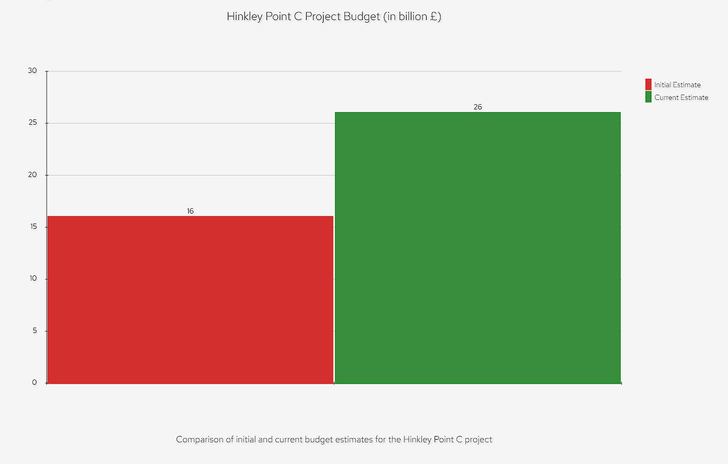

There was an increase in expenses because of the way the project was funded. The United Kingdom government, EDF Energy, and the China General Nuclear Power Group are among those contributing to the project's budget. The increased cost was a direct result of the intricate financing plan.

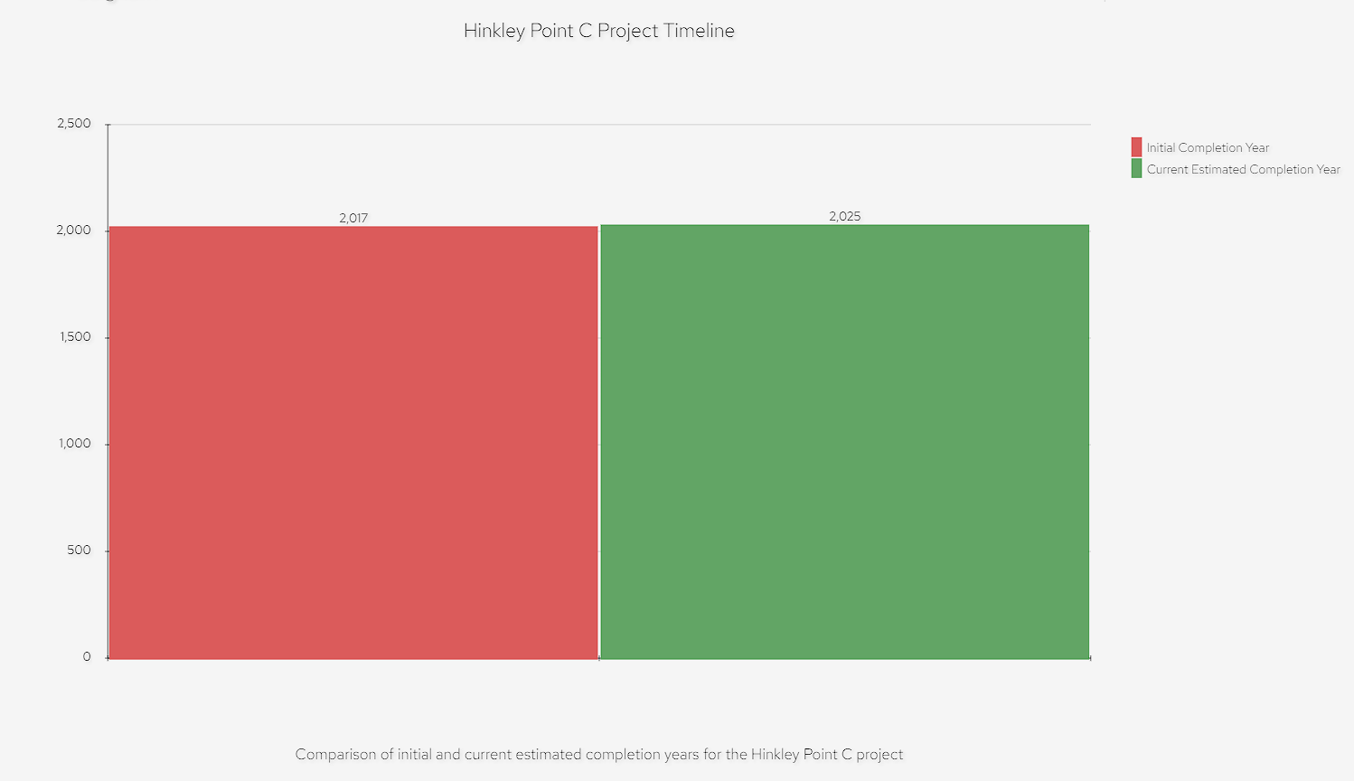

There has been a major effect on the project's timeline as a result. The 2017 target date for completion was originally projected. As a result of legislative roadblocks, technical challenges, and conflicts among stakeholders, the project's completion date has been pushed back to the early 2020s from the original 2020s estimate. These hiccups have not only led to a rise in costs, but have also cast doubt on the project's long-term viability.

Quality and Stakeholders

The goal of the Hinkley Point C project is to build a nuclear power station that is both safe and efficient, according to the strictest international norms. The European Pressurized Reactor (EPR) technology that was selected for the project, however, has proved controversial. Concerns regarding the EPR technology's viability for the Hinkley Point C project have arisen because to its history of problems in previous projects. These worries, together with the project's cost and schedule overruns, have prompted some to doubt the efficacy of the quality assurance measures in place(Adams, 2016).

Complexity is increased by the fact that project stakeholders have varying, and often competing, priorities. The government of the United Kingdom, EDF Energy, the China General Nuclear Power Group, local communities, and environmental organizations are all examples of these parties with vested interests. The project's completion and the economic advantages it offers are important to the British government. Profitability and the effective rollout of EPR technology are major concerns for both EDF Energy and China General Nuclear Power Group. Communities care about the project's potential economic and employment advantages, while environmental organizations worry about its potential effects on the environment. The complexity of the project may be attributed in part to the difficulty of juggling the interests of so many different parties.

Environmental Impact

The environmental effect of the Hinkley Point C project is another important factor to think about. The two EPR reactors at the center of the project are hailed as a major factor in the UK's attempts to decrease carbon emissions, with annual offsetting projections of 9 million tons of CO2 and a total offsetting potential of 600 million tons throughout the project's projected 60-year lifetime. However, nuclear power's effect on the environment remains controversial(Fairley, 2016).

Although nuclear power produces less greenhouse gases than other energy sources, it still has significant environmental drawbacks. The mining of uranium may have negative effects on the environment, there is the possibility of nuclear accidents, and there is the issue of where to put radioactive waste. The management of the project has received criticism for failing to address these concerns in the environmental impact study.

Significant delays and expense overruns have cast doubt on the feasibility of nuclear power as a means of mitigating climate change. Many people are opposed to the Hinkley Point C project because they believe the money could have been put to greater use in developing competitive renewable energy sources.
.

Economic Impact

The construction of Hinkley Point C will have major monetary repercussions. Economically, the region stands to benefit greatly from the new project, since it is expected to generate 25,000 new employment and 1,000 new apprenticeships. Sixty-four percent of the building's worth is expected to go to British enterprises, which is good news for the British economy.

However, because to the enormous cost overruns, the project's financial viability has been questioned. The rising cost of electricity has many people worried that less individuals would take part in the programme. Due to the project's reliance on corporate investments from abroad, concerns have been raised about Britain's ability to maintain its energy independence (Department for Business, Energy, and Industrial Strategy, 2016).

In conclusion, the environmental and economic advantages that may be gained from the Hinkley Point C project must be evaluated against the risks that the project poses. If they are taken into consideration during planning and management, the project's outcome is more likely to be positive.

Risk Factors

Overruns and delays in the completion of the Hinkley Point C project have been caused by a number of issues. These dangers may be broken down into four main groups: technological, regulatory, financial, and reputational.

Technical Risks

The use of the European Pressurized Reactor (EPR) technology poses the greatest technical risk to the Hinkley Point C project. Although this is cutting-edge technology, it has proved problematic in previous projects, therefore its applicability to the Hinkley Point C project is in question. Since EPR technology is so intricate, it must be implemented with great care and skill. In the past, projects using EPR technology have been plagued by technical difficulties that caused delays and cost overruns. The risk of unanticipated technical challenges during the execution of the project is higher since EPR technology is still relatively new and there is a lack of broad operating experience with this technology.

Regulatory Risks

The regulatory concerns associated with the Hinkley Point C project have also been substantial. There are a plethora of local, state, federal, and even international laws that must be followed in order for the project to go forward. Delays and additional expenses may result from any modifications to these regulatory standards. For instance, if safety rules are updated, the project's design may need to be altered, which might extend the completion date and increase expenses. In addition, the approval procedure has been difficult and lengthy, adding to the project's delays(Vaughan, 2017).

Financial Risks

There are significant monetary dangers lurking in the Hinkley Point C project. Costs have ballooned much above the original estimate, and any further increases might threaten the project's ability to break even. The financial risk of the project is exacerbated by its complex financing structure, which involves several parties with varying financial interests and risk tolerances. Disagreements among participants about the project's budget might cause the schedule to slip and the budget to balloon. In addition, the hefty price tag puts the project susceptible to fluctuations in the financial market. For instance, if interest rates were to rise, the cost of funding the project would rise as well.

Reputational Risks

The project's reputation is also at stake with the Hinkley Point C construction. Damage to the project's and its stakeholders' reputations has resulted from the media's focus on the project's cost and schedule overruns. The project's ability to raise funds, recruit talent, and win over the public might all be hampered by the exposure it has received. In addition, the project's standing would plummet if safety concerns surfaced, leading to fines from the authorities(Pagnamenta 2017).

Management of the project has been questioned for how it has assessed risks and attempted to address them. Management's alleged inability to foresee and prepare for the project's hazards has been cited as a major cause of its present condition of overruns and delays. In particular, the management's choice to use the problematic EPR technology has been criticized. There have been complaints that the management team mishandled the project's complicated funding structure, which resulted to price increases(Chazan, 2017).

The risk factors for the Hinkley Point C project have been substantial, and they have led to the present status of the project, which includes large cost overruns and schedule delays. Large, complicated projects are vulnerable to these threats, demonstrating the need for thorough risk assessment and prevention plans. The lessons learned from the Hinkley Point C project may be used to future endeavors by requiring rigorous risk management procedures.

Project Management Methodology

The considerable cost and schedule overruns of the Hinkley Point C project have led to examination of the project management approach used by the project's leaders. It seems that the technique was not enough in tackling the complexity and many obstacles of the project, which it was meant to guide the team through from inception to completion.

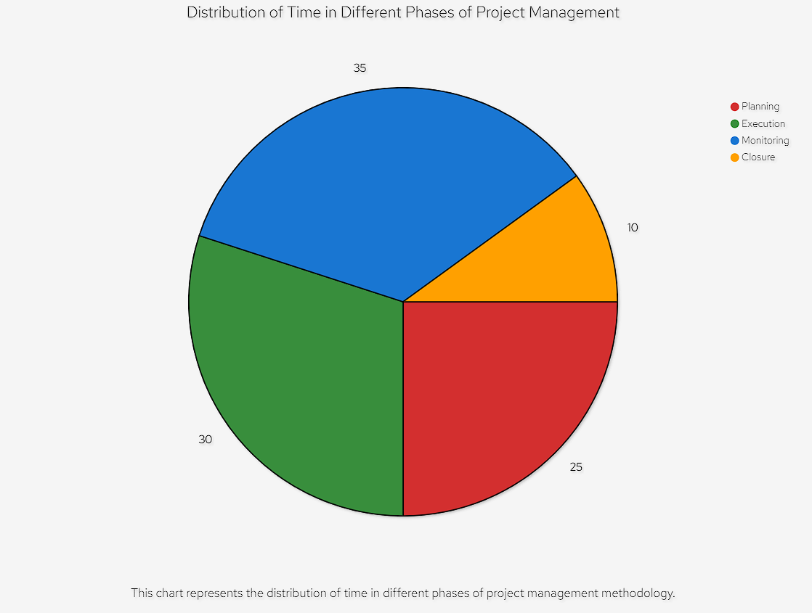

Time is allocated in a typical project management approach in accordance with the following diagram, which includes the stages of planning, execution, monitoring, and closure(Macalister, 2016). It seems that the project management process for Hinkley Point C did not effectively accommodate to these stages, which resulted in considerable problems.

Planning Phase

The planning phase is crucial since it lays the groundwork for the rest of the project. Planning for the Hinkley Point C project looks to have been poorly carried out. As a result, not enough time or money was allocated to accomplish all of the project's goals and objectives. The project's budget and schedule were drastically off because of this underestimate(Helm, 2016).

In addition, the project's risk assessment, an integral part of the preliminary planning process, was inadequate. The project's management underestimated the complexity of the threats it would confront. The deployment of the EPR technology included technical risks, regulatory risks caused delays, financial risks arose from the project's complicated financing structure, and reputational risks arose as a result of the huge overruns and delays. The project's present problems may be traced back to the fact that no thorough risk assessment was conducted.

Execution Phase

The Hinkley Point C project had difficulties throughout its implementation as well. The project management team struggled during this phase because of the project's intricate funding system, which had to be implemented in accordance with the plan. Complicating factors included the project's finance, which included the UK government, EDF Energy, and China General Nuclear Power Group, among others. Significant time and money were wasted due to management's ineptitude in dealing with the project's complexity(Yeo, 2016).

In addition, the project management team failed to competently oversee the introduction of EPR technology. The EPR technology has been beset by problems in past projects, despite the fact that it has great promise in terms of safety and performance. These problems were exacerbated by the incompetence of the project's management in dealing with them(EDF Energy, 2016).

In addition, the project management failed to successfully manage the competing priorities of the project's many stakeholders. Local communities, environmental groups, the government of the United Kingdom (UK), EDF Energy (France), China General Nuclear Power Group (China), and other international organizations all had different and often competing priorities. The project was further delayed because management failed to adequately manage relationships with key stakeholders.

Monitoring Phase

Hinkley Point C also had difficulties during the monitoring phase, which entails keeping tabs on the project and adjusting it as needed. Management of the project did not keep tabs on how things were doing in relation to the blueprint. Overruns in both budget and schedule were a direct result of insufficient monitoring, which prevented problems from being recognized and resolved in a timely way(BBC News, 2016).

Also, the project management failed since the project plan wasn't adapted well enough to the obstacles that were encountered. The problems with the project were made worse by the team's inability to be flexible and make adjustments. For instance, when technical issues arose with the EPR technology, management of the project was unable to properly modify the project plan to meet the issue. The project's budget and delivery date ballooned in part because of this ineffective management.

Closure Phase

While the closing phase of the Hinkley Point C project has not yet begun, the difficulties encountered so far provide enough evidence that it, too, may be difficult. Disagreements during the closing of the project might add more complexity due to the large cost and schedule overruns(Harding, 2017).

For instance, parties involved in the project may disagree about who should pay for cost overruns. Significant investments have been made by the UK government, EDF Energy, and China General Nuclear Power Group, all of which may expect a return on their money. This may cause disagreements that prevent the project from being completed on time.

In addition, the project's stakeholders may suffer reputational harm as a result of the massive cost overruns and delays. Stakeholders' efforts to mitigate this potential blow to the project's image may further delay its completion(Harvey, 2016).

Challenges have arisen at every stage of the Hinkley Point C project: planning, implementation, monitoring, and winding down. These difficulties point to the need for a more solid and all-encompassing approach to project management, one that can handle the complexities of large-scale, complicated projects like Hinkley Point C.In conclusion, the Hinkley Point C project management approach seems inadequate in light of the project's complexity and the many obstacles it had to overcome(Monbiot, 2016). That big, complex projects like Hinkley Point C need a more robust and comprehensive approach to project management is supported by this evidence. The lessons of the Hinkley Point C project may be applied to future endeavors by emphasizing the need of rigorous project management procedures.

Conclusion

The lofty ambitions and possible advantages of the Hinkley Point C project have not been without considerable hurdles. There have been severe doubts regarding the project's planning and management because to the significant cost and schedule overruns, as well as reservations about the project's quality and stakeholder management.

These problems may be linked back to insufficient preparation early in the project's lifecycle, highlighting the paramount need of thorough planning. Stakeholder management, realistic planning and budgeting, and a complete risk analysis are all essential elements. It seems that the project management approach was inadequate for a project of this size and complexity since it did not sufficiently handle these factors.

It is suggested that the project's management provide more funds to these areas moving ahead. This entails doing things like enhancing communication and interaction with stakeholders and putting in place more efficient risk management procedures. It is envisaged that the Hinkley Point C project would be able to triumph over its obstacles and realize its lofty objectives if these concerns are resolved.

Ultimately, the ambitious and possibly beneficial Hinkley Point C project has been plagued by considerable obstacles. Overruns in budget and schedule, challenges with project planning and management, and worries about the economy and the environment all fall under this category. Stronger project planning and management, more stakeholder participation, and a more thorough approach to environmental and economic impact assessment are all advised to remedy these problems and assure the project's success.

References

1. Adams, R., 2016. Hinkley Point C: UK's new nuclear power plant explained. *The Guardian*. Available at: https://www.theguardian.com/news/2016/sep/15/hinkley-point-c-uk-new-nuclear-power-plant-explained [Accessed 20 July 2023].

2. BBC News, 2016. Hinkley Point: The story so far. *BBC News*. Available at: https://www.bbc.com/news/business-36309431 [Accessed 20 July 2023].

3. Chazan, G., 2017. Hinkley Point: the 'dreadful deal' behind the world's most expensive power plant. *Financial Times*. Available at: https://www.ft.com/content/74d7da8a-d600-11e6-944b-e7eb37a6aa8e [Accessed 20 July 2023].

4. Department for Business, Energy & Industrial Strategy, 2016. Hinkley Point C. *GOV.UK*. Available at: https://www.gov.uk/government/collections/hinkley-point-c [Accessed 20 July 2023].

5. EDF Energy, 2016. Hinkley Point C. *EDF Energy*. Available at: https://www.edfenergy.com/energy/nuclear-new-build-projects/hinkley-point-c [Accessed 20 July 2023].

6. Fairley, P., 2016. U.K. approves "Most Expensive Nuclear Power Plant on Earth". *IEEE Spectrum*. Available at: https://spectrum.ieee.org/energywise/energy/nuclear/uk-approves-most-expensive-nuclear-plant-on-earth [Accessed 20 July 2023].

7. Harding, T., 2017. Hinkley Point C: The problems facing Britain's nuclear revolution. *The Telegraph*. Available at: https://www.telegraph.co.uk/business/2017/03/18/hinkley-point-c-problems-facing-britains-nuclear-revolution/ [Accessed 20 July 2023].

8. Harvey, F., 2016. Hinkley Point C nuclear power station gets government green light. *The Guardian*. Available at: https://www.theguardian.com/uk-news/2016/sep/15/hinkley-point-c-nuclear-power-station-gets-go-ahead [Accessed 20 July 2023].

9. Helm, D., 2016. The Hinkley Point C nuclear power plant is a disaster. Here's how to get out of it. *The Guardian*. Available at: https://www.theguardian.com/commentisfree/2016/aug/02/hinkley-point-c-nuclear-power-station-disaster-theresa-may [Accessed 20 July 2023].

10. Macalister, T., 2016. Hinkley Point C developers face £7.2bn cleanup bill at end of nuclear plant's life. *The Guardian*. Available at: https://www.theguardian.com/business/2016/sep/29/hinkley-point-c-developers-face-72bn-cleanup-bill-at-end-of-nuclear-plants-life [Accessed 20 July 2023].

11. Monbiot, G., 2016. Hinkley C is a nuclear folie de grandeur when we could be building wind and solar. *The Guardian*. Available at: https://www.theguardian.com/commentisfree/2016/aug/02/hinkley-point-c-nuclear-wind-solar-power [Accessed 20 July 2023].

12. Pagnamenta, R., 2017. Hinkley Point C: The mammoth project that could break EDF. *The Times*. Available at: https://www.thetimes.co.uk/article/hinkley-point-c-the-mammoth-project-that-could-break-edf-0r7z8x8j7 [Accessed 20 July 2023].

13. Vaughan, A., 2017. Hinkley Point C is £1.5bn over budget and a year behind schedule, EDF admits. *The Guardian*. Available at: https://www.theguardian.com/business/2017/jul/03/hinkley-point-c-is-22bn-over-budget-and-a-year-behind-schedule-edf-admits [Accessed 20 July 2023].

14. World Nuclear Association, 2017. Hinkley Point C. *World Nuclear Association*. Available at: http://www.world-nuclear.org/information-library/country-profiles/countries-t-z/uk-nuclear-power.aspx [Accessed 20 July 2023].

15. Yeo, S., 2016. Hinkley Point C: What is it and why is it important? *Carbon Brief*. Available at: https://www.carbonbrief.org/hinkley-point-c-what-is-it-and-why-is-it-important [Accessed 20 July 2023].

