

BIRMINGHAM CAMPUS

STUDENT NAME: PADAM BAHADUR SHAHI
STUDENT NUMBER: 1711132
PROGRAMME: BA LEADERSHIP AND MANAGEMENT SKILLS FOR THE WORKPLACE
MODULE: BMSW6102- DEVELOPING INNOVATION AND CREATIVITY FOR BUSINESS ADVANTAGE
GROUP: 2
LECTURER: DR. MD NAZMUL HASAN



Table of Contents
Introduction 3
1. Product 3
Product description 3
Customer identification 4
Product Name 4
Product selling strategy 4
Profit making strategy 5
Competitor’s analysis 6
Competitors 6
Product differentiation 6
Benefits of Clear Facemask 7
Effective communication 7
Ease for deaf people 7
Safety measure 7
Unique Selling Point (USP) 7
Delivery options 7
2. E-commerce – (Online retail store) 8
Online platform- Amazon 8
Operational network of online market place of Clear Facemask 8
Reasons to choose Amazon FBA option for online retail store setup 10
Multichannel fulfilment 10
Payment system 11
Payment security plan 11
SSL protocol 11
PCI compliance 11
Tokenization 12
3D Secure 12
Address Verification Service (AVS) 12
3. Marketing 13
Product promotion strategy 13
Marketing objectives 15
Market positioning 16
Marketing mix 17
Control 17
References 20

Introduction

This report will discuss detailed plan for launch of a modified innovative product Clear Facemask in UK market. This report will discuss its features, competitive advantage, e-commerce market place and payment security plan. This report will also discuss detailed marketing plan for promotion of Clear Facemask in its targeted market.

1. Product

Clear Facemask

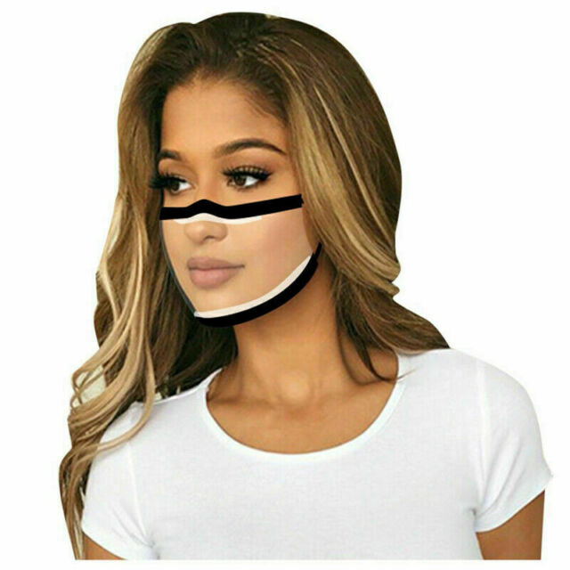

Product description
Price: | £190 for bulk purchase of 100 units
Colours: | Black, Royal Blue, Gray, Navy Green and Red
Themes: | Shopping, Running, Health, Security
Types: | N95, Cone style, disposable surgical masks
Size: | 20.5 X 11.5cm
Applicable objects: | Men and Women
Specifications: | - Makes lips visible  - Aids in effective communication  - Minimises security risks  - Deliver facial expressions  - Make lip reading convenient  - Anti-fogging technology

Customer identification
The product targeted customers include both men and women from 15 years to 50 Plus. Anyone who is willing to wear a visible mask can purchase Clear Facemask irrespective of profession, occupation, ethnicity or income group.

Product Name
The name of new product is “Clear Facemask”

Product selling strategy
How: The product selling strategy to meet sales targets of “Clear Facemask” will follow product development strategy. The aspects involved in product selling strategy of this new product that how it will be sold in market will include following aspects:

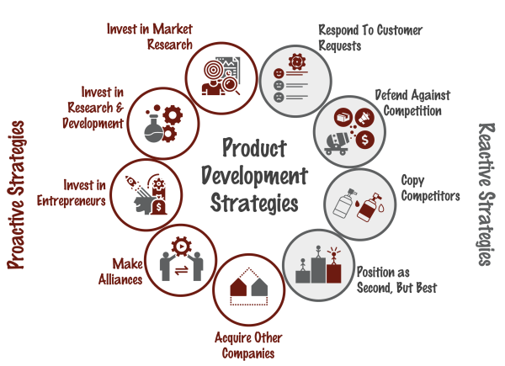
(Mora, 2020)

Clear Facemask will be sold online to business and individual customers through B2B and B2C network through Amazon e-commerce website.

Profit making strategy
In order to achieve breakeven point and sustain profitability cost leadership strategy will be opted. In order to keep economies of high to opt cost leadership strategy, Chinese suppliers will be added to supply chain throughout the operational period with high quality, prompt delivery and low prices. Moreover, Just in Time (JIT) production model will be followed in order to avoid unnecessary cost of storage or unsold inventory (Singh, 2012). In order to ensure timely delivery to customers using JIT, regular evaluation of suppliers will be conducted to keep supply chain efficient.

SWOT- Analysis

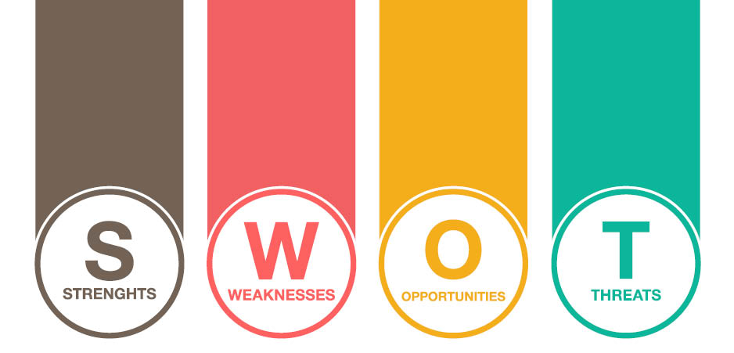

Strengths  - It enables a user to keep his/her face visible.  - It uses anti-fogging technology.  - It is 5% more safer than standard technology for a face mask to counter Covid-19 or any other viruses.  - Due to face visibility it aids in effective communication (Whitley, 2020).  - It aids in security concerns about identity of a person by keeping face visible. | Weaknesses  - Due to newness of this idea, the brand awareness for clear facemask is low.  - It is expensive than regular masks i.e. 2x.  - It offers limited designs or styles to customers according to different attires unlike other key mask manufacturers in UK, which offer wide variety of colors and styles.  - The distribution channel of clear facemask is limited.
Opportunities  - Due to increasing security issues and communication errors caused by regular masks, the demand of visible facemasks has been growing in UK (WFMJ, 2020). | Threats  - Due to high focus of pharmaceutical and medical equipment manufacturing companies on production of new and different face masks to meet the growing demand the expected competition is high for Clear Facemask (OECD, 2020).

Competitor’s analysis

Competitors
The competition for clear facemask is growing in UK industry due to increasing health concerns because of Covid-19 and prospective viruses. Issues in communication and security have led to growing demand of visible facemask. The current competitors of Clear Facemask are big medical equipment producers i.e. Ambu, Teleflex and Moldex-Metric, Inc. (Technavio, 2020)

Product differentiation
In order to cope up with the current competition with already operating mask production companies in UK and Europe, Clear Facemask has set a strong product differentiation specification. The price of Clear Facemask is 40% lower than other visible facemasks currently available in company. Moreover, it offers 5% more safety as per health standards to provide higher level of security to users.

Benefits of Clear Facemask
Some of the key benefits of using clear facemask include following:

Effective communication
Due to use of regular masks it has become difficult to understand tone and expressions of a communicator (Ueda, 2020). Clear facemasks help in making communication visible to help people conversation without misunderstandings.

Ease for deaf people
It improves delivery of visual cues for deaf and hard hearing individuals to make communication easy for them. It also helps in lowering down volume and delivery message with more convenience as compared to regular mask for special people (Martin, 2020).

Safety measure
It provides a huge deal of safety against burglars and thieves as they can hide their identity using regular masks. Use of clear masks improves security concerns and measures by keep identity of each individual clear (Ueda, 2020).

Unique Selling Point (USP)
The key unique selling points of Clear Facemask to capture a potential clientele in UK include following:
- Higher safety: It is 5% safer than standard technology for a face mask to counter Covid-19 or any other viruses.
- Low price: The price of Clear Facemask is 40% lower than other visible facemasks currently available in company.
- Anti-fogging technology: It uses anti-fogging technology on both with or without filter masks to keep fresh breath of customers.
- Wide and prompt delivery options: Clear Facemask is available within 2-3 working days of ordering of minimum 100 units which is 50% less delivery time as compared to other mask manufacturers in UK. Moreover, it offers wide delivery option under Amazon delivery facility as per convenience of customers.

Delivery options
Clear Facemask will opt multiple different delivery options available at Amazon.com (Its E-commerce website) to facilitate customers.
Production time: 2-3 working days
Packaging: Bulk: 100 units; dimensions 20" x 18" x 12", Weight 4 lbs.
Channels
Following are different delivery channels and options Clear Facemask will opt to meet demands of customers in different cities and counties in UK.
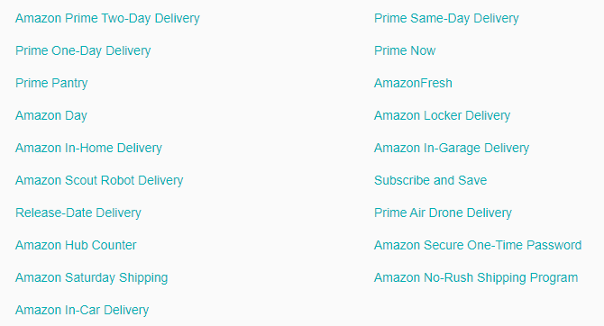
(Davis, 2020)

2. E-commerce – (Online retail store)

Online platform- Amazon
Clear Facemask management will sell out its product on Amazon.com under Fulfilment by Amazon (FBA) program.

Operational network of online market place of Clear Facemask
The key steps which will be involved in setting up an online retail store for Clear Facemask and selling process will be comprised of following:
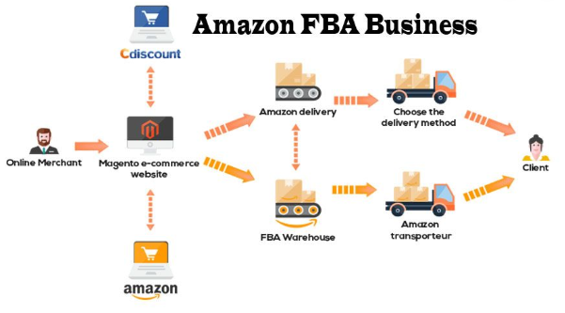
(Haselden, 2018)

Online store setup: Online store will be setup on Amazon through Amazon selling account option. Clear Facemask management will opt professional selling plan which will charge £39.99 monthly subscription fee (Carragher, 2020).

Product listing: Once Amazon account will be created; detailed product listing will be done under inventory option on our online store on the giant e-commerce market place (Carragher, 2020). This product listing page will be interlinked with official website of Clear Facemask to project traffic on Amazon account. The same account link will be on social media accounts while promoting and on YouTube channels along with blogs using Amazon Affiliate Program to promote this product.

Product preparation: Upon receiving orders from customers, the product preparation process will take 2-3 working days for each order (Carragher, 2020). The finished product i.e. minimum 100 units of Clear Facemask will be delivered to Amazon warehouse in London.

Product shipping: Clear Facemask will opt multiple different shipping plans available on Amazon website to facilitate its customers as per their convenience (Carragher, 2020).

Reasons to choose Amazon FBA option for online retail store setup
Under the online e-commerce market place of Amazon using FBA program, following benefits will be accrued for increase in sales of Clear Facemask in UK.

Giant market place: Amazon is giant e-commerce market place with millions of online customers’ project (Haselden, 2018). It will help in enhancing confidence of targeted customers of Clear Facemask as it has minimal brand awareness in UK to meet its sales and marketing related objectives.

Shipping standardization: It provides reliable shipping option for Clear Facemask prospective sales as Amazon management processes other seller’s merchandise through the same process as its own inventory (Haselden, 2018). It will enable the new company to label its official website on its packaging material. It will also enable Clear Facemask sales to grow through subsidized shipping fees under Amazon Prime and Free Supper Saver Shipping programs.

Multichannel fulfilment
As Amazon can ship and handle inventory that is being sold on multiple channels, and not just through the Amazon marketplace. With Multi-Channel Fulfilment (MCF) Clear Facemask management would improve customer experience with faster delivery and simplified operations. It will leverage the same delivery speeds as Amazon Prime with 1-day, 2-day, or standard (3-5 business day) delivery options (Haselden, 2018).
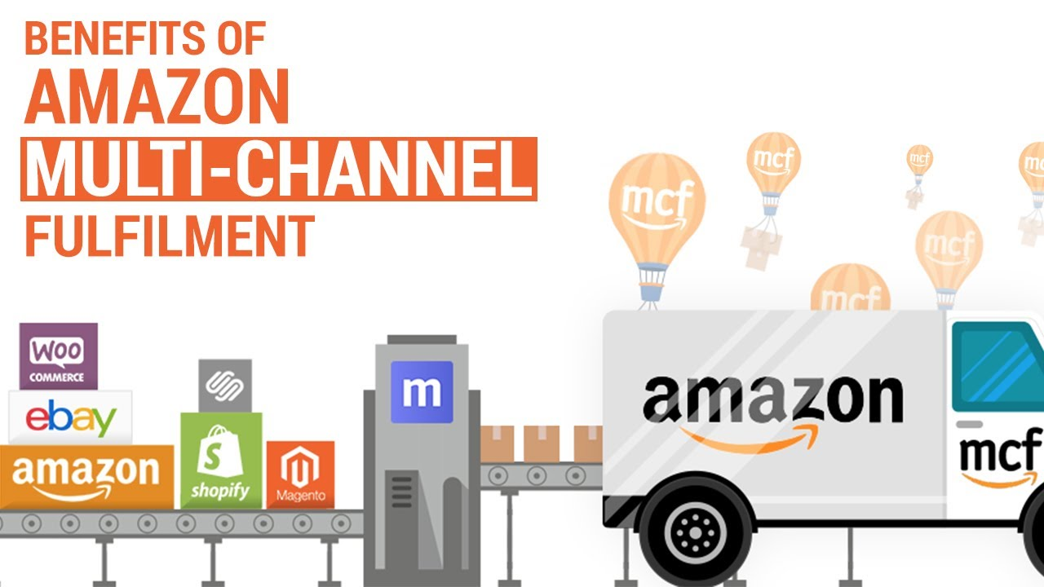
(Haselden, 2018)

Payment system
The payment system to be used for collection of Clear Facemask charges is through credit card option available on Amazon website.

Payment security plan
Though the security measures taken by Amazon payment segment are flawless and strong, Clear Facemask finance management will devise its own payment security plan as well to implement on its official website. The payment security plan in order to protect customer’s data and provide value to them will be comprised of following aspects:

SSL protocol
This is a systematic protocol which will be helpful in encryption of information and data on a specific website (Securion Pay, 2020). We will use this protocol in order to ensure data and information of customers’ credit card and bank details are protected to avoid any kind of cyber-attack.

PCI compliance
We will follow 12 general data security requirements outlined by PCI compliance by major payment credit cards i.e. MasterCard, Visa, American Express etc. to ensure payment security (Securion Pay, 2020). It will be helpful to make credit card transactions secure against theft and cyber attacks to protect transaction details and credit cards data.

Tokenization
We will use tokenization technology to ensure security of payment related transactions and data of customers related to credit card information. This technology will contribute in keeping a close check on identity of a cardholder and the person carrying out the transaction to avoid any kind of theft or misuse (Securion Pay, 2020). It will be helpful to reduce the chances of data breach, because if a token is stolen, it will be useless to fraudsters.
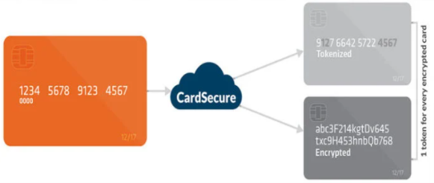
(Securion Pay, 2020)

3D Secure
This technology will provide an additional layer of security for card-not-present transactions under three domain secure model. These three domains include technology that processes the transaction, credit card issuing bank and the bank where the card is used (Securion Pay, 2020). It will use biometric technology to authenticate identity of a customer to avoid any kind of theft or data breach.

Address Verification Service (AVS)
This measure will help in avoiding any kind of fraudulent activity i.e. use of stolen credit card through billing address related to a credit with the one associated with it. This technology will add up an extra layer of security for Clear Facemask customers to ensure their data security.

3. Marketing

Product promotion strategy
The product promotion strategy for Clear Facemask will be comprised of following:
Segment target
The targeted market segment for promotion of Clear Facemask includes adults from 15 to 50 plus years irrespective of any income group or nationality (Camilleri, 2017). Due to widening of its targeted market segment, the potential of promotion of Clear Facemask is wide in UK as demand of visible facemasks is growing.
Pricing
Clear Facemask will promote its product by offering competitive pricing with high quality of its product along with unique features (Tanwar, 2013). It will operate on cost leadership strategy basis to attract and retain customers and further expand its targeted market segment outside UK.
Channels
The different channels which will be used to promote Clear Facemask will include:
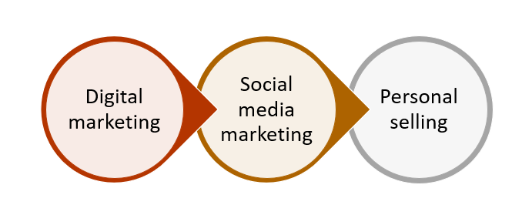
- Digital platforms i.e. TV channels.
- Social media platforms i.e. Facebook, Twitter, Instagram and YouTube.
- Personal selling through sales man on pharmacies and malls
Marketing plan
The marketing plan for promotion of Clear Facemask will be comprised of following aspects to accomplish its promotional targets related to sales, profitability and customer loyalty:
Prelaunch promotion
As a prelaunch promotional activity, Clear Facemask marketing team will approach YouTube influencers in UK to create awareness for this new facility. It will be helpful in assessing and conducting detailed market research about potential of visible facemasks and demand related to different colours, designs and styles.
Social media marketing
The social media marketing of Clear Facemask will comprise of following areas:
Social media handles
Clear Facemask marketing team will create social media accounts and fan pages on Facebook, Twitter and Instagram. These platforms are highly populated with customers of all age groups which are expected to achieve marketing objectives of this new product launch (Abdallah Alalwana & P.Rana, 2017). Clear Facemask marketing team will utilize online algorithm to show its ads on different social media handles that search using keywords to ensure optimum utilization of marketing budget.

YouTube promotions
Clear Facemask marketing team will send gifts and give away to top YouTube influencers and Vloggers in UK to persuade customers to utilize this new product. It will also hire reviewers with dense followers on YouTube to promote this new product among their audience (Chen, 2020).
Blogging through Amazon Affiliate Program
Clear Facemask marketing team will utilize online blogging platforms through use of Amazon Affiliate Program by offering commission to bloggers who write about this new product on their blogs to encourage audience to purchase it (Prater, 2020).

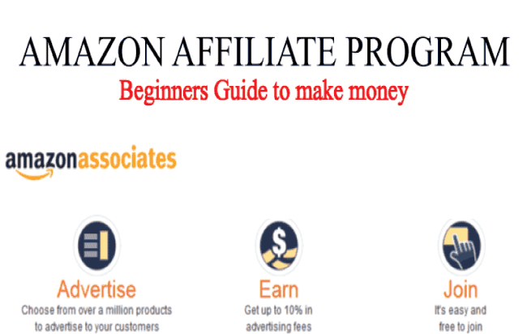
(Prater, 2020)

Marketing objectives
The objectives of marketing of Clear Facemask include following:
- Breakeven point: To attain breakeven point within one month of launch of Clear Facemask.
- Sales: To grow sales @10-20% during first two quarters of its launch.
- Market expansion: To expand its market from UK to Europe within 8 months of its launch.
- Customer loyalty: To grow customer loyalty to achieve recurring sales through high customer satisfaction throughout its operations.

Market positioning
The market positioning of Clear Facemask in UK industry has shown as follows:

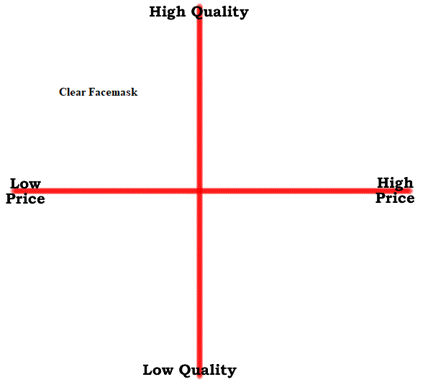
(Author)

Promotional budget allocation
The promotional budget allocation of Clear Facemask has given as follows:
Print media = £2000
Social media = £1000
Personal selling = £1000

Marketing mix
The marketing mix of Clear Facemask has stated a follow:

(Polo, 2018)

Marketing mix element | Description
Product | - Visible face mask in one standard size i.e. 20.5 X 11.5cm  - Available in five different colours  - Available for both men and women  - Offered in four different themes  - Anti-fogging technology incorporated
Place | - Available online through Amazon.com for customers in UK.
Price | - Offering competitive pricing i.e. £190 for bulk purchase of 100 units.
Promotion | - Digital and print media: Ads are to be displayed on one TV channel for first two weeks prelaunch and six weeks post launch.  - Social media: Facebook, YouTube, Twitter and Instagram accounts will be created by Clear Facemask marketing team (Newberry, 2020). It will also build up official website to project traffic from its social media handle along with Amazon.com page link.  - Personal selling: Customers will be approached on metro stations and malls with free samples for six weeks post launch.

Control
In order to ensure the marketing plan for promotion of Clear Facemask accomplishes its objectives, the marketing team of the company will follow following process:
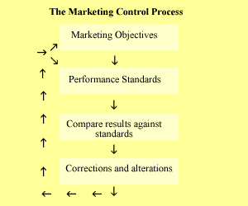
(Gok & Hacioglu, 2010)

Marketing objectives: Foremost marketing objectives will set using SMART framework i.e. Specific, measurable, achievable, realistic and timely (Chaffey, 2020).
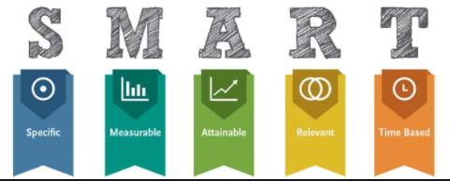
(Chaffey, 2020)
Performance standards: Once marketing objectives are set, the next step will involve setting performance standards in terms of key performance indicators (KPIs) such as revenue percentage, profitability percentage, breakeven point etc. (Gok & Hacioglu, 2010).
Comparison of results: At the end of allocated time period, the marketing results will be compared with set KPIs (Chen, 2020).
Corrections and alterations: In case of positive results, the same strategies will be continued for marketing of Clear Facemask otherwise alternations would be made (Chen, 2020).

References
- Abdallah Alalwana, A., & P.Rana, N. (2017). Social media in marketing: A review and analysis of the existing literature. Telematics and Informatics , 34 (7), 1177-1190.
- Camilleri, M. (2017). Market Segmentation, Targeting and Positioning. Travel Marketing, Tourism Economics and the Airline Product , 1, 100-105.
- Carragher, G. (2020). How to Leverage the Power of Amazon FBA. Retrieved Nov 05, 2020 from https://www.bigcommerce.com/blog/amazon-fba/#disadvantages-of-using-fulfillment-by-amazon-fba
- Chaffey, D. (2020). How to define SMART digital marketing objectives. Retrieved Oct 09, 2020 from https://www.smartinsights.com/goal-setting-evaluation/goals-kpis/define-smart-marketing-objectives/
- Chen, J. (2020). How to set ecommerce social media up for success. Retrieved Aug 25, 2020 from https://sproutsocial.com/insights/social-media-ecommerce/
- Davis, L. (2020). The Complete List of Your Amazon Delivery Options. Retrieved Oct 05, 2020 from https://www.offers.com/blog/post/amazon-delivery-options/
- Gok, O., & Hacioglu, G. (2010). The organizational roles of marketing and marketing managers. Marketing Intelligence & Planning , 28 (3), 291-309.
- Haselden, J. (2018). How to Sell on Amazon for Beginners Using FBA: A Step by Step Guide. Retrieved Nov 05, 2020 from https://www.nchannel.com/blog/how-to-sell-on-amazon-for-beginners-using-fba/
- Martin, J. (2020). Benefits of Clear Face Masks for Individuals Who are Deaf and Hard of Hearing. Retrieved Nov 09, 2020 from https://www.boystownhospital.org/knowledge-center/communication-benefits-of-clear-face-masks#:~:text=In%20addition%20to%20speaking%20slowly,of%20hearing%20communicate%20more%20easily.
- Mora, M. (2020). 9 Product Development Strategies To Consider. Retrieved Nov 05, 2020 from https://www.relevantinsights.com/blog/product-development-strategies-to-consider
- Newberry, C. (2020). How to Create a Social Media Strategy in 8 Easy Steps (Free Template). Retrieved Oct 17, 2020 from https://blog.hootsuite.com/how-to-create-a-social-media-marketing-plan/
- OECD. (2020). The face mask global value chain in the COVID-19 outbreak: Evidence and policy lessons. Retrieved Nov 05, 2020 from http://www.oecd.org/coronavirus/policy-responses/the-face-mask-global-value-chain-in-the-COVID-19-outbreak-evidence-and-policy-lessons-a4df866d/
- Polo, M. P. (2018). Acts or events? A perspective from the marketing mix. IROCAMM-International Review Of Communication And Marketing Mix , 1 (1), 56-66.
- Prater, M. (2020). Everything You Need to Know About the Amazon Affiliate Program. Retrieved Nov 05, 2020 from https://blog.hubspot.com/sales/amazon-affiliate
- Securion Pay. (2020). Everything You Should Know About Payment Security. Retrieved Nov 05, 2020 from https://securionpay.com/payment-security/
- Singh, G. (2012). Just-in-time manufacturing: literature review and directions. International Journal of Business Continuity and Risk Management , 3 (1), 57 - 98.
- Tanwar, R. ( 2013). Porter’s Generic Competitive Strategies. IOSR Journal of Business and Management , 15 (1), 11-17.
- Technavio. (2020). Coronavirus Outbreak Boosts the Sales of World’s Top 10 N95 Mask Manufacturers. Retrieved Nov 05, 2020 from https://blog.technavio.com/blog/top-10-n95-mask-manufacturers
- Ueda, J. (2020). The benefits of clear face masks—and where to buy them. Retrieved Nov 09, 2020 from https://www.usatoday.com/story/tech/reviewedcom/2020/07/22/benefits-clear-face-masks-and-where-buy-them/5489635002/#
- WFMJ. (2020). Face Mask Market 2020 Global Industry Size, Share, Price, Trend and Forecast to 2025. Retrieved Nov 05, 2020 from https://www.wfmj.com/story/42542755/face-mask-market-2020-global-industry-size-share-price-trend-and-forecast-to-2025
- Whitley, A. (2020). Face Masks 101: Benefits, Types And How Often You Should Use One. Retrieved Nov 05, 2020 from https://eminenceorganics.com/ca/blog/2019/09/30/face-masks-101-benefits-types-and-how-often-you-should-use-one

