Synthesize a solution to a potential real life scenario
Andom Alemayo: Computer network: Module: Computer Networks and cyber security
Abstract: Forensics is the application of scientific techniques and procedures to find solution to the committed crime by maintaining the best practice.

Index Terms: Secure Digital (SD) cards, the forensic toolkit (FTK), Structured Query Language (SQL), Computer Aided Investigative Environment (CAINE), Message-digest Algorithm (MD5), Secure Hashing Algoris1 (SHA1),

INTRODUCTION
T
his assignment is associated with the computer forensic analysis process where a given case requires evidence that is required to be presented in the court of law.
The use of investigative techniques, methods practices, procedures and tools will be displayed throughout to give an insight into how software’s are able to trace evidence.
Investigative tools allow to gather evidence from lost, corrupt and deleted files as well as files that are present on the disk drive, things such as usernames, passwords, files, hidden files and other amenities can be discovered and presented into a viewable format for the user. The processes of evidence collection include: collecting the evidence from the raw origin, processing of the evidence into a viable format and presenting the evidence into a format that can be presented to a jury in court.

task one

research on the forensic tools
Definition of Forensics

The term forensics is derived of the Latin word “forensis” which means community conversation. However, in this modern times the contextual meaning has changed and the term is constantly used in the judiciary system and this contributes to the definition forensic [1].
Therefore, forensics can be defined as the application of scientific techniques and procedures to find solution to the committed crime.
Although, the forensic science is a broad subject and it tends to cover different fields of science such as Toxicology, Psychology, Geology, and Optometry and so on, the main focus of this discussion is going to be about Digital forensics [1].

Digital forensics

Digital forensics is an offshoot of forensic science that utilised scientific knowledge to for gathering, parsing, preserving and presenting the digital evidences which are associated with the computer crime to be used in the court of law. Digital forensics can be classified into many groups based on the source of the acquired electronic evidence as Computer forensics, Database forensic, Network forensic and Mobile forensics [1]

Computer Forensics
Computer forensic is a branch digital forensic that deal with extracting electronic evidences that can be gained from desktop computers, laptops, digital storage devices like External hard drive, Pen drive and Secure Digital (SD) cards. And the digital data stored in the Random Access Memory.

Mobile Forensics
Mobile Forensic is an offshoot of digital forensics that involves the acquisition of digital evidence from the mobile devices. Mobile devices can be any computing devices like Smart phones, Phones, Tables, Smart watches, and other wearable devices that are capable of making phone call via the standard communication networks [2].

Network Forensics
Network Forensics is another branch of digital forensics that concerns with supervising and parsing the traffic flow in the digital network. It involves processes like identifying intrusion or finding out the source of the cyber security attack. What makes this type of digital forensics unique is that, it deals with dynamic and live data only [3].

Database Forensics
Database Forensics is also another division of digital forensics that deals with the investigation of data and metadata which are presented in the data base like Oracle, Structured Query Language (SQL), MYSQL and many more.

Digital forensics tools

Below are some of the most popular forensics tools which are frequently used to in investigating digital crimes.

SANS Investigative Forensic Toolkit (SIFT)

The SIFT Work station is an open source forensic tool which is commonly used incident response digital forensic investigations. This tool is created to undergo in-depth forensic examinations in a different setting. It encompasses different tools which are used in a virtual machine as a forensic suit. SIFT is based on Ubuntu operating system and can be used to examine a number of files systems, and evidence formats [4] [5].

EnCase forensic tool

The EnCase is one of the most popular commercial source forensic tool commonly used for data acquisition, analysis, classification, recovery and restoration of the past events. It is a very handy tool when data imaging or disk imaging is required. EnCase allows the investigators to be able connect the Ethernet cable with the suspected device so that the data in the device can be seen. Possessing a mechanism that prevents the investigators from committing any alteration to the original data source makes the tool more acceptable in front of the law.
This is mainly because the EnCase concept is founded on the evidence file, which encompasses the header, data blocks and checksum. The data blocks are data clones of the suspected device and the checksum is done to verify any error that might took place in copy the data as well as to notify any modifications on the main data source [6]. Some advantages of EnCase are;
It is produces a simplified reporting architecture in comparison to the other tools. Customizations of object oriented programming language can be done easily with EnCase. However, this tool possesses complex features in terms of the designer and user interface. The live searches and time limitations of the end user training are some drawbacks of this tool comparing to the other tools.

Forensic Toolkit (FTK)

The forensic toolkit (FTK) is another famous forensic tool which allows the investigator to choose the preferred hashing option to verify disk drive during the coping process. It is also a convenient tool for cracking passwords of documents locked with Portable Document Format, Excess spreadsheet and so on.
Moreover, FTK is capable of providing more relevant evidence at the relatively shorter time comparing to the other forensic tools [7].
In doing so it uses the distributed processing and it is the only forensic solution that can make use of the multi-core computer this means it is possible to allocate the analysis and processing to three computers which in turn allow the computers to perform the three analysis tasks correspondingly. This process accelerates the forensic processes [6].
Additionally, the completion of the indexing a head makes filtering and searching more efficient comparing to the other tools.
The use of the secure and central one shared case database decreases the cost and difficulty which can occur due to many data sets [8].It possess a highly developed feature and characters relative to EnCase. It uses easy methods to scan the digital data hard drive and memory card. However, combining this tool with intermediary tool is complicate and tedious process [9].

Operating System Forensics (OSForensics)

Although this tool is commercial, it is relatively low cost and easy to use comparing to some commercial forensic tools. Additionally, this tool can perform most of the tasks which can be done using tools like EnCase and FTK but it does not have some specialised features like a known File Filter [6].
This tool is very helpful in enabling effective data management effectively. Addition it also allows quick extraction of digital evidences from a computer via advanced search and indexing.
Nevertheless, this tool has some drawbacks. For examples it has watermarked view and it allows only five passwords per browser type [6].

Helix

Helix is a Linux live Compact Disk (CD) which is mainly utilised for forensic computers. The data presented in the suspected device can be analysed by letting the device to boot into Linux using the Helix CDs then, with the help of the tools in the Helix, the data source can be analysed. Helix possess many useful features, despite of all these features the tools is not as popular EnCase and FTK [6].
This tool is mainly utilised in incidence response, hex editors and password cracking besides the computer forensics [10].
Forcing the devices to boot into Linux using a CD leaving the tool to be distinguishable from the above-mentioned tools [6]. Helix possess key feature which enables the tool to acquire, analyse and generate live network data. However, the backup and live process of this tool are little bit complex. Additionally, this tool also has a complex command which require training and knowledge to master them.

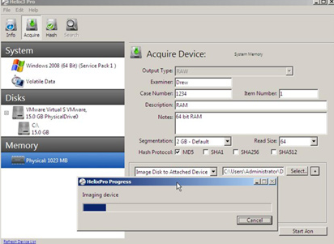
Figure 1- Helix software [11]

The Sleuth Kit

The sleuth kit is an assembly of command-line tools and a C programming language library. This tool kit permits the investigator to analyse the disk image in a live system. And since this tool does not relay on operating systems to process the file system, it is possible to perform an investigation in an interruptive way to discover the view the hidden and deleted files [11] [12]. The sleuth kit tools are capable presenting the content of the data blocks within the file system, displaying the node information, search for the file or directory, copying image of the hard disk so on. It is layered approach in which the different tools utilised for a particular layer and each layer represents different category of analysis media. The file system present in the in different disk partitions like Fast File System (FFS), Extended 2 File Systems (ext2fs), and File Allocation Table (FAT) and so on [13].
Autopsy is a graphical overlook of sleuth which is allows access to the Sleuth through browser.
Sleuth Kit have a fewer features and not easy to use as compared to other forensic tools. It is not also recommend for general search of the deleted files [6].
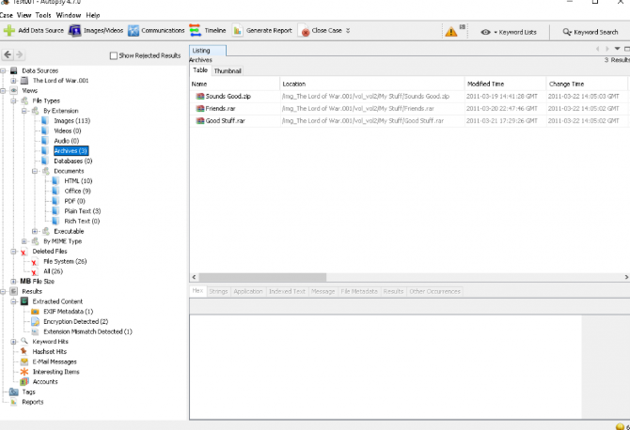
Figure 2- sleuth kit forensic tool [15].
Computer Aided Investigative Environment (CAINE)

CAINE is an open source forensic tool which created in 2014. The name CAINE is derived from the famous character “Horatio Caine” television series.
CAINE is based on Linux live Compact Disk (CD) and it is also endowed with various tools such as semi-automated report creation and tools for mobile forensics, user-friendly Graphical User Interface (GUI), Network forensics and Data Recovery and more [14].
CAINE tools can let the investigator to be able to perform time line analysis, keyword searching, hash filtering, and many other tasks.
What makes CAINE distinguishable from the other distro is that it provides a collection of general purpose desktop tools that enables it to be used as a typical Ubuntu system and at the same time maintain the existence of advanced forensic tools. Moreover, it also avoids the necessity for going back and forth between the normal desktop environment and the sophisticated forensic features. Unlike the other purpose distro CAINE has the capacity of running in a virtual partition together with Virtual Machine Workstation (VMW). In CAINE mounting is only carried out via Mounter which is an applet [15].
CAINE also holds a number of specialized tools such as memory forensics, mobile devices, databases and networking [15].
Currently, the latest version Caine 10.0 is based on Ubuntu 12.04 and Linux kernel 3.2. And it came up with many useful updates, such as e Win-UFO which can provide a better way of incident Response or Live analysis on the windows operating system [15].

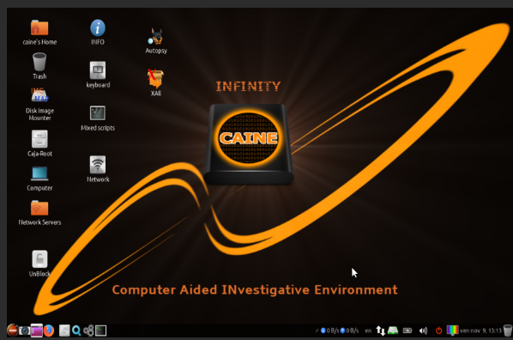
Figure 3- CAINE forensic tool [14]

Bulk Extractor

Bulk Extractor is an open source computer forensic tool that has the capacity of extracting user credit card number, email addresses and Uniform Resource Locator (URL) and other useful information from the electronic evidence files. Using this tool it is also possible perform tasks like malicious software and intrusion investigation, cyber investigation as well as parsing image data and cracking passwords and so on [16].
Unlike other forensic tools, Bulk Extractor has the capacity of extracting processing curved or compressed files such as zipped (ZIP) files and Portable Document Format (PDF). Based on the words in the data and the zipped files which are present in the unallocated space this tool can build words which can be utilize in cracking password [16].
Moreover, this tool also operates by scanning the directory of the file, disk image or a file to obtain a useful information but without analyzing the file system. The findings are stored in an isolated file so that it can be further, investigated or analyzed using another forensic tools [16].

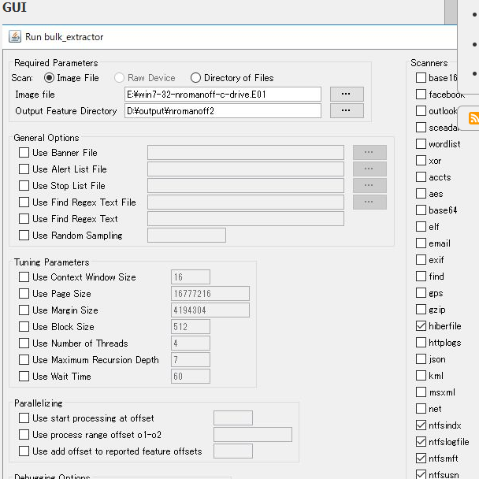
Figure 4 bulk extractor forensic tool [17].

Volatility
Volatility framework is an open source memory forensic tool which encompasses a number of tools. It is also based on python programming language. This tool is commonly utilized for incident response and malicious software parse. Mainly because it is very powerful in extracting the volatile digital information which are stored in the Random Access Memory (RAM). And the obstruction technique can be performed in any device regardless of the system under investigation and it still will provide a remarkable visibility into the runtime of the system [17].
Moreover, using this tool it is also possible to extract digital information from the network sockets, live procedures, registry hive and network configurations. And it also assists in pulling out memory dumps from a number of Operating Systems such as 32-and 64- bit Windows versions, services packets including XP, server 2003, 2008 R2 and so on. In addition to these, Volatility also has the ability to deal with memory dumps like those in a virtual machine snapshot raw format, a Microsoft crash dump, Linux memory dumps, hibernation files and others [15].

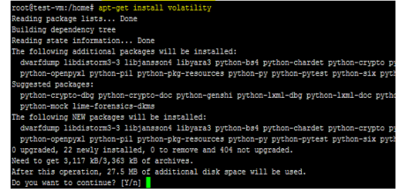
Figure 5- volatility forensic tool [18].
The table below shows the classification of digital forensic tools.

Tool type | Type of operating system | Type of digital forensics
SIFT | Ubuntu | Computer Forensics
EnCase | Windows | Computer Forensics
FTK | windows | Computer forensics
OSForensics | windows
Helix | Windows | Network forensics
Sleuth Kit | Linux | Computer forensics
Bulk Extractor | Linux | Computer forensics
CAINE | Linux | Computer forensics
Volatility | Linux | Computer forensics

Table 1 – classfication of digital forensic tools.

- Task Two

- Forensic methodology
Forensics methodologies are step by step scientific procedures that enables the criminal incident handler to collect a valid and crucial information which can be presented in the court through the investigator in order to execute the criminal investigation.
As a branch of forensic science, Digital forensics should also have to follow certain methodologies in gathering, preserving, examining, analyzing and presenting the digital evidences. But most importantly the evidence has to be authenticated, acquired without any modification, analyses without any alteration and admissible [18].

Figure 6 - example

Digital forensic investigator is an individual who is responsible for providing an expert explanation or clarifications of the evidence in a more secure format which is legally acceptable. This profession requires a wide range of experience, knowledge and skills about the forensic processes and the forensic tools. A high level of literacy is also important as the report needs to be presented in the court [19].
Incident handling is the outline of the processes and prescribed actions needed for an effective, efficient and actionable incident management. The personnel that deals with the incidence is called incidence handler [18].
Based on the given scenario John is the incident handler, who is going to utilize all the necessary forensic methodologies and procedures to collect and deliver a useful evidence to the investigator Mr. Mark Wales, who is in turn going to use these evidences to write an expert report in relation to the case and present it to the court in a legally accepted manner.

The author of this report is going to take part as an incident handler and this is mainly because the author lacks the necessary skills and experience that an investigator possesses. Additionally, license and certifications are also required to work as an investigator [1].
In conduct forensic investigation on the suspected device, the forensic processes which are involved will be clearly discussed. The first process details all the necessary activities and processes which are required to collect the evidence source. In the second process the major tasks needed to be taken to preserve the source of the evidence will be briefed out. And after examining the image files, analysis will be conducted and then the report will be generated.
First and foremost, the incident handler (John in this case) needs to agree about the payment
Of taking the case before hand, unless they are clients.
  - Data collection process
In the data collection process the first step is data seizure. And in this step more emphasis should be placed on collecting the physical evidence of the suspected device in this step.
To start the case, John should prepare an evidence form. And as John has done, photos of the suspected Dell laptop need to be taken. Then, John should start taking some filling the evidence to get details about the type of the device, model, serial number and state of the device to check whether the device is in a hibernating mode, standby mode and so on. To facilitate the process, the incident handler can also label or put tags to the device. Additionally, the time clock on the Dell Laptop should be recorded and checked against the actual time. The state of the lap top should also be checked to see whether the device is switched ON or OFF. Additional noted should also be taken by asking Mr. Mark Wales. And this marks the end of first step [20].

See the photo Laptop taken while collecting the digital evidence.

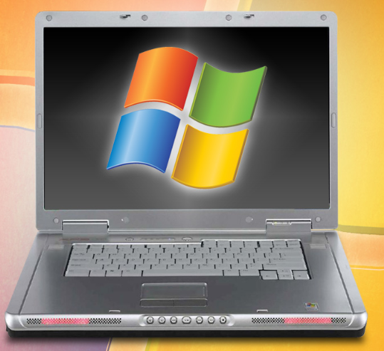
Figure 7 - Shows the sample photo of the photo captured during data collection process.
[21]

The main objective of the data seizure is to confirm that the source of the evidence is not tampered and at the same chain of custody is maintained.
The figure below shows the possible details of the Laptop device.

Device type | Serial number | Operating System | Model
DEL Laptop | MNE15689445 | Windows XP S2 | Dell “Inspiron 15.6”
Table 2 – Shows Details of the device

Then on a second step, the data acquisition process has to be done. And since the Dell laptop was in its Standby mode which means the device is not fully switched off. Care must be taken not to lose the volatile data. Volatile data are electronic information which are stored temporarily on the Random Access Memory (RAM) of the computer and this type of data will disappear once the power of the device is turned off. Some examples of the volatile data are system files, open files, network in formation, process information, command history and so on.
To be able to protect the volatile data John should use the Volatility forensic tool which has the capacity of extracting volatile digital information from RAM, cache and Registry hives. Using this tool, it is possible to extract the digital data from the network sockets, live procedures, and the network configurations. Volatility also aids in pulling out memory dumps from a number of Operating systems [22].
Next, to acquire the data which residence on the hard disk of the Laptop, John should implement the data acquisition technics using the forensic software tools. This tools play a great role in the extraction of the non-volatile data. Non-volatile data are electronic information which are stored magnetically in the secondary memory. Second memory could be Hard disk, Solid State Drive
(SSD), Pen drive, or Memory card, Compact Disk (CD) and so on. On the digital devices non-volatile data can be found in the hidden files, index.dat files, swap space, unused partitions, registry setting and so on [23].
Unlike the volatile data of these type of data does not disappear when the power of the device is switched off.
To acquire the exact copy of the source data, it is best recommended that John use an automated Forensic tool called FTK Imager tool which has the capacity of acquiring a bit –bit copy of the original data. And once a clone of the original data is gained, the FTK Imager can generate an Message Digest algorism (MD5) and Secure Hashing Algoris1 (SHA1) values which can be used to verify integrity of the data but it is also possible to use forensic tools such as Hash Calculator (HashCalc) or HashMyFiles which are very helpful tools that uses to authenticate the bit-stream image of the data source. At this stage it is also expected from John to compare the MD5 and SHA1 values of the original data with its bit-stream image data and if both matched, Mr. Mark and John should put their signatures on the evidence files for approval, and authentication. And above all to maintain the chain of custody [24] [25].

The figure below shows the result of the check sum the Laptop hard disk and its image.
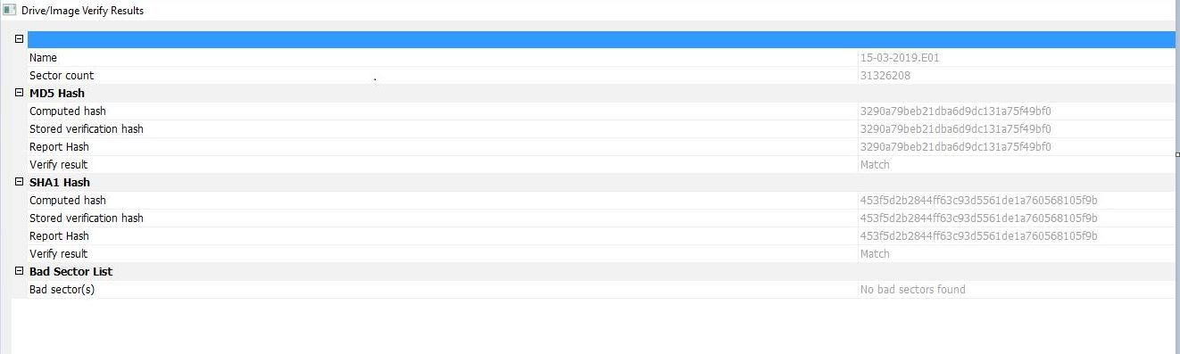
Figure 8 - Rresults of the MD5 and SHA1 values shows successful matching

  - Preservation process
During the preservation phase, once all the necessary data collection processes are completed, it is very important that the incident handler transported the suspected Dell Laptop device safely, where full protection from hazardous factors like physical and environmental factors such as ventilation, temperature, moisture are maintained. Placing the device in a well-designed bag like Faraday’s bag will also help in preventing data lose due to static electricity [26].
While in the laboratory, John should store the device in a very secure location where electronic, electrical, magnetic factors which has the potential of corrupting or destroying the device or the electronic data are taken care of [26].

  - Examination
Where to look for the non-volatile electronic data?
It should be clearly noted that, once the bit- by- bit copy of the image is acquired, John should perform the examination and the analysis process on the clone of the data.
Using the above tools John should search for files generated by the system like Log files, Configuration files, History files, Backup files and Printer Spool files. Likewise, John should also search for the files which are created by the user such as Database, Media files, Internet Bookmarks, presentations, Spreadsheet, Portable Document File (PDF) and Address book. And finally, to thoroughly investigate the protected files, John should also search for the compressed files, encrypted files, Hidden files, Password protected files, files having extension mismatch and Steganography [27].
Steganography is a technique of hiding information in a way that the data and message looks like invisible by hiding them in to different places.
To gain the digital information stored temporarily in the Random Access Memory (RAM), John should investigate the system files, open files, logged –on users, process information, clipboard contents, service information, process memory, command history and so on [27].

  - Data Analysis
The data analysis process is a very important and talent demanding process. John must perform the data analysis process on the image of the data source and this is mainly because to present the tampering the actual source data [28].
Data analysis process require John to scrutinize, identify, sort-out, convert, transform and forming data into useful and meaningful and information.
Although, there are a number of forensic tools which enables the data analysis to be performed more efficient and effective. It is strongly recommended that, John use OSForensic, FTK, and Autopsy forensic tools. And this is mainly because these tools possess many features that enables the extraction of the useful digital files which can serve as a good evidence [28].
Upon the request of Mr. Mark, for the search of different documents and file types John should use the FTK Forensic tool. This is mainly because FTK tool has the potential of extracting various documents and file types including the hidden files, deleted files, encrypted files, steganography and compressed files [28].

How John should retrieve the requested file structures
- Once the image file is imported into the FTK, the software extracted the different file structures as it can be seen from the screenshot below.
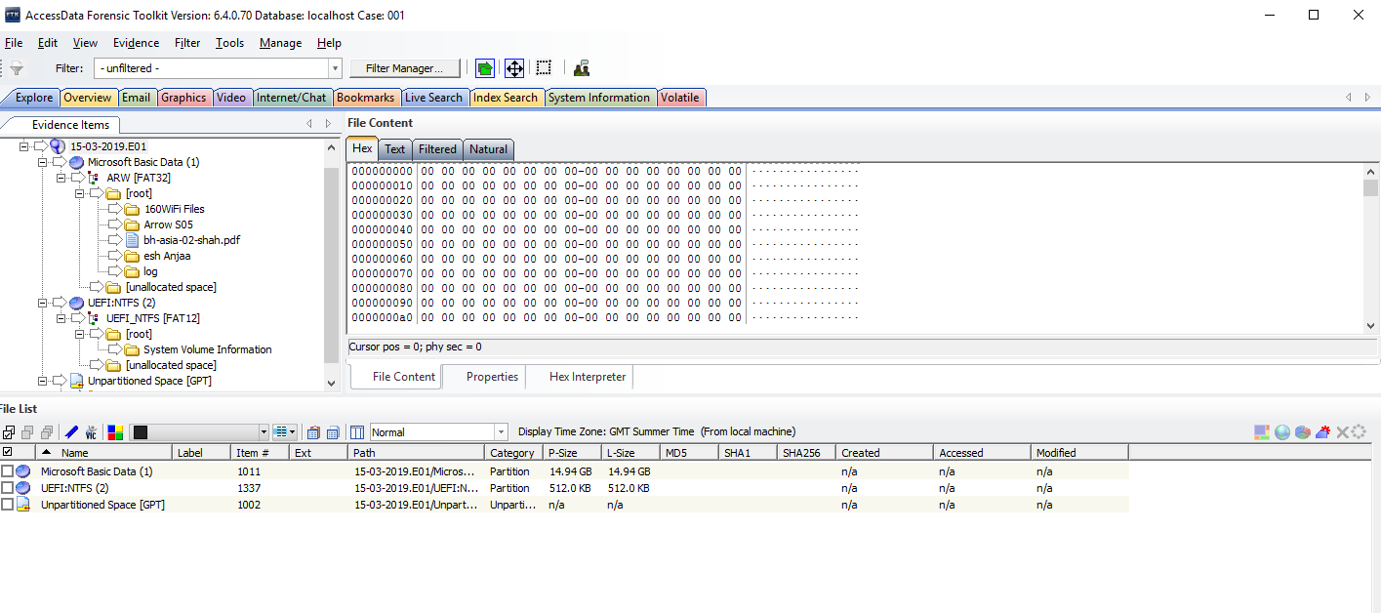
Figure 9 – shows the folder structure.

- To discover the different file types John should use the key words index search files that could be found in the unallocated space and the slack space.
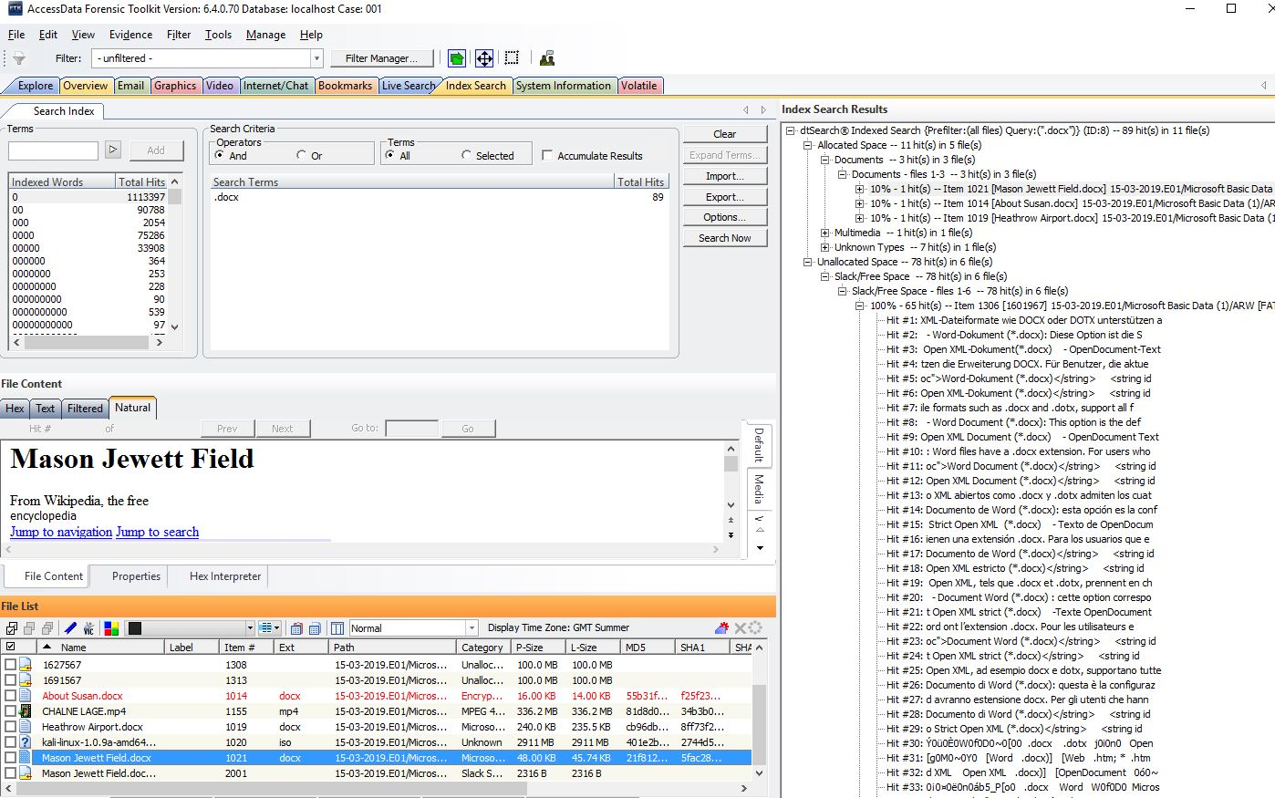
Figure 10 - shows the index search using .doc key word.

- John should look and search for the deleted, encrypted files and bad extension file by selecting the overview tab. See the screenshot below.
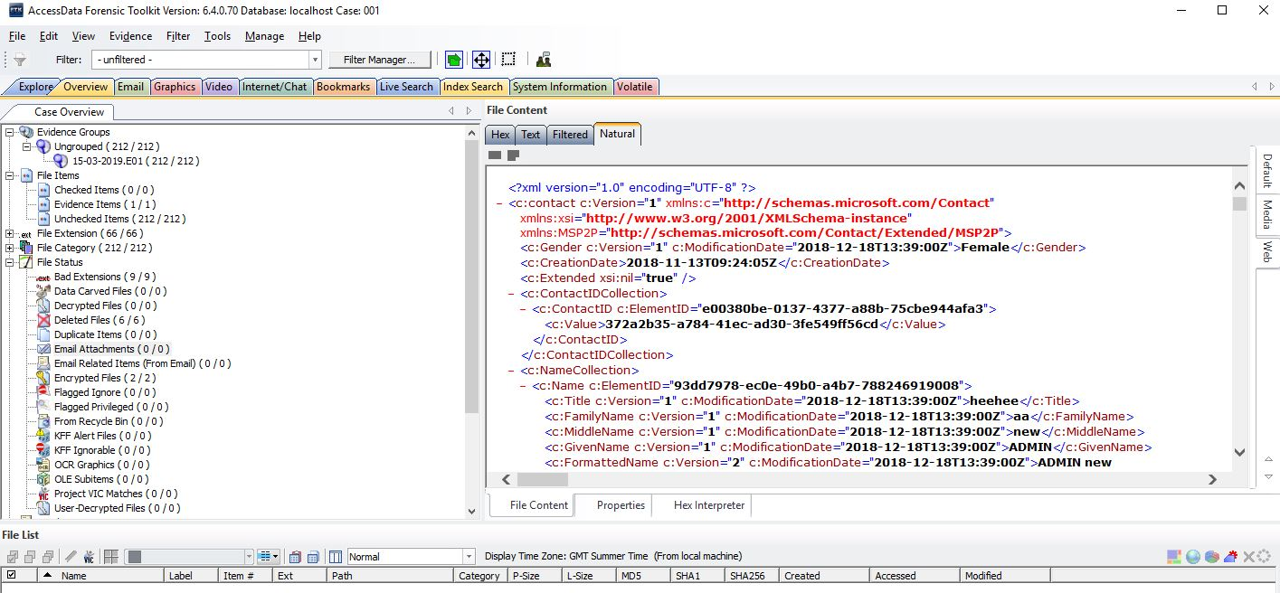
Figure 11 - contents of the hard disk

The result from the above screenshot shows that there are nine bad extension files, two encrypted files and six deleted files.

- For more in-depth search of the deleted, encrypted files or password locked files John should use OSForensic tool and this is because of the software’s ability of crack the passwords easily and decrypt the encrypted files.

The screenshot of the word document password cracking.

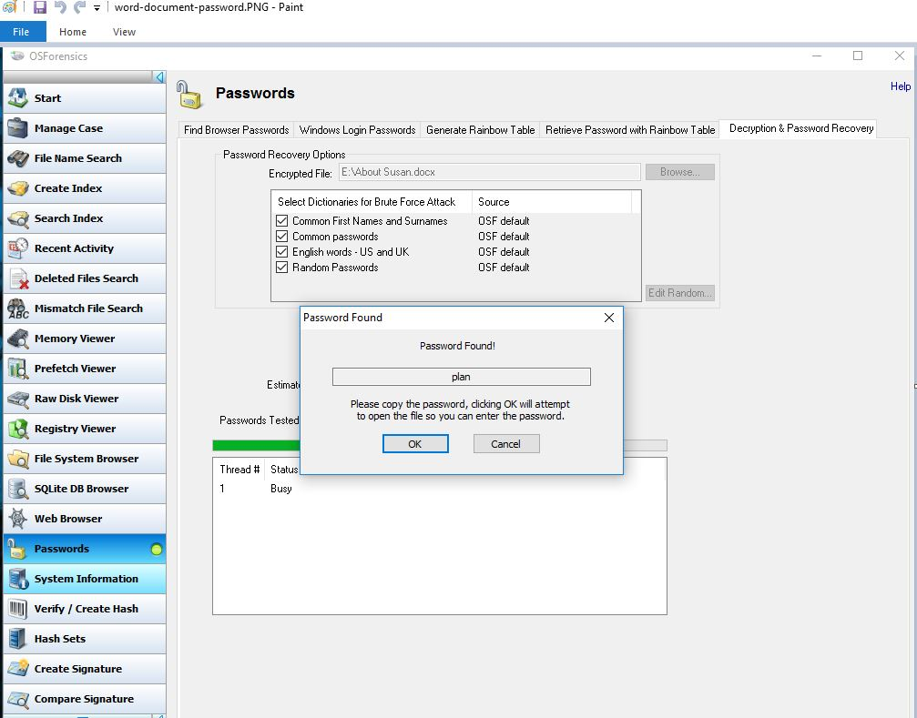

Figure 12 - shows the password of the document was cracked and it is found to be “plan”

- To be able to search for curved files and email analysis of the Internet related files, John should use the Autopsy forensic tool. This is because the tool has a strong capability of finding email files which are related to the case. The screenshot below shows the analysis of the email files [29].
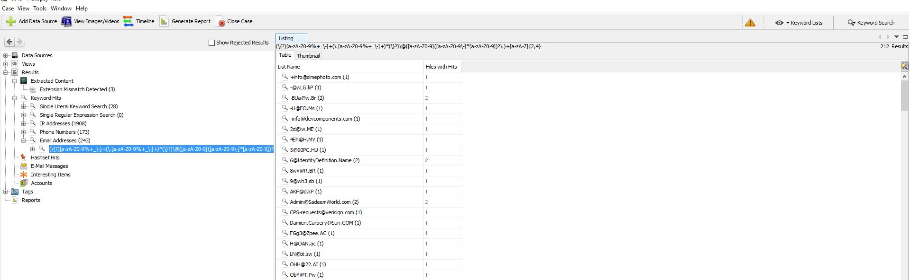

Figure 13 - shows the email addresses found using Autopsy

- Discovered list of videos and documentation

After discovering and viewing the video details, John should prepare a brief documentation regarding the contents of each video and the list of videos found. And up on writing the documentations, John should include the timing of when did the video where created, modified, accessed, the forensic tool implemented to extract this files, and their root directory on the file system, in order to maintain the authentication, admissibility and reliability of the evidence obtained by maintaining the chain of custody.
Moreover, the video obtained looks suspicious and they need to be handed it to Mr. Mark Wales who is the chief investigator and who studied criminology. Mark can also see and decided whether the evidence gained has a link with the case or not. Besides, Mr. Mark Wales is the one who have the right to give an expert witness by conveying or demonstrating a complicated technical details into a simple and understood way or language. Moreover, the expert witness is the only one who can include owns opinion. While other witnesses are only allowed to justify what they have heard or seen. And this is due to the facts that the Judges lack of technical knowledge about the digital evidence.

And who knows, the video may also detail a plot of attack in the feature, as the video shows the detailed view of the Fuji airport, military training on the camp, the 9-11-2001 attack on the United State of America, terrorist speech and many more similar videos. So it is strongly suggested that John provided a short brief about the documentation to Mr. Mark Wales.

- Software used to extract the list of terrorist contacts in the Microsoft Outlook

To find out the contact list of the suspected terrorist, John should use an email analysis forensic tool such as Paraben Email Examiner. This is because this tool has a powerful email examining capacity. It analysis email archives from the Outlook, Outlook Express, Box, and Mozilla Mail, Microsoft Network(MNS) mail and so on [18].

- Excel sheets discovered

To investigate the contents of the excel sheets which are protected with a password, John first needs to crack a password using an OSForensic tool. See the screengrab below.
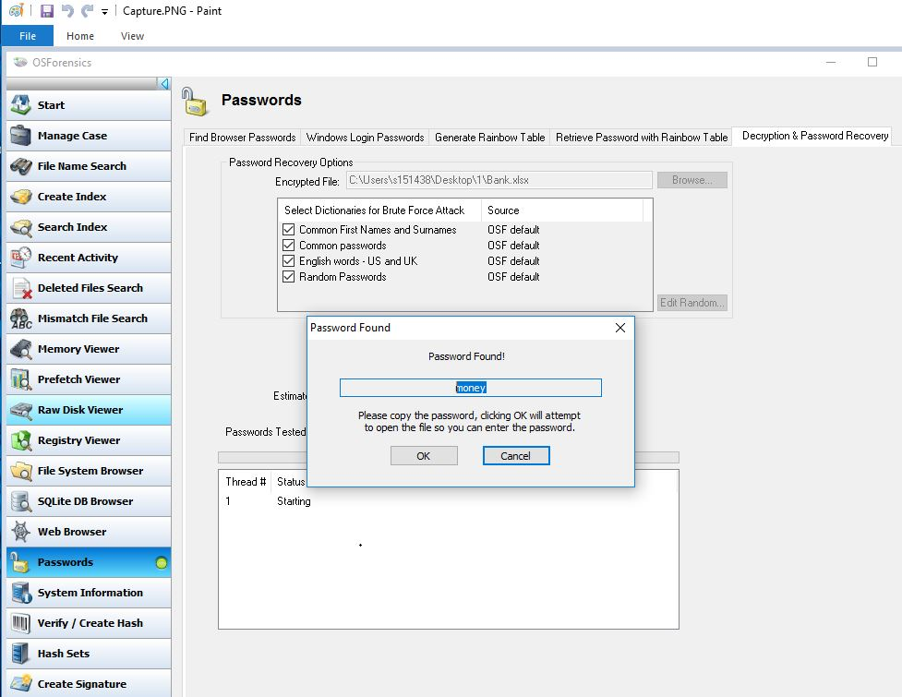
Figure 14 - shows the password of the Excel file was cracked and it is found to be “money”.

Then using the password “money” to the excel sheet, John be able to find the following bank account names and details of inflow of funds to the account.
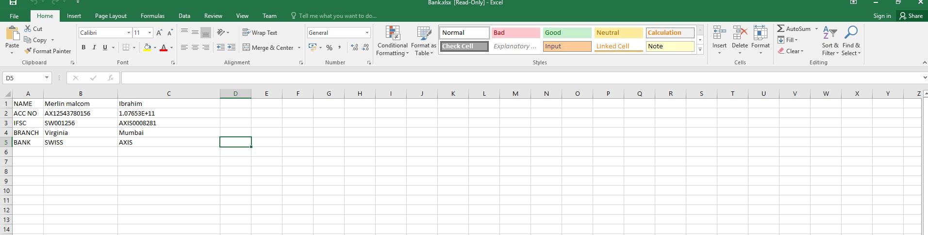
Figure 15 - shows the content of the excel sheet

- Report to be given to Mr. Mark Wales

Digital analysis has been conducted on the image of the source data using the digital forensic tools FTK, Autopsy, Paraben and OS Forensics.
Upon the investigation of the digital data image using the FTK tool, it is discovery that the fifty eight items where checked out of which out of which are fourteen documents, twenty two graphs , and ten folders seven file systems, where discovered. The graphs discovered depicts the detailed view and map of the London airport, London Bridge, Hotels, and maps along with passport of women.

Files with bad extension, and stenographic files were as also discovered, the content of these files is also revealed by changing the file extension.
Two password protected documents were also and using the OS Forensic tool the password of these tools was cracked.
The content of the email files and their address was also examined using the Email examiner tool called Paraben.
The files located in the unallocated spaced and slack space are also check for useful digital information.

While conducting the analysis using the FTK software thirteen video file was discovered, and after a closely watching the contents of the each video it’s discovered that the all the video shows an act and speech of the tourism. As this created suspicion to the incident handle, the video contents will be send to you for further investigations.
See the attached file located on the appendix section.

Conclusions
For the best analytic result of the digital information research about the most important and commonly used forensic tools were conducted. The pros and cons of each tool has been also briefly discussed.

Finally, digital evidence were successfully gathered. All the necessary digital forensics methodology and procedures were followed. And up on the careful follow up of the methodology, an authentic and admissible digital evidence was collected, analyzed and once, useful and uncorrupted digital information were gathered a report was drafted to the investigator so that and an expert witness related can be presented to the law of court.

References

[1] | H. A. Nihad, Digital Forensics Basics, New York: Apress, 2019.
[2] | T. R. a. B. S. Mahlik Heather, Practical Mobile Forensics, New York: Packt Publishing, 2016.
[3] | D. Samir, Learnig Network Forensics, Birmingham : Packt Puplishing, 2016.
[4] | SAND DFIR, "SIFT Workstation," SAND DFIR, 2018. [Online]. Available: https://digital-forensics.sans.org/community/downloads. [Accessed 27 February 2019].
[5] | R. K. S. Elizabeth K. Hawthorne, "TEACHING DIGITAL FORENSICS AND CYBER INVESTIGATIONS ONLINE : OUR EXPERIENCES," European Scientific Journal, vol. II, no. 15, september,2014.
[6] | C. Easttom, Systems Forensics,Investigaton, and Response, Burlington: Jones and Bartlett Learing, 2019.
[7] | Access Data, "FORENSIC TOOLKIT (FTK)," Access Data, [Online]. Available: https://accessdata.com/products-services/forensic-toolkit-ftk. [Accessed 28 February 2019].
[8] | T. S. a. B. Jenkison, Foresnsic Computing, Swindon: British Library Cataloguing in Publication Data, 2007.
[9] | D. R. Hayes, A Practical Guide to Computer forensics Investigation, Indianapolis: Pearson Education, Inc, 2015.
[10] | N. J. a. D. D. R. Kalbande, "A Comparative Study based Digital Forensic Tool:," The International Journal of, vol. I, no. 1, pp. 22-29, 2014.
[11] | Steve Ramos, Alain Gyger et al, "Is the Open Way a Better Way? Digital Forensics using Open Source Tools," in Proceedings of the 40th Hawaii International Conference on System Sciences, Pomona, 2007.
[12] | B. Carrier, Basis Technology, January 2019. [Online]. Available: https://www.sleuthkit.org/index.php. [Accessed 04 March 2019].
[13] | C. A. a. H. Carvey, Digital Forensics With Open Source Tools, Waltham: Elsevier,Inc., 2011.
[14] | "CAINE COMPUTER Forensics Linux Live Distro," CAINE , [Online]. Available: https://www.caine-live.net/page11/page11.html. [Accessed 06 March 2019].
[15] | C. A. N. A. e. a. Decusatis Casimer, "Methodology for an Open Digital Forensics Model Based on CAINE," in 2015 IEEE International Conference on Computer and Information Technology, Liverpool, 2015.
[16] | KALI TOOLS, "bulk-extractor Package Description," KALI TOOLS, January 2016. [Online]. Available: https://tools.kali.org/forensics/bulk-extractor. [Accessed 20 April 2019].
[17] | KALI TOOLS, "Volatility Package Description," KALI TOOLS, January 2016. [Online]. Available: https://tools.kali.org/forensics/volatility. [Accessed 22 April 2019].
[18] | C. D. a. D. C. Philpp Aaron, Hacking Exposed, San Francisco: MCGraw-Hill, 2016.
[19] | The Charted Society of Forensic Sciences, "Digital Forensic Investigator," The Charted Society of Forensic Sciences, 05 January 2016. [Online]. Available: https://www.csofs.org/Vacancies/Digital-Forensic-Investigator/37683. [Accessed 02 March 2019].
[20] | J. D. D. D. a. K.-K. Leom Di Ming, "Forensic Collection and Anaysis of Thumbnails in Android," 2015 IEEE Trustcom/BigDataSE/ISPA, vol. I, no. 3, pp. 1059-1066, 2015.
[21] | H. Alan, "what should I Do with My old Windows Xp Laptop," Gizmodo Media Group, 02 April 2017. [Online]. Available: https://lifehacker.com/what-should-i-do-with-my-old-windows-xp-laptop-493108508. [Accessed 01 March 2019].
[22] | Y. D.-N. Y. H. S. H.-H. Lin Yu-chieh, "Data Acquicition for Probalistic Nearest-Neighbor Query," IEEE Transactions on Knowledge and Data Engineering, vol. XXVII, no. 2, pp. 410-427, 2015.
[23] | G. T. L. T. a. M. T. Freiling Felix, "Advanced in Forensic Data Acquisition," IEEE Design & Test, vol. XXXV, no. 5, pp. 63-74, 2018.
[24] | A. C. a. H. Carvey, Digital Forensics with Open Source Tools, waltham: Elservier Inc, 2015.
[25] | L. Q. Z. P. e. a. Feng Peijun Feng, "Private Data Acquisition Method Based on System-Level Data Migration and Volatile Memory Forensics for Android Applications," IEEE, vol. VII, no. 13, pp. 16695-16703, 2019.
[26] | O. Adedyo, "Big data and digital forensics," in IEEE, Vancouver, 2016.
[27] | C. Dr.Campbell, "ACCB5000," UWTSD, 20 September 2018. [Online]. Available: https://moodle.uwtsd.ac.uk/course/view.php?id=4719. [Accessed 01 March 2019].
[28] | A. Varol and Y. U. Sonmez, "Review of evidence analysis and reporting phases in digital forensics process," in IEEE, Antalya, 2017.
[29] | M. H. Marie, Computer Forensics cybercriminals,Laws and Evidence, Burlington: Jones & Bartlett, 2210.

- Appendices

- Bomb key work index search

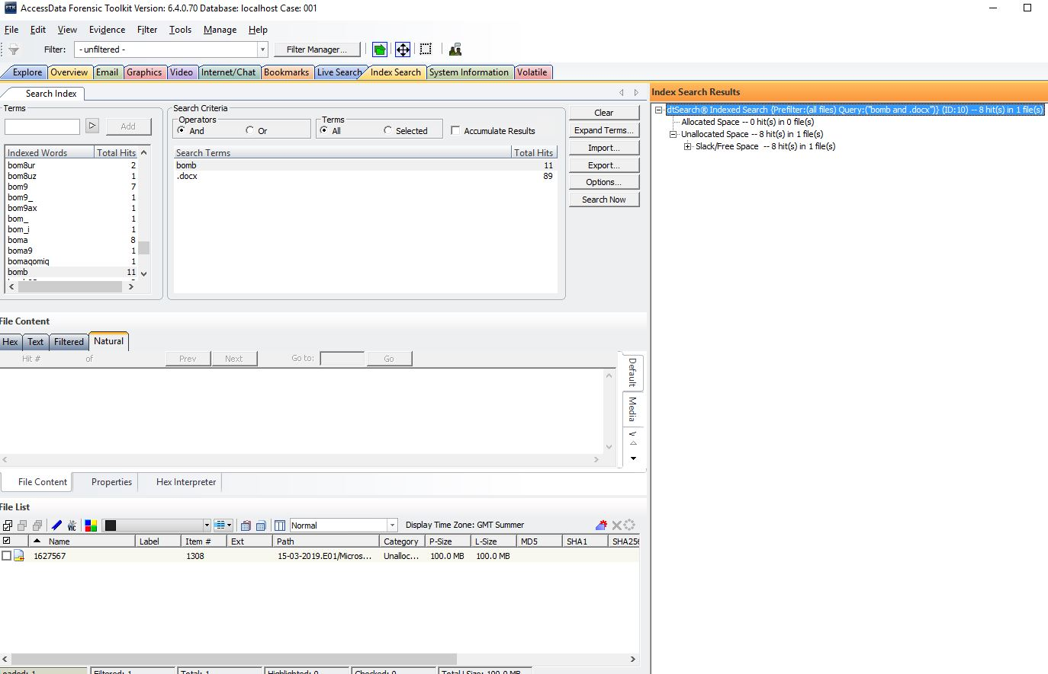

- Invoice

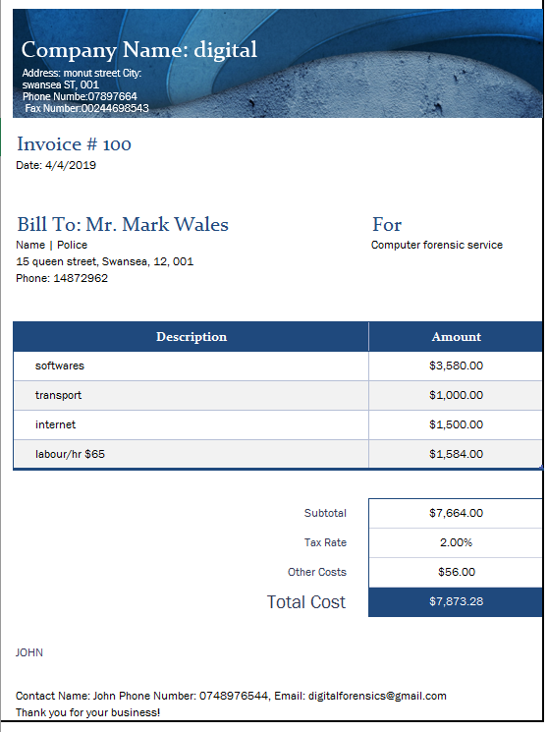

- The Video files did not include in the report which is generated by the FTK forensic tool. Therefore, a sample screenshot from each video are attached below.

- 9/11 bomb attack

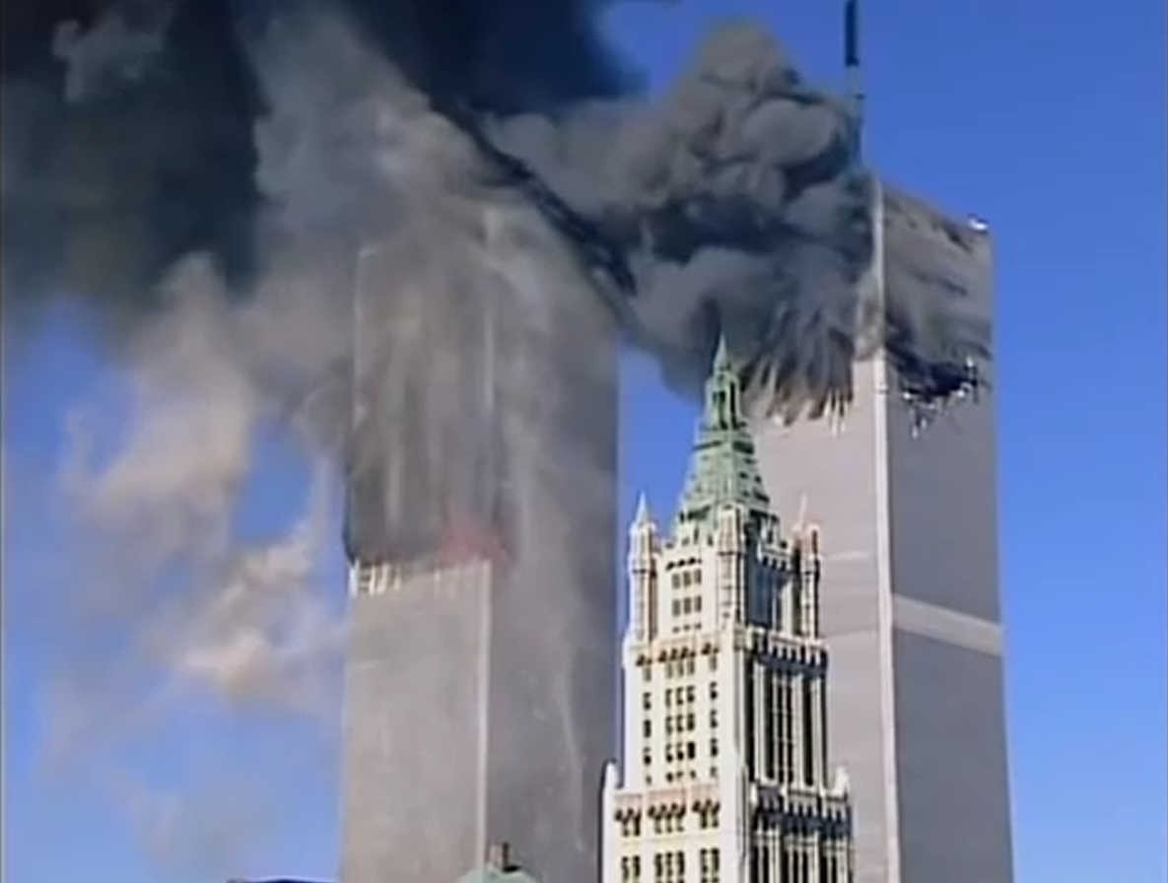

- 9/11 September 2001 attack plant

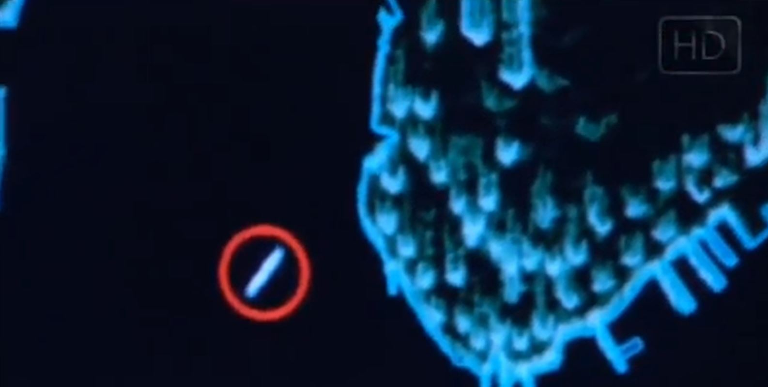

- How Brussels Bomb Attack happened

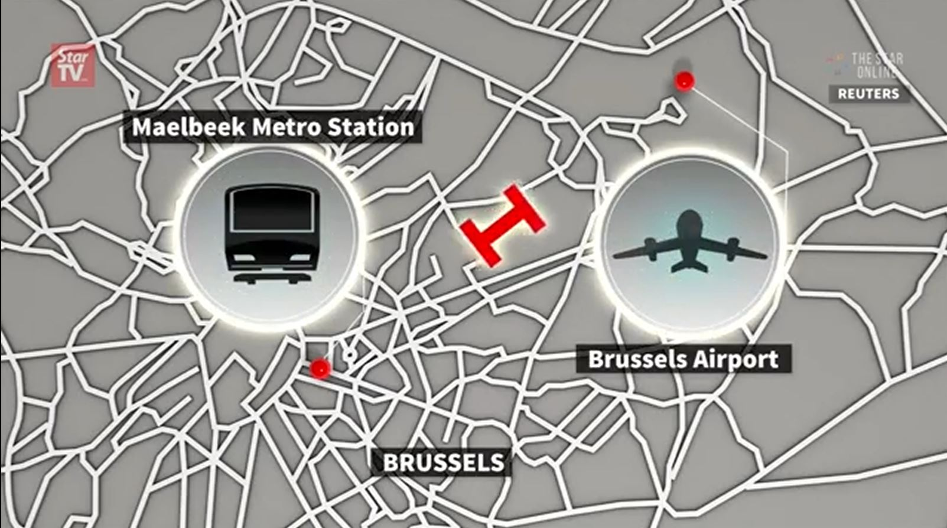

- Detailed view of London’s airport



- Modi’s speech on terrorism attack
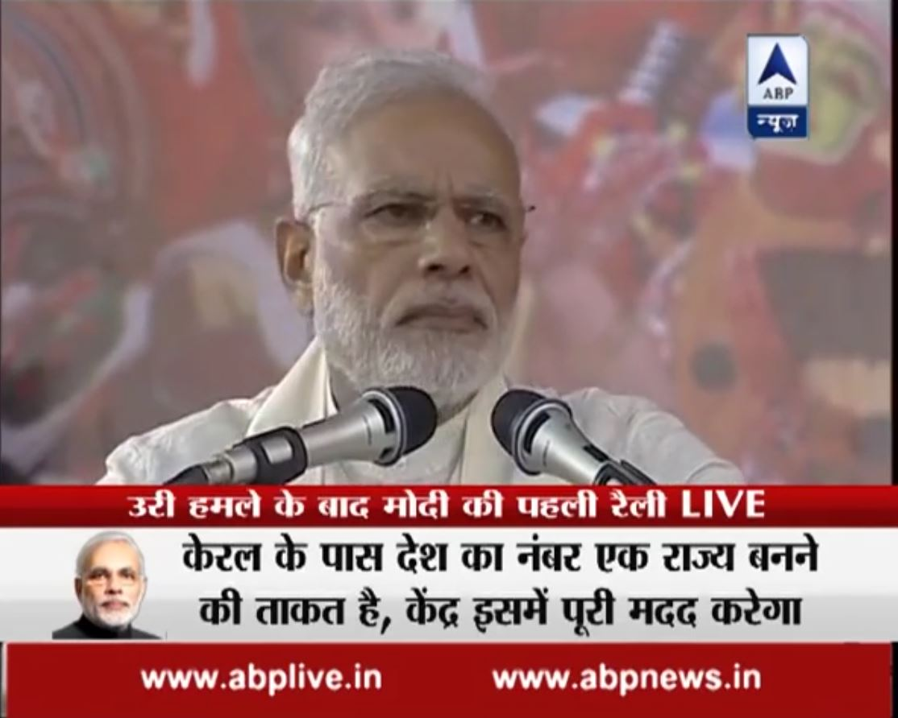

- Obama’s speech on strategies against ISIS

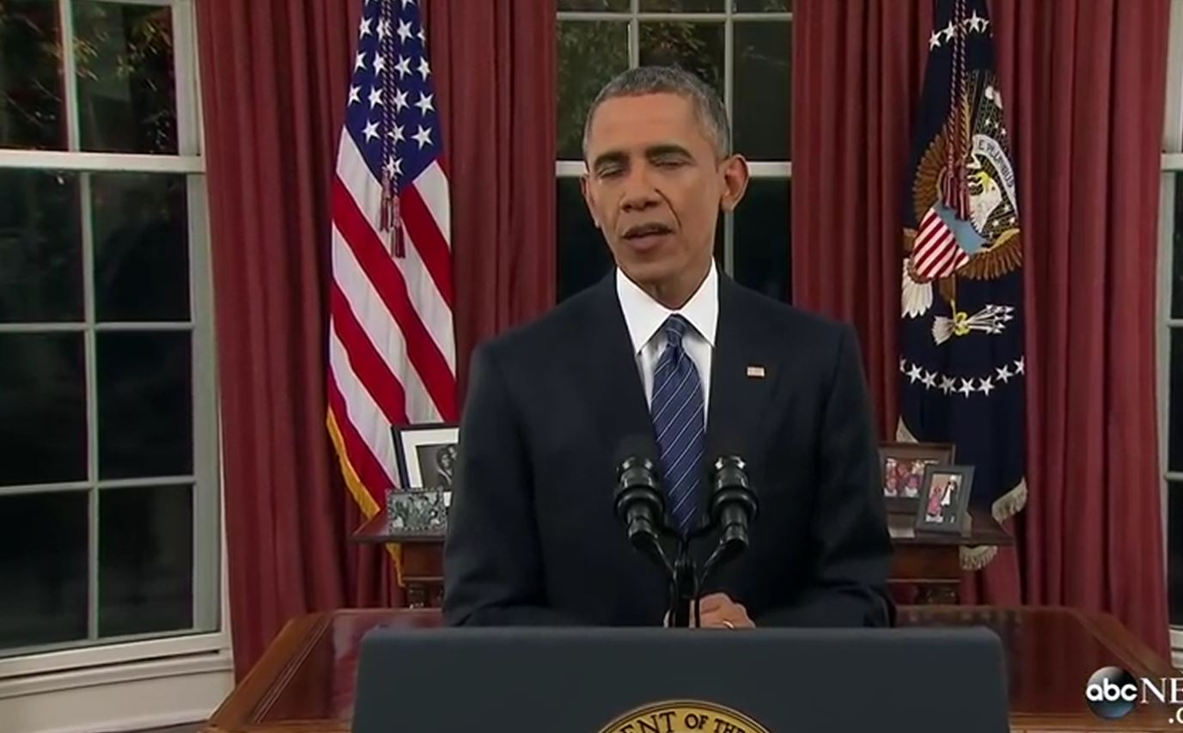

- Said Arab’s Crown Prince regarding the terror attack



- Video that shows the flying system of the FIJI airways



- Attack on Istanbul airport



- The world’s most wanted terror’s

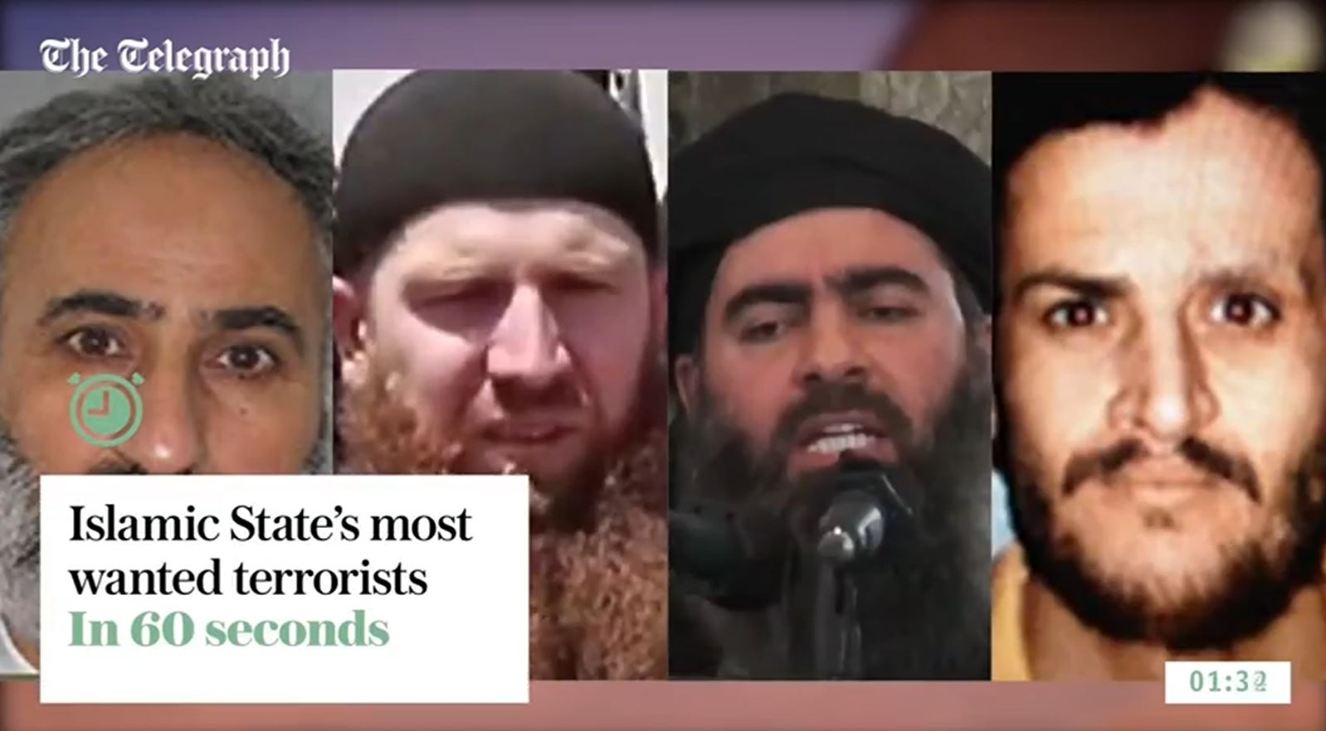

- Vishwaroopam’s bombing causality
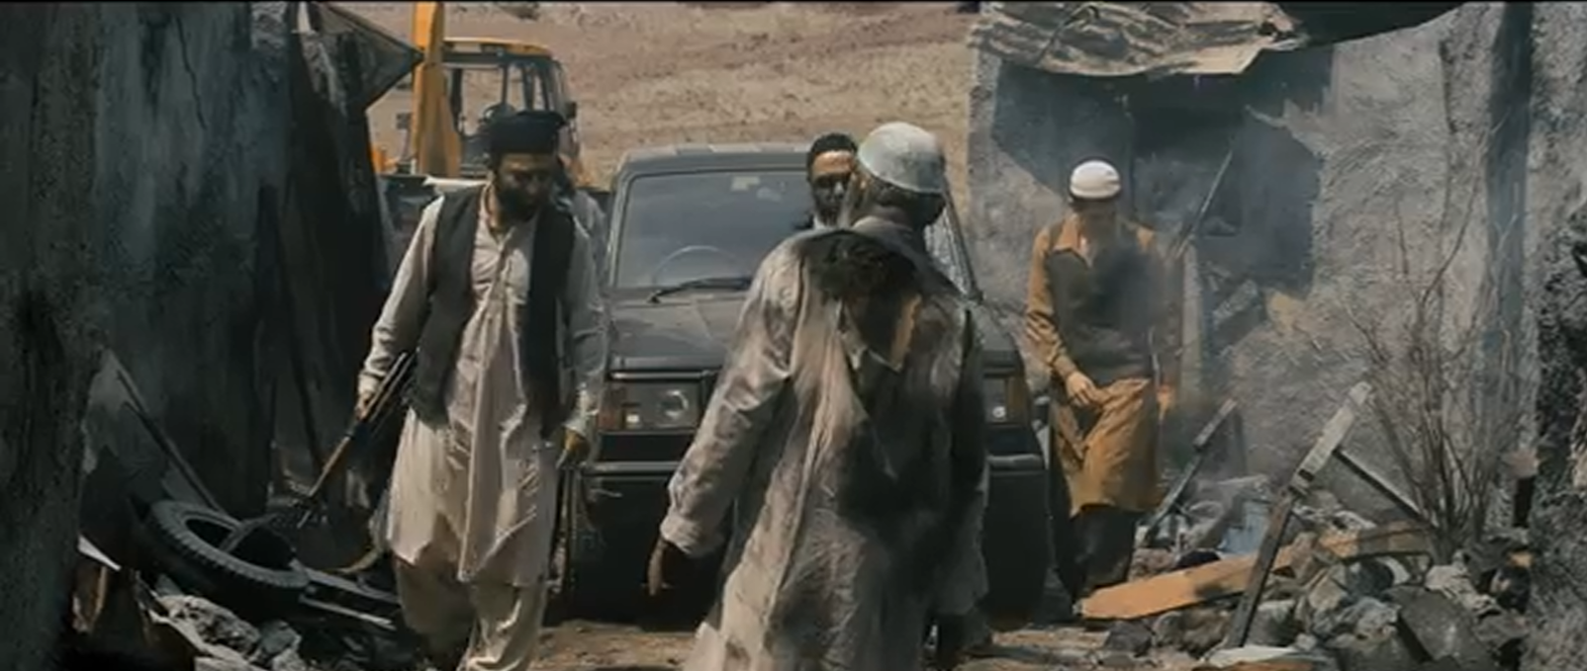

- Thuppaki Engal Tholile ‘s military training course at the camp
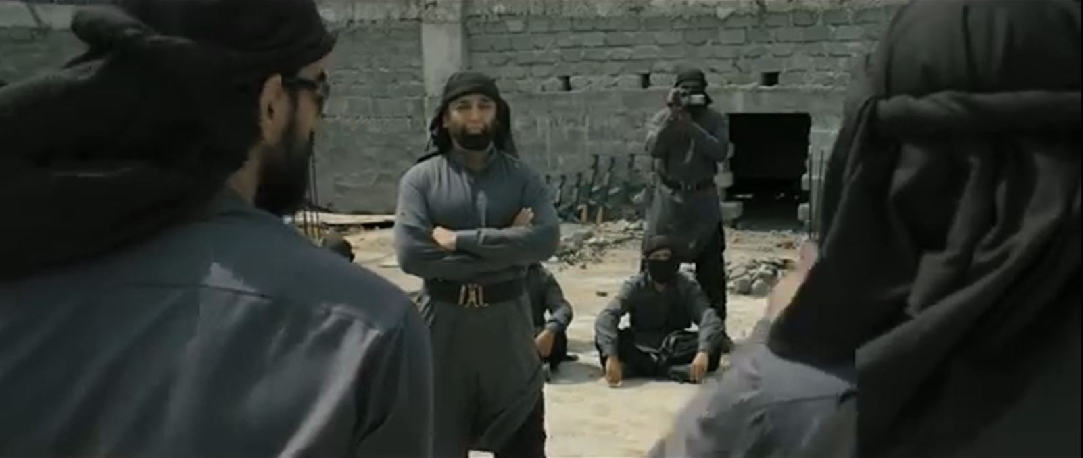

- Vishwaroopam’s expected confrontational scenarios
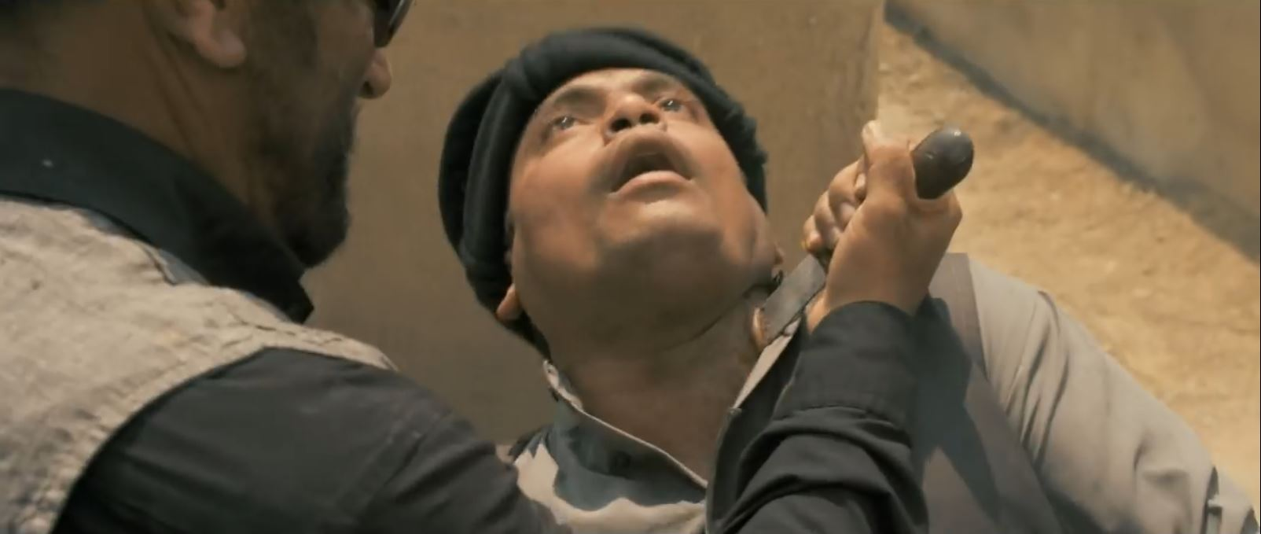

marking criteria and Student FEEDBACK

This section details the assessment criteria. The extent to which these are demonstrated by you determines your mark. The marks available for each criterion are shown. Lecturers will use the space provided to comment on the achievement of the task(s), including those areas in which you have performed well and areas that would benefit from development/improvement.

Common Assessment Criteria Applied (Assignment 1) | Marks available | Marks  awarded
1. Research-informed Literature
Extent of research and/or own reading, selection of credible sources, application of appropriate referencing conventions.
Outstanding knowledge of research informed literature. High level of referencing skills consistently applied. (Grade mark: 95.00%) | 20 | 19
2. Knowledge and Understanding of Subject
Extent of knowledge and understanding of concepts and underlying principles associated with the discipline.
High detailed knowledge & understanding of the main theories and concept (Grade mark: 93.33%) | 15 | 14
3. Analysis
Analysis, evaluation and synthesis; logic, argument and judgement; analytical reflection; organisation of ideas and evidence
ery high quality evaluation analysis developed. It would be good to maintain the numbering to match the development of the case for easier reading and marking but this was excellently done. Appropriate softwares/tools identified for the case scenario. Fees invoice included. In your conclusion it would be good to add recommendation or future work. (Grade mark: 95.55%) | 45 | 43
4. Practical Application and Deployment
Deployment of methods, materials, tools and techniques; application of concepts; formulation of innovative and creative solutions to solve problems.
Additional file uploaded as evidence that you have created a copy of the provided disk image without modification. It would be good if you had uploaded copied image to the provided link or shared it from OneDrive (Grade mark: 80.00%) | 15 | 12
5. Skills for Professional Practice
Attributes in professional practice: individual and collaborative working; deployment of appropriate media; presentation and organisation.
Can communicate professionally and confident in a suitable format  (Grade mark: 100.00%) | 5 | 5

Assignment Mark (Assessment marks are subject to ratification at the Exam Board. These comments and marks are to give feedback on module work and are for guidance only until they are confirmed. ) | Late Submission Penalties (tick if appropriate) |  | 93%
 | Up to four weeks late |  | 93%
 | First Attempt? |  | 93%

