L4 - Physics (OME) ACDA4007

Dynamic Stress-Strain Investigation

Natalie Coplin - 2113351
Contents
Figures 2
Tables 2
Abstract 3
Introduction 3
Method 3
Results 4
Discussion 6
Conclusion 7
References 9

Figures
Figure 1 ABAQUS error message 5
Figure 2 An example of the model set-up in ABAQUS 5
Figure 3 Graph showing the change in velocity of the projectile when it impacts the laminated armour plating – all 6 simulations 6
Figure 4 Graph showing the change in velocity of the projectile when it impacts armour plating 6
Figure 5 Graph showing the change in velocity of the projectile when it impacts armour plating 7
Figure 6 Graph showing the change in velocity of the projectile when it impacts armour plating 7

Tables
Table 1 Material parameters entered in to ABAQUS for each material 5
Table 2 Final velocity of the projectile for each combination of steels 8

Abstract
Using a predefined ABAQUS model of a high speed ballistic impacting a laminated plate, the behaviour of both the projectile and laminated plate were explored. Variations in material for the laminated armour was used and the change in velocity of the projectile from the point of impact was observed. f

Introduction
Finite Element (FE) Analysis, used in this assignment, is a numerical technique used to simulate physical interactions. Modelling this way can help reduce the risk of physical testing and also reduce the cost of producing many prototypes. It can also prove difficult to produce certain prototypes for real life simulations [1]. Utilising finite element analysis it is possible to put models through various stresses and observe how they behave and potentially fail. This allows for the quantification of any changes a material goes through under the load conditions of a simulation such as direct and sheer stress. Other conditions can be observed such as velocity change throughout the simulation, this comparison was chosen for this study.
Finite element analysis software uses a system of nodes and elements. These are arranged in a system referred to as the mesh and this mesh contains all the inputted properties of the model. Nodes are all connected to other adjacent nodes so the end result looks very much like a net over the model structures. This system reduces the infinite number of data points that would have results calculated for them, down to a manageable number (finite) [2]. Despite this system there will still be many thousands of nodes and elements!
In an attempt to accurately model the projectile and laminated armour plate in this study, the Johnson Cook material and damage models were used. The software chosen for the study was Dassault Systems, ABAQUS. These Johnson Cook models have been widely used and tested across many finite element analysis packages [3]. Both models are numerical with no physical foundation [4]. C. Roth and D Mohr highlighted many studies when the Johnson Cook models have proved to be suitably accurate in computational studies [5]. Modelling/simulation of composite materials has been comprehensively studied in recent years due to the potential benefits offered over solid materials. Its light-weight nature and penetration resistance to high speed impact is of great interest. The material used needs to be resistive while also dissipating the impact to avoid injury to the wearer or to prevent damage to a vehicle, for example. As mentioned above real life studies can prove difficult to undertake and computer modelling has been the method of choice for initial studies [6].
A predefined model was used as a starting point. This model contained material data for copper, plastic, another steel and aluminium projectile. Johnson Cook parameters for different steels were obtained and entered in to ABAQUS. Three different types of steel were chosen for this study, AISI 1045, AISI 4140 and AISI 4340. After material parameters had been entered in to ABAQUS for each steel and the details for copper confirmed, side by side comparisons were made of changes to velocity after impact with the laminated armour plate.

Method
Starting with a supplied model set-up of a projectile and a laminated plate with five individual layers, data for the Johnson Cook damage model and the Johnson Cook material models were entered in to ABAQUS using the material manager. The parameters for these models can be seen in Table 1. The materials were then assigned to parts for the projectile or laminated armour plate. Working through options in ABAQUS such as mesh, interaction and load other conditions of the simulation were defined. Each of the simulations were conducted as dynamic explicit analyses.
Material | A (MPa) | B (MPa) | n | C | m | d1 | d2 | d3 | d4 | d5 | Transition Temp ( °C) | Melting Temp (°C)
AISI 1045 Steel [7] | 50.1 | 176.09 | 0.518 | 0.106 | 0.57 | 0.025 | 16.93 | -14.8 | 0.021 | 0 | 1200 | 1520
AISI 4140 Steel [8] | 595 | 580 | 0.133 | 0.023 | 1.03 | 1.5 | 3.44 | -2.12 | 0.002 | 0.1 | 1200 | 1416
AISI 4340 Steel [9] | 792 | 510 | 0.26 | 0.014 | 1.03 | 0.05 | 3.44 | -2.12 | 0.002 | 0.61 | 1200 | 1416
Copper [10] | 320 | 80 | 0.324 | 0.012 | 1 | 0.54 | 4.89 | -3.03 | 0.014 | 1.12 | 1000 | 1085
Table 1 Material parameters entered in to ABAQUS for each material
Due to lack of experience with the software, a significant amount of troubleshooting was required throughout the simulations. One of the error messages which could not be easily resolved can be seen in Figure 1.
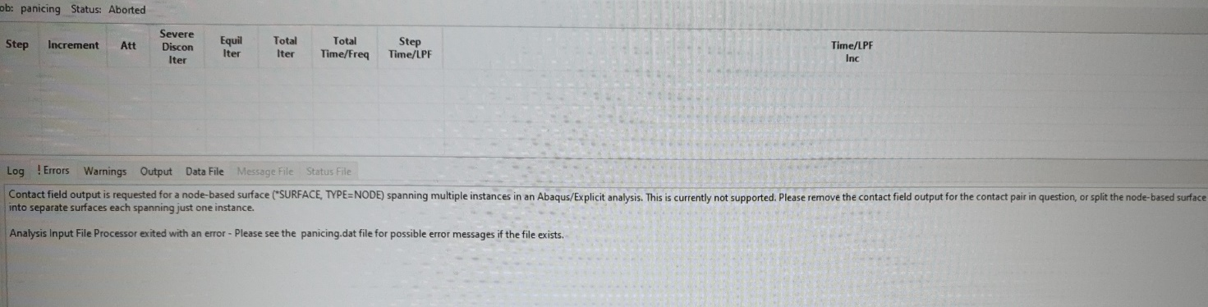
Figure 1 ABAQUS error message
Figure 2 shows a screenshot of one of the six material set-ups in ABAQUS. Each material is assigned an alternative colour, this can be used as a quick cross reference to ensure the material assignment has been done correctly. The alternating steels in the laminated armour plate are easily visible.
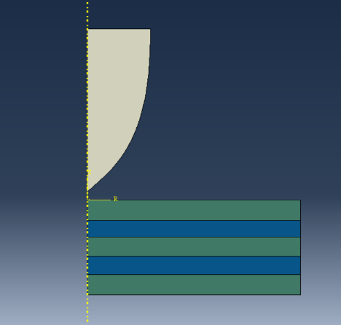
Figure 2 An example of the model set-up in ABAQUS

Results
Due to the large amount of data obtained during the simulations, the extracted data from ABAQUS has not been included in this report but is available upon request.
For all graphs the first number for each simulation indicates three layers of this material in the laminated plate. The second number indicates two layers of that material in the laminated plate.

Figure 3 Graph showing the change in velocity of the projectile when it impacts the laminated armour plating – all 6 simulations

Figure 4 Graph showing the change in velocity of the projectile when it impacts armour plating

Figure 5 Graph showing the change in velocity of the projectile when it impacts armour plating

Figure 6 Graph showing the change in velocity of the projectile when it impacts armour plating

Final velocity of the projectile at the end of the simulation (m/s)
1040/4140 | 1040/4340 | 4140/1040 | 4140/4340 | 4340/1040 | 4340/4140
131.3559 | 127.84509 | 137.0274 | 173.51013 | 127.87994 | 140.63648
Table 2 Final velocity of the projectile for each combination of steels

Discussion
The results clearly show a decrease in velocity when the projectile impacts the laminated armour plate in each simulation in Figure 2. Initially this is largely the same in each simulation but in the 4140/1045 and 4140/4340 model the decrease in velocity drops significantly at approximately 0.00011 seconds, indicating armour with more layers of 4140 steel may not be as effective as the other combinations where 4140 is only in two of the laminated layers. Considering there is a decrease in velocity all combinations of steel can be said to have been successful in slowing down the projectile however, none of the simulations completely stopped penetration.
There are unexpected fluctuations in velocity on the graph. These may be due to elements in the laminated plate shrinking and then being deleted at failure. The simulation then considers the projectile to be accelerating as there are now no nodes directly in front of it and therefore no material. Another possible explanation is the layers in the laminated plate may not have been adhered together correctly in the model, so when the simulation is run each layer is affected individually rather than as one entire plate and they effectively move passed each other.
Looking at the data in Table 2, there is clearly a combination of steels which performed slightly better than the others and a combination which was considerably less effective at slowing down the projectile. Both combinations of 1040 and 4340 have a greater resistive force than the other combinations of steel. The simulations with 4140 and 4340 resulted in a much higher final velocity. This implies that 4140 is the weakest of all three steels used in this study.
Despite the many benefits of FE analysis, it does have some serious drawbacks and flaws. The biggest of these is the user. Without extensive knowledge and experience it is extremely challenging to create an accurate and precise model reflecting a real life test. This is possibly a contributing factor to the unexpected increases in velocity shown in the results. A comparison study of real life and FE analysis [11] noted that real life residual velocities were lower when compared to FEA velocities for that set-up. The authors proposed this may be due to their limited knowledge of the effect of dynamic friction and a lack of availability of some required material parameters to input in to the FEA software.
There are also some points to bear in mind when considering if the model reflects real life events.
- No centripetal force was applied to the projectile in the simulation. This does not account for the potential greater penetration power of rifled ammunition (due to less speed and therefore energy being lost prior to point of impact when compared to non-rifled ammunition) [12].
- If programmed correctly the model will presume perfect adhesion between laminate layers. Whereas in reality an armoured plate would have many inherent lamination flaws, such as air pockets. In addition to this, the model doesn’t account for possible micro-fractures in the armour plate that would affect its actual response to the impact.
- The simulation is limited by number of nodes, affecting the reliability of the data set. The number of nodes can be increased but this also increases the running time of the simulation and the amount of data obtained. This is a balancing act! To some extent the model removes real life randomness. For example, if the simulation was run 1000 times, the results would be the same every single time. Real life does not reflect this and it is unlikely the same results would be obtained twice if 1000 tests were conducted.
- ABAQUS does not have the capability to consider external factors e.g. heat from direct sunlight having an effect on the material properties of the model. This could potentially have serious consequences in real life.
- In the simulation the projectile is on a perfectly straight path - it is level at the point of impact. In a real life situation, projectile trajectory would affect the penetration depth.
- Setting up ABAQUS to realistically represent the real life material features would help in producing a valid simulation. It is not known if all the possible parameters were entered in to the model set-up. For an inexperienced user of any FEA software, the menus are complicated, this could easily lead to missing information.

An understanding of the material responses to any simulation is critical to valid interpretation of the results [13].

Conclusion
Finite Element Analysis can be incredibly useful, providing the user has the knowledge and experience to input the required information, ask the correct questions of the software and correctly interpret the results. Getting an answer is not the difficult part, getting an accurate answer for what you want to ask, is [14]. Consideration of factors affecting impact dynamics is essential in order to produce a suitable model for simulation [15].
The modelling in this simulation provided data, but perhaps more experience of the software and the ability to troubleshoot issues would provide some confidence of reliable and accurate results. M.A.G Silva et al [16] suggest simulation data should always be compared to real life tests. This would have been a useful but ultimately impossible on this occasion.
As expected, the velocity of the projectile decreased upon impact with all of the laminated armour plates, but confidence is low as to whether real life testing would produce comparable values. It is suggested that simulations with a non-laminated armour plate would provide useful comparisons to the data already obtained and if time was available this comparison would have been made to improve this data set. This testing would help confirm the assumption that 4140 is the weakest of the three metals tested. To take the work further, a deeper understanding of FEA and ABAQUS is required. Once developed, more complicated simulations could be run looking at any potential high strain rate strength and plasticity increases.

References

[1] | V. S. Y. N. C.T. Lim, “Finite-element modeling of the ballistic impact of fabric armor,” International Journal of Impact Engineering, vol. 28, pp. 13-31, 2003.
[2] | K. B. A Srirekha, “Infinite to finite: An overview of finite element analysis,” Indian Journal of Dental Research, vol. 21, no. 3, pp. 425-432, 2010.
[3] | M. M. a. D. W. Jung, “Johnson Cook Material and Failure Model Parameters Estimation of AISI-1045 Medium Carbon Steel for Metal Forming Applications,” Materials, no. 12, pp. 608-626, 2019.
[4] | C. C. R. a. D. Mohr, “Effect of strain rate on ductile fracture initiation in advanced high strength steel sheets: Experiments and modeling,” International Journal of Plasticity, vol. 56, pp. 19-44, 2014.
[5] | D. M. Christian C Roth, “Effect of strain rate on ductile fracture initiation in advanced high strength steel sheets: Experiments and modeling,” International Journal of Plasticity, vol. 56, pp. 19-44, 2014.
[6] | “Modeling and Simulations, Applications in Ballistic and Blast,” in Elastomeric Polymers with High Rate Sensitivity, William Andrew, 2015, pp. 280-318.
[7] | M. M. D. W. Jung, “Johnson Cook Material and Failure Model Parameters Estimation of AISI-1045 Medium Carbon Steel for Metal Forming Applications,” Materials, no. 12, pp. 608-626, 2019.
[8] | S. K. Kalidasan Rathinam, “Numerical simulation of two tool turning process,” The 4th International Conference on Engineering, Aplied Sciences and Technology (ICEAST 2018), 2018.
[9] | J. F. R. T. Mabrouki, “A contribution to a qualitative understanding of thermo-mechanicaleffects during chip formation in hard turning,” Journal of Materials Processing Technology, vol. 176, pp. 214-221, 2006.
[10] | J. Z. X. X. Y. Q. Z. L. W. Z. Hongguang Liu, “Effects of Dislocation Density Evolution on Mechanical Behavior of OFHC Copper during High-Speed Machining,” Materials, vol. 12, no. 15, 2019.
[11] | A. C. M. I. Md Muslim Ansari, “An experimental and finite element investigation of the ballistic performance of laminated GFRP composite target,” Composites Part B, vol. 125, pp. 211-226, 2017.
[12] | S. C. Crist, “High-Performance Alternatives To The 5.56 NATO Round,” in Infantry, 2006, pp. 28-31.
[13] | G. Visser, “https://simteqengineering.co.za,” 21 10 2014. [Online]. Available: https://simteqengineering.co.za/blog/accurate-fea/#:~:text=FEA%20can%20yield%20spectacularly%20accurate,1%25%20error%20is%20entirely%20possible.. [Accessed 01 07 2022].
[14] | Ł. Skotny, “https://enterfea.com/,” 3 Feb 2019. [Online]. Available: https://enterfea.com/how-accurate-is-finite-element-analysis/. [Accessed 30 June 2022].
[15] | S. Abrate, “Modeling of impacts on composite structures,” Composite Structures, vol. 51, no. 2, pp. 129-138, 2001.
[16] | C. C. M.A.G.Silva, “Numerical simulation of ballistic impact on composite laminates,” International Journal of Impact Engineering, vol. 31, no. 3, pp. 289-306, 2005.

