
Fundementals of cunstruction technology
Assignment 2

March 15, 2022
Liam evans
2110014

Contents
Introduction 2
Foundation 2
Timber Frame Construction 2
Section Details 3
Detail 1 3
Detail 2 3
Detail 3 4
Detail 4 5
Roof Structure 5
Off site Construction 6
Conclusion 7

Introduction
Within this essay I intend to produce a technical report for Miss A Client that addresses some of the construction details required as they are unfamiliar with timber frame construction. This report will include annotated drawings to make it easier for the client to understand the process. The construction process can be a confusing one when you are not familiar with it, by compiling detailed drawings of the different stages of the build it will make it all a lot clearer.

Foundation
The foundation appropriate for this property will be a raft foundation. A raft foundation is often used when ground conditions are poor. The reason for this is that the load is spread across the whole area of the building. With strip foundations or even piled foundations, the load is all placed in a small area, meaning that solid ground is required in order to transfer this load adequately. With the poor ground conditions being this way as the ground was used for agricultural use. The benefits of this raft foundation being used is that there is a cost saving on needing to install piles into the ground. These piles are needed to be done by specialist contractors and does increase the total bill of the project. The raft foundation is a layer of concrete ‘typically 150mm to 300mm’ in thickness (designbuildingwiki, 2021) The thickness of the foundation can be increased in areas where it is supporting a structural wall. Some of these walls may include the external walls and any spine walls that may be running through the property.

Timber Frame Construction
Timber frame construction has become one of the most popular methods of building a house in recent years. Building the inside skin of the property in timber and then the outside skin in brickwork or blockwork has proved over the years to be a great way of building. One of the best benefits of this chosen method is how fast we are able to form the building. The frames are able to be assembled very fast and speeds up the process enabling us to stick to tighter deadlines. This method of building is also able to be constructed in wet weather conditions which also adds to the speed of the build. Another benefit to timber frame is the thermal values that can be achieved from it. Having the voids between the stud partitions allows room to put insulation in between and in the cavities giving high U values to the property and insulating it very well. With rising energy costs and heating costs, this can be very beneficial to any homeowner. Having the timber frame structure built once the concrete slab is in can be a very good thing when it comes to design for the client. Having the stud partitions in place and the layout already early on can lead to the client wanting to move things slightly to further suit their needs. This flexibility of timber frame is a great benefit from the clients side for this reason.

The outer skin of this specific property is set to be built in brickwork and some areas in blockwork with a rendered finish. This traditional method of building is very popular in Wales and the United Kingdom. Brickwork was first seen in the United Kingdom in the 14th century. ‘It was not until about the 16th century that bricks became more widely used for smaller houses.’ (Tenderingdc, 2021) This method of construction has stayed with us and has become an integral part of our architecture across Britain. Concrete blocks however have been around a fraction of this time. Both products are used day to day in construction and are proven to be very effective at what we use them for. Block as an aesthetic product is not the prettiest, which is why render is so often used on buildings and dwellings. Sand and cement render gives the blockwork an aesthetically pleasing finish.

Section Details

Detail 1
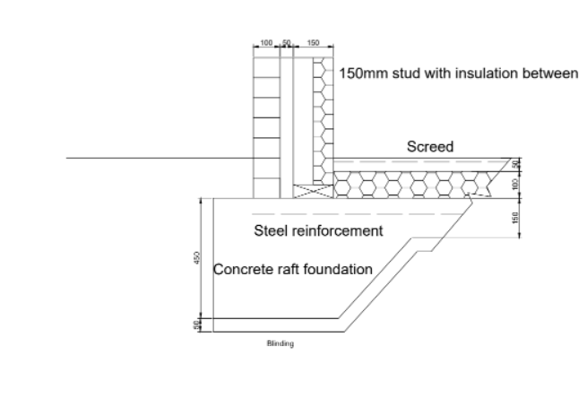
As seen in the below foundation detail for the property it will be a raft foundation. This detail entails on large slab often reinforced with steel. This is sufficient to take the load of the building even with imperfect ground conditions. The steel reinforcement will give the slab the strength needed to take the loads. Concrete as a material is weak under tension while strong in compression, while streel is the opposite. Having steel reinforcement offers both qualities we look for in a foundation. Looking at diagram 1 the thickness of the slab increases when supporting load baring walls. On top of this slab, sit the internal and external skin of the external walls. One side being brickwork, and the inner wall being timber with insulation sat inside. The thickness of the timber stud is 140mm which will be made from C16 CLS timbers of 150mmx50mm measurements. Having insulation within the voids of the timbers allows us to nit need such a void in the cavity. A cavity of 75mm will be adequate as a clear cavity in order to create a separation for any ingress of water to fall through and not cause any damp issues. At the bottom of the internal skin, a sole plate will be placed to give the structure a solid base. In this instance will be made of timber but can be made by laying a course of brickwork around the perimeter.

Detail 2
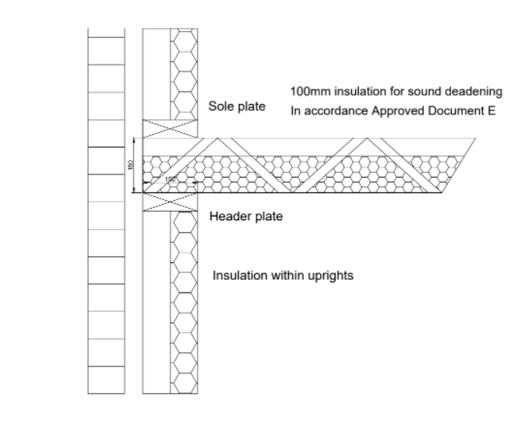
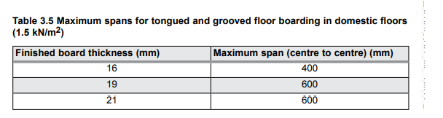
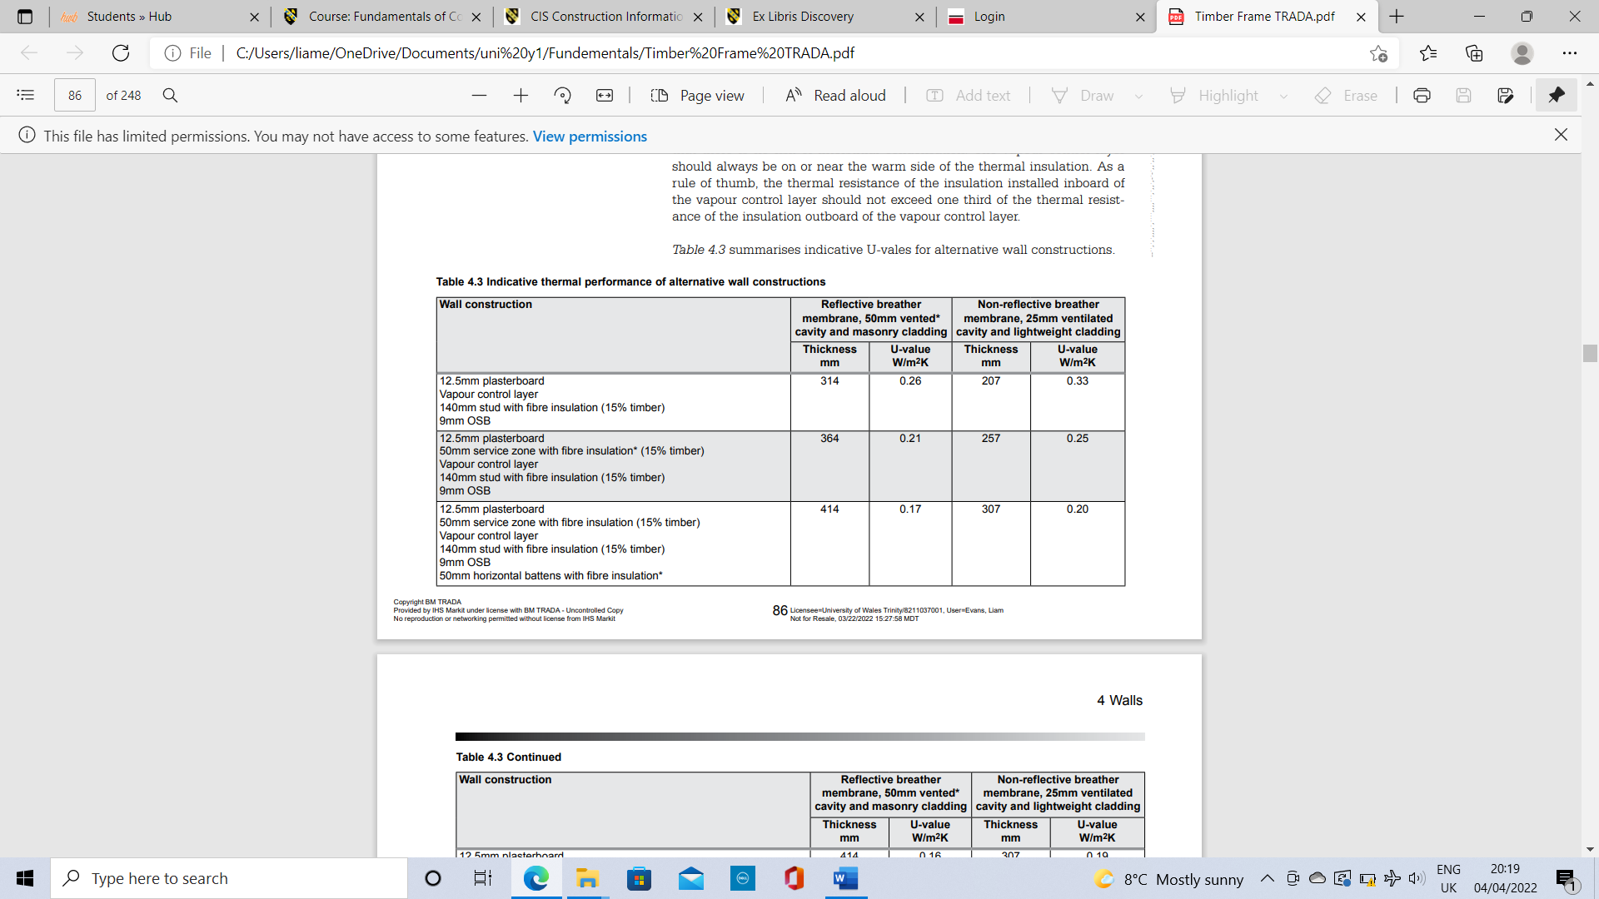
In my second detail I have drawn the first floor construction, highlighting the detail of the floor joists specifically of the first floor. As seen, the floor joists will sit on a header plate on the stud partitions. The size of the joists will vary with the differing spans of the rooms. These spans can be found by looking at the ‘Trada span tables’ (Trada, 2022). Spacings, sizing and grade of timber can be found by looking at this table of contents. I have also decided to use engineering joists for the purpose of ease of getting services through. Cutting through joists can reduce their performance and is not practical. These engineered joists allow new feeds to be put through with ease and keep the space tidy. The header and sole plate will run perpendicular to the uprights of the stud partition and will give the joists a flat base to sit on. Floor joists typically will run across the shortest distance which allows us to use the smallest possible timbers while not sacrificing any strength values. By doing this, it saves on the cost on the build. Sat on top of the joists will be tongue and groove softwood flooring. Weyroc flooring is often used for this purpose and is widely used across the industry. The table to the left highlights the thickness of flooring needed depending on the distance between centres of the floor joists. This table is taken from the ‘Timber frame construction’ handbook which is published by Trada (Trada, 2011). Having standards given by thr likes of Trada give the industry a standard that is needed to be kept to. This ensures that any new build or renivation complies with these standards given.

The above table is taken from the Trada timber frame document (Trada, 2011) This highlighs the required components to achieve adequate U values for the wall construction. The depth of stud will allow the insulation to to kept within the stud then with a 50mm service gap within the cavity. These are then in accordance with BS EN ISO 6946.

Detail 3
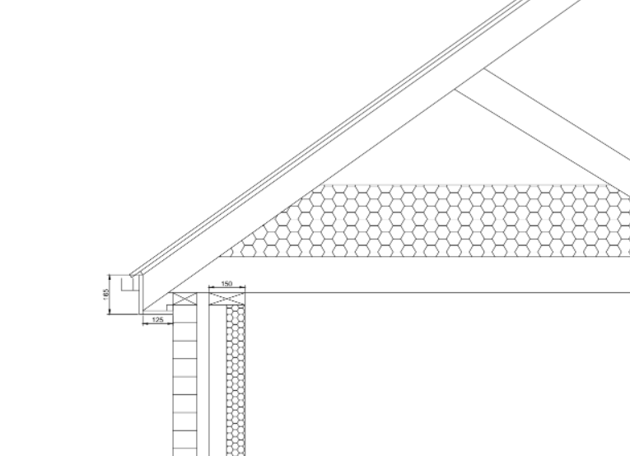
The eaves detail is a very important detail in construction to get correct. The design of this build is a trussed roof. Trussed roof is ‘Roof trusses are made from either wood or steel or a combination of both, constructed of pieces that are bolted together to support the weight of roofing material, whether it’s slate or tile.’ (Angi.com, 2021) The trusses are assembled off site and are then delivered to be fixed straight on the built superstructure. The spans and dimensions will all have been calculated to fit perfectly when delivered to site. This limits the error that can be had by using rafters to form the roof structure. As seen at the top of the internal and external skin, a wall plate is placed in order to fix the trusses to. These wall plates will be fixed by galvanized straps to make the whole structure solid. At the eaves level of the roof, the trusses overhang the external wall. This is to ensure that water runs off the roof and is collected by the gutters that will run at the perimeters of the eaves. The rafters are finished by using UPVC or timber fascia and soffit board. In accordance with ‘Approved Document F' (planningportal, 2021) over fascia vents will be placed to allow movement of air to run up the rafters and vented then through a vented ridge or other methods. Stagnating air can cause issues with regards to condensation and form cold spots in the property.

Detail 4
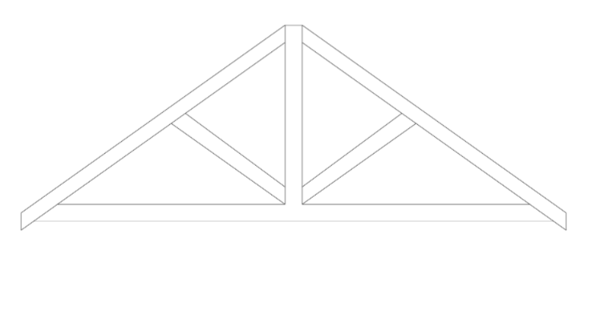
Detail 4 is a section of the roof construction on it’s own. The design of truss I have drawn is a Kings post truss, which has a post down the center with bracing from either side tied to the rafters running down the rake. This roof design is in accordance with ‘BS5268-2’ (Trada, 2011). With regards to the construction of the trusses, they will require to be ‘birdmouthed’ over the wall plate in order for them to sit level on wall plate of the wall. This will take the load of the roof right down to the footing and in turn into the ground. OSB board will sit on the trusses giving the metal profile sheeting a solid base to fix to. Loft insulation runs across the whole area and is then in accordance with ‘Approved Document L1B’ (Planningportal, 2016). Pitched roof with insulation after rafter level is required to be of U Value 0.18. This is able to be achieved by supplying 270mm of wool insulation above rafter level.

Roof Structure
The roof covering of choice in the brief is a metal profile sheeting finish installed on OSB boards. This method of roof covering does offer some advantages but then does hold some disadvantages. Some of these advantages include the lightweight yet tough structure of the material and the durability of it. Once the roof is correctly installed it will withstand adverse weather conditions so that is of no concern. The product is also a cheaper alternative if this is an area of concern for the client. A lot of the disadvantages of the product lie within the aesthetics of it. This type of roofing can divide opinions and may not be of some peoples taste. Another disadvantage that metal roof sheeting has is the noise that it makes when exposed to weather such as wind and rain. Especially during Welsh climate it may be more suitable for a different climate.
There are many alternatives to the metal sheeting as a roof covering but I believe the most suitable for the building would be concrete tiles. One reason I say this is because of the aesthetic look it gives the building. With the roof having concrete tiles it modernizes the building and is more in keeping with surrounding areas. Repairs on a tiled roof are also easier to replace. Tiles are easy to replace and is far more practically viable than replacing long sheets and possibly the OSB boards underneath. Having tiled roof also eliminates the sound of rain or wind on the roof which could be irritating to the client.

Off site Construction
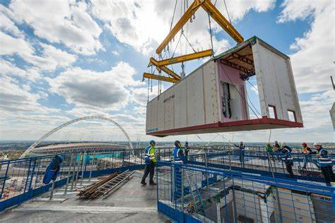
‘Offsite construction refers to structures or components built at a different location than the location of use’ (ikopolymeric.com, 2016). There are some benefits to this method of construction, and I believe these will come in handy to the client. These may come in the form of the inside skin which is timber frame. One of the benefits to off site construction are that they are made to measure and likely hood for mistakes is kept to a minimum. There are 4 different types of off site construction that the client will be able to look at ‘Modular system’, ‘Structural insulated panels’, ‘pre engineered m&e services’, ‘pre assembled components’. (ikopolymeric.com, 2016) Modular systems are complete elements of a building without the final finishes. These finishes are completed on site such as the decorating as an example of a final finish. Modular construction will lessen time on site massively but may not be the best suited for this building specifically. The reason for this is because the building is 2 skins and the outer is of brick and block which is unable to be done via modular construction.
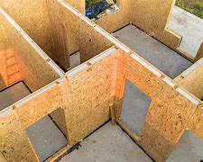
Structural insulated panels are another modern method of construction and one I believe is a viable option for the client to use. ‘The panels consist of an insulating foam core sandwiched between two structural facings, typically oriented strand board’ (sips, 2022) These panels are put into place and can be made to fit any design or size of building. These panels will all be in accordance with building regulations with regards to U values. The outer skin can be built around these panels and then trussed roof placed on top. The OSB boards will allow things like the kitchen units to be fixed to the panels without losing its strength. This method, like all of them will reduce construction time dramatically which is usually of interest to the client.
Modular construction
Another form of off site possible foe the client to consider are pre engineered m&e services. This method consists of entire service rooms being constructed of site and then imported straight into the build. The services are then all connected to the off site service build and speeds these processes up for the client. This is a method I would not recommend as with this it may be hard for the building to be adapted in the future. This may be a hinderance to the client further down the line.
Structural Insulated Panels
The final method of off site construction and the one I believe will be most viable for the client to use pre assembled components. ‘This method consists of taking materials that would be installed individually on site and pre assembling them in a factory.’ (ikopolymeric.com, 2016) The way I think the client should incorporate this is by pre assembling the timber framed sections and the roof trusses off site. This not only speeds up the time on the build, but ensures that all measurements and dimensions and perfect. BY speeding up the build it will save the client money and of course get them to completion of build sooner.

Conclusion
Throughout this essay I intended to highlight the different stages of their build while explaining what needs to be done at each detail. The client was unsure on what off site construction was, and I believe I have enlightened her on what this is and where I believe she is able to incorporate this to her project. The details given are all in accordance with current building regulations for a new build property.

References
Tendering.gov.uk. (2021) [Online] Available at: https://www.tendringdc.gov.uk/sites/default/files/documents/planning/heritage,%20conservation%20%26%20trees/TDC_BricksB.pdf#:~:text=Bricks%20were%20first%20introduced%20into%20Britain%20by%20the,bricks%20became%20more%20widely%20used%20for%20smaller%20houses [Accessed 24 Apr. 2022]
Trada.co.uk. (2019). Span Tables | TRADA. [online] Available at: https://www.trada.co.uk/ad-hoc/span-tables/.
Angi. (2021). What Is a Roof Truss? [online] Available at: https://www.angi.com/articles/what-is-roof-truss.htm.
IKO Polymeric. (2016). Offsite Construction - Modern Methods of Construction. [online] Available at: https://ikopolymeric.com/offsite-construction-methods-and-their-benefits/#:~:text=Offsite%20construction%20refers%20to%20structures%20or%20components%20built [Accessed 26 Apr. 2022].
www.sips.org. (n.d.). What Are Sips. [online] Available at: https://www.sips.org/what-are-sips.
www.planningportal.co.uk. (n.d.). Approved Document L1B: Conservation of fuel and power in existing dwellings - Part L - Conservation of fuel and power - Planning Portal. [online] Available at: https://www.planningportal.co.uk/applications/building-control-applications/building-control/approved-documents/part-l-conservation-of-fuel-and-power/approved-document-l1b-conservation-of-fuel-and-power-in-existing-dwellings/ [Accessed 26 Apr. 2022]

